|  |
| --- |
| **INFO2320 Assignment 1 Section XX Team YY**  *By signing below, I certify that I have fully complied with the INFO2320 Code of Honor.*  Student 1: Brittany McNabb  Student 2: Shakir Hansrod  Student 3: Khachig Kerbabian  Student 4: ______________________________ |

1. **Individual VP Lab** (20% of A1 mark for each member / presenter)

Complete the table below after each member has completed their VP lab. Fill out the location (e.g., Zoom, MS Teams) and date & time, where the demo was completed. *Members must sign their own name.*

|  |  |  |
| --- | --- | --- |
| **Team Member**  (Presenter) | **Location, Demo Date and Time** | **Certified By**  (another team member) |
| 1. Brittany McNabb | Zoom, 1st October, 2021 | Shakir Hansrod/. Khachig Kerbabian |
| 2. Shakir Hansrod | Zoom, 1st October, 2021 | Brittany McNabb/ Khachig Kerbabian |
| 3. Khachig Kerbabian | Zoom, 1st October, 2021 | Shakir Hansrod/ Brittany McNabb |
| 4. |  |  |

1. **Team Assignment 2** (80% of A1 mark)

**Task 1: VPRU Agile Project Charter**

*< Below is a sample Agile Project Charter template.>*

1. **System Objectives**

*<Read the VPRU background information on VPRU Case Study (also on Page 66 of SADCW textbook) and complete the sentence fragments below.>*

* VPRU is an online travel service that books spring break trips to resorts for college students.
* VPRU requires a new information system to replace the current travel booking software product, which has missing functionality and is no longer supported by the vendor.
* The new system must continue to support the three existing subsystems: updated booking information, resort information updated, and travel information for booked.
* VPRU recently decided to add a new social networking features subsystem to enhance the student experience before, during and after the trip.
* The new system must provide an extensive set of reports and that can be viewed and printed.

1. **Project Roles/Responsibilities**

*<Fill out the Technical Staff with your student names that belong to your INFO2320 team, and modify the positions and roles, as appropriate.>*

**Client Staff**

* Wayne Powell, VPRU Operations Manager: Project Sponsor, responsible for approving the project initially and then approving deliverables as the project proceeds;
* Meyer Tanuan, VPRU Analyst: Project Contact / Domain Expert, responsible for working with the Technical Staff to manage the project on a day-to-day basis; also responsible for providing information and answering questions.

**Technical Staff**

* Brittany McNabb Senior Software Developer Scrum Master responsible for facilitating scrum meetings and activities; removes obstacles of the Development team;
* Shakir Hansrod Business Analyst / QA Product Owner, responsible for business analysis and software testing;
* Khachig Kerbabian Senior Software Developer Development Team Member responsible for developing the back-end services (API) of the system;
* ___<…>___, Software Developer Development Team Member responsible for developing the UI of the system.

1. **Business Benefits**

*<Name at least three (3) expected benefits of the new subsystems.>*

* The new Resort Relations subsystem will increase the sales by 50% year over year.
* The Student Booking subsystem will correct current information and images about resorts.
* The Accounting and Finance subsystem will ensure accurate calculation of deposit, refund, fully paid and damage calculation
* The Social Networking subsystem will increase the number of bookings.

1. **Requirements**

**4A. Preliminary Functional Requirements**

*Note: The appropriate event table and use cases will be identified in Task 3 below.*

<Identify at least one (1) non-functional requirement per category listed in the table below.>

**4B. Non-functional Requirements**

|  |  |
| --- | --- |
| **Usability requirements**  <User interface, ease of use> | * The system should be easy for a user to be able to learn from it and use it |
| **Reliability requirements**  <Failure rates, backup/ recovery methods> | * The system is to be backed regularly |
| **Performance requirements**  <Response time and throughput> | * Response time cannot go past 5 seconds. |
| **Security requirements**  <Access control, encryption> | * Data and Network Security |

1. **Project Team Critical Success Factors**

*<Identify at least four (4) project critical success factors. Project critical success factors are about how the project team is managed, not about how the software will be developed. >*

* The development staffing level and development staff time commitment must not drop
* The product owner must be co-located and work with the development team on a daily basis.
* Project contacts must be available to attend product demonstrations and provide feedback to the technical staff.
* The project sponsor must take timely decisions when project milestones are reached

1. **Preliminary Technical Architecture:**

*< Select one of the possible technical architecture options from the reference slides>*

**The technical architecture selected was** Preliminary Technical Architecture

* 1. **Development environment**
* Existing developer PCs and laptops running Windows 10
* C#, Visual Studio, WinForms
* Justinmind, Visual Paradigm
  1. **Server Production Environment**
* Microsoft Azure
* Microsoft Cloud
  1. **Client Production Environment**
* Laptops that run windows 10
* Existing Clients PC

**Task 2: Workflow / Activity Diagram**

**2A. Business Process: VPRU Acquire Vacation Package Provider**

Process Goal: < describe the purpose of this process (e.g., why and how the process will benefit the organization). >

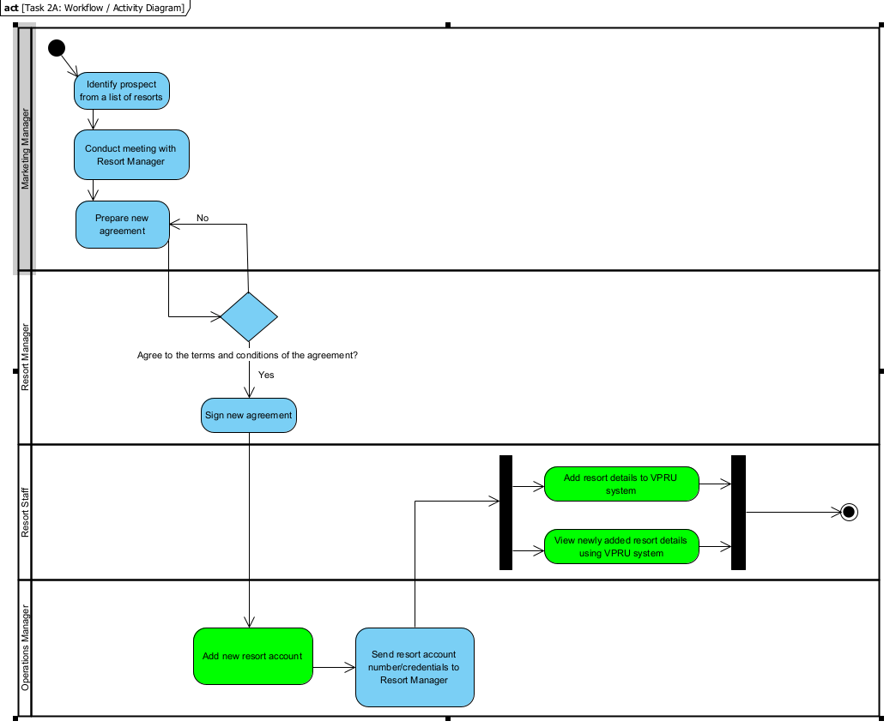

**2B. Business Process:** **Resort Provide Vacation Package Voucher**

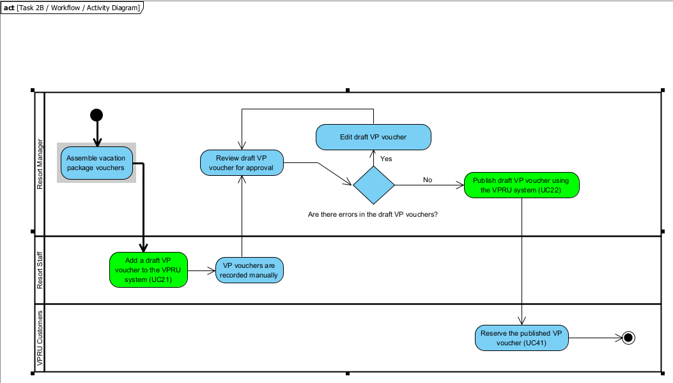Process Goal:

**Task 3: Event Table with Use Cases**

**S1. VPRU Resort Relations Subsystem Event Table**

|  |  |  |  |  |
| --- | --- | --- | --- | --- |
| **Event Type** (external, temporal, state) | **Event Name** (who-does-what) | **Use Case ID** (UC#) | **Actor(s)** | **Use Case**  (format: verb + noun) |
| External | The resort staff add the draft VP voucher to the VPRU system | **UC11** | Resort Staff | Add a draft VP voucher |
| External | The Resort manager publishes the draft VP voucher using the VPRU system | UC12 | Resort Manager | Publish a draft VP voucher |
| External | The customer pays to reserve a VP voucher. | UC13 | VPRU Customers | Reserve the published VP voucher |
| External | VPRU Customers create account using VPRU system | UC14 | VPRU Customers | Create account |

**S2. VPRU Vacation Booking Subsystem Event Table**

|  |  |  |  |  |
| --- | --- | --- | --- | --- |
| **Event Type** (external, temporal, state) | **Event Name** (who-does-what) | **Use Case ID** (UC#) | **Actor(s)** | **Use Case**  (format: verb + noun) |
| Temporal | The expiry date on the vacation package. | UC21 | Timer | Expiry Date |
| Temporal | Primary guest  Log in to make changes to the VP booking | UC22 | Primary guest | Make changes |
| Temporal | Primary guest  can reserve a vacation package for one day without paying an initial deposit | UC23 | Primary guest | Reserve a vacation package |

**Task 4: Use Case Diagram (UCD)**

**S1. VPRU Resort Relations Subsystem Use Case Diagram**

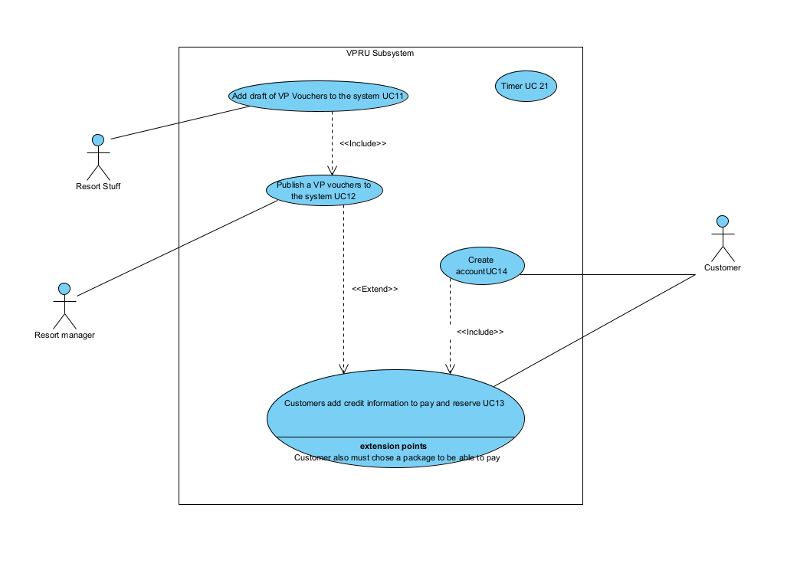

**S2. VPRU Vacation Booking Subsystem Use Case Diagram**

