2. First Approach: Poroviscoelastic (PVE) Model

In order to model the liver microenvironment, a three-dimensional poroviscoelastic finite element model of a quarter liver lobule (Figure 1) was created in Abaqus (v6.12, 3DS Dassault Systems, Waltham, MA), modified from the prior work of Nishii et al [ref]. A poroviscoelastic material model was selected because this constitutive description of liver tissue mechanics has been shown to capture the viscoelastic stress-strain behavior of the solid matrix as well as pressure-driven flow of fluid through the matrix pores [refs]. To reduce computational time only one-fourth of the hexagonal lobule geometry was simulated, and symmetry boundary conditions were applied to *X*, *Y* and *Z* planes (Figure 1). Model thickness in the *Z* direction was set to 30 μm to approximate the diameter of one hepatocyte. Dimensions and parenchyme material properties were obtained from literature [refs] as described below. Once the base model geometry was established (Figure 1A), three different sized tumors denoted as seed (50 μm diameter), small (200 μm diameter), and medium (400 μm diameter) tumors were included. Tumors were also modeled as poroviscoelastic solids, but with greater stiffness and altered hydraulic conductivity compared with normal parenchyme. Tumors were placed at the midpoint of the central-portal axis (termed the “center” position) and in the portal triad (termed the “portal” position). Tumor sizes and locations are shown in Figure 1B. Each model run simulated only one tumor size at one location.

2.1 Method

2.1.1 Starting Model Assumptions

It was assumed that necrosis is a source of fluid pressure as necrotic cells release fluid. It was also assumed that proliferating cells are a fluid pressure sink as proliferating cells grow in part by absorbing fluid. Accordingly, the medium (400 μm diameter) tumor was considered as a net pressure source, reflecting a release of fluid from the necrotic core that exceeds the uptake of fluid by cells in the viable rim. For comparison, in a different model iteration the medium tumor was considered as neutral, neither a source nor a sink, to reflect the possible condition that fluid release and fluid uptake are in balance. The small (200 μm diameter) tumor was considered as a net pressure sink reflecting more proliferation than necrosis. Lastly, the tumor seed (50 μm diameter) was considered as neutral, as a tumor of this size would consist of only a few cells and its contribution as a fluid source or sink may be neglected.

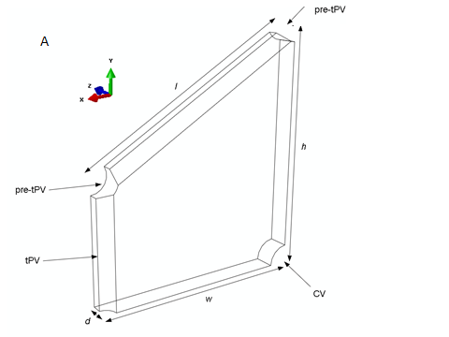 

B

**Figure 1. Model geometry (A) and simulated tumor sizes and positions (B). (A) Quarter liver lobule showing locations of the pre-terminal portal vein (pre-tPV), terminal portal vein (tPV), and central vein (CV). Dimensions *l*, *w*, *h,* and *d* are given in Table 1. (B) Tumors of different sizes (seed, small, medium) were simulated for different lobule locations, including the midpoint of the central-portal axis (termed the “center” position) and in the portal triad (termed the “portal” position).**

2.1.2 Model Geometry

Model geometry is given in Figure 1. Lobule dimensions and vessel radii (Table 1) were obtained from histological images in published literature [refs]. Dimensions for *l* and *h* are reported as the distance between the center of the pre-tPVs, and *d* is reported as the farthest distance between model faces in the z and -z direction. Each quarter-lobule model contained from 299,258 to 677,457 quadratic tetrahedral elements (Abaqus element type C3D10MP). Simulation time was 150 seconds and the minimum time step was 0.15 seconds.

**Table 1. Quarter lobule dimensions adapted from Nishii et al [ref].**

|  |  |
| --- | --- |
| Dimensions (µm) | |
| CV radius | 26.5 |
| tPV radius | 16 |
| pre-tPV radius | 23 |
| Edge length (*l*) | 350 |
| Edge width (*w*) | 303.1 |
| Edge height (*h*) | 350 |
| Lobule depth (*d*) | 30 |

2.1.3 Poroviscoelasticity

A detailed mathematical description of the mechanics of poroviscoelastic materials was published by Simon [1992], and the application of poroviscoelastic models to liver tissue has been demonstrated by Raghhunathan et al. [2010], Moran et al. [2012], and Evans et al. [2013] among others. The summary given here is adapted from Athanasiou and Natoli [2009], Evans et al. [2013], and Nishii et al. [2015]. A biphasic material consists of a linear elastic solid phase and an incompressible fluid phase, where relative motion between the two phases produces rate-dependent (i.e. viscoelastic) behavior [Mow 1980]. If the fluid phase is inviscid, biphasic theory is equivalent to poroelasticity. Poroviscoelasticity extends poroelasticity by modeling the solid phase as viscoelastic, rather than linear elastic [Mak 1986]. Equations 1-7 comprise biphasic material mechanics, Equations 8 and 9 provide for viscoelasticity of the solid phase, and Equations 10 and 11 finish the constitutive description.

The conservation of mass for incompressible solid and fluid phases can be written as:

 (Eq. 1)

where *s* and *f* indicate solid and fluid phase, respectively, **and **are solid and fluid volume fractions, and *v* is velocity. If inertial forces are negligible compared with internal frictional forces, the conservation of linear momentum can be written as:

 (Eq. 2)

 (Eq. 3)

where  and are Cauchy stress tensors and and  are viscous drag forces arising from the interaction between the fluid and solid phases. and are proportional to their relative velocities and inversely proportional to hydraulic permeability, *k*:

 (Eq. 4)

Stress tensors in the fluid and solid phases can be written as:

 (Eq. 5)

 (Eq. 6)

where *p* is hydrostatic pressure and  is apparent solid stress due to solid matrix deformation [Mow 1980, Mak 1986, Suh 1998].

If the solid phase is linear elastic, then can be written as:

 (Eq. 7)

where is the infinitesimal strain tensor and *λ* and *μ* are Lamé constants.

To account for intrinsic viscoelasticity of the solid phase, the solid stress tensor can be replaced with:

 (Eq. 8)

where *G* and *K* are elastic shear and bulk relaxation functions,  is deviatoric strain, and  is volumetric strain [Mak 1986, Suh 1998]. The relaxation functions can be defined by a Prony series expansion:

 (Eq. 9)

where *R* is the time-dependent modulus,  is the long-term modulus, and *n*, *ri*, *τi* are Prony series constants.

In the Abaqus implementation in the present work, the material behavior was defined by specifying the hydraulic conductivity (*K*), the specific weight of the liquid (*γ*), the Prony series constants, a long-term Young’s modulus (), and Poisson’s ratio (ν) so that:

 (Eq. 10)

 (Eq. 11)

2.1.4 Material Properties

Model material properties are given in Tables 2-4. The Young’s modulus of the parenchyme was taken as 4.4 kPa and Poisson’s ratio as 0.35 [Nishii et. al, Evans et al.]. The Young’s modulus for tumor tissue was set as 30 kPa [Venkatesh et al., Lu et al.] and Poisson’s ratio was assumed equal to normal tissue. A four-term Prony series expansion was used to model to tissue viscoelasticity, with Prony series constants taken from previous nano-indentation experiments on perfused liver tissue [Evans et al.].

At the macroscopic (cm) length scale, tumors have been reported to have higher hydraulic conductivity *K* relative to the surrounding tissue [Swabb et. al., Pishko et. al., Netti et. al.]. However, the hydraulic conductivity of smaller tumors on the order of 50-400 μm is unknown. For each tumor size/location combination in the present study, we simulated the effects of high and low hydraulic conductivity in the tumor. For the high hydraulic conductivity case, we used a value of 3.65 times that of normal liver, based on hydraulic conductivity of hepatocarcinoma determined from measurements of Swabb et al. [ref]. For the low hydraulic conductivity case, we used 0.3 times that of normal liver, to span approximately one order of magnitude in our high/low conditions. Normal liver parenchyme hydraulic conductivity was taken as 1.85 x 10-6 m/s as reported by Nishii et al. [2015], based on void ratio measurements from histological image analysis. Void ratio, e, is defined as:

(Eq. 12)

where is the void ratio, is the void volume, is the volume of solid in the lobule, and is the total volume of the lobule. Void ratio is related to hydraulic conductivity as follows [Nishii et al. 2015]:

(Eq. 13)

where *K* is the hydraulic conductivity (m/s), is fluid density (kg/m3), *g* is gravitational acceleration (m/s2), is the void ratio, is the average radius of a sinusoid (m), and is the dynamic viscosity of the permeating fluid (Pa·s).

**Table 2. Elastic constants for parenchyme and tumor. Materials are assumed isotropic.**

|  |  |  |
| --- | --- | --- |
|  | Parenchyme | Tumor |
| Elastic Modulus (kPa) | 4.4 | 30 |
| Poisson's ratio | 0.35 | 0.35 |

**Table 3. Viscoelastic constants (same values used for parenchyme and tumor).**

|  |  |  |
| --- | --- | --- |
| Term | *gi* (dim) | *τi* (sec) |
| 1 | 0.53 | 2.00E-05 |
| 2 | 0.376 | 1 |
| 3 | 0.027 | 7.65 |
| 4 | 0.01 | 100 |

**Table 4. Hydraulic conductivity and related properties**

|  |  |  |  |
| --- | --- | --- | --- |
| Property | Parenchyme | Tumor, High Hydraulic Conductivity | Tumor, Low Hydraulic Conductivity |
| Hydraulic Conductivity (m/s) | 1.85E-06 | 6.75E-06 | 5.50E-07 |
| Void Ratio | 0.8 | 1.55 | 0.052 |
| Specific Weight of Fluid (kg/m3) | 9855 | 9855 | 9855 |

2.1.5 Boundary Conditions

As noted above, one-quarter of the hexagonal lobule was modeled to minimize computational cost; therefore symmetric boundary conditions were applied to the *X*, *Y*, and *Z* planes (Figure 1A). Following the work of Bonfiglio et al. [2010], the model assumed uniform expansion in the axial direction (in the *XY* plane) and no expansion in the longitudinal (*Z*) direction. Pressure in the CV surface was set to zero to serve as a pressure sink, and pressures in the terminal portal vein (tPV) and pre-terminal portal vein (pre-tPV) were set to 2.23 mmHg (297.3 Pa) above the CV pressure so that the physiological pressure difference was preserved [ref]. The pressure condition at the tumor boundary varied depending on tumor size (see Section 2.1.1 and Table 5). A total of 13 model runs were performed, varying tumor position and size, pressure condition at the tumor boundary, and tumor permeability relative to surrounding parenchyme (Table 5). Lastly, a control model was created with no tumor but with identical parenchyme properties and vascular pressure boundary conditions, to serve as a basis for comparison.

**Table 5. Variable parameters for finite element model runs.**

|  |  |  |  |  |
| --- | --- | --- | --- | --- |
| Model Run | Tumor Position | Tumor Size  (diam., μm) | Tumor as Pressure Source or Sink  (Pa) | Tumor Hydraulic Conductivity  (m/s) |
| 1 | Center | Seed (50) | Neutral | Low (5.50E-07) |
| 2 | Center | Seed (50) | Neutral | High (6.75E-06) |
| 3 | Center | Small (200) | Sink (0) | Low (5.50E-07) |
| 4 | Center | Small (200) | Sink (0) | High (6.75E-06) |
| 5 | Portal | Seed (50) | Neutral | Low (5.50E-07) |
| 6 | Portal | Seed (50) | Neutral | High (6.75E-06) |
| 7 | Portal | Small (200) | Sink (0) | Low (5.50E-07) |
| 8 | Portal | Small (200) | Sink (0) | High (6.75E-06) |
| 9 | Portal | Medium (400) | Source (600) | Low (5.50E-07) |
| 10 | Portal | Medium (400) | Source (600) | High (6.75E-06) |
| 11 | Portal | Medium (400) | Neutral | Low (5.50E-07) |
| 12 | Portal | Medium (400) | Neutral | High (6.75E-06) |
| 13 | Control | No Tumor | N/A | Parenchyme (1.85E-06) |

2.2 Results

Figures 2-5 illustrate the fluid velocity and strain distribution results across different conditions. The complete set of model results, including fluid pressure and solid matrix stress distributions, are provided in Supplemental Information.

In the control condition in the absence of any tumor, fluid velocity increased in an approximately exponential pattern from the portal vein inlet to the central vein outlet (Fig. 2), with velocity magnitudes ranging from 0 to ~800 μm/sec. Solid matrix strain decreased slightly from 3% strain at the lobule periphery to ~1.7% near the central vein outlet (Fig. 2).

For the tumor seed (50 μm diameter) located in the Center position, the pressure at the tumor boundary was neutral and hence the difference between high and low tumor permeability conditions was detectable in the fluid velocity results (Fig. 3). Fluid velocities were notably elevated in the high permeability tumor condition (200 μm/sec) as compared with the low permeability tumor condition (57 μm/sec) or the normal parenchyme at a comparable location within the lobule (95 μm/sec, path length of 200 μm). Strain increased at the tumor margins, from 3% to ~ 4.2%, and dropped to negligible values inside the tumor itself as a result of the increased tumor stiffness (Table 2) relative to surrounding tissue.

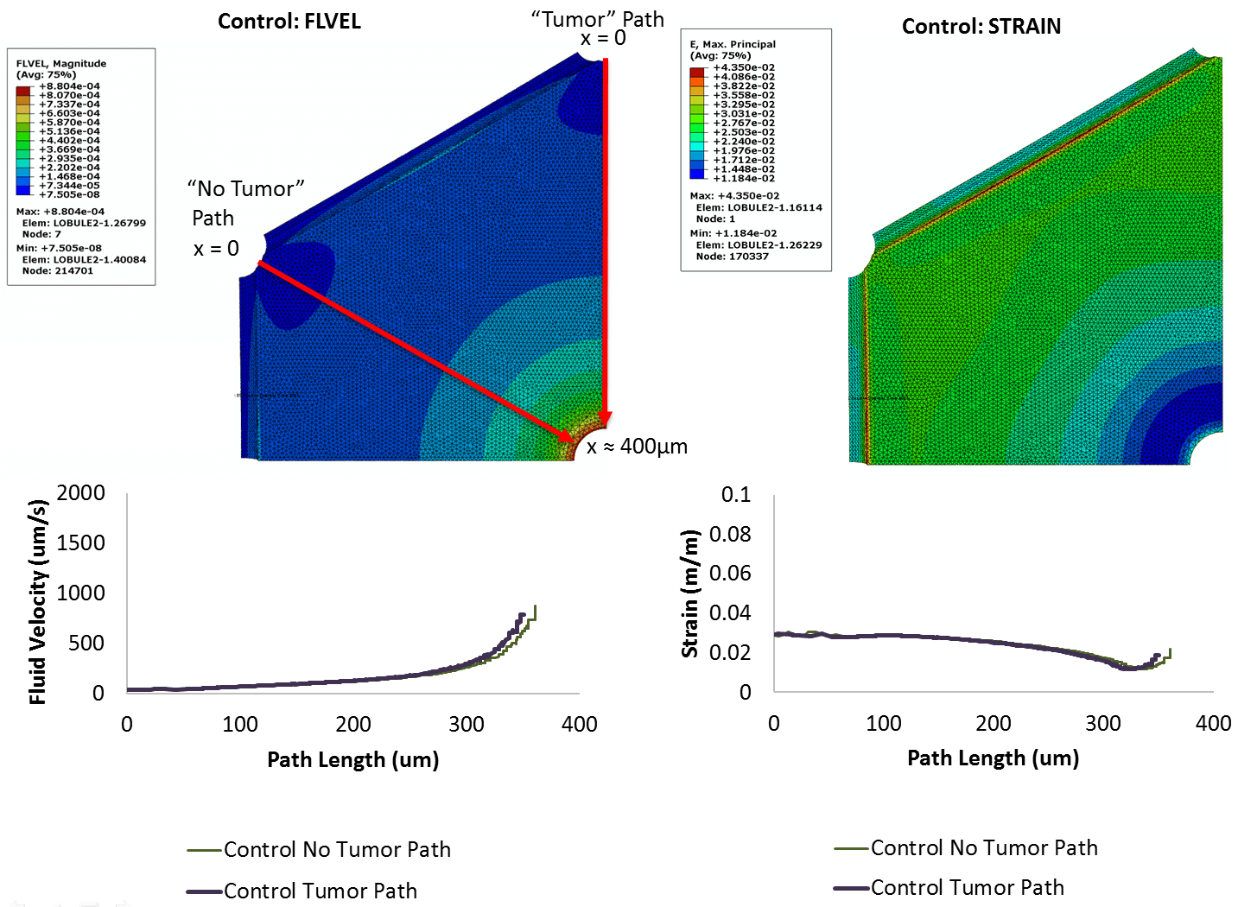

**Figure 2. Caption.**

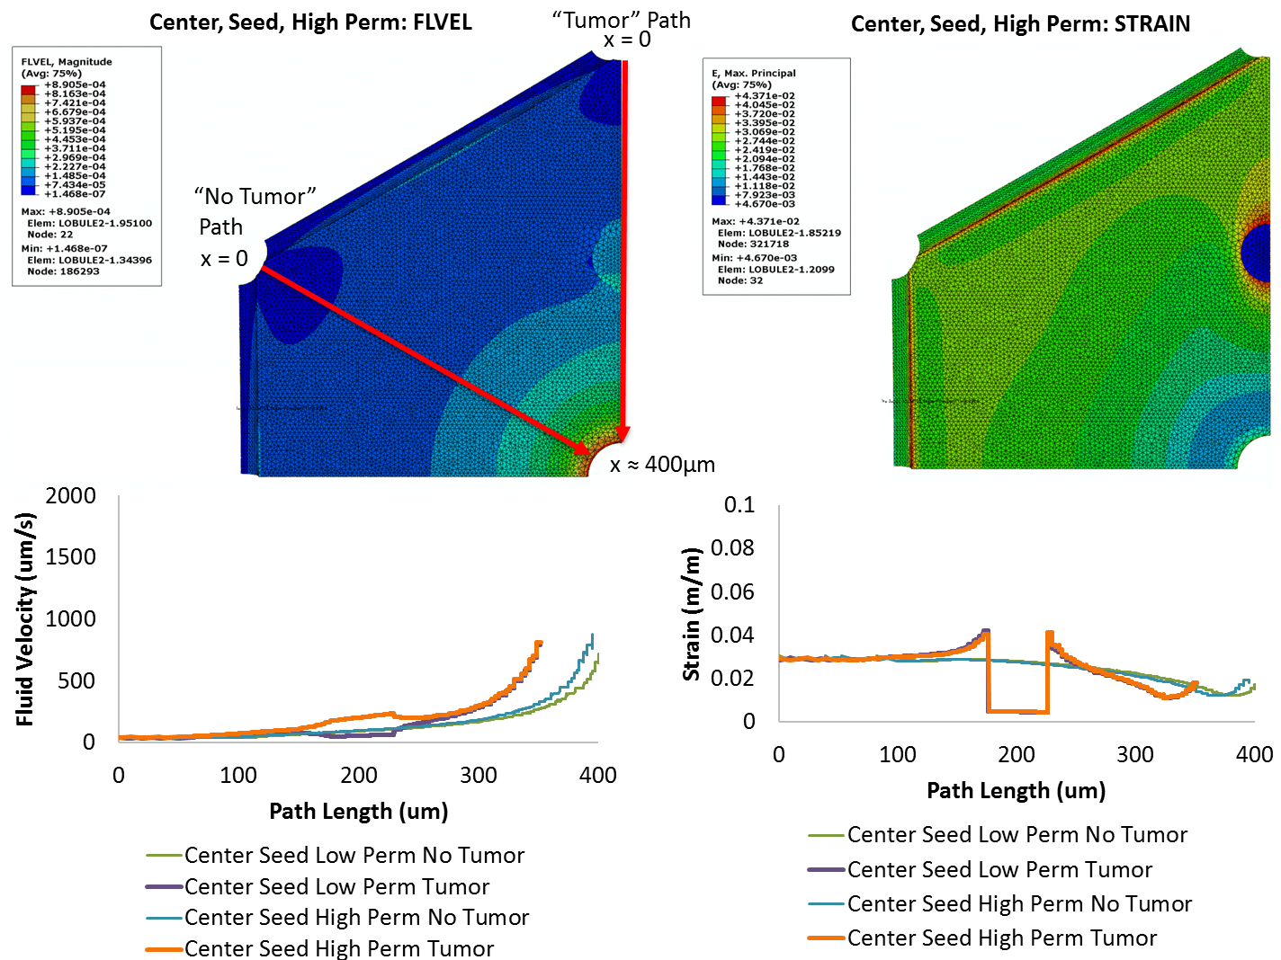

**Figure 3. Caption**

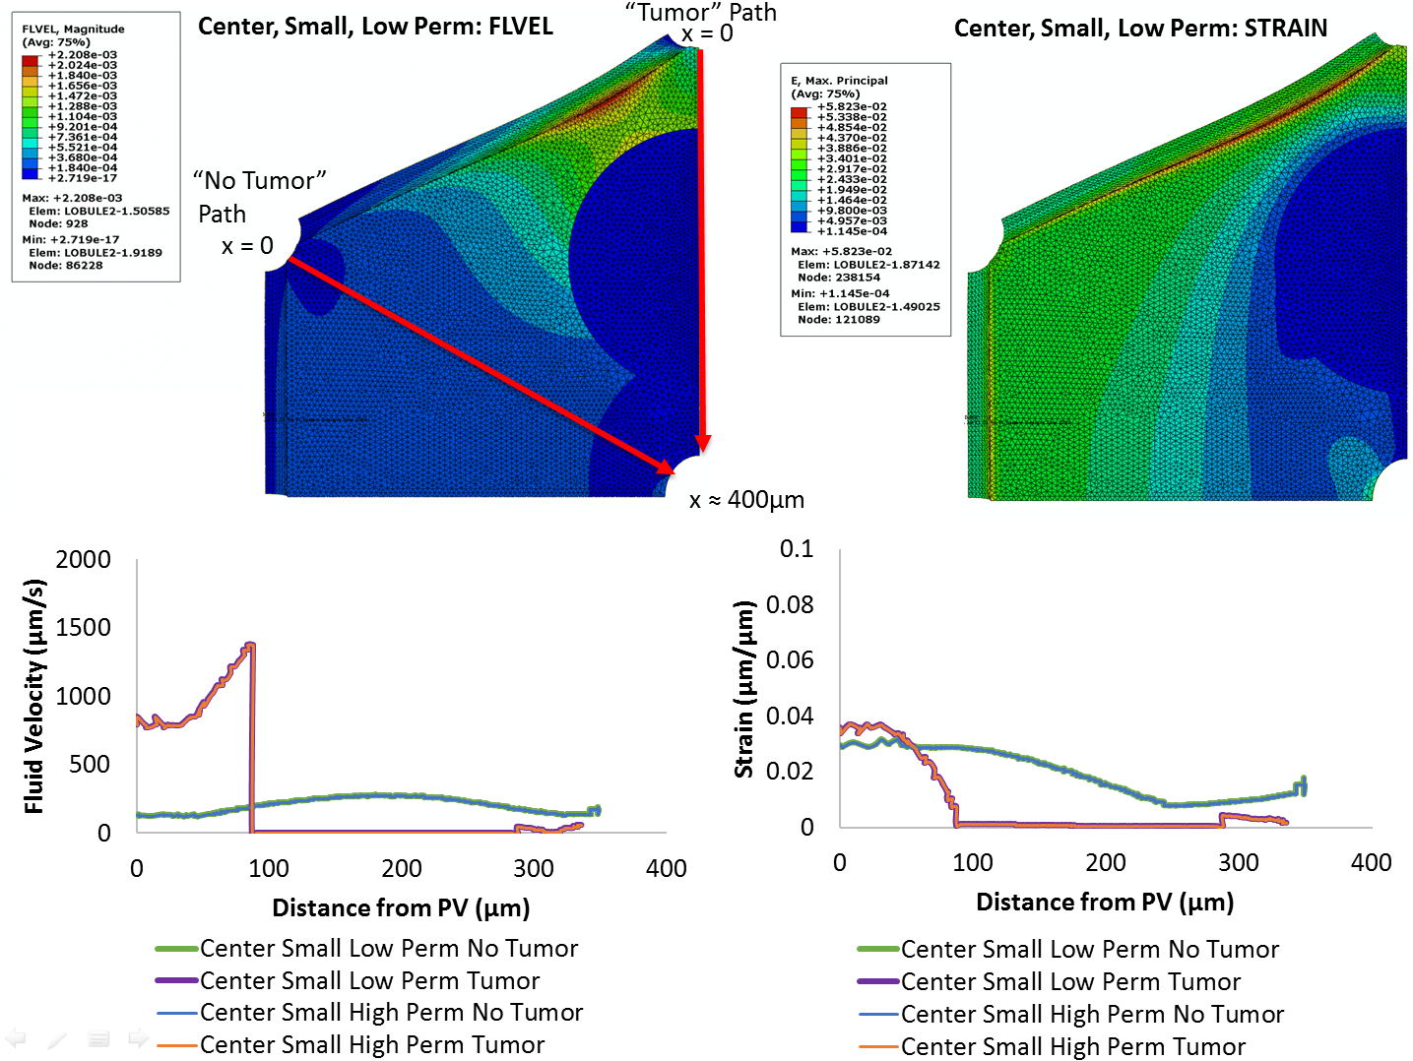

**Figure 4. Caption.**

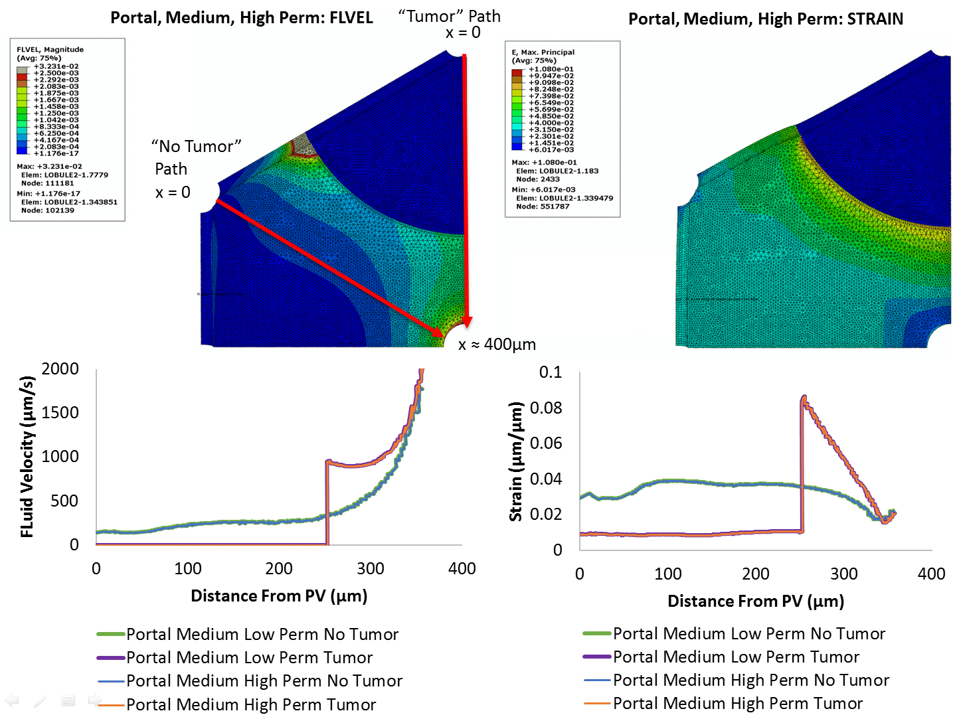

**Figure 5. Caption.**

For the small tumor (200 μm diameter) located in the Center position, setting the tumor boundary as a pressure sink had a significant impact on the strain and velocity profiles (Fig. 4). For the flow path passing through the tumor, the velocity of fluid entering the lobule from the portal vein was higher (800 μm/sec) compared with control (~0 μm/sec), increased to a maximum of 1370 μm/sec as it approached the tumor boundary, then dropped to negligible values within the tumor itself. Flow along the path through normal parenchyme had lower velocities overall (130-270 μm/sec) than the control. In contrast to the neutral pressure boundary case (Fig. 2), for the pressure sink tumor condition the strain decreased from 3% to zero at the tumor boundary, and again remained negligible within the tumor itself. No differences were noted between the high and low permeability tumor conditions.

For the medium tumor (400 μm diameter) located in the Portal position, results are shown for the condition with the tumor boundary set as a pressure source (Fig. 5). Results for the neutral pressure medium tumor are given in the Supplemental Information. As with the pressure sink condition (Fig. 4), the flow velocity and strain within the tumor itself were negligible, as expected with a constrained tumor pressure boundary condition and elevated tumor stiffness. Fluid velocities increased sharply from zero to ~1000 μm/sec at the tumor boundary, then continued to increase up to ~2000 μm/sec at the central vein. Flow along the path through normal parenchyme showed a velocity trend similar to the control condition but with a higher peak velocity (~2000 μm/sec) at the central vein. Strains increased sharply at the tumor boundary to a peak value of 9%, the highest strain magnitude of any condition.

2.2.1 Initial Insights from PVE Model

Changes in tumor permeability had little to no effect in cases where the tumor was modeled as a pressure sink (Fig. 4) or source (Fig. 5). However, when the tumor was modeled as neutral (neither source nor sink, Fig. 3), fluid flowed faster through the high permeability tumor and slower through the low permeability tumor as compared with normal parenchyme. For the neutral condition, high tumor permeability was also associated with higher tumor stresses (Supplemental Information). When the tumor was modeled as a pressure sink (Fig. 4), much of the fluid entering the lobule drained through the tumor boundary, so that fluid velocities in the region of the central vein were negligible. Setting the tumor as a pressure sink also produced a drop in stress and strain at the tumor edge, unlike the spike in stress and strain noted in the other two conditions. Lastly, modeling the tumor as a pressure source produced the highest overall magnitudes of fluid velocity and strain (Fig. 5).

References

Nishii, Kenichiro, et al. "Multiscale computational model of fluid flow and matrix deformation in decellularized liver." *Journal of the mechanical behavior of biomedical materials* 57 (2016): 201-214.

Fukumura, Dai, and Rakesh K. Jain. "Tumor microenvironment abnormalities: causes, consequences, and strategies to normalize." *Journal of cellular biochemistry* 101.4 (2007): 937-949.

Swabb, Edward A., James Wei, and Pietro M. Gullino. "Diffusion and convection in normal and neoplastic tissues." *Cancer research* 34.10 (1974): 2814-2822.

Pishko, Gregory L., et al. "Sensitivity analysis of an image-based solid tumor computational model with heterogeneous vasculature and porosity."*Annals of biomedical engineering* 39.9 (2011): 2360-2373.

Netti, Paolo A., et al. "Role of extracellular matrix assembly in interstitial transport in solid tumors." *Cancer research* 60.9 (2000): 2497-2503.

Venkatesh, Sudhakar K., et al. "Magnetic resonance elastography of liver tumors-preliminary results." *AJR. American journal of roentgenology* 190.6 (2008): 1534.