A database of total zooplankton biomass in Australian marine waters
Felicity R. McEnnulty¹, Claire H. Davies¹ ,Asia O Armstrong¹³, Natalia Atkins¹², Frank Coman², Lesley Clementson¹, Steven Edgar², Ruth Eriksen¹, Jason D. Everett^{2,7,8}, Miles Furnas⁶ , Christian Lønborg⁶, A. David McKinnon⁶, Margaret Miller², Todd O’Brien¹¹, Sarah Pausina^{2,4}, Julian Uribe Palomino², Wayne Rochester², Peter Rothlisberg², Anita Slotwinski², Joanna Strzelecki³, Iain M. Suthers^{8,9} Kerrie M. Swadling⁵, Mark L. Tonks², David H. Tranter², Paul van Ruth¹⁰, Jock W. Young¹, Anthony J. Richardson^{2,7}
Affiliations
- CSIRO Oceans and Atmosphere, Castray Esplanade, Hobart, TAS, 7000, Australia
- CSIRO Oceans and Atmosphere, Queensland Biosciences Precinct, St Lucia, QLD, 4067, Australia
- CSIRO Oceans and Atmosphere, Indian Ocean Marine Reasearch Centre, Crawley, WA, 6009, Australia
- School of Biological Sciences, The University of Queensland, St Lucia, QLD, 4072, Australia
- Institute for Marine and Antarctic Studies, University of Tasmania, TAS, 7001, Australia
- Australian Institute of Marine Science, Townsville, QLD, 4810, Australia
- Centre for Applications in Natural Resource Mathematics, School of Mathematics and Physics, The University of Queensland, St Lucia, QLD, 4072, Australia
- Centre for Marine Science and Innovation, School of Biological, Earth and Environmental Science, University of NSW, Sydney, NSW, 2052 Australia
- Sydney Institute of Marine Science, Chowder Bay Road, Mosman, NSW, 2088, Australia
- South Australian Research and Development Institute – Aquatic Sciences, West Beach, SA, 5024, Australia
- NOAA Fisheries - COPEPOD, Silver Spring, Maryland, USA
- Australian Ocean Data Network, Integrated Marine Observing System, University of Tasmania, Hobart, TAS, 7001, Australia
- Project Manta, School of Biomedical Sciences, The University of Queensland, St Lucia, QLD, 4072, Australia

Abstract
Zooplankton biomass data have been collected in Australian waters since the 1930s, yet most datasets have been unavailable to the research community. We have searched archives, scanned the primary and grey literature, and contacted researchers, to collate 49067 records of marine zooplankton biomass from waters around Australia (0-60°S, 110-160°E). Many of these datasets are relatively small, but when combined, they provide >85 years of zooplankton biomass data for Australian waters from 1932 to the present.
Data have been standardised, erroneous data removed, and all available metadata included. We have lodged this dataset with the Australian Ocean Data Network (AODN), allowing full public access. The Australian Zooplankton Biomass Database will be valuable for global change studies, research assessing trophic linkages, and for initialising and assessing biogeochemical and ecosystem models of lower trophic levels.

Background and Summary
Zooplankton are the animal component of the plankton and are the primary link between phytoplankton and higher trophic levels. Plankton, originating from the Greek word planktos meaning “to drift”, includes organisms capable of movement in water but unable to progress against currents. Zooplankton communities are highly diverse and almost all phyla are represented. They range from microzooplankton such as heterotrophic flagellates, foraminiferans and radiolarians, to metazoans such as crustaceans, chaetognaths, molluscs, cnidarians and chordates such as salps and larval fish. Zooplankton are extremely abundant, with one group, the copepods, possibly even outnumber insects in abundance¹. The carrying capacity of marine systems – the biomass of exploited fish, squid and shellfish; the numbers of marine mammals, seabirds and sea turtles; and the diverse bottom-dwelling communities of crabs and fish – is related to the biomass of zooplankton. The Australian Zooplankton Biomass Database is focused on the meso- and macrozooplankton (0.2-20 mm and 2-20 cm, in size) traditionally sampled by devices that filter the plankton from the water directly at sea: towed nets (e.g. bongo nets and ring nets) and towed samplers (e.g. Continuous Plankton Recorder (CPR), The majority of samples were collected by nets with mesh sizes 200-333 µm although meshes vary from 73-550 µm. More recently, optical devices such as Optical Plankton Counters (OPC) and Laser Optical Plankton Counters (LOPC) have been used to estimate zooplankton biomass and data collected using this method are also included.

Biomass is the most common method used to measure the entire zooplankton community and can be measured in many different ways and generates a variety of data measurement units²⁻⁴. The zooplankton biomass can be measured as a weight (e.g. wet mass, dry mass or carbon mass), or as a biovolume (e.g. displacement volume, settled volume) with the volume of zooplankton (in millilitres), converted to mass by assuming zooplankton are neutrally buoyant⁵ and so their density is 1 g/cm³. When comparing biomass values, it is customary to standardise them to the volume of water filtered during the collection of the sample. To enable comparisons, this dataset also includes a conversion of biomass into carbon using the standard units of µg Carbon per litre (µg C/L) which are equivalent to mg C/m³, with the exception of the optical generated data.

The Australian Zooplankton Biomass Database follows on from a series of datasets collated for the Australian marine region for zooplankton composition and abundance⁶, phytoplankton composition and abundance⁷ and chlorophyll a⁸, made freely available through the Australian Ocean Data Network portal (https://portal.aodn.org.au/). Figure 1 is a flow diagram of the data acquisition and QA/QC processes used in collating the database. The records collated here for zooplankton biomass largely cover the entire greater Australian region, including the Southern Ocean (Figure 2). We compiled a total of 39 datasets, containing 49067 records, from 1932 to the present. Of these, 11546 records are from net samples, 2162 from Continuous Plankton Recorder (CPR) samples and 35358 are from Optical Plankton Counter (OPC) and Laser OPC (LOPC) calculated biomass records. A metadata summary for the individual project data included in the dataset is shown in Table 1.
The biomass dataset can be used to: develop maps of zooplankton biomass; determine changes in zooplankton biomass over time or with oceanographic conditions; and to initialise and assess biogeochemical and ecosystem models⁹. The Australian Zooplankton Biomass Database is available through the AODN (https://catalogue-imos.aodn.org.au/geonetwork/srv/eng/main.home). The dataset is maintained by the CSIRO Data Centre and is updated with new records periodically and uploaded to the AODN. Researchers wishing to submit new data should contact the corresponding author or the AODN. A snapshot of the Australian Zooplankton Biomass Database as it is at the time of this publication has been assigned a DOI and will be maintained in perpetuity by the AODN (Data Citation 1).

Methods
Data held in the Australian Zooplankton Biomass Database have been collated from literature, active and retired researchers, consultancies, archives and databases. Only project data with the relevant corresponding metadata regarding collection location, date and methods have been included. Samples have been collected on research and commercial vessels in coastal and oceanic waters across a range of depths from the tropics to the sub-Antarctic, with estuarine waters excluded. Samples for zooplankton biomass measurement were collected in one of three ways in the current dataset. First, using towed nets^{5,10,11}, with a variety of mesh sizes and diameters. Second, using the CPR¹², which has an aperture of 1.61 cm². Last, by using optical counting instruments (e.g. the OPC or LOPC) ^{13,14}, which were towed in situ and have an aperture that the zooplankton passes through and their size and number are counted via occlusion of light or a laser beam across the tunnel.
The collection stategy (sampling method, tow direction and time of day) used by individual projects has an important influence on the biomass of zooplankton collected. Many zooplankton vertically migrate diurnally and larger ones can swim sufficiently to evade collection. This dataset includes samples that have been collected using different tow directions (vertical, horizontal and oblique) as shown in Figure 4B. Vertical sampling can mitigate the effects of vertical migration if the entire water column is sampled such as in shallow coastal and shelf waters, but in oceanic locations vertical net drops are often stopped prior to the bottom, typically at about 200 m, missing deeper zooplankton. Oblique tows sample diagonally through the water column between specified depths, and are often used to target larger, faster-swimming zooplankton. Horizontal tows can be taken at the surface or at specific depths and are often used to target a specific feature of the water column or to understand vertical migration or layering. Samples have been collected throughout the day and night and the collection times are included where available. We have generated the variable, day_night in the database to determine whether the sample was collected in the day or night to enable analysis of the. This was estimated using the crepuscule function in the maptools package in R¹⁵, which compares the local time of the sample with the times of dawn and dusk for the date and latitude. To provide a bathymetrical data for each record in the database, we determined the bottom depth based on latitude and longitude. Bathymetric depth was obtained from the ETOPO1 bathymetry and topography database developed using an 1 Arc-Minute Global Relief Model¹⁶ using the Marmap package in R¹⁷.
The size of zooplankton targeted in net tows, whether micro-, meso-, or macro-zooplankton, is dependent upon the mesh size used, the diameter of the net, and the direction the net is towed, and the tow speed¹⁸. Finer-mesh nets generally collect more zooplankton and thus measure higher biomass, because smaller species and more lifestages are captured. However, finer-mesh nets (e.g. 100 µm) are more prone to clogging by phytoplankton and consequently can only be towed for short distances and at slow speeds, therefore sampling a smaller water volume. These smaller water volumes are appropriate for sampling microzooplankton and mesozooplankton such as copepods, but not ideal for sampling the rarer and larger macrozooplankton. This can be compensated for by increasing the filtering area of the net^{19,20}. Coarser-mesh nets (e.g. 500 µm), often with larger diameters can be towed at higher speeds to capture larger, more-motile zooplankton such as euphausiids and amphipods, but miss the small zooplankton²¹⁻²⁴. Coarse mesh nets are often towed obliquely and deployed in deep waters to target the larger zooplankton that can be strong vertical migrators which swim to the surface at night and sink deeper during the day.
Many net mesh sizes exist in the project datasets ranging from 73-515 µm mesh. Net types and dimensions also vary considerably among projects. Some nets can open and close to target particular depths (e.g. MOCNESS), and some vertical nets (e.g. ring nets) are deployed free-fall (sampling going down) or hauled upwards (sampling going up). The various sampling gear used and measurement methods imply that care should be taken when comparing biomass values across projects, however gear and methods are usually consistent within each project. In particular, mesh size is a major determinant of the magnitude of the biomass measurement. For example McKinnon²⁵ found the >73 µm fraction of the zooplankton was 2.3 times greater than the 350 µm fraction in waters of the Great Barrier Reef and 3.6 times greater in the waters off the Kimberley coast.
Biomass calculations require the volume of water filtered during the zooplankton collection, the volume is the product of the distance travelled and net mouth area. This can be obtained by a combination of the following variables: tow duration, calibrated flowmeter values, tow speed and/or sampling depth. Hence, a variety of calculations exist to determine the volume of water sampled^{2,26-29}. The collection method and biomass measurement are included for inter-project comparisons (Table 1.). For the Australian Zooplankton Biomass Database the initial zooplankton biomass values were all converted into standard units of µg Carbon per litre (µg C/L) using accepted calculations^{2,27,30-34} for the zooplankton dry mass, wet mass, displacement volume or settled volume. Biomass measurement method used in sampling varies over time as shown in Figure 3.
Probably the most important effect of gear on the magnitude of zooplankton biomass is mesh size^{24,35,36}. Comparisons of zooplankton biomass collected by different nets and samplers were summarised by Skjoldal³⁷. Certainly the suggested standard of a 200 μm mesh net, was used more historically in Australia, but is now considered inappropriate for capturing the smaller zooplankton typical of oligotrophic tropical waters in much of the region^{25,38}. In the analysis of the global COPEPOD dataset³⁹⁻⁴³, they found 333 μm mesh to be the most commonly used mesh size, so a factor was derived to convert all the other biomass records to 333 µm-equivalent values to enable comparison among datasets. It was noted that each mesh size did not offer a complete geographic coverage and that the use of 333 μm mesh was absent in their Southern Ocean data^{32,39-43} . The mesh size in the Australian Zooplankton Biomass Database is highly variable and probably varies regionally and seasonally as well as temporally (Figure 4a). No attempt is made in this database to convert to a standardised mesh size and the mesh size is therefore included as a factor to be interpreted by the data users.
The database contains estimates of zooplankton biomass from CPR samples. The CPR is towed primarily by “ships of opportunity” (commercial vessels plying their trading routes) as well as research vessels, at speeds of 10 to 25 knots and at ~10 m depth for about 450 nautical miles. Methods of counting and processing data are described by Richardson et al.¹². The biomass estimate includes the dry weight of both the phytoplankton and zooplankton washed of the silk and filtered through a 75 μm filter, although the biomass is usually dominated by zooplankton. Further, the CPR underestimates zooplankton abundance and biomass compared with net-collected data sets^{12,44,45}. Although conversions between CPR abundance (not biomass) have been used before⁴⁶, these are most likely species and area-specific^{12,47}. CPR data included in this dataset can therefore be used by themselves as they are internally consistent, but they are a poor measure of absolute abundance or biomass⁴⁷ (Richardson et al. 2006).
Zooplankton biomass can also be estimated from measurements of plankton body-size by optical instruments. In this database, we include measurements from an Optical Plankton Counter (OPC)⁴⁸ and a Laser Optical Plankton Counter (LOPC)¹⁴. The OPC and LOPC measure the change in light attenuance as particles pass in front of their light emitting diode (OPC) or laser (LOPC) light sources. These changes in light attenuance are recorded as an Equivalent Spherical Diameter (ESD), which is the diameter of each particle, assuming the shape of a sphere. As the majority of zooplankton (e.g. copepods) are the shape of an oblate spheroid (Length:Width:Depth ratio of 3:1:1)⁴⁸, we use the cross-sectional area of the sphere to calculate the equivalent cross-sectional area of an oblate spheroid, giving an improved estimate of the length, width and depth measurements of the particle. These measurements, along with the density of water (1 g/m³), are used to calculate a biovolume and then biomass of each particle.The use of these instruments in oceanographic studies provides a standard procedure to rapidly count and size zooplankton at a high spatial (metres) and temporal (0.5 seconds) resolution. However, there are potential limitations such as the lack of taxonomic information and the influence of sediment and marine snow⁴⁹. The OPC and LOPC data in this dataset were collected from the RV Southern Surveyor and RV Investigator between the surface and a maximum depth of 300 m using a modified SeaSoar and Triaxus (MacArtney, Denmark). Each vertical cast was split into 50 m increments, and the summed biomass between ESDs of 300 μm and 12 mm reported. As the OPC/LOPC data are derived from a measurement of individual size (rather than a direct biomass measurement) these data should be analysed separately unless standardised. These data are not converted to a carbon equivalent.
A total of 11546 records from net samples are included in the database. Of these data: 1835 records were provided by the Australian Institute of Marine Science (AIMS) from research projects around tropical Australian waters, 2868 records were from on-going Integrated Marine Observing System (IMOS) research projects, and 4435 records were from historical CSIRO datasets. On a global scale, Moriarty & O’Brien³² compiled 153,163 zooplankton biomass records in the online Coastal and Oceanic Plankton Ecology, Production and Observation Database (COPEPOD) hosted by NOAA. Only 2% of these COPEPOD records are within the geographical boundaries of 0-60°S, 110-160°E and are included here within the Australian Zooplankton Biomass Database, with acknowledgement (Appendix 1). Our data set contains >9000 additional net collected records of zooplankton biomass for the Australian region.
Unfortunately, while some of the earliest research cruises in the Australian region sampled zooplankton, they did not quantitatively measure the biomass. This includes the following voyages/research expeditions: Challenger Expedition, 1873 to 1876, off south-east Australia – surface sampling was not quantitative^{50,51}; Siboga, 1899 to 1900, around the Dutch East Indies⁵²; British Antarctic Expedition Terra Nova, 1910 to 1913⁵³; Australia Antarctic Expedition 1911 to 1914⁵⁴; 1928 GBR expedition^{55,56}; Dana II, 1929 to 1930, Tasman Sea⁵⁷; BANZARE, 1929 to 1931, Australian-Antarctic quadrant⁵⁸; Dakin and Colefax’s 1930s studies of New South Wales^{59,60} - “no attempt was made to quantitatively determine the amount of plankton”; “NAGA” – cruises S1-S10 collected biomass but cruise S11 in Australian waters did not⁶¹. The historical dataset with biomass data from Discovery, 1932 to 1934⁶² is included from COPEPOD along with datasets from 1956-2002. Details on individual projects included from COPEPOD are in Appendix 1.

Data Records
Each data record belongs to a project (e.g. P_599 is the IMOS National Reference Stations dataset) and represents the total zooplankton biomass at a certain point in space and time and has been given a unique record identification number: P_(project_id) _(record_id). A project is defined as a set of data records that have been analysed together, usually as a cruise or study with the same sampling and processing methods. Metadata ascribed to a project relates to all the data records within that project and are given in Table 1. Each sample within that project has a unique sample_id. The sample_id for each record is composed of a string of fields from the original data set to maintain traceability to the orginal source. Database fields for each data record are: latitude, longitude, sample date and time (local and UMT), depth (minimum, maximum, bathymetric), biomass (value, measurement units and method) as in the original project, biomass converted to carbon (µg C/m³), net/gear type, mesh size, tow direction (vertical, horizontal, oblique) and day/night. Note: carbon was not calculated for P_1135.
The majority of the projects have ceased and the final project dataset is collated for this database. However, the IMOS National Reference Stations (P_599) and Continuous Plankton Recorder Survey (P_597) datasets are ongoing long-term IMOS projects. Data are continually updated and available through the AODN separately. These two surveys from 2009 to the present, currently contribute >2800 records to the database and this figure will continue to increase.

Technical validation
Zooplankton biomass has been sampled using a variety of methods and measured in many different ways. The biomass measurement method is recorded as the original measurement used by each project: biomass calculated as dry/wet mass or carbon; or biovolume calculated as displacement volume or settled volume. While projects are internally consistent, if the original values are used for analyses across projects, attention is required as the units vary (e.g. mg/m³ and g/m³). All biomass values (except from the optical dataset, P_1135) have been converted to a carbon equivalent (µg C/L) to allow inter-project comparison, but it is possible that the conversions (developed elsewhere in the world) do not hold true in some circumstances (e.g. high volumes of gelatinous specimens). If using multiple datasets, users are encouraged to build their own statistical models using the orginal projects as fixed or random factors.
Original data records with missing location and/or sampling dates have been excluded from the dataset. Some projects are missing data in some fields such as minimum and maximum depths, tow direction and/or net type. Bottom depth was calculated from the ETOPO1 bathymetry and topography database from NOAA¹⁷ using 1/6th degree squares. For some records close to land, depth could not be resolved from this dataset or was inaccurately calculated (e.g. Darwin Harbour samples: P_4). This is only 125 records for the net data (700 for the optical data) and depth could be estimated from nautical charts if required. It must also be noted that project datasets have different spatial and temporal scales and depth profiles and are not comprehensive and are patchy in some areas.
Day or night was calculated for each data record which had a time of collection. There are also some projects which had no time of collection provided but did note whether the sample was collected in day or night so the time portion of the date field will read 00:00 (HH:MM). Due to the timestamp used in the database, data records without a time will read 00:00 but do not have a day/night allocation.
The optical plankton dataset (P_1135) provides biomass estimates from ESDs of 300 μm upwards. It has an collection aperture but minimum size “sampled” is set by what is resolved by the intrument. The biomass is an estimated wet weight calculated from the biovolume and these values are not directly comparable with the conventionally collected biomass values. The optical samplers do not discriminate between particle types (i.e. between detritus and plankton) and for this reason biomass values are always higher then those collected by other methods. Hence, carbon is not calculated for this project dataset.
The CPR sampler (P_597) uses silk mesh, which retains smaller organism than conventional smoother nylon mesh¹². We therefore suggest that the optical plankton and CPR data should be either analysed separately from the net-collected data as they are internally consistent, or analysed together with net samples using appropriate statistical models.
As with the Australian Phytoplankton Database, Zooplankton Abundance Database, Chlorophyll a Database, the Australian Zooplankton Biomass Database has been built with ease of use and minimising user error in mind. Therefore it provides clean, easily comparable data at a level that requires minimal interpretation. The CSIRO database holds all the raw data, original datasets and ambiguous records, from these datasets, and researchers can request further information from the custodians detailed in Table 1 or via the links to COPEPOD datasets in Appendix 1.

Usage Notes
With a comprehensive continental-scale dataset, care must be taken when analysing the data. Data were collected under vastly different environmental conditions, from tropical, to sub-Antarctic waters. This database is complementary to the Australian Zooplankton Abundance Database⁶, which provides species-level data and is available through the AODN. The Australian Phytoplankton Abundance Database⁷ and the Australian Chlorophyll a Database⁸ (both available through the AODN) also provide complementary data that can be matched to the zooplankton biomass data via Project_id and to individual records via sample_id or by sampling date and time details.

Data citation
- McEnnulty, F.R., Davies, C.H., Armstrong, A.O., Atkins, N., Coman, F., Clementson, L., Edgar, S., Eriksen, R., Everett, J., Furnas, M., Longborg, D., McKinnon, D., Miller, M., O’Brien, T., Pausina, S.A., Uribe-Palomino, J., Rochester, W., Rothlisberg, P., Slotwinski, A., Strzelecki, J., Swadling, K.M., Tonks, M.L., Tranter, D.H., van Ruth, P., Young, J.W., Richardson, A.J. Australian Ocean Data Network 10.26198/5c4170d42ab24 (2019)

Acknowledgements
We acknowledge the contributions from all collaborators and their institutions. If data from multiple projects are used, please acknowledge this publication, but if data from individual projects are used, please acknowledge use of data as per the custodian information. The relevant acknowledgement data is available from the metadata files attached to the data. We would also encourage the data user to enter into collaboration with the researchers involved in the data they use – understanding the history of a project will add value to your research. If using data from P_599 the IMOS National Reference Stations or P_597 the Australian Continuous Plankton Recorder, please use the following acknowledgement: “Data sourced from the Integrated Marine Observing System (IMOS) – IMOS is a national collaborative research infrastructure, supported by the Australian Government.” Similarly , for Project 591 “Data for this project was collected with support from Healthy Waterways, Queensland ARC LPO883663”. For P_1109, please acknowledge “COPEPOD: the global plankton database (2018) available at http://www.st.nmfs.noaa.gov/copepod/”.

Author contributions
FRM collated data and co-wrote manuscript. CHD collated data and built database, co-wrote manuscript. AJR co-wrote manuscript and conceived the study. SE, MM provided database support and set up the web server export to the AODN. NA represents the AODN. The following authors provided data from the projects in brackets: CHD, FEC, FRM, RE, MT, AS, JUB (P_597, 599); MF, CL, ADM (P_4,5,9,15,16,17,1089, 1098, 1101); AA (P_1088); LC(P_1148); PR (P_10, P_1099); SP(P_591); JS (P_11, 1115); DHT(P_1090, 1091, 1092, 1105); JWY(P_1106); JDE, IMS(P_1135); TOB (P_1109); KMS (P_21, 23. 1149); PvR (P_1143).

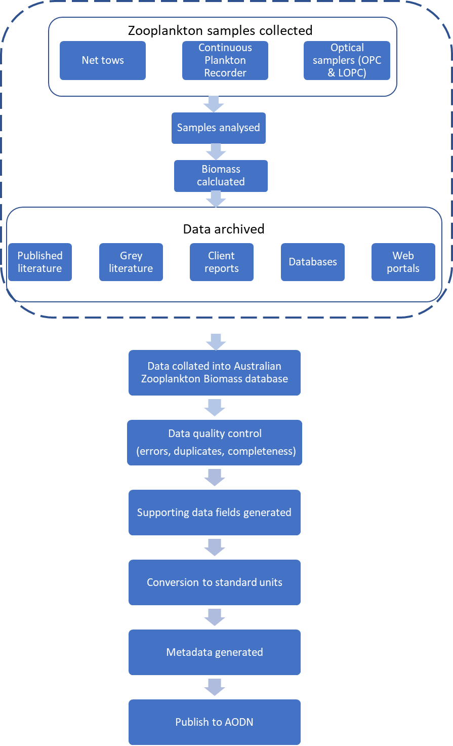

Figure 1. Flow diagram showing process of data enter into biomass database

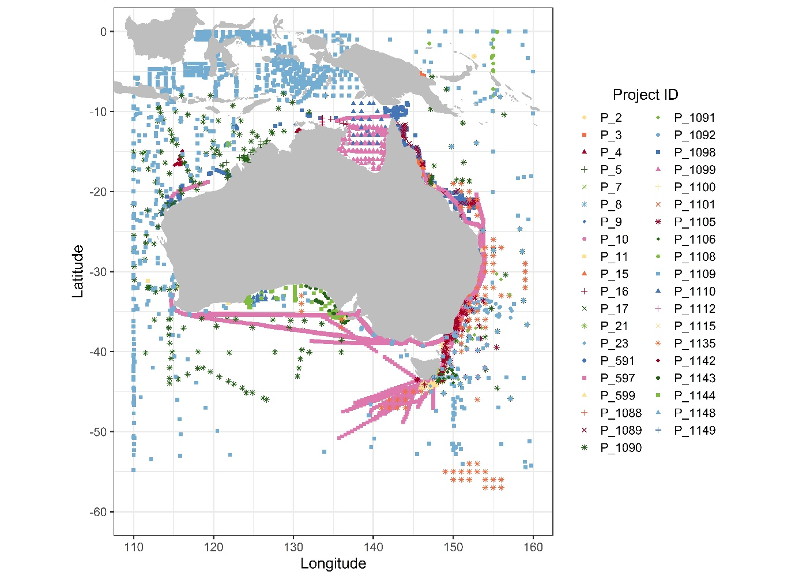
Figure 2. Sampling locations mapped by Project, see Table 1 for project details using project id.

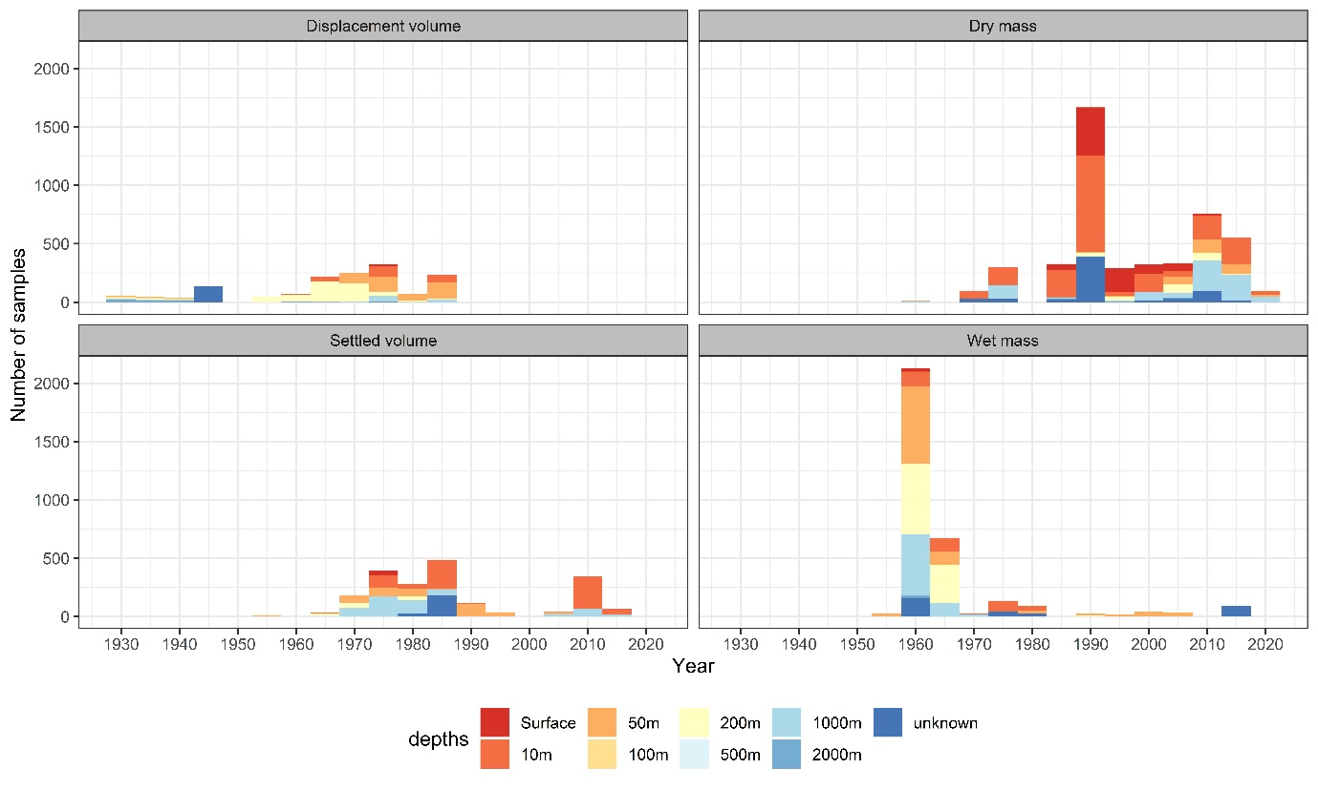Figure 3. Histogram of the number of samples over the collection period for each biomass collection method showning sampling depth distribution

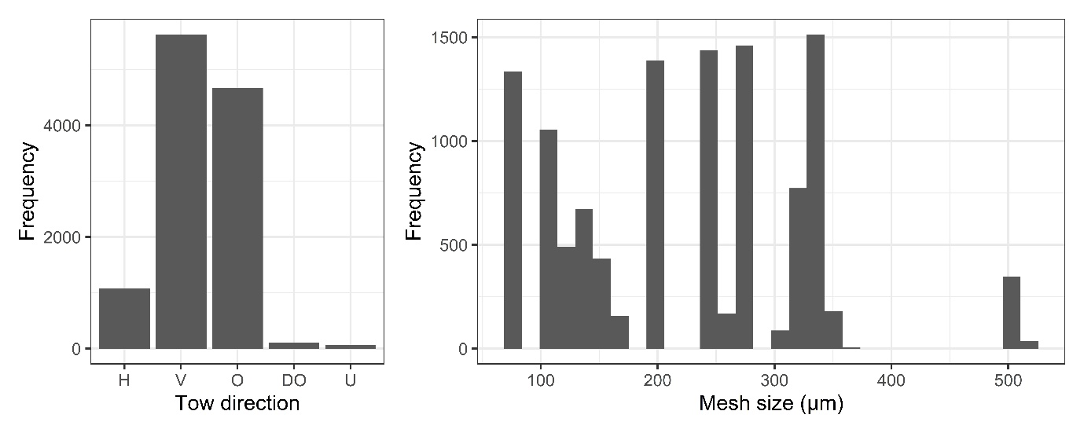

Figure 4. Histograms showing the frequency of the net towed direction (A) and the range of net mesh sizes used (B), where H = horizontal tow, V = vertical tow, O = oblique tow, DO = double oblique tow and U = tow direction unknown

Table 1. Summary of the project data included in the data set (projects in yellow without citation)
Project ID | Project name | Short name | Custodian name | Custodian affiliation | Acknowledgement | Sampling Location | Project date range | No. records | Citation
P_2 | Lihir effects of mining | Lihir | Anthony Richardson | CSIRO |  | Papua New Guinea | 2006-2006 | 196 | ⁶³
P_3 | Ramu effects of mining | Ramu | Anthony Richardson | CSIRO |  | Papua New Guinea | 2009-2009 | 34 | ⁶⁴
P_4 | Darwin Harbour zooplankton | Darwin | David Mckinnon | AIMS |  | Darwin, Northern Territory, Australia | 2002-2004 | 56 | ⁶⁵
P_5 | Kimberley zooplankton (150 micron) | Kimberley | David Mckinnon | AIMS |  | Kimberley, Western Australia, Australia | 2011-2014 | 264 | ⁶⁶
P_7 | Scott Reef ecosystem processes, zooplankton (100 micron) | Scott100 | David Mckinnon | AIMS |  | Scott Reef, Western Australia, Australia | 2008-2009 | 138 | ⁶⁷
P_8 | Scott Reef ecosystem processes, zooplankton (500 micron) | Scott500 | David Mckinnon | AIMS |  | Scott Reef, Western Australia, Australia | 2009-2009 | 3 | ⁶⁷
P_9 | Bathurst Island | Bathurst | David Mckinnon | AIMS |  | Bathurst Island, Northern Territory, Australia | 2005-2006 | 6 | ⁶⁸
P_10 | Albatross Bay zooplankton | Albatross | Peter Rothlisberg | CSIRO |  | Gulf of Carpentaria, Australia | 1986-1992 | 1540 | ²⁰
P_11 | WA Eddies | WAeddies | Joanna Strzelecki | CSIRO |  | Mid-west coast of Australia | 2003-2003 | 8 | ⁶⁹
P_15 | Zooplankton dynamics in the GBR | GBR | David Mckinnon | AIMS |  | Great Barrier Reef, Queensland, Australia | 2000-2002 | 42 | ⁷⁰
P_16 | Wessels, Arafura Sea | Wessels | David Mckinnon | AIMS |  | Arafura Sea, Australia | 2011-2011 | 11 | ⁷¹
P_17 | North West Cape | Northwest | David Mckinnon | AIMS |  | North West Cape, Western Australia, Australia | 1997-2003 | 172 | ⁷²
P_21 | East coast Tasmania, shelf and near-shelf waters | EastTas | Kerrie Swadling | IMAS |  | Mid- east coast Tasmania, Australia | 1971-1972 | 92 | ⁷³
P_23 | Mid-slope zooplankton south of Tasmania | SouthTas | Kerrie Swadling | IMAS |  | Southern Ocean, south of Tasmania, Australia | 1992-1993 | 4 | ⁷⁴
P_591 | Moreton Bay plankton community dynamics | MoretonBay | Sarah Pausina | UQ | Healthy Waterways ARC LPO883663 | Moreton Bay, Queensland, Australia | 2009-2012 | 89 | ⁷⁵
P_597 | IMOS AusCPR | AusCPR | Anthony Richardson | CSIRO | IMOS | Australia | 2010-2018 | 2163 | ¹²
P_599 | IMOS National Reference Stations | NRS | Anthony Richardson | CSIRO | IMOS | Darwin, Esperance, Kangaroo Island, Maria Island, Ningaloo, North Stradbroke Island, Yongala, Australia | 2008-2018 | 705 | ^{38,76}
P_1088 | Zooplankton of Lady Elliot Island | LadyElliot | Asia Armstrong | UQ | UQ | Lady Elliot Island, Great Barrier Reef, Queensland, Australia | 2014-2014 | 90 | ⁷⁷
P_1089 | Coral Sea Connections | CoralSea | David Mckinnon | AIMS | AIMS | Coral Sea and GBR, Australia | 1987-2005 | 145 | ^{25,78}
P_1090 | CSIRO OCR cruises 1959-62 | CSIRO | CSIRO_literature | CSIRO | CSIRO O&A Data Centre | Australia | 1959-1962 | 389 | ⁷⁹⁻⁸⁸
P_1091 | Derwent Hunter OSL cruises 1960-62 | Derwent60-62 | CSIRO_literature | CSIRO | CSIRO O&A Data Centre | East coast of Australia | 1960-1962 | 171 | ⁸⁹⁻⁹²
P_1092 | Derwent Hunter cruises 1957 | Derwent57 | CSIRO_literature | CSIRO | CSIRO O&A Data Centre | East coast of Australia | 1957 | 44 | ⁹³⁻⁹⁵
P_1098 | Tropical Australia zooplankton (63 micron) 1987-2009 | Tropics | Miles Furnas | AIMS |  | Australia | 1957-1957 | 821 | ⁷⁸
P_1099 | Zooplankton biomass in GOC 1975-77 | GOC | CSIRO O&A Data Centre | CSIRO | CSIRO O&A Data Centre | Gulf of Carpentaria, Australia | 1975-1977 | 300 | ⁹⁶
P_1100 | Southern Surveyor cruises Griffiths | Griffiths | CSIRO O&A Data Centre | CSIRO | CSIRO O&A Data Centre | Australia | 1991-1993 | 104 | ⁹⁷
P_1101 | Inshore GBR waters 1976-78 | InshoreGBR | C.Lonborg | AIMS | AIMS | Great Barrier Reef, Queensland, Australia | 1976-1978 | 177 | ⁹⁸
P_1105 | Tranter zooplankton cruises 1957-63 | Tranter | CSIRO | CSIRO |  | Australia | 1957-1961 | 1043 | ⁹⁹
P_1106 | BIONESS cruises 1992-93 | BIONESS | Jock Young | CSIRO |  | East coast of Australia | 1992-1993 | 82 | ¹⁰⁰
P_1108 | Australian Equatorial JGOFS dataset | JGOFS | CSIRO | CSIRO |  | North coast of Australia | 1992-1993 | 42 | ¹⁰¹
P_1109 | COPEPOD database | COPEPOD | Todd O'Brien | NOAA | COPEPOD NOAA | Australia | 1932-2008 | 3537 | ¹⁰²
P_1110 | GOC & GAB productivity 1965 & 1968 | Motoda | Motoda | Hokkaido University |  | Gulf of Carpentaria & Great Australian Bight, Australia |  | 38 | ¹⁰³
P_1112 | Plankton at Cronulla onshore station | Cronulla | CSIRO | CSIRO |  | East coast of Australia | 1943-1946 | 133 | ¹⁰⁴
P_1115 | Marmion Lagoon zooplankton | Marmion | Joanna Strezlecki | CSIRO |  | Mid-west coast of Australia | 2007-2008 | 38 | ¹⁰⁵
P_1135 | LOPC around Australia | LOPC | Jason Everett & Iain Suthers | UNSW |  | Australia | 2004-2018 | 35358
P_1142 | East Indian Ocean larval research 1987 | IndianOcean | CSIRO | CSIRO |  | East Indian Ocean | 1987-1987 | 302 | ¹⁰⁶
P_1143 | Eastern GAB productivity | GAB | Paul van Ruth | SARDI | SARDI | Great Australian Bight, Australia | 2004-2005 | 39 | ¹⁰⁷
P_1144 | Soela cruises GAB 1980-81 | Soela80-81 | CSIRO | CSIRO |  | Great Australian Bight, Australia | 1980-1981 | 152 | ¹⁰⁸
P_1148 | Storm Bay study 1985-87 | StormBay85-87 | Lesley Clementson | CSIRO |  | Tasmania, Australia | 1985-1988 | 132 | ¹⁰⁹
P_1149 | Zooplankton biomass in Storm Bay | StormBay | Kerrie Swadling & Christine Crawford | IMAS |  | Tasmania, Australia | 2009-2015 | 407 | ¹⁰⁶

Appendix 1 – Datasets sourced from COPEPOD - accessed 2017
copePID | Project name in COPEPOD | Institute in COPEPOD | No. records
au-04001 | Magga Dan, 1959 | Commonwealth Scientific and Industrial Research Organization (CSIRO), Australia | 5
au-05101 | CSIRO Australia, 1959-1963 | Commonwealth Scientific and Industrial Research Organization (CSIRO), Australia | 1099
fr-03004 | L'ORSTOM III, 1958 | Oceanic Lab of the Inst of French Oceania, Noumea - New Caladonia | 6
fr-03103 | CINECA IV - CORINDON - CORiolis-INDONesia, 1981 | Office de la Recherche Scientifique et Technique Outre Mer (ORSTOM), France | 58
id-05101 | IMR Collection,1970-1983 | Institute of Marine Research-Jakata (IMR), Indonesia | 1340
jp-04301 | Hakuho Maru collection, 1979 | Japan Meteorological Agency (JMA ), Japan | 28
jp-05101 | Japanese Antarctic Research Expedition (JARE) database, 1972 - 2008 | National Institute of Polar Research – (NIPR), Japan | 128
jp-05201 | JMA North Pacific Surveys, 1993-2002 | Japan Meteorological Agency (JMA ), Japan | 14
nl-03001 | Snellius II Expedition, 1984-1985 | Netherlands Council of Oceanic Research (NRZ), Netherlands | 264
ru-01003 | Soviet Antarctic Expedition (SAE) - R/V OB 1956-1958 | Arctic and Antarctic Scientific Research Institute (AARI), Zoological Institute Russian Academy of Science, Russia | 12
ru-04102 | Vityaz Indian Ocean Cruises 31 and 33, 1959 | Institute of Oceanology/USSR Academy of Sciences – Vityaz Indian Ocean Cruises | 112
ru-04103 | Vityaz Pacific Ocean Cruises, 1957-1958 | Institute of Oceanology/USSR Academy of Sciences – Vityaz Pacific Ocean Cruises | 32
uk-04102 | Foxton 1956, Discovery Cruises- Volume XXVIII, 1932-1939 | National Institute of Oceanography, United Kingdom | 137
us-01046 | SOSC Gear Study, 1967 | Smithsonian Institution, USA | 45
us-04101 | R/V ELTANIN Cruises 16, 25, 26, 27, 1965-1969 | United States Antarctic Research Project - USAP/USARP, USA | 43
zz-03201 | International Indian Ocean Expedition (IIOE), 1962-1965 | Commonwealth Scientific and Industrial Research Organization (CSIRO), Australia  Japan Meteorological Agency (JMA ), Japan  Institute of Oceanology/USSR Academy of Sciences – Vityaz Indian Ocean Cruises | 213
zz-03301 | Cooperative Study of the Kuroshio and adjacent regions (CSK), 1968 | JMA - Japan Meteorological Agency | 1

Footnote: The “copePID” is a permanent unique identifier to each project data set in COPEPOD . You can instantly access this dataset and associated metadata with the smart hyperlink e.g. au-04001: https://www.st.nmfs.noaa.gov/copepod/data/au-04001/

Endnote citations
1 Schminke, H. K. Entomology for the copepodologist. J. Plankton Res. 29, i149-i162, doi:10.1093/plankt/fbl073 (2007).
2 Le Borgne, R. Equivalences between the measures of biovolumes, dry weight, ashfree dry weight, carbon, nitrogen and phosphorus of the mesozooplankton of the tropical Atlantic. Cahiers O.R.S.T.O.M. (Office de la Recherche Scientifique et Technique Outre-Mer) Serie Oceanographie 13, 179-196 (1975).
3 Corral Estrada, J. Contribucion al conocimiento del plancton de Canarias. Estudio cuantitativo, sistematico y observaciones ecologicas de nos Copépodos epipelagicos en la zona de Santa Cruz de Tenerife en el curso de un ciclo anual. Publnes Fac. Cienc. Madrid, Seccion de Biol., (A) 129 Doct. thesis, University of Madrid, (1970).
4 Lovegrove, T. in Some contemporary studies in marine science (ed H. Barnes) 429-467 (Allen and Unwin, 1966).
5 Harris, R., Wiebe, P., Lenz, J., Skjoldal, H. R. & Huntley, M. ICES zooplankton methodology manual. (Elsevier, 2000).
6 Davies, C. H. et al. Over 75 years of zooplankton data from Australia. Ecology 95, 3229-3229, doi:10.1890/14-0697.1 (2014).
7 Davies, C. H. et al. A database of marine phytoplankton abundance, biomass and species composition in Australian waters (vol 3, 160043, 2016). Scientific Data 3, doi:10.1038/sdata.2016.111 (2016).
8 Davies, C. H. et al. A database of chlorophyll a in Australian waters. Scientific Data 5, doi:10.1038/sdata.2018.18 (2018).
9 Skerratt, J. H. et al. Simulated nutrient and plankton dynamics in the Great Barrier Reef (2011–2016). J. Mar. Syst. 192, 51-74, doi:https://doi.org/10.1016/j.jmarsys.2018.12.006 (2019).
10 Bernardi, D. in A manual on methods for the assessment of secondary productivity in freshwaters (eds J.A Downing & F.H. Rigler) 59-86 (Blackwell Scientific, Oxford, 1984).
11 Omori, M. & Ikeda, T. Methods in marine zooplankton ecology. (Wiley, 1984).
12 Richardson, A. J. et al. Using continuous plankton recorder data. Prog. Oceanogr. 68, 27-74, doi:10.1016/j.pocean.2005.09.011|ISSN 0079-6611 (2006).
13 Everett, J. D. et al. Modeling What We Sample and Sampling What We Model: Challenges for Zooplankton Model Assessment. Frontiers in Marine Science 4, doi:10.3389/fmars.2017.00077 (2017).
14 Herman, A. W., Beanlands, B. & Phillips, E. F. The next generation of Optical Plankton Counter: The Laser-OPC. J. Plankton Res. 26, 1135-1145, doi:10.1093/plankt/fbh095 (2004).
15 Bivand, R. & Lewin-Koh, N. maptools: Tools for Handling Spatial Objects. R package version 0.9-5. https://CRAN.R-project.org/package=maptools. (2019).
16 Amante, C. & Eakins, B. W. ETOPO1 1 Arc-Minute Global Relief Model: Procedures, Data Sources and Analysis. NOAA Technical Memorandum NESDIS. NGDC-24. doi:10.7289/V5C8276M. 19 (NOAA., National Geophysical Data Center, 2009).
17 Pante, E. & Simon-Bouhet, B. marmap: A Package for Importing, Plotting and Analyzing Bathymetric and Topographic Data in R. Plos One 8, doi:10.1371/journal.pone.0073051 (2013).
18 Wiebe, P. H. & Benfield, M. C. From the Hensen net toward four-dimensional biological oceanography. Prog. Oceanogr. 56, 7-136, doi:10.1016/s0079-6611(02)00140-4 (2003).
19 Smith, P. E., Counts, R. C. & Clutter, R. I. Changes in the filtering efficiency of plankton nets due to clogging under tow. Cons. Perm. Int. p. l'Expl. d. l. Mer (1968).
20 Jackson, C. J., Rothlisberg, P. C. & Pendrey, R. C. Role of larval distribution and abundance in overall life-history dynamics: a study of the prawn Penaeus semisulcatus in Albatross Bay, Gulf of Carpentaria, Australia. Mar. Ecol. Prog. Ser. 213, 241-252, doi:10.3354/meps213241 (2001).
21 Hernroth, L. Sampling and filtration efficiency of 2 commonly used plankton nets - A comparative study of the Nansen net and the UNESCO WP-2 net. J. Plankton Res. 9, 719-728, doi:10.1093/plankt/9.4.719 (1987).
22 Verheye, H. M., Richardson, A. J., Hutchings, L., Marska, G. & Gianakouras, D. Long-term trends in the abundance and community structure of coastal zooplankton in the southern Benguela system, 1951-1996. South African Journal of Marine Science-Suid-Afrikaanse Tydskrif Vir Seewetenskap 19, 317-332 (1998).
23 Colton, J. B., Green, J. R., Byron, R. R. & Frisella, J. L. Bongo net retention rates as effected by towing speed and mesh size. Canadian Journal of Fisheries and Aquatic Sciences 37, 606-623, doi:10.1139/f80-077 (1980).
24 Pillar, S. C. A comparison of the performance of four zooplankton samplers. South African Journal of Marine Science, 1-18 (1984).
25 McKinnon, A. D. et al. Zooplankton Growth, Respiration and Grazing on the Australian Margins of the Tropical Indian and Pacific Oceans. PLOS ONE 10, e0140012, doi:10.1371/journal.pone.0140012 (2015).
26 Beers, J. R. Determination of zooplankton biomass. Monogr Oceanogr Methodol No. 4, 35-84 (1976).
27 Postel, L., Fock, H. & Hagen, W. in ICES zooplankton methodology manual (eds Roger Harris et al.) 83-192 (Elsevier, 2000).
28 Motoda, S. Plankton sampler for collecting uncontaminated materials from several zones by a single vertical haul. Rapp. Proc.-verb. Réun. Cons. perm. int. Mer., 153, 55-58 (1962).
29 Motoda, S. & Osawa, K. Filteration ratio, variance of samples and estimated distance of haul in vertical hauls with Indian Ocean standard net. Inf. Bull. Planktol. Japan 11, 11-24 (1964).
30 Wiebe, P. H., Boyd, S. & Cox, J. L. Relationships between zooplankton displacement volume, wet weight, dry weight, and carbon. Fishery Bulletin US 73, 777-796 (1975).
31 Wiebe, P. H. Functional regression equations for zooplankton displacement volume, wet weight, dry weight, and carbon: a correction. U S Fish Wildl Serv Fish Bull 86, 833-835 (1988).
32 Moriarty, R. & O'Brien, T. D. Distribution of mesozooplankton biomass in the global ocean. Earth System Science Data 5, 45-55, doi:10.5194/essd-5-45-2013 (2013).
33 Omori, M. Some factors affecting on dry-weight, organic weight and concentrations of carbon and nitrogen in freshlt prepared and in preserved zooplankton. Int. Rev. Gesamt. Hydrobiol. 63, 261-269, doi:10.1002/iroh.19780630211 (1978).
34 Balvay, P. G. Equivalence entre quelques paramètres estimatifs de l'abondance du zooplancton total. Swiss Journal of Hydrology 49, 75-84, doi:10.1007/BF02540381 (1987).
35 Tranter, D. J. Comparison of zooplankton biomass determinations by Indian Ocean Standard Net, Juday Net and Clarke-Bumpus sampler. Nature 198, 1179, doi:10.1038/1981179a0 (1963).
36 DeVries, D. R. & Stein, R. A. Comparison of three zooplankton samplers: a taxon-specific assessment. J. Plankton Res. 13, 53-59, doi:10.1093/plankt/13.1.53 (1991).
37 Skjoldal, H. R. et al. Intercomparison of zooplankton (net) sampling systems: Results from the ICES/GLOBEC sea-going workshop. Prog. Oceanogr. 108, 1-42, doi:10.1016/j.pocean.2012.10.006 (2013).
38 Eriksen, R. S. et al. Australia’s Long-Term Plankton Observations: The Integrated Marine Observing System National Reference Station Network. Frontiers in Marine Science 6, doi:10.3389/fmars.2019.00161 (2019).
39 O’Brien, T. D. COPEPOD: The Global Plankton Database. An overview of the 2014 database contents, processing methods, and access interface. U.S. Dep. Commerce, NOAA Tech. Memo., NMFS-F/ST-37. 29 p. (2014).
40 O’Brien, T. D. COPEPOD: The Global Plankton Database. An overview of the 2010 database contents, processing methods, and access interface. U.S. Dep. Commerce, NOAA Tech. Memo., NMFS-F/ST-36. 28 p. (2010).
41 O’Brien, T. D. COPEPOD: The Global Plankton Database. A review of the 2007 database contents and new quality control methodology. U.S. Dep. Commerce, NOAA Tech. Memo., NMFS-F/ST-34. 28 p. (2007).
42 O’Brien, T. D. COPEPOD: A Global Plankton Database. U.S. Dep. Commerce, NOAA Tech. Memo. NMFS-F/SPO-73. 136 p. (2002).
43 O'Brien, T. D., Wiebe, P. H. & Falkenhaug, T. ICES Zooplankton Status Report 2010/2011. 208 (2013).
44 Clark, R. A., Frid, C. L. J. & Batten, S. A critical comparison of two long-term zooplankton time series from the central-west North Sea. J. Plankton Res. 23, 27-39 (2001).
45 John, E. H., Batten, S. D., Harris, R. P. & Hays, G. C. Comparison between zooplankton data collected by the Continuous Plankton Recorder survey in the English Channel and by WP-2 nets at station L4, Plymouth (UK). Journal of Sea Research 46, 223-232 (2001).
46 Pitois, S. G. & Fox, C. J. Long-term changes in zooplankton biomass concentration and mean size over the Northwest European shelf inferred from Continuous Plankton Recorder data. ICES J. Mar. Sci. 63, 785-798, doi:10.1016/j.iccsjms.2006.03.009 (2006).
47 Richardson, A. J., John, E. H., Irigoien, X., Harris, R. P. & Hays, G. C. How well does the continuous plankton recorder (CPR) sample zooplankton? A comparison with the Longhurst Hardy Plankton Recorder (LHPR) in the northeast Atlantic. Deep-Sea Research Part I-Oceanographic Research Papers 51, 1283-1294, doi:10.1016/j.dsr.2004.04.002|ISSN 0967-0637 (2004).
48 Herman, A. W. Design and calibration of a new optical plankton counter capable of sizing small zooplankton. Deep Sea Research Part A. Oceanographic Research Papers 39, 395-415, doi:https://doi.org/10.1016/0198-0149(92)90080-D (1992).
49 Espinasse, B. et al. Conditions for assessing zooplankton abundance with LOPC in coastal waters. Prog. Oceanogr. 163, 260-270, doi:https://doi.org/10.1016/j.pocean.2017.10.012 (2018).
50 Brady, G. S. Report on the Copepoda collected by H. M. S. 'Challenger' during the years 1873-76. Rep. Sci. Results, Voy. of H. M. S. "Challenger," Zool. viii, 1-142 (1883).
51 Knox, G. A. & Knox, G. A. Biology of the Southern Ocean. Second edition. (2007).
52 Scott, A. The Copepoda of the Siboga Expedition, Part I. Free swimming, littoral and semi-parasitic Copepoda. Uitkomsten op zool., botan., ocean., geol. gebied, verzameld, in Ned. Indie, 1899-1900, aan boord H.M. Siboga, onder commando van Lt. t-z Ic Kl. G. F. Tydeman, uitge-geven door Max Weber. Resultats des explorations zool., botan., ocean., geol. entreprises a bord du Siboga sous le commandement de G. F. Tydeman, publies par Max Weber. Siboga expeditie. 29a, 323 p. (1909).
53 Farran, G. P. Crustacea, Part X. Copepoda. Natural History Report 8 no. 3. ( London (Trustees Brit. Mus.), 1929).
54 Brady, G. S. Copepoda : in Scientific Reports. Australian Antarctic Expedition 1911-1914 Ser C 5, pp. 1-48 (1918).
55 Russell, F. S. & Colman, J. S. Great Barrier Reef expedition 1928-1929. The zooplankton I. Gear, methods and station list. 2-35 (The Bristish Museum, London, 1931).
56 Marshall, S. M. The production of microplankton in the Great Barrier Reef region. Sci. Rpts. Gt. Barrier Reef Exped. London 1928-29 2, pp. 111-157 (1933).
57 Jesperson, P. Quantative investigation of the distribution of the macroplankton in different oceanic regions. Rep. "Dana" Exped. 2, 1-44 (1935).
58 Sheard, K. Plankton of the Australian-Antarctic quadrant. Rep. BANZ Antarct. Res. Exped.. ser. B 6, 1-120 (1947).
59 Dakin, W. J. & Colefax, A. The marine plankton of the coastal waters of New South Wales. I. The chief planktonic forms and their seasonal distribution. Proc. Linn. Soc. N.S.W. 58, pp. 186-222 (1933).
60 Dakin, W. J. & Colefax, A. The plankton of the Australian coastal waters off New South Wales Part I. Publications of the University of Sydney, 210 (1940).
61 Thompson, H. Pelagic Tunicates in the plankton of South-eastern Australian Waters, and their place in Oceanographic studies. Bulletin Council for Scientific and Industrial Research Australia 153, pp. 1-51 (1942).
62 Foxton, P. The distribution of the standing crop of zooplankton in the Southern Ocean. Discovery Reports 28, 191-236 (1956).
63 Brewer, D. T. et al. Impacts of gold mine waste disposal on a tropical pelagic ecosystem. Mar. Pollut. Bull. 64, 2790-2806, doi:10.1016/j.marpolbul.2012.09.009 (2012).
64 Dennis, D. et al. Baseline assessment of the status of the tropical marine benthic and pelagic communities adjacent to and distant from the nickel/cobalt refinery site at Basamuk, PNG. Final Report for Ramu NiCo Management Ltd.Commericial-in-confidence., 208 (CSIRO Marine and Atmospheric Research, Australia, 2009).
65 Duggan, S., McKinnon, A. D. & Carleton, J. H. Zooplankton in an Australian tropical estuary. Estuar Coasts 31, 455-467 (2008).
66 McKinnon, A. D., Duggan, S., Holliday, D. & Brinkman, R. Plankton community structure and connectivity in the Kimberley-Browse region of NW Australia. Estuar Coast Shelf S 153, 156-167, doi:10.1016/j.ecss.2014.11.006 (2015).
67 McKinnon, A. D., Duggan, S., Boettger-Schnack, R., Gusmaoa, L. F. M. & O'Leary, R. A. Depth structuring of pelagic copepod biodiversity in waters adjacent to an Eastern Indian Ocean coral reef. J. Nat. Hist. 47, 639-665 (2013).
68 McKinnon, A. D. Planning tools for environmentally sustainable tropical finfish cage culture in Indonesia and northern Australia. Final Report, ACIAR Project FIS 2003/027. Australian Centre for International Agricultural Research, Canberra. (2009).
69 Strzelecki, J., Koslow, J. A. & Waite, A. Comparison of mesozooplankton communities from a pair of warm- and cold-core eddies off the coast of Western Australia. Deep-Sea Research Part II-Topical Studies in Oceanography 54, 1103-1112, doi:10.1016/j.dsr2.2007.02.004 (2007).
70 Mckinnon, A. D., Duggan, S. & De'ath, G. Mesozooplankton dynamics in nearshore waters of the Great Barrier Reef. Estuarine, Coastal and Shelf Science 63, 497-511, doi:10.1016/j.ecss.2004.12.011 (2005).
71 AIMS. Biological Oceanographic Reconnaissance of the Arafura Sea. https://apps.aims.gov.au/metadata/view/7b5b2d16-052e-054a098-a392-e051a835e64746 (Australia, 2019).
72 McKinnon, A. D. & Duggan, S. Summer copepod production in subtropical waters adjacent to Australia's North West Cape. Mar Biol (Berl) 143, 897-907, doi:10.1007/s00227-003-1153-1 (2003).
73 Taw, N. Studies on the zooplankton and hydrology of south-eastern coastal waters of Tasmania. PHD Thesis PHD thesis, University of Tasmania, (1975).
74 Terauds, A. in Tasmanian Slope Trophodynamics: Final Report. FRDC Project 91/7 (ed J. Parslow, Koslow, J.A., Griffiths, F.B., Clementson, L., Rathbone, C., Bonham, P., McKenzie, D.) 213 (CSIRO Division of Fisheries, 1995).
75 Pausina, S. et al. in Moreton Bay Quandamooka & Catchment: Past, present and future. (ed Rothlisberg P.C. Tibbetts I.R., Neil D.T., Homburg T.A., Brewer D.T., Arthington A.H.) Ch. Pausina S, Greenwood J, Pitt K, Rissik D, Rochester W, Skerratt J, Uribe-Palomino J, Richardson AJ (2019) Zooplankton of Moreton Bay. In: Tibbetts IR, Rothlisberg PC, Neil DT, Homburg TA, Brewer DT, Arthington AH (Eds) Moreton Bay Quandamooka & Catchment: Past, present and future. The Moreton Bay Foundation. Brisbane, Australia. , pp. 335-360 (The Moreton Bay Foundation, 2019).
76 Lynch, T. P. et al. in Oceans 2008, Vols 1-4 Oceans-Ieee 367-374 (Ieee, 2008).
77 Armstrong, A. O. et al. Prey Density Threshold and Tidal Influence on Reef Manta Ray Foraging at an Aggregation Site on the Great Barrier Reef. Plos One 11, doi:10.1371/journal.pone.0153393 (2016).
78 Furnas, M. J., Mitchell, A. W., Gilmartin, M. & Revelante, N. Phytoplankton biomass and primary production in semi-enclosed reef lagoons of the central Great Barrier Reef, Australia. Coral Reefs 9, 1-10, doi:10.1007/bf00686716 (1990).
79 CSIRO. Oceanographical observations in the Indian Ocean in 1959. H.M.A.S. Diamantina cruises Dm1/59 and Dm2/59. Oceanographical Cruise Report 1. Division of Fisheries and Oceanography. CSIRO Australia. (1962).
80 CSIRO. Oceanographical observations in the Indian Ocean in 1960. H.M.A.S. Diamantina cruise Dm1/60. Oceanographical Cruise Report 2. Division of Fisheries and Oceanography. CSIRO Australia. (1962).
81 CSIRO. Oceanographical observations in the Indian Ocean in 1961. H.M.A.S. Diamantina cruise Dm2/61. Oceanographical Cruise Report 9. Division of Fisheries and Oceanography. CSIRO Australia. (1963).
82 CSIRO. Oceanographical observations in the Indian Ocean in 1961. H.M.A.S. Diamantina cruise Dm1/61. Oceanographical Cruise Report 7. Division of Fisheries and Oceanography. CSIRO Australia. (1963).
83 CSIRO. Oceanographical observations in the Indian Ocean in 1960. H.M.A.S. Diamantina cruise Dm2/60. Oceanographical Cruise Report 3. Division of Fisheries and Oceanography. CSIRO Australia. (1963).
84 CSIRO. Oceanographical observations in the Indian Ocean in 1961. H.M.A.S. Diamantina cruise Dm3/61. Oceanographical Cruise Report 11. Division of Fisheries and Oceanography. CSIRO Australia. (1964).
85 CSIRO. Oceanographical observations in the Pacific Ocean in 1960. H.M.A.S. Gascoyne cruises G1/60 and G2/60. Oceanographical Cruise Report 5. Division of Fisheries and Oceanography. CSIRO Australia. (1962).
86 CSIRO. Oceanographical observations in the Pacific Ocean in 1961. H.M.A.S. Gascoyne cruise G1/61. Oceanographical Cruise Report 8. Division of Fisheries and Oceanography. CSIRO Australia. (1963).
87 CSIRO. Oceanographical observations in the Pacific Ocean in 1961. H.M.A.S. Gascoyne cruise G4/61. Oceanographical Cruise Report 12. Division of Fisheries and Oceanography. CSIRO Australia. (CSIRO Division of Fisheries and Oceanography, 1967).
88 CSIRO. Oceanographical observations in the Pacific Ocean in 1962. H.M.A.S. Gascoyne cruise G1/62. Oceanographical Cruise Report 13. Division of Fisheries and Oceanography. CSIRO Australia. (1967).
89 Crooks, A. D. Coastal hydrological investigations in the New South Wales tuna fishing area, 1960. Oceanographical Station List. Volume 53. CSIRO Division of Fisheries. CSIRO Australia. (1963).
90 CSIRO. Investigations by F.R.V. Derwent Hunter on the eastern Australian tuna grounds in 1961. Oceanographical Station List. Volume 54. CSIRO Division of Fisheries. CSIRO Australia. (1968).
91 CSIRO. Investigations by F.R.V. Derwent Hunter on the eastern Australian tuna grounds in 1962. Oceanographical Station List. Volume 59. CSIRO Division of Fisheries. CSIRO Australia. (CSIRO Division of Fisheries and Oceanography, 1968).
92 CSIRO. Coastal investigations at Port Hacking, New South Wales, 1961. Oceanographical Station List. Volume 81. CSIRO Division of Fisheries. CSIRO Australia. (1961).
93 CSIRO. F.R.V. "Derwent Hunter". Scientific report of Cruises 13/57-16/57. Report. Division of Fisheries and Oceanography, 21., (CSIRO Australia, 1959).
94 CSIRO. F.R.V. Derwent Hunter. Scientific report of Cruises 5/57-8/57. Report of Division of Fisheries and Oceanography 19., (CSIRO Division of Fisheries and Oceanography, 1958).
95 CSIRO. F.R.V. Derwent Hunter. Scientific report of Cruises DH 9/57-12/57. Report of Division of Fisheries and Oceanography 20., (1959).
96 Rothlisberg, P. C. & Jackson, C. J. Temporal & spatial variation of plankton abundance in the Gulf of Carpentaria, Australia 1975-1977. J. Plankton Res. 4, 19-40, doi:10.1093/plankt/4.1.19 (1982).
97 CSIRO. RV Southern Surveyor dropnet data files: C2012/7164, C2012/7171, C2012/7166. (CSIRO Oceans & Atmosphere DataCentre, Australia, 2012).
98 Ikeda, T. et al. Biological, chemical and physical observations in inshore waters of the Great Barrier Reef, North Queensland 1975-1978. AIMS Technical Bulletin AIMS-OS-80-1. 56 (1980).
99 Tranter, D. J. Zooplankton abundance in Australasian waters. Australian Jour Mar and Freshwater Res 13, 106-142 (1962).
100 Young, J. W., Bradford, R. W., Lamb, T. D. & Lyne, V. D. Biomass of zooplankton and micronekton in the southern bluefin tuna fishing grounds off eastern Tasmania, Australia. Mar. Ecol. Prog. Ser. 138, 1-14 (1996).
101 CSIRO. Australian Equatorial JGOFS Dataset. CSIRO Division of Marine Research, <http://www.marine.csiro.au/datacentre/JGOFSweb/inventory/index.htm> (2000).
102 COPEPOD. COPEPOD: the global plankton database (2018). NOAA, <http://www.st.nmfs.noaa.gov/copepod/> (2018).
103 Motoda, S., Kawamura, T. & Taniguchi, A. Differences in productivities between the Great Australian Bight and the Gulf of Carpentaria, in summer. Mar Biol (Berl) 46, 93-99, doi:10.1007/bf00391524 (1978).
104 Sheard, K. Plankton characteristics at the Cronulla Onshore Station, New South Wales 1943-46. Bull. Commonw. Sci. industr. Res. Organ. Aust. No. 246, pp. 1-23 (1949).
105 Thompson, P., Lourey, M., Strzelecki, J., Wild-Allen, K. & McLaughlin, J. in Final report. Southwest Australian Coastal Biogeochemistry (ed J. Keesing) (CSIRO, 2011).
106 Davis, T. L. O. & Clementson, L. A. Data report on the vertical and horizontal distribution of tuna larvae in the east Indian Ocean, January-February 1987. Aust C S I R O Mar Lab Rep, 1-39 (1990).
107 van Ruth, P. D. Spatial and temporal variation in primary and secondary productivity in the easten Great Australian Bight Phd thesis, University of Adelaide, (2009).
108 Stevens, J. D., Hausfeld, H. F. & Davenport, S. R. Observations on the biology, distribution and abundance of Trachurus declivis, Sardinops neopilchardus and Scomber australasicus in the Great Australian Bight. 27 (1984).
109 Clementson, L. A., Harris, G. P., Griffiths, F. B. & Rimmer, D. W. Seasonal and inter-annual variability in chemical and biological parameters in Storm Bay, Tasmania. 1. Physics, chemistry and the biomass of components of the food chain. Aust. J. Mar. Freshw. Res. 40, 25-38 (1989).

