**State and Trend Assessment: Secondary production (zooplankton)**

Richardson AJ1,2, Everett JD1,2,3, Davies CH4, Rochester W2

1 Centre for Applications in Natural Resource Mathematics, School of Mathematics and Physics, The University of Queensland, St Lucia, QLD, 4072, Australia

2CSIRO Oceans and Atmosphere, Queensland Biosciences Precinct, St Lucia, QLD, 4067, Australia

3 School of Biological, Earth and Environmental Science, University of NSW, Sydney, NSW, 2052, Australia.

4CSIRO Oceans and Atmosphere, GPO Box 1538, Hobart, TAS, 7001, Australia

*Name and contact details for two independent reviewers of this assessment.*

Iain Suthers (UNSW) – I.Suthers@unsw.edu.au

Kerrie Swadling (UTas) – [K.Swadling@utas.edu.au](mailto:K.Swadling@utas.edu.au)

**Main text** *(500 words, 1 table and 1 figure or 2 figures)*

**1. Description of species/habitat/community/process (incl. spatial area of relevance)**

Secondary production in the ocean is the generation of biomass by zooplankton – the primary consumers of phytoplankton. The most common zooplankton, the copepods, are the most abundant animals on Earth, even outnumbering insects (Schminke 2006). Zooplankton are important components of the biological pump, shunting carbon from surface to deeper waters through sinking of faeces and carcasses (Turner 2015). The recruitment of fish and the carrying capacity of marine ecosystems – the mass of fish, squid, shellfish, marine mammals, seabirds and sea turtles – is regulated by secondary production (Bakun 2006). Productivity hotspots (e.g. Eden and Bonney upwelling zones) have high densities of zooplankton, sustaining invertebrates, fish and whales alike (Gill 2002).

**2. Pressures/issues of importance**

In coastal areas, zooplankton can be influenced by eutrophication (Uye 1994), but over large regions, climate change is likely to be the major pressure (Richardson & Schoeman 2004). Fishing and its influence on the biomass of fish can reduce the biomass of zooplankton through top-down control (Cury et al. 2000), but this is probably also rare over large regions (Richardson & Schoeman 2004).

**3. Current state and recent trend (2016-2021) of species/ habitat/ community/ process (refer to the key to grades for state, trend provided for consistency of language)**

Although primary production can be measured from satellite, secondary production cannot, so it needs to be measured in-water. The best data for secondary production around Australia are the zooplankton data from the IMOS National Reference Stations and the Australian Continuous Plankton Recorder (AusCPR) Survey.

Based on data from the IMOS NRS, all Coastal areas showed an increase in zooplankton over the past decade, with four of the seven stations exhibiting statistically significant increases (Fig. 1). CPR data from Offshore areas generally agreed, with statistically significant increases in zooplankton abundance in three of four bioregions (Fig. 1). The underlying cause/s of this likely increase in zooplankton abundance over the time-series – and the general increase in zooplankton since the last SoE report – is unknown.

We also examined the response of copepod diversity (the Shannon Index), the most abundant zooplankton group and one that is relatively easy to identify to species (Fig. 2). There are mixed signals in the copepod diversity data, with some Coastal Areas/Bioregions declining, others increasing, and others showing no change. With no consistent trend, there is little evidence suggesting a decline in copepod diversity.

**4. Resilience**

Zooplankton are generally more resilient to human pressures than higher trophic levels. Although humans have spread zooplankton species from their native ranges (e.g. into Port Phillip Bay, Hewitt et al. 2004), there is currently no holozooplankton (i.e. species that live their entire life free-floating) that are on the IUCN red list. However, the impact of warming on thermal niches of zooplankton could lead to rapid regime shifts (Beaugrand 2015), and changes in the abundance and diversity of zooplankton could be lead indicators of mass extinction events (Sheets et al. 2016).

**5. Main uncertainties and knowledge gaps associated with providing an assessment of current state and recent trend**

The analysis here is based on IMOS data from only seven coastal stations and a limited number of CPR routes, representing a relatively small proportion of the Australian region. We have also assumed that zooplankton abundance is an index of secondary production. In reality, secondary production is the product of biomass and growth, although Huntley & Lopez (1992) argue that biomass is the best proxy for secondary production because biomass varies much more in the ocean than does growth. Using zooplankton abundance or biomass gives no information of the changes in community composition, but a stable diversity index may indicate that the composition is not changing significantly.

**6. Pressures/issues of importance and associated management**

There is scope for local management interventions in coastal bays (e.g. reducing nutrient inputs into Moreton Bay), but the main driver of large-scale changes in secondary production is climate change. Thus any negative large-scale impacts on zooplankton require mitigation of greenhouse gas emissions.

**7. Outlook**

Secondary production is key to healthy fisheries and ecosystems. Its continued monitoring is important for identifying both abrupt and long-term changes. Once IMOS time series are >20 years long, we will be more confident in distinguishing long-term trends from short-term variability (Poloczanska et al. 2013, Hoegh-Guldberg et al. 2014).

**8. References (not included in 500 word limit)**

Bakun A (1996) Patterns in the ocean: Ocean processes and marine population dynamics. California Sea Grant College System, 323 pp.

Beaugrand, G., 2015. Theoretical basis for predicting climate-induced abrupt shifts in the oceans. Philos Trans R Soc Lond B Biol Sci 370.

Cury, P., Bakun, A., Crawford, R.J.M., Jarre, A., Quiñones, R.A., Shannon, L.J., Verheye, H.M., 2000. Small pelagics in upwelling systems: patterns of interaction and structural changes in “wasp-waist” ecosystems. ICES J Mar Sci 57, 603–618.

Gill PC (2002) A blue whale (*Balaenoptera musculus*) feeding ground in a southern Australian coastal upwelling zone. *Journal of Cetacean Research and Management* 4:179-184.

Hewitt, C.L., Campbell, M.L., Thresher, R.E., Martin, R.B., Boyd, S., Cohen, B.F., Currie, D.R., Gomon, M.F., Keough, M.J., Lewis, J.A., Lockett, M.M., Mays, N., McArthur, M.A., O’Hara, T.D., Poore, G.C.B., Ross, D.J., Storey, M.J., Watson, J.E., Wilson, R.S., 2004. Introduced and cryptogenic species in Port Phillip Bay, Victoria, Australia. Marine Biology 144, 183–202.

Hoegh-Guldberg O, Cai R, Poloczanska ES, Brewer PG, Sundby S, Hilmi K, Fabry VJ, Jung S, and 21 Contributing authors including Richardson AJ (2014) Chapter 30: The Ocean. In: *Climate Change 2014: Impacts, Adaptation, and Vulnerability. Part B: Regional Aspects.* *Contribution of Working Group II to the Fifth Assessment Report of the Intergovernmental Panel on Climate Change* [Barros VR, Field CB, Dokken DJ, Mastrandrea MD, Mach KJ, Bilir TE, Chatterjee M, Ebi KL, Estrada YO, Genova RC, Girma B, Kissel ES, Levy AN, MacCracken S, Mastrandrea PR, White LL (Eds)]. Cambridge University Press, Cambridge, United Kingdom and New York, NY, USA, pp. 1655-1731.

Huntley ME, Lopez MDG (1992) Temperature-dependent production of marine copepods: a global synthesis. *The American Naturalist* 140: 201-242.

Poloczanska ES, Brown CJ, Sydeman WJ, Kiessling W, Moore PJ, Brander K, Bruno JF, Buckley L, Burrows MT, Duarte CM, Halpern BS, Holding J, Kappel CV, O’Connor MI, Pandolfi JM, Parmesan C, Schoeman DS, Schwing F, Thompson SA, Richardson AJ (2013) Global imprint of climate change on marine life. *Nature Climate Change* 3: 919-925. *DOI 10.1038/NCLIMATE1958.* 7 pp.

Richardson AJ, Schoeman DS (2004) Climate impact on plankton ecosystems in the Northeast Atlantic. *Science* 305: 1609-1612.

Schminke HK (2006) Entomology for the copepodologist. *Journal of Plankton Research* **29**, 149-162.

Sheets, H.D., Mitchell, C.E., Melchin, M.J., Loxton, J., Štorch, P., Carlucci, K.L., Hawkins, A.D., 2016. Graptolite community responses to global climate change and the Late Ordovician mass extinction. Proc Natl Acad Sci USA 113, 8380–8385.

Turner JT (2015) Zooplankton fecal pellets, marine snow, phytodetritus and the ocean’s biological pump. *Progress in Oceanography* 130: 205-248.

Uye S-I. 1994. Replacement of large copepods by small ones with eutrophication of embayments; cause and consequence. Hydrobiologia. 292-293(0):513-519.

**9. Table/Figure captions (not included in 500 word limit)**

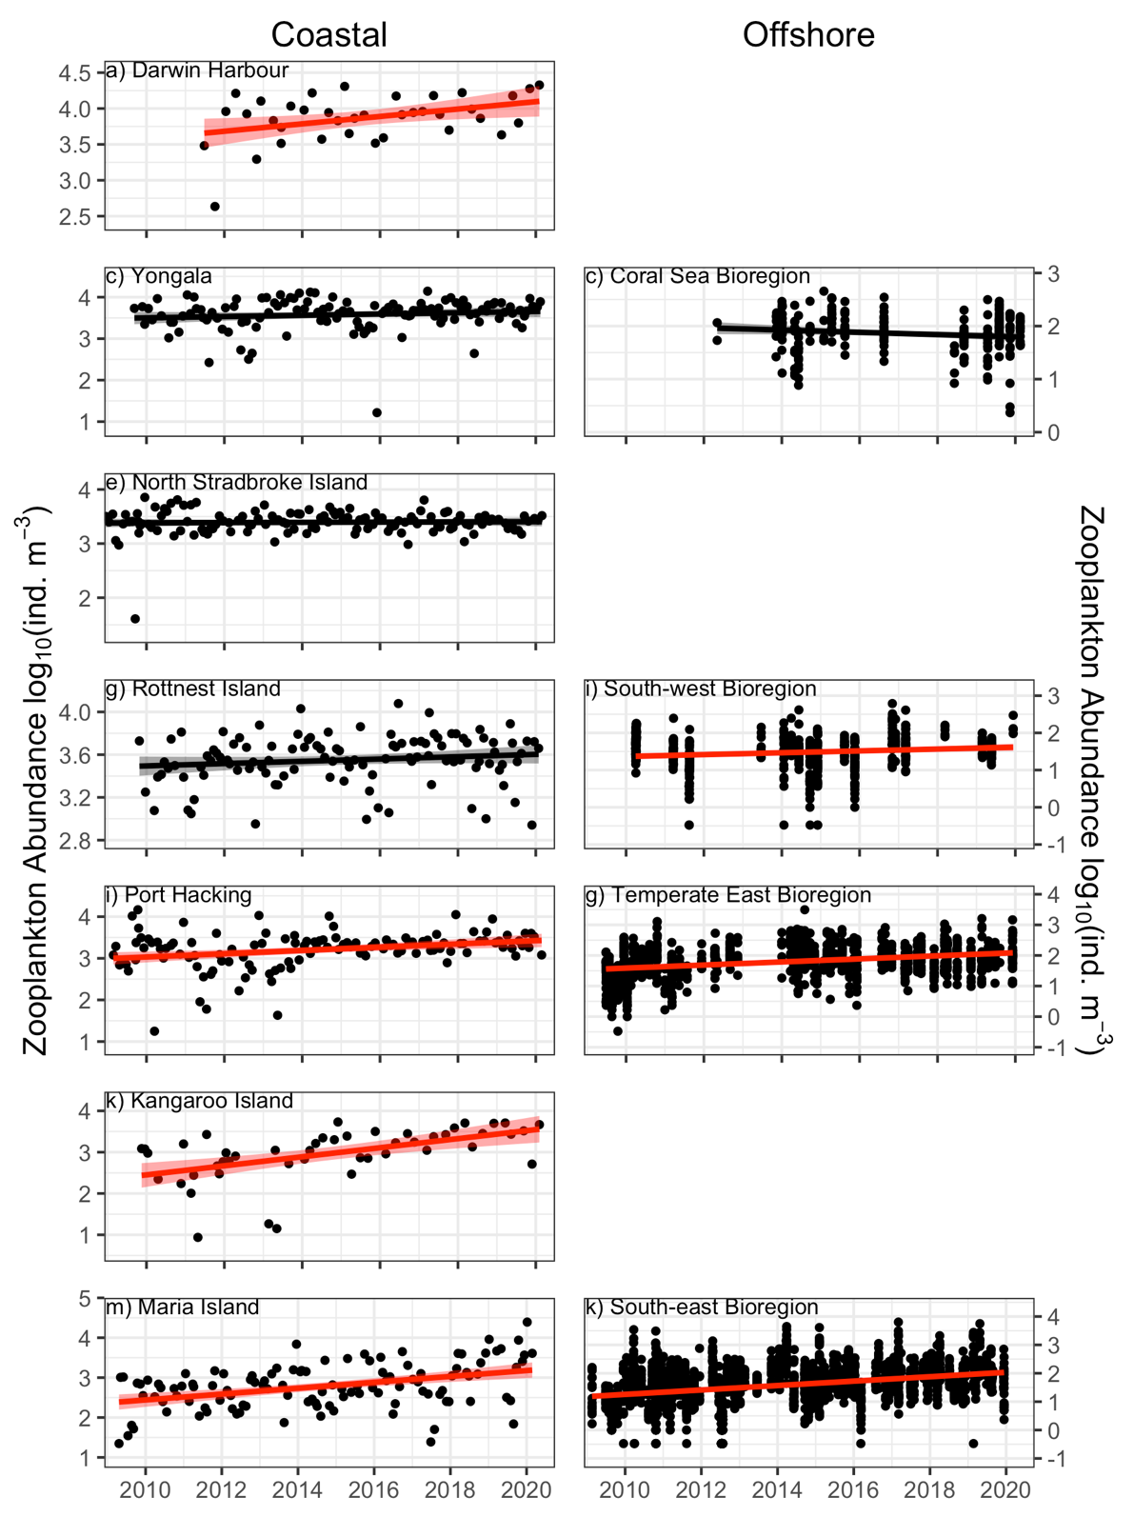

**Figure 1.** Abundance ofzooplankton in coastal (left, IMOS National Reference Stations) and offshore (right, IMOS Australian Continuous Plankton Recorder survey) areas.

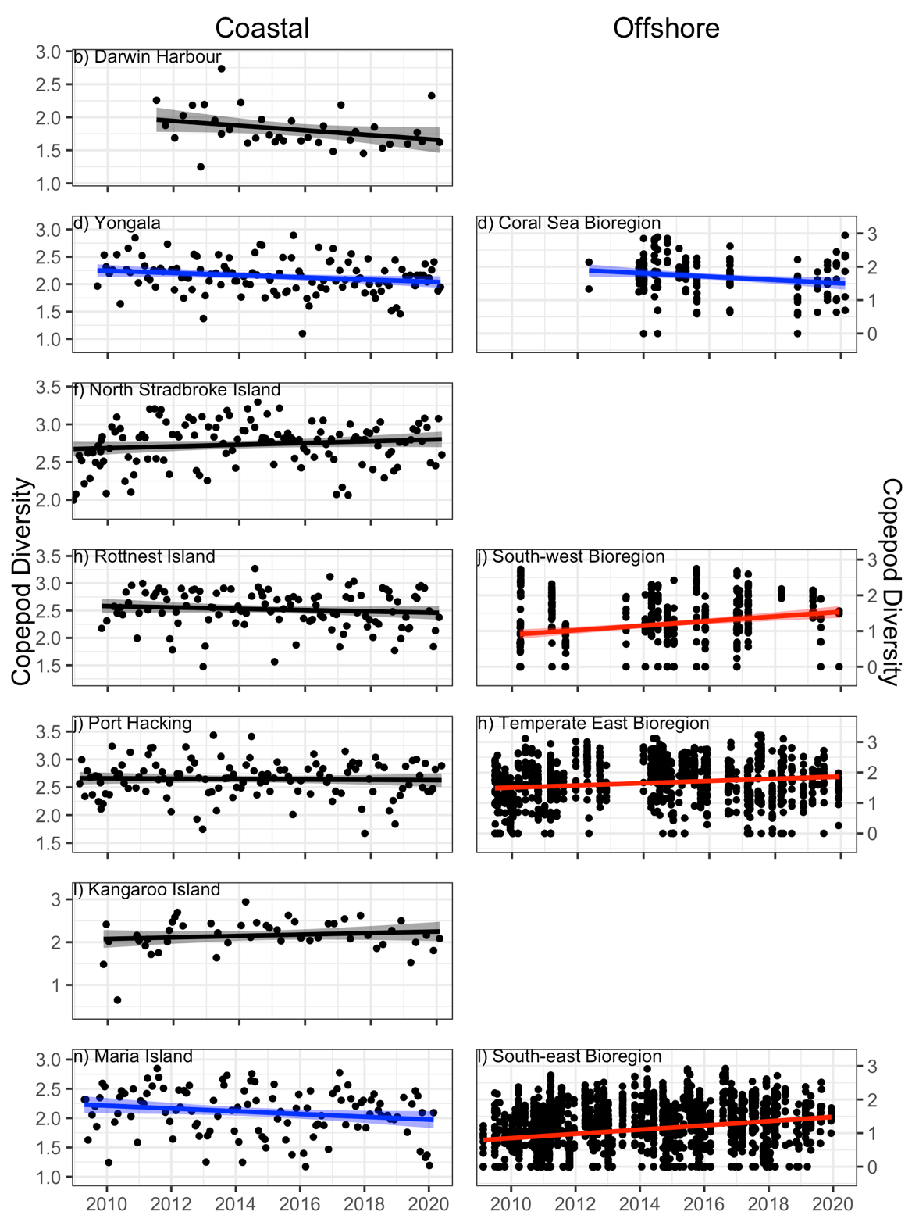

**Figure 2.** Diversity ofzooplankton in coastal (left, IMOS National Reference Stations) and offshore (right, IMOS Australian Continuous Plankton Recorder survey) areas.

*Assessment summary (see example assessment summary and key to grades for state, trend and confidence provided)*

Please include:

1. Proposed state and recent trend and confidence in each (see table below)

See below.

1. Comparability of 2021 assessment to the 2016 assessment (see table below)

See below.

1. A 20-word (strict maximum) explanation for this assessment (e.g. the spatial area the assessment might be restricted to, the current extent of information available for the assessment, particular issues of relevance to the assessment)

We analysed secondary production (zooplankton) in Coastal areas (from nets at IMOS NRS) and Offshore bioregions (from IMOS CPR).

1. The state and trend of each bioregion relative to the national assessment (i.e. is the north/north-east/south-east/south-west/north-west on average in a better/worse state than the national state).

|  |  |  |  |  |  |
| --- | --- | --- | --- | --- | --- |
| Year | Assessment grade | | Confidence | | Comparability with 2016 assessment |
| Grade | Trend | Grade | Trend |
| 2021 | Zooplankton abundance | Improving (increasing trend in zooplankton abundance in most Coastal and Offshore regions. Four of the six bioregions were assessed) | Somewhat adequate | Improving | No trend in zooplankton abundance was detected in the 2016 assessment |
|  | Copepod diversity | Unclear | Limited | Improving | Not assessed |

*Metadata*

Please include details of:

1. Data used in the assessment (incl. spatial and temporal coverage)

We analysed secondary production (zooplankton) data in Coastal areas (from nets at IMOS National Reference Stations, see Eriksen et al. (2019) for detailed methodology) and Offshore bioregions (from the IMOS Australian Continuous Plankton Recorder Survey, see Richardson et al. (2006) for detailed methodology).

1. Quality of data used in the assessment

IMOS data used in this assessment are the only zooplankton time series information available in Australia. Before the introduction of IMOS, no assessment of secondary production was possible. Collecting and counting zooplankton data in IMOS adheres to strict quality control protocols (Eriksen et al. 2019, Batten et al. 2019, Richardson et al. 2006).

1. Custodian and location of data

All zooplankton data were processed by the IMOS National Reference Station and the IMOS Australian Continuous Plankton Recorder facilities. All data are freely available from the AODN (<https://portal.aodn.org.au/>).

1. Method used to determine state or recent trend

For the assessment, we used all available zooplankton data from Coastal areas (from the IMOS National Reference Stations) and Offshore bioregions (from the IMOS Australian Continuous Plankton Recorder Survey). We developed two time series: 1. The abundance of zooplankton based on total sample counts, standardised for sample volume and expressed per m3) (Figure 1); and 2. An index of copepod diversity (copepods are the dominant zooplankton group) using the Shannon diversity index (Figure 2).

Zooplankton abundance and copepod diversity were used as response variables in linear models (in R), with Year and Month (to adjust for seasonality and reduce temporal autorocorrelation) as predictors. The trend line in each figure is the slope of the Year term. Following visual assessment of the diagnostic plots of the model, we log10-transformed zooplankton abundance to reduce leverage of outliers and to improve the homogeneity of variance assumption.

1. If the assessment has changed from the 2016 assessment what factors/parameters have contributed to the change and how?

The 2016 assessment based only on IMOS CPR data suggested the trend in zooplankton abundance was stable. The longer IMOS time series now available, together with combined information from both the NRS and AusCPR, have provided more data and greater confidence in the results.

Relevant publications (particularly those published since the 2016 assessment) and links to publications

**Methods for CPR data**

BattenSD, Abu-Alhaija R, ChibaS., Edwards M, Graham G, Jyothibabu R, KitchenerJA, KoubbiP, McQuatters-GollopA, Muxagata E, Ostle C, Richardson AJ, Robinson KV, TakahashiKT, VerheyeHM, Wilson W (2019) A Global Plankton Diversity Monitoring Program. *Frontiers in Marine Science*. June 2019, Vol. 6, Article 321: 14 pp.

**Richardson** **AJ**, Walne AW, John AWG, Jonas TD, Lindley JA, Sims DW, Witt M (2006) Using Continuous Plankton Recorder Data. *Progress in Oceanography* 68: 27-74

**Methods for IMOS NRS data**

Eriksen RS, Bonham P, Davies CH, Coman FE, Edgar S, McEnnulty FR, McLeod D, Miller MJ, RochesterW, Slotwinski A, Tonks ML, Uribe-Palomino J, Richardson AJ (2019) Australia’s Long-term Plankton Observations: The Integrated Marine Observing System National Reference Station Network. *Frontiers in Marine Science* 6: 161. 17 pp.

**Support for zooplankton state and trends observed**

Richardson AJ, Eriksen R, Moltmann T, Hodgson-Johnston I, Wallis JR (2020) State and Trends of Australia’s Ocean Report, Integrated Marine Observing System, Hobart. 164 pp. A total of 27 contributions from 70 authors from 12 institutions. <https://www.imosoceanreport.org.au/>