**Target journal**

Ecological Modelling

**Title**

Resolving global patterns in zooplankton community composition with functional traits

**Authors**

Ryan F. Heneghan1,2*, Jason E. Everett1,3, Patrick Sykes1, Julia L. Blanchard4, Anthony J. Richardson1,5

1 Centre for Applications in Natural Resource Mathematics (CARM), School of Mathematics and Physics, University of Queensland, Brisbane, QLD, Australia

2 Institut de Ciència i Tecnologia Ambientals (ICTA), Universitat Autònoma de Barcelona, Barcelona, Spain

3 School of Biological, Earth and Environmental Sciences, University of New South Wales, Sydney, NSW, Australia

4 Institute of Marine and Antarctic Studies, University of Tasmania, Hobart, TAS, Australia

5 CSIRO Oceans and Atmosphere, Queensland Biosciences Precinct, St Lucia, QLD, Australia

*Corresponding Author: ryan.heneghan@gmail.com

**Keywords**

Zooplankton, functional traits, size spectrum model, marine ecosystem structure

**Highlights**

* A trait-based ecosystem model to resolve broad patterns in the global zooplankton community
* Zooplankton groups represented by body size range, size-based feeding characteristics and carbon content
* Emergent patterns of total zooplankton biomass and maximum growth rates agree well with empirical observations
* Composition of zooplankton changes from low to high productivity waters, reflecting how functional traits give rise to community structure
* Resolving different zooplankton groups has implications for the total biomass of higher trophic levels, highlighting the critical role of zooplankton as the linchpin of the marine ecosystem

**Abstract**

As the main energy pathway between phytoplankton and fish, zooplankton are a critical component of the global marine ecosystem. Despite their central role, the diversity of zooplankton are not typically resolved in marine ecosystem models. However, trait-based approaches – where zooplankton are grouped based on functional traits such as body size – are increasingly being used to explore zooplankton composition across environmental gradients, and are a promising approach to improving our understanding of zooplankton as the linchpin of the marine ecosystem. Here, we present a functional size-spectrum model that resolves nine major zooplankton functional groups (heterotrophic flagellates and ciliates, larvaceans, omnivorous and carnivorous copepods, chaetognaths, euphausiids, salps and jellyfish), with each group represented using the functional traits of body size, size-based feeding characteristics and carbon content. The model is run globally, and zooplankton community composition emerges based on the relative fitness of the different groups. The emergent pattern of zooplankton biomass and growth rates agrees with empirical data and across the global ocean there were changes in zooplankton community composition. In oligotrophic waters larvaceans, salps, carnivorous copepods, chaetognaths and jellyfish were most prevalent, collectively comprising around 80% of zooplankton biomass. In contrast omnivorous copepods and euphausiids dominated in eutrophic regions, together comprising over 90% of zooplankton biomass. Finally, we consider the role of the different zooplankton groups in supporting higher trophic levels, by exploring the sensitivity of total fish biomass to the removal of individual zooplankton groups. For instance, removing larvaceans caused total fish biomass to decrease by up to 30% in oligotrophic waters. In contrast, total fish biomass increased by up to 50% in oligotrophic waters when carnivorous copepods were excluded from the model. In eutrophic waters, the removal of euphausiids or omnivorous copepods caused fish biomass to decrease by over 60%. Our model demonstrates how body size and size-based feeding characteristics are major drivers of both zooplankton community composition and the potential roles of different zooplankton groups in supporting global fish biomass.

# Introduction

Zooplankton are the linchpin of the marine ecosystem, serving as the grazers of phytoplankton and bacteria, and prey of small fish (Mitra *et al.,* 2014). All marine phyla are represented in the zooplankton and this diversity is ubiquitous across the world, with most major groups present in every region of the world’s oceans (O’Brien, 2005; Bucklin *et al.,* 2010). Despite their global presence, the composition of the zooplankton community is not constant, with groups dominating under different biotic and abiotic regimes depending on their relative fitness (Barton *et al.,* 2013). Variation in the zooplankton has implications for how efficiently energy moves through the marine food web from oligotrophic (low primary production) to eutrophic (high primary production) regions, with implications for ecosystem resilience, fisheries catch, and overall productivity (Friedland *et al.,* 2012; Jennings and Collingridge, 2015; Heneghan *et al.,* 2016; Dam and Baumman, 2017). Therefore, resolving the mechanisms that drive shifts in zooplankton community composition across environmental gradients is critical to understanding and predicting how marine ecosystems function.

In current marine ecosystem models, the dynamics of the zooplankton are typically poorly resolved or ignored (Gislason *et al.,* 2014; Mitra *et al.,* 2014), with most models typically using highly idealized representations of zooplankton as: a handful of amorphous boxes that transfer biomass from phytoplankton to fish, as inputs from independent earth system models without feedback from higher trophic levels, or ignored altogether and lumped with phytoplankton or small fish (Everett *et al.,* 2017). The assumption implicit in current ecosystem models not resolving zooplankton is that the dynamics of this group does not affect ecosystem function. This is despite studies demonstrating that the productivity and structure of higher trophic levels is highly sensitive to the representation of lower trophic levels. Mitra *et al.,* (2014) demonstrated that in a modelled plankton food web, trophic dynamics were sensitive to small changes in parameterisation of zooplankton feeding rates. Similarly, Fuchs and Franks (2010) found that zooplankton with high predator-prey mass ratios (PPMR) which ate a narrow size range (feeding kernel) of prey gave rise to a flatter plankton abundance size spectra (relatively more large organisms), in comparison to zooplankton with small PPMRs and a larger feeding kernel, which led to a steeper plankton size spectra. Jennings and Collingridge (2015) demonstrated that the productivity and total biomass of the global fish community was highly sensitive to the trophic transfer efficiency of zooplankton. Finally, Heneghan *et al.,* (2016) used a simple model to illustrate how the size-based feeding characteristics of different zooplankton functional groups leads to changes of up to four orders of magnitude in the total fish biomass that can be sustained by a given phytoplankton community.

The choice to simplify the zooplankton is made by modellers because – among other things - the zooplankton community exhibits tremendous taxonomic diversity. However, an alternative to resolving taxonomic diversity is to model organisms based on functional traits, such as body size, body composition and feeding strategy, since these are factors that determine an organism’s relative fitness (McGill *et al.,* 2006; Litchman *et al.,* 2013; Andersen *et al.,* 2016a; McConville *et al.,* 2017). In the past 15 years, the functional trait-based approach has been applied to explain the distribution of phytoplankton groups (Follows *et al.,* 2007; Edwards *et al.,* 2013; Avevedo-Trejos *et al.,* 2015), and there is a growing literature applying the approach to the challenge of the zooplankton (Fuchs and Franks, 2010; Brun *et al.,* 2016; Schnedler-Meyer *et al.,* 2016; Prowe *et al.,* 2018) and fish communities (Stuart-Smith *et al.,* 2013; van Denderen *et al.,* 2018; Petrik *et al.,* 2019).

Body size is a major trait that determines the trophic position of zooplankton in the marine food web (Andersen *et al.,* 2016a) and the size-based feeding behaviour of different zooplankton groups structures the zooplankton community across oligotrophic and eutrophic systems (Mitra and Davis, 2010; Barton *et al.,* 2013). Zooplankton are the primary grazers of phytoplankton, which span up to nine orders of magnitude in body size – from picoplankton (0.2 - 2 m equivalent spherical diameter, ESD; 10-14.5 – 10-11.5g wet weight) to microplankton (>20 m ESD; >10-8.4 g wet weight) – and the size structure of phytoplankton changes across environmental gradients (Agawin *et al.,* 2000; Brewin *et al.,* 2010; Barnes *et al.,* 2011). Phytoplankton communities in eutrophic coastal and upwelling systems have greater abundance and proportion of microplankton – which translates to a higher intercept and flatter abundance size spectrum slope. In low nutrient oligotrophic systems, phytoplankton is less abundant and dominated by picoplankton (<2 m ESD), with little or no microplankton (>20 m ESD). In terms of the phytoplankton abundance spectrum, this means a lower intercept and a steeper slope. Changes in the size structure of the phytoplankton have implications for the structuring of the zooplankton community, which in turn affects how primary production is transported to higher trophic levels. This is because zooplankton exhibit vast diversity in their feeding behaviour, with preferred predator-prey mass ratios (PPMRs) varying over 7 orders of magnitude across different functional groups, from for carnivorous copepods to for salps and larvaceans (Wirtz, 2012). Coupled with their range of body sizes, from single-cell flagellates, to jellyfish that reach up to 1 tonne (Levinton, 2013), the pathways of energy transfer from phytoplankton to fish could shift markedly with changes in the composition of the zooplankton community from oligotrophic to eutrophic waters.

Similar to the diversity in body size and feeding strategy, zooplankton vary widely in their body composition, between gelatinous and non-gelatinous groups (Kiørboe, 2013; McConville *et al.,* 2017). Carbon is the primary structural component of zooplankton (Kiørboe, 2013), and critical physiological and competitive processes such as metabolism, search rate, and average growth efficiency scale with carbon across zooplankton groups (Acuña *et al.,* 2011; Kiørboe, 2011; Kiørboe and Hirst, 2014; McConville *et al.,* 2017). This means that changes in carbon content affects the relative fitness of different zooplankton groups. Moreover, a zooplankton community dominated by more gelatinous groups offers less nutritional value and growth potential for higher trophic levels. This means that including the carbon content of the different zooplankton is necessary to resolve the implications of changing zooplankton community composition for energy transfer from phytoplankton to fish.

Using functional traits such as body size and PPMR to resolve the diversity of the zooplankton in marine ecosystem models is not an entirely new idea; 25 years ago Hansen *et al.,* (1994) hypothesised that with knowledge of the size selectivity of different zooplankton groups, it would be possible to construct a simple size-based model of the pelagic food web. Here, we use the extensive literature on zooplankton functional traits, and recent developments in functional size-spectrum modelling (Guiet *et al.,* 2016; Blanchard *et al.,* 2017) to develop a model of the marine ecosystem that resolves phytoplankton, nine zooplankton functional groups (heterotrophic flagellates and ciliates, omnivorous and carnivorous copepods, larvaceans, euphausiids, salps, chaetognaths and jellyfish) and fish. The zooplankton functional groups are resolved using their size ranges, size-based feeding characteristics and carbon content. Across the global ocean, the model is initialised with the same zooplankton composition and the zooplankton community structure emerges. Shifts in zooplankton community composition can be explained by the relative fitness of the various groups in different regions of the global ocean, which is driven by their functional traits. The model is able to reproduce global patterns of zooplankton biomass, as well as maximum growth rates from flagellates to fish. By resolving zooplankton functional diversity and resulting shifts in zooplankton community composition, the model allows us to examine the unique roles of different zooplankton groups in supporting higher trophic level biomass. To that end, we finish with a sensitivity analysis of modelled fish biomass to the absence of different zooplankton functional groups, from oligotrophic to eutrophic waters.

# Methods We used the functional size-spectrum framework (Blanchard *et al.,* 2017) to construct a marine ecosystem model that resolves the body size ranges, size-based feeding characteristics and carbon content of nine of the most abundant zooplankton groups and three fish communities. The functional size spectrum model is run across the global ocean, split into 5x5 degree regions (Figure 1). For each region, the model is forced with annual-average satellite sea surface temperature and chlorophyll *a* from MODIS-Aqua (accessed via the GIOVANNI portal: <https://giovanni.gsfc.nasa.gov/giovanni/>).

## **The functional size spectrum model**

We represented the marine size-spectrum as three communities: phytoplankton, zooplankton and fish (Figure 1; Table 1, 2, 3). In keeping with past size-spectrum models, the dynamics of the phytoplankton are not explicitly resolved in the model, with the phytoplankton size-spectrum serving as a static resource for zooplankton (Blanchard *et al.,* 2009; Law *et al.,* 2009; Guiet *et al.,* 2016; Heneghan *et al.,* 2016). Instead, the size structure of the phytoplankton community is estimated directly from satellite chlorophyll *a* observations (Brewin *et al.,* 2010; Barnes *et al.,* 2011; Hirata *et al.,* 2011).

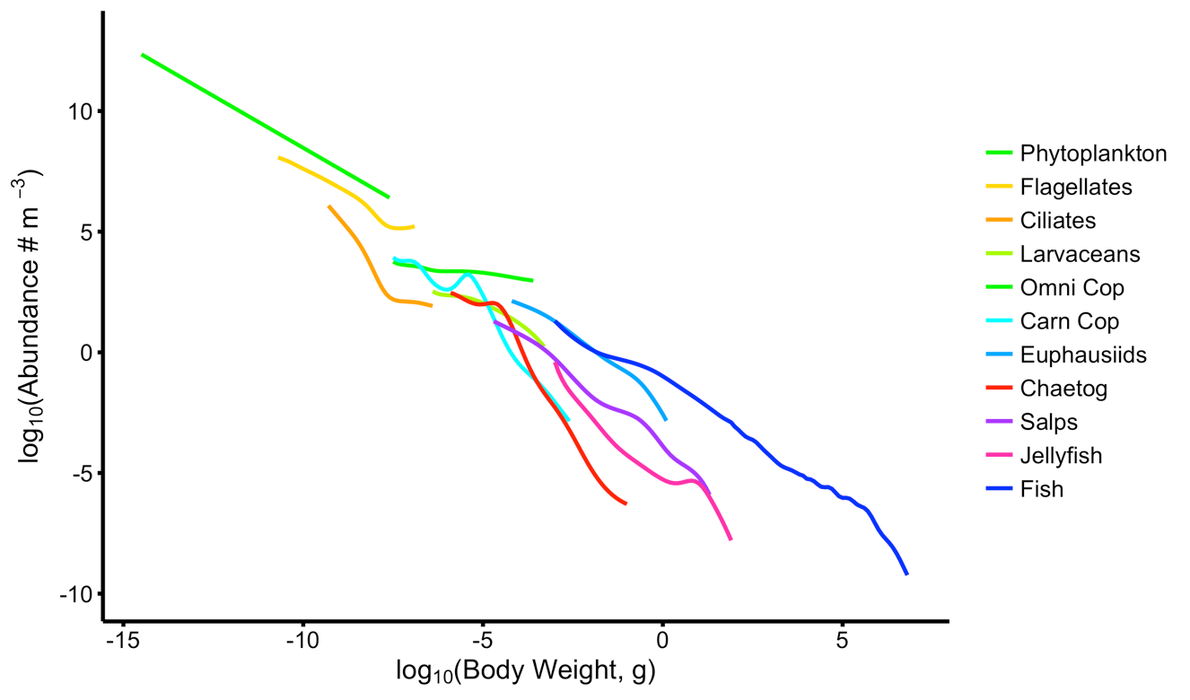

**Figure 1:** The modelled marine size-spectrum from one of the 5x5 degree regions of the global ocean. The phytoplankton spectrum is held constant, and abundances of the zooplankton and fish communities are governed by size-dependent processes of growth and mortality.

The abundances of the zooplankton and fish communities are driven by the size-dependent processes of growth and mortality, with the temporal dynamics of each functional group governed by separate second-order McKendrick-von Foerster equations,

The density of individuals in group of weightat timeper is given by and their individual growth, mortality and diffusion rates are denoted by *,*  and , respectively. We used the MvF equation to govern the dynamics of both fish and zooplankton communities because it is a popular choice for modelling fish-focused size spectrum models, and it is similar to the governing equations in plankton-focused size-based models (Baird and Suthers, 2007; Fuchs and Franks, 2010; Zhou *et al.,* 2010; Ward *et al.,* 2012, Cuesta *et al.,* 2018). Looking ahead, this means that future model developments that resolve the dynamics of the phytoplankton, or more of the functional diversity of the zooplankton could be achieved with the same – or similar - governing equation as what has been employed here.

From the perspective of a predator from group , the feeding rate on prey group *j* depends on the density of suitable prey (g m-3), using a simple type 1 functional response:

where (E9, Table 1; all subsequent equations are also found in Table 1) is the probability a predator of size would consumer an individual of size . The growth rate of a predator from group , of size at time is fuelled by the consumption and conversion of prey biomass to new biomass (g yr-1):

where is the predator’s search rate (E11), is the growth conversion efficiency for predators eating prey from group (E12)and is the effect of temperature on ingestion for group (E3). A type 2 functional response is more commonly used in fish-focused functional size-spectrum models (e.g., Blanchard *et al.,* 2014), however we did not find sufficient information on how maximum consumption scales with body size for the different zooplankton groups in the literature (but see Hansen *et al.,* 1997; Wirtz, 2013; Kiørboe and Hirst, 2014). The main drawback of the type 1 functional response is that it ignores the effect of satiation at high food densities. This means that the growth rates of the zooplankton and fish groups could be unrealistically high in areas with high chlorophyll *a* concentration. However, the effect of high growth rates would be the same across all functional groups, and so would not affect their relative fitness.

Temperature effects are represented using a temperature coefficient:

where and are the temperatures in Kelvin of each 5x5 degree grid square, and the reference temperature where , respectively.

From the perspective of the prey, the total mortality from predation by the larger size classes () is given by:

where is the maximum size of a predator from group . Since individuals grow through time, an additional source of mortality from senescence was incorporated that increased with body size ():

where is the body size after which senescence mortality rapidly increases for an individual from group . This senescence mortality term also acts as a closure term for the largest size classes, by preventing a build-up of large individuals who are not exposed to predation (Andersen *et al.,* 2016b). For an individual of size , at time , from group , total mortality () is given by summing predation and senescence mortality ():

Finally, the second-order diffusion term for an individual from group of size at time is ():

## **Parameterizing the static phytoplankton abundance spectrum**

We split the global ocean into 5x5 degree regions. For each region, the density of phytoplankton of size is given by:

The slope *a*, intercept *b* and maximum size of the static phytoplankton spectrum were derived from temporally and spatially averaged satellite chlorophyll *a* obtained from MODIS-Aqua (accessed via the GIOVANNI portal: https://giovanni.gsfc.nasa.gov/giovanni/), using the synoptic model developed by Brewin *et al.,* (2010). The Brewin model gives an estimate of the percentage contribution of 3 phytoplankton size classes - pico (0.2-2 m ESD), nano (2-20 m ESD) and micro (>20 m ESD) – to the total chlorophyll *a* concentration (mg m-3). Pico-phytoplankton comprise up to 75% of the biomass in low chlorophyll *a* (oligotrophic) waters, declining to less than 10% in high chlorophyll *a* (eutrophic) waters as micro-phytoplankton increase from <10% in oligotrophic waters to over 75% in eutrophic waters, and nano-phytoplankton increase marginally from 20% in oligotrophic to 45% in mid-chlorophyll *a* waters, before declining to around 15% in eutrophic waters (Figure 1 a).

The contribution of micro-phytoplankton, and the phytoplankton community’s maximum size increases with chlorophyll *a* concentration (Brewin *et al.,* 2010; Hirata *et al.,* 2011; Barnes *et al.,* 2011). We incorporated this change in the size range of the micro-phytoplankton with increasing chlorophyll *a* by linearly increasing the maximum size of the micro group from 21 - 60 m ESD, depending on the percentage contribution of the micro group to total chlorophyll *a*. We used 60 m as the maximum possible ESD for the phytoplankton following Barnes et al.’s (2011) finding that 90% of phytoplankton fall below 55-65 m across polar, tropical and upwelling environments. Total chlorophyll *a* concentration for each of the 3 size classes was converted to grams wet weight (assuming 1 g chlorophyll *a* = 50 g C; Zhou *et al.,* 2010, and 1 g C = 10 g wet weight; Hansen *et al.,* 1994, Boudreau & Dickie, 1992, Woodworth-Jefcoats *et al.,* 2013) and the three size ranges were also converted from ESD to grams wet weight (assuming 1 cm3 = 1 g wet weight; Boudreau & Dickie, 1992).

Total biomass in each of the size ranges was then spread uniformly across each size range (Sheldon *et al.,* 1972; Blanchard *et al.,* 2009; Woodworth-Jefcoats *et al.,* 2013; Barange *et al.,* 2014) before being converted to numerical abundance. Finally, slope and intercept were found analytically with E8 (see Appendix 1). The phytoplankton slopes we derived ranged from -1.2 to -0.77 across the global ocean (Figure 2 b), which is similar to the range reported by previous empirical studies (Moreno-Ostos *et al.,* 2015).

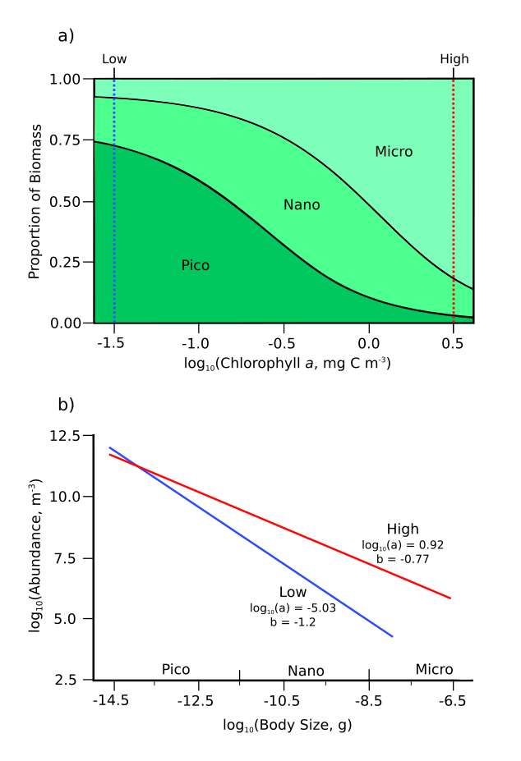

Figure 2 a) Proportion of phytoplankton that is picoplankton ( ESD), nanoplankton ( ESD) and microplankton ( ESD), against log10(Chlorophyll *a),* adapted from Brewin *et al.,* (2010); b) Phytoplankton abundance spectrum at low (10-1.5 g m-3) and high (100.5 g m-3) chlorophyll *a*. The slope *a* and intercept *b* for the two spectra were calculated analytically using satellite chlorophyll *a* from MODIS-Aqua, and the synoptic model from Brewin *et al.,* (2010) (see Appendix 1 for more information).

Table 1 Model equations with their units and in-text reference numbers.

|  |  |  |  |
| --- | --- | --- | --- |
| Description | Equation | Units | Equation Number |
| Growth and mortality: |  |  |  |
| Density of suitable prey from group *j* for group |  |  | E1 |
| Individual growth rate for group |  |  | E2 |
| Temperature effect for group |  | *-* | E3 |
| Individual predation rate |  |  | E4 |
| Senescence mortality |  |  | E5 |
| Total mortality |  |  | E6 |
| Individual diffusion term for group |  |  | E7 |
| Phytoplankton spectrum |  |  | E8 |
| Functional traits: |  |  |  |
| Size selection for group | *=* | - | E9 |
| Feeding kernel width parameter for group |  |  | E10 |
| Search rate for group |  |  | E11 |
| Average growth efficiency for predator eating prey of group *j* |  | *-* | E12 |
| Lower boundary condition for group |  |  | E13 |

## **Incorporating functional traits**

### Body size and predator-prey mass ratio

The marine ecosystem is size-structured, with an individual organism’s position in the food chain strongly dictated by its body size. For each zooplankton group, we established body size range in wet weight using measurements and conversion equations from the literature (see Table 2, Figure 3).

Prey preference for predators of certain size was represented using the ratio of a predator’s body size, against its preferred prey body size (PPMR; Table 2, Figure 3). Across zooplankton taxa, PPMR increases with predator size, due to the non-isometric scaling of feeding-related apparatus with body size (Pearre, 1980; Wirtz, 2012). We used the mechanistic formulation from Wirtz (2012) to calculate the PPMR range for each zooplankton group. Wirtz (2012) links PPMR to a quantitative measure of the feeding mode: raptorial, active feeding is linked to a lower PPMR because predators eat prey closer to their own size. By contrast, passive, suspension feeding yields a higher PPMR. In keeping with previous studies, PPMR for the fish communities was held constant at 100 across their size ranges (Hartvig *et al.,* 2011; Andersen *et al.,* 2016b).

The body sizes and relatively high PPMRs of salps, larvaceans and omnivorous copepods means that these groups feed exclusively on phytoplankton, heterotrophic flagellate and ciliate communities. Euphausiids also have high a PPMR range, but not as large as salps and larvaceans, which means that their largest size classes also access juvenile copepods, consistent with their diet in the oceans (Schmidt and Atkinson, 2016). The low PPMR ranges of carnivorous copepods, chaetognaths and jellyfish, coupled with their larger body size means that these groups are almost totally carnivorous, we further restricted their diets so that they do not feed on phytoplankton at all, which is consistent with most current understandings of their diets (Terazaki, 2000; Purcell and Arai, 2001).

### Prey size selectivity

The range of available prey sizes for an individual predator of body size from group is defined by a log-normal feeding kernel, centred on the predator’s preferred predator-prey mass ratio (PPMR; ) and a standard deviation () given by the kernel width parameter for that predator’s group (Table 2):

A wider feeding kernel means a predator can feed from a larger size range of prey. For zooplankton, feeding kernel width is positively correlated with PPMR (Hansen *et al.,* 1994; Fuchs and Franks, 2010; Kiørboe, 2016); filter feeders such as larvaceans or salps with a large average PPMR feed over a wider size range than carnivorous copepods or heterotopic flagellates. We used the empirical model developed by Fuchs and Franks (2010) to link the feeding kernel width of each zooplankton group (), to that group’s average PPMR ():

The feeding kernel width for the fish communities were held constant at 1.3, in keeping with previous studies (Andersen *et al.,* 2016b).

### Growth conversion efficiency and carbon content

Straile (1997) found that average growth conversion efficiency – as a measure of prey carbon converted to predator carbon – was fixed at around 0.25 across a large range of zooplankton taxa. This agrees with the hypothesis that prey groups with a comparatively higher carbon content and energy density contribute more to predator wet-weight growth in comparison to lower carbon groups such as jellyfish (Spitz *et al.,* 2010; Kiørboe, 2013; Mitra *et al.,* 2014). In terms of wet weight, the growth conversion efficiency () of a predator feeding on prey from group *j* prey is

where is the carbon-wet weight ratio of group (Table 2).

### 

Figure 3 Overview of the size ranges of the model’s functional groups (solid boxes), and their prey size ranges (dashed boxes).

Table 2 Parameter values for the nine zooplankton and three fish groups.

|  |  |  |  |  |  |  |  |  |  |
| --- | --- | --- | --- | --- | --- | --- | --- | --- | --- |
| Group | Min. Size, | | | Max Size, | | | log10PPMR range, | Feeding Kernel Width, | Carbon -  Wet Weight Ratio, |
| Length | ESD | log10(g)* | Length | ESD | log10(g)* |
| Hetero. Flagellates | - | 3x10-4 cm*a* | -10.7*a* | - | 7x10-3 cm*a* | -6.8*a* | 0.2 – 0.72 | 0.363^ | 0.154 |
| Hetero. Ciliates | - | 1x10-3 cm*b* | -9.3*b* | - | 1x10-2 cm*b* | -6.3*a* | 2.5 – 2.92 | 0.473^ | 0.154 |
| Larvaceans | 8x10-3 cm*c* | 1x10-2 cm*c* | -6.3*c* | 3x10-1 cm*c* | 1x10-1 cm*c* | -2.3*c* | 6.8 – 7.87 | 0.73^ | 0.019 |
| Omni. Cop. | - | 6x10-3 cm*d* | -7.5*d* | 2.8x10-1 cm*e* | 9x10-2 cm*e* | -3.5*e* | 3.6 – 4.62 | 0.573^ | 0.129 |
| Carn. Cop. | - | 6x10-3 cm*d* | -7.5*d* | 6x10-1 cm*e* | 1.8x10-1 cm*e* | -2.5*e* | 0.8 – 1.92 | 0.43^ | 0.129 |
| Euphausiids | - | 6x10-2 cm*f* | -4.2*f* | 6 cm*g* | 1.5 cm*g* | 0.3*g* | 6.6 – 7.83,15 | 0.703^ | 0.129 |
| Chaetognaths | 1x10-1 cm*h* | 1.5x10-2 cm*h* | -5.9*h* | 4 cm*h* | 6x10-1 cm*h* | -0.9*h* | 1.9 - 3.416 | 0.463^ | 0.049 |
| Salps | 5x10-2 cm*i* | 5x10-2 cm*i* | -4.3*i* | 1.9 cm*i* | 1.6 cm*i* | 0.6*i* | 6.8 – 8.52 | 0.73^ | 0.019 |
| Jellyfish | - | 1x10-1 cm*j* | -3*j* | - | 15 cm*j* | 2.6*j* | 2.7 – 4.71 | 0.523^ | 0.0059 |
| Small Fish | - | 1x10-1 cm*k* | -3*k* | - | 6 cm | 2 | 221 | 1.321 | 0.1022 |
| Medium Fish | - | 1x10-1 cm*k* | -3*k* | - | 27 cm | 4 | 221 | 1.321 | 0.1022 |
| Large Fish | - | 1x10-1 cm*k* | -3*k* | - | 125 cm | 6 | 221 | 1.321 | 0.1022 |

* g wet weight calculated from ESD, assuming 1 gram = 1 cm3.

^ Feeding kernel widths were calculated with the empirical equation derived in (3), using mean log10(PPMR) for this group.

Size range source notations: *a*: From Table 3 in (1), *b*: From figure 1 in (5), *c*: Minimum and maximum larvacean trunk lengths taken from (6) and (8) respectively, and converted to ESD and wet weight using equation derived in (7), *d*: Carbon mass obtained from supplementary material in (10), converted to wet weight and ESD using carbon: wet weight ratio from (9) *e*: Maximum omnivorous and carnivorous copepod lengths taken from (11) and converted to ESD and then wet weight using equation derived in (12), *f*: Euphausiid embryo ESD from figure 2 in (13), *g*: Maximum length taken from supplementary material in (3) and converted to ESD and wet weight using equation from (14), *h*: ESD from supplementary material in (3), derived using head width: body length ratio from (16) *i*: Minimum and maximum salp length taken from (17) and converted to ESD and wet weight using equation derived in (18), *j*: Taken from supplementary material in (19), *k*: Taken from (20).

1. Hansen et al. (1997), 2. Wirtz (2012), 3. Fuchs and Franks (2010), 4. Menden-Deuer and Lessard (2000), 5. Taylor (1978), 6. López-Urrutia (2004), 7. Deibel (1998), 8. Hopcroft et al. (1998), 9. Kiørboe (2013), 10. Kiørboe & Hirst (2014), 11. Benedetti et al. (2016), 12. Azevedo and Dias (2012), 13. Kawaguchi et al. (2011), 14. Meyer and Teschke (2016), 15. Schmidt and Atkinson (2016), 16. Pearre (1980), 17. Henschke et al. (2016), 18. Heron (1988), 19. Acuña et al. (2011), 20. Heneghan et al. (2016), 21. Andersen *et al.,* (2016b), 22. Pauly and Christensen (1995).

Table 3 Model parameter values.

|  |  |  |  |  |
| --- | --- | --- | --- | --- |
| Symbol | Definition | Value | Unit | Source |
|  | Coefficient of search rate |  |  | 1 |
|  | Exponent of search rate |  | - | 1,2 |
|  | Body size at which senescence mortality begins for group |  | g | 5,6 |
|  | Coefficient of senescence mortality | 1 |  | 5,6 |
|  | Exponent of senescence mortality | 0.3 | - | 5,6 |
|  | Relative abundance of smallest size class | Flagellates = 1 Ciliates = 0.1 Larvaceans = 0.1 Omni. Copepods = 0.1 Carn. Copepods = 0.1 Euphausiids = 0.1  Chaetognaths = 0.1 Salps = 0.01 Jellyfish = 0.01 | - | See 2.1.5.1 |
|  | Temperature scaling coefficient | 2 | - | - |
|  | Reference temperature | 303.15 | K | - |

Z, zooplankton; F, fish.

1. Hansen *et al.,* 1997, 2. Peters 1983, 3. Jennings *et al.,* 2008, 4. Blanchard *et al.,* 2012, 5. Hall *et al.,* 2006, 6. Heneghan *et al.,* 2016.

## **Numerical implementation**

### Boundary conditions for the size-spectrum model

For each zooplankton group, the abundance of the smallest size class at time , , was fixed with respect to the total abundance of the other groups in that size class:

where is the relative abundance of group in size class , with respect to the total abundance of the other groups. For the smallest group, heterotrophic flagellates, the abundance of their smallest size class was fixed to be equal to the abundance of the phytoplankton community in the same size class, in keeping with past size spectrums studies (Heneghan *et al.,* 2016). Similarly, the smallest size class abundance for the total fish community was fixed at the total zooplankton abundance in that size class, divided equally among the three fish groups. For all other zooplankton groups, except for salps and jellyfish, was fixed at 0.1. Salps and jellyfish are the two largest zooplankton groups, and was set at 0.01 to prevent these groups from dominating the biomass of the zooplankton community.

### Running the size-spectrum model

Dynamics of the zooplankton and fish groups were modelled with separate second order McKendrick-von Foerster equations, which we solved numerically using a second order semi-implicit upwind finite difference scheme (Press *et al.,* 2007). For numerical implementation we discretised the zooplankton and fish community size ranges into equal 0.1 log10 size intervals. The model is initialised with the same zooplankton community, then integrated forward through time for 500 years, with a half weekly time step. We chose these values to discretise the weight and time intervals after experimenting with smaller and larger interval widths, to ensure convergence in our numerical implementation, whilst minimising the time required to run the simulation.

### Size-spectrum model assessment

Strömberg *et al.,* (2009) created a map of the distribution of total zooplankton carbon biomass, using observations from the COPEPOD database and the Continuous Plankton Recorder (CPR) dataset, which we can use to assess the performance of the model in capturing the global pattern of total zooplankton biomass. We will focus on comparing our model’s emergent patterns of biomass with Stromberg et al.’s distributions, over the absolute biomass from either approach. This is because of the difference between the sampled biomass data underlying Strömberg et al.’s (2009) global distribution, which only captures a fraction of the total biomass of the entire zooplankton community. In contrast, the total biomass from the size-spectrum model will be the sum of all the zooplankton in the model, so we would expect our model’s biomass to be higher than that of Strömberg *et al.,* (2009).

Energy transfer through the zooplankton from phytoplankton to fish is driven by the growth rates of the different zooplankton functional groups. To test whether the model produced realistic rates of energy transfer through the zooplankton functional groups, we compared modelled maximum growth rates with data from Kiørboe and Hirst, 2014 (deposited in Pangaea, http:// doi.pangaea.de/10.1594/PANGAEA.819855). The dataset from Kiørboe and Hirst, 2014 contains maximum growth rates with body size for many zooplankton functional groups, from flagellates to planktivorous fish. Comparing the model’s maximum growth rates with data also allows us to assess whether or not a simple type 1 functional response is a sufficient parameterization of zooplankton feeding rates at this scale.

# Results

**Global zooplankton biomass**

**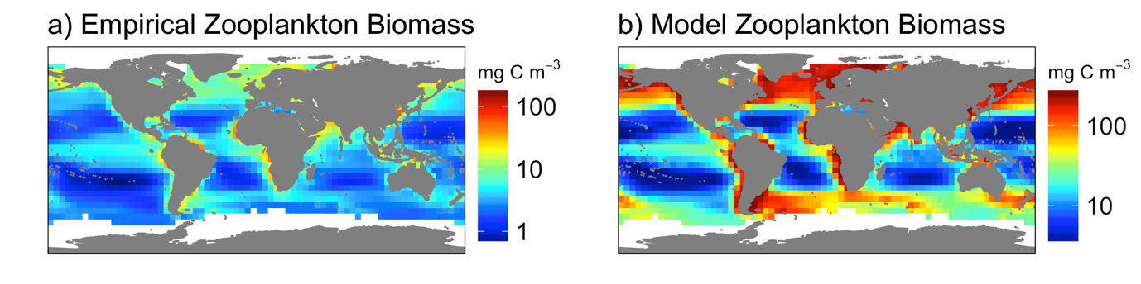  
Figure 4** Comparison of model map of global zooplankton carbon biomass (mg C m-3), with a map derived from observations. a) Global annual average (1998-2005) zooplankton carbon biomass map (mg C m-3), calculated with zooplankton biomass observations from the COPEPOD database and the Continuous Plankton Recorder. Reproduced with permission from Strömberg *et al.,* (2009). b) Functional size-spectrum model total zooplankton carbon biomass map (mg C m-3).

Global distribution of zooplankton carbon biomass from the size-spectrum model is shown in comparison to an empirically derived estimate in Figure 4. There is strong agreement in the spatial pattern between the model’s global zooplankton biomass and the empirically derived map, with a correlation coefficient of 0.84 between the two. The model qualitatively captures global-scale patterns of empirically derived total zooplankton biomass (Figure 4 a,b), showing the lowest levels of biomass in the oligotrophic ocean gyres, and highest in upwelling regions and coastal shelves. Both data-derived and model distributions of global biomass is similar to that of satellite-derived chlorophyll *a* at this scale. However, our model has a larger number of grid-squares with maximum or near maximum zooplankton biomass in high-productivity regions, compared to the empirically derived estimate, this could indicate that our model is overestimating the biomass of zooplankton in eutrophic waters. On the other hand, it could also mean that zooplankton biomass is underestimated in the observations underpinning the empirically derived estimate.

**Maximum growth rates  
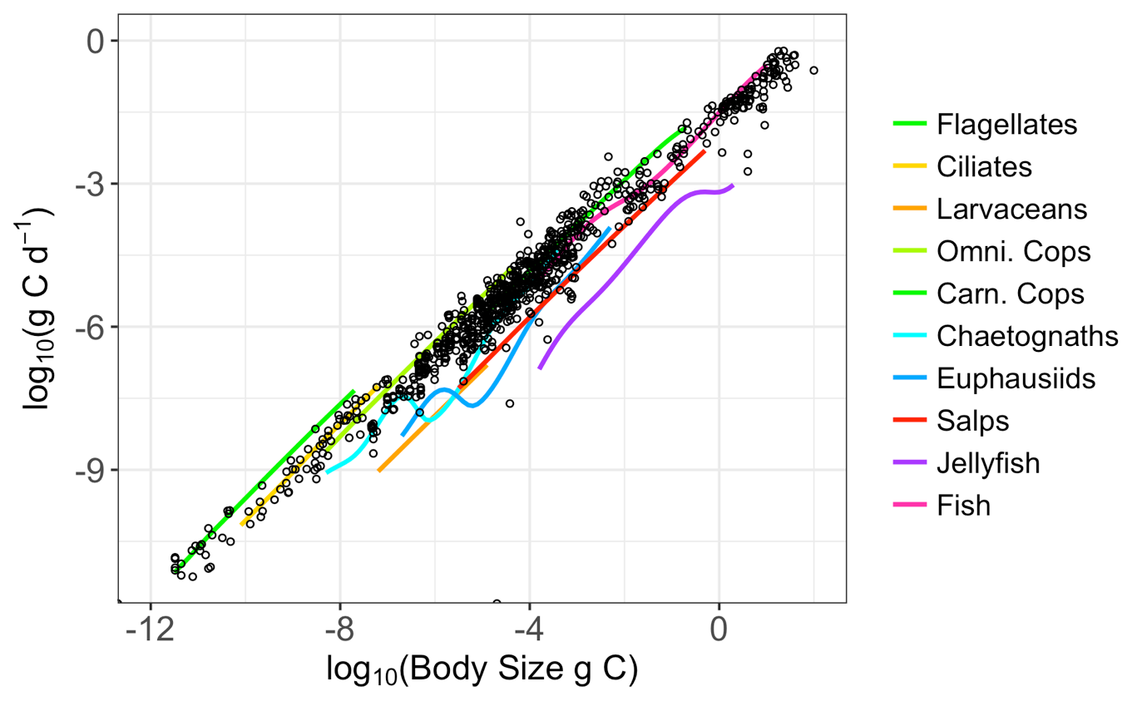**

**Figure 5** Modelled maximum growth rates (g C d-1) as a function of body size (g C) and functional group. The black circles represent the food saturated maximum growth rates (g C d-1) with body size (g C) of juveniles from various functional groups (nanoflagellates, ciliates, non-calanoid and calanoid copepods, other crustaceans, tunicates, cnidarians and ctenophores, chaetognaths and planktivorous fish), taken from Kiørboe and Hirst (2014) (available at Pangaea, ﻿http:// doi.pangaea.de/10.1594/PANGAEA.819855).

In Figure 5, modelled maximum growth rates across body size and functional groups were plotted with observed maximum growth rates from Kiørboe and Hirst (2014). The observed maximum growth rates come from various functional groups (nanoflagellates, ciliates, non-calanoid and calanoid copepods, other crustaceans, tunicates, cnidarians and ctenophores, chaetognaths and planktivorous fish), allowing us to compare across the functional groups in our model. Modelled maximum growth rates fell within the range of the observed maximum growth rates, with the model’s maximum growth rates not noticeably exceeding the empirical data for any body size or functional group. Although this is not a comprehensive assessment of the growth rates from the model, it does indicate that our model is not overestimating the growth rates and resulting energy flow through the zooplankton to higher trophic levels.

**Zooplankton community composition**

**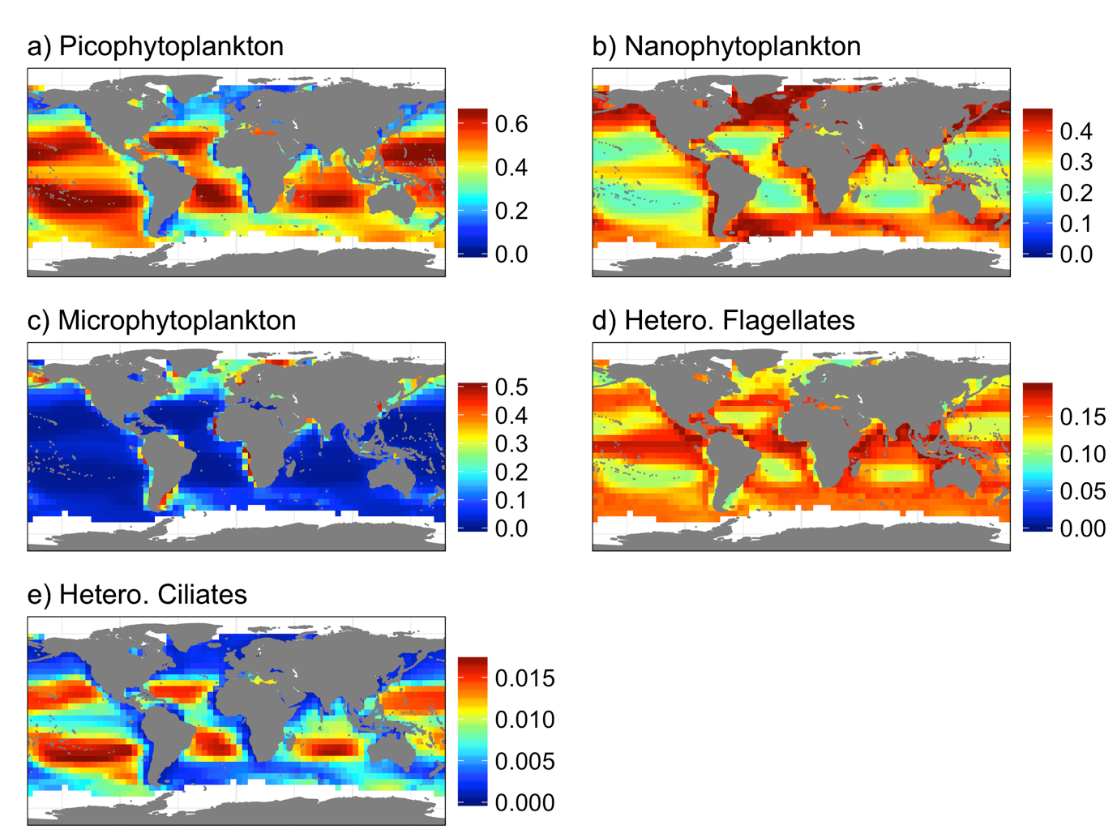  
Figure 6** Emergent relative biomass (wet weight composition) of the microzooplankton (heterotrophic flagellates and ciliates) and phytoplankton community. Biomass’ of the phytoplankton groups are not emergent from the model, but come from splitting total phytoplankton biomass using Brewin *et al.,*’s (2010) synoptic model (see section 2.2). Proportion of total wet weight for these five groups from a) Picophytoplankton, b) Nanophytoplankton, c) Microphytoplankton, d) Heterotrophic Flagellates, e) Heterotrophic Ciliates.   
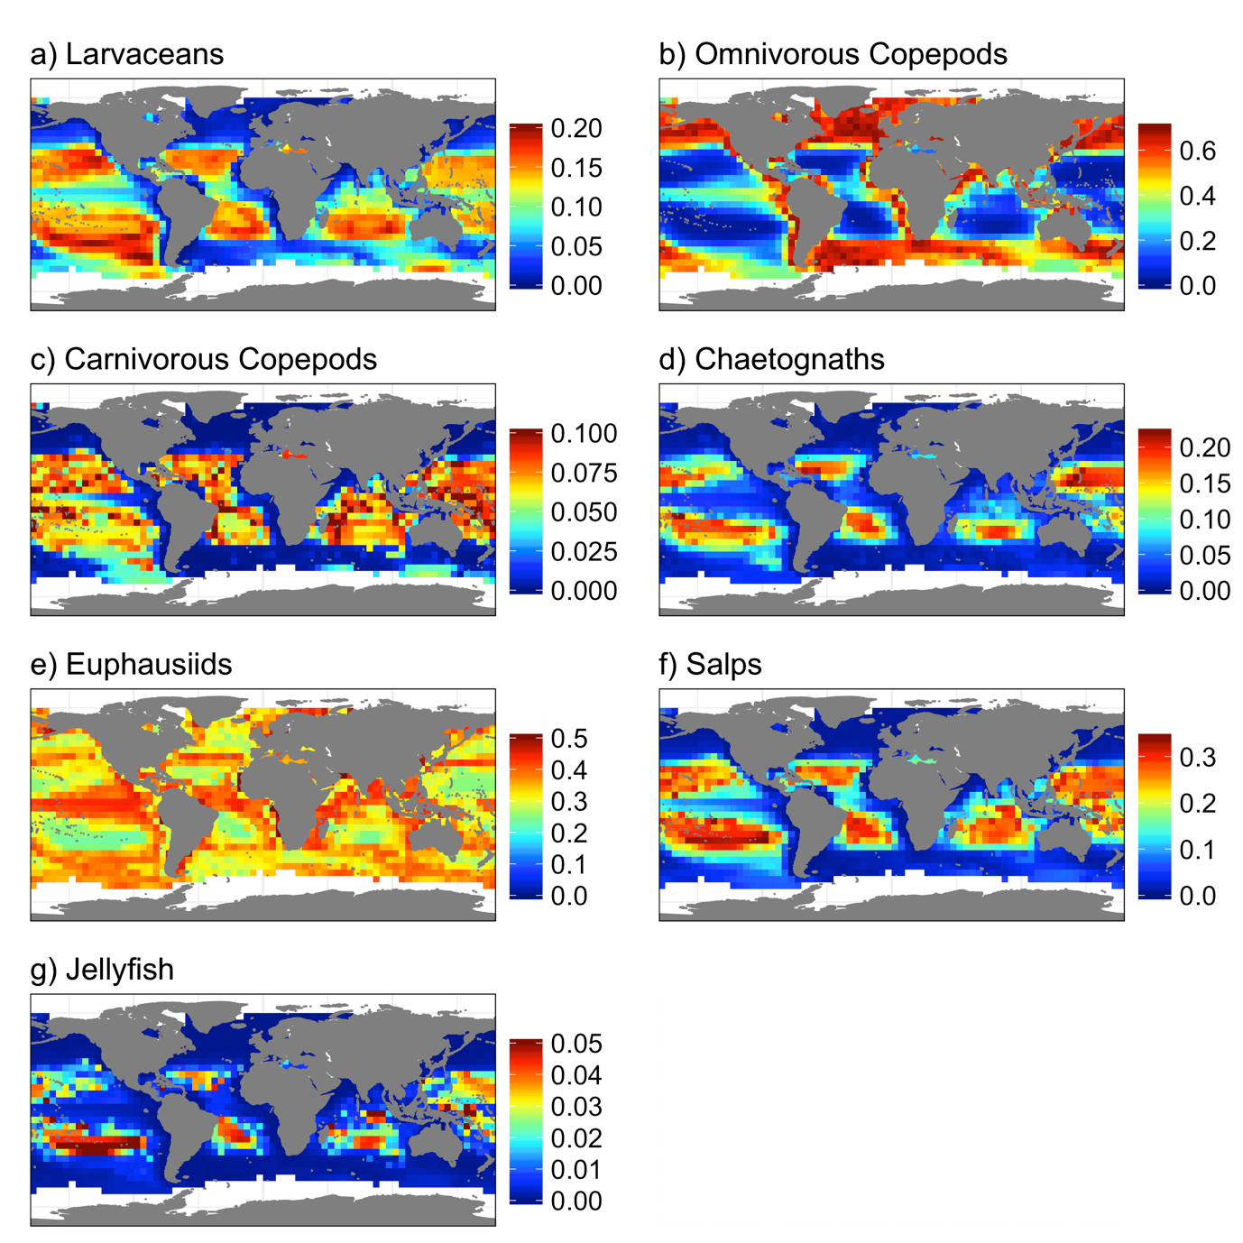

**Figure 7** Emergent relative biomass (wet weight composition) of the macrozooplankton community (excluding flagellates and ciliates) from the size-spectrum model. Proportion of total macrozooplankton wet weight (excluding flagellates and ciliates) from a) Larvaceans, b) Omnivorous Copepods, c) Carnivorous Copepods, d) Chaetognaths, e) Euphausiids, f) Salps and g) Jellyfish.

Across the global ocean, the emergent composition of the plankton was not uniform. To see shifts in community composition more clearly, we split the total phytoplankton and zooplankton communities into micro (phytoplankton, heterotrophic flagellates and ciliates; Figure 6) and macroplankton groups (all zooplankton groups except heterotrophic flagellates and ciliates; Figure 7). Size classes in the phytoplankton community were set and are not emergent from the model, but help drive changes in the zooplankton community. Picophytoplankton comprise over 60% of the microplankton biomass in oligotrophic waters, declining to around 10% in eutrophic waters as microphytoplankton increase from <5% in oligotrophic waters to around 50% in eutrophic waters, and nanophytoplankton increase from 25% of macroplankton biomass in oligotrophic to around 50% in eutrophic waters (Figure 6 a, b, c).

Heterotrophic flagellates comprise between 10-15% of the microplankton biomass in oligotrophic waters, increasing to around 20% in eutrophic waters (Figure 6 d). In contrast, heterotrophic ciliates were most prevalent in oligotrophic regions, comprising around 1.5% of microplankton biomass, but decreasing to less than 0.1% in eutrophic regions (Figure 6 e). Taken together, heterotrophic flagellates and ciliates comprised at least 15% of the total microplankton biomass across the global ocean.

In the seven macrozooplankton groups (Figure 7), omnivorous copepods and euphausiids were a significant component of the zooplankton in all regions, comprising at least 10% and 25% respectively of the macrozooplankton biomass in oligotrophic waters. They were most prevalent in eutrophic regions, where nanophytoplankton and microphytoplankton - the two size classes of phytoplankton that fall in these groups’ prey size ranges (Figure 3) - dominate the microplankton community (Figure 6 b,c), with their respective biomass’ increasing to around 60% and 40% in these regions (Figure 7 b, e). In contrast, salps and larvaceans, have similar body size ranges, but larger predator-prey mass ratios than omnivorous copepods and euphausiids (Table 2; Figure 3), which means that they can access the picophytoplankton for food (Figure 3). As a result salps and larvaceans are most prevalent in the oligotrophic open ocean gyres, where picophytoplankton comprise over 60% of microplankton biomass (Figure 6 a), respectively making up about 20% and 30% of macrozooplankton biomass in these waters, declining to less than 1% in eutrophic regions. Finally, the three carnivorous groups – carnivorous copepods, chaetognaths and jellyfish – were most prevalent in oligotrophic waters, altogether making up over 30% of microzooplankton biomass in these regions (Figure 7 c, d, g).

**Fish community biomass sensitivity**

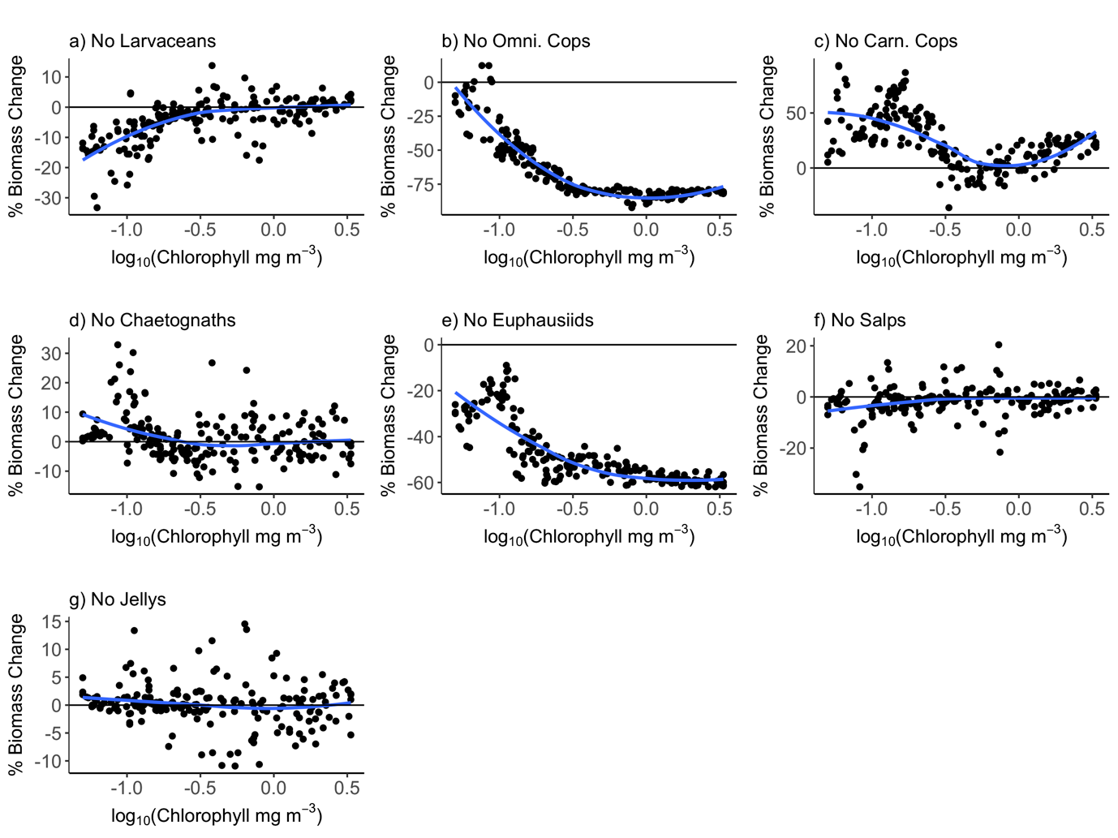

**Figure 8** Change in total fish biomass against chlorophyll *a* concentration when a) Larvaceans, b) Omnivorous copepods, c) Carnivorous Copepods, d) Chaetognaths, e) Euphausiids, f) Salps and g) Jellyfish are omitted from the model, compared to total fish biomass when all zooplankton groups are present. Each dot represents an individual 5x5 degree grid square from the global ocean. To clarify the trend with chlorophyll *a* in each figure, a blue line was fit with a spline smoother. The solid black line at 0% shows where there is no change in total fish biomass.

To assess the sensitivity of fish community biomass to the composition of the zooplankton from oligotrophic to eutrophic waters, we calculated the change in total fish biomass when each of the zooplankton functional groups (excluding flagellates and ciliates) were removed individually, and plotted this against chlorophyll *a* (Figure 8).

Removing larvaceans, salps, carnivorous copepods, chaetognaths or jellyfish - groups that were most prevalent in oligotrophic regions of the global ocean (Figure 7 a, c, d, f, g) - caused the greatest change in fish biomass in low chlorophyll *a* grid squares. The removal of larvaceans caused declines in fish biomass of up to 30% in grid squares with low chlorophyll *a*, however as chlorophyll *a* increased the effect of larvaceans being removed did not cause a consistent increase or decrease in fish biomass (Figure 8a). The removal of salps caused a similar pattern of fish biomass change as larvaceans, however the declines in oligotrophic waters were less pronounced (Figure 8 f). In contrast, removing carnivorous copepods led to an increase of up to 90% in fish biomass in low chlorophyll *a* areas, and in regions of high productivity removing this group caused an increase of around 10% in fish biomass (Figure 8 c). This is despite carnivorous copepods comprising less than 1% of the biomass of macrozooplankton in eutrophic regions (Figure 7 c). Removing chaetognaths also caused up to a 30% increase in fish biomass in low chlorophyll *a* regions, however the trend with chlorophyll *a* was weak, with no consistent pattern of biomass change for most regions when this group was removed (Figure 8 d). Finally, when jellyfish were removed there was a 1-2% average increase in fish biomass in low chlorophyll *a* regions, however this increase was small compared to the 10% changes in different grid squares, from low to high chlorophyll *a* regions(Figure 8 g).

Omnivorous copepods and euphausiids comprised over 90% of macrozooplankton biomass in eutrophic upwelling and shelf regions (Figure 7 b, e), and removing these groups caused the greatest declines in fish biomass in high chlorophyll *a* regions. When omnivorous copepods were removed, there was no change in fish biomass in low chlorophyll *a* regions, however as chlorophyll *a* increased total fish biomass was reduced by up to 80%, compared to when this group was included in the zooplankton community (Figure 8 b). Removing euphausiids caused declines of up to 60% in high chlorophyll *a* waters, however unlike omnivorous copepods low chlorophyll *a* waters saw a reduction of 20% in total fish biomass(Figure 8 e), reflecting the fact that euphausiids still comprised about 25% of microzooplankton biomass in oligotrophic waters (Figure 7 e).

# ﻿Discussion

The challenge of resolving the zooplankton in ecosystem models lies in their diversity of species, life histories and ecological strategies (Litchman *et al.,* 2013). A significant advantage of the trait-based approach is that community structure can emerge based on the functional traits of the community, and environmental conditions. Our results demonstrate the power of the trait-based approach to resolving global patterns in zooplankton community composition. With only the body size ranges, size-based feeding traits and carbon content of nine zooplankton functional groups, it is possible to resolve emergent changes in the zooplankton community across the global ocean, and the role of different zooplankton groups in supporting higher trophic level biomass. This is an important result; resolving the mechanisms that give rise to the zooplankton community across environmental gradients is critical to better understanding overall ecosystem function, particularly the resilience and productivity of higher trophic levels across environmental gradients (Mitra *et al.,* 2010, 2014; Irigoein *et al.,* 2014; Jennings and Collingridge, 2015; Steinberg and Landry, 2017).

Changes in zooplankton community structure were primarily driven by changes in the size structure of the phytoplankton, and this had implications for higher trophic level biomass. In eutrophic, high chlorophyll *a* waters, the phytoplankton community is mostly nano and microphytoplankton (> 2 m ESD; Figure 2a) and we found that euphausiids and omnivorous copepods – crustaceans that prey on larger phytoplankton - were most dominant in these regions. What is more, when these groups were excluded from the model, eutrophic regions saw the greatest decreases in fish biomass (Figure 8 b,e). In oligotrophic regions where the phytoplankton community is dominated by picophytoplankton (< 2 m ESD; Figure 2a), these omnivorous groups comprised less of the zooplankton, and were replaced by carnivorous copepods, chaetognaths and jellyfish. The fact that fish biomass was higher when these carnivorous groups were removed (Figure 8 c, d) suggests that these carnivorous groups increased the degree of top-down control and grazing within the zooplankton, and so decrease transfer efficiency from phytoplankton to fish in oligotrophic waters. This corroborates the traditional hypothesis that oligotrophic food chains have a lower average PPMR and more trophic steps, and so are less efficient than eutrophic systems that can support more fish biomass per unit phytoplankton (Ryther, 1969; Lalli and Parsons, 1995; Boyce *et al.,* 2015).

On the other hand, the presence of salps and larvaceans in low chlorophyll *a* areas challenges the idea that average PPMR decreases and the number of trophic steps in the food chain increases with decreasing primary productivity. Larvaceans and salps have the largest PPMRs of the zooplankton functional groups and as a result these two groups were most prevalent in oligotrophic waters, as they are able to take advantage of the prevalence of picophytoplankton in these regions. The fact that fish biomass declined in oligotrophic waters when these groups were removed from the model suggest that they represent an important energy pathway from phytoplankton to fish in oligotrophic waters, at least partially offsetting the decline in transfer efficiency caused by the increase in carnivorous copepods, chaetognaths and jellyfish in oligotrophic regions. The “appendicularian shunt” has been hypothesised as an energy pathway from the dominant picophytoplankton in oligotrophic waters, to planktivorous fish (Diebel and Lee, 1992; Bone, 1997). Our results here support this hypothesis; the prevalence of larvaceans – and salps – in oligotrophic waters, coupled with their large body sizes, indicates that they would be an important food source for higher trophic levels in these waters, representing an alternative direct pathway from phytoplankton to fish to omnivorous copepods and euphausiids. However, although salps and larvaceans cover roughly the same body size classes as omnivorous copepods and euphausiids, they have a much lower carbon content, which would be why the reduction in fish biomass when these groups are excluded from the model is not as great as for the more carbon-dense crustaceans.

The model does not incorporate the dynamics of the phytoplankton, instead representing the community as a continually renewable resource for zooplankton, not affected by predation. Because of this, our model could be overestimating the degree of herbivory of groups that can access the phytoplankton, by providing them with a food source of large phytoplankton that is unaffected by predation pressure. No predation feedbacks in the phytoplankton mean that omnivorous groups with an overlap in their phytoplankton prey size ranges are not competing for a limited resource. However, this would not qualitatively change our results, but everything else being equal it does mean that we could be overestimating the decline in fish biomass when zooplankton that feed on phytoplankton are excluded from the model. The processes of nutrient uptake, growth and mortality are strongly size-structured in the phytoplankton, and these size-based relationships have been used to resolve the dynamics of the phytoplankton over large spatial scales (Follows *et al.,* 2007; Fuchs and Franks, 2010; Ward *et al.,* 2012, 2014; Cuesta *et al.,* 2017). An important next step to improving the model presented here would be to incorporate the size-dependent dynamics of the phytoplankton.

The relative fitness of an organism is a function of feeding, growth, mortality and reproduction (Litchman *et al.,* 2013). Our model resolves the first three, but not the dynamics of reproduction for the zooplankton or fish. This does not mean that we consider reproduction unimportant, but merely that it falls outside of the scope of the model we have developed here. This is primarily because of the spatial and temporal scope of the model – the annual average zooplankton community across the global ocean. We focussed on traits such as body size, predator-prey mass ratio and carbon content because, at this spatial and temporal scale, there is a strong case in the literature that these traits are foundational for how energy moves through the marine food web (Hansen *et al.,* 1994; Andersen *et al.,* 2016a; McConville *et al.,* 2017). What is more, although reproduction in fish is a relatively simple process of the production of similarly sized fertilized eggs across taxa (Neuheimer *et al.,* 2015), reproduction in the zooplankton is much more diverse, from alternating generations of sexual and asexual reproduction in salps and jellyfish, to the hermaphroditism of chaetognaths, and intersexuality in copepods (Litchman *et al.,* 2013). As the first functional size spectrum ecosystem model that resolves multiple zooplankton groups, our work here is intended to be built upon, and resolving the diversity of reproductive strategies in the zooplankton is an important next step in the development of this model.

How zooplankton are parameterised is one of the most critical components of ecosystem models (Gislason *et al.,* 2007; Mitra *et al.,* 2014; Everett *et al.,* 2017). Despite this, zooplankton are typically side-lined in the development of marine ecosystem models, with the implicit assumption that the dynamics of this group is not an important component of ecosystem function. Our results demonstrate that the composition of the zooplankton is not static, and that the role of different zooplankton groups in supporting higher trophic level biomass varies from oligotrophic to eutrophic regions across the global ocean. The model we have presented here demonstrates that functional traits are a powerful way to resolve zooplankton and the critical role they play as the linchpin of the marine ecosystem.

# Acknowledgements The authors wish to acknowledge Iain M. Suthers, Claire H. Davies and Simon Jennings for helpful discussions during the development of the model, and Todd O’Brien for making the Strömberg *et al.,* (2009) global zooplankton map available for our use.

# Funding RFH was funded by an Australian Government Research Training Program Scholarship, and the Spanish Ministry of Science, Innovation and Universities, through the Acciones de Programacion Conjunta Internacional (PCIN-2017-115).

# References

Acuña, J.L., López-Urrutia, Á., Colin, S., 2011. Faking giants: The evolution of high prey clearance rates in jellyfishes. Science 333, 1627–1629. https://doi.org/10.1126/science.1205134

Agawin, N.S.R., Duarte, C.M., Agustí, S., 2000. Nutrient and temperature control of the contribution of picoplankton to phytoplankton biomass and production. Limnol. Oceanogr. 45, 591–600. https://doi.org/10.4319/lo.2000.45.3.0591

Andersen, K.H., Jacobsen, N.S., Farnsworth, K.D., 2016b. The theoretical foundations for size spectrum models of fish communities. Can. J. Fish. Aquat. Sci. 73, 575–588. https://doi.org/10.1139/cjfas-2015-0230

Andersen, K.H., Prowe, A.E.F., Berge, T., Palacz, A., Olsson, K., Jacobsen, N.S., Andersen, K.H., Lindemann, C., Traving, S.J., Wadhwa, N., Visser, A.W., Gonçalves, R.J., Hylander, S., Martens, E.A., Neuheimer, A.B., Heuschele, J., Kiørboe, T., Sainmont, J., Hartvig, M., 2016a. Characteristic Sizes of Life in the Oceans, from Bacteria to Whales. Ann. Rev. Mar. Sci. 8, 217–241. https://doi.org/10.1146/annurev-marine-122414-034144

Azevedo, F. de, Dias, J.D., Braghin, L. de S.M., Bonecker, C.C., 2012. Length-weight regressions of the microcrustacean species from a tropical floodplain. Acta Limnol. Bras. 24, 01-11. https://doi.org/10.1590/s2179-975x2012005000021

Baird, M.E., Suthers, I.M., 2007. A size-resolved pelagic ecosystem model. Ecol. Modell. 203, 185–203. <https://doi.org/10.1016/j.ecolmodel.2006.11.025>

Barange, M., Merino, G., Blanchard, J.L., Scholtens, J., Harle, J., Allison, E.H., Allen, J.I., Holt, J., Jennings, S., 2014. Impacts of climate change on marine ecosystem production in societies dependent on fisheries. Nat. Clim. Chang. 4, 211.

Barnes, C., Irigoien, X., De Oliveira, J.A.A., Maxwell, D., Jennings, S., 2011. Predicting marine phytoplankton community size structure from empirical relationships with remotely sensed variables. J. Plankton Res. 33, 13–24. https://doi.org/10.1093/plankt/fbq088

Barton, A.D., Pershing, A.J., Litchman, E., Record, N.R., Edwards, K.F., Finkel, Z. V., Kiørboe, T., Ward, B.A., 2013. The biogeography of marine plankton traits. Ecol. Lett. 16, 522–534. https://doi.org/10.1111/ele.12063

Benedetti, F., Gasparini, S., Ayata, S.D., 2016. Identifying copepod functional groups from species functional traits. J. Plankton Res. 38, 159–166. https://doi.org/10.1093/plankt/fbv096

Blanchard, J.L., Andersen, K.H., Scott, F., Hintzen, N.T., Piet, G., Jennings, S., 2014. Evaluating targets and trade-offs among fisheries and conservation objectives using a multispecies size spectrum model. J. Appl. Ecol. 51, 612–622. https://doi.org/10.1111/1365-2664.12238

Blanchard, J.L., Heneghan, R.F., Everett, J.D., Trebilco, R., Richardson, A.J., 2017. From Bacteria to Whales: Using Functional Size Spectra to Model Marine Ecosystems. Trends Ecol. Evol. 32, 174–186. https://doi.org/10.1016/j.tree.2016.12.003

Blanchard, J.L., Jennings, S., Holmes, R., Harle, J., Merino, G., Allen, J.I., Holt, J., Dulvy, N.K., Barange, M., 2012. Potential consequences of climate change for primary production and fish production in large marine ecosystems. Philos. Trans. R. Soc. B Biol. Sci. 367, 2979–2989. <https://doi.org/10.1098/rstb.2012.0231>

Blanchard, J.L., Jennings, S., Law, R., Castle, M.D., McCloghrie, P., Rochet, M.-J., Benoît, E., 2009. How does abundance scale with body size in coupled size-structured food webs? J. Anim. Ecol. 78, 270–280. <https://doi.org/10.1111/j.1365-2656.2008.01466.x>

Bone, Q., 1997. *The biology of pelagic tunicates.* Oxford: Oxford University Press.

Boudreau, P.R., Dickie, L.M., 1992. Biomass spectra of aquatic ecosystems in relation to fisheries yield. Can. J. Fish. Aquat. Sci. 49, 1528-1538. <https://doi.org/10.1139/f92-169>

Boyce, D.G., Frank, K.T., Leggett, W.C., 2015. From mice to elephants: overturning the ‘one size fits all’ paradigm in marine plankton food chains. Ecol. Lett. 18, 504–515. https://doi.org/10.1111/ele.12434

Brewin, R.J.W., Sathyendranath, S., Hirata, T., Lavender, S.J., Barciela, R.M., Hardman-Mountford, N.J., 2010. A three-component model of phytoplankton size class for the Atlantic Ocean. Ecol. Modell. 221, 1472–1483. https://doi.org/10.1016/j.ecolmodel.2010.02.014

Brun, P., Payne, M.R., Kiørboe, T., 2016. Trait biogeography of marine copepods – an analysis across scales. Ecol. Lett. 19, 1403–1413. <https://doi.org/10.1111/ele.12688>

Bucklin, A., Nishida, S., Shnack-Schiel, S., Wiebe, P.H., Lindsay, D., Machida, R.J., et al., 2010. A Census of Zooplankton of the Global Ocean, in: McIntyre, A.D. (Ed.), Life in the World’s Oceans: Diversity, Distribution, and Abundance. 1st ed. Blackwell Publishing., West Sussex, pp. 247 – 265.

Cuesta, J.A., Delius, G.W., Law, R., 2018. Sheldon spectrum and the plankton paradox: two sides of the same coin—a trait-based plankton size-spectrum model. J. Math. Biol. 76, 67–96. https://doi.org/10.1007/s00285-017-1132-7

Dam, H.G., Baumann, H., 2017. Climate Change, Zooplankton and Fisheries. Clim. Chang. Impacts Fish. Aquac. II, 851–874. https://doi.org/10.1002/9781119154051.ch25

Diebel,D. 1998. Feeding and metabolism of Appendicularia, in: Bone,Q. (Ed.), The Biology of Pelagic Tunicates. Oxford University Press, New York, pp. 139–149.

Diebel, D., Lee, S.H., 1992. Retention efficiency of submicron particles by the pharyngeal filter of the pelagic tunicate Oiopleura vanhoeffeni. Mar. Ecol. Prog. Ser. 81, 25-30.

Edwards, K.F., Litchman, E. & Klausmeier, C.A., 2013. Functional traits explain phytoplankton community structure and seasonal dynamics in a marine ecosystem. Ecology Letters 16, 56–63. <https://doi.org/10.1111/ele.12012>

Everett, J.D., Baird, M.E., Buchanan, P., Bulman, C., Davies, C., Downie, R., Griffiths, C., Heneghan, R., Kloser, R.J., Laiolo, L., Lara-Lopez, A., Lozano-Montes, H., Matear, R.J., McEnnulty, F., Robson, B., Rochester, W., Skerratt, J., Smith, J.A., Strzelecki, J., Swadling, K.M., Suthers, I.M., van Ruth, P., Richardson, A.J., 2017. Modeling What We Sample and Sampling What We Model: Challenges for Zooplankton Model Assessment. Front. Mar. Sci. 4, 1–19. <https://doi.org/10.3389/fmars.2017.00077>

Follows, M.J., Dutkiewicz, S., Grant, S., Chisholm, S.W., 2007. Emergent biogeography of microbial communities in a model ocean. Science (80-. ). 315, 1843–1846. https://doi.org/10.1126/science.1138544

Friedland, K.D., Stock, C., Drinkwater, K.F., Link, J.S., Leaf, R.T., Shank, B. V., Rose, J.M., Pilskaln, C.H., Fogarty, M.J., 2012. Pathways between primary production and fisheries yields of large marine ecosystems. PLoS One 7, e28945. https://doi.org/10.1371/journal.pone.0028945

Fuchs, H.L., Franks, P.J.S., 2010. Plankton community properties determined by nutrients and size-selective feeding. Mar. Ecol. Prog. Ser. 413, 1–15. https://doi.org/10.3354/meps08716

Gislason, A., St. John, M., Koppelmann, R., Gentleman, W.C., Mitra, A., Kuhn, P., Licandro, P., Halsband, C., Nielsen, T.G., Bode, A., Agersted, M.D., Jónasdóttir, S.H., Lindeque, P.K., Castellani, C., Møller, E.F., Flynn, K.J., Calbet, A., 2014. Bridging the gap between marine biogeochemical and fisheries sciences; configuring the zooplankton link. Prog. Oceanogr. 129, 176–199. https://doi.org/10.1016/j.pocean.2014.04.025

Guiet, J., Aumont, O., Poggiale, J.C., Maury, O., 2016. Effects of lower trophic level biomass and water temperature on fish communities: A modelling study. Prog. Oceanogr. 146, 22–37. <https://doi.org/10.1016/j.pocean.2016.04.003>

Hall, S.J., Collie, J.S., Duplisea, D.E., Jennings, S., Bravington, M., Link, J., 2006. A length-based multispecies model for evaluating community responses to fishing. Can. J. Fish. Aquat. Sci. 63, 1344–1359. https://doi.org/10.1139/f06-039

Hansen, B., Bjornsen, P.K., Hansen, P.J., 1994. The size ratio between planktonic predators and their prey. Limnol. Oceanogr. 39, 395–403. https://doi.org/10.4319/lo.1994.39.2.0395

Hansen, P.J., Bjørnsen, P.K., Hansen, B.W., 1997. Zooplankton grazing and growth: Scaling within the 2-2,000-μm body size range. Limnol. Oceanogr. 42, 687–704. https://doi.org/10.4319/lo.1997.42.4.0687

Hartvig, M., Andersen, K.H., Beyer, J.E., 2011. Food web framework for size-structured populations. J. Theor. Biol. 272, 113–122. https://doi.org/10.1016/j.jtbi.2010.12.006

Heneghan, R.F., Everett, J.D., Blanchard, J.L., Richardson, A.J., 2016. Zooplankton Are Not Fish: Improving Zooplankton Realism in Size-Spectrum Models Mediates Energy Transfer in Food Webs. Front. Mar. Sci. 3, 1–15. https://doi.org/10.3389/fmars.2016.00201

Henschke, N., Everett, J.D., Richardson, A.J., Suthers, I.M., 2016. Rethinking the Role of Salps in the Ocean. Trends Ecol. Evol. 31, 720–733. https://doi.org/10.1016/j.tree.2016.06.007

Heron, A., McWilliam, P., Dal Pont, G., 1988. Length-weight relation in the salp Thalia democratica and potential of salps as a source of food. Mar. Ecol. Prog. Ser. 42, 125–132. https://doi.org/10.3354/meps042125

Hirata, T., Hardman-Mountford, N.J., Brewin, R.J.W., Aiken, J., Barlow, R., Suzuki, K., Isada, T., Howell, E., Hashioka, T., Noguchi-Aita, M., Yamanaka, Y., 2011. Synoptic relationships between surface Chlorophyll-a and diagnostic pigments specific to phytoplankton functional types. Biogeosciences 8, 311–327. https://doi.org/10.5194/bg-8-311-2011

Hopcroft, R.R., Roff, J.C. and Bouman, H.A., 1998. Zooplankton growth rates: the larvaceans Appendiculara, Fritallaria and Oikopleura in trophic waters. Journal of Plankton Research. 20, 539-555. <https://doi.org/10.1093/plankt/20.3.539>

Irigoien, X., Klevjer, T.A., Røstad, A., Martinez, U., Boyra, G., Acuña, J.L., Bode, A., Echevarria, F., Gonzalez-Gordillo, J.I., Hernandez-Leon, S., Agusti, S., Aksnes, D.L., Duarte, C.M., Kaartvedt, S., 2014. Large mesopelagic fishes biomass and trophic efficiency in the open ocean. Nat. Commun. 5, 3271. https://doi.org/10.1038/ncomms4271

Jennings, S., Collingridge, K., 2015. Predicting consumer biomass, size-structure, production, catch potential, responses to fishing and associated uncertainties in the world’s marine ecosystems. PLoS One 10, e0133794. https://doi.org/10.1371/journal.pone.0133794

Jennings, S., Mélin, F., Blanchard, J.L., Forster, R.M., Dulvy, N.K., Wilson, R.W., 2008. Global-scale predictions of community and ecosystem properties from simple ecological theory. Proc. R. Soc. B Biol. Sci. 275, 1375–1383. <https://doi.org/10.1098/rspb.2008.0192>

So, K., Haruko, K., Robert, K., Lillian, H., Thomas, B., P., R.J., Akio, I., Masahide, W., Patti, V., Stephen, N., Atsushi, I., 2011. Will krill fare well under Southern Ocean acidification? Biol. Lett. 7, 288–291. https://doi.org/10.1098/rsbl.2010.0777

Kiørboe, T., 2011. How zooplankton feed: Mechanisms, traits and trade-offs. Biol. Rev. 86, 311–339. https://doi.org/10.1111/j.1469-185X.2010.00148.x

Kiørboe, T., 2013. Zooplankton body composition. Limnol. Oceanogr. 58, 1843–1850. <https://doi.org/10.4319/lo.2013.58.5.1843>

Kiørboe T., 2016. Foraging mode and prey size spectra of suspension‑feeding copepods and other zooplankton. Marine Ecology Progress Series 558, 15-20. <https://doi.org/10.3354/meps11877>

Kiørboe, T., Hirst, A.G., 2014. Shifts in Mass Scaling of Respiration, Feeding, and Growth Rates across Life-Form Transitions in Marine Pelagic Organisms. Am. Nat. 183, E118–E130. <https://doi.org/10.1086/675241>

Lalli, C., Parseon, T., 1997. *Biological Oceanography An Introduction 2nd Edition.* Oxford: Elsevier.

Law, R., Plank, M.J., James, A., Blanchard, J.L., 2009. Size-spectra dynamics from stochastic predation and growth of individuals. Ecology 90, 802–811. <https://doi.org/10.1890/07-1900.1>

Levinton, J.S., 2013. Marine Biology: Function, Biodiversity, Ecology. 4th ed, Oxford University Press, Oxford.

Litchman, E., Ohman, M.D., Kiørboe, T., 2013. Trait-based approaches to zooplankton communities. J. Plankton Res. 35, 473–484. <https://doi.org/10.1093/plankt/fbt019>

López-Urrutia, Á., Harris, R.P., Smith, T., 2004. Predation by calanoid copepods on the appendicularian Oikopleura dioica. Limnol. Oceanogr. 49, 303–307. <https://doi.org/10.4319/lo.2004.49.1.0303>

Mcconville, K., Atkinson, A., Fileman, E.S., Spicer, J.I., Hirst, A.G., 2017. Disentangling the counteracting effects of water content and carbon mass on zooplankton growth. J. Plankton Res. 39, 246–256. <https://doi.org/10.1093/plankt/fbw094>

McGill, B.J., Enquist, B.J., Weiher, E., Westoby, M., 2006. Rebuilding community ecology from functional traits. Trends Ecol. Evol. 21, 178–185. <https://doi.org/https://doi.org/10.1016/j.tree.2006.02.002>

Menden-Deuer, S., Lessard, E.J., 2000. Carbon to volume relationships for dinoflagellates, diatoms, and other protist plankton. Limnol. Oceanogr. 45, 569–579. <https://doi.org/10.4319/lo.2000.45.3.0569>

Meyer, B., Teschke, M., 2016. Physiology of Euphausia superba, in: Volker, S., Biology and Ecology of Antarctic Krill. 1st ed, Springer International Publishing, pp. 145-175.

Mitra, A., Davis, C., 2010. Defining the “to” in end-to-end models. Prog. Oceanogr. 84, 39–42. <https://doi.org/10.1016/j.pocean.2009.09.004>

Mitra, A., Castellani, C., Gentleman, W.C., Jónasdóttir, S.H., Flynn, K.J., Bode, A., Halsband, C., Kuhn, P., Licandro, P., Agersted, M.D., Calbet, A., Lindeque, P.K., Koppelmann, R., Møller, E.F., Gislason, A., Nielsen, T.G., St. John, M., 2014. Bridging the gap between marine biogeochemical and fisheries sciences; configuring the zooplankton link. Prog. Oceanogr. 129, 176–199. <https://doi.org/https://doi.org/10.1016/j.pocean.2014.04.025>

Moreno-Ostos, E., Blanco, J.M., Agustí, S., Lubián, L.M., Rodríguez, V., Palomino, R.L., Llabrés, M., Rodríguez, J., 2015. Phytoplankton biovolume is independent from the slope of the size spectrum in the oligotrophic Atlantic Ocean. J. Mar. Syst. 152, 42–50. <https://doi.org/https://doi.org/10.1016/j.jmarsys.2015.07.008>

Neuheimer, A. B., Hartvig, M., Heuschele, J., Hylander, S., Kiørboe, T., Olsson, K. H., et al., 2015. Adult and offspring size in the ocean over 17 orders of magnitude follows two life history strategies. Ecology 96, 3303–3311. <https://doi.org/10.1890/14-2491.1>

O'Brien, T., 2005. Copepod: a global plankton database.U.S. Dep. Commerce, NOAATech. Memo. NMFS-F/SPO-73, 136.

Pauly, D., Christensen, V., 1995. Primary production required to sustain global fisheries. Nature 376, 255-257.

Pearre, S., 1980. Feeding by Chaetognatha: The Relation of Prey Size to Predator Size in Several Species. Mar. Ecol. Prog. Ser. 3, 125–134. https://doi.org/10.3354/meps003125

Peters, R.H., 1983. The Ecological Implications of Body Size. Cambridge University Press, Cambridge.

Press, W.H., Teukolsky, S.A., Vetterling, W.T., Flannery, B.P., 2007. Numerical Recipes: The Art of Scientific Computing, Third Edition. Cambridge University Press, New York.

Purcell J.E, and Arai M.N., 2001. Interactions of pelagic cnidarians and ctenophores with fish: a review. Hydrobiologia 451, 27–44. <https://doi.org/10.1023/A:1011883905394>

Prowe, A.E.F., Andersen, K.H., Kiørboe, T., Visser, A.W., Chiba, S., 2018. Biogeography of zooplankton feeding strategy. Limnol. Oceanogr. lno.11067. <https://doi.org/10.1002/lno.11067>

Ryther, J.H., 1969. Photosynthesis and Fish Production in the Sea. Science (80-. ). 166, 72 LP-76. https://doi.org/10.1126/science.166.3901.72

Schnedler-Meyer. N.A, Patrizio, M., Thomas, K., 2016. The global susceptibility of coastal forage fish to competition by large jellyfish. Proc. R. Soc. B Biol. Sci. 283, 20161931. https://doi.org/10.1098/rspb.2016.1931

Schmidt, K and Atkinson, A., 2016. Feeding And Food Processing Antarctic Krill (Euphausia Superba Dana), in: Volker, S., Biology and Ecology of Antarctic Krill. 1st ed, Springer International Publishing, pp. 175-224.

Sheldon, R.W., Prakash, A., Sutcliffe, W.H., 1972. the Size Distribution of Particles in the Ocean. Limnol. Oceanogr. 17, 327–340. <https://doi.org/10.4319/lo.1972.17.3.0327>

Spitz, J., Mourocq, E., Schoen, V., Ridoux, V., 2010. Proximate composition and energy content of forage species from the Bay of Biscay: high- or low-quality food? ICES J. Mar. Sci. 67, 909–915. https://doi.org/10.1093/icesjms/fsq008

Steinberg, D.K., Landry, M.R., 2017. Zooplankton and the Ocean Carbon Cycle. Ann. Rev. Mar. Sci. 9, 413–444. https://doi.org/10.1146/annurev-marine-010814-015924

Straile, D., 1997. Gross growth efficiencies of protozoan and metazoan zooplankton and their dependence on food concentration, predator-prey weight ratio, and taxonomic group. Limnol. Oceanogr. 42, 1375–1385. <https://doi.org/10.4319/lo.1997.42.6.1375>

Strömberg, K.H.P., Smyth, T.J., Allen, J.I., Pitois, S., O’Brien, T.D., 2009. Estimation of global zooplankton biomass from satellite ocean colour. J. Mar. Syst. 78, 18–27. https://doi.org/https://doi.org/10.1016/j.jmarsys.2009.02.004

Taylor, W.D., 1978. Maximum growth rate, size and commonness in a community of bactivorous ciliates. Oecologia 36, 263–272. https://doi.org/10.1007/BF00348052

Terazaki, M., 2000. Feeding of Carnivorous Zooplankton, Chaetognaths in the Pacific, in: Dynamics and Characterization of marine Organic Matter. 1st ed. Terrapub, pp. 257-276.

van Denderen, P.D., Lindegren, M., MacKenzie, B.R., Watson, R.A., Andersen, K.H., 2018. Global patterns in marine predatory fish. Nat. Ecol. Evol. 2, 65–70. https://doi.org/10.1038/s41559-017-0388-z

Ward, B.A., Dutkiewicz, S., Follows, M.J., 2014. Modelling spatial and temporal patterns in size-structured marine plankton communities: Top-down and bottom-up controls. J. Plankton Res. 36, 31–47. https://doi.org/10.1093/plankt/fbt097

Ward, B.A., Dutkiewicz, S., Jahn, O., Follows, M.J., 2012. A size-structured food-web model for the global ocean. Limnol. Oceanogr. 57, 1877–1891. https://doi.org/10.4319/lo.2012.57.6.1877

Wirtz, K.W., 2013. How fast can plankton feed? Maximum ingestion rate scales with digestive surface area. J. Plankton Res. 35, 33–48. <https://doi.org/10.1093/plankt/fbs075>

Wirtz, K.W., 2012. Who is eating whom? Morphology and feeding type determine the size relation between planktonic predators and their ideal prey. Mar. Ecol. Prog. Ser. 445, 1–12. <https://doi.org/10.3354/meps09502>

Woodworth-Jefcoats, P.A., Polovina, J.J., Dunne, J.P., Blanchard, J.L., 2013. Ecosystem size structure response to 21st century climate projection: Large fish abundance decreases in the central North Pacific and increases in the California Current. Glob. Chang. Biol. 19, 724–733. <https://doi.org/10.1111/gcb.12076>

Zhou, M., Carlotti, F., Zhu, Y., 2010. A size-spectrum zooplankton closure model for ecosystem modelling. J. Plankton Res. 32, 1147–1165. https://doi.org/10.1093/plankt/fbq054

**Appendix 1: Deriving phytoplankton community slope, intercept and maximum size**

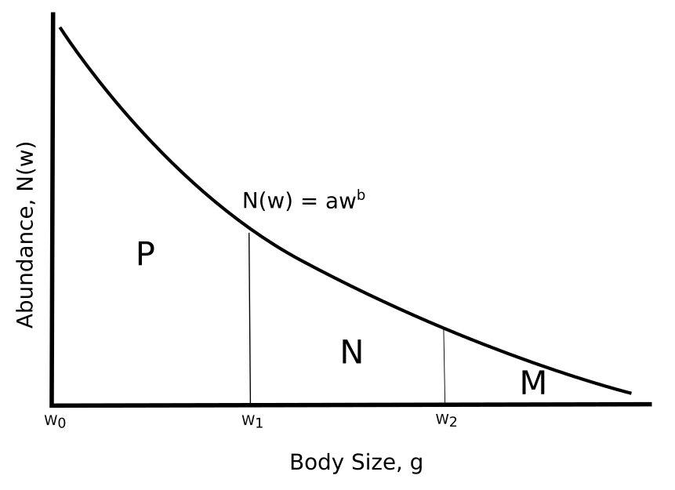

**Figure A1:** A schematic of the phytoplankton abundance spectrum with intercept and slope . P is the total biomass of picophytoplankton (0.2-2 m), N is the total biomass of nanophytoplankton (2-20 m) and M is the total biomass of microphytoplankton (>20 m).

We know w0 (0.2 m, 10-14.5 g), w1 (2 m, 10-11.5 g) and w2 (20 m, 10-8.5 g)and from Brewin *et al.,*’s (2010) synoptic model, we can break total phytoplankton biomass into the biomass of picophytoplankton , nanophytoplankton and microphytoplankton . Total phytoplankton biomass for each 5x5° grid square by converting chlorophyll *a* concentration to wet weight, assuming 1 g chlorophyll *a* = 50 g C (Zhou *et al.,* 2010), and 1 g C = 10 g wet weight (Hansen *et al.,* 1994, Boudreau & Dickie, 1992, Woodworth-Jefcoats *et al.,* 2013).

To use this information in the size spectrum model, we need to find the slope and intercept of the phytoplankton size spectrum (Figure A1). Using , w0 and w1 we can obtain an expression for the intercept :

,

Using :

Similarly, using , w1 and w2:

Puttingand together, we can solve for :

We can simplify further, because

and

**Calculating maximum extant phytoplankton size class**

The maximum size of the phytoplankton community (*wmax*) increases linearly with the proportion of the total phytoplankton biomass that comes from micro-phytoplankton (*m*, >20 m, 10-8.5g), from 20 m to 60 m (10-7g):

We chose 60 m as the upper limit for the phytoplankton community based on Barnes et al., (2011), who found that 90% of phytoplankton fall below 55-65 m equivalent spherical diameter across polar, tropical and upwelling environments. Maximum size class is rounded to the nearest log10 size interval. Figure A2 shows, across chlorophyll *a*, intercept (Figure A2 a), slope (Figure A2 b), maximum size (Figure A2 c), using the algorithm described here.

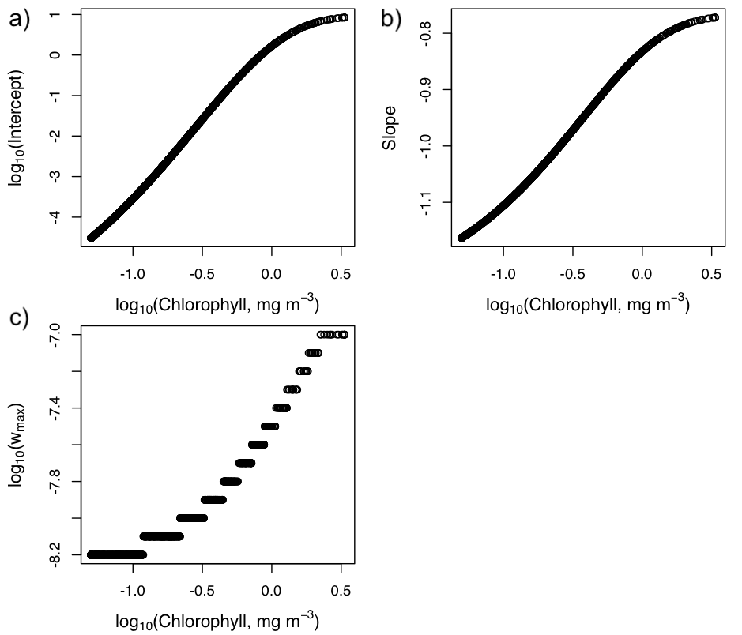

**Figure A2:** Output from the algorithm, against chlorophyll *a*: phytoplankton community a) intercept , b) slope , c) maximum size .

**Appendix References**

Boudreau, P.R., Dickie, L.M., 1992. Biomass spectra of aquatic ecosystems in relation to fisheries yield. Can. J. Fish. Aquat. Sci. 49, 1528-1538. <https://doi.org/10.1139/f92-169>

Brewin, R.J.W., Sathyendranath, S., Hirata, T., Lavender, S.J., Barciela, R.M., Hardman-Mountford, N.J., 2010. A three-component model of phytoplankton size class for the Atlantic Ocean. Ecol. Modell. 221, 1472–1483. <https://doi.org/10.1016/j.ecolmodel.2010.02.014>

Hansen, B., Bjornsen, P.K., Hansen, P.J., 1994. The size ratio between planktonic predators and their prey. Limnol. Oceanogr. 39, 395–403. <https://doi.org/10.4319/lo.1994.39.2.0395>

Woodworth-Jefcoats, P.A., Polovina, J.J., Dunne, J.P., Blanchard, J.L., 2013. Ecosystem size structure response to 21st century climate projection: Large fish abundance decreases in the central North Pacific and increases in the California Current. Glob. Chang. Biol. 19, 724–733. <https://doi.org/10.1111/gcb.12076>

Zhou, M., Carlotti, F., Zhu, Y., 2010. A size-spectrum zooplankton closure model for ecosystem modelling. J. Plankton Res. 32, 1147–1165. https://doi.org/10.1093/plankt/fbq054