NCAA evidence walkthrough
A continuing reading record • Started 23 October 2026
We will recover the evidence one plot at a time. Each entry keeps the figure, its population and settings, a plain-English reading, and the questions or decisions from our discussion. This first entry revisits an existing plot; it does not run a new analysis.

Entry 1 The original performance band overlay
Question: Among players in the same performance range, how does the observed draft rate vary across teams with different mean performance?
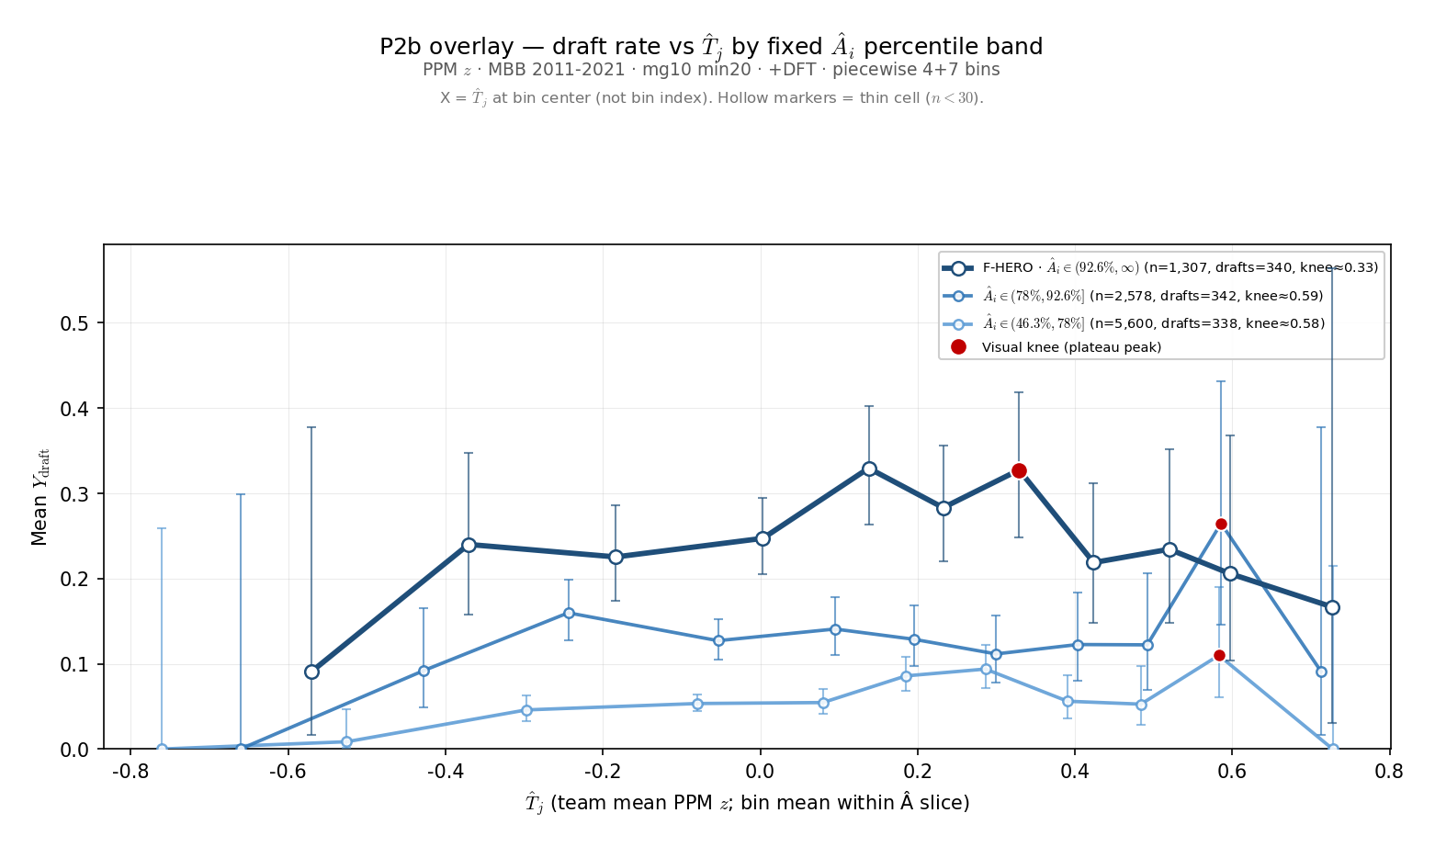
Figure 1. Original saved overlay from 24 August 2026. Each blue line represents a different range of individual performance. The horizontal axis is the full-team mean, including the focal player.

Start by following one line
The darkest line contains the highest of the three performance bands. Moving right means comparing observations from teams with higher mean performance. Moving up means a larger fraction of those observations belongs to players labeled ever drafted.
We are comparing different players and seasons within a performance band. We are not following one player as he moves between teams, and we are not holding individual performance at one exact value.

Entry 1 What went into this figure
Population: NCAA men’s basketball, 2011–2021, player-season observations at colleges represented by a draftee in the analysis window. The saved settings use at least 20 recorded minutes per player-season and the team-game setting mg10; the current source code implements that as more than 10 recorded team-season games.
Performance: points per minute, standardized within season. The horizontal measure is the full-team mean of that performance. This figure uses neither leave-one-out performance nor sigmoid roster pressure, so theta, gamma, lambda, and selection temperature do not generate its curves.
Binning: 11 bins per line, using four coarser lower-range bins and seven finer upper-range bins. Edges are calculated separately within each performance band. This is neither equal-count quantile binning nor one common equal-width grid. Points are placed at the mean team performance in each bin.

The three colors and their counts
Line and percentile range | Rows | Ever-drafted rows | Rate
Dark: 92.6–100 | 1,307 | 340 | 26.0%
Middle: 78–92.6 | 2,578 | 342 | 13.3%
Light: 46.3–78 | 5,600 | 338 | 6.0%
These are player-season counts, not distinct drafted people. The same player can contribute in multiple seasons. Percentile bands describe measured performance; they do not establish “superstars” or a draft bubble.

What we can see and what remains open
The darkest line is generally above the other two. It rises to roughly 33% and is lower farther right, but the last point is only 1 ever-drafted-positive observation out of 6. The middle and light lines are irregular. The saved red dots are visual plateau markers, not statistically established turning points.
This is a useful picture of the question we want to investigate. It does not by itself show that stronger teammates cause lower draft prospects, or that the apparent downturn is statistically reliable. No new significance test has been run for this entry.

Our place in the discussion
Agreed on 23 October: the historical top 7.4% band is a useful exploratory slice, but it was not validated as a group of draft “locks” or players near the selection boundary. Before replacing it, we will examine observed draft rates against individual performance. Band definitions and the main peer measure remain open.
Source locator: 3-Master_Plan/re_entry/HEROs_and_PASSes/basic_data_plots/
CCT_P2b_ai_band_overlay_lines.png, with matching CCT_P2b_ai_band_overlay.json and CCT_P2b_ai_band_overlay_sweep.csv. Generator: sports/scripts/cct_p2b_ai_band_overlay.py. Saved values checked against companion files; historical raw-data reconstruction remains pending.

Entry 2 Own performance and draft outcomes
Question: Does a high value of our performance measure identify players who are almost certain to be drafted? First, we return to the own-performance plot used in the lab presentation.
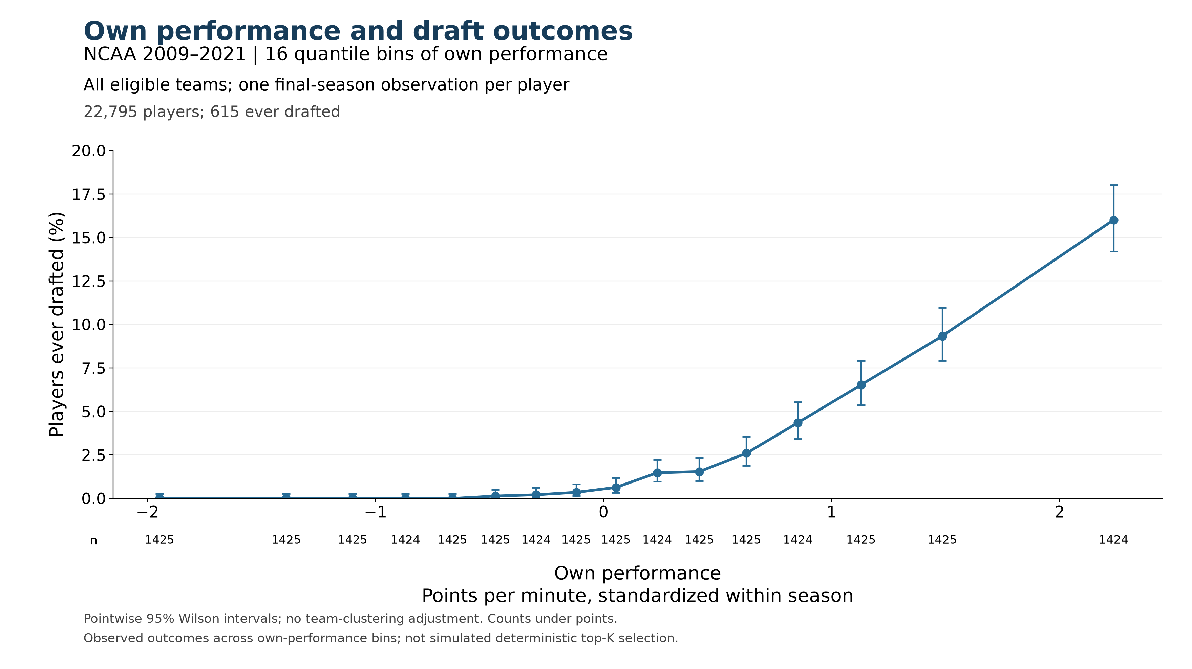
Figure 2. Existing empirical plot, with saved values unchanged. Points show ever-drafted rates in 16 approximately equal-count performance bins. Horizontal positions are bin means; the highest point represents roughly the top 6.25%, not one exact performance value.

What the highest point tells us
Higher own performance is associated with higher draft rates in this plot. In the highest bin, 228 of 1,424 players were ever drafted, or 16.0%. That broad upper band is therefore far from an almost-certain-selection group. Its average does not tell us whether a much narrower extreme tail has a substantially higher rate.

Keep the population distinction visible
This figure uses 2009–2021, all eligible colleges, and one final-season observation per player: 22,795 players, including 615 ever drafted (2.70%). Entry 1 used 2011–2021, draftee colleges, and all eligible player-seasons. The 16% here and 26% in Entry 1 are not a controlled comparison of band cutoffs.
Performance is points per minute standardized within season. The saved analysis uses at least 20 recorded minutes per player-season and more than 10 recorded team-season games. The overall 2.70% is an observed cohort outcome rate, not an annual draft quota or an automatic performance cutoff.
Next question: What happens inside this highest bin? We have not yet chosen replacement bands or assumed that points per minute alone will identify draft locks.
Source locator: new_VECTOR_work/lab_presentation_20261022/empirical_ncaa_2009_2021/
ncaa_naive_2009_2021_own_performance.png; naive_plotted_bins.csv; naive_provenance.json. Source counts checked: 22,795 players and 615 ever drafted. Existing intervals are pointwise Wilson intervals without college clustering; no new significance test was run.

Entry 3 A closer look inside the highest bin
We divided the highest performance bin from Entry 2 into eight equal-count groups. Each contains 178 distinct players, ordered by their own performance. The cohort, performance values, and ever-drafted labels are unchanged.
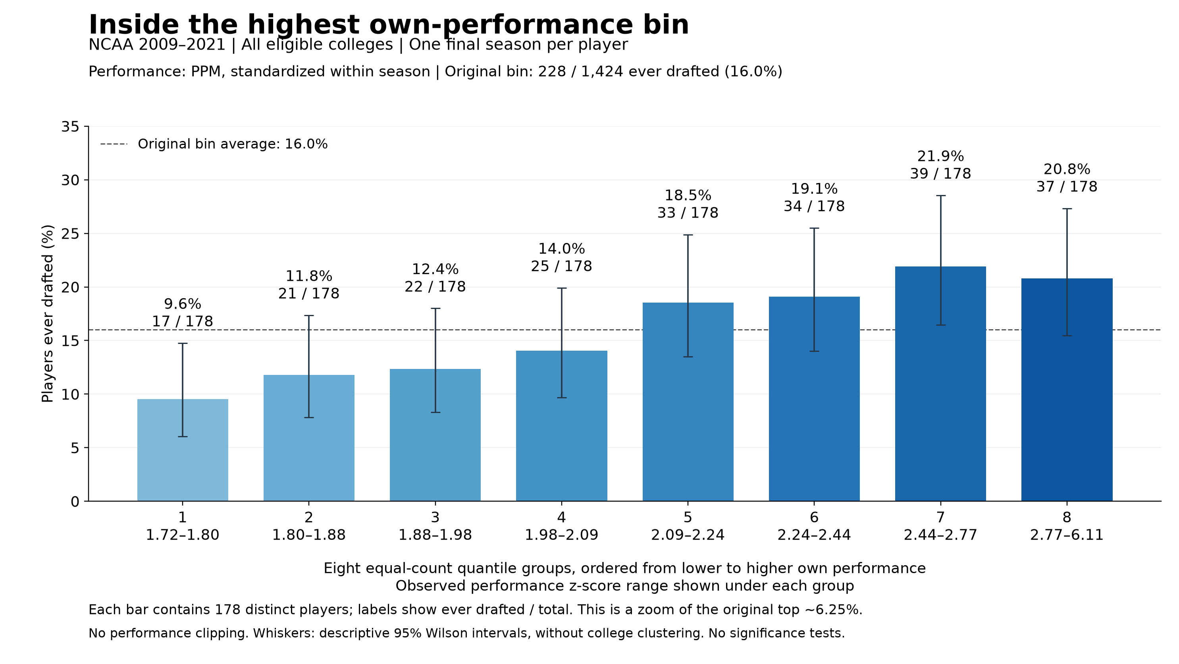
Figure 3. Eight quantile groups within the original highest bin. Each bar is a separate set of players, not a cumulative top-percent group. Counts above the bars are players ever drafted divided by total players. The dashed line is the original bin’s 16.0% average.

How to read the result
Follow the bars from left to right. The first contains the lowest performances within the original highest bin: 17 of 178 players were ever drafted, or 9.6%. Rates generally rise as performance increases. The seventh group reaches 39 of 178, or 21.9%, and the highest group contains 37 of 178, or 20.8%.
The final decrease amounts to two players among equally sized groups. We have not tested whether it reflects a systematic downturn. The main finding at this resolution is that none of these high-performance groups has a draft rate close to certainty.

What this changes in our thinking
Narrowing the broad upper performance band did not reveal an obvious group of draft locks in these eight slices. This does not rule out a smaller subset with a much higher rate. It does mean that we should not equate extreme points per minute with nearly guaranteed drafting without checking the actual outcomes.
The highest group is approximately the top 0.78% of the full cohort, with observed standardized performance from 2.77 to 6.11. That wide performance range remains grouped into one bar. We have not chosen new superstar or selection-boundary bands from this plot.

Entry 3 Counts and reproducible settings
These eight rows partition the exact 1,424 players in Entry 2’s highest bin. The total is still 228 ever drafted and 1,196 not drafted. Each player appears once.
Group | Observed PPM z range | Players | Ever drafted | Draft rate
1 | 1.717 to 1.796 | 178 | 17 | 9.6%
2 | 1.796 to 1.878 | 178 | 21 | 11.8%
3 | 1.878 to 1.976 | 178 | 22 | 12.4%
4 | 1.976 to 2.088 | 178 | 25 | 14.0%
5 | 2.089 to 2.237 | 178 | 33 | 18.5%
6 | 2.238 to 2.438 | 178 | 34 | 19.1%
7 | 2.443 to 2.773 | 178 | 39 | 21.9%
8 | 2.773 to 6.114 | 178 | 37 | 20.8%
Total | 1.717 to 6.114 | 1,424 | 228 | 16.0%
Ranges show observed minimum and maximum values rounded to three decimals. They are not equal-width intervals; each group contains the same number of players.

What stayed fixed
NCAA men’s basketball, 2009–2021; all eligible colleges; one final-season observation per player; at least 20 recorded minutes per player-season; more than 10 recorded team-season games. The full cohort contains 22,795 players and 615 ever drafted. Performance is points per minute standardized within season, retaining the historical values. No own-performance clipping is applied.

How the split was checked
The stored player-level snapshot passed its saved file-hash check. Rebinning its own-performance values reproduced the counts, drafted counts, and mean performance in all 16 original bins. We then ranked only the players in bin 16 and divided them into eight equal-count groups. Source row order resolves ties; no tied values straddle the seven new boundaries.
The whiskers are descriptive pointwise 95% Wilson intervals. They do not account for college clustering. No significance tests, congestion-score changes, fitted parameters, or simulated selections were used. This is an observed own-performance relationship; peer composition is not held fixed.

Our place in the discussion
Completed: inspect the broad upper bin more closely before naming replacement performance bands. Finding: draft rates generally rise across these slices, but even the highest slice is far from certain selection. Open: whether PPM alone can identify the conceptual superstar and borderline groups we want to compare across peer environments.
Source locator: new_VECTOR_work/manuscript_figures/ncaa_evidence_walkthrough/
highest_bin_draft_rates.png; highest_bin_counts.csv; highest_bin_provenance.json; zoom_highest_performance_bin.py. Input snapshot: manuscript_figures/section_4_5/roster_pressure_comparison/cache/last.pkl. Analysis and discussion entry added 23 October 2026.

