NCAA evidence walkthrough
A continuing reading record • Started 23 October 2026
We will recover the evidence one plot at a time. Each entry keeps the figure, its population and settings, a plain-English reading, and the questions or decisions from our discussion. This first entry revisits an existing plot; it does not run a new analysis.

Entry 1 The original performance band overlay
Question: Among players in the same performance range, how does the observed draft rate vary across teams with different mean performance?
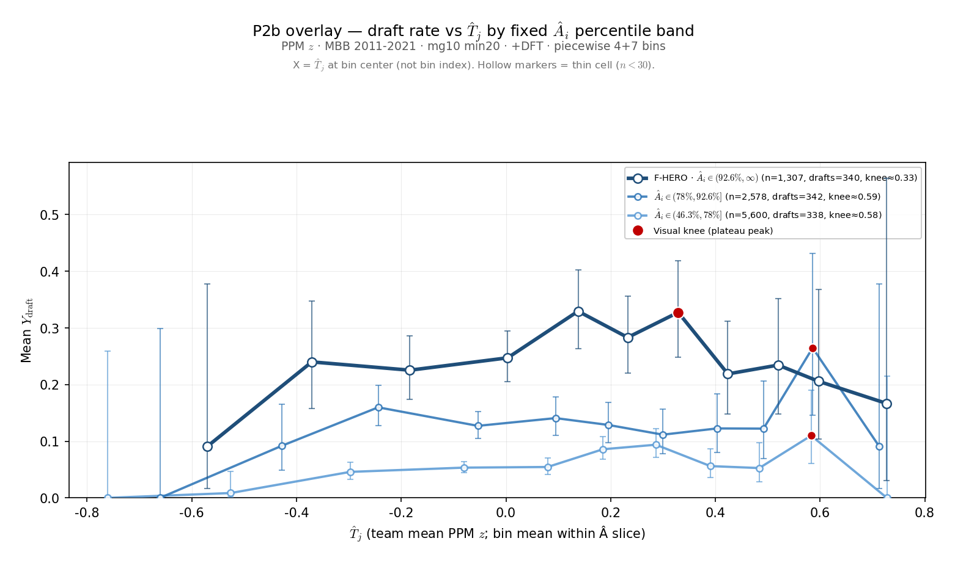
Figure 1. Original saved overlay from 24 August 2026. Each blue line represents a different range of individual performance. The horizontal axis is the full-team mean, including the focal player.

Start by following one line
The darkest line contains the highest of the three performance bands. Moving right means comparing observations from teams with higher mean performance. Moving up means a larger fraction of those observations belongs to players labeled ever drafted.
We are comparing different players and seasons within a performance band. We are not following one player as he moves between teams, and we are not holding individual performance at one exact value.

Entry 1 What went into this figure
Population: NCAA men’s basketball, 2011–2021, player-season observations at colleges represented by a draftee in the analysis window. The saved settings use at least 20 recorded minutes per player-season and the team-game setting mg10; the current source code implements that as more than 10 recorded team-season games.
Performance: points per minute, standardized within season. The horizontal measure is the full-team mean of that performance. This figure uses neither leave-one-out performance nor sigmoid roster pressure, so theta, gamma, lambda, and selection temperature do not generate its curves.
Binning: 11 bins per line, using four coarser lower-range bins and seven finer upper-range bins. Edges are calculated separately within each performance band. This is neither equal-count quantile binning nor one common equal-width grid. Points are placed at the mean team performance in each bin.

The three colors and their counts
Line and percentile range | Rows | Ever-drafted rows | Rate
Dark: 92.6–100 | 1,307 | 340 | 26.0%
Middle: 78–92.6 | 2,578 | 342 | 13.3%
Light: 46.3–78 | 5,600 | 338 | 6.0%
These are player-season counts, not distinct drafted people. The same player can contribute in multiple seasons. Percentile bands describe measured performance; they do not establish “superstars” or a draft bubble.

What we can see and what remains open
The darkest line is generally above the other two. It rises to roughly 33% and is lower farther right, but the last point is only 1 ever-drafted-positive observation out of 6. The middle and light lines are irregular. The saved red dots are visual plateau markers, not statistically established turning points.
This is a useful picture of the question we want to investigate. It does not by itself show that stronger teammates cause lower draft prospects, or that the apparent downturn is statistically reliable. No new significance test has been run for this entry.

Our place in the discussion
Agreed on 23 October: the historical top 7.4% band is a useful exploratory slice, but it was not validated as a group of draft “locks” or players near the selection boundary. Before replacing it, we will examine observed draft rates against individual performance. Band definitions and the main peer measure remain open.
Source locator: 3-Master_Plan/re_entry/HEROs_and_PASSes/basic_data_plots/
CCT_P2b_ai_band_overlay_lines.png, with matching CCT_P2b_ai_band_overlay.json and CCT_P2b_ai_band_overlay_sweep.csv. Generator: sports/scripts/cct_p2b_ai_band_overlay.py. Saved values checked against companion files; historical raw-data reconstruction remains pending.

Entry 2 Own performance and draft outcomes
Question: Does a high value of our performance measure identify players who are almost certain to be drafted? First, we return to the own-performance plot used in the lab presentation.
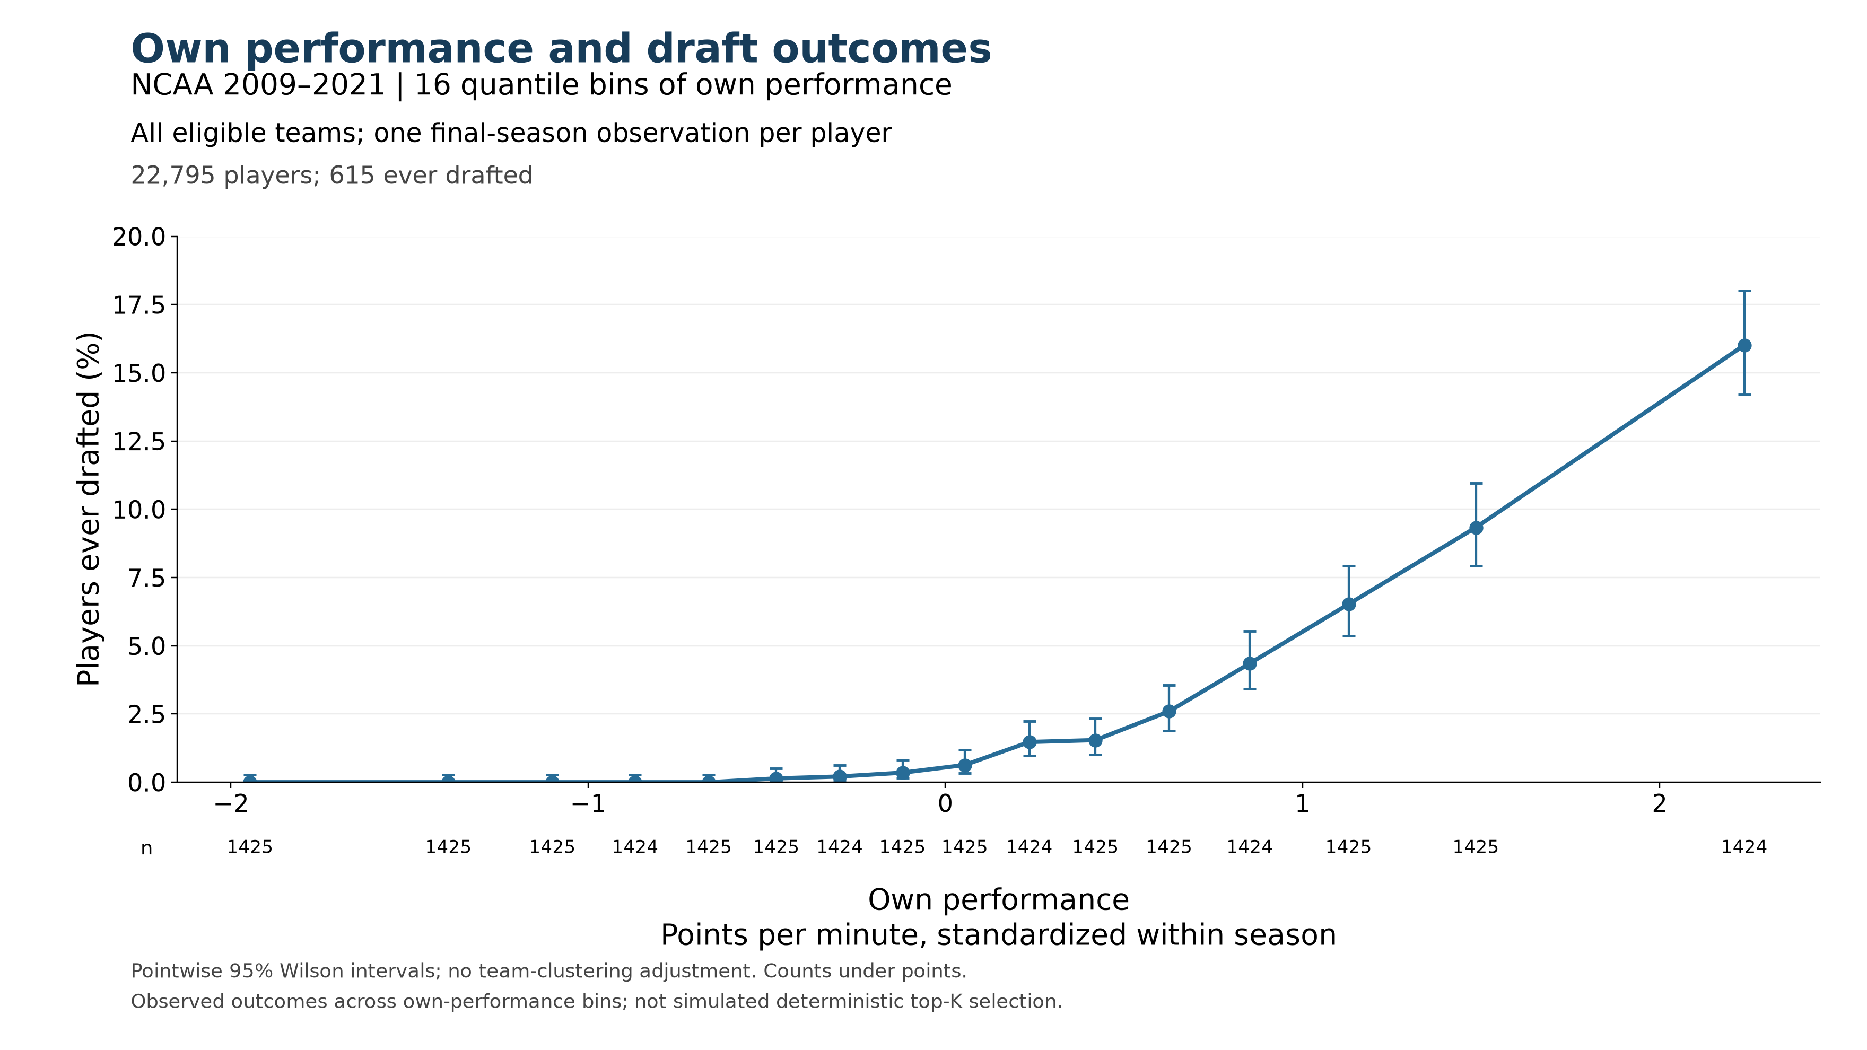
Figure 2. Existing empirical plot, with saved values unchanged. Points show ever-drafted rates in 16 approximately equal-count performance bins. Horizontal positions are bin means; the highest point represents roughly the top 6.25%, not one exact performance value.

What the highest point tells us
Higher own performance is associated with higher draft rates in this plot. In the highest bin, 228 of 1,424 players were ever drafted, or 16.0%. That broad upper band is therefore far from an almost-certain-selection group. Its average does not tell us whether a much narrower extreme tail has a substantially higher rate.

Keep the population distinction visible
This figure uses 2009–2021, all eligible colleges, and one final-season observation per player: 22,795 players, including 615 ever drafted (2.70%). Entry 1 used 2011–2021, draftee colleges, and all eligible player-seasons. The 16% here and 26% in Entry 1 are not a controlled comparison of band cutoffs.
Performance is points per minute standardized within season. The saved analysis uses at least 20 recorded minutes per player-season and more than 10 recorded team-season games. The overall 2.70% is an observed cohort outcome rate, not an annual draft quota or an automatic performance cutoff.
Next question: What happens inside this highest bin? We have not yet chosen replacement bands or assumed that points per minute alone will identify draft locks.
Source locator: new_VECTOR_work/lab_presentation_20261022/empirical_ncaa_2009_2021/
ncaa_naive_2009_2021_own_performance.png; naive_plotted_bins.csv; naive_provenance.json. Source counts checked: 22,795 players and 615 ever drafted. Existing intervals are pointwise Wilson intervals without college clustering; no new significance test was run.

Entry 3 A closer look inside the highest bin
We divided the highest performance bin from Entry 2 into eight equal-count groups. Each contains 178 distinct players, ordered by their own performance. The cohort, performance values, and ever-drafted labels are unchanged.
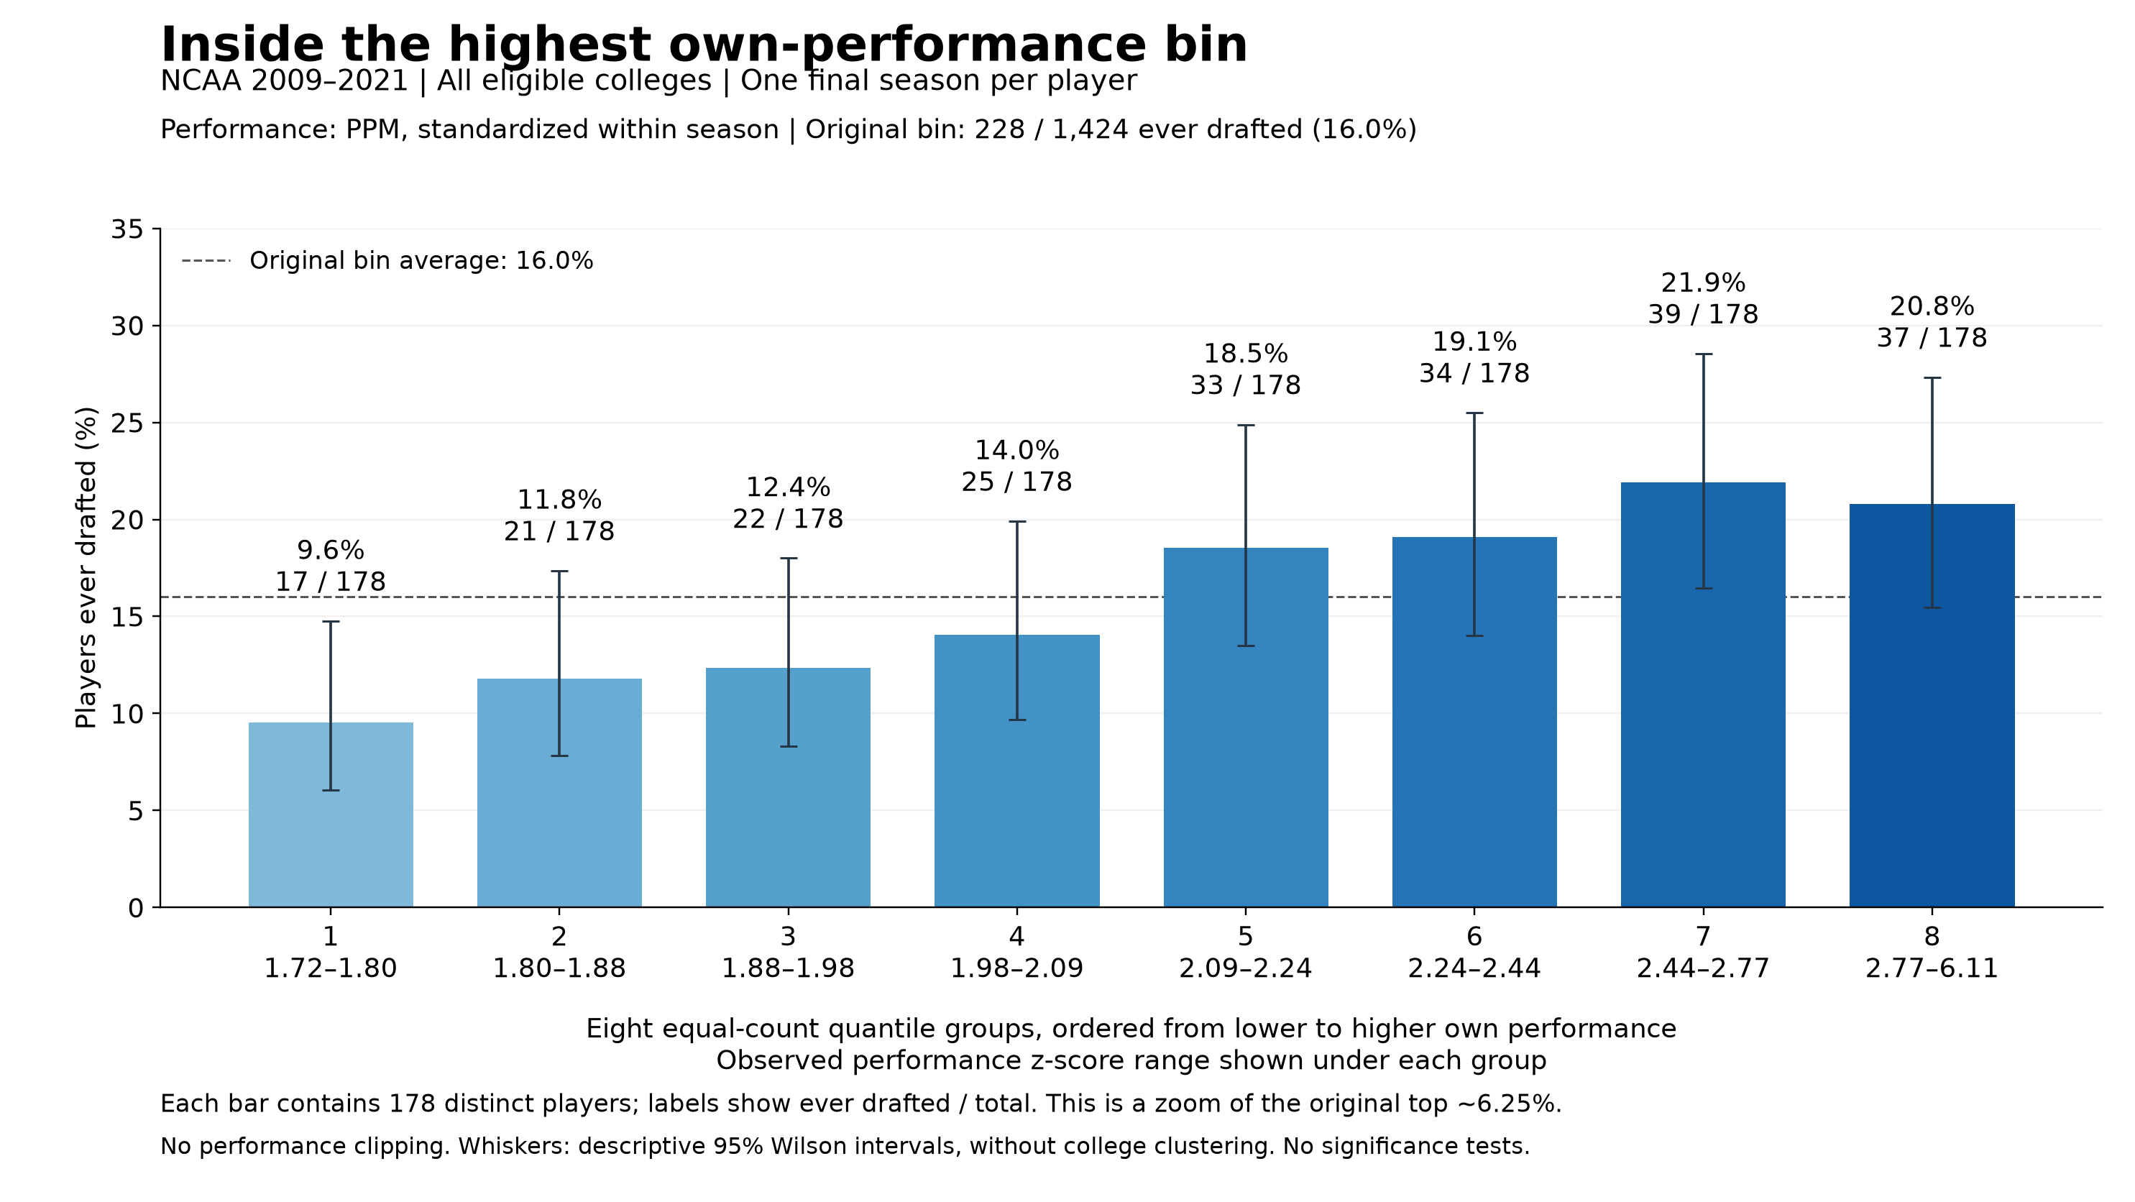
Figure 3. Eight quantile groups within the original highest bin. Each bar is a separate set of players, not a cumulative top-percent group. Counts above the bars are players ever drafted divided by total players. The dashed line is the original bin’s 16.0% average.

How to read the result
Follow the bars from left to right. The first contains the lowest performances within the original highest bin: 17 of 178 players were ever drafted, or 9.6%. Rates generally rise as performance increases. The seventh group reaches 39 of 178, or 21.9%, and the highest group contains 37 of 178, or 20.8%.
The final decrease amounts to two players among equally sized groups. We have not tested whether it reflects a systematic downturn. The main finding at this resolution is that none of these high-performance groups has a draft rate close to certainty.

What this changes in our thinking
Narrowing the broad upper performance band did not reveal an obvious group of draft locks in these eight slices. This does not rule out a smaller subset with a much higher rate. It does mean that we should not equate extreme points per minute with nearly guaranteed drafting without checking the actual outcomes.
The highest group is approximately the top 0.78% of the full cohort, with observed standardized performance from 2.77 to 6.11. That wide performance range remains grouped into one bar. We have not chosen new superstar or selection-boundary bands from this plot.

Entry 3 Counts and reproducible settings
These eight rows partition the exact 1,424 players in Entry 2’s highest bin. The total is still 228 ever drafted and 1,196 not drafted. Each player appears once.
Group | Observed PPM z range | Players | Ever drafted | Draft rate
1 | 1.717 to 1.796 | 178 | 17 | 9.6%
2 | 1.796 to 1.878 | 178 | 21 | 11.8%
3 | 1.878 to 1.976 | 178 | 22 | 12.4%
4 | 1.976 to 2.088 | 178 | 25 | 14.0%
5 | 2.089 to 2.237 | 178 | 33 | 18.5%
6 | 2.238 to 2.438 | 178 | 34 | 19.1%
7 | 2.443 to 2.773 | 178 | 39 | 21.9%
8 | 2.773 to 6.114 | 178 | 37 | 20.8%
Total | 1.717 to 6.114 | 1,424 | 228 | 16.0%
Ranges show observed minimum and maximum values rounded to three decimals. They are not equal-width intervals; each group contains the same number of players.

What stayed fixed
NCAA men’s basketball, 2009–2021; all eligible colleges; one final-season observation per player; at least 20 recorded minutes per player-season; more than 10 recorded team-season games. The full cohort contains 22,795 players and 615 ever drafted. Performance is points per minute standardized within season, retaining the historical values. No own-performance clipping is applied.

How the split was checked
The stored player-level snapshot passed its saved file-hash check. Rebinning its own-performance values reproduced the counts, drafted counts, and mean performance in all 16 original bins. We then ranked only the players in bin 16 and divided them into eight equal-count groups. Source row order resolves ties; no tied values straddle the seven new boundaries.
The whiskers are descriptive pointwise 95% Wilson intervals. They do not account for college clustering. No significance tests, congestion-score changes, fitted parameters, or simulated selections were used. This is an observed own-performance relationship; peer composition is not held fixed.

Our place in the discussion
Completed: inspect the broad upper bin more closely before naming replacement performance bands. Finding: draft rates generally rise across these slices, but even the highest slice is far from certain selection. Open: whether PPM alone can identify the conceptual superstar and borderline groups we want to compare across peer environments.
Source locator: new_VECTOR_work/manuscript_figures/ncaa_evidence_walkthrough/
highest_bin_draft_rates.png; highest_bin_counts.csv; highest_bin_provenance.json; zoom_highest_performance_bin.py. Input snapshot: manuscript_figures/section_4_5/roster_pressure_comparison/cache/last.pkl. Analysis and discussion entry added 23 October 2026.

Entry 4 How much did the highest group play
Charles asked whether some extreme points-per-minute values came from players who barely played. Yes: 44 of the 178 players in Entry 3’s highest group had fewer than 100 recorded minutes for their entire season. That is 24.7% of the group. Of those 44, 39 had fewer than 50 minutes.

Recorded season minutes in the same 178 players
Season minutes | Players | Ever drafted
20–49 | 39 | 0
50–99 | 5 | 1
100–499 | 19 | 3
500–999 | 55 | 10
1000+ | 60 | 23
Total | 178 | 37
The median was 851 recorded season minutes; the range was 20 to 1,336. Thus the group contains both very small samples and substantial playing records. Counts are distinct players, and draft status is the existing ever-drafted label.

The most extreme values illustrate the problem
The highest standardized performance belonged to Devonte Fuller in 2018: 37 recorded points in 34 minutes, giving 1.088 points per minute. The next two were Caleb Woods in 2015, with 18 points in 21 minutes, and Tariq Ingraham in 2021, with 22 points in 25 minutes. Stephen Curry’s 2009 record, fourth in this ordering, contained 974 points in 1,145 minutes. Their scoring rates rest on very different amounts of playing time.

What we can conclude now
PPM measures scoring rate, not overall basketball quality. A handful of scoring events can produce an extreme rate when the denominator is small. Standardizing PPM within season changes its scale but does not give a 25-minute record the reliability of a full season. The current minimum of 20 total season minutes admits these small samples.
For a descriptive check within this fixed group, the 44 players below 100 minutes include 1 ever drafted. The other 134 include 36 ever drafted, or 26.9%, compared with 20.8% for all 178. Small samples account for part of the low observed rate, but this simple exclusion still does not produce a near-certain-draft group. The 100-minute split is a diagnostic, not a newly adopted eligibility rule.
Low recorded minutes do not themselves mean low ability: James Wiseman’s saved 2020 record contains 69 minutes and an ever-drafted label of 1. We also have not checked these season totals against complete external records; missing source coverage and limited actual participation remain distinct possibilities.
Record of this step: inspected the same saved 178-player group; verified PPM equals recorded points divided by minutes. No cohort changes, rebinning, restandardization, or significance tests. Full player list and counts: new_VECTOR_work/manuscript_figures/ncaa_evidence_walkthrough/highest_group_player_minutes.csv and highest_group_minutes_summary.csv; method and source hash in highest_group_minutes_provenance.json. Added 23 October 2026.

Entry 5 Testing two narrower BPM bands
Why this step: Charles proposed trying Box Plus/Minus (BPM) with a narrower upper tier and a band of excellence immediately below it. We agreed to begin with the top 3% and the next 3%, then inspect their observed draft rates and playing time before drawing peer-environment curves. These labels are provisional.
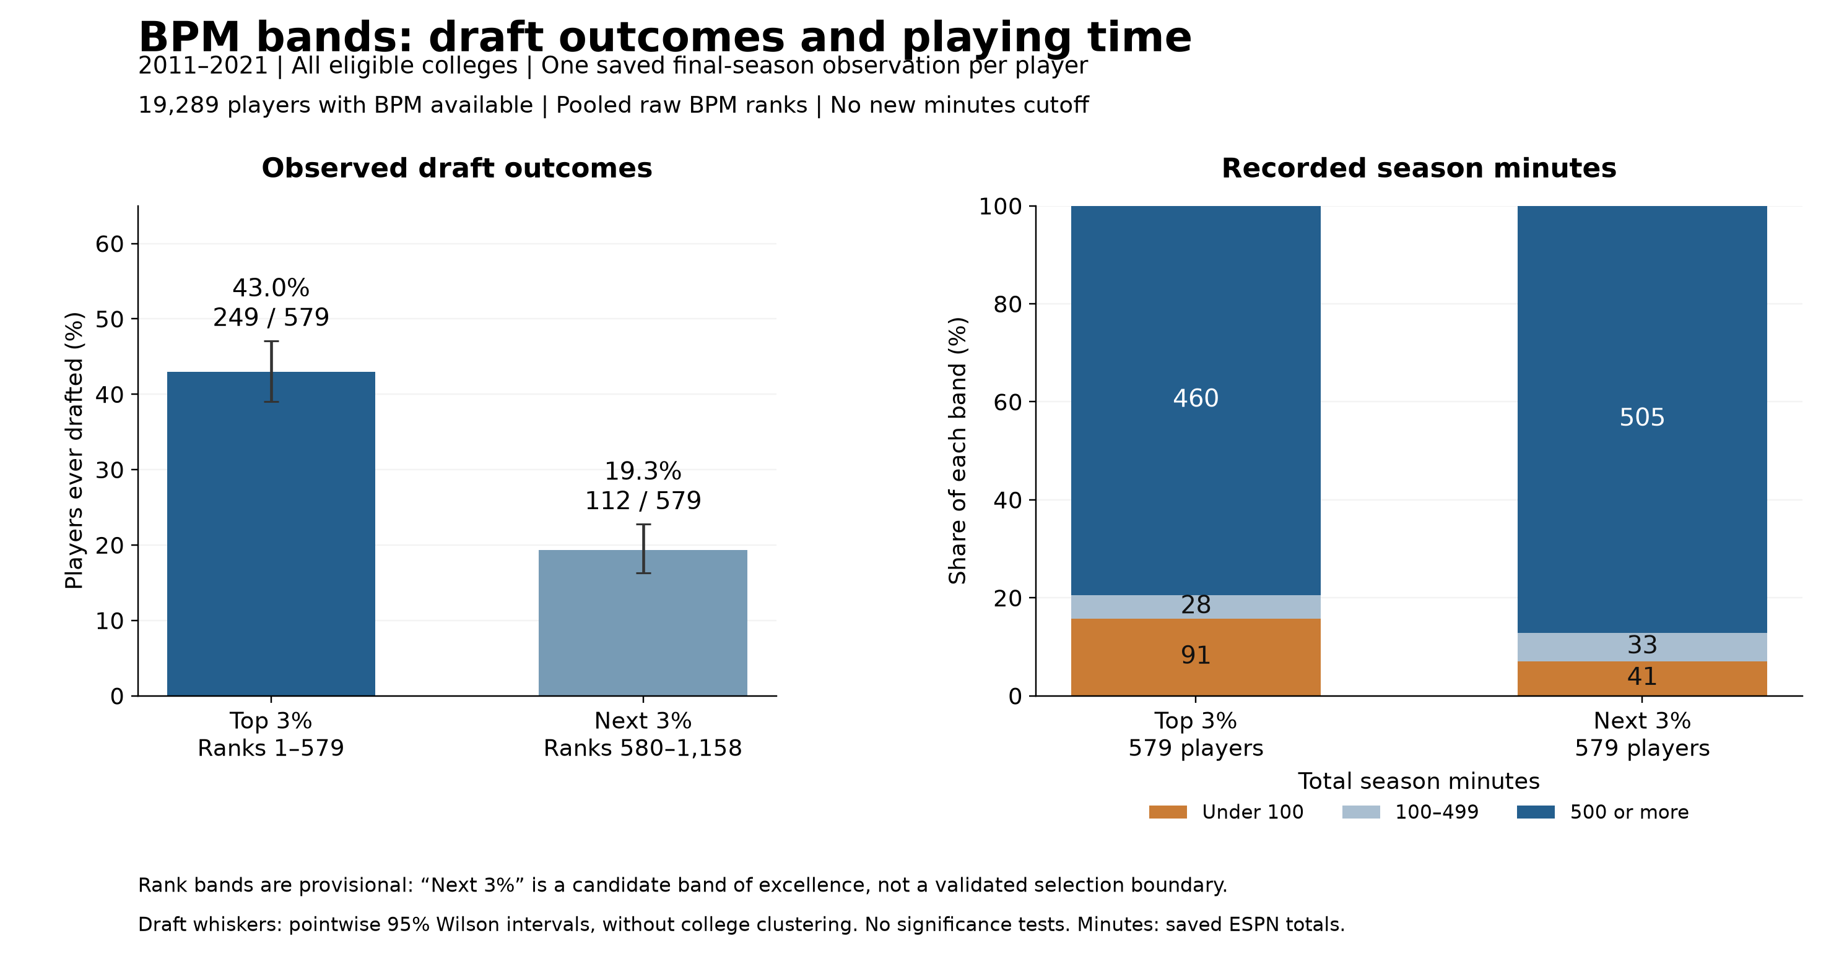
Figure 4. Initial BPM comparison. Each performance band contains 579 distinct players. The left panel shows ever-drafted counts and rates. The right panel shows player counts by recorded season minutes. No new playing-time restriction has been imposed.

What the first comparison shows
The top 3% contains 249 ever-drafted players out of 579, or 43.0%. The next 3% contains 112 out of 579, or 19.3%. The observed gap is 23.7 percentage points. These bands differ in draft outcomes, but neither result by itself establishes an almost-certain-draft group or identifies a selection boundary.
The top band includes 91 players with fewer than 100 recorded season minutes (15.7%), compared with 41 in the next band (7.1%). Most players in both bands have substantial records: their median season minutes are 984 and 963, respectively. BPM has not eliminated the small-minute extremes.
For example, the highest saved BPM is Steve Dulley’s 2020 value of 43.3, based on 23 minutes in both the ESPN and Sports-Reference fields. Zion Williamson’s 2019 value is 20.1 with 990 minutes. The first nine players in the BPM ranking all have fewer than 100 recorded minutes. This is a reason to examine playing-time eligibility before interpreting the upper tier as the best players.

What we have not concluded
This is not yet a controlled comparison showing that BPM outperforms PPM: the metric, band width, and available population differ from earlier entries. Nor have we tested congestion, drawn a new HERO curve, or selected a minimum-minutes rule. The next decision is how much playing-time evidence to require before defining the bands again.

Entry 5 Definitions and decisions to retain
Population: preserve the frozen final-season cohort from Entries 2–4, then retain only records with finite BPM. Do not replace missing final-season BPM with a value from an earlier season. “Final season” means the saved last observed season within the data window, not an independently verified career endpoint.
Coverage step | Players | Ever drafted
Original saved cohort | 22,795 | 615
Excluded 2009–2010 with no BPM | 2,992 | 95
Excluded 2011–2021 with missing BPM | 514 | 10
Available BPM population | 19,289 | 510
BPM coverage within 2011–2021 is 19,289 of 19,803 players (97.4%). The available population’s observed ever-drafted rate is 2.64%; this is not an annual draft quota. All eligible colleges remain included.

Exactly how the bands were defined
Rank the recorded raw BPM values from highest to lowest across all 19,289 available players. This first check uses pooled BPM, without additional within-season standardization or season-specific percentile ranks. Keep the inherited minimum of 20 recorded ESPN season minutes. We chose this simple initial comparison so playing-time problems remain visible before adopting a new restriction.
Take the first ceiling of 3% of N, giving ranks 1–579, as the upper band. Take the next ranks through the ceiling of 6% of N, giving ranks 580–1,158, as the adjacent band. Each contains about 3.002% after rounding. Draft outcomes are not used to assign the bands.
Equal-count ranks retain the established convention of breaking ties by stable source row order. BPM = 8.3 spans the first boundary: 13 of 25 tied players enter the top band and 12 enter the next. BPM = 6.6 spans the second: 17 of 45 tied players enter the next band and 28 fall below it. Consequently, the groups cannot be recreated solely with inclusive numeric BPM cutoffs. The saved ranked player list preserves exact membership.

What was checked and saved
The input snapshot’s file hash matches its saved manifest. Player IDs are unique; the two bands do not overlap. Band and minutes-category totals reconcile. ESPN and Sports-Reference minutes are retained separately; both sources identify 91 top-band and 41 next-band players below 100 minutes. The displayed intervals are descriptive Wilson intervals without college clustering. No significance tests or 4% alternatives were run.
Keep these distinctions: “top 3%” identifies a measured-performance rank; “superstar” is a substantive claim still to validate. “Next 3%” is a candidate band of excellence, not an established draft bubble. A playing-time cutoff must be justified before inspecting which cutoff produces the desired peer-environment curve.
Reproduction files: new_VECTOR_work/manuscript_figures/ncaa_evidence_walkthrough/
compare_bpm_three_percent_bands.py; bpm_band_provenance.json; bpm_band_summary.csv; bpm_coverage_by_season.csv; bpm_available_ranked_population.csv; bpm_top_and_next_3pct_players.csv; bpm_band_minutes_counts.csv; bpm_top_and_next_3pct.png. Added 23 October 2026. Earlier entries and source snapshots remain unchanged.

