Club Choice and Complementary Teams
Study proposal developed by Charles Levine with Leo | 6 October 2026
We propose a family of models that begins with one dimensional talent, expands into interest and skill vectors, and ultimately examines how precisely complementary people might produce exceptional results. The central productivity hypothesis expects different member profiles to work together in unusually effective combinations. Similarity remains useful for explaining attachment to groups.

1 Begin with one dimensional talent
The simplest talent model gives every individual one talent value. A team has a current mean talent, initially set to the population mean while empty. An arriving person can favor teams with nearby means. Rho controls the strength of that homophily preference; prescribed roster sizes constrain the available seats.
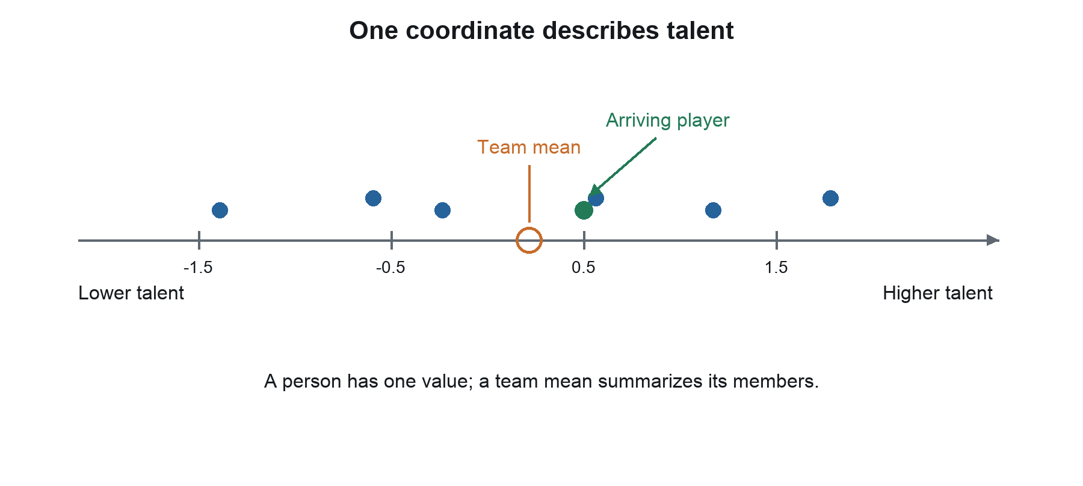
Figure 1. Scalar talent and a team mean. Points and positions are illustrative.
This one dimensional model helps us understand sorting. It leaves open what people are interested in and whether a particular mixture of members accomplishes a mission well. We introduce those features gradually, without making them requirements of the basic scalar model.

2 Five fixed clubs on an interest spectrum
Replace the single talent value with two interest coordinates: math and literature. For the simplest picture, constrain their sum to one. A person with coordinates (0.75, 0.25) leans toward math; (0.25, 0.75) leans toward literature. Two recorded coordinates describe a single degree of freedom in this first example.
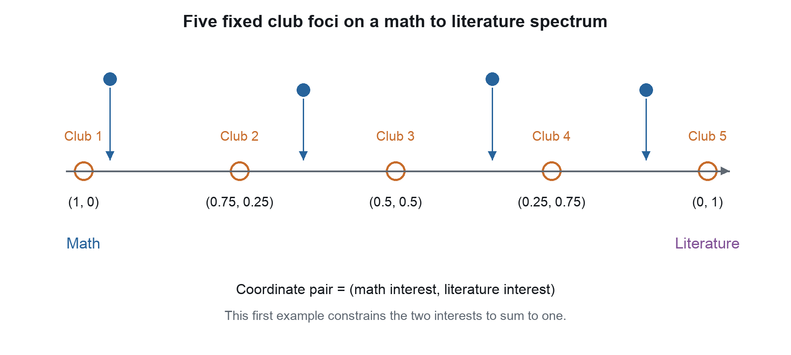
Figure 2. Five fixed clubs span the constrained math and literature spectrum. Arrows illustrate possible choices, not deterministic assignments.

Fixed purposes make the first choice problem simple
The five clubs have permanent foci at the endpoints, quarter points and midpoint. A person can favor nearby club foci through a distance based attachment rule. Club membership changes, but the stated club focus stays fixed. Capacity can still constrain assignment; remaining seats provide opportunities rather than a preference for larger clubs.

The spectrum is a deliberate simplification
A strongly math oriented person need not actually dislike literature. This constrained example imposes a tradeoff so that we can draw the model on a line. Later we remove that restriction and allow both interests to be high or low independently. Interest and proficiency are also distinct: enthusiasm for mathematics need not imply advanced mathematical skill.

3 Three topic anchors in a two dimensional plane
Following the original sketch, place math, history and art anchors in a two dimensional space. Put eight fixed club foci somewhere in quadrant I, where x and y are both positive. An individual occupies a point in the same plane and has a distance to each topic anchor and to each club focus.
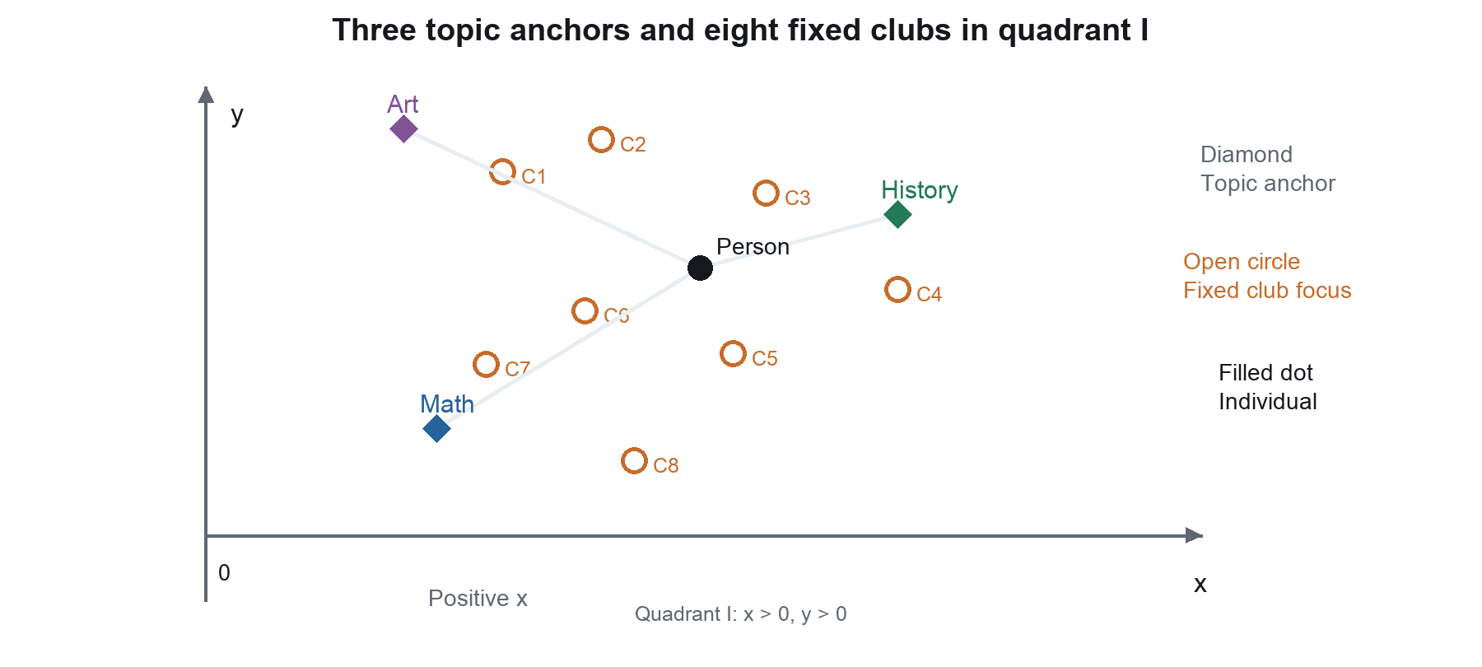
Figure 3. Three fixed topic anchors, eight fixed club foci and one person. All club foci are in quadrant I; coordinates are illustrative.

Topic anchors and club foci have different jobs
The three anchors identify reference interests. The eight club foci identify particular group purposes, such as a club positioned between art and history. Several clubs can share a broad topic while having different foci. Choice among clubs depends on the person and the club foci; distances to topic anchors help interpret that person or club in the interest space.

The axes define a map rather than three independent interests
In this drawing, x and y are abstract coordinates. Their signs carry no positive or negative judgment about people. Three distances derived from two coordinates are geometrically related, so this map cannot express every possible independent combination of three interests. Euclidean distance is a simple illustrative possibility, not a required final metric.

4 Give each interest its own dimension
Now give math, history and art separate coordinates. A person can be strongly interested in all three, weakly interested in all three, or any mixture. These profiles no longer need to sum to one. Add a fourth interest by adding another coordinate; the conceptual model does not depend on our ability to draw every dimension.
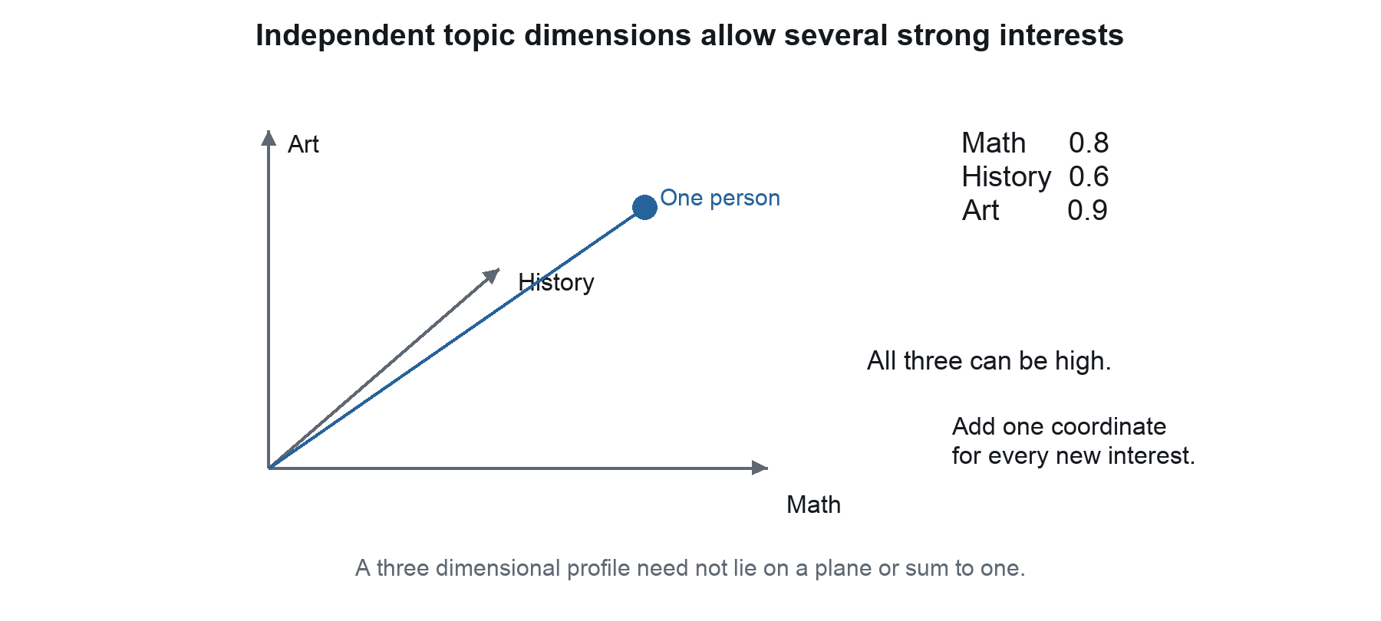
Figure 4. Three independent interest coordinates. The drawing shows the idea of a profile, rather than an exact projection of the displayed numbers.

Pure topic anchors define reference directions
On an illustrative scale from zero to one, a maximum math anchor has math equal to one and the other interests equal to zero. The art and history anchors are defined similarly. These pure anchors describe topic directions; they do not imply that high interest in one topic excludes high interest in another. A person high in all topics can occupy a position away from every pure anchor.

Clubs also receive complete profiles
A fixed club focus is now a vector of its interests or intended emphasis. An interdisciplinary club can be high on several coordinates. Comparison can preserve both the pattern of interests and their intensity. A method that ignores vector magnitude would treat some strongly and weakly interested profiles as equivalent, so that choice must be deliberate.

5 Separate interests from skills and other attributes
A richer individual profile contains several vectors. Interest describes what attracts the person. Skill describes what the person can contribute. Social attributes describe aspects of working with others. Background records training, experience and exposure. These categories can interact without being collapsed into a single undifferentiated number.
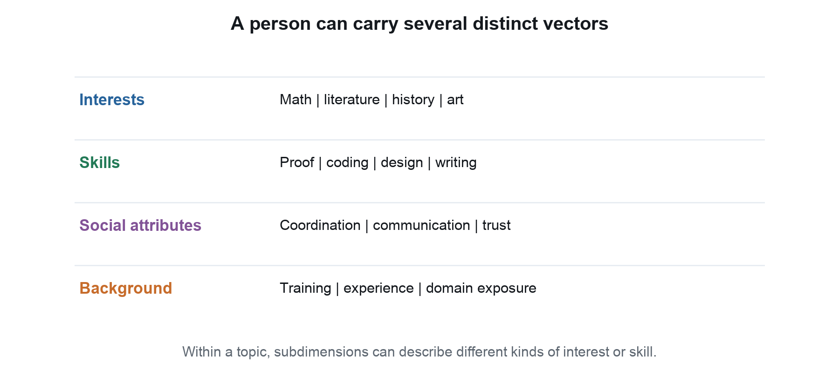
Figure 5. Separate profile blocks illustrate different meanings and possible coordinate types. The listed attributes are proposed examples.

The same topic can contain several distinct abilities
Two people who both score highly in mathematics can differ in proof, computation, modeling and explanation. Artistic ability can include visual design, narrative or performance. A research center may need several kinds of ability within the same broad topic, making a single topic score too coarse for the mission model.

Preserve what the coordinates mean
A club choice mechanism may compare interests; a mission function may draw on skills, social attributes and background. Some features describe proficiency, some preference and some category membership. The earlier vector comparison discussion offers ways to describe resemblance, but its linear combination of similarity scores does not establish productive complementarity. The profile representation and the productivity operation are separate design choices.

6 Let club foci emerge while topic anchors stay fixed
Keep a fixed set of clubs, but remove their permanent assigned foci. Give every empty club a neutral initial focus. Once members arrive, each club focus becomes the running mean of its members' interest vectors. The math, art and history anchors remain fixed references, allowing us to describe where the clubs go.
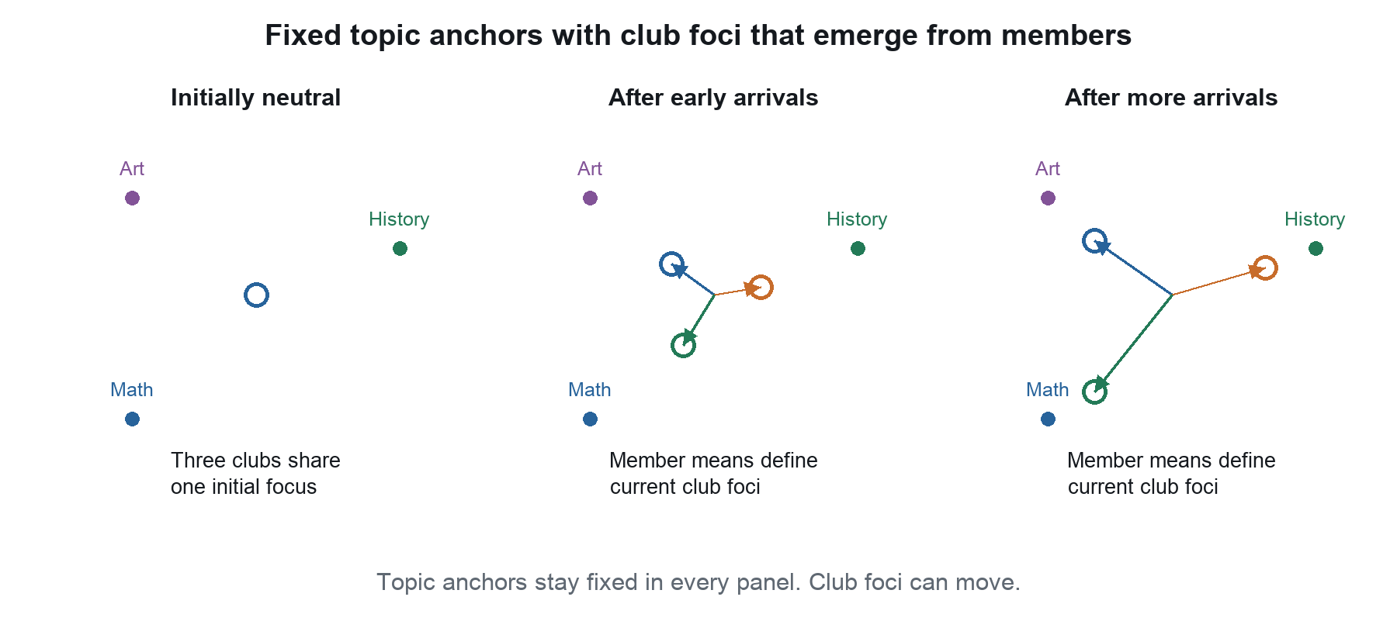
Figure 6. A conceptual sequence with three evolving clubs. Arrows illustrate possible movement of member means, not a simulated trajectory.

Define neutrality before interpreting movement
A neutral initial focus can mean equal topic emphasis or the realized population mean. It need not be the zero vector: on a nonnegative interest scale, zero can mean no interest. We leave the exact neutral initialization open here. The first member replaces the empty placeholder; subsequent members determine the actual member mean.

Similar initial clubs can develop different identities
With identical initial foci and identical capacities, the attachment preference initially cannot distinguish clubs. Tie handling or random assignment gives them their first members. Subsequent choices may reinforce differences as foci move. Whether clubs specialize, remain mixed or cluster together becomes a question for the model. A fixed topic anchor does not automatically exert an additional attraction unless we explicitly add that mechanism.

7 Allow each topic its own internal space
Another expansion gives each broad topic its own coordinate space. A person has a location within mathematics, a location within art and a location within history. These spaces can describe subtopics, styles of interest or kinds of skill. Their dimensions need not match.
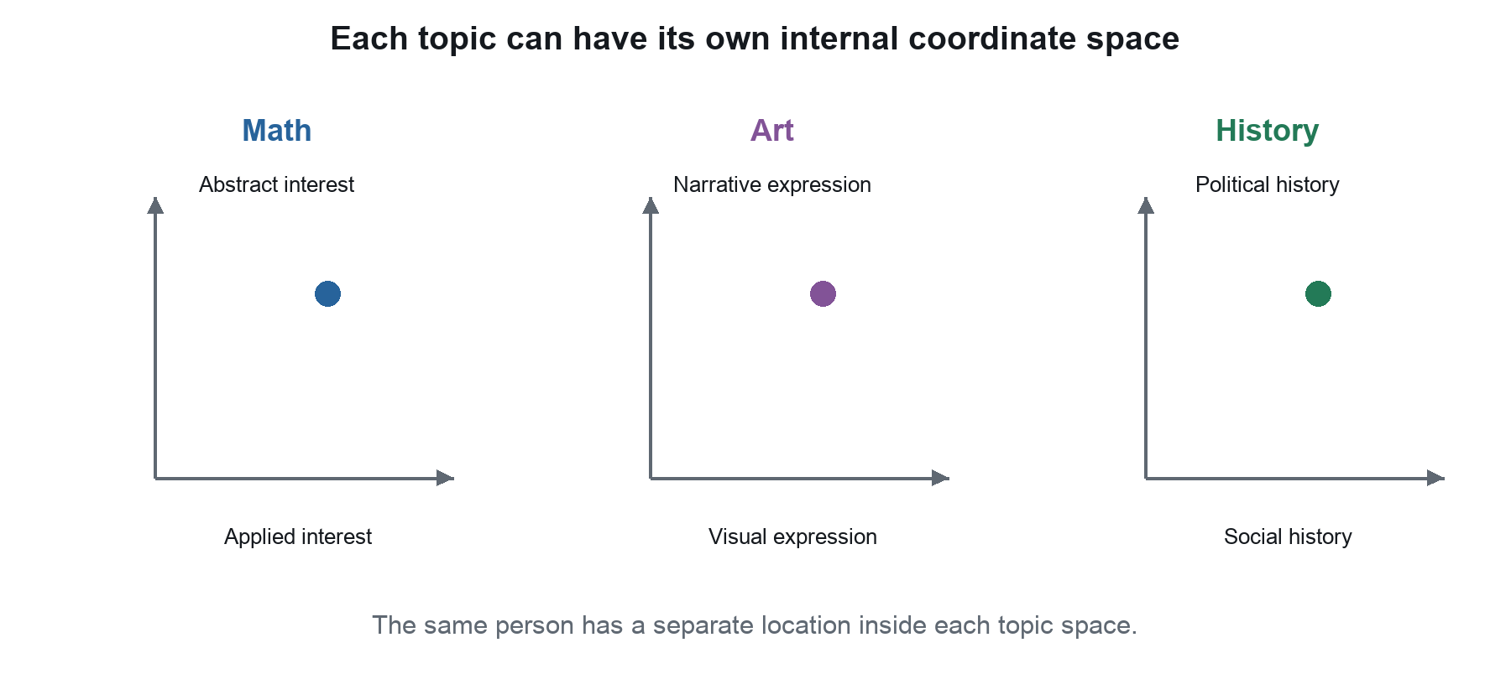
Figure 7. Three topic spaces with example internal axes. These are separate coordinate systems, not three mutually exclusive locations for a person.

Two representations can coexist
A broad topic vector says how much emphasis a person places on math, art and history. Internal topic vectors say what kind of mathematics, art or history the person favors or can practice. A pure maximum math anchor can remain a broad reference while several internal math anchors distinguish particular forms of mathematical focus.

Fixed anchors do not require fixed group identities
Clubs can have fixed internal foci, or their internal foci can evolve as member means. They can also begin neutral in each space. This extends the previous mechanism without forcing a new interpretation of club count. The number of clubs, the number of topics and the number of coordinates within a topic are separate quantities. The model can preserve several group summaries while retaining all individual vectors for later productivity analysis.

8 Move from club preference to mission requirements
A mission introduces a new question: what can this collection of people accomplish? The simplest mission model specifies desired coverage, such as enough mathematical, artistic and social capability. Headcounts of broad types are a useful first approximation, but the full vectors distinguish people within those types.
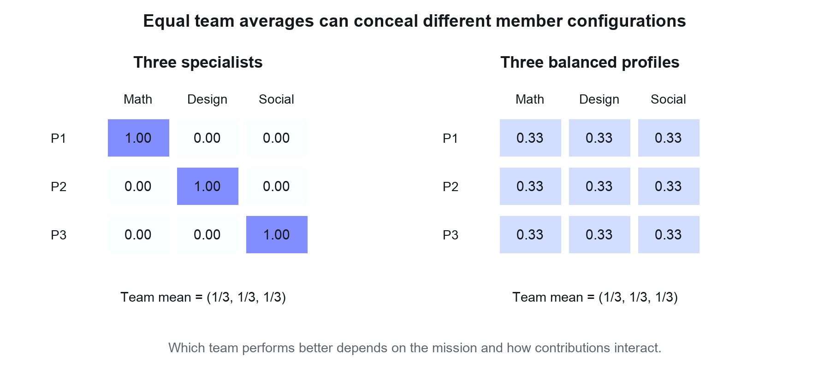
Figure 8. Illustrative teams have identical means and total attribute coverage, but different member profiles. Neither team is assumed universally superior.

A team mean loses information about who contributes what
The left team concentrates each capability in a specialist. The right team spreads all three capabilities evenly. Both have the same coordinate totals and means. A mission needing deep specialist expertise could favor the first configuration; a mission needing interchangeable generalists could favor the second. A centroid alone cannot distinguish them.

Mission requirements and attachment preferences can differ
An individual can prefer an interest compatible club even when another team would benefit more from that person's abilities. A mission allocation model could value the contribution a person adds to the existing configuration. That contribution may come from a very different vector than those already on the team. This is a separate mechanism from homophily, even if both operate in the same model.

9 Develop a function for complementary productivity
The central hypothesis is that particular combinations of dissimilar member vectors can activate one another's contributions. We expect productive differences to matter. A team may contain individually capable people and produce ordinary results, while a rare configuration makes those capabilities useful together in a much more powerful way.
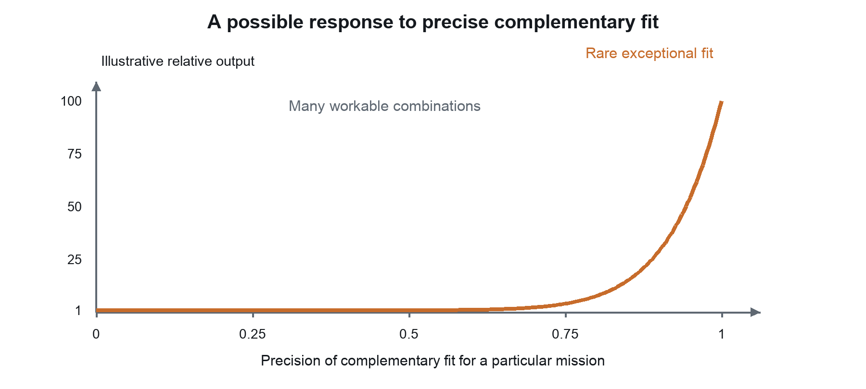
Figure 9. An invented response curve illustrates the hypothesis of a narrow region of exceptional fit. Its shape and hundredfold upper value are assumptions for illustration, not evidence or a calibrated prediction.

Build the productivity operation in stages
Begin with separate contributions added together. Next allow two contributions to reinforce each other. Then allow a three person combination to create value that no pair can create alone. Multiplication is one possible operation: if several enabling contributions must be present, a weak factor can limit the result. Other nonlinear functions can represent thresholds, saturation or a narrow region of exceptional fit.

Alignment describes complementary relationships
The mission function acts on the complete collection of member vectors, potentially including working relationships and role assignments. Similarity scores do not specify that function. Neither does dissimilarity alone guarantee value. The hypothesis concerns precise, mission specific complementarity. Extremely large gains are a possibility to explore; a function chosen to generate them establishes a model behavior rather than proving that real teams behave that way.

10 Preserve the idea as a standalone exploration
This proposal develops a standalone conceptual family of models for group choice and complementary productivity. Fixed club foci, evolving member means and mission accomplishment can each be explored on their own. The examples provide ways to think about the idea, while leaving its eventual application open.
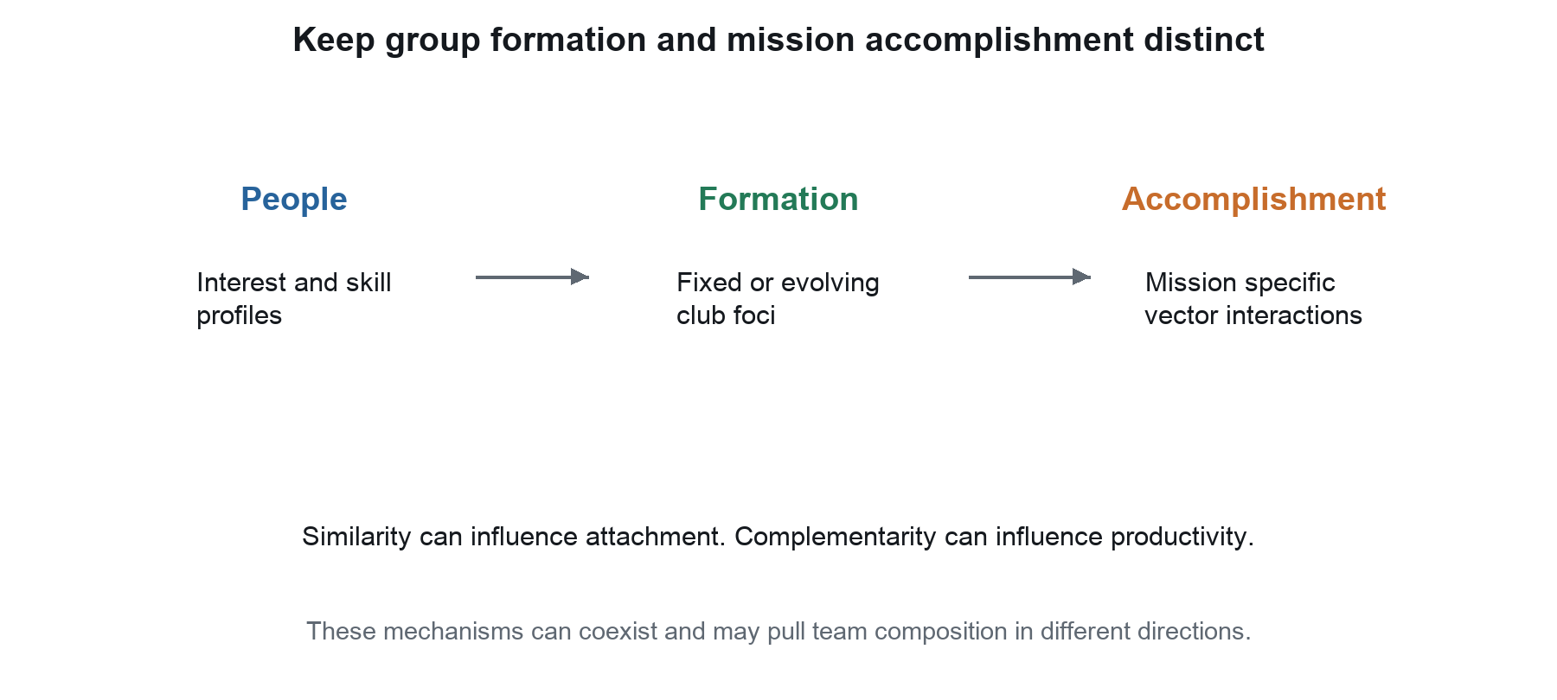
Figure 10. The conceptual sequence separates individual profiles, group formation and mission accomplishment.

The progression preserves distinct scientific questions
First examine scalar sorting. Next examine choice among five fixed clubs on a two interest spectrum, then eight fixed clubs among three anchors in a two dimensional plane. Remove geometric tradeoffs by adding independent topic dimensions. Introduce richer profile blocks and internal topic spaces. Then let club identities emerge from neutral beginnings. Finally evaluate mission coverage and interactions among the complete member vectors.

The proposal seeks an explanation for rare exceptional teams
The startup example motivates a possible pattern: many combinations fail or perform modestly, while a very small fraction achieve extraordinary outcomes. The conceptual question is whether a narrow set of complementary configurations helps explain that difference. We leave empirical sources and practical study design for later discussion. Similarity may draw people together even when a mission benefits from precisely arranged differences.

Source ideas
Charles Levine's club_choice_spectrum.pdf supplies the initial spatial sketch. The discussion in vector_comparison_discussion.pdf supplies comparison concepts, with similarity distinguished here from complementarity. The diagrams and later stages develop Charles's ideas from this conversation. Numeric positions, scales and response shapes in this document are illustrative.

