NCAA evidence walkthrough
A continuing reading record • Started 23 October 2026
We will recover the evidence one plot at a time. Each entry keeps the figure, its population and settings, a plain-English reading, and the questions or decisions from our discussion. This first entry revisits an existing plot; it does not run a new analysis.

Entry 1 The original performance band overlay
Question: Among players in the same performance range, how does the observed draft rate vary across teams with different mean performance?
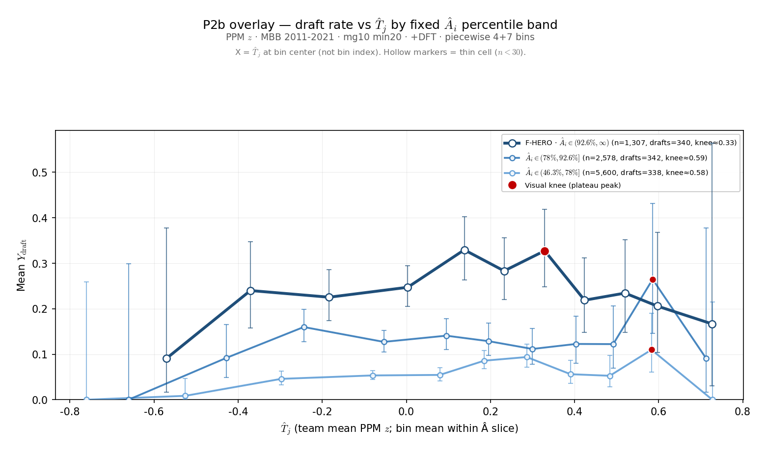
Figure 1. Original saved overlay from 24 August 2026. Each blue line represents a different range of individual performance. The horizontal axis is the full-team mean, including the focal player.

Start by following one line
The darkest line contains the highest of the three performance bands. Moving right means comparing observations from teams with higher mean performance. Moving up means a larger fraction of those observations belongs to players labeled ever drafted.
We are comparing different players and seasons within a performance band. We are not following one player as he moves between teams, and we are not holding individual performance at one exact value.

Entry 1 What went into this figure
Population: NCAA men’s basketball, 2011–2021, player-season observations at colleges represented by a draftee in the analysis window. The saved settings use at least 20 recorded minutes per player-season and the team-game setting mg10; the current source code implements that as more than 10 recorded team-season games.
Performance: points per minute, standardized within season. The horizontal measure is the full-team mean of that performance. This figure uses neither leave-one-out performance nor sigmoid roster pressure, so theta, gamma, lambda, and selection temperature do not generate its curves.
Binning: 11 bins per line, using four coarser lower-range bins and seven finer upper-range bins. Edges are calculated separately within each performance band. This is neither equal-count quantile binning nor one common equal-width grid. Points are placed at the mean team performance in each bin.

The three colors and their counts
Line and percentile range | Rows | Ever-drafted rows | Rate
Dark: 92.6–100 | 1,307 | 340 | 26.0%
Middle: 78–92.6 | 2,578 | 342 | 13.3%
Light: 46.3–78 | 5,600 | 338 | 6.0%
These are player-season counts, not distinct drafted people. The same player can contribute in multiple seasons. Percentile bands describe measured performance; they do not establish “superstars” or a draft bubble.

What we can see and what remains open
The darkest line is generally above the other two. It rises to roughly 33% and is lower farther right, but the last point is only 1 ever-drafted-positive observation out of 6. The middle and light lines are irregular. The saved red dots are visual plateau markers, not statistically established turning points.
This is a useful picture of the question we want to investigate. It does not by itself show that stronger teammates cause lower draft prospects, or that the apparent downturn is statistically reliable. No new significance test has been run for this entry.

Our place in the discussion
Agreed on 23 October: the historical top 7.4% band is a useful exploratory slice, but it was not validated as a group of draft “locks” or players near the selection boundary. Before replacing it, we will examine observed draft rates against individual performance. Band definitions and the main peer measure remain open.
Source locator: 3-Master_Plan/re_entry/HEROs_and_PASSes/basic_data_plots/
CCT_P2b_ai_band_overlay_lines.png, with matching CCT_P2b_ai_band_overlay.json and CCT_P2b_ai_band_overlay_sweep.csv. Generator: sports/scripts/cct_p2b_ai_band_overlay.py. Saved values checked against companion files; historical raw-data reconstruction remains pending.

Entry 2 Own performance and draft outcomes
Question: Does a high value of our performance measure identify players who are almost certain to be drafted? First, we return to the own-performance plot used in the lab presentation.
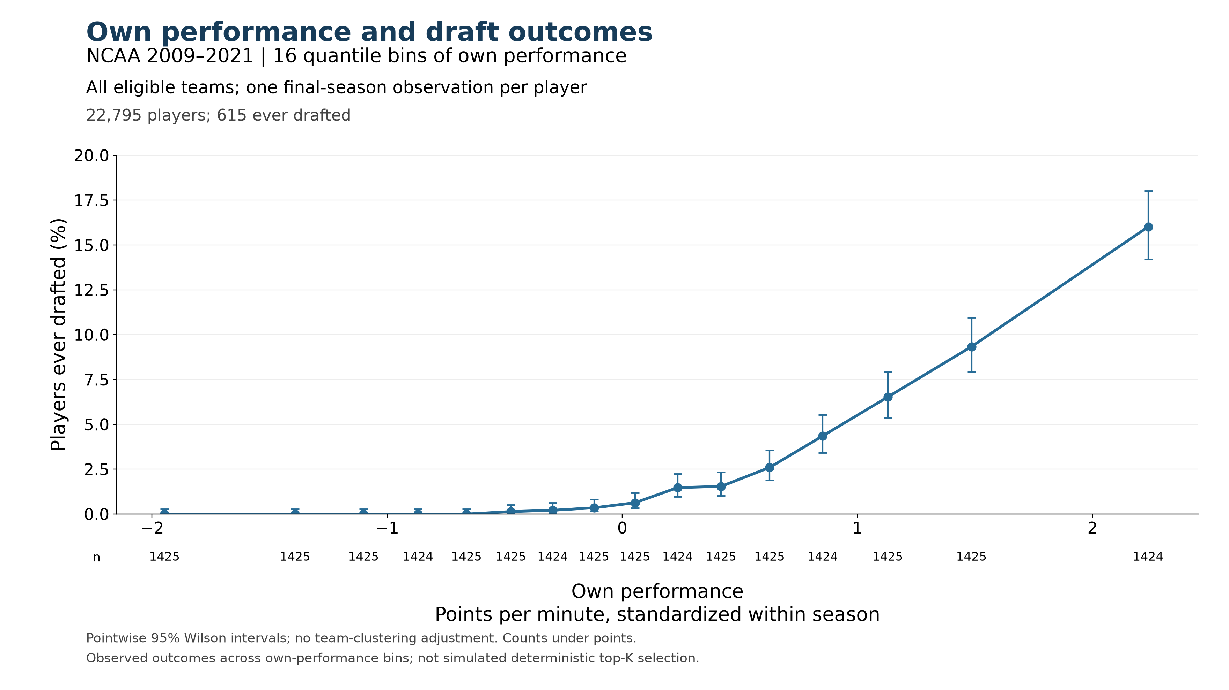
Figure 2. Existing empirical plot, with saved values unchanged. Points show ever-drafted rates in 16 approximately equal-count performance bins. Horizontal positions are bin means; the highest point represents roughly the top 6.25%, not one exact performance value.

What the highest point tells us
Higher own performance is associated with higher draft rates in this plot. In the highest bin, 228 of 1,424 players were ever drafted, or 16.0%. That broad upper band is therefore far from an almost-certain-selection group. Its average does not tell us whether a much narrower extreme tail has a substantially higher rate.

Keep the population distinction visible
This figure uses 2009–2021, all eligible colleges, and one final-season observation per player: 22,795 players, including 615 ever drafted (2.70%). Entry 1 used 2011–2021, draftee colleges, and all eligible player-seasons. The 16% here and 26% in Entry 1 are not a controlled comparison of band cutoffs.
Performance is points per minute standardized within season. The saved analysis uses at least 20 recorded minutes per player-season and more than 10 recorded team-season games. The overall 2.70% is an observed cohort outcome rate, not an annual draft quota or an automatic performance cutoff.
Next question: What happens inside this highest bin? We have not yet chosen replacement bands or assumed that points per minute alone will identify draft locks.
Source locator: new_VECTOR_work/lab_presentation_20261022/empirical_ncaa_2009_2021/
ncaa_naive_2009_2021_own_performance.png; naive_plotted_bins.csv; naive_provenance.json. Source counts checked: 22,795 players and 615 ever drafted. Existing intervals are pointwise Wilson intervals without college clustering; no new significance test was run.

Entry 3 A closer look inside the highest bin
We divided the highest performance bin from Entry 2 into eight equal-count groups. Each contains 178 distinct players, ordered by their own performance. The cohort, performance values, and ever-drafted labels are unchanged.
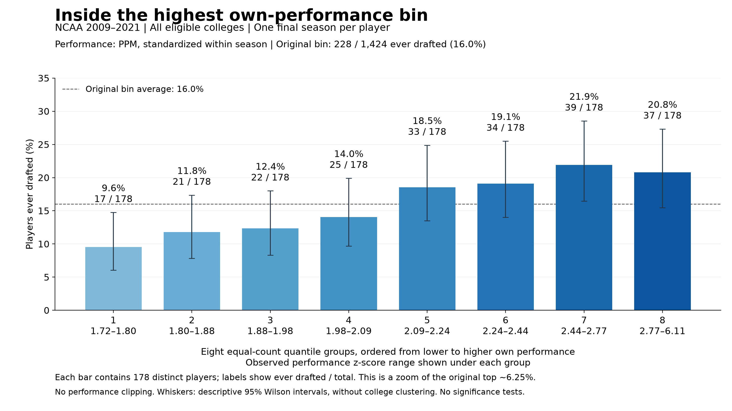
Figure 3. Eight quantile groups within the original highest bin. Each bar is a separate set of players, not a cumulative top-percent group. Counts above the bars are players ever drafted divided by total players. The dashed line is the original bin’s 16.0% average.

How to read the result
Follow the bars from left to right. The first contains the lowest performances within the original highest bin: 17 of 178 players were ever drafted, or 9.6%. Rates generally rise as performance increases. The seventh group reaches 39 of 178, or 21.9%, and the highest group contains 37 of 178, or 20.8%.
The final decrease amounts to two players among equally sized groups. We have not tested whether it reflects a systematic downturn. The main finding at this resolution is that none of these high-performance groups has a draft rate close to certainty.

What this changes in our thinking
Narrowing the broad upper performance band did not reveal an obvious group of draft locks in these eight slices. This does not rule out a smaller subset with a much higher rate. It does mean that we should not equate extreme points per minute with nearly guaranteed drafting without checking the actual outcomes.
The highest group is approximately the top 0.78% of the full cohort, with observed standardized performance from 2.77 to 6.11. That wide performance range remains grouped into one bar. We have not chosen new superstar or selection-boundary bands from this plot.

Entry 3 Counts and reproducible settings
These eight rows partition the exact 1,424 players in Entry 2’s highest bin. The total is still 228 ever drafted and 1,196 not drafted. Each player appears once.
Group | Observed PPM z range | Players | Ever drafted | Draft rate
1 | 1.717 to 1.796 | 178 | 17 | 9.6%
2 | 1.796 to 1.878 | 178 | 21 | 11.8%
3 | 1.878 to 1.976 | 178 | 22 | 12.4%
4 | 1.976 to 2.088 | 178 | 25 | 14.0%
5 | 2.089 to 2.237 | 178 | 33 | 18.5%
6 | 2.238 to 2.438 | 178 | 34 | 19.1%
7 | 2.443 to 2.773 | 178 | 39 | 21.9%
8 | 2.773 to 6.114 | 178 | 37 | 20.8%
Total | 1.717 to 6.114 | 1,424 | 228 | 16.0%
Ranges show observed minimum and maximum values rounded to three decimals. They are not equal-width intervals; each group contains the same number of players.

What stayed fixed
NCAA men’s basketball, 2009–2021; all eligible colleges; one final-season observation per player; at least 20 recorded minutes per player-season; more than 10 recorded team-season games. The full cohort contains 22,795 players and 615 ever drafted. Performance is points per minute standardized within season, retaining the historical values. No own-performance clipping is applied.

How the split was checked
The stored player-level snapshot passed its saved file-hash check. Rebinning its own-performance values reproduced the counts, drafted counts, and mean performance in all 16 original bins. We then ranked only the players in bin 16 and divided them into eight equal-count groups. Source row order resolves ties; no tied values straddle the seven new boundaries.
The whiskers are descriptive pointwise 95% Wilson intervals. They do not account for college clustering. No significance tests, congestion-score changes, fitted parameters, or simulated selections were used. This is an observed own-performance relationship; peer composition is not held fixed.

Our place in the discussion
Completed: inspect the broad upper bin more closely before naming replacement performance bands. Finding: draft rates generally rise across these slices, but even the highest slice is far from certain selection. Open: whether PPM alone can identify the conceptual superstar and borderline groups we want to compare across peer environments.
Source locator: new_VECTOR_work/manuscript_figures/ncaa_evidence_walkthrough/
highest_bin_draft_rates.png; highest_bin_counts.csv; highest_bin_provenance.json; zoom_highest_performance_bin.py. Input snapshot: manuscript_figures/section_4_5/roster_pressure_comparison/cache/last.pkl. Analysis and discussion entry added 23 October 2026.

Entry 4 How much did the highest group play
Charles asked whether some extreme points-per-minute values came from players who barely played. Yes: 44 of the 178 players in Entry 3’s highest group had fewer than 100 recorded minutes for their entire season. That is 24.7% of the group. Of those 44, 39 had fewer than 50 minutes.

Recorded season minutes in the same 178 players
Season minutes | Players | Ever drafted
20–49 | 39 | 0
50–99 | 5 | 1
100–499 | 19 | 3
500–999 | 55 | 10
1000+ | 60 | 23
Total | 178 | 37
The median was 851 recorded season minutes; the range was 20 to 1,336. Thus the group contains both very small samples and substantial playing records. Counts are distinct players, and draft status is the existing ever-drafted label.

The most extreme values illustrate the problem
The highest standardized performance belonged to Devonte Fuller in 2018: 37 recorded points in 34 minutes, giving 1.088 points per minute. The next two were Caleb Woods in 2015, with 18 points in 21 minutes, and Tariq Ingraham in 2021, with 22 points in 25 minutes. Stephen Curry’s 2009 record, fourth in this ordering, contained 974 points in 1,145 minutes. Their scoring rates rest on very different amounts of playing time.

What we can conclude now
PPM measures scoring rate, not overall basketball quality. A handful of scoring events can produce an extreme rate when the denominator is small. Standardizing PPM within season changes its scale but does not give a 25-minute record the reliability of a full season. The current minimum of 20 total season minutes admits these small samples.
For a descriptive check within this fixed group, the 44 players below 100 minutes include 1 ever drafted. The other 134 include 36 ever drafted, or 26.9%, compared with 20.8% for all 178. Small samples account for part of the low observed rate, but this simple exclusion still does not produce a near-certain-draft group. The 100-minute split is a diagnostic, not a newly adopted eligibility rule.
Low recorded minutes do not themselves mean low ability: James Wiseman’s saved 2020 record contains 69 minutes and an ever-drafted label of 1. We also have not checked these season totals against complete external records; missing source coverage and limited actual participation remain distinct possibilities.
Record of this step: inspected the same saved 178-player group; verified PPM equals recorded points divided by minutes. No cohort changes, rebinning, restandardization, or significance tests. Full player list and counts: new_VECTOR_work/manuscript_figures/ncaa_evidence_walkthrough/highest_group_player_minutes.csv and highest_group_minutes_summary.csv; method and source hash in highest_group_minutes_provenance.json. Added 23 October 2026.

Entry 5 Testing two narrower BPM bands
Why this step: Charles proposed trying Box Plus/Minus (BPM) with a narrower upper tier and a band of excellence immediately below it. We agreed to begin with the top 3% and the next 3%, then inspect their observed draft rates and playing time before drawing peer-environment curves. These labels are provisional.
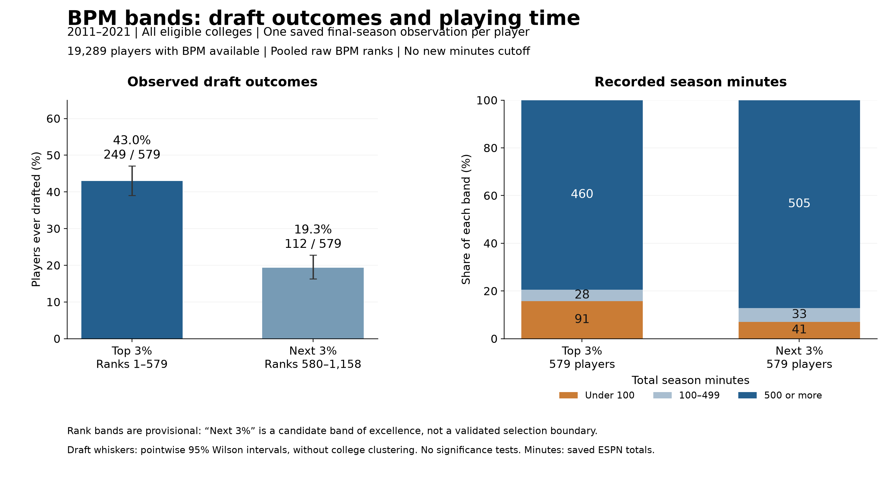
Figure 4. Initial BPM comparison. Each performance band contains 579 distinct players. The left panel shows ever-drafted counts and rates. The right panel shows player counts by recorded season minutes. No new playing-time restriction has been imposed.

What the first comparison shows
The top 3% contains 249 ever-drafted players out of 579, or 43.0%. The next 3% contains 112 out of 579, or 19.3%. The observed gap is 23.7 percentage points. These bands differ in draft outcomes, but neither result by itself establishes an almost-certain-draft group or identifies a selection boundary.
The top band includes 91 players with fewer than 100 recorded season minutes (15.7%), compared with 41 in the next band (7.1%). Most players in both bands have substantial records: their median season minutes are 984 and 963, respectively. BPM has not eliminated the small-minute extremes.
For example, the highest saved BPM is Steve Dulley’s 2020 value of 43.3, based on 23 minutes in both the ESPN and Sports-Reference fields. Zion Williamson’s 2019 value is 20.1 with 990 minutes. The first nine players in the BPM ranking all have fewer than 100 recorded minutes. This is a reason to examine playing-time eligibility before interpreting the upper tier as the best players.

What we have not concluded
This is not yet a controlled comparison showing that BPM outperforms PPM: the metric, band width, and available population differ from earlier entries. Nor have we tested congestion, drawn a new HERO curve, or selected a minimum-minutes rule. The next decision is how much playing-time evidence to require before defining the bands again.

Entry 5 Definitions and decisions to retain
Population: preserve the frozen final-season cohort from Entries 2–4, then retain only records with finite BPM. Do not replace missing final-season BPM with a value from an earlier season. “Final season” means the saved last observed season within the data window, not an independently verified career endpoint.
Coverage step | Players | Ever drafted
Original saved cohort | 22,795 | 615
Excluded 2009–2010 with no BPM | 2,992 | 95
Excluded 2011–2021 with missing BPM | 514 | 10
Available BPM population | 19,289 | 510
BPM coverage within 2011–2021 is 19,289 of 19,803 players (97.4%). The available population’s observed ever-drafted rate is 2.64%; this is not an annual draft quota. All eligible colleges remain included.

Exactly how the bands were defined
Rank the recorded raw BPM values from highest to lowest across all 19,289 available players. This first check uses pooled BPM, without additional within-season standardization or season-specific percentile ranks. Keep the inherited minimum of 20 recorded ESPN season minutes. We chose this simple initial comparison so playing-time problems remain visible before adopting a new restriction.
Take the first ceiling of 3% of N, giving ranks 1–579, as the upper band. Take the next ranks through the ceiling of 6% of N, giving ranks 580–1,158, as the adjacent band. Each contains about 3.002% after rounding. Draft outcomes are not used to assign the bands.
Equal-count ranks retain the established convention of breaking ties by stable source row order. BPM = 8.3 spans the first boundary: 13 of 25 tied players enter the top band and 12 enter the next. BPM = 6.6 spans the second: 17 of 45 tied players enter the next band and 28 fall below it. Consequently, the groups cannot be recreated solely with inclusive numeric BPM cutoffs. The saved ranked player list preserves exact membership.

What was checked and saved
The input snapshot’s file hash matches its saved manifest. Player IDs are unique; the two bands do not overlap. Band and minutes-category totals reconcile. ESPN and Sports-Reference minutes are retained separately; both sources identify 91 top-band and 41 next-band players below 100 minutes. The displayed intervals are descriptive Wilson intervals without college clustering. No significance tests or 4% alternatives were run.
Keep these distinctions: “top 3%” identifies a measured-performance rank; “superstar” is a substantive claim still to validate. “Next 3%” is a candidate band of excellence, not an established draft bubble. A playing-time cutoff must be justified before inspecting which cutoff produces the desired peer-environment curve.
Reproduction files: new_VECTOR_work/manuscript_figures/ncaa_evidence_walkthrough/
compare_bpm_three_percent_bands.py; bpm_band_provenance.json; bpm_band_summary.csv; bpm_coverage_by_season.csv; bpm_available_ranked_population.csv; bpm_top_and_next_3pct_players.csv; bpm_band_minutes_counts.csv; bpm_top_and_next_3pct.png. Added 23 October 2026. Earlier entries and source snapshots remain unchanged.

Entry 6 BPM and the peer environment
Why this step: Charles asked whether the performance measure and our broad upper tier had obscured the pattern of interest. We now carry the top 3% and next 3% BPM bands from Entry 5 into the shared-versus-leave-one-out roster-pressure comparison. The first result does not reveal a stronger downturn: the high-pressure region has a higher draft rate than the middle region in both bands under the declared settings.
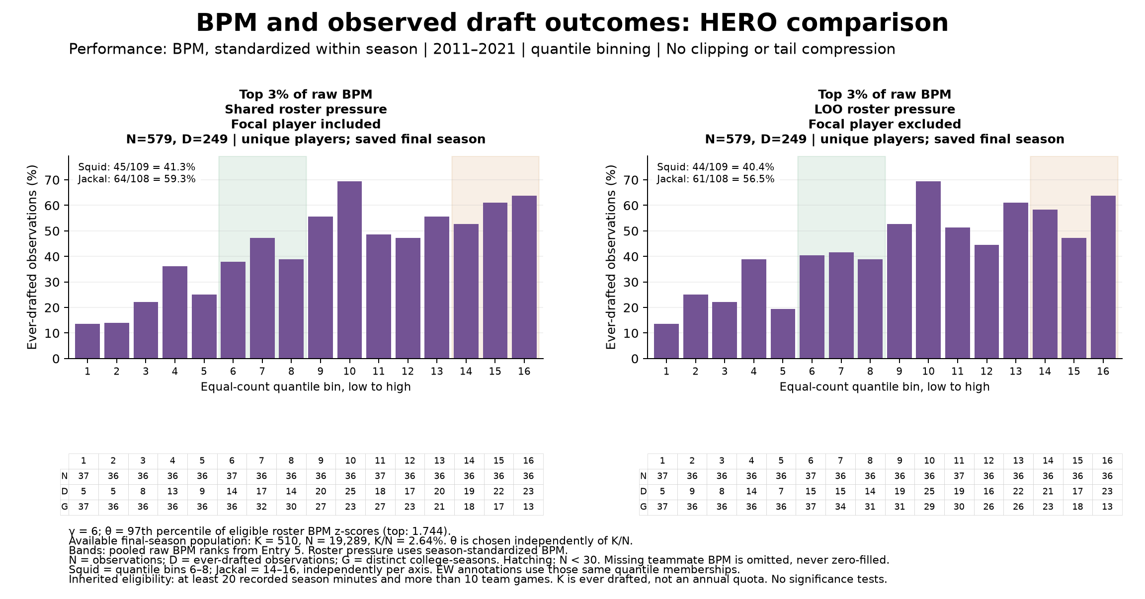
Figure 5. Top 3% of raw BPM, 579 distinct players. Shared pressure includes the focal player; LOO pressure excludes that player. Both charts use equal-count quantile bins. N, D and G report players, ever-drafted players and distinct college-seasons.

Start with the top band
Overall, 249 of these 579 players were ever drafted, or 43.0%, exactly as in Entry 5. For shared pressure, the middle region called Squid contains 45 drafted players out of 109 (41.3%); the far-right region called Jackal contains 64 out of 108 (59.3%). For LOO pressure, the corresponding figures are 44 of 109 (40.4%) and 61 of 108 (56.5%).
There are local rises and falls. Both versions peak at bin 10, with 25 of 36 players drafted (69.4%), and finish at 23 of 36 (63.9%). That small peak-to-final-bin difference is not the pronounced right-tail collapse we were looking for. No significance test has been run, and choosing a peak after inspecting these bars remains a separate inferential issue.
The paired charts use exactly the same focal players. However, removing a player from the group average can move that player to another environmental bin. Squid and Jackal therefore need not contain the same identities on the two axes. Their definitions remain quantile bins 6–8 and 14–16, respectively.

Entry 6 The adjacent band and our next decision
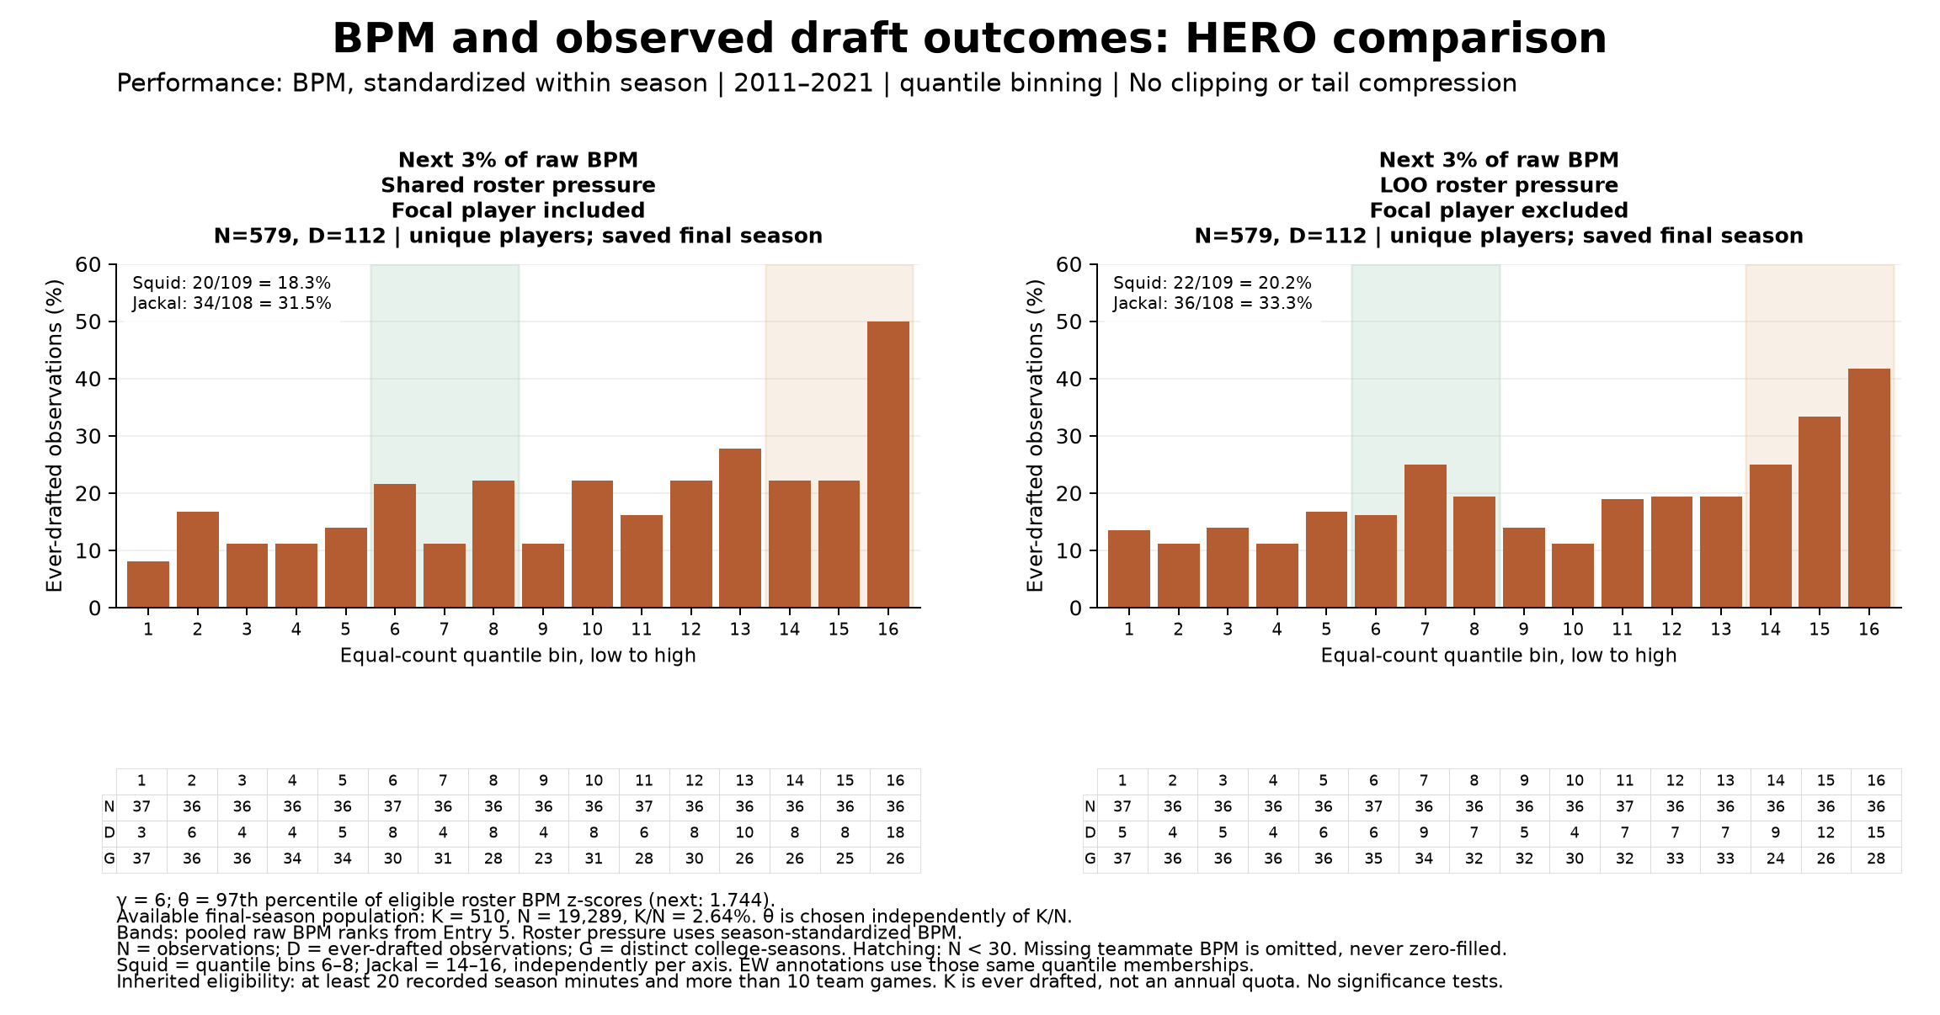
Figure 6. The next 3% of raw BPM, another 579 distinct players. The two performance bands do not overlap. These bars describe observed draft outcomes; they are not probabilities generated by the scoring and selection model.
In this band, 112 of 579 players were ever drafted (19.3%). Shared pressure gives 20 of 109 (18.3%) in Squid and 34 of 108 (31.5%) in Jackal. LOO pressure gives 22 of 109 (20.2%) and 36 of 108 (33.3%). The last bin is the highest in both paired charts: 18 of 36 (50.0%) for shared pressure and 15 of 36 (41.7%) for LOO pressure.

Definitions that keep this comparison reproducible
The band memberships still use pooled raw BPM ranks from Entry 5. Environmental calculations use BPM standardized within each season over the available eligible full rosters, with sample standard deviation. Competitive relevance uses gamma = 6 and theta at the 97th percentile of those roster z-scores, giving theta = 1.7442. We average relevance before selecting either focal band. Gamma and theta remain chosen settings, not fitted values.
The effective window is 2011–2021 because the saved 2009–2010 records lack BPM. The available final-season population is N = 19,289 and K = 510 ever-drafted players, so K/N = 2.64%. Theta is chosen independently of that rate. The baseline eligibility remains at least 20 recorded season minutes and more than 10 team games. Missing teammate BPM is omitted, not zero-filled: 4,301 focal players have at least one missing teammate, including 103 in the top band and 97 in the next. No focal observations were lost to undefined LOO.
We have not resolved the playing-time issue: 91 top-band and 41 next-band players still have fewer than 100 recorded season minutes. Nor is this a metric-only comparison with the old PPM figures, because coverage, band definitions and the high-band observation unit differ. The notebook retains a historical-band option, but matching populations and years would still be needed to isolate the metric change.
Saved and checked: the BPM companion notebook, quantile and equal-width mosaics, six paired HERO figures, counts, player memberships and an eight-page printable comparison PDF. Independent peer-mean calculations and all bin totals passed checks. No new minutes cutoff, parameter sweep or significance test was added. The original PPM notebook and runs remain intact. Added 25 October 2026.
Reproduce from manuscript_figures/section_4_5/roster_pressure_comparison/NCAA_Shared_vs_LOO_Roster_Pressure_BPM.ipynb. Run: 20261025_180439_473151. Change settings in Section 1, set REBUILD_FIGURES = True, then Run All. Counts and method details are saved with each run.

Entry 7 Aligning the threshold and performance bands
Why this step: Charles proposed making the first performance band correspond to the threshold, then examining two wider bands below it. We start with BPM alone: top 2%, top 10% excluding top 2%, and top 30% excluding top 10%. The same final-season candidate population and season-standardized BPM values now define both theta and the bands. This is a separate experiment; the prior notebooks and results remain available.
The alignment works exactly at these settings. Theta is 2.0315, the 98th percentile of 19,289 candidates. Exactly 386 candidates exceed it and none equal it. These are the top-band players, of whom 191 were ever drafted (49.5%). Gamma remains 6. Theta is chosen, not fitted or calculated from K/N; K = 510 and K/N = 2.64% describe ever-drafted candidates, not an annual draft quota.
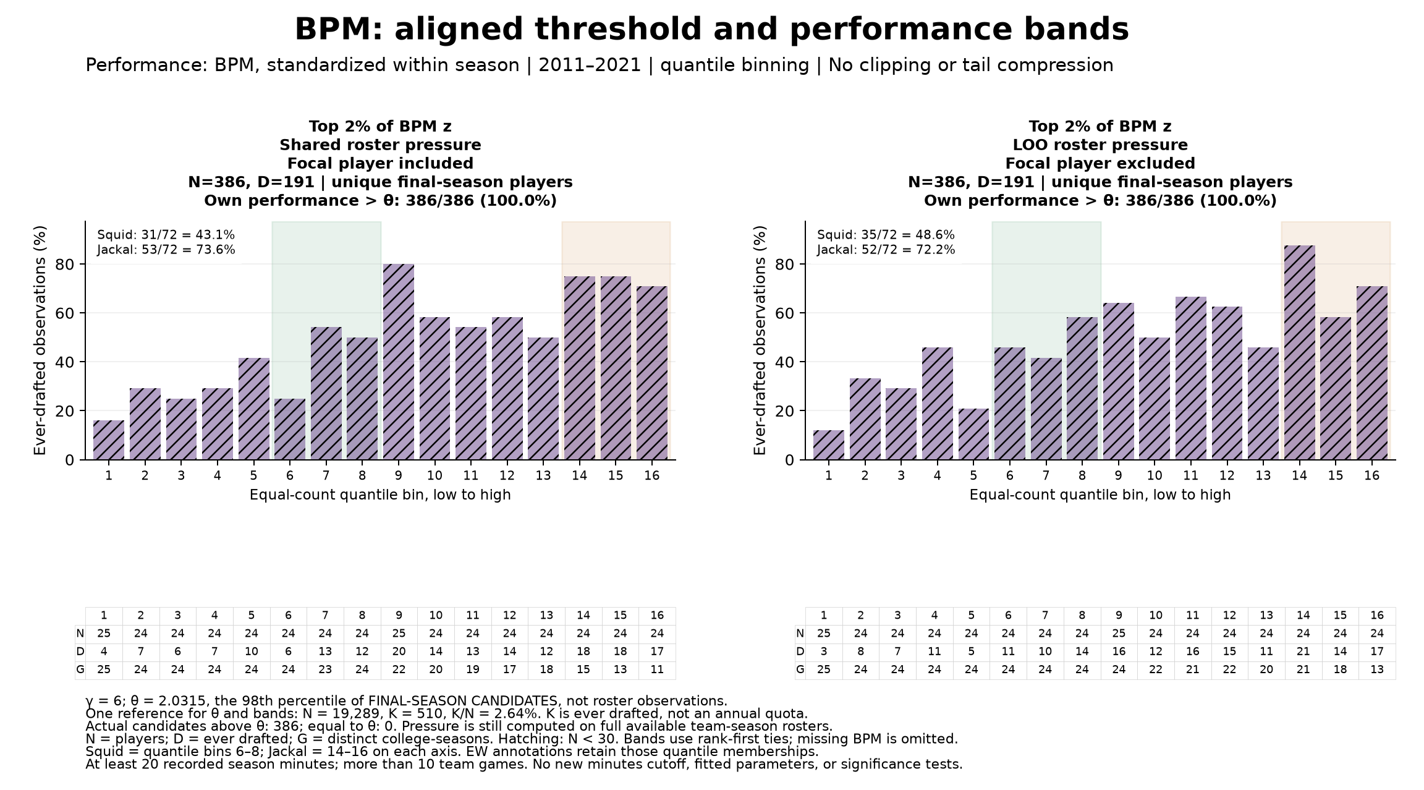
Figure 7. Top 2% of season-standardized BPM. The same 386 candidates appear on both axes. Each bar contains 24 or 25 players, so all are hatched under our fewer-than-30 rule. N is players, D is ever drafted, and G is distinct college-seasons.
The middle Squid region contains 31 of 72 drafted players (43.1%) for shared pressure, compared with 53 of 72 (73.6%) in the high-pressure Jackal region. LOO gives 35 of 72 (48.6%) versus 52 of 72 (72.2%). There are local fluctuations, but this comparison does not show the broad high-pressure downturn we had anticipated. No significance test was run.
The playing-time question remains: 75 of these 386 players have fewer than 100 recorded season minutes. A high BPM rank is not yet a defensible label for a draft lock, and the overall 49.5% rate reinforces that distinction.

Entry 7 The wider band below the threshold
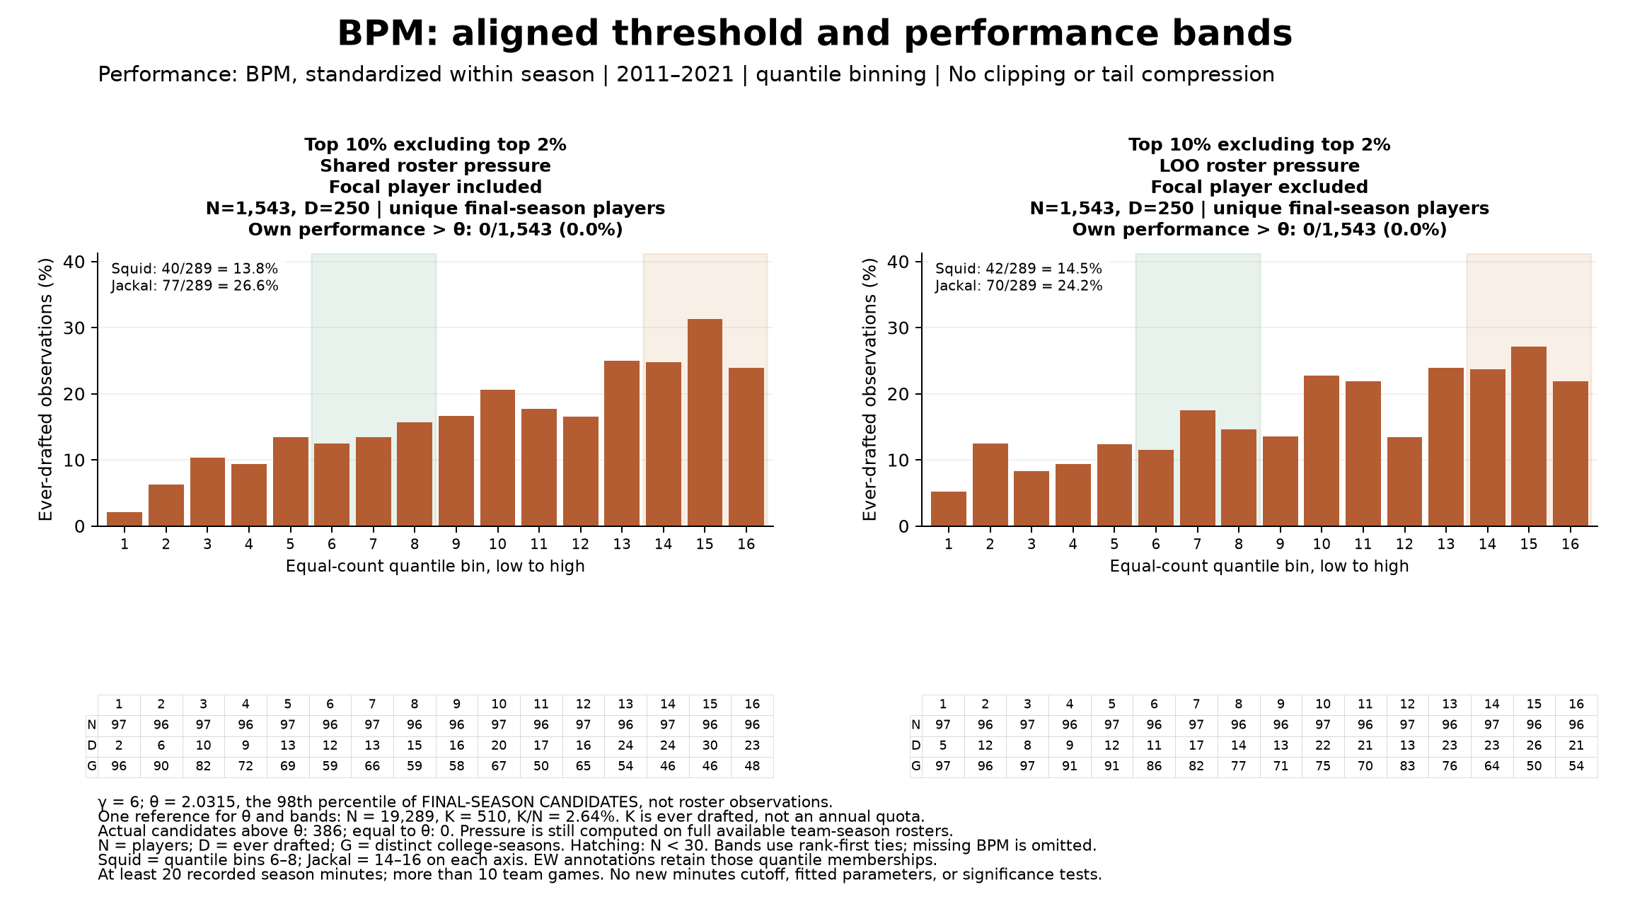
Figure 8. Top 10% excluding top 2%, a band of 1,543 final-season players. All lie below theta. Of these players, 250 were ever drafted, or 16.2%.
Shared pressure gives 40 of 289 drafted players (13.8%) in Squid and 77 of 289 (26.6%) in Jackal. LOO gives 42 of 289 (14.5%) and 70 of 289 (24.2%). The final bin is below the preceding bin in both charts, but the high-pressure region as a whole remains above the middle region. A local decline and a broad tail decline are different descriptions.

What changed from the previous branch
Entry 6 recorded top 3% and next 3% bands. Charles then tried top 2% and next 2% with theta at the 98th percentile and gamma = 6. That saved baseline run is 20261025_184918_282428. It ranked candidates by raw BPM and calculated theta on all eligible roster observations, giving theta = 1.9015. The baseline top band contained 386 players with 184 ever drafted; the next band contained 386 with 111 ever drafted.
This experiment changes three things together: theta uses final-season candidates, band ranks use season-standardized BPM, and the lower bands become wider. The top band retains 363 previous members and replaces 23. We therefore cannot attribute a difference from the baseline solely to theta or solely to the band widths. The same 19,289 candidates, performance values and outcome labels remain available underneath both designs.
These broad bands do not hold own performance exactly fixed. Quantile environmental bins are formed separately within each band and each axis, so the same bin number need not represent the same numerical environment. EW plots use common numerical edges. Y scales match within a row but can differ across rows. No clipping or tail compression is applied.

Entry 7 The lower band and the route back
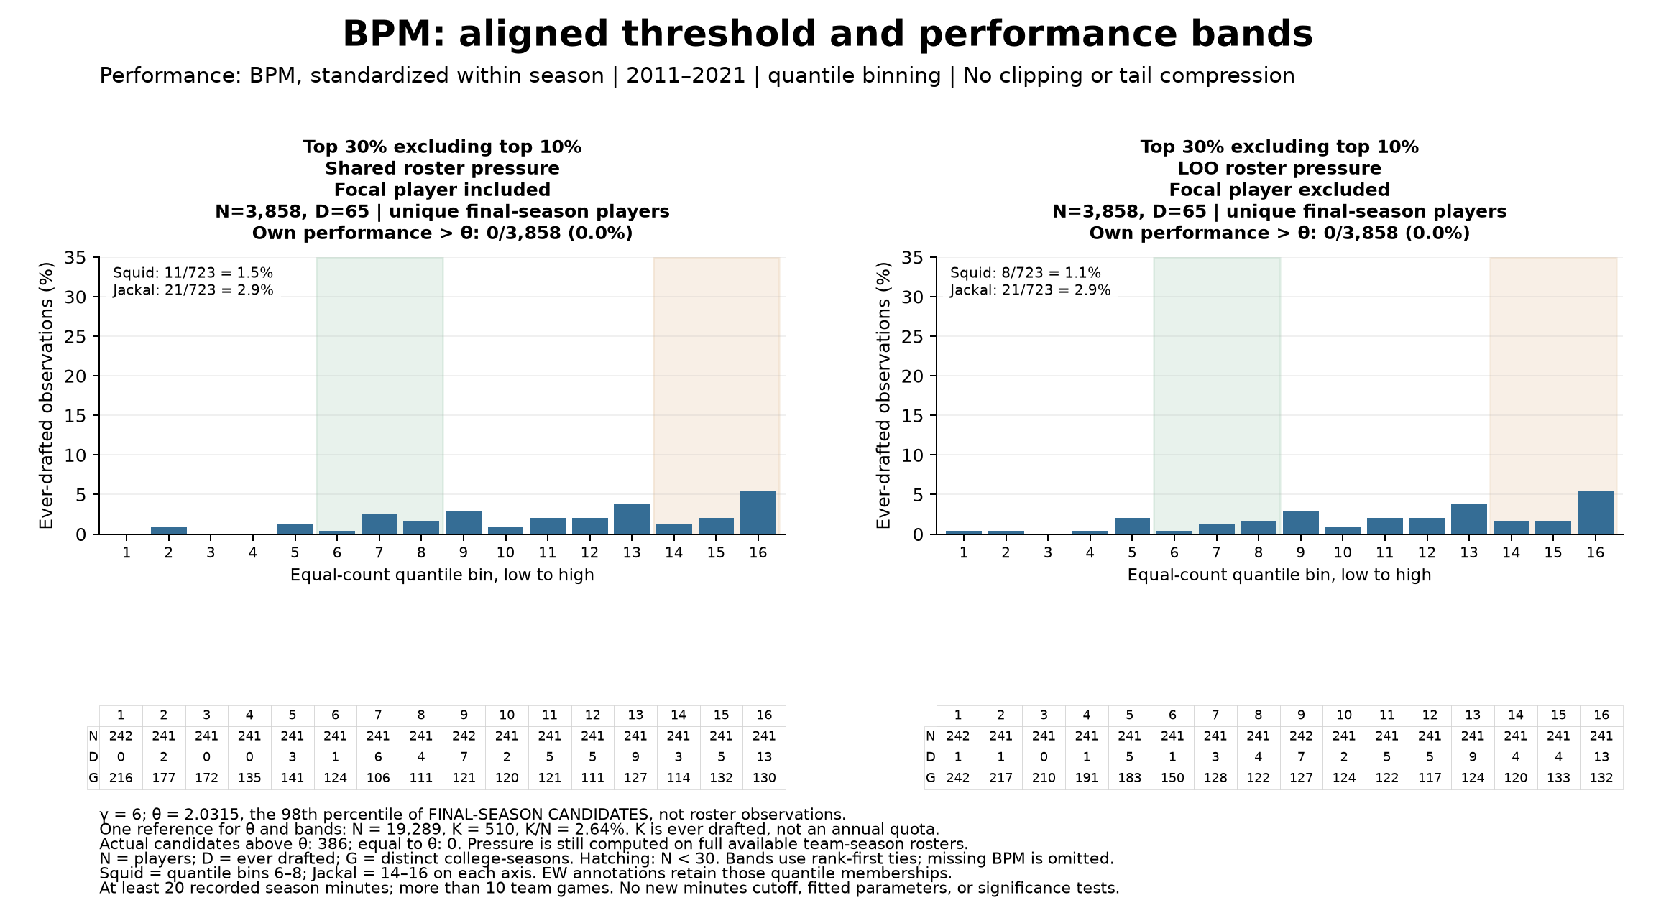
Figure 9. Top 30% excluding top 10%, a band of 3,858 final-season players. All lie below theta. Of these players, 65 were ever drafted, or 1.7%.
Shared pressure gives 11 of 723 drafted players (1.5%) in Squid and 21 of 723 (2.9%) in Jackal. LOO gives 8 of 723 (1.1%) and 21 of 723 (2.9%). These are descriptive associations. They do not establish that stronger peers cause better draft outcomes.
Reproducibility: the effective window remains 2011–2021 because the saved 2009–2010 data lack BPM. Standardization uses the full available eligible roster in each season and sample standard deviation. Pressure averages use complete available team-season rosters before filtering focal bands. Eligibility remains at least 20 recorded season minutes and more than 10 team games. Missing BPM is omitted. Last season means last observed eligible season in the window. The three bands contain 75, 101 and 246 players under 100 minutes, respectively.
Fixed-count bands and quantile bins use stable rank-first allocation, which can split ties. No tie crosses the top boundary here; ties do cross the lower boundaries, and their counts are saved. Independent roster-average checks, disjoint band memberships, unchanged candidate identities and all bin totals passed. Gamma changes did not change band membership. No new minutes filter, threshold sweep or significance test was added.
Where to continue: open NCAA_BPM_Aligned_Theta_Bands.ipynb in the roster_pressure_comparison/aligned_threshold_bands folder. Change settings in Section 1, set REBUILD_FIGURES = True, then Run All. The first band follows 1 minus theta_quantile automatically. Each run saves its counts, memberships, figures, source hashes and exact settings. This run is 20261025_191833_184458. Added 25 October 2026.
To return: open the original NCAA_Shared_vs_LOO_Roster_Pressure_BPM.ipynb one folder above. Its prior saved run remains bpm_runs/20261025_184918_282428. A notebook and code snapshot is also in aligned_threshold_bands/baseline. The PPM notebook remains unchanged. Our next discussion starts with Figure 7, not another sweep.

