TITLE: Improved peak detection in mass spectrum by incorporating continuous wavelet transform-based pattern matching

CWT can greatly enhance the effective signal-to-noise ratio.Furthermore,with this technique no baseline removal or peak smoothing preprocessing steps are requied before peak detection,and this improves the robustness of peak detection under a variety of conditions.

Currently, most of the peak detection algorithms identify peaks by searching local maxima with
a local signal to-noise ratio (SNR) over a certain threshold. The estimation of SNR is usually
dependent on the peak amplitude relative to the surrounding noise level. However, high amplitudes do not always guarantee real peaks: some sources of noise can result in high amplitude spikes.Conversely,low amplitude peaks can still be real.

The second difficulty of peak detection comes from the following observation: the width and height of ‘true’ MS peaks can vary a great deal in the same spectrum

As presented below, the algorithm was evaluated with MS spectra with known polypeptide compositions and positions.(实验数据为已知的多肽组织)

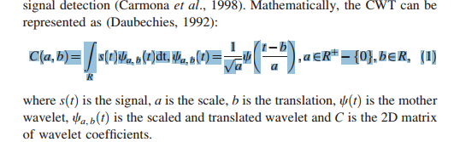

Intuitively, the wavelet coefficients (C ) reflect the pattern matching between the signals s(t) and
Ψa,b(t).

For peak detection, we examine the effect of changes in the width and height of peaks by the scaled and translated waveletΨa,b(t).

The Mexican Hat wavelet (Fig. 1) is proportional to the second derivative of the Gaussian probability density function
.

2.2Removal of the baseline

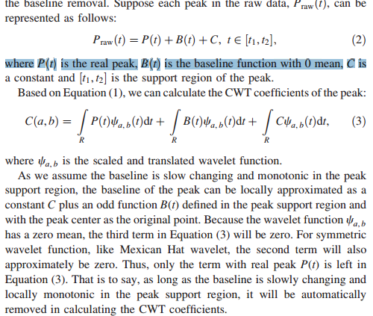

2.3 Peak identification process
Suppose the 2D CWT coefficient matrix is N · M, where N is the number of CWT scales, and M is the length of the MS spectrum.

