D and $\overline{D}$ Diagonal matrices used for computing scaled versions of X, e.g. $A_{L}$ =DX or $A_{R}$ =X $\overline{D}$

It is well known that any non-singular matrix T defines a rotation of the solution by

X=GF+E=GT $T^{-1}F$ +E=G'F'+E

G'=GT F'= $T^{-1}F$

uncertainty file 可以是使用者定义，或者是由unc_eqn文件生成

species == variables

SN计算方法：

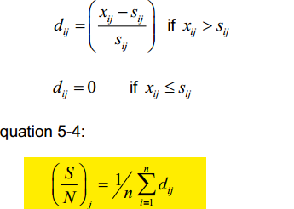

BAD: S/N <0.5

WEAK: 0.5<S/N<1 (设置为weak 后，Uncertainty value 变为原来的3倍)

功能：时序图；不同变量之间的二维散点图（观察变量之间的关系）；残差分布图（x已进行标化，sum(y)=100）；

NNMF