二分类算法的目标函数

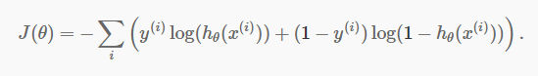

Note that only one of the two terms in the summation is non-zero for each training example (depending on whether the label y(i) is 0 or 1). Wheny(i)=1 minimizing the cost function means we need to make  hθ(x(i)) large, and when  y(i)=0 we want to make  1−hθ large as explained above.

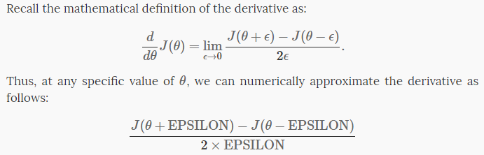

判断你的梯度计算方法是否正确，（通常取e=10-4）

Softmax regression (or multinomial logistic regression)

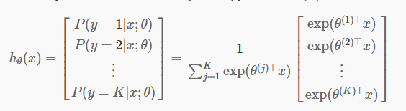

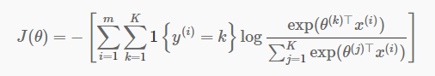

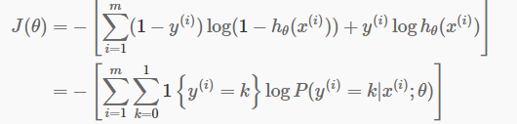



NMF

Find two non-negative matrices (W, H) whose product approximates the non-  
negative matrix X. This factorization can be used for example for  
dimensionality reduction, source separation or topic extraction.

components:H transformation: W  
The objective function is::  
  
 0.5 * ||X - WH||_Fro^2  
 + alpha * l1_ratio * ||vec(W)||_1  
 + alpha * l1_ratio * ||vec(H)||_1  
 + 0.5 * alpha * (1 - l1_ratio) * ||W||_Fro^2  
 + 0.5 * alpha * (1 - l1_ratio) * ||H||_Fro^2

Where::  
  
 ||A||_Fro^2 = \sum_{i,j} A_{ij}^2 (Frobenius norm)  
 ||vec(A)||_1 = \sum_{i,j} abs(A_{ij}) (Elementwise L1 norm)

解法：

ALS（迭代最小二乘法）

cd(坐标下降法)

pg(Project Gradient solver)

流程：(cd)

一.初始化W与H

二.判断是否对W和H进行正则化

令l1_W=l1_H=alpha*l1_ratio l2_W=l2_H=alpha*(1-l1_ration)

三.循环迭代更新W与H

(1).更新W

1.HHt=H*H'+eye()*l2_W ,XHt=X*H'-l1_W*ones() (X=WH XH'=WHH')

2.grad=W*HHt-XHt

3.W=W-grad./diag(HHt)

4.W[W<0]=0

(2). 更新H

1.HHt=W'*W+eye()*l2_H XHt=X'*W-l1_H*ones() （X=WH X'=H'W' X'W=H'W'W）

2.grad = H'*HHt-XHt

3.H'=H'-grad./diag(HHt)

4.H'[H'<0]=0

(3).判断是否达到退出条件，不满足则回到(1)