Antiderivatives

The rates of change of variables turn up frequently when studying real-life interactions including velocity, acceleration, and current. In cases where we know the derivative and we want to determine the original function, then we want to find the *antiderivative.*

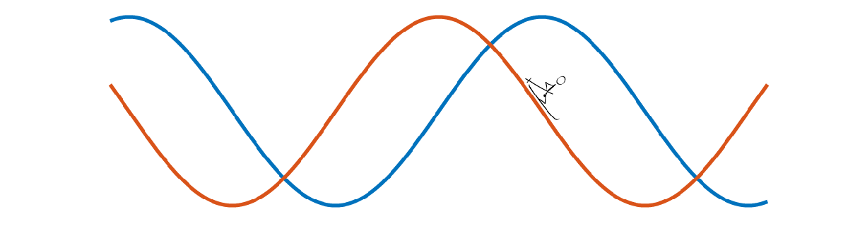

By using the knowledge of derivatives, it is possible to define an operation that will undo a derivative.

Table of Contents

Review of Derivatives   
Definition of Antiderivatives   
Antiderivatives are Linear   
 Power Rule   
 Exercise 1   
 Exponential Rule   
 Exercise 2   
 Logarithm Rule   
 Exercise 3   
 Cosine Rule   
 Exercise 4   
 Sine Rule   
 Exercise 5   
Practice Randomized Antiderivatives   
 Practice App   
Helper Functions

**Before you get started:**

This live script is intended to be used with the code hidden. On the **View** tab of the MATLAB toolstrip, in the **View** section, select **Hide Code**. Alternately, select **Hide Code** using the icon  at the top right of the Live Editor pane.

 Although the code is hidden, some interactivity requires familiarity with MATLAB. If you need more instruction, consider taking [MATLAB Onramp](https://www.mathworks.com/learn/tutorials/matlab-onramp.html), a free 2-hour online tutorial that teaches the essentials of MATLAB.

 For an optimal experience, follow the instructions and steps in the given sequence. Proceed to a new section only after completing the preceding one.

# Review of Derivatives

**Power & Linearity Rules Transcendental Rules**

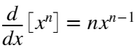 for constant  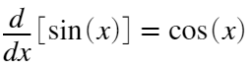 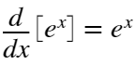

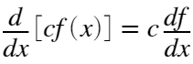 for constant  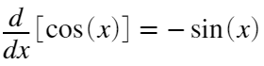 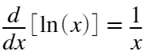

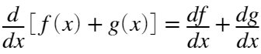

# Definition of Antiderivatives

Define an antiderivative  of a function  by the relationship 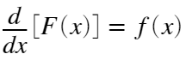. In any case where one antiderivative exists, there is an entire family of antiderivatives  for each function  because, by the linearity rule for derivatives:

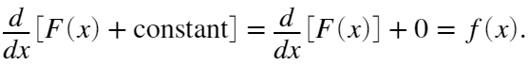

Similarly, if we have found two different antiderivatives  and  for a function , then we know that



Because the only functions with 0 derivative are constant values, this means that  for some constant value . This means we can define a symbol to represent the operation of finding an antiderivative:

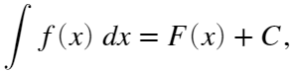

where  is a constant and  is any antiderivative of .

f = @(x) sin(x);

xVals = -5:.02:5;

syms x

F(x) = int(f,x);

figure

pf = plot(xVals,F(xVals),"k","LineWidth",3);

hold on

Copts = [-5:.5:-.5 .5:.5:5];

FVals = F(xVals)+Copts';

pF = plot(pf.Parent,xVals,FVals,"b","LineWidth",1);

hold off

title("Plotting the family of antiderivatives $F(x)+C$","Interpreter","latex")

pfC = copyobj(pf,pf.Parent);

pfC.Color = [1 0 0];

legend(pf.Parent,["F(x)" "Family of F(x)" "F(x)+C"],"Location","bestoutside")



To select a particular element of the family, choose a value of .

C = -4; %#ok<NASGU>

ani = false;

Fx = double(F(xVals));

FxMin = min(Fx);

FxMax = max(Fx);

if ani

pfC.Parent.YLim = [FxMin FxMax] + [-10 10];

for C = [-10:.25:10 10:-.25:-10]

pfC.YData = Fx + C;

subtitle(pfC.Parent,"$C = $"+C,"Interpreter","latex");

pause(0)

drawnow

end

else

pfC.YData = F(xVals)+C; %#ok<UNRCH>

subtitle(pfC.Parent,"$C = $"+C,"Interpreter","latex");

end

drawnow



# Antiderivatives are Linear

Just as with derivatives, antiderivatives are linear operators. Let  be an antiderivative for  and  be an antiderivative for . Applying the derivative linearity rules and definition of an antiderivative we have:





## Power Rule

The power rule for derivatives states:  for constant . This means the antiderivative of a power can be computed by taking the antiderivative of both sides:

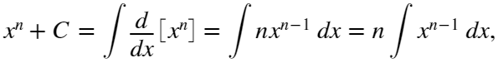

thus, for any value of ,

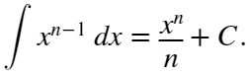

This is usually written as

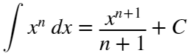 for . 

### Exercise 1

Solve the integrals below in the variables given. In each case, you should identify the value of  and  as used in equation . Use C for an arbitrary constant, as required.

a. 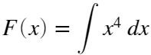

an = 4; anp1 = 5; asoln = @(x,C)x^5/5+C;

checkExercise1(an,anp1,asoln,4)

b. 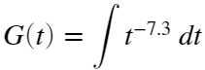

bn = -7.3; bnp1 = -6.3; bsoln = @(t,C)t^(-6.3)/-6.3+C;

checkExercise1(bn,bnp1,bsoln,-7.3)

c. 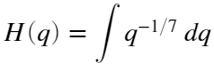

cn = sym(-1/7); cnp1 = sym(6/7); csoln = @(q,C)7/6*q^(6/7)+C;

checkExercise1(cn,cnp1,csoln,-1/7)

## Exponential Rule

Start from 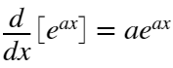 for constant . Taking the antiderivative of both sides we have:

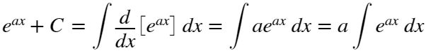

Solving for the antiderivative,

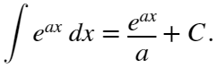 

### Exercise 2

Solve the integrals below in the variables given. Use C for an arbitrary constant, as required and identify  as it is in equation  . Remember the MATLAB notation for  is exp(x).

a. 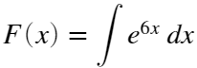

an = 6; asoln = @(x,C)exp(6*x)/6+C;

checkExercise2(an,asoln,6)

b. 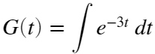

bn = -3; bsoln = @(t,C)exp(-3*t)/-3+C;

checkExercise2(bn,bsoln,-3)

## Logarithm Rule

Start from , taking the antiderivative of both sides we have

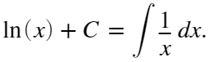

This only makes sense for values of . What happens if ? In this case . Then, using the chain rule for derivatives,

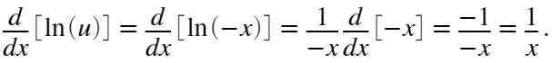

This means that

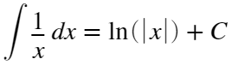 for  or .

### Exercise 3

Solve the integrals below in the variables given. Use C for an arbitrary constant, as required. Remember that the MATLAB notation for  is log(x) and for  is abs(x).

a. 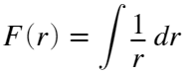

asoln = @(r,C) log(r)+C;

checkExercise3(asoln,1,"ln")

b. 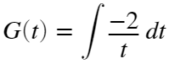

bsoln = @(t,C) -2*log(abs(t))+C;

checkExercise3(bsoln,-2,"ln")

c. 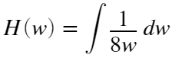

csoln = @(w,C) log(abs(w))/8+C;

checkExercise3(csoln,1/8,"ln")

## Cosine Rule

Start from 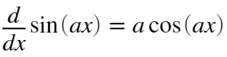. Taking the antiderivative of both sides, we have:



Solving for the antiderivative,

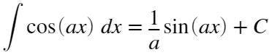

### Exercise 4

Solve the integrals below in the variables given. Use C for an arbitrary constant, as required.

a. 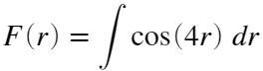

asoln = @(r,C) 1/4*sin(4*r)+C;

checkExercise3(asoln,4,"cos")

b. 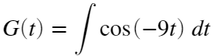

bsoln = @(t,C) -1/9*sin(-9*t);

checkExercise3(bsoln,-9,"cos")

c. 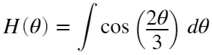 Note:  should be theta in the typed solution.

csoln = @(theta,C) 3/2*sin(2*theta/3)+C;

checkExercise3(csoln,2/3,"cos")

## Sine Rule

Start from 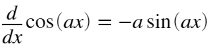. Taking the antiderivative of both sides, we have:



Solving for the antiderivative,

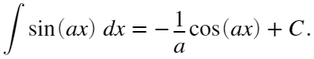

### Exercise 5

Solve the integrals below in the variables given. Use C for an arbitrary constant, as required.

a. 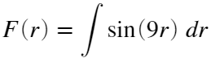

asoln = @(r,C) r;

checkExercise3(asoln,9,"sin")

This solution is correct.

b. 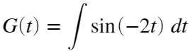

bsoln = @(t,C) t;

checkExercise3(bsoln,-2,"sin")

This solution is correct.

c. 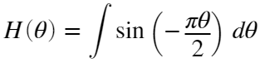 Note: The variable  should be theta in the typed solution and the constant  should be pi.

cinput = str2sym(" theta");

csoln = matlabFunction(cinput,Vars=[sym("theta"),sym("C")]);

checkExercise3(csoln,-pi/2,"sin")

This solution is correct.

# Practice Randomized Antiderivatives

 **Pro-tip**. MATLAB syntax is 7*t^(2/3) for . The variable you use in the solution matters, as does appropriate use of parentheses and multiplication operators.

% Clear variables that may be reused in other parts of this module

clear errorCount totAntiProbs totAttempts adjustcount lastFive myFun varChoice

syms t r x z C % Declare symbolic variables

varOpts = [t r x z]; % Define the list of variables to use in the problems

errorCount = 0; % Initialize a count of errors

totAntiProbs = 0; % Initialize a count of total problems attempted

totAttempts = 0; % Initialize a count of total solutions offered

adjustCount = 0; % Preserve the counts if the user resubmits a solution

lastFive = zeros(1,5); % Initialize a matrix to record the last five solution results

disp("Values initialized for Antiderivative Practice.")

Values initialized for Antiderivative Practice.

% Check if the previous section has run

% If not, provide warning. If so, generate a problem.

if ~exist("totAntiProbs","var")

warning("You must initialize values before you can generate a problem.")

else

[myFun,varChoice] = genProbType(varOpts,1); % genProbType is defined in Helper Functions

% genProbType sets up a variable and generates a randomized function

totAntiProbs = totAntiProbs+1; % Increase the count of total problems attempted

end

% Run this section

myAnswer = r; % User-defined solution, default value r

totAttempts = totAttempts + 1; % Updates count of total attempts at solution

[lastFive,errorCount,totAttempts,adjustCount] = resubmissionCheck(totAttempts,totAntiProbs, ...

adjustCount,myFun,varChoice,myAnswer,1,errorCount,lastFive);

% resubmissionCheck is defined in Helper Functions

% resubmissionCheck records the attempt and provides appropriate feedback

% Run this section

Once you have completed sufficient practice, track the overall results of your practice here:

analyzeResults(totAntiProbs,errorCount,totAttempts,adjustCount,lastFive)

## Practice App

You can practice in the Calculus Flashcards app. You can start the app by clicking on the image below. You should set the problem type to be "Integrals of Functions" in the Integrals section. The app will open in a new window.

[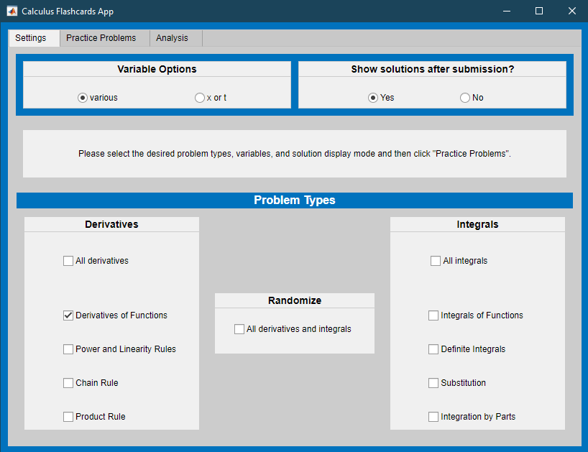](matlab:%20CalculusFlashcards)

[Calculus Flashcards App](matlab:%20CalculusFlashcards)

# Helper Functions

If you wish to see the details of the code, select the **View** tab and switch to **Output Inline**. Alternately, select **Output inline** using the icon  at the top right of the Live Editor pane.

**Check Exercise 1**

Check that some effort has been made and give appropriate feedback.

function checkExercise1(n,np1,mysoln,nReal)

syms x C

if n == nReal

if nReal+1 == np1

if isAlways(diff(mysoln(x,C),x)==x^(nReal),"Unknown","false")

if diff(mysoln(x,C),C)~=0

disp("This solution is correct.")

else

disp("Although you have the correct identification of n and n+1, your answer is incorrect because it is missing +C")

end

else

disp("Although you have the correct identification of n and n+1, your answer is incorrect. Please check the power rule.")

end

elseif np1 == 0

disp("You have begun the problem. Please finish before submitting.")

else

disp("Although you have the correct identification of n, you have an incorrect value for n+1. Please check your arithmetic.")

end

elseif n == 0 && np1 == 0 && isequal(mysoln(x,C),x)

disp("Please attempt the problem before submitting.")

else

disp("That is not the correct value for n. Please check your patterns and try again.")

end

end

**Check Exercise 2**

Check that some effort has been made and give appropriate feedback.

function checkExercise2(n,mysoln,nReal)

syms x C

if n == nReal

if isAlways(diff(mysoln(x,C),x)==exp(nReal*x),"Unknown","false")

if diff(mysoln(x,C),C)~=0

disp("This solution is correct.")

else

disp("Although you have the correct identification of a, your answer is incorrect because it is missing +C")

end

else

disp("Although you have the correct identification of a, your answer is incorrect. Please check the exponential rule.")

end

elseif n == 0 && isequal(mysoln(x,C),x)

disp("Please attempt the problem before submitting.")

else

disp("That is not the correct value for a. Please check your patterns and try again.")

end

end

**Check Exercise 3**

Check that some effort has been made and give appropriate feedback.

function checkExercise3(mysoln,a,type)

syms x C

assume(x,"real") % Add assumption on x to avoid complex derivatives

switch type

case "ln"

integrand = @(x,par) par/x;

case "cos"

integrand = @(x,par) cos(par*x);

case "sin"

integrand = @(x,par) sin(par*x);

end

if isequal(mysoln(x,C),x)

disp("Please attempt the problem before submitting.")

elseif isAlways(diff(mysoln(x,C),x)==integrand(x,a),"Unknown","false")

if diff(mysoln(x,C),C)~=0

disp("This solution is correct.")

else

disp("Your answer is incorrect because it is missing +C")

end

else

switch type

case "ln"

disp("Your answer is incorrect. Please check the logarithm rule.")

case "cos"

disp("Your answer is incorrect. Please check the cosine rule.")

case "sin"

disp("Your answer is incorrect. Please check the sine rule.")

end

end

assume(x,"clear")

end

**Practice Problem Generating Functions**

Analyze the results and give feedback

function analyzeResults(totProbs,errorCount,totAttempts,adjustCount,lastFive)

% analyzeResults provides feedback in the single problem type case

% totProbs, errorCount, totAttempts and adjustCount are integers

% lastFive is a vector

overallRight = (1 - sum(errorCount)/sum(totProbs))*100;

if sum(totAttempts) > sum(totProbs)

% If the user has resubmitted after seeing the solution, respond

disp("Why are you resubmitting after you know the solution?")

disp("Resubmissions are not included in your statistics.")

if sum(adjustCount) > 1

% If the user is repeatedly resubmitting, encourage them to use

% this problem generator as intended by starting over

disp("You have resubmitted " + sum(adjustCount) + " times.")

disp("Please consider restarting the count using the `Initialize Values' button.")

end

end

if totProbs >= 5

lastCorrect = sum(lastFive);

% If more than 5 problems have been attempted, provide grammatically

% appropriate feedback on success rates

if lastCorrect > 1

str = compose("The overall success rate is %.1f%% on %i total problems \n\n" + ...

"Of the last five, %i were correct.",overallRight,totProbs,lastCorrect);

elseif lastCorrect == 1

str = compose("The overall success rate is %.1f%% on %i total problems \n\n" + ...

"Of the last five, one was correct.",overallRight,totProbs);

elseif lastCorrect == 0

str = compose("The overall success rate is %.1f%% on %i total problems \n\n" + ...

"Of the last five, none were correct.",overallRight,totProbs);

end

else

% If fewer than 5 problems have been attempted, encourage persistence

str = compose("The overall success rate is %.1f%% on %i total problems \n\n" + ...

"Please do at least five problems.",overallRight,totProbs);

end

disp(str)

end

Check the submitted solution for correctness

function [lastFive,errorCount] = check1(myFunc,myVar,myAnswer,errorCount,lastFive)

% check1 generates correct answers by integrating and updates

% errorCount and lastFive

%

% Inputs: myFunc is the symbolic function to differentiate or integrate

% myVar is the independent variable

% myAnswer is the symbolic test function or number

% errorCount is an integer tracking total incorrect attempts

% lastFive is a vector tracking the last five attempts

% Output: correctAnswer is a symbolic function that is the

% solution to probType applied to myFunc(myVar) with bds

syms C

correctAnswer = int(myFunc,myVar)+C;

lastFive(1:4) = lastFive(2:5);

disp("When simplified, this function is: ")

disp(myAnswer)

if correctAnswer == myAnswer

disp("That answer is correct.")

lastFive(5) = 1;

elseif isAlways(diff(myAnswer,myVar)-myFunc==0,"Unknown","false")

if diff(myAnswer,C) == 1

disp("That answer is correct. Another possible form is:")

disp(correctAnswer-C + "C")

lastFive(5) = 1;

else

disp("You are missing a +C.")

disp("The correct answer is:");

correctAnswer %#ok<NOPRT>

errorCount = errorCount + 1;

lastFive(5) = 0;

end

else

disp("That is incorrect. The correct answer is:");

correctAnswer %#ok<NOPRT>

errorCount = errorCount + 1;

disp("Please try again with a new problem.")

lastFive(5) = 0;

end

end

Construct a problem to display

function [myFun,varChoice] = genProbType(varOpts,probType)

% genProbType sets up a variable and generates a randomized function

%

% Inputs: varOpts is an array of possible variables

% probType is a string that identifies the function type

% Outputs: myFun is a symbolic function

% varChoice is the independent variable

% probType is an integer tracking the type of question asked

% [a, b] are the bounds for the definite integral, if required

% Randomly select a variable from the set varOpts

varChoice = varOpts(randi([1 length(varOpts)],1));

% Use genFunDiff to generate simple functions

% genFunDiff is defined in Helper Functions

% The inputs to genFunDiff are the variable varChoice, a range of values

% from which to select coefficients and a value indicating which warnings

% have already been printed during problem generation

switch probType

case 1 % Simple integral problem

syms f(x) x F(x)

[f(x),~] = genFunDiff([1 10],x,[1 10],0);

myFun = diff(f(varChoice),varChoice);

% Display the integral problem

disp("Calculate the integral:")

displayFormula("F(varChoice) == int(myFun,varChoice)")

end

end

Generate appropriate randomized functions

function [myFunc,type] = genFunDiff(bds,var,range,prevFuncType)

syms f(t) % Create a symbolic function f(t)

params = randi(bds,[1 4]); % Randomly choose parameter values

shift = randi([0 max(abs(bds))],1); % Randomly choose a shift that may be 0

sgns = randi([0 1],[1 3]); % Randomly choose +/- signs

type = randi(range,1);

% For readability, create parameters a,b,c, and d

a = (-1)^sgns(1)*params(1);

b = (-1)^sgns(2)*params(2);

c = max(params(3),params(4)); % c > 0, it is only used as a denominator

d = (-1)^sgns(3)*shift;

switch type

case 1

f(t) = a*t^b+c*t^d;

case 2

f(t) = a*t^b+t^(d/c);

case 3

f(t) = t^a+c*t^b+t^d;

case 4

f(t) = t^a+c*t^b+d;

case 5

f(t) = a*t^(b);

case 6

f(t) = a*t^(b/c);

case 7

f(t) = a*log(abs(b)*t);

if (prevFuncType ~= 7)&&(prevFuncType ~= 11)

disp("Remember that log(x) is the notation " + ...

"for a natural logarithm of x in MATLAB. ")

end

case 8

f(t) = a*exp(b*t);

if prevFuncType ~= 8

disp("Remember that exp(x) is the notation " + ...

"for $e^x$ in MATLAB. ")

end

case 9

f(t) = a*sin(b*t);

case 10

f(t) = a*cos(b*t);

case 11

f(t) = a*log(ceil(c/4)*t);

if (prevFuncType ~= 7)&&(prevFuncType ~= 11)

disp("Remember that log(x) is the notation " + ...

"for a natural logarithm of x in MATLAB. ")

end

case 12

f(t) = a*t^c;

case 13

f(t) = a*sin(b*t+d)*exp(b*t);

case 14

f(t) = a*cos(b*t+d)*exp(b*t);

end

myFunc = f(var);

end

Handle submissions

function [lastFive,errorCount,totAttempts,adjustCount] = resubmissionCheck(totAttempts,totProbs, ...

adjustCount,myFun,varChoice,myAnswer,probType,errorCount,lastFive)

if sum(totAttempts > (totProbs + adjustCount))

% Check if this is a resubmission after the solution has been provided

% If so, provide feedback but do not record in errorCount or lastFive

% If not, update the values of lastFive and errorCount using check1

adjustCount = totAttempts-totProbs;

[lastFive,errorCount] = check1(myFun,varChoice,myAnswer,errorCount,lastFive);

elseif sum(totAttempts < (totProbs + adjustCount))

% Check if this is a submission after the generation of multiple problems that were skipped

% If so, add the skipped problems to errorCount and adjust the totAttempts

% to compensate. Explain to the user that skipped problems count as incorrect.

numSkipped = totProbs + adjustCount - totAttempts;

errorCount = errorCount + numSkipped;

totAttempts = totProbs + adjustCount;

for k = 1:length(totProbs)

if numSkipped(k) < 5

lastFive(k,:) = [lastFive(k,1+numSkipped:5),zeros(1,numSkipped)];

else

lastFive(k,:) = zeros(1,5);

end

if sum(numSkipped) > 1

disp("The "+sum(numSkipped)+" problems generated without attempts at solution " + ...

"have been included in the count of errors.")

else

disp("The problem generated without an attempt at solution has been " + ...

"included in the count of errors.")

end

[lastFive,errorCount] = check1(myFun,varChoice,myAnswer,errorCount,lastFive);

end

else

[lastFive,errorCount] = check1(myFun,varChoice,myAnswer,errorCount,lastFive);

end

end