Substitution

A thorough understanding of the integral as an antiderivative can only take you so far. Just as with derivatives, there are integration rules that can be built through the combination of functions as well. The method of substitution that will be discussed in this live script applies to nearly every integral you will ever calculate. In fact, you will likely forget that you are even applying it in some cases because it will become so natural to use!



The method of substitution allows you to replace a complicated integral with a simpler one.

Table of Contents

Inverting the Chain Rule for Derivatives   
 Substitution for Indefinite Integrals   
 Substitution for Definite Integrals   
 Practice using substitution   
 Exercise 1   
 Exercise 2   
 Exercise 3   
 Exercise 4   
Visualizing changing variables   
 One step at a time   
 Visualize the Subdivisions Over Entire Areas   
 Animate Visualization by Original or Substitution-size Steps   
 Show Only One Set of Steps   
Fully Visualizing the Substitution Process   
 Animate Visualization by Original or Substitution-size Steps   
 Show Only One Set of Steps   
Practice Randomized Substitution Integrals   
 Practice App   
Helper Functions

**Before you get started:**

This live script is intended to be used with the code hidden. On the **View** tab of the MATLAB toolstrip, in the **View** section, select **Hide Code**. Alternately, select **Hide Code** using the icon  at the top right of the Live Editor pane.

 Although the code is hidden, some interactivity requires familiarity with MATLAB. If you need more instruction, consider taking [MATLAB Onramp](https://www.mathworks.com/learn/tutorials/matlab-onramp.html), a free 2-hour online tutorial that teaches the essentials of MATLAB.

 For an optimal experience, follow the instructions and steps in the given sequence. Proceed to a new section only after completing the preceding one.

# Inverting the Chain Rule for Derivatives

Remember that the chain rule for derivatives looks like



## Substitution for Indefinite Integrals

If we apply the concept of antiderivatives to this rule, we see that

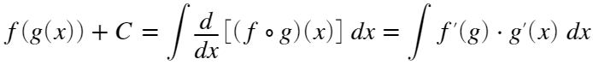 

In fact, because  tracks the measure of a small step in the direction of integration while  does the same, we can define a new measure  which allows us to note that

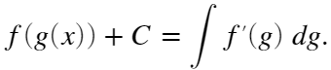

## Substitution for Definite Integrals

Applying the fundamental theorem of calculus, we have:

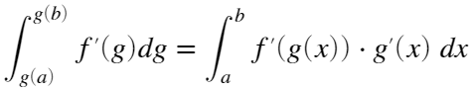

which is

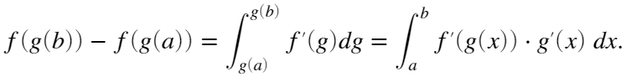 

## Practice using substitution

Rewrite each of the following integrals in terms of the new variable provided by the substitution function. Then solve the integral.

### Exercise 1

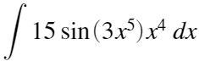 where 

First, find the derivative of  with respect to :

What is the new measure going to be in terms of ?

If we define 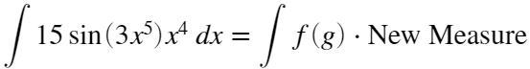, what is ?

Calculate the function 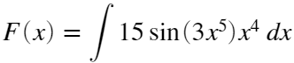.

 **Note:** In many textbooks it is common to use a variable  in place of the variable  in equations  and , or even to call this method -substitution.

### Exercise 2

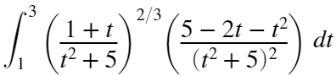 where 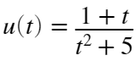

Calculate the derivative .

Calculate the new bounds and new measure for the integral in terms of .

If we define 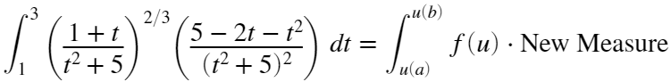, what is ?

Calculate the function 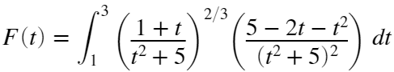.

### Exercise 3

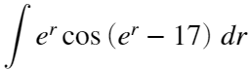 where 

Remember that  is written as exp(x) in MATLAB.

If we define  ,

### Exercise 4

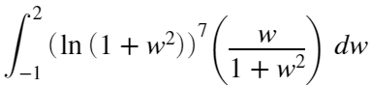 where .

If we define  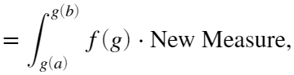

This result is still not immediately computable, so let's make another substitution with . Remember that  is written log(g) in MATLAB.

If we define  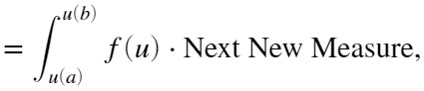

Putting everything together, compute the result:

# Visualizing changing variables

It can be counterintuitive to visualize how a change of variables affects your function or the resulting integral. Use this to investigate different combinations of functions.

## One step at a time

Set up the functions to use:

Choose a left endpoint  and a right endpoint  such that :

Visualize the graph as  vs  or  vs :

 **Try**.

1.  and  with  and ?
2.  and  with  and ? or with  and ?
3.  and  with  and ? or  and ? or  and ?
4.  and  with  and ?
5. Any other functions you like!

Choose a step size and an initial point:

Observe the fact that the actual distance covered by a given "step size" can change quite a lot based on the choice of the initial point  as well as the choice to consider a fixed , or a fixed  or a computed .

 **Try**.

1. Move the values on the  slider all the way to the right with  and  and  and . What happens?
2. Move the values on the  slider all the way to the left with  and  and  and . What happens?
3. Move the values on the  slider all the way to the left and to the right with a constant value of . What happens?
4. Change the dropdown to view a plot of  versus  and repeat steps 1-4. What happens?
5. Try changing the functions  and , for instance to cos(x) and exp(x). If the bounds on your sliders do not make sense for the new functions, you can either set values directly by editing the numerical field or you can right click on the sliders and set new minimum and maximum values.

## Visualize the Subdivisions Over Entire Areas

Set up the functions and the bounds to use.

### Animate Visualization by Original or Substitution-size Steps

First, show the positions of intervals defined by a constant step size , then subdivide the same region by intervals defined by a constant step size  under the map  where  is the initial point of the  interval. Equivalently,  is the lower bound of the corresponding interval.

### Show Only One Set of Steps

If the checkbox is selected, then the plot shows the region subdivided into constant-size intervals . If the checkbox is not selected, then the plot shows the region subdivided into constant-size intervals . In the latter case, the plotted interval ends occur after lengths . Because this depends on the value of  it can be a linear transformation, but it can also be highly nonlinear.

 **Try**.

1. What happens when  is a linear function?
2. What happens when  is periodic?
3. What happens when  takes on a wide range of values over the given domain?

# Fully Visualizing the Substitution Process

Set up the functions and the bounds to use.

### Animate Visualization by Original or Substitution-size Steps

First, show the positions of intervals defined by a constant step size , then subdivide the same region by intervals defined by a constant step size  under the map  where  is the initial point of the  interval. Equivalently,  is the lower bound of the corresponding interval.

How many intervals?

### Show Only One Set of Steps

If the checkbox is selected, then the plot shows the region subdivided into constant-size intervals . If the checkbox is not selected, then the plot shows the region subdivided into constant-size intervals . In the latter case, the plotted interval ends occur after lengths . Because this depends on the value of  it can be a linear transformation, but it can also be highly nonlinear.

 **Try**.

1. What happens when  is a linear function?
2. What happens when  is periodic?
3. What happens when  takes on a wide range of values over the given domain?

# Practice Randomized Substitution Integrals

 **Pro-tip**. MATLAB syntax is 7*t^(2/3) for . The variable you use in the solution matters, as does appropriate use of parentheses and multiplication operators.

Once you have completed sufficient practice, track the overall results of your practice here:

## Practice App

You can practice in the Calculus Flashcards app. You can start the app by clicking on the image below. You should set the problem type to be "Substitution" in the Integrals section. The app will open in a new window.

[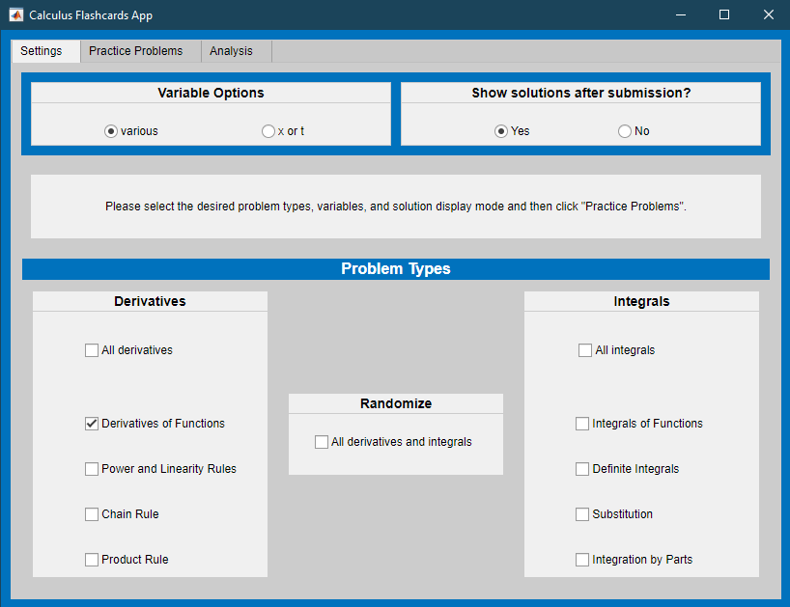](matlab:%20CalculusFlashcards)

[Calculus Flashcards App](matlab:%20CalculusFlashcards)

# Helper Functions

If you wish to see the details of the code, select the **View** tab and switch to **Output Inline**. Alternately, select **Output Inline** using the icon  at the top right of the Live Editor pane.

**Exercise 1 Solutions**

a.  where 

b.  where 

c  where 

d.  where .