OPENHACK HACKATHON
Nginx Web Server — Complete Technical Documentation
Participant: MATHAN S | Kali Linux | 08 October 2026
This document records the implementation, verification procedure, troubleshooting, and terminal evidence for all five organizer tasks. Exactly five screenshots are included under each task, for a total of 25 screenshots.
Task | Requirement | Main Evidence | Final Verification
1 | Nginx + custom HTML | Nginx status, web root, HTML | curl HTTP
2 | Access from another computer | IP, SSH, HTTP response | Second-machine HTTP
3 | Remote modification | SSH/HTML workflow | Changed HTTP response
4 | Different page on port 8002 | Second site config | curl :8002
5 | HTTPS | OpenSSL + Nginx SSL config | curl -k HTTPS

Task 1 — Set Up Nginx and Serve the Custom HTML Page
Install/configure Nginx on the local Kali Linux machine and use it to serve the organizer-provided custom HTML page.
- Server IP: `10.10.145.207`
- Web root: `/var/www/html`
- Web server: Nginx
- Default HTTP port: `80`
The terminal evidence shows Nginx being located and its systemd service being checked.
which nginx
sudo systemctl status nginx
The service output shows the Nginx service running.
cd /var/www/html
ls
cat index.html
The existing default page was inspected before replacing it with the organizer's page.
The supplied custom HTML was copied into `/var/www/html/index.html`.
The screenshots also document permission problems encountered while changing files under `/var/www/html`. Administrative operations were therefore performed with `sudo`.
sudo nginx -t
Expected successful output:
nginx: the configuration file /etc/nginx/nginx.conf syntax is ok
nginx: configuration file /etc/nginx/nginx.conf test is successful
sudo systemctl restart nginx
Nginx was successfully configured and running. The custom HTML page was placed in the Nginx document root and subsequently returned by HTTP requests.
Five screenshots are included in `evidence/task-1-nginx/`.
Show:
sudo systemctl status nginx
curl http://10.10.145.207
Then show the returned custom HTML page.

Terminal Evidence — 5 Screenshots
Evidence 1/5 — Screenshot_2026-10-08_10_53_31.png
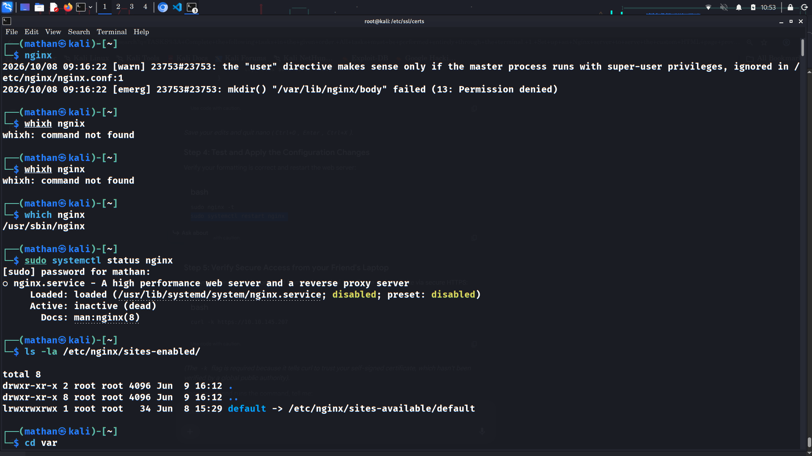

Evidence 2/5 — Screenshot_2026-10-08_10_53_46.png
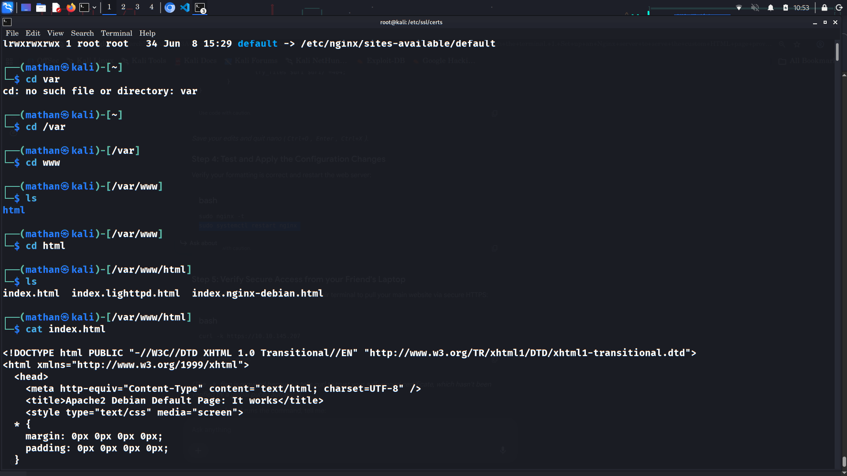

Evidence 3/5 — Screenshot_2026-10-08_10_53_59.png
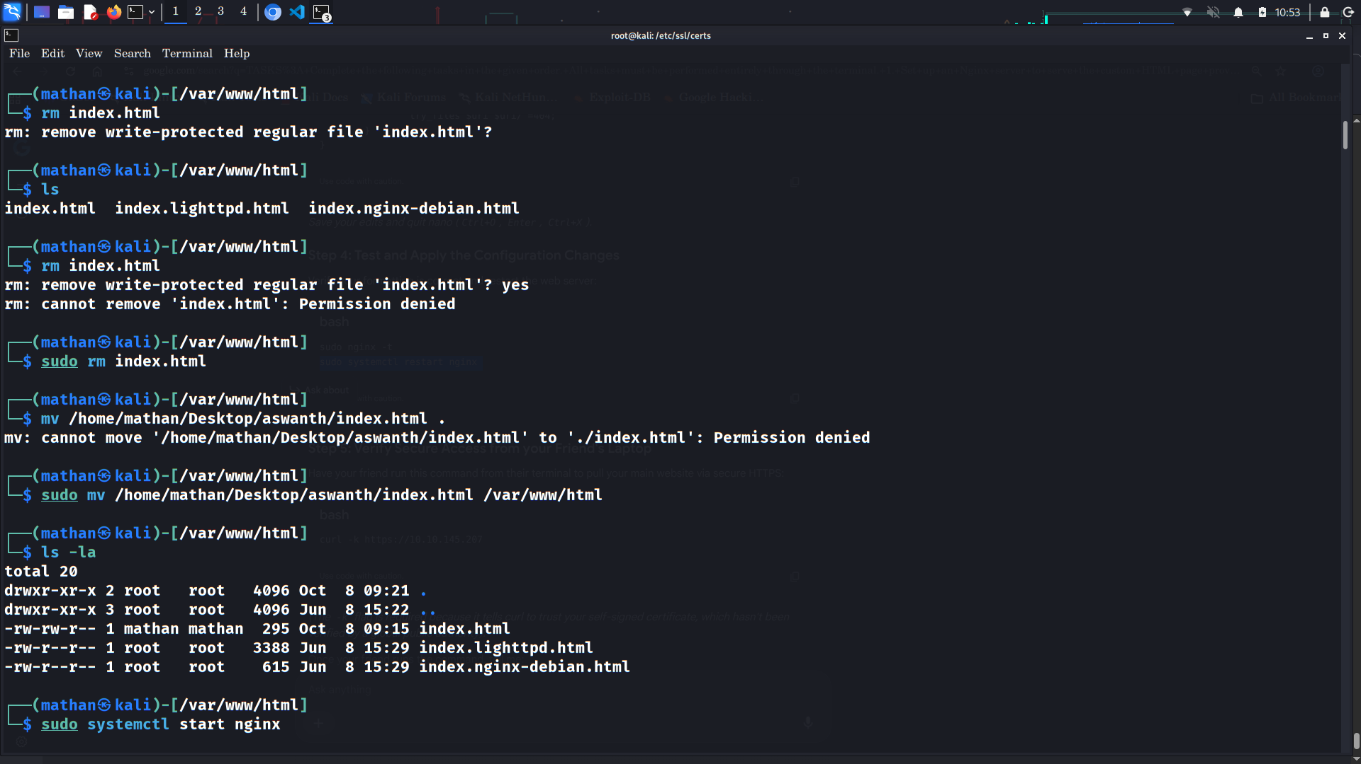

Evidence 4/5 — Screenshot_2026-10-08_10_54_02.png
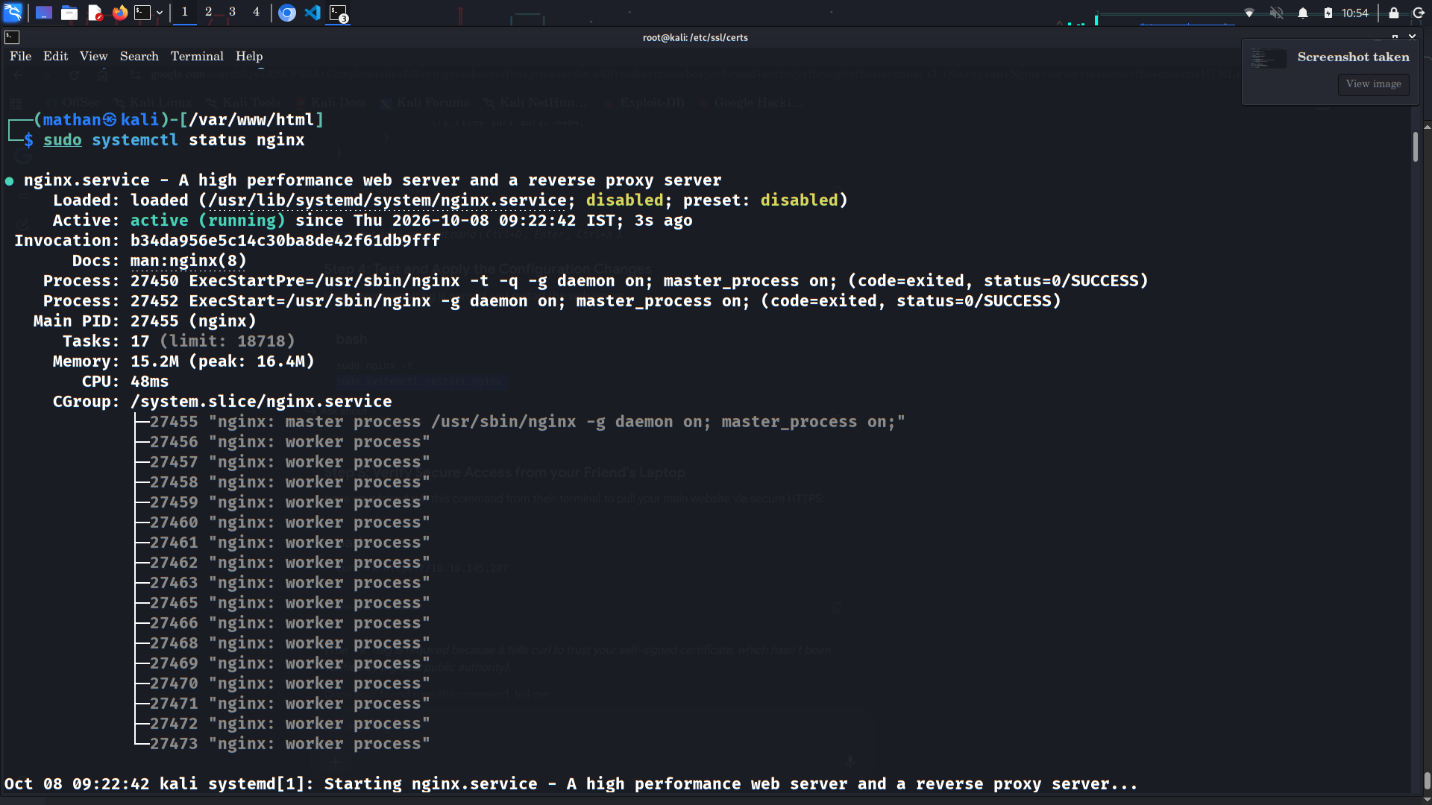

Evidence 5/5 — Screenshot_2026-10-08_10_54_09.png
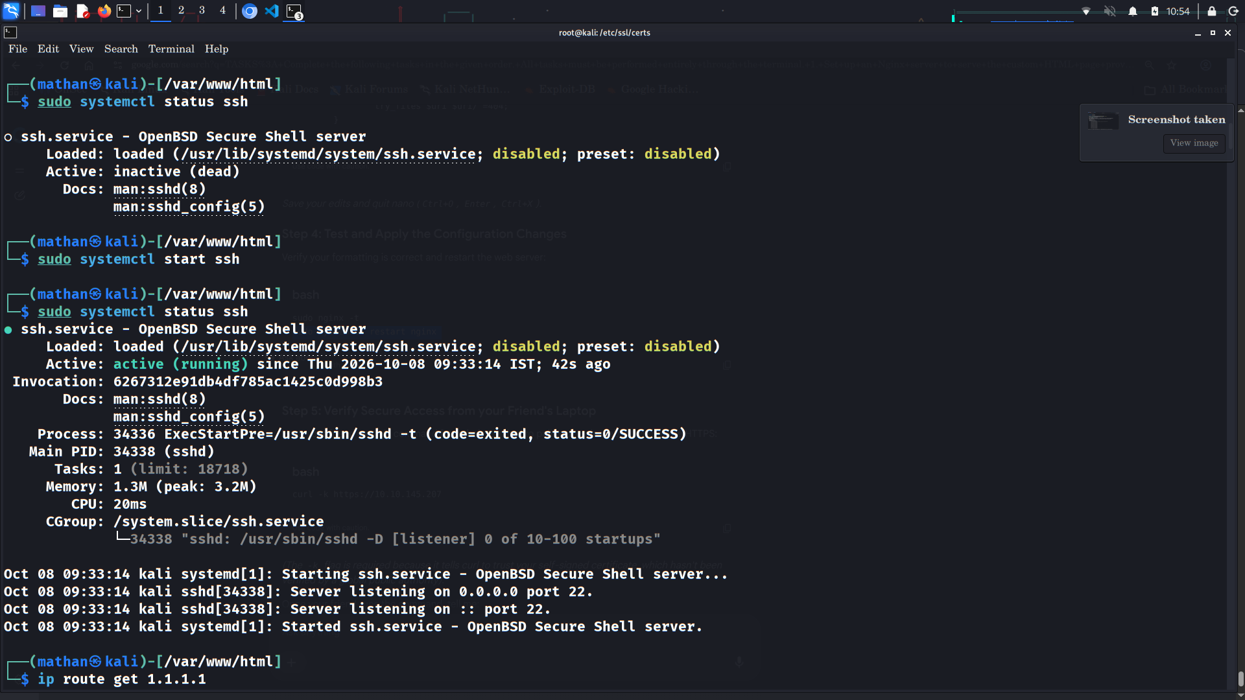

Task 2 — Access the Hosted Page from Another Computer
Make the Nginx-hosted page reachable from another computer connected to the same network.
The server interface was checked with:
ip -br a
The server address shown in the evidence is:
10.10.145.207/20
The routing table also shows:
10.10.144.1
as the gateway.
SSH was enabled to support remote administration:
sudo systemctl start ssh
sudo systemctl status ssh
The SSH service reported:
Server listening on 0.0.0.0 port 22.
Server listening on :: port 22.
A remote SSH connection to the server address was also captured in the evidence.
The custom page was queried using:
curl http://10.10.145.207
The returned HTML includes the organizer page content, demonstrating that the server is serving the intended file.
The competition specifically requires access from **another computer on the same network**.
The screenshots provide network, HTTP, and remote-session evidence, but the final organizer demonstration should explicitly use a second physical computer. On that second computer run:
curl http://10.10.145.207
or open:
http://10.10.145.207
in a browser.
The server is configured on the LAN address `10.10.145.207`, Nginx is reachable, and the custom HTML response is available.
Five screenshots are included in `evidence/task-2-remote-access/`.
Use a second laptop/PC on the same network and show the address in a browser or terminal.

Terminal Evidence — 5 Screenshots
Evidence 1/5 — Screenshot_2026-10-08_10_54_13.png
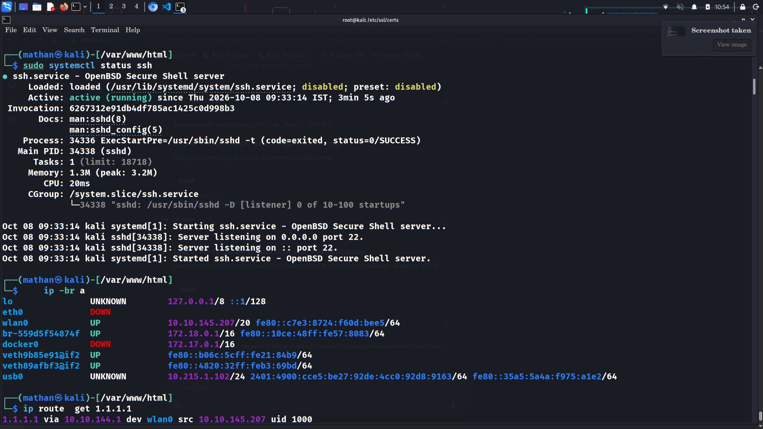

Evidence 2/5 — Screenshot_2026-10-08_10_54_19.png
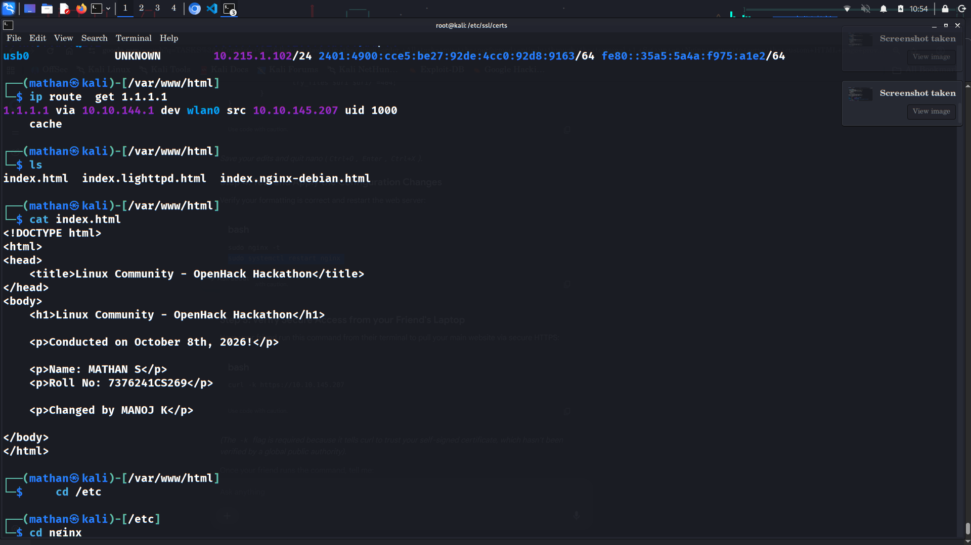

Evidence 3/5 — Screenshot_2026-10-08_10_54_48.png
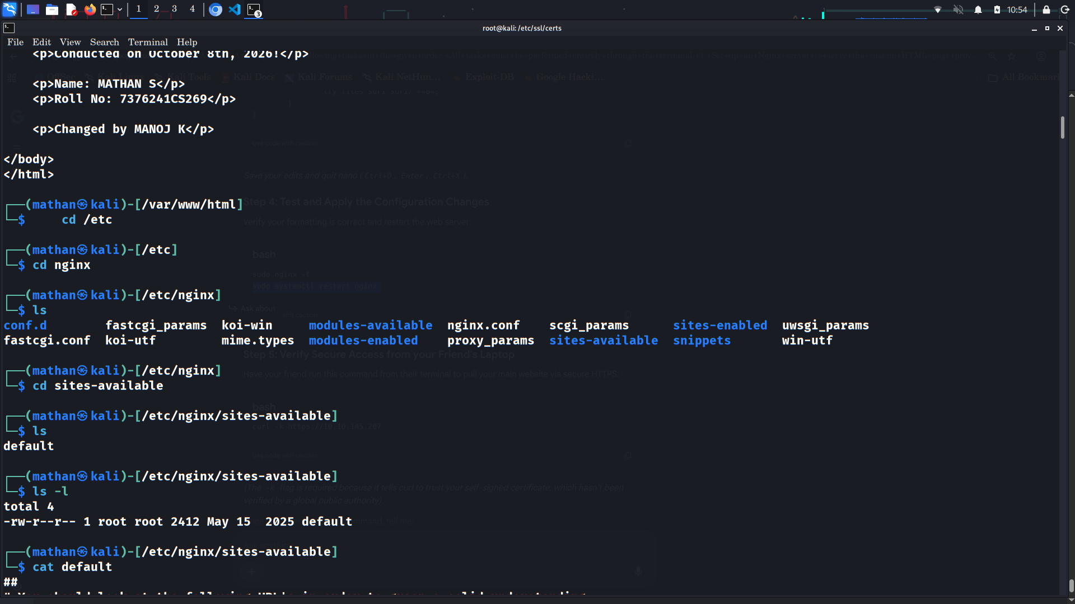

Evidence 4/5 — Screenshot_2026-10-08_10_54_57.png
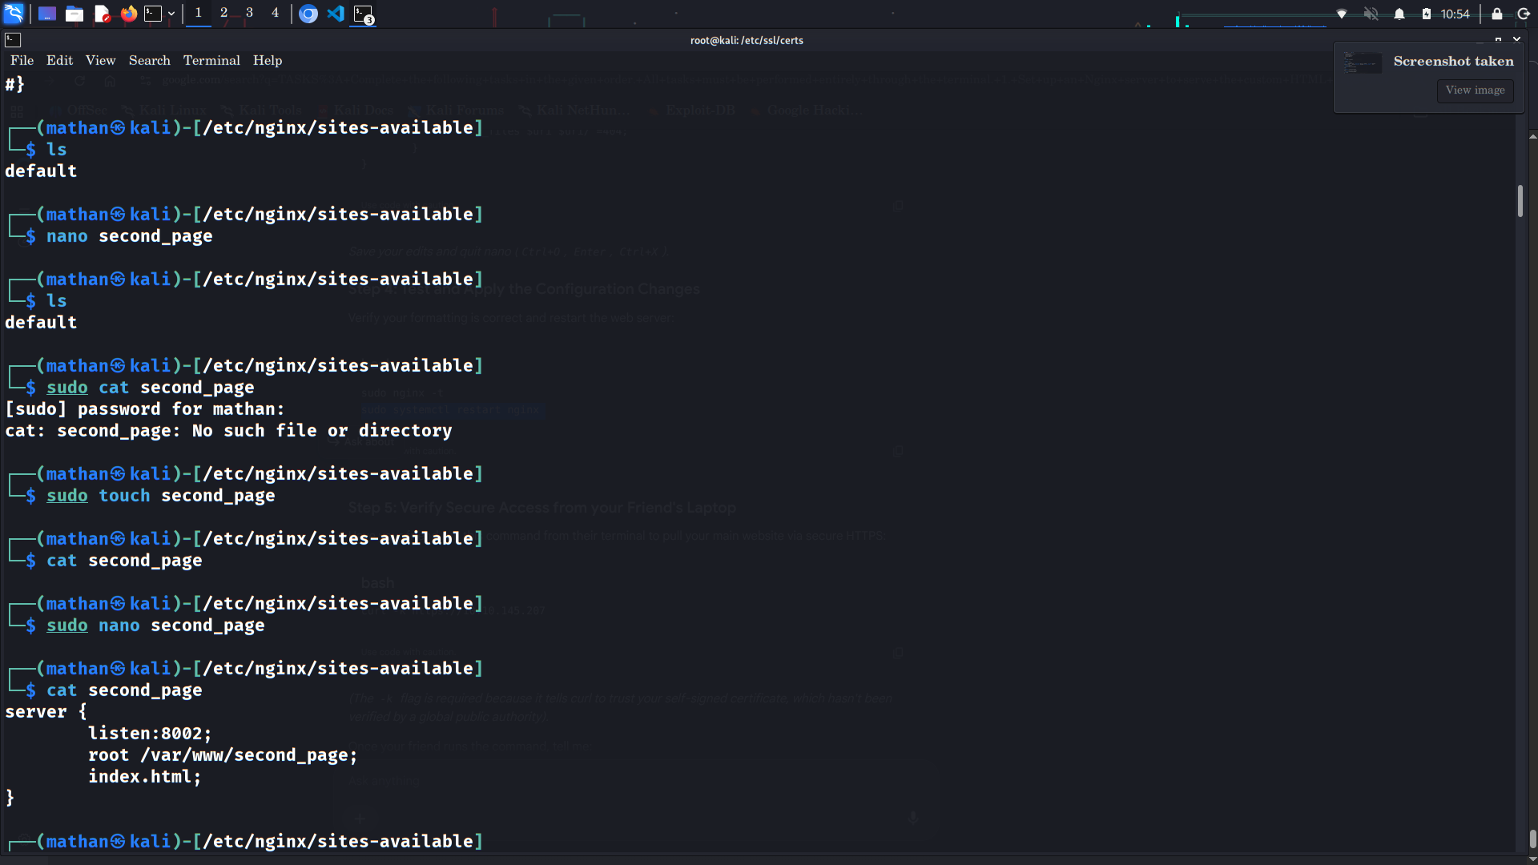

Evidence 5/5 — Screenshot_2026-10-08_10_55_00.png
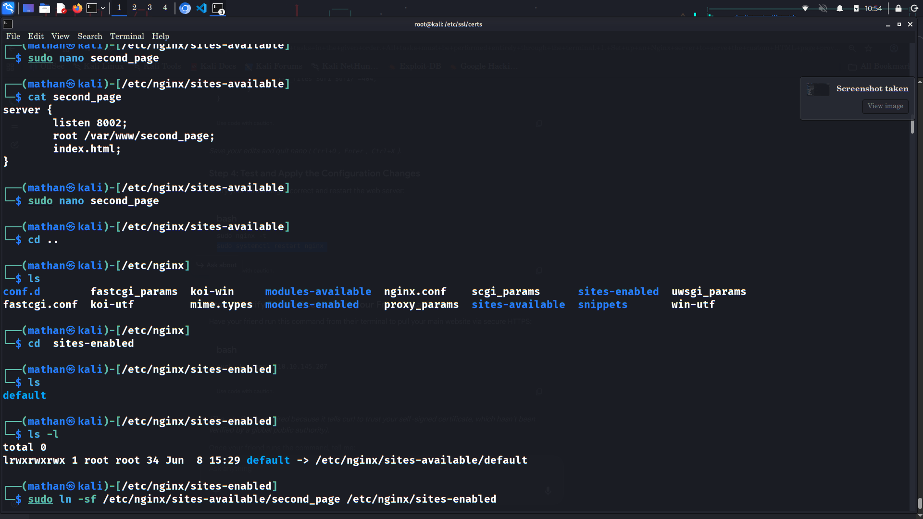

Task 3 — Modify the HTML Page Remotely and Verify the Change
Modify the hosted HTML page from another computer and demonstrate that Nginx immediately serves the changed content.
The evidence includes an SSH service configured to listen on port 22 and a remote login session to:
10.10.145.207
A remote client can therefore administer the server without physically editing the server's console.
From the second computer, use the permitted remote administration method and edit:
/var/www/html/index.html
For example, with SSH:
ssh mathan@10.10.145.207
Then edit:
sudo nano /var/www/html/index.html
Change a visible value such as the heading or a paragraph.
Save the file and exit.
Nginx does not need to be restarted for a static HTML file change.
Verify from the second computer:
curl http://10.10.145.207
The changed text should appear in the response.
A browser can also be refreshed at:
http://10.10.145.207
The supplied screenshots document the SSH setup, remote session, HTML content, and command history. They do not capture a clean before/after pair of the same HTML element from a clearly identified second physical computer.
Therefore, for the competition's final proof, capture these two additional terminal states if permitted:
1. Before modification — show the original HTML response.
2. After modification — show the changed HTML response from the second computer.
This makes the Task 3 evidence unambiguous.
The architecture supports remote modification because the page is a normal static file served by Nginx. A file change is reflected on the next HTTP request without restarting Nginx.
Five screenshots are included in `evidence/task-3-remote-modification/`.

Terminal Evidence — 5 Screenshots
Evidence 1/5 — Screenshot_2026-10-08_10_55_04.png
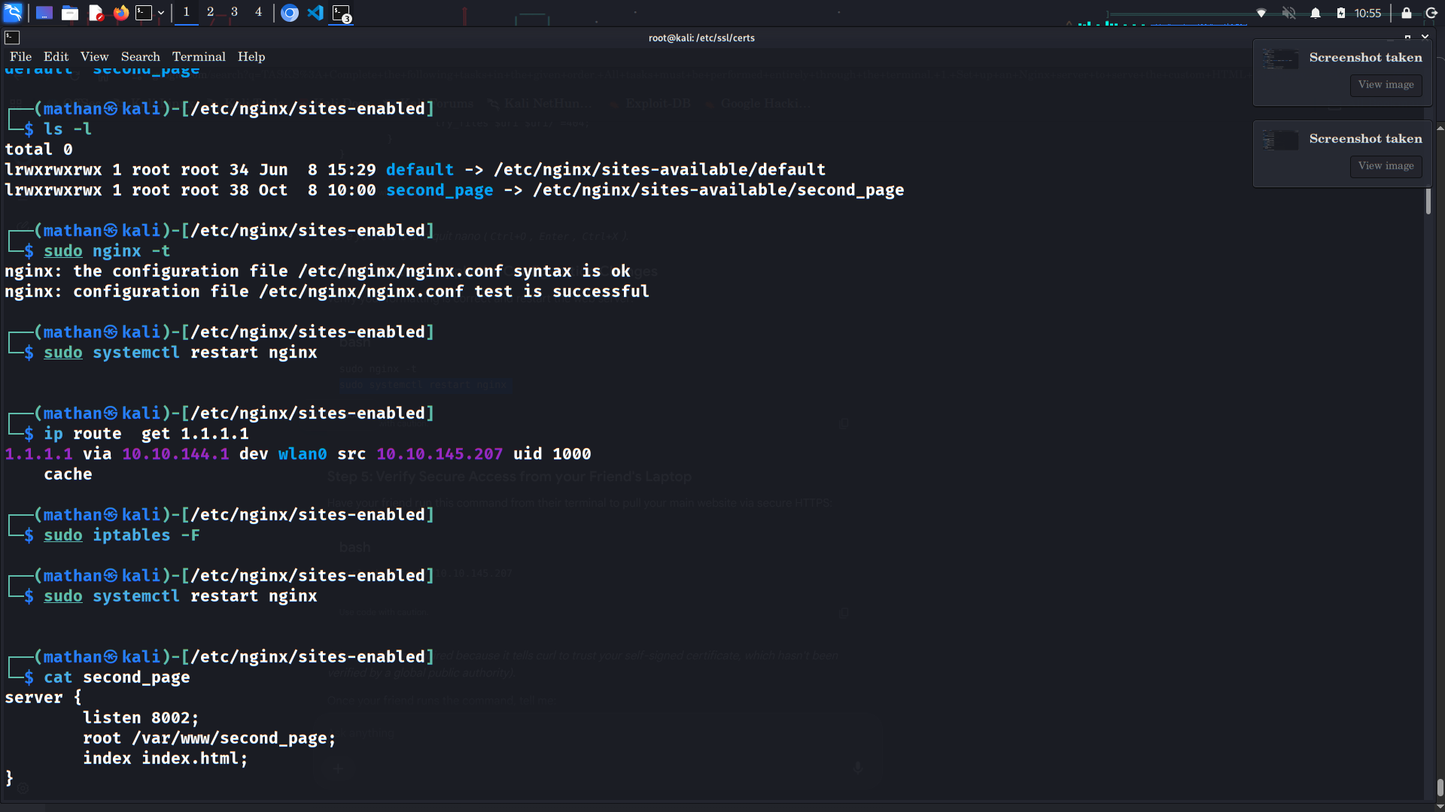

Evidence 2/5 — Screenshot_2026-10-08_10_55_10.png
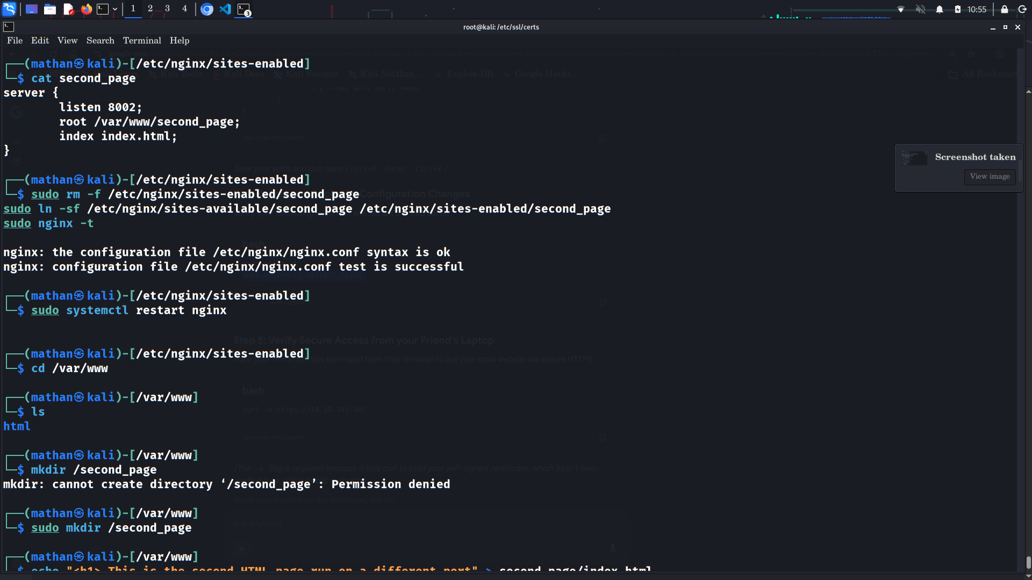

Evidence 3/5 — Screenshot_2026-10-08_10_55_18.png
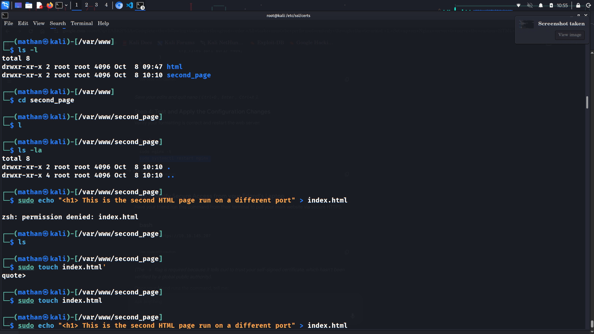

Evidence 4/5 — Screenshot_2026-10-08_10_55_22.png
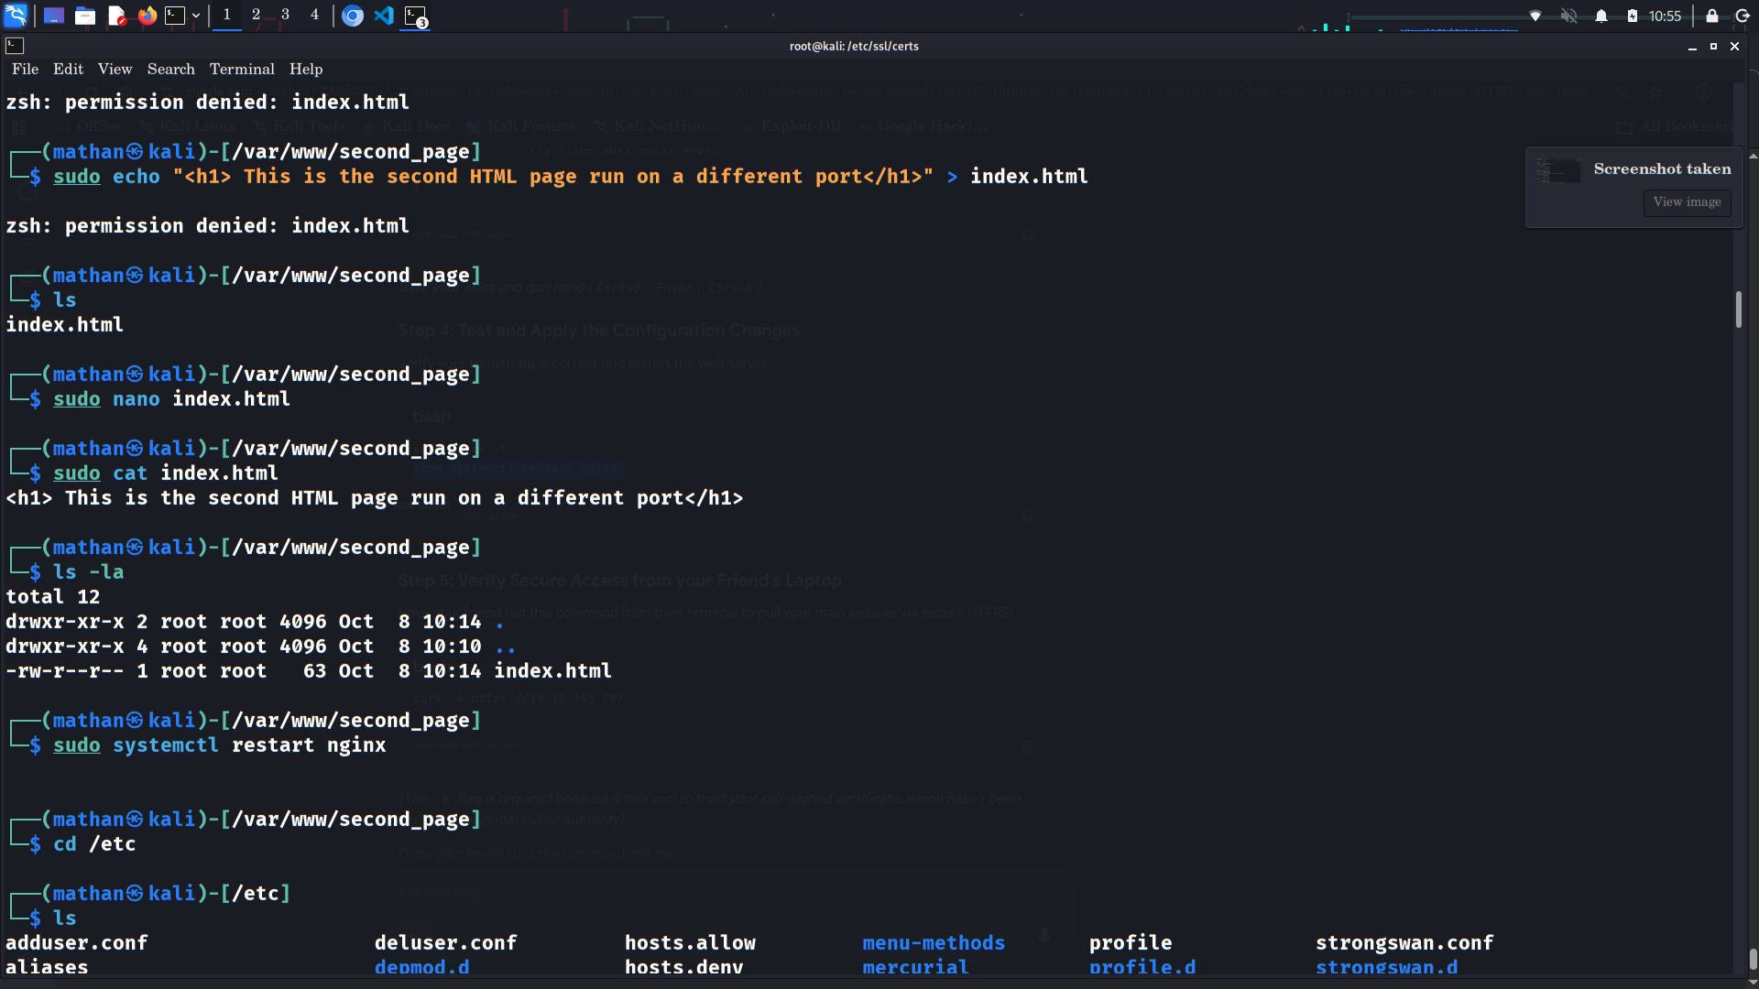

Evidence 5/5 — Screenshot_2026-10-08_10_56_24.png
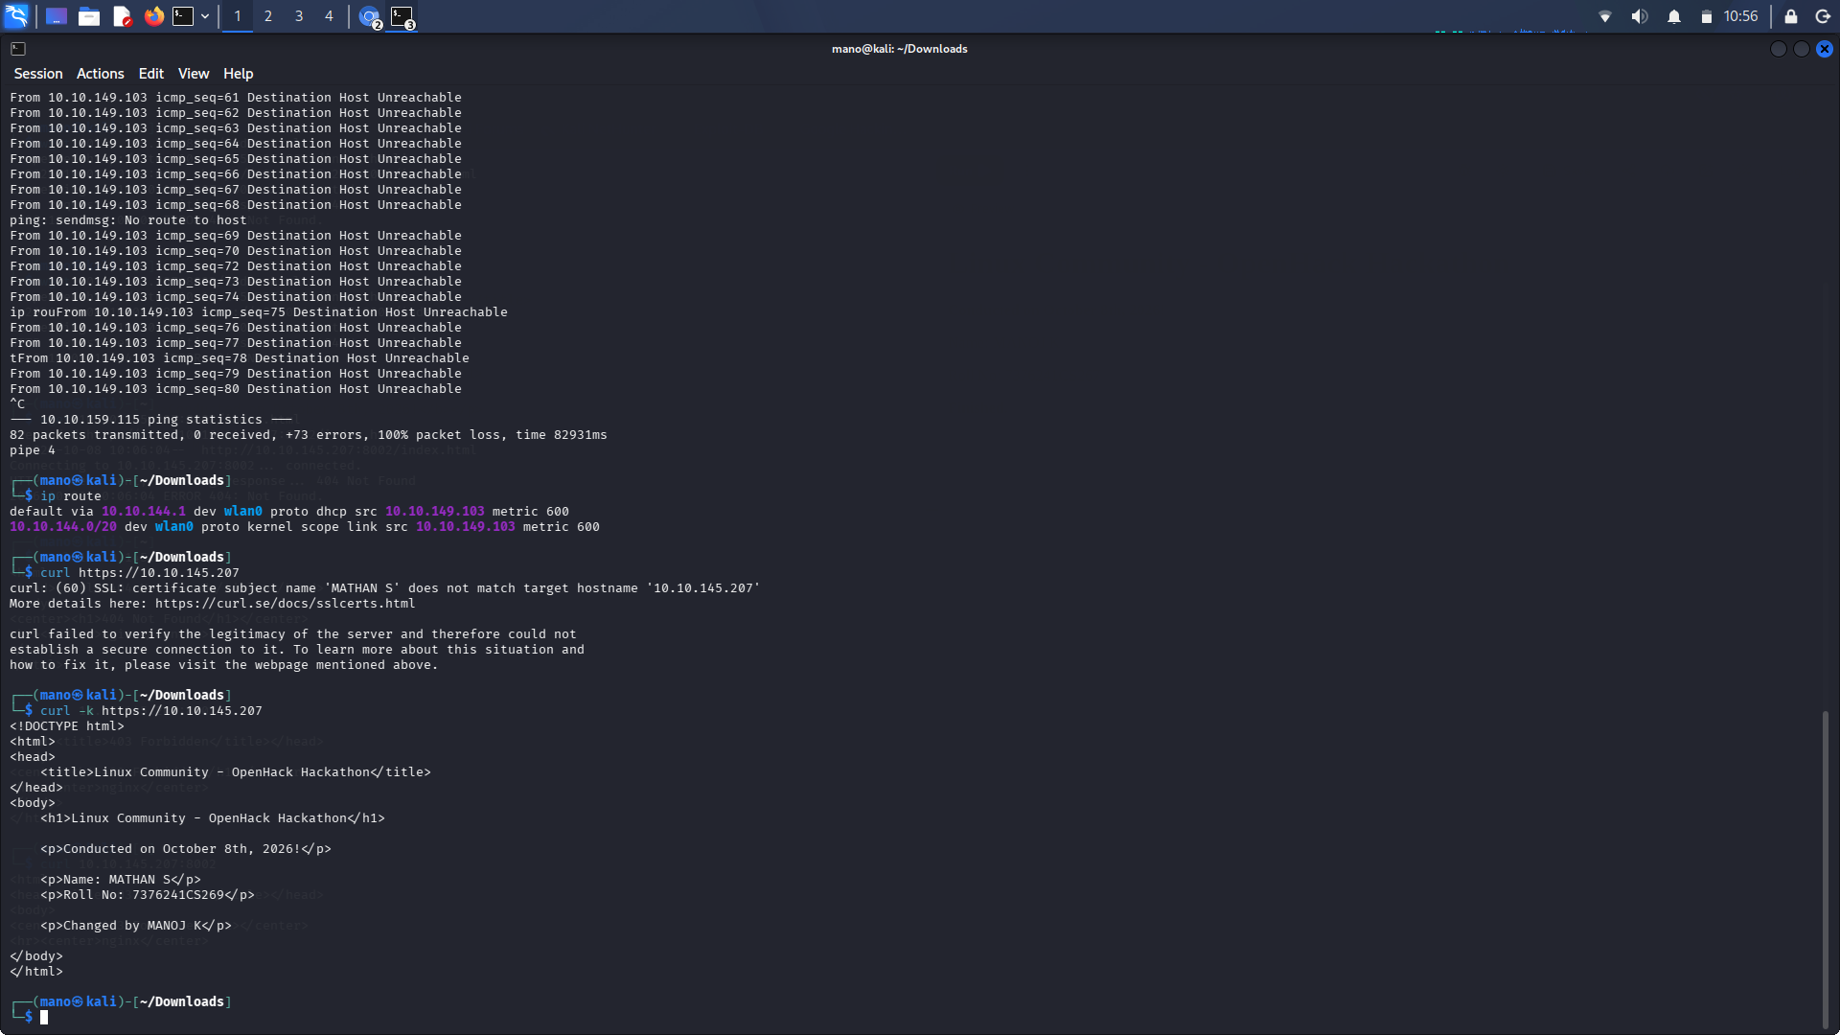

Task 4 — Serve a Different HTML Page on a Separate Port
Create a second HTML page and serve it from Nginx on a different port.
The second document root is:
/var/www/second_page
The HTML file contains:
<h1>This is the second HTML page run on a different port</h1>
A separate site configuration was created at:
/etc/nginx/sites-available/second_page
Configuration:
server {
listen 8002;
root /var/www/second_page;
index index.html;
}
The site was enabled with:
sudo ln -sf /etc/nginx/sites-available/second_page \
/etc/nginx/sites-enabled/second_page
sudo nginx -t
The evidence shows:
syntax is ok
test is successful
Then Nginx was restarted:
sudo systemctl restart nginx
The final verification was performed with:
curl 10.10.145.207:8002
The successful response was:
<h1>This is the second HTML page run on a different port</h1>
The terminal also shows earlier `404 Not Found` responses while the second page was being prepared. This was resolved after creating the correct document root and `index.html`.
Task 4 was successfully implemented: the second HTML page is served independently through Nginx on TCP port `8002`.
Five screenshots are included in `evidence/task-4-second-port/`.
Run:
curl http://10.10.145.207:8002
and show the returned second-page heading.

Terminal Evidence — 5 Screenshots
Evidence 1/5 — Screenshot_2026-10-08_10_56_46.png
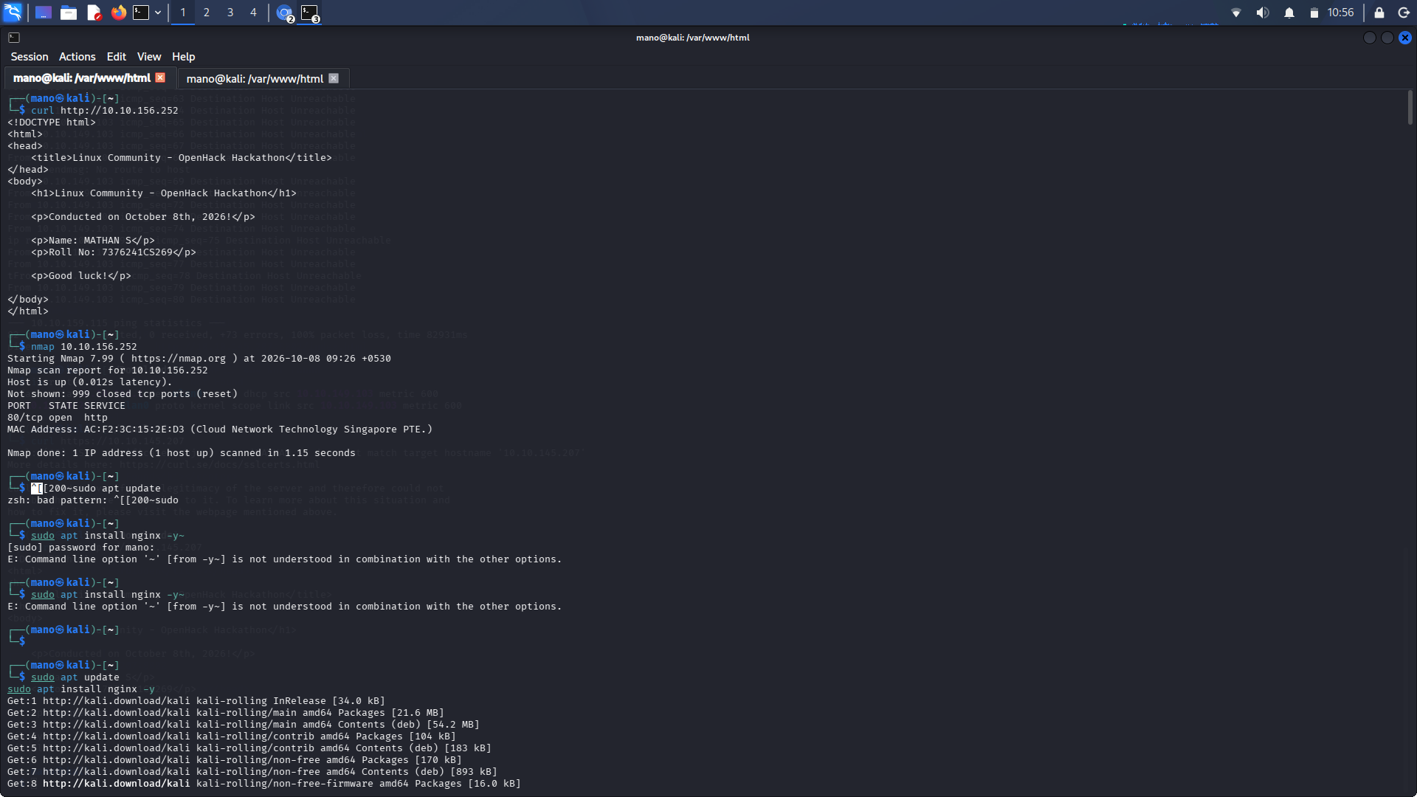

Evidence 2/5 — Screenshot_2026-10-08_10_57_52.png
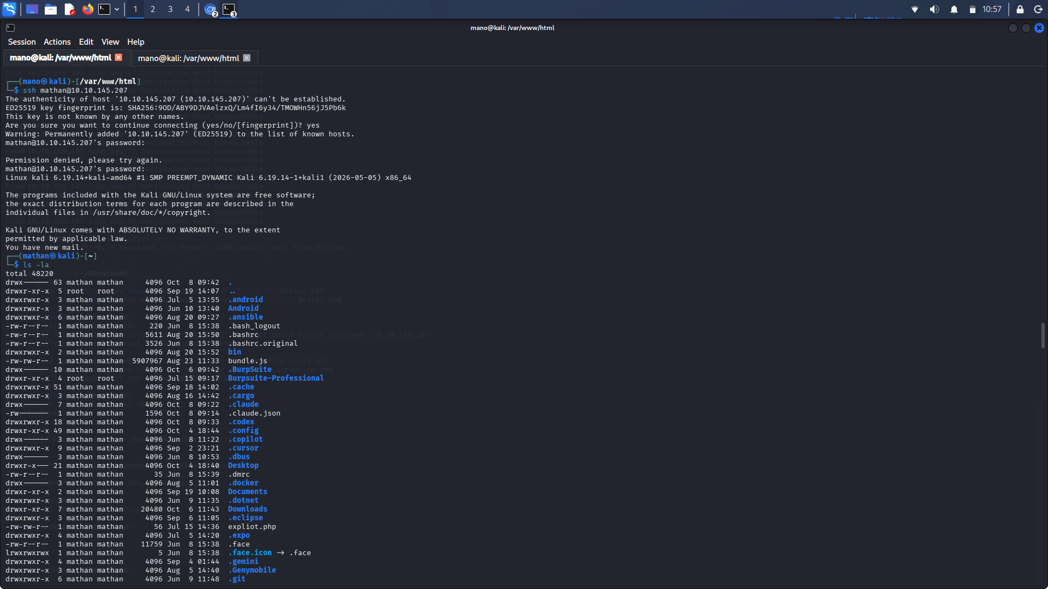

Evidence 3/5 — Screenshot_2026-10-08_10_58_02.png
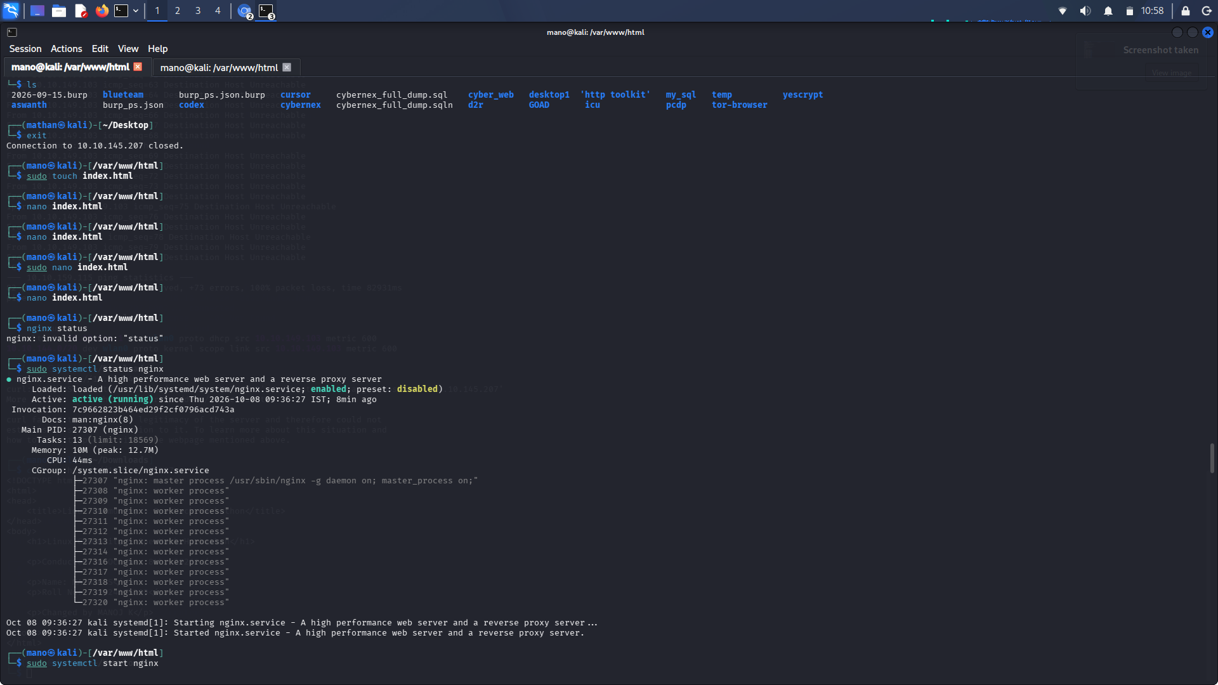

Evidence 4/5 — Screenshot_2026-10-08_10_58_23.png
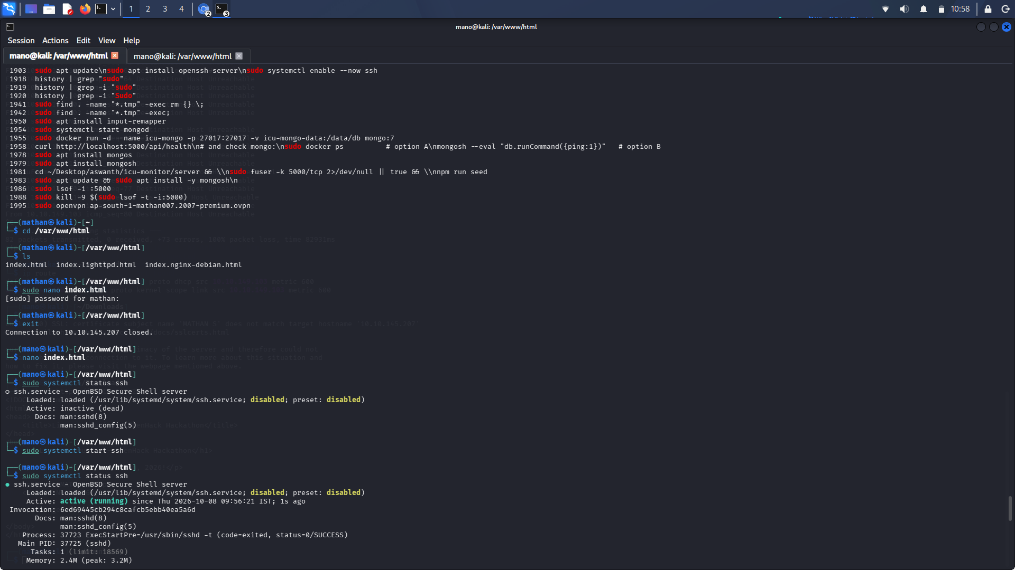

Evidence 5/5 — Screenshot_2026-10-08_10_58_37.png
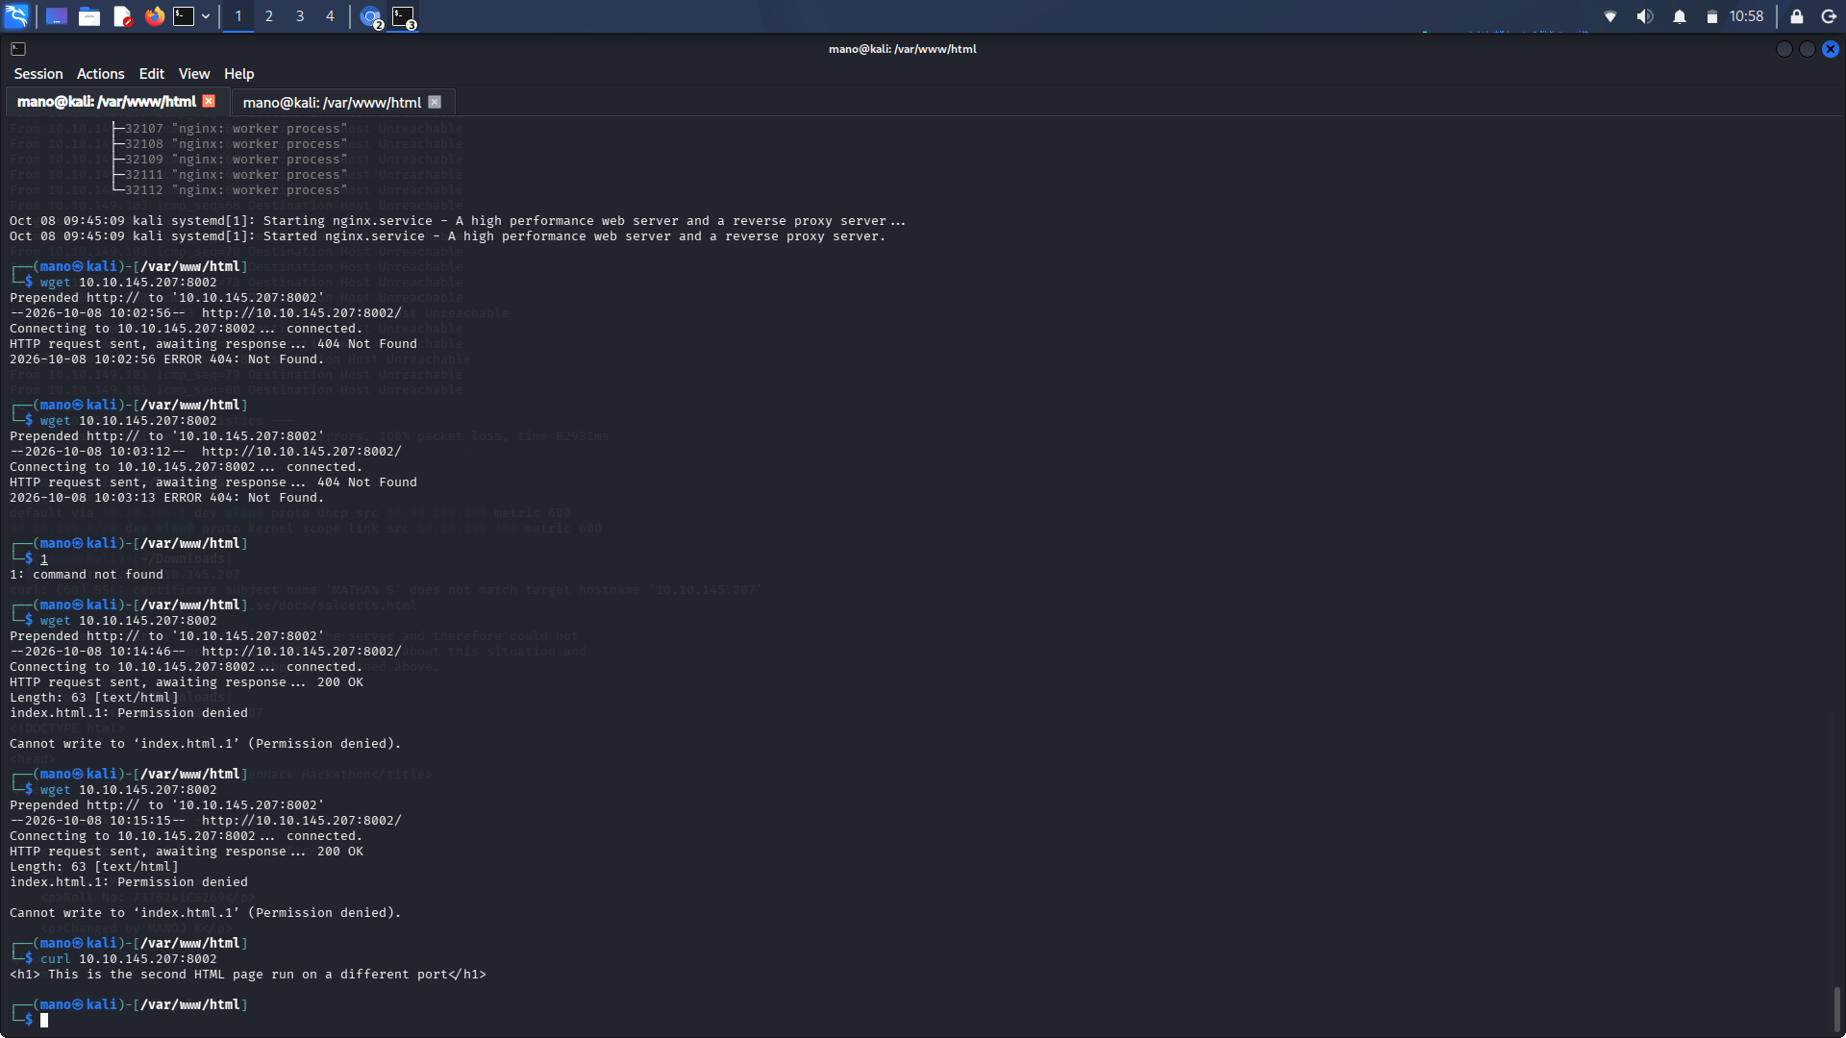

Task 5 — Convert the Hosted Page to HTTPS
Serve the custom HTML page through HTTPS using Nginx.
A self-signed RSA certificate was generated with OpenSSL:
sudo openssl req -x509 -nodes -days 365 \
-newkey rsa:2048 \
-keyout /etc/ssl/private/nginx-selfsigned.key \
-out /etc/ssl/certs/nginx-selfsigned.crt
Certificate subject information was entered during the OpenSSL prompts.
The Nginx default server configuration was edited to enable SSL on port `443`.
The relevant configuration concept is:
listen 443 ssl default_server;
listen [::]:443 ssl default_server;
and the server uses the generated certificate and private key.
sudo nginx -t
The evidence shows:
nginx: the configuration file /etc/nginx/nginx.conf syntax is ok
nginx: configuration file /etc/nginx/nginx.conf test is successful
Nginx was then restarted:
sudo systemctl restart nginx
Because the certificate is self-signed, normal certificate validation will reject it as untrusted.
For local verification:
curl -k https://10.10.145.207
The `-k` option tells curl to continue despite the self-signed certificate.
The HTTPS request returned the custom HTML page, confirming that the page was being served over TLS.
This certificate is appropriate for a local hackathon/lab demonstration. It is **not a trusted production certificate**.
For a production deployment, use a certificate issued by a trusted CA and configure a proper hostname.
HTTPS was configured and the custom page was successfully returned through the HTTPS endpoint.
Five screenshots are included in `evidence/task-5-https/`.
Run:
curl -k https://10.10.145.207
Then open:
https://10.10.145.207
in a browser and explain that the browser warning is expected because the certificate is self-signed.

Terminal Evidence — 5 Screenshots
Evidence 1/5 — Screenshot_2026-10-08_10_52_41.png
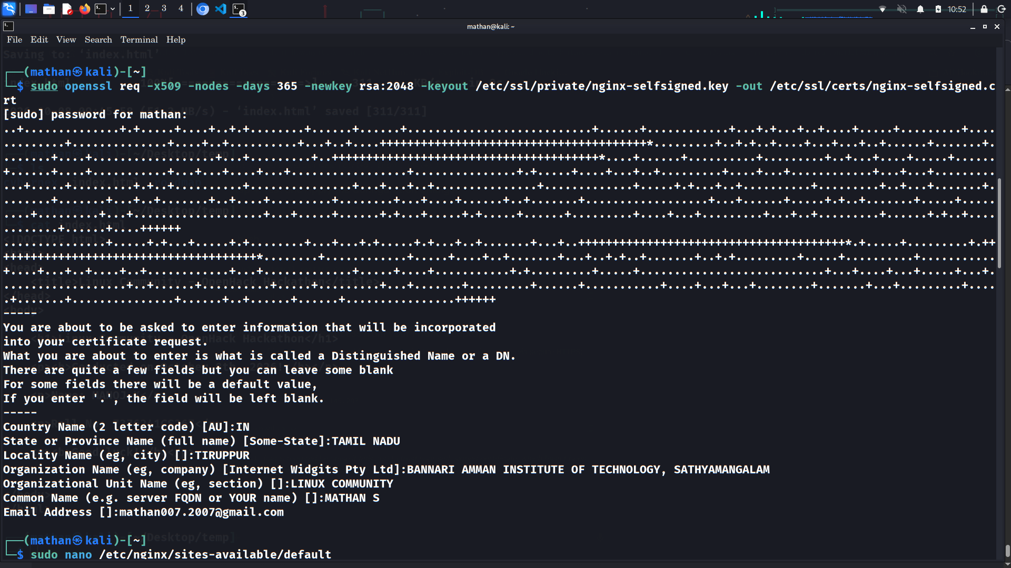

Evidence 2/5 — Screenshot_2026-10-08_10_53_01.png
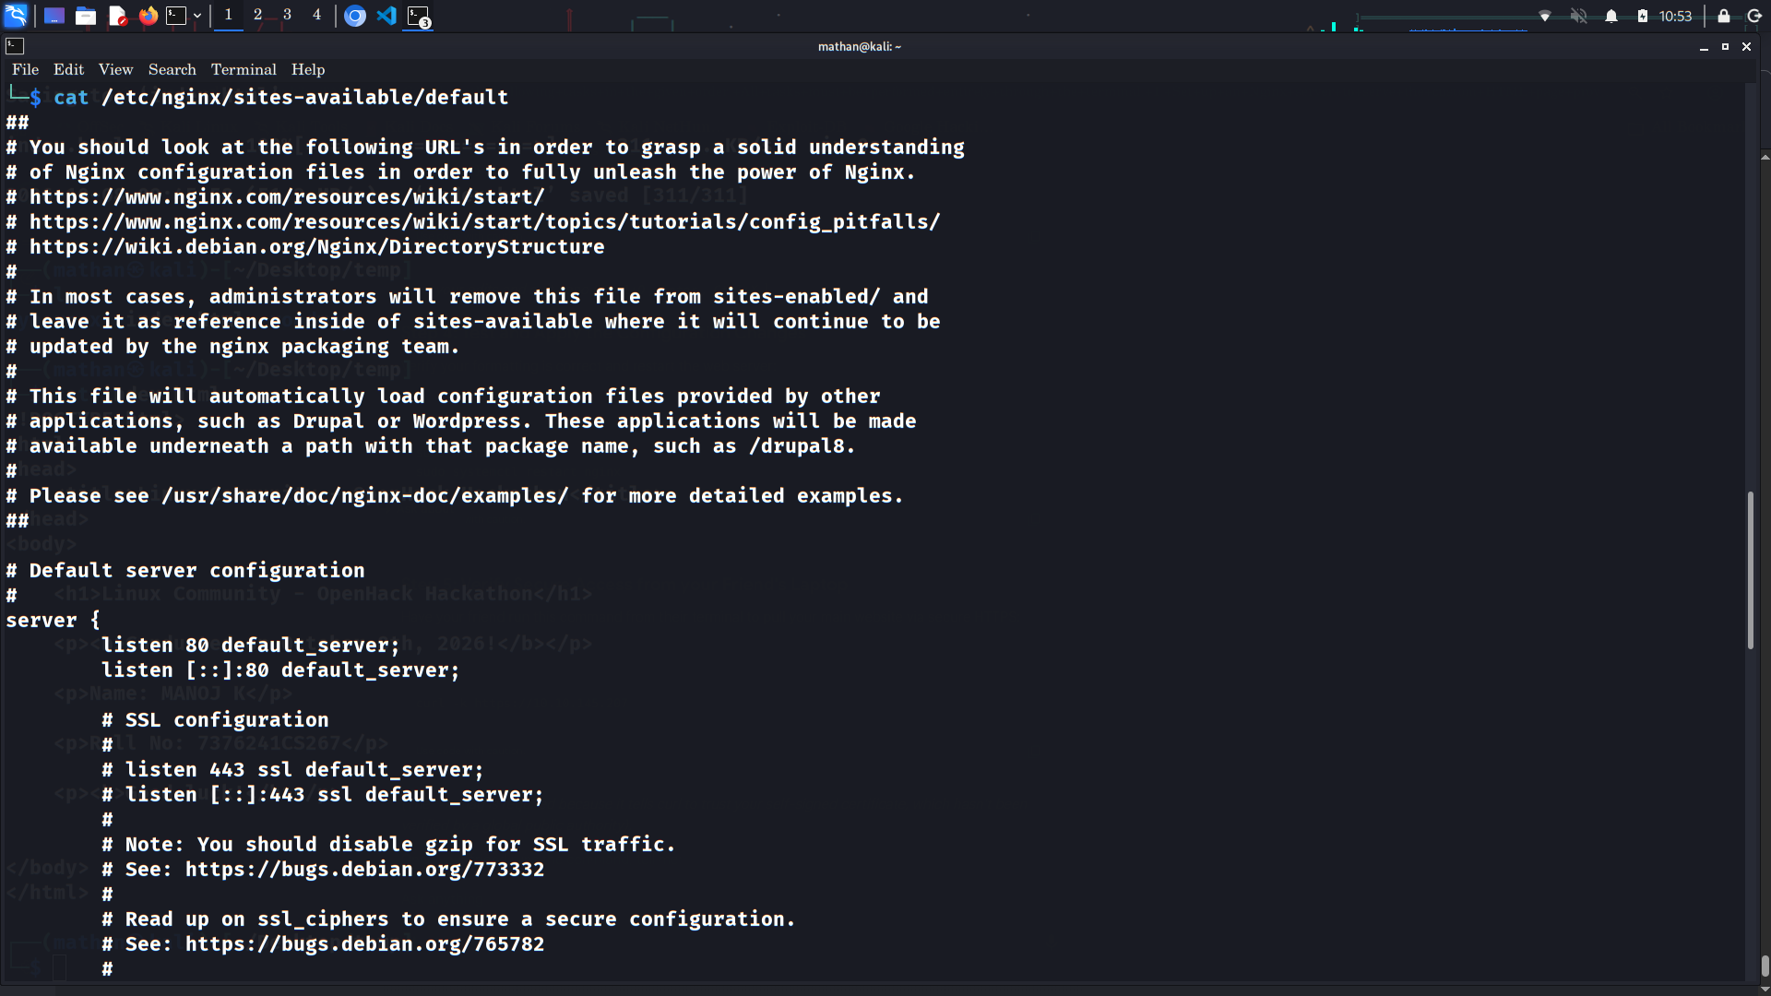

Evidence 3/5 — Screenshot_2026-10-08_10_53_03.png
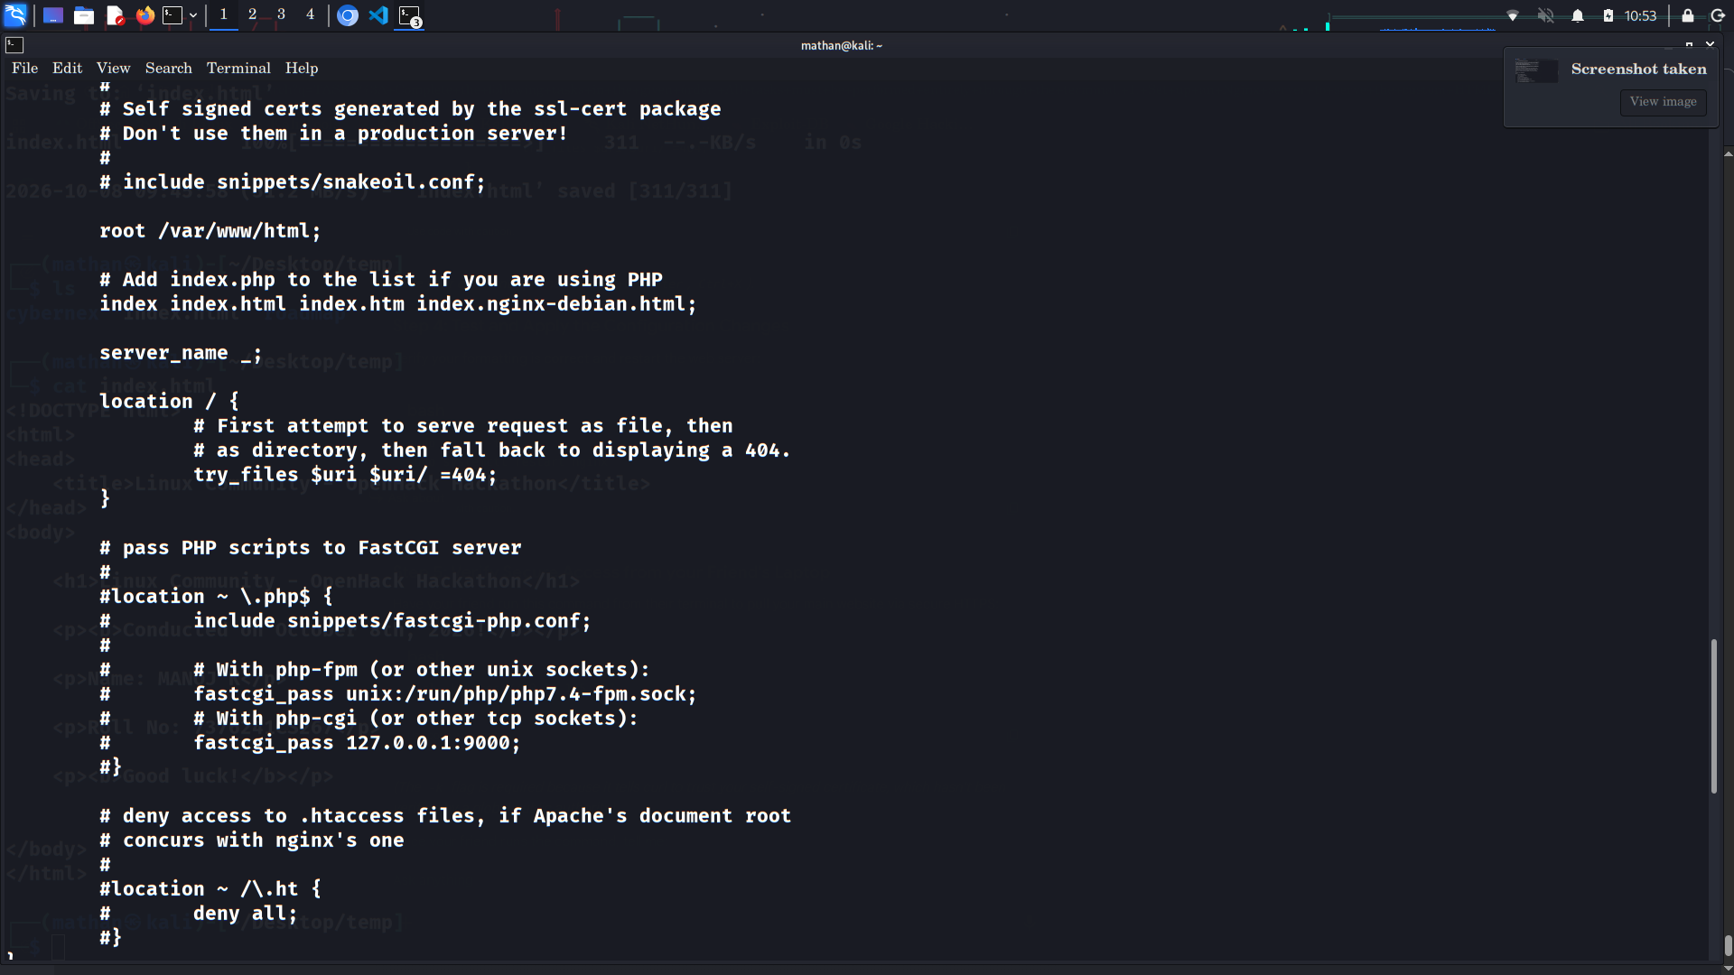

Evidence 4/5 — Screenshot_2026-10-08_10_53_05.png
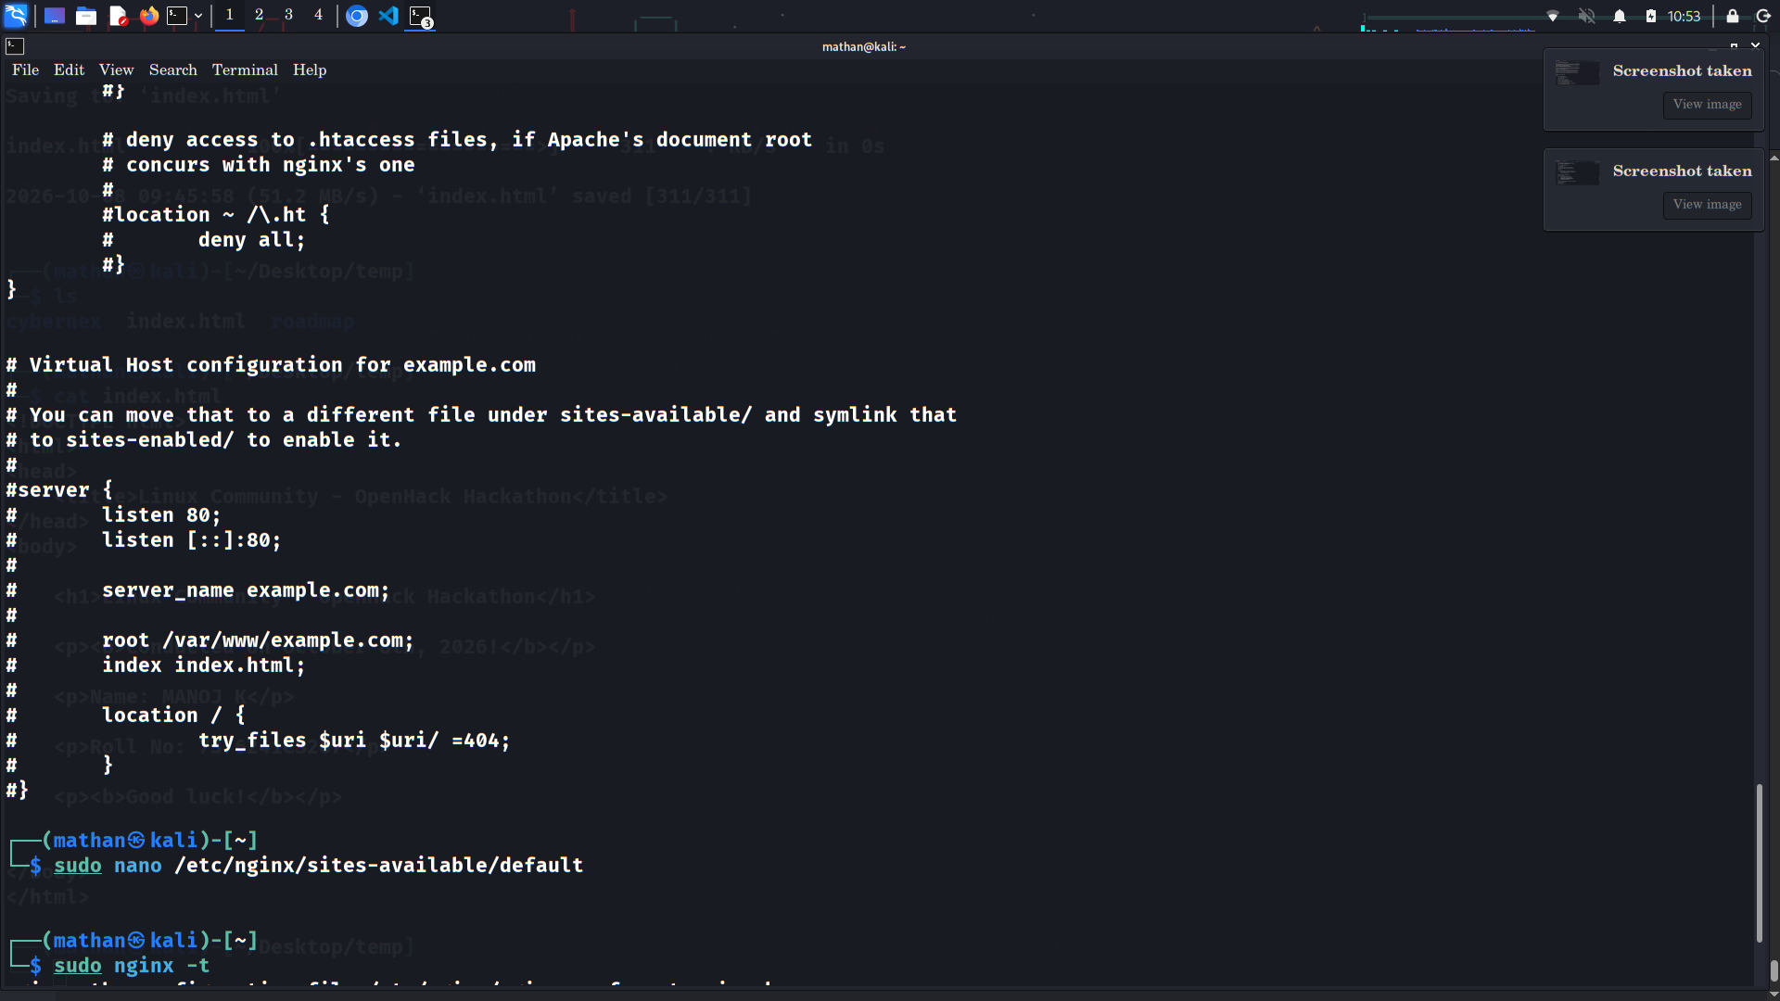

Evidence 5/5 — Screenshot_2026-10-08_10_53_08.png
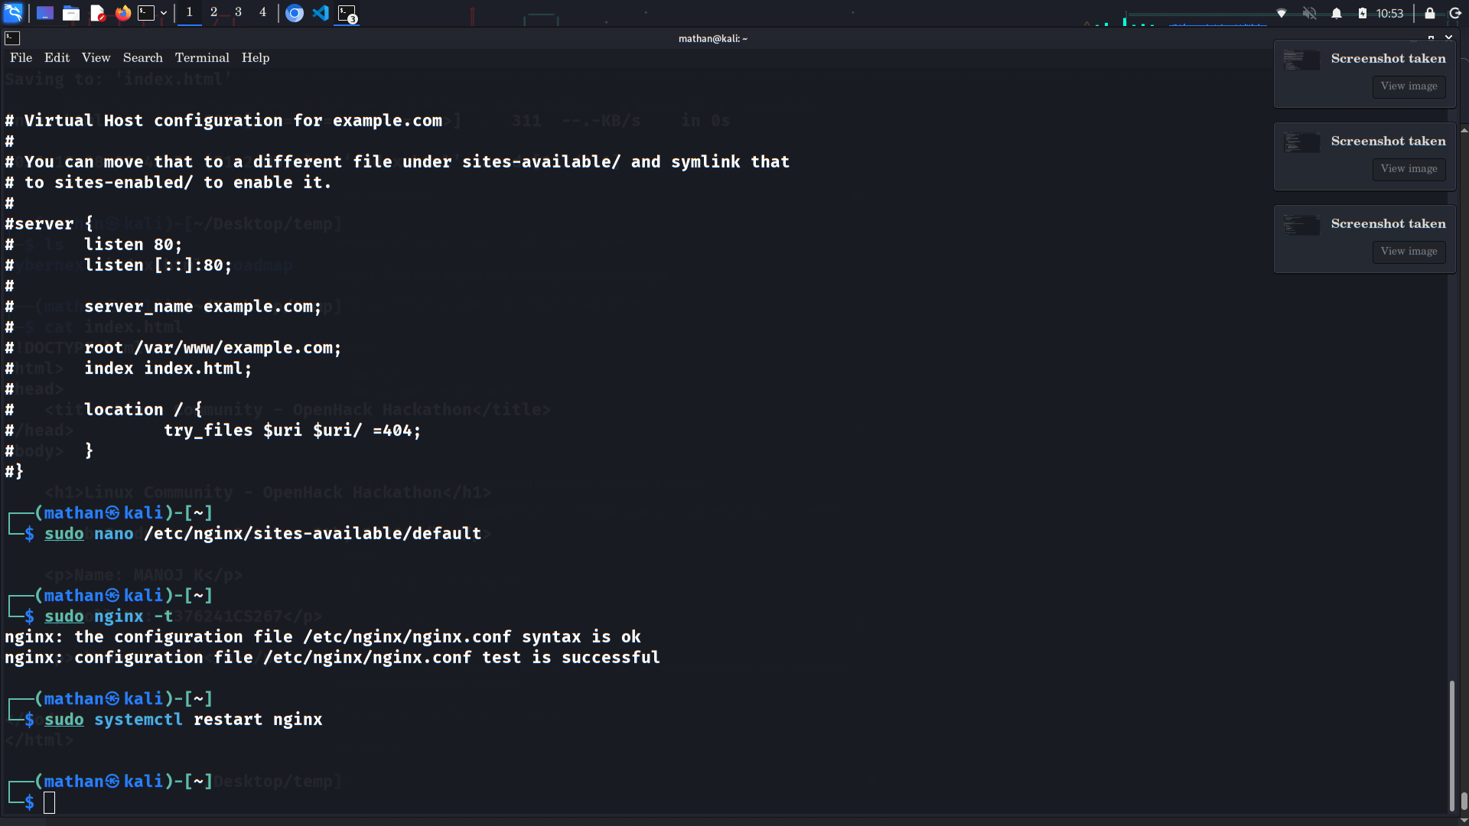

Final Submission Notes
The screenshots are preserved exactly as supplied. The documentation does not claim that a local curl request proves the separate-computer requirement. For Tasks 2 and 3, the final live demonstration should be made from a second physical computer on the same LAN.
The HTTPS certificate is self-signed. A browser trust warning is therefore expected; successful TLS serving is verified with curl -k.

