1. **@configuration**=Indicates that a class declares one or more @Bean methods and may be processed by the Spring container to generate bean definitions and service requests for those beans at runtime
2. **@componentscan** =Configures component scanning directives for use with @ Configuration classes. Provides support parallel with Spring XML's <context:component-scan> element.
3. **@EnableTransactionManagement**=Enables Spring's annotation-driven transaction management capability, similar to the support found in Spring's <tx:*> XML namespace.
4. **@Bean**=A bean is an object that is instantiated, assembled, and otherwise managed by a Spring IoC container. These beans are created with the configuration metadata that you supply to the container, for example, in the form of XML <bean/>
5. **@Autowired** =annotation provides more fine-grained control over where and how autowiring should be accomplished.
6. **@Component**=annotation marks a java class as a bean so the component-scanning mechanism of spring can pick it up and pull it into the application context
7. **@Service**=All business logic is here i.e. Data related calculations and all.This annotation of business layer in which our user not directly call persistence method so it will call this methods using this annotation**. It will request @Repository as per user request**
8. **@Controller**=annotation marks a class as a Spring Web MVC controller

where your **request** **mapping from presentation page**

1. **@Repository**=This is Persistence layer(Data Access Layer) of application which used to get data from database. i.e. **all the Database related operations are done by repository.**

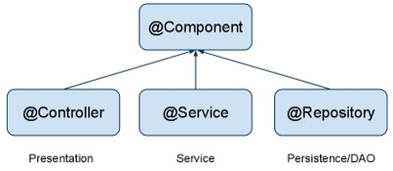

1. **@Transactional=Spring** dynamically creates a proxy that implements the same interface(s) as the class you're annotating.
2. **@RequestMapping** annotation is used to map web requests onto specific handler classes and/or handler methods.
3. **@Qualifier** annotation along with @Autowired to remove the confusion by specifying which exact bean will be wired.