Project Report - Software Installation Request Automation in ServiceNow

1. INTRODUCTION
Project Overview
This project automates software installation requests using ServiceNow.
Purpose
To reduce manual work by automating request submission, approvals, fulfillment and notifications.

2. IDEATION PHASE
Problem Statement
Employees request software through emails causing delays.
Empathy Map Canvas
Focuses on employee needs, faster approvals and transparency.
Brainstorming
Centralized service catalog, automated approvals, workflow and notifications.

3. REQUIREMENT ANALYSIS
Customer Journey Map, Solution Requirements, Data Flow Diagram and Technology Stack (ServiceNow, Flow Designer, Service Catalog, Business Rules).

4. PROJECT DESIGN
Problem Solution Fit
Automates the complete software installation lifecycle.
Proposed Solution
Service Catalog + Flow Designer + Approval + Fulfillment.

Solution Architecture Employee → Service Catalog → Approval → IT Support → Completion

5. PROJECT PLANNING & SCHEDULING
Sprint planning, backlog, user stories and implementation schedule.

6. FUNCTIONAL & PERFORMANCE TESTING
Verified request submission, approval, workflow execution, task creation and completion.

7. RESULTS
Output screenshots are shown below.

8. ADVANTAGES & DISADVANTAGES
Advantages: Automation, transparency, tracking.
Disadvantages: Depends on ServiceNow and approvals.

9. CONCLUSION
The project successfully automates software installation requests.

10. FUTURE SCOPE
Multi-level approvals, asset management, AI recommendations.

11. APPENDIX
GitHub Link
Demo Link
Source Code

Figure 1: Application(Licensed software installation management)
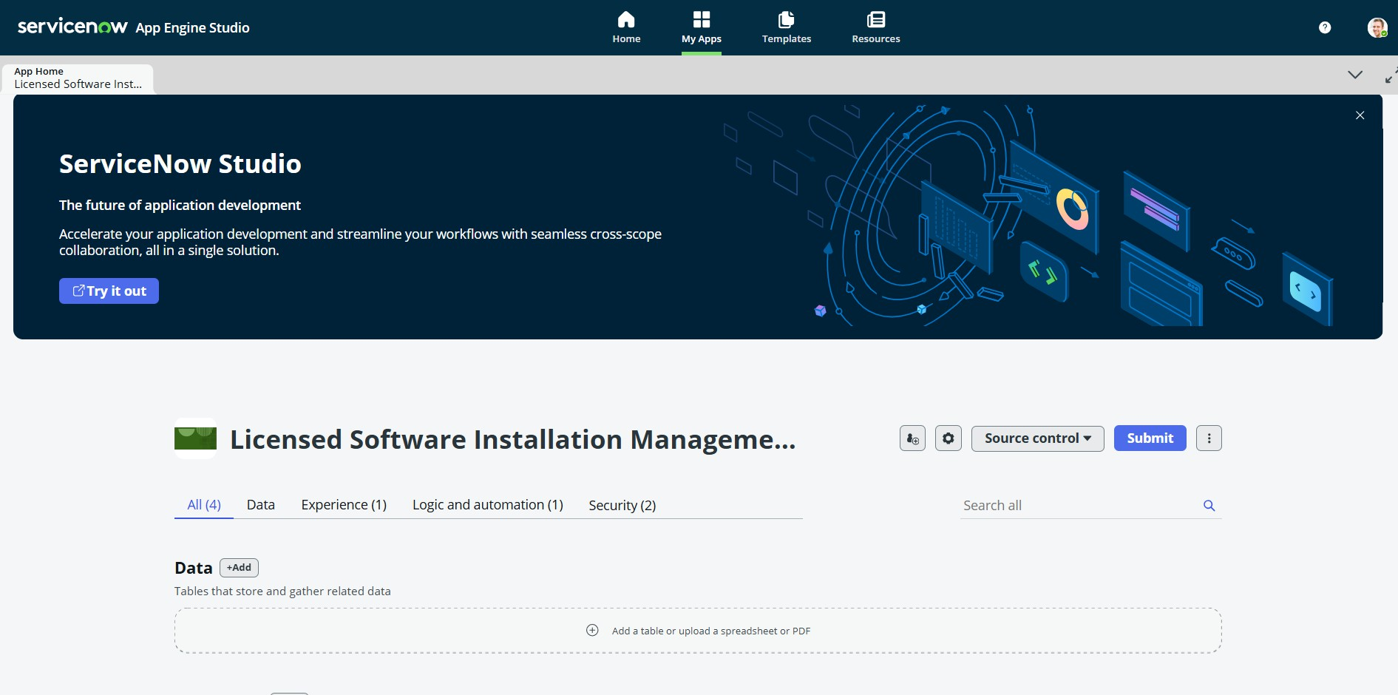
Figure 2: activitites
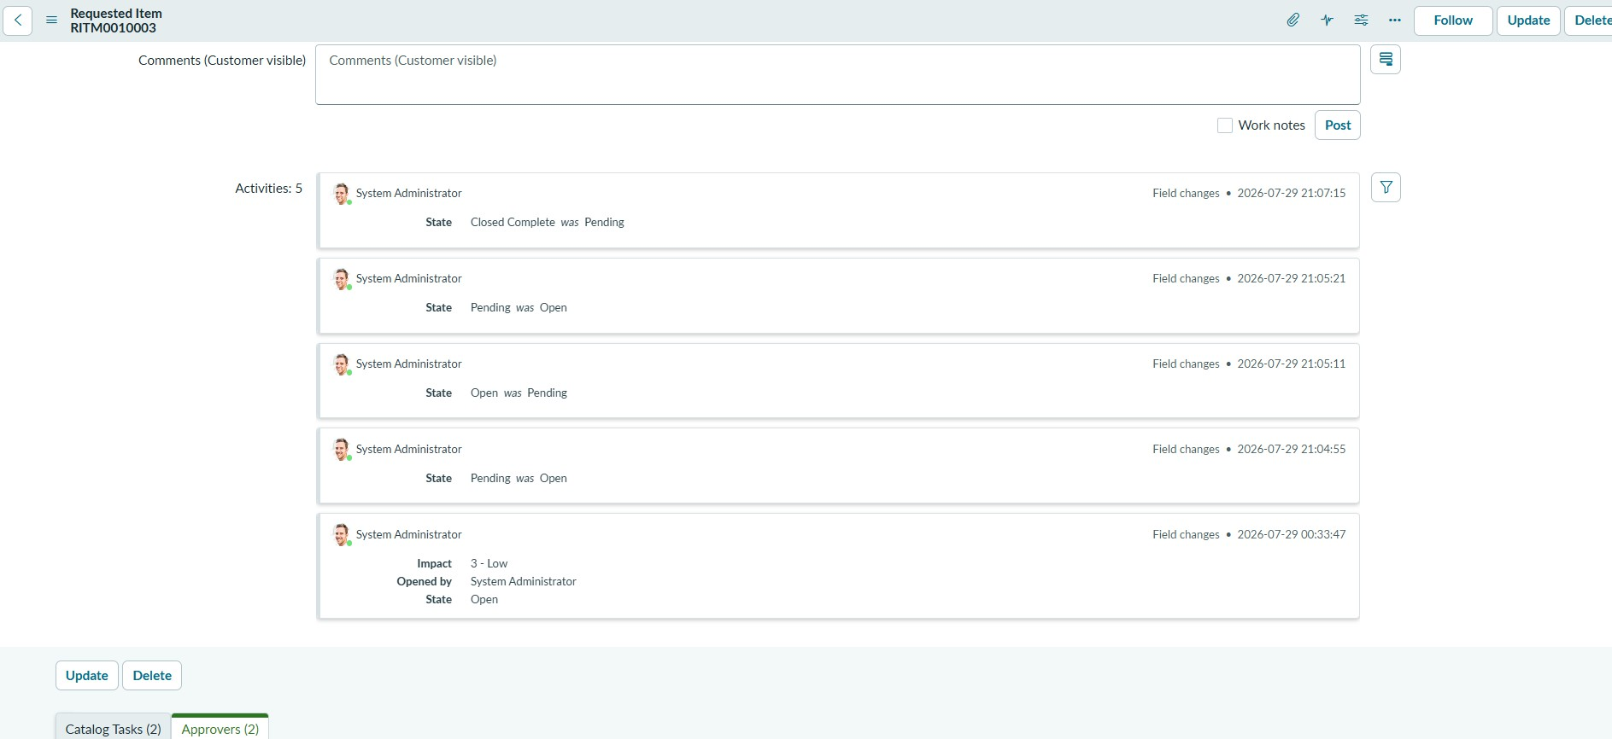
Figure 3: after completing workflow

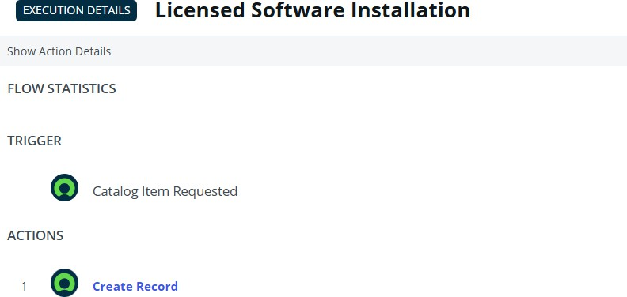

Figure 4: after run
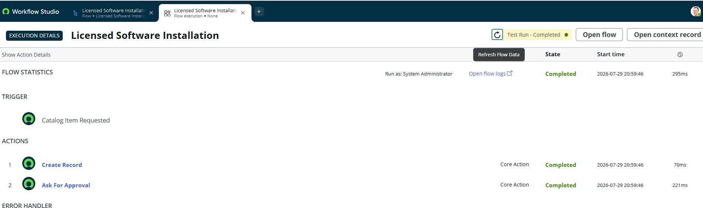

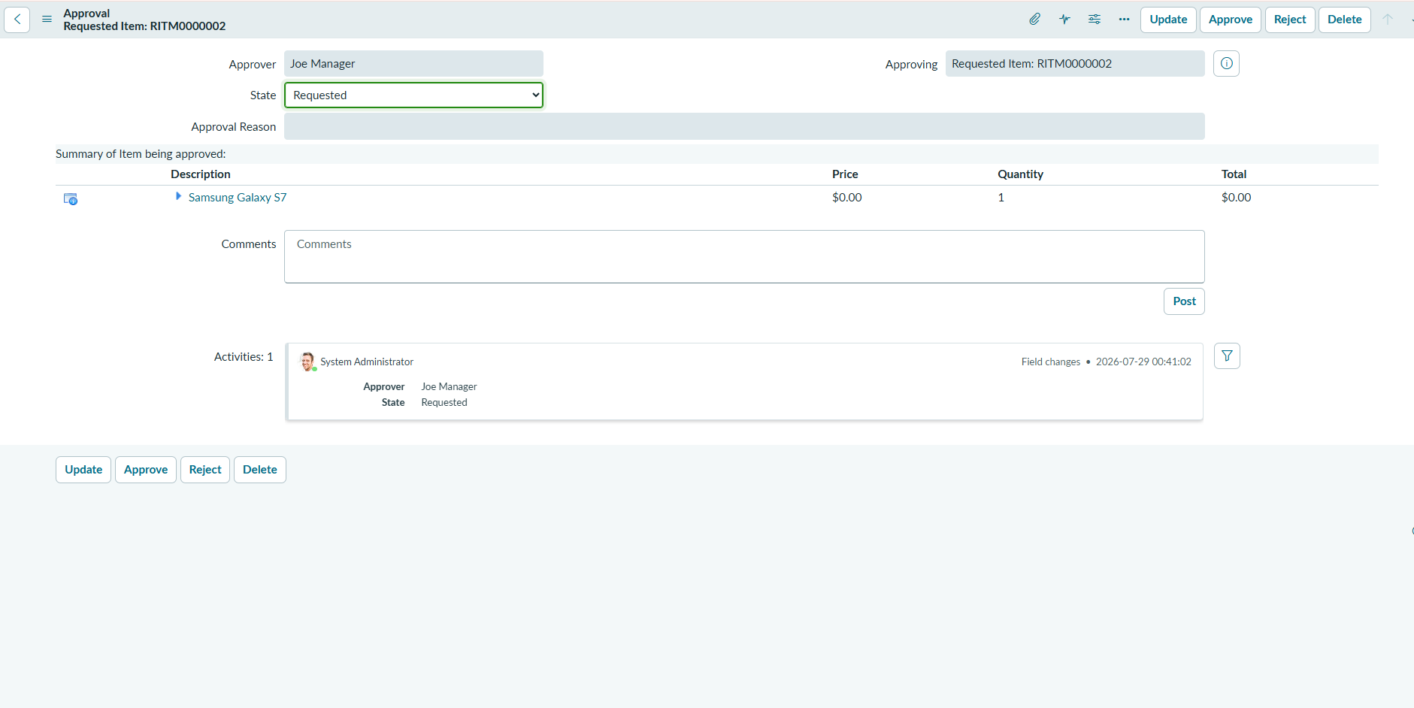
Figure 6: ask for approval
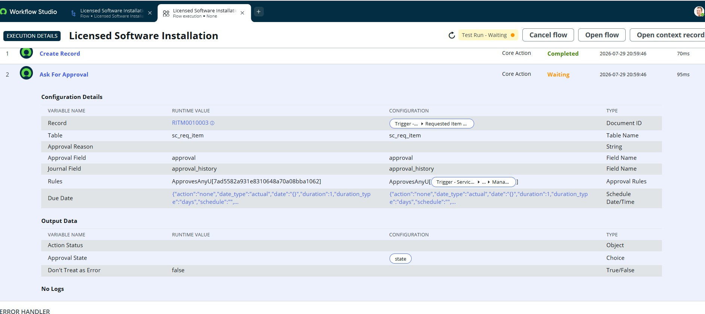

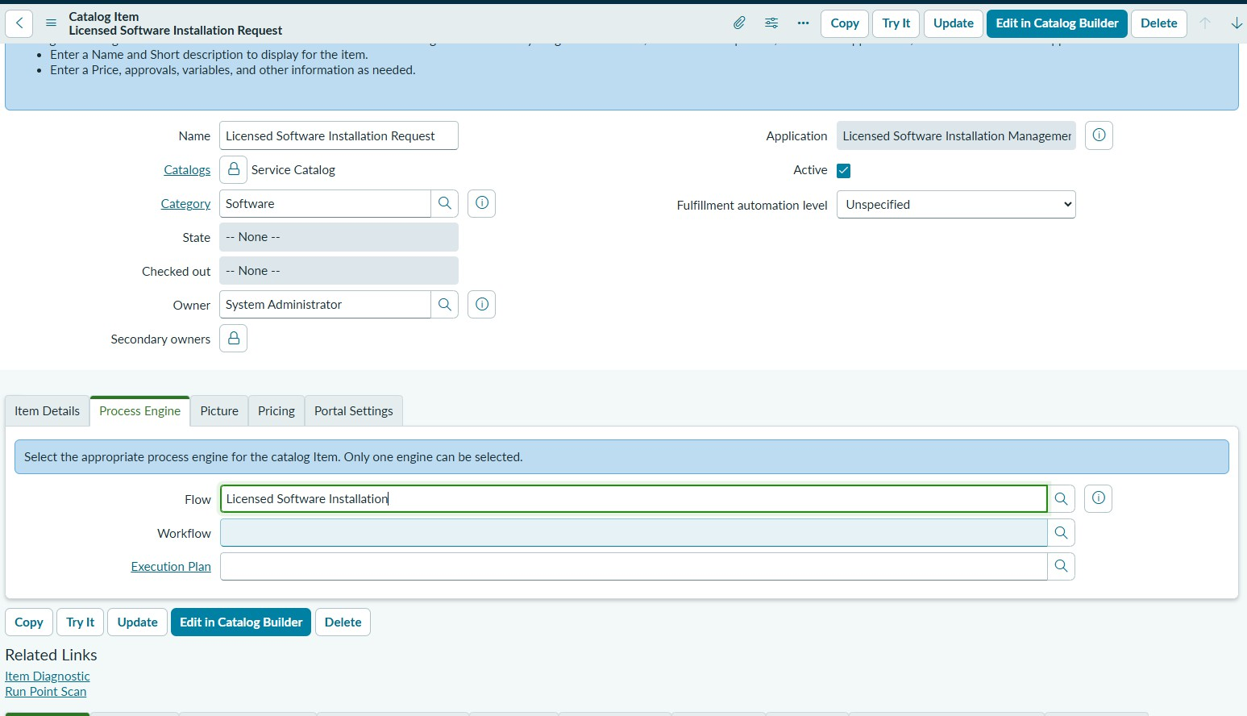
Figure 8: before approver workflow
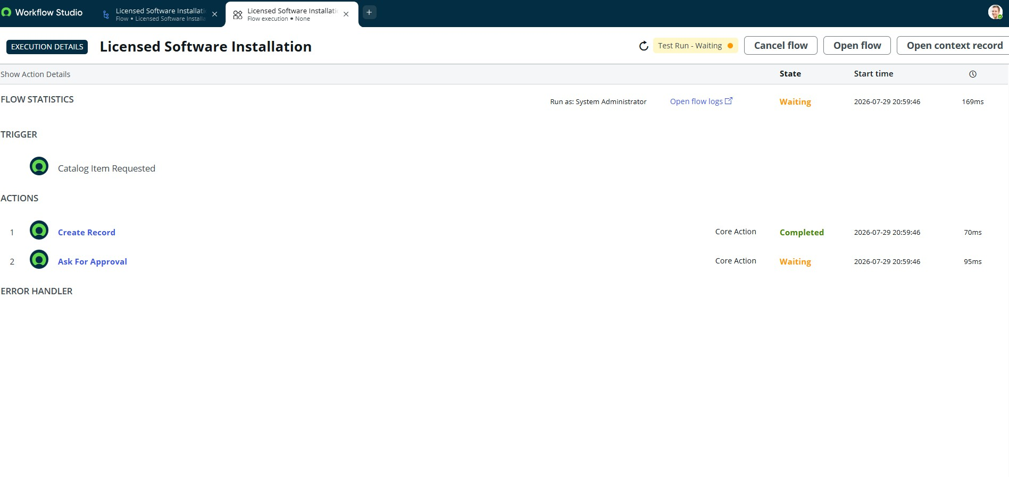

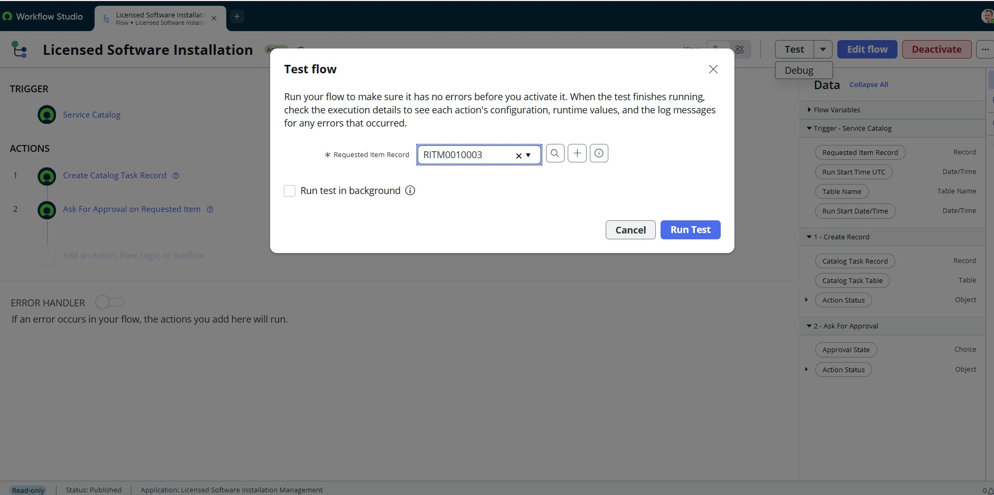
Figure 10: before workflow ordered req page
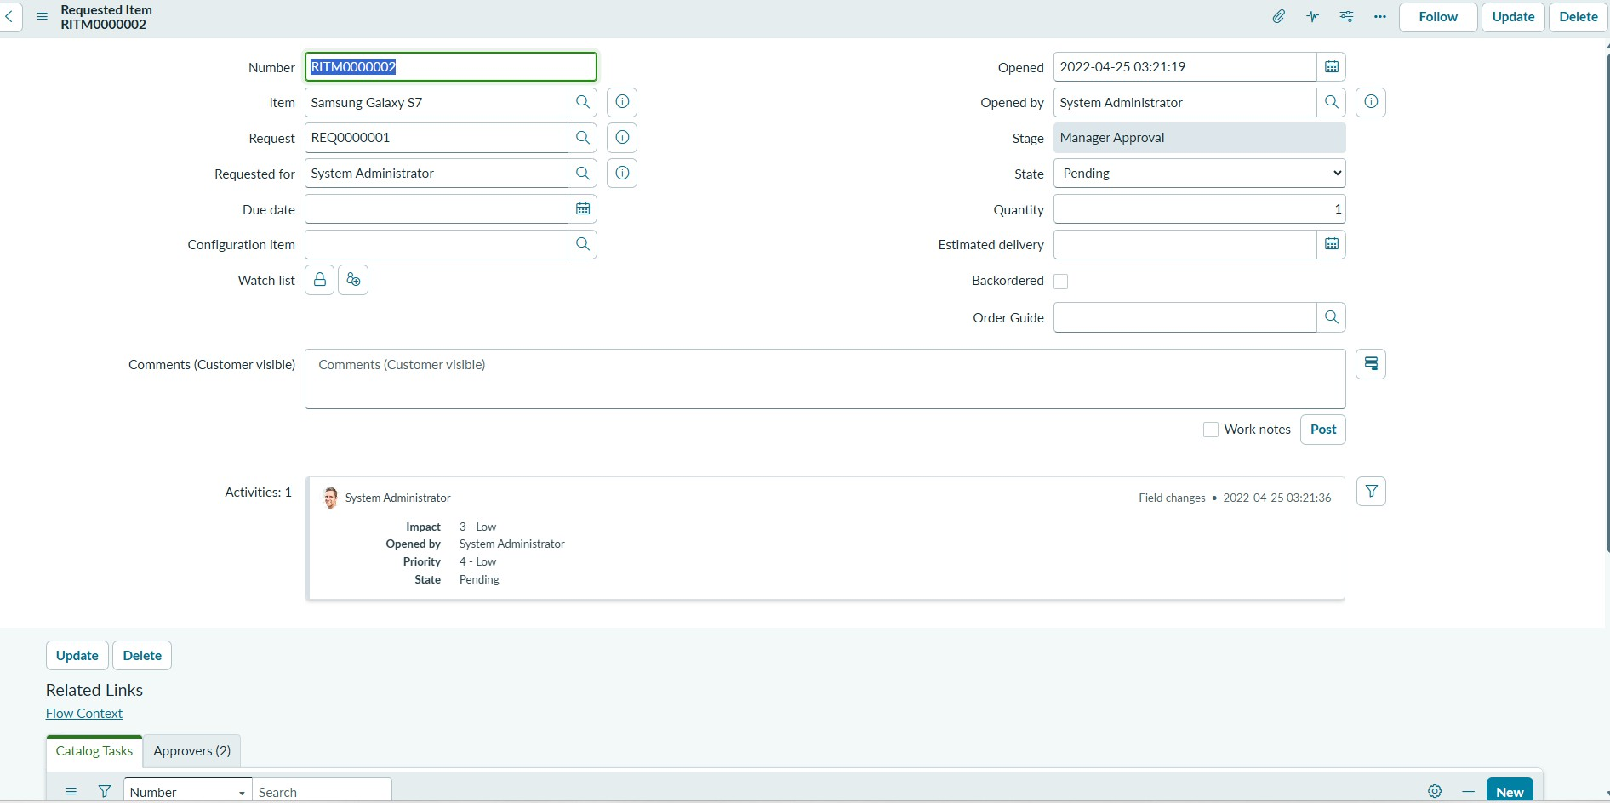

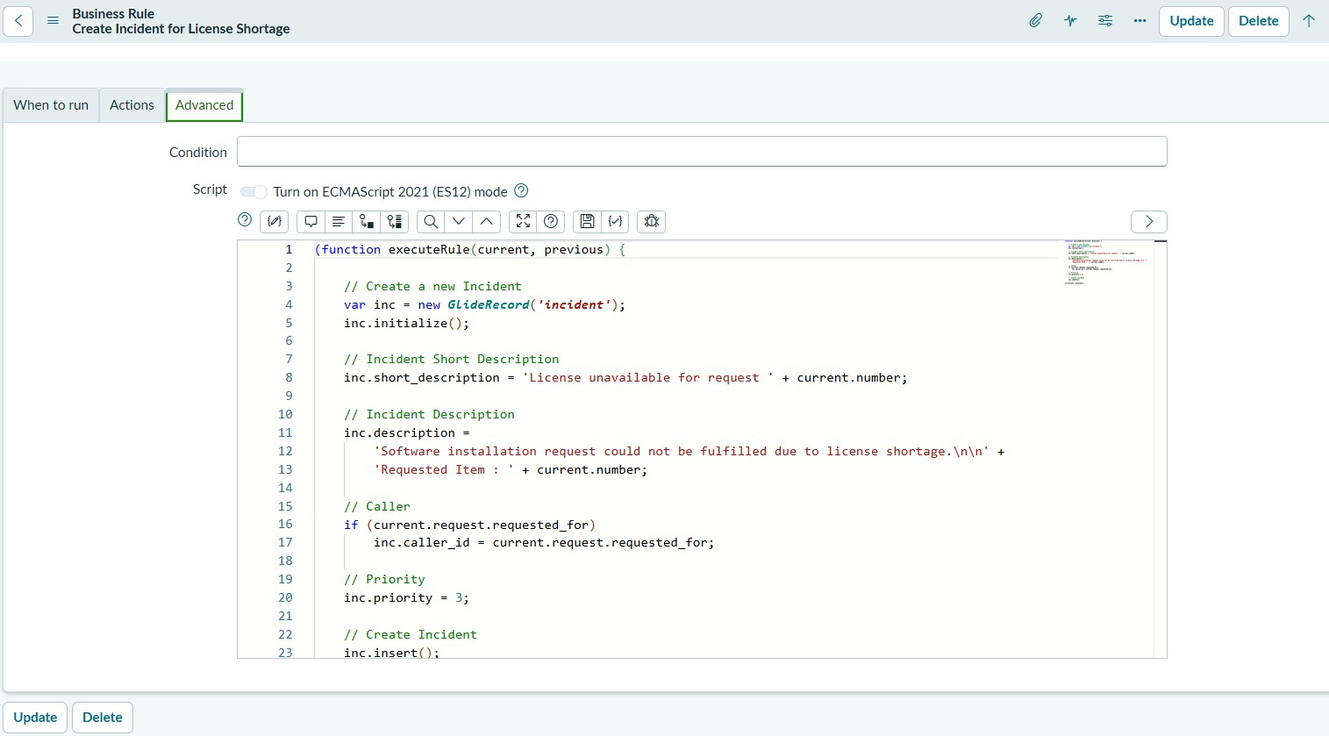
Figure 12: business rule
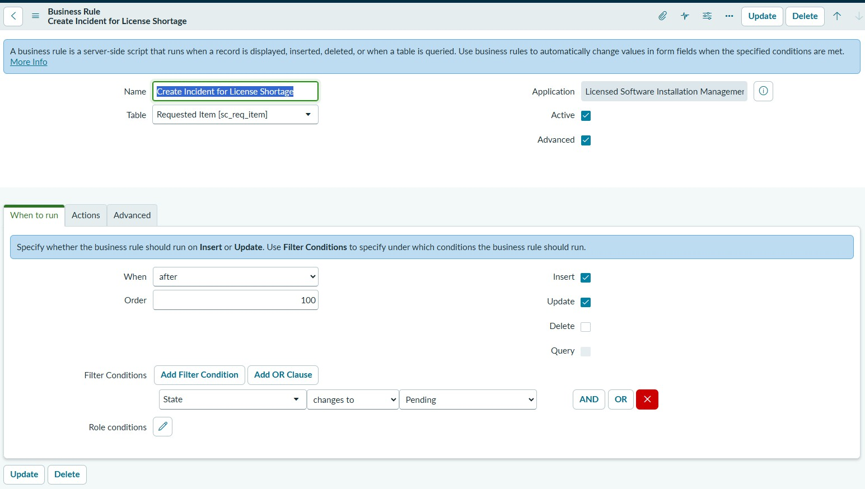

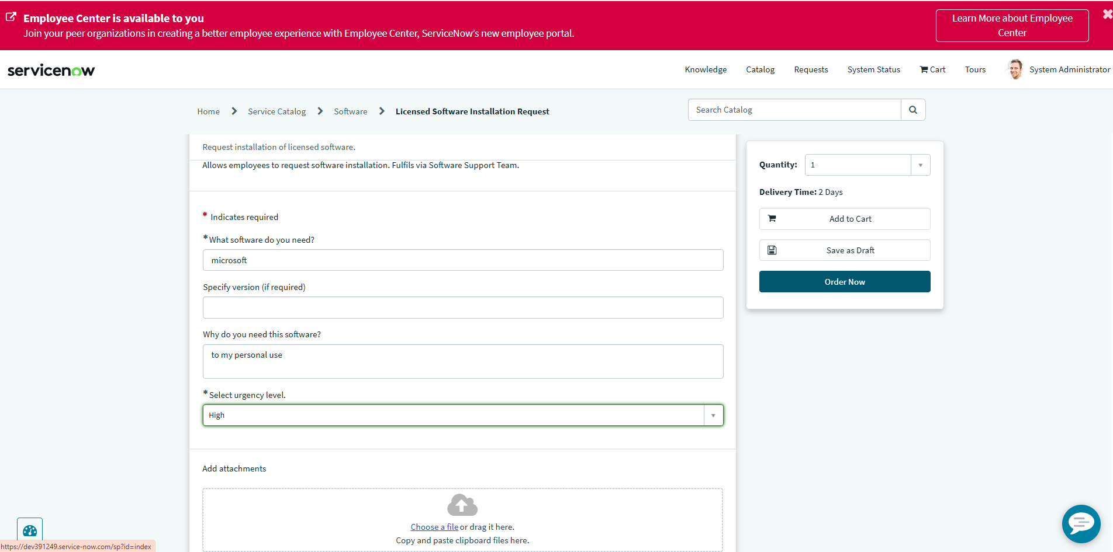
Figure 14: final output
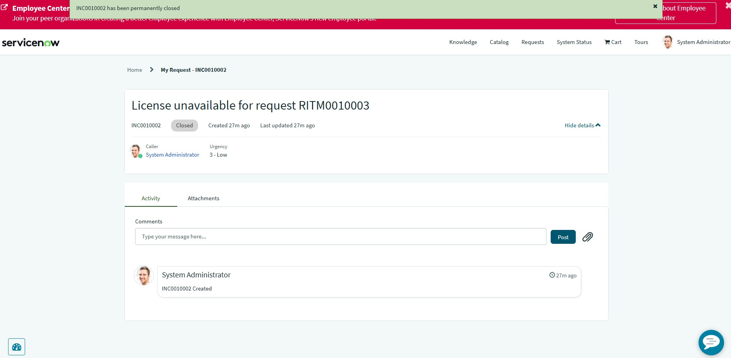

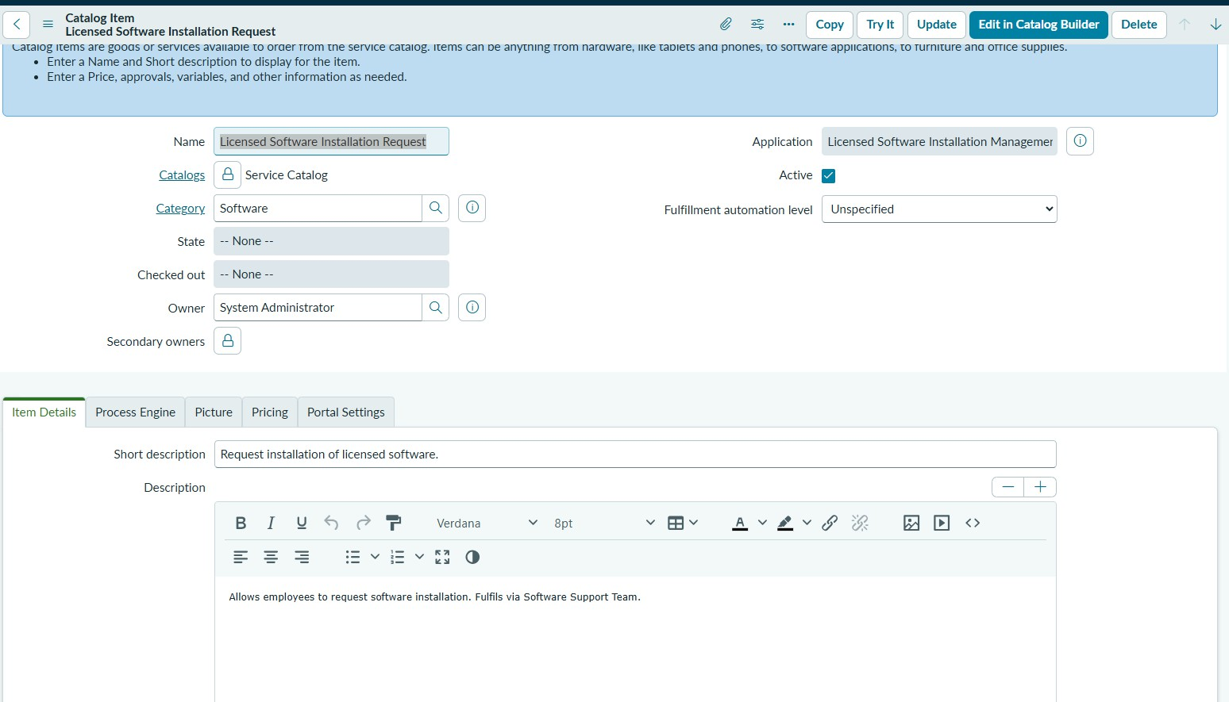
Figure 16: manageer approval
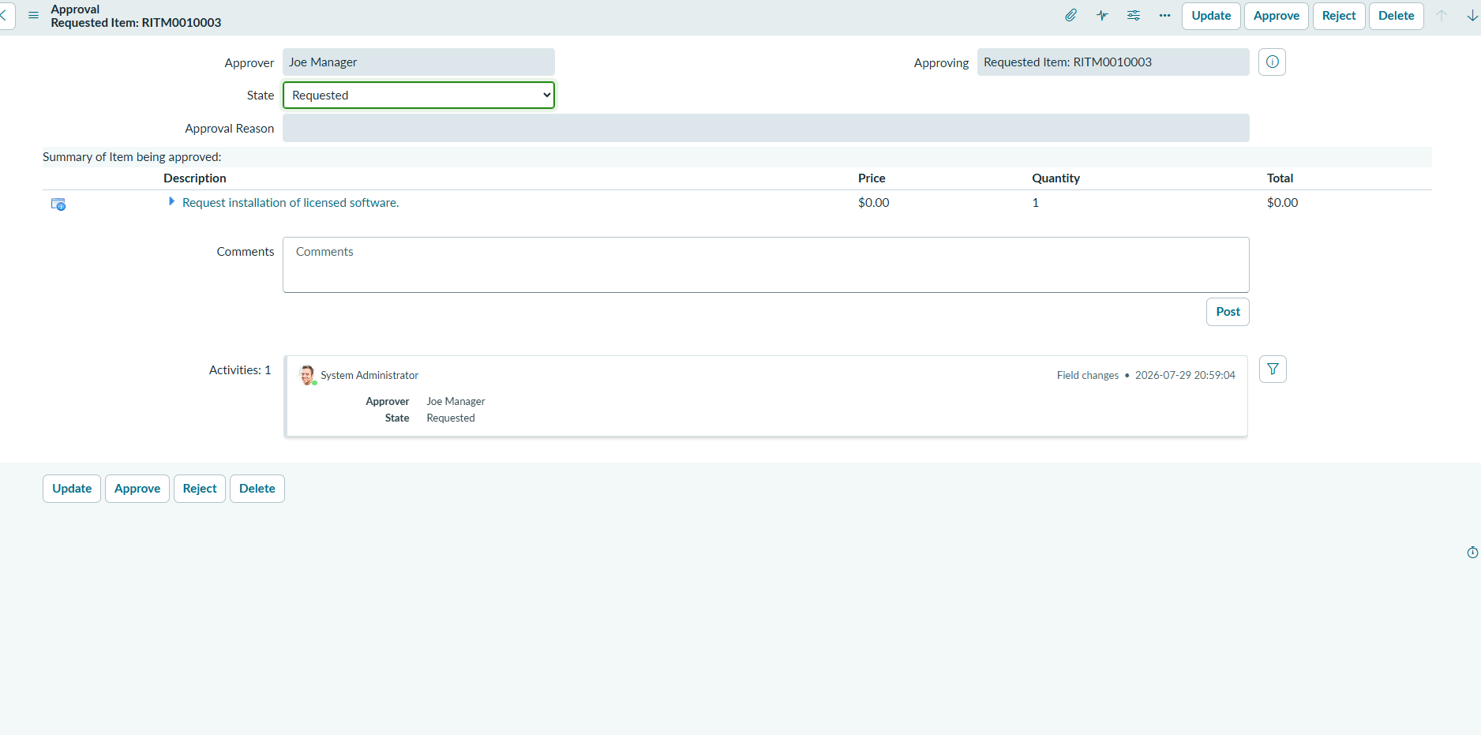

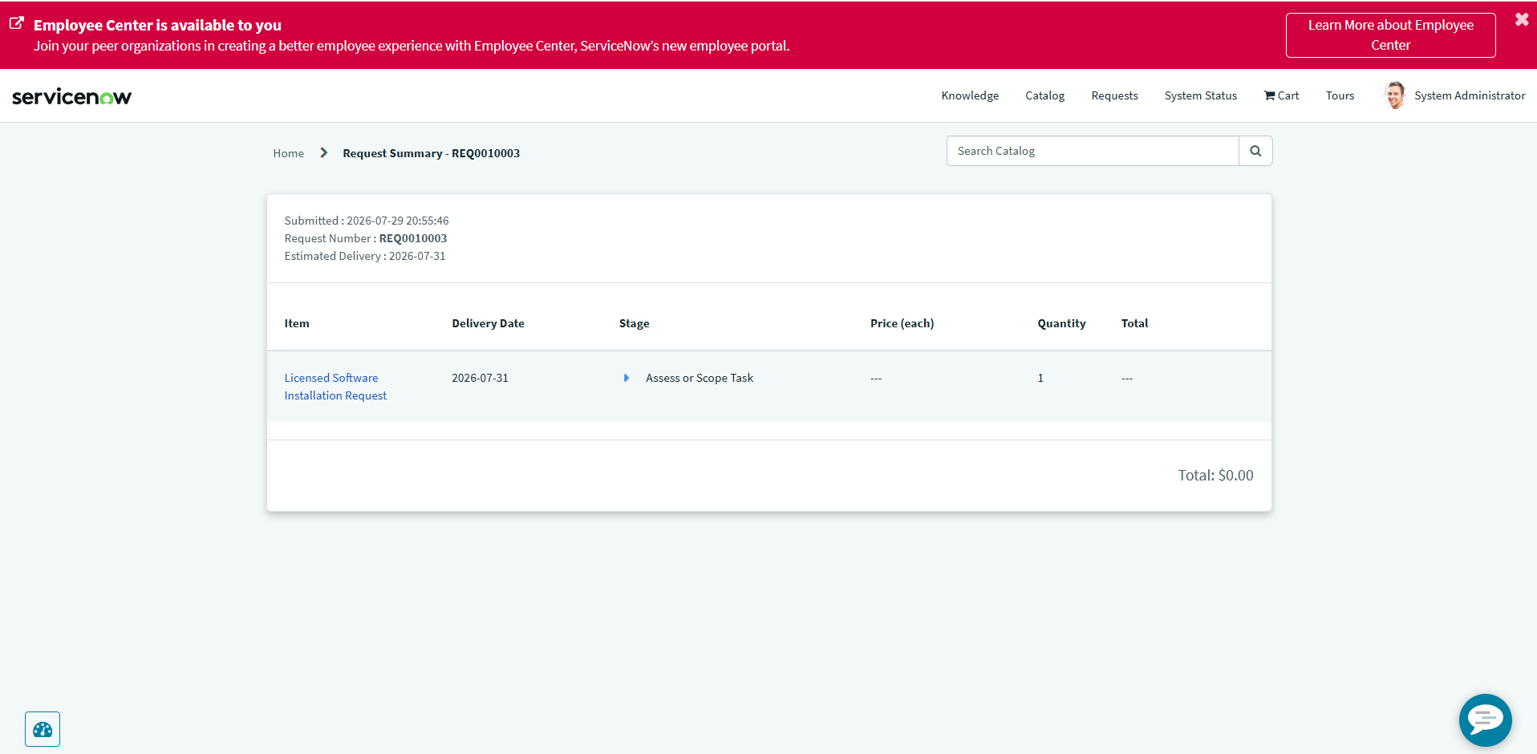
Figure 18: order confirmation.1
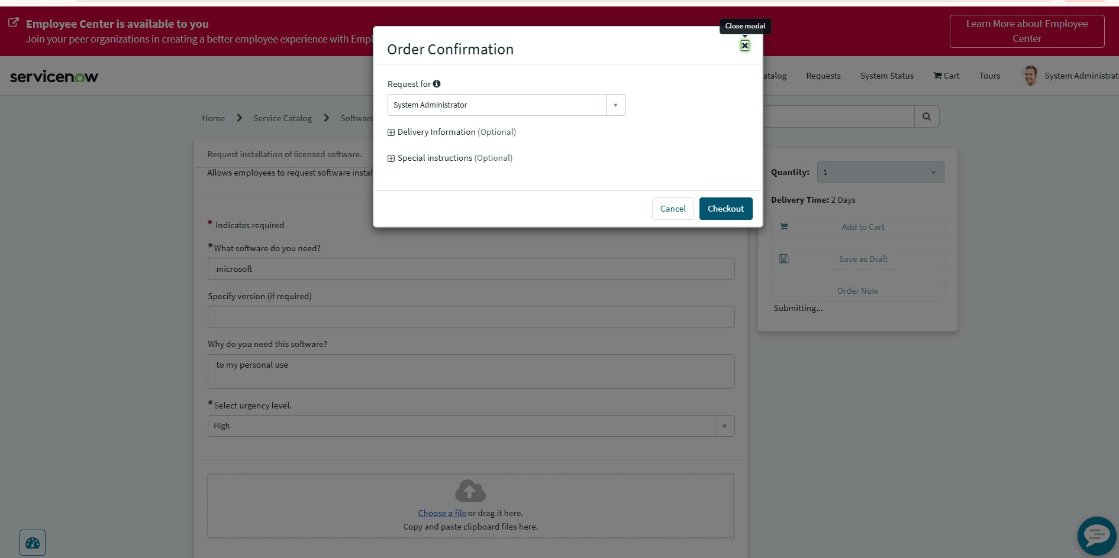

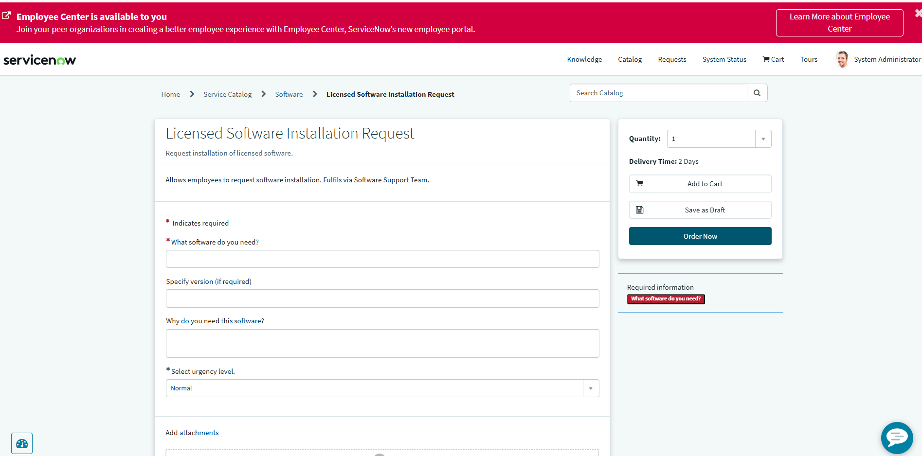
Figure 20: record created successfully
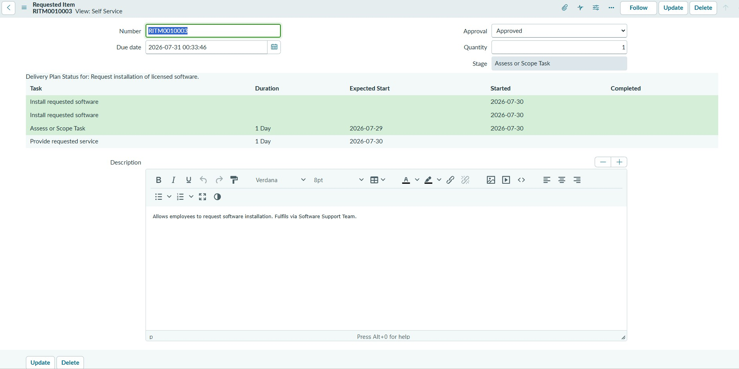

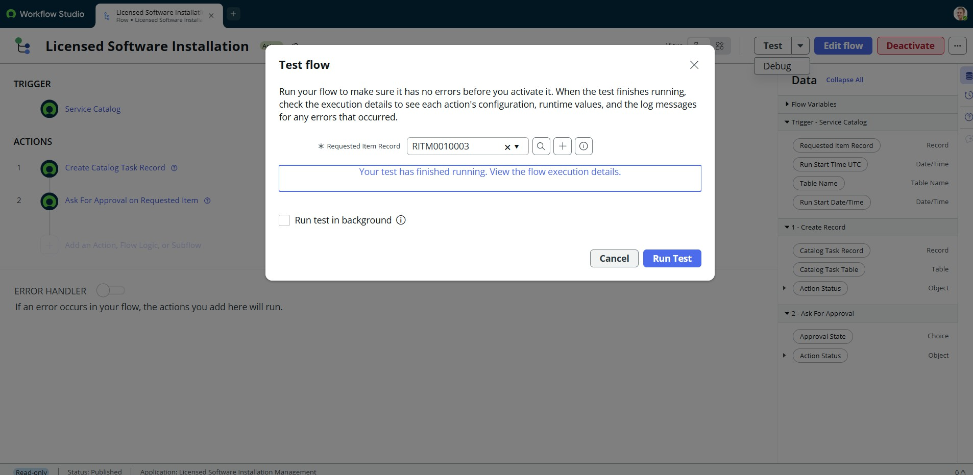
Figure 22: service catalog
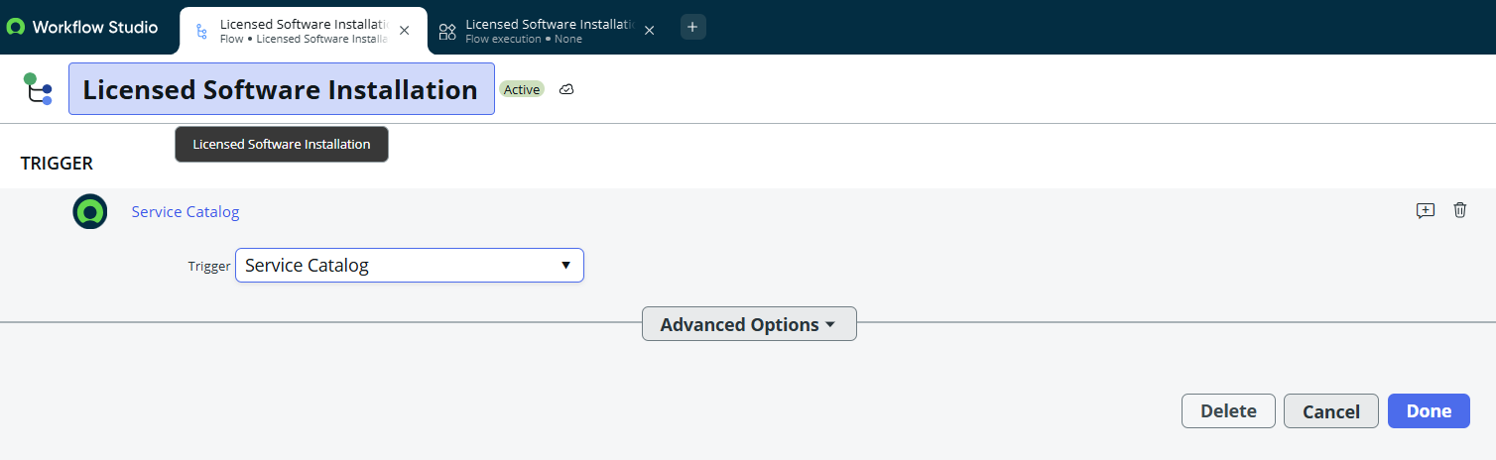

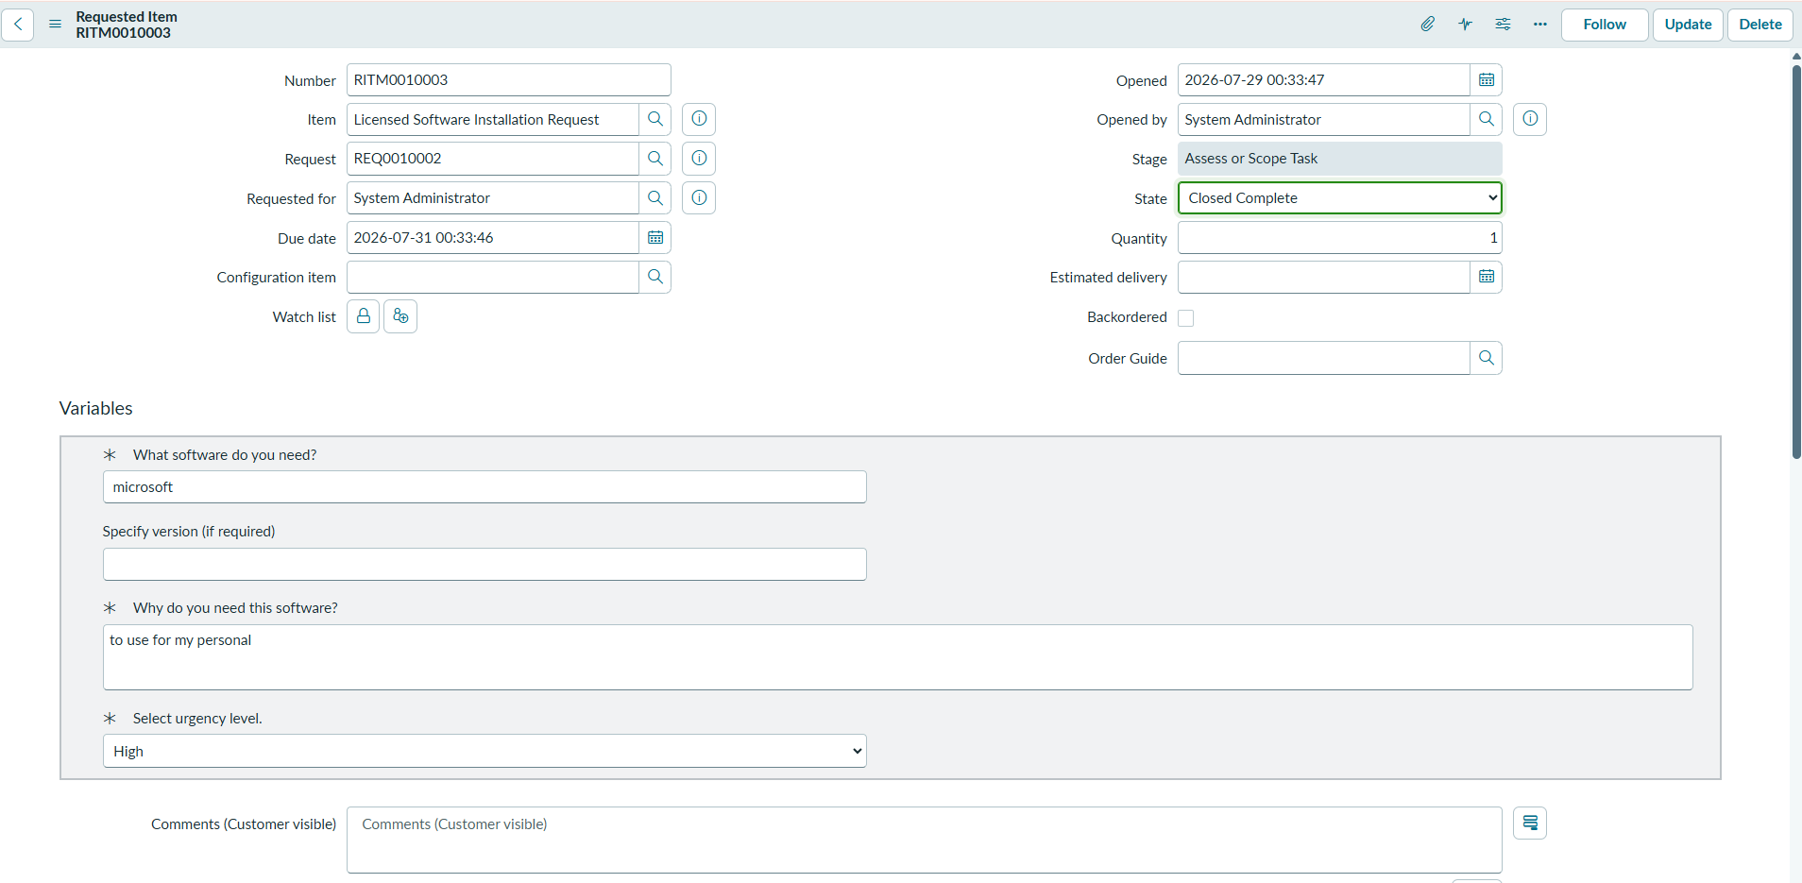
Figure 24: variable item
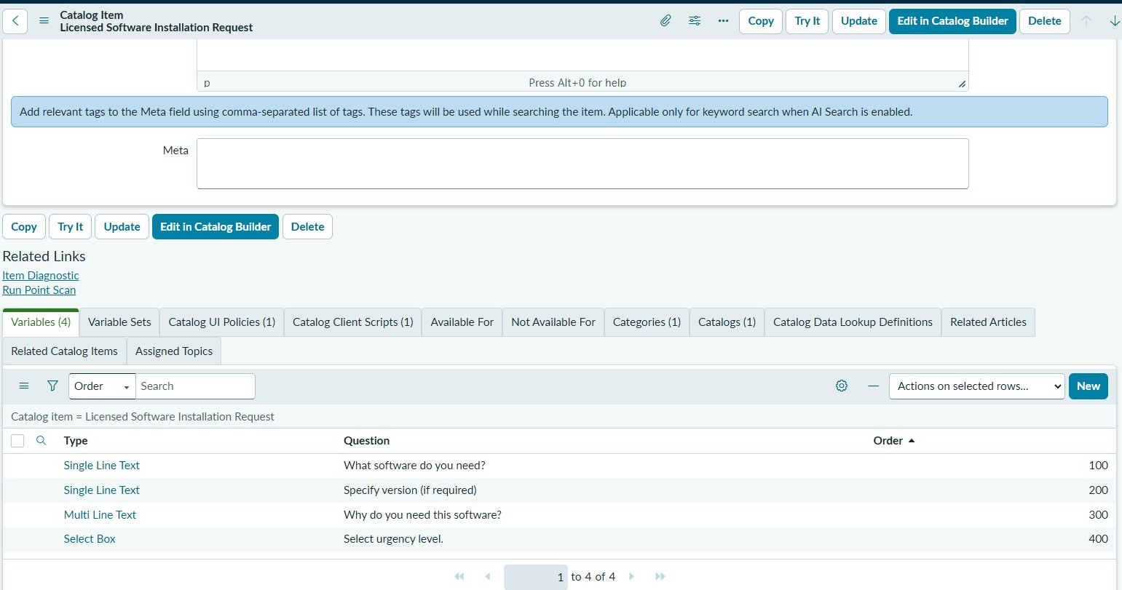

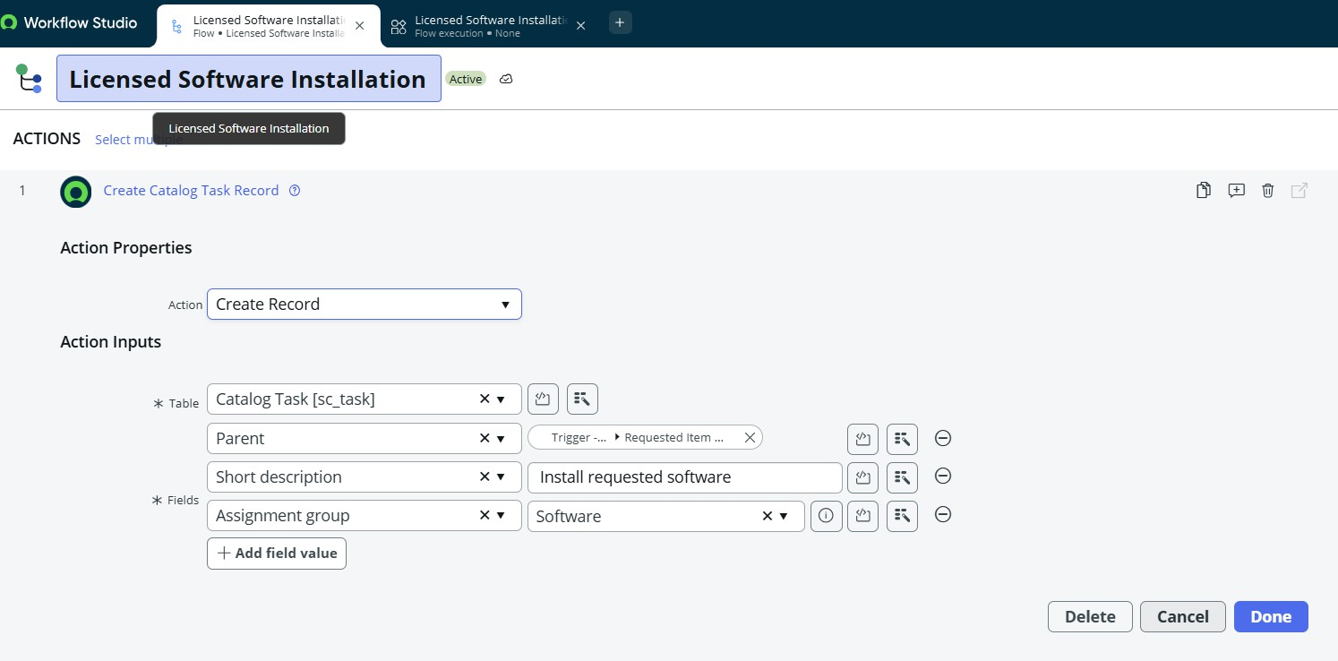
Figure 26: workflow ask fro approval on req items
