<Line of Business>  
 <Sub-Line of Business>

Quantitative Model Name (as shown in MoRS)

Quantitative model type (or functional area):

Portfolio or product name:

Risk Rating: <1/2/3/4>

Model number: <As shown in MoRS>

Model version:

Date created: 20yy-mm-dd

Last updated: 20yy-mm-dd

Template type: Generic

Template version: 2020.04.30

Document version: [x.x]

Author(s):

Contributor(s):

{Template instructions}

1. Use of this template alone does not guarantee that the model documentation is complete. The modeler is expected to review all applicable policy and regulatory guidance and incorporate them in this Model Development Document.

The documentation should be sufficiently detailed so that parties unfamiliar with the model can understand how it operates and how its limitations and its key assumptions work. This is a technical document, please include analytical details. If you are new to writing Model Development Documents or unsure about the appropriate level of detail required, please ask your governance or validation partner to provide some examples.

A color code has been applied in the document to highlight the nature of specific content to the user, as follows:

* Items in green are specific to vendor models or components.
* Items in blue are specific to qualitative model components.
* Items in brown are specific to statistical models.
* Items in fuchsia are specific to models of traded products

Several subsections in this template contain grids describing requirements by risk rank. These are meant to represent coarse-grained floor requirements for the specific subsection, but more detail may be required. The developers should be always driven by the holistic requirements of overall model justification and management of key model risks when proposing what is sufficient to include in the respective sub-sections of the development document.

For additional document content requiring insertion at the back of the document, users should add numbered sections (heading 1) instead of the appendices to preserve the unity of references.

Document version control

{If document has been updated, please complete a document version control entry in the table below.}

|  |  |  |  |  |
| --- | --- | --- | --- | --- |
| Version number | Status | Summary | Author | Date |
|  |  | {Include any model changes, significant finding closure memos, analysis as appendices/addendums to this model document and note as a new version.} |  |  |
|  |  |  |  |  |
|  |  |  |  |  |

{Add discussion, as necessary or appropriate.}

Template version control

|  |  |  |  |
| --- | --- | --- | --- |
| Version number | Summary | Author(s) | Date |
| 2021.04.30 | Initial Version | Jean-Francois Lagae, Ken Fu, Xiaobo Liu, Harsh Singhal | 4/30/2021 |
|  |  |  |  |
|  |  |  |  |
|  |  |  |  |

{The above table is only for template management. It should be dropped from the actual model development report.}

Contents

1 Model objectives, business context, and key model risks 1

1.1 Business objectives and key model risk(s) 1

1.2 Model use scope: portfolio, transaction, or process 1

1.3 (Proposed) Wells Fargo model risk ranking 1

2 Model framework and summary of development outcome 1

2.1 Model framework, theory, and assumptions 1

2.2 Summary of model development outcome 1

3 Model data/inputs 1

3.1 Inputs from systems and databases 1

3.2 Inputs from upstream models 1

3.3 Inputs that are obtained through qualitative methodologies 1

3.4 Data preparation and transformations 1

3.5 Summary of data/inputs 1

4 Model estimation/development/calibration/fitting 1

4.1 Model specification/structure 1

4.2 Variable selection and model estimation/calibration 1

4.3 Key model configurations and alternative specifications 1

4.4 Final model form characterization 1

5 Model testing and model performance 1

5.1 Model outputs 1

5.2 Sensitivity analysis and testing 1

5.3 Model outcome analysis and testing 1

5.4 Performance on stress conditions/out-of-sample/extrapolated conditions/data 1

5.5 Developmental benchmarking 1

5.6 Adjustments performed through qualitative methodologies 1

5.7 Summary of testing and outcome analysis 1

6 Model production implementation and control 1

6.1 Model implementation 1

6.2 Change control and adjustments management 1

6.3 Security and control 1

7 Model ongoing performance monitoring 1

Definition of terms 1

References 1

List of figures

List of tables

Table 1.1. Key Model Risk(s) 9

Table 2.1. Model limitations 15

Table 3.1. Upstream models use summary table 17

Table 4.1. Summary of final model specification 25

Table 7.1. Key Performance Indicators 34

# Model objectives, business context, and key model risks

{In this section, provide an outline of the current business need that the model addresses. Provide a high-level outline of the primary purpose of this model, a summary description, key model risk(s) and explain why the model is adequate given regulatory requirements, risk management and business objectives, and intended use scope.}

{Example text below.}

This document is the technical report of the newly developed <<Model Name>>. It replaces the current model, ≪Name of Current Model Used≫. This model has been developed in accordance with <<Policy/Compliance/Legal>> requirements.

## Business objectives and key model risk(s)

* {Describe the business process(es) that this model supports. Describe the business, risk management (including risk stripes) and regulatory requirements applicable to each supported process, including, as applicable, the related tolerances and/or where conservatism is sought.
* All information provided here explains the broader context under which the model operates.
* Identify the key risk(s) arising from the model use in each of the business, risk management and regulatory reporting processes.
* How could modeling risk (i.e., a failing model) affect the business, risk managers, compliance officers, among other aspects? How is the impact measured? What are the acceptability thresholds? Explain how such acceptance levels are obtained and the applicable governance processes.

{use Caption for all table captions and place above table}

Table .. Key Model Risk(s)

|  |  |  |  |
| --- | --- | --- | --- |
| Use case (use Table Col Head* for entire column heading row) | Key Model Risk (business defined) | Description and measure | Risk tolerance if possible |
| Use Table Body* for entire table body. |  |  |  |

* Describe the model use within each business, risk management and regulatory reporting process. This includes the outputs or functionalities that this model provides to the model users or downstream models.
* If known or derivable, provide the tolerances or acceptability thresholds of the model outputs as demanded by the business process.
* If tolerances or acceptability thresholds (at the level of this model) are not know or derivable, explain how the model outputs are determined to be acceptable (or any mitigation control in place).
* For vendor models, describe what conditions are present that favor the use of a vendor model (e.g., lack of sufficient data, insufficient performance from previous internally developed models, business case, market or industry position of the vendor etc.)

## Model use scope: portfolio, transaction, or process

1. Portfolio and scope of business use

* {Provide an overview of the LOB(s) and products, portfolios, transactions, or activities to which this model applies. Briefly describe the operational and applicable regulatory environment under which the model is used that may impact its developmental process or risk.
* If applicable, Provide background information regarding trading platforms (OTC/exchange), liquidity (bid-ask spreads, maturities traded), and counterparty information.
* If applicable, Provide information regarding trade characteristics for the current or anticipated book of business (payoff non-linearity, correlation dependency, forward skew dependency, maturity, currencies, typical moneyness, etc.)
* Illustrate trade contract details with a payoff formula.
* If applicable, Provide information about planned hedging strategy.
* Provide a summary of the business and portfolios balances, losses, trends, acquisitions/sales, etc., over the past XX (as appropriate) years.
* Explain the main drivers of model risk for all model uses, e.g., factors impacting output uncertainty with respect to products/portfolios, transactions, activities, or business decisions.
* Discuss any anticipated changes that may impact the model, its implementation, evaluation, and usage over time. This may include several changes, as follows:
* Planned changes to the products, channels, policies, account management, collections, marketing activities, among other modifications.
* Potential shift in customer base over the lifetime of the model compared with the current customer base and the target customer profile.
* Anticipated future conditions that may deviate from the environment under which the model is developed.
* Regulatory changes.
* Changes in technology that supports the model implementation in production.
* changes in market structure or liquidity
* For models not tied to a portfolio, discuss the scope of model use.
* Describe the generative mechanism for model inputs, as well as the history and anticipated future changes to this generative mechanism.
* If relevant, Discuss potential for adversarial inputs designed by sophisticated actors, which are intended to confound the model.

1. Developer(s) information

* {Provide basic information about the internal model development group and key contacts.
* For vendor models, Provide information about the company that contributed to the development and key contacts.}

*ToDo: Need to add a section for H2O.ai Intro, and key contacts for H2O3 and AutoDoc*

1. Model History

* {Provide an overview of the model history, with a focus on major events or changes in purpose, uses, framework, methodologies, operational environments, regulatory requirements, risk, or performance.
* If this model replaces existing models (Qualitative or Quantitative) that are currently in use, document which models will be replaced.
* If this is a redevelopment of an existing model, explain why the model is under redevelopment.
* For vendor models, also discuss the history of model use in Wells Fargo, including any vendor customization efforts for Wells Fargo.}

## (Proposed) Wells Fargo model risk ranking

**Note:** If the model classification is official, remove “Proposed” from the title of this section.

{Provide a brief description of the proposed or actual model risk ranking. This information should be consistent with the CMoR Risk Ranking Template and procedures. In particular, it should note the filing date of the Risk Ranking Template, and it should cover the ratings in terms of reliance, materiality, and complexity dimensions. Use a table as appropriate.}

# Model framework and summary of development outcome

{The objective of this section is to detail the modeling framework and the outcome of its model development process. This documentation must be sufficiently detailed, so that parties unfamiliar with the model understand the modeling approaches, the methodologies, the main developmental and implementation techniques, the limitations, and the mitigating controls under the context of key model risks.}

## Model framework, theory, and assumptions

1. Core model requirements

* Given the high-level objectives and context given in section 1.1 and 1.2, describe the core requirements on the overall theory, design, and selection of the modeling framework.
* Such core requirements can include, for example, the ability of the model to respond to certain macroeconomic scenarios or demonstrate the necessary behaviors that guide the selection of structure of the mathematical model, segmentation, variable selection, or key modeling components.

1. Model components and their uses

{If applicable, provide a list of model components or submodels with respective uses or portfolios, to which they apply. Also note if components are developed according to the quantitative or qualitative approach. Discuss if and how any of the model components impacts key model risks.

Qualitative model components should be fully described and supported in

* Section 3.3 if they constitute a qualitative methodology that is used as input to the quantitative model (e.g., management input, search terms for query tools, and estimated value).

• Section 5.6 if they constitute a post processing qualitative methodology used to adjust the quantitative output (e.g., adjustments to model parameters, threshold, business rules, scalars, and alert suppression rules.).

• Section 4.1 if they constitute additional or parallel methodologies, used for example for specific portfolios or specific scenarios (e.g., base or stress, specific products, or portfolios).

* For vendor models, clearly distinguish between components that can be configured/customized for/by Wells Fargo versus those that are not subject to such choices.

If applicable, include a flow diagram showing how the model structure and components fit into the overall objective and use cases of the model.}

1. Description and justification: framework, assumptions, and specification

* {Detail and justify the theoretical framework or approach of the model and components:
* The modeling framework or approach to be employed and rationale.
* Explain and justify how the key relevant financial, business and economics concepts are translated into a sound and appropriate mathematical and/or statistical framework.
* Are the key abilities that the model must exhibit, as given in 1), all present? Discuss and justify.
* List and justify the key high level modeling choices, including fundamental assumptions, technical approaches, and business decisions, underlying the modeling framework. Use tables for clarity if possible. Address the following specifically:
* Explain the relevant risk factors that will impact the model outcome (NPV, sensitivities, etc., as applicable)
* Explain if all market risk factors are captured by the model and the current market structure of these factors (more or less steady, highly volatile, basis risk, etc.)
* If a market risk factor (e.g., volatility skew and basis risk) is excluded, justify the exclusion and assess the impact of ignoring some risk factors and explain the control and governance process of managing the model risk.
* Explain the relationships assumed to hold between risk factors (e.g., constant spread and ratio) and how these assumptions will impact model uses, such as pricing and VaR
* Detail the final specification of the modeling framework and key numerical implementation techniques including main calibration or fitting approaches with details that are further explained in Section 4.
* Include vendor information for a vendor-developed model and explain why a vendor model is needed.
* If model can be represented in a table or formula manner, include in this section. Otherwise, include a summary and refer to the location in the documentation where the model is clearly outlined. For complicated models comprised of multiple steps or parameters, use a visual format or table to enable the reader to quickly understand the model form.
* For redevelopments or model changes from previous versions, note any open findings related to model framework and theory and the related recommendations. Specify, whether the findings were partially or fully resolved, as a result of this development, and if there will be any special handling of those findings.

1. As a large portion of the model development consists in making choices related to data, model estimation, etc., detailed assumptions and related techniques should be discussed in each section of the development document as appropriate rather than within this section.

# H2O-3 Software Platform

H2O is an open source, in-memory, distributed, fast, and scalable machine learning and predictive analytics platform that allows you to build machine learning models on big data and provides easy productionalization of those models in an enterprise environment.

H2O’s core code is written in Java. Inside H2O, a Distributed Key/Value store is used to access and reference data, models, objects, etc., across all nodes and machines. The algorithms are implemented on top of H2O’s distributed Map/Reduce framework and utilize the Java Fork/Join framework for multi-threading. The data is read in parallel and is distributed across the cluster and stored in memory in a columnar format in a compressed way. H2O’s data parser has built-in intelligence to guess the schema of the incoming dataset and supports data ingest from multiple sources in various formats.

H2O’s REST API allows access to all the capabilities of H2O from an external program or script via JSON over HTTP. The Rest API is used by H2O’s web interface (Flow UI), R binding (H2O-R), and Python binding (H2O-Python).

The speed, quality, ease-of-use, and model-deployment for the various cutting edge Supervised and Unsupervised algorithms like Deep Learning, Tree Ensembles, and GLRM make H2O a highly sought-after API for big data science.

H2O-3 built a Gradient Boosting Machine to predict DEFAULT_PAYMENT_NEXT_MONTH given 23 original features from the input dataset. This classification experiment completed in 4 seconds (0:00:04).

1. Literature review

|  |  |  |  |
| --- | --- | --- | --- |
| Risk Rank 4 | Risk Rank 3 | Risk Rank 2 | Risk Rank 1 |
| Optional | Basic: Demonstrate alignment with industry practices | | Detailed: Demonstrate deep understanding of range of practices and their relative advantages and disadvantages |

* Provide reference to the literature to support theory of proposed model methodology, potentially specific to each use.
* Provide prior application of this methodology in related businesses.
* All reference sources must be included in the References section at the end of the final document.

**Generalized Boosting Machines**

The following algorithm description comes directly from the "Theory and Framework" section in H2O.ai's Gradient Boosting Machine with H2O Booklet (Click et al. 9-10):

*Gradient boosting is a machine learning technique that combines two powerful tools: gradient-based optimization and boosting. Gradient-based optimization uses gradient computations to minimize a model's loss function in terms of the training data.*

*Boosting additively collects an ensemble of weak models to create a robust learning system for predictive tasks. The following example considers gradient boosting in the example of K-class classification; the model for regression follows a similar logic. The following analysis follows from the discussion in Hastie et al (2010) at http://statweb.stanford.edu/˜tibs/ElemStatLearn/.*

* *Initialize*
* *For m = 1 to M:*
* *Set*
* *For k = 1 to K*
* *Compute*
* *Fit a regression tree the targets* *giving terminal regions*
* *Compute*
* *Update*
* *Output*

*In the above algorithm for multi-class classification, H2O builds k-regression trees: one tree represents each target class. The index, m, tracks the number of weak learners added to the current ensemble. Within this outer loop, there is an inner loop across each of the K classes.*

*Within this inner loop, the first step is to compute the residuals, rikm, which are the gradient values, for each of the N bins in the CART model. A regression tree is then fit to these gradient computations. This fitting process is distributed and parallelized. Details on this framework are available at https://www.h2o.ai/blog/building-distributed-gbm-h2o/.*

*The final procedure in the inner loop is to add the current model to the fitted regression tree to improve the accuracy of the model during the inherent gradient descent step. After M iterations, the final "boosted" model can be tested out on new data.*

1. Alternative model designs considered

|  |  |  |  |
| --- | --- | --- | --- |
| Risk Rank 4 | Risk Rank 3 | Risk Rank 2 | Risk Rank 1 |
| Optional | Basic: Subjective evaluation of alternatives | | Detailed: Analytic evaluation of alternatives |

* {Provide discussion around alternative model designs considered.
* Discuss why the methodology was chosen over alternative methodologies, potentially specific to each use and how different choices impact how key model risks are managed.
* For vendor models, Clearly indicate alternative solutions considered by model owners in addition to any alternative approaches considered by vendor as part of their development process.}

## Summary of model development outcome

1. Model adequacy for use

* Summarize key model risks to each of the main model uses and the impact of model risk to regulatory requirements and business and risk management objectives.
* Summarize how key model risks are managed throughout the model development process and explain why the final model is adequate given the regulatory requirements, the risk management, and the business objectives and intended use scope.
* Wherever applicable, structure the documentation with clear sub-headings such as modeling framework, data and input, estimation/calibration, implementation, which can be borrowed from subsequent sections of the report.
* Explain how elements of the model such as framework, assumptions, data, and implementation methods contribute to the key model risk to the business and how testing results support the modeling conclusion.
* In many cases, the summary justification of model adequacy for use will rely on holistic evidence.

1. Key limitations and mitigating controls

* Given the objectives and requirements laid out in section 1.1, list the model potential failure modes, which have been flagged for further testing or analysis in subsequent sections of this document.
* Identify model weaknesses, including both the ones known from the theory, framework, assumptions, and the ones identified through testing and analysis in subsequent sections (e.g., boundary conditions or extreme environments). Explain the impact of model weaknesses on business objectives and uses.
* Highlight mitigating controls including both in-model treatment and out-of-model adjustments, if applicable.

Table .. Model limitations

|  |  |
| --- | --- |
| Title of Limitation | ***List the limitation.*** |
| Description | ***Description and source of the limitation.*** |
| Assessment | ***Assess the materiality of the limitation using the tests and analyses performed in later sections to estimate its impact regarding key model risks.*** |
| Mitigation/Monitoring | ***As applicable, discuss any mitigation (e.g., overlays) or monitoring related to this limitation. Given model tolerances provided in section -1.1, justify that the (final) model output is adequate and/or results in a conservative estimate, as appropriate.*** |
| Title of Limitation |  |
| Description |  |
| Assessment |  |
| Mitigation/Monitoring |  |

# Model data/inputs

{This section refers to data used for model development and testing. Any considerations specific to data for model implementation should be discussed in Section 6.1. Provide a rigorous assessment of data adequacy, quality, and relevance. The developers must be able to demonstrate that development data are suitable for the model and its uses and that data are consistent with the theory. The developers should document where data may contribute to key model risks, and how such risks are managed. Document if the data are not representative of the bank’s portfolio. If not, justify the choice of data selection, document limitations, and explain mitigating control if applicable.

## Inputs from systems and databases

1. Data sources and processing overview

* {Discuss the systems where data are extracted and the general governance process.
* Discuss the data collection and extraction process, including the processing of the data within the system from the source.
* For vendor models, distinguish data sources and processing on the vendor side and the model user and developer side. Include information on data used for data relevance analysis (actual analysis presented in Section 4.3).
* Discuss any third-party data if used with rationale (e.g., exchange or credit bureau).
* Discuss any data used that are the output from another model and possible interactions.
* Explain the reasonableness and appropriateness of the data sources.
* Discuss how the data are consistent with the model theory and the chosen methodology.
* Explain if the data are representative of the bank’s portfolio or if adjustments and limitations are considered.
* For vendor models, clearly outline the approach to ensure that the data is representative of Wells Fargo’s use of the model. Include assumptions and limitations.
* If industry data are used in the model without any customization, explain why the data strategy are appropriate.
* Include a diagram of the data flow process (if possible, include summary here and details in an Appendix – see instructions related to appendices under “Template instructions”).
* Identify data that are not market observable (trader input, historical or other estimation) and reference policy governing such data. Provide further details and assessment in Section 3.3}

1. Data integrity and reconciliation

* {Provide evidence that the modeling dataset reconciles with general reporting information (GL, Greenbook, etc.) as applicable.
* Provide checks and screening, such as looking for extreme or specious values or large changes from one time period to the next, performed to ensure that the data are correct.
* Provide rationale for data discarded as the result of the process, as well as any systematic impact discarding may have on the results.
* Provide findings with respect to data and variable integrity.
* Ensure that adequate data quality analysis has been performed and that data quality findings have been adequately addressed.
* Verify the data from internal sources is reconciled back to the source or tested to verify that the process used to extract data from a source is appropriate.
* Note any uncertainty about the data and inputs.
* For vendor models, in addition to the above general guidance, discuss the mechanism that the vendor uses to ensure data integrity and quality and provide evidence on the mechanism in addition to the above general guidance.}

## Inputs from upstream models

* List all the upstream models. For each upstream model, list the “business requirements” from this model.
* Discuss why this model’s “business requirements” for the inputs from the upstream model are appropriate.
* Assess whether the “business requirements” are consistent with or a subset of the “outputs or functionalities” in the upstream model document (section 1.1).
* Determine the contribution of the upstream model on this model’s key model risks, and consequently the tolerances or acceptability threshold of the upstream model’s output as demanded by this model.
* Discuss outstanding findings, limitations and restriction on the upstream models, mandatory for severity 1 and 2 items, assessing the impact on this model and any mitigation.
* Do not copy the findings table of another model in this section. Discuss only relevant model risk findings (use finding ID and summary to clarify). If lengthier explanations are beneficial, use an Appendix —see instructions related to appendices under “Template instructions.”

For upstream models, fill in the table below or provide equivalent assessment for all upstream models (only one level up). If no upstream models, note that there are no upstream models in this section.

Table .. Upstream models use summary table

|  |  |  |
| --- | --- | --- |
| Upstream model number and name  Ex: 99238 - FICO Score | Functionality/Output of the upstream model used in this model | ***Describe the functionality or output from the upstream model that is consumed by this model.*** |
| Rationale | ***Explain if the upstream model’s approved uses (and restrictions) are consistent with this model. Justify why the input from upstream meets the requirements from this model.*** |
| Impact and any mitigation from relevant upstream weaknesses | ***Given the tolerances for this model and significance of this specific input on outcome, assess the impact and any mitigation for relevant and significant outstanding findings or limitations from the upstream model*** |
| Upstream model number and name  Ex: 99238 - FICO Score | Functionality/Output of the upstream model used in this model |  |
| Rationale |  |
| Impact and any mitigation from relevant upstream weaknesses |  |

* In case of vendor models, clearly Indicate whether the model relies on other models developed by the vendor or by other vendors in the industry. If so, discuss the reliance on or sensitivity to those upstream models, as wells as the manner in which the risks of those uses are managed, including whether it is feasible for those models to be identified and validated separately.}

## Inputs that are obtained through qualitative methodologies

This section covers inputs or independent variables that are constructed or obtained using qualitative methods. These may include:

* Proxies
* Market non-observable inputs (such as correlations) marked by traders.

The depth of analysis for each variable should be commensurate with its impact on the assessment of overall key model risk(s), taking into account the uncertainty in this variable, its significance to the final model outcome and stated overall tolerances.

For each key variable, provide the following:

* Describe data or other inputs used to derive these qualitative variables or inputs. Explain details such as the data characteristics and data preparation and quality processes or steps.
* Describe any assumptions used and provide rationale supporting these assumptions. For Inputs that are impactful to the overall model, provide analysis or evidence supporting the appropriateness of these assumptions and describe how the assumption is periodically reviewed to ensure it remains adequate.
* Describe the methodology employed to derive these qualitative inputs or variables. Include the formulas or mathematical expressions used.
* Assess the appropriateness of these variables or inputs for use in the model. Describe any analysis or tests performed to evaluate the appropriateness of these, such as sensitivity analysis on the key assumptions or inputs in the derivation of the variable
* Explain if and how any of the qualitative components impact key model risks.

## Data preparation and transformations

1. Data description and adequacy analysis

|  |  |  |  |
| --- | --- | --- | --- |
| Risk Rank 4 | Risk Rank 3 | Risk Rank 2 | Risk Rank 1 |
| Can be judgment based | Basic quantitative approach: Emphasis on reconciliation and reasonableness | Advanced quantitative: Detect subtle discrepancies and relationships | |

* {Provide summary statistics, variable processing, imputations, missing values, etc., of the overall model development data. For RR1-2 models, include pivots by time periods, vintages, products, and other pertinent groups to demonstrate the data is appropriate and representative of the bank’s portfolio.
* Discuss market benchmarks or instruments or observables used for model calibration or deriving model parameters such as mean reversion or correlation: their availability, liquidity, adequacy, filtering logic, the chosen time window, and other applicable processing logic. Explain key assumptions, limitations, and relevant controls.
* For RR1-2 models, the model developers should aim for detailed quantitative and qualitative assessment of possible differences between vendor modeling data and any internal data used to test or apply the model. (For RR3-4 models, a high-level discussion of the appropriateness of data for Wells Fargo exposure is included in section 3.1. The model developer can supplement more in-depth analysis here if needed.)
* If vendor data is customized for the Bank in any way, documentation should include analysis on both pre- and postcustomization data.
* . Wells Fargo exposure or use-case concentrations, which are not captured or for which limited coverage is available in the vendor models sample should be identified; concentration volumes should be quantified, and mitigating rationale and evidence should be provided.”
* Provide clear justification of the relevance of development data.
* Provide a discussion of data assumptions, premises, findings, and limitations in the context of the data analysis.
* Discuss data peculiarities (e.g., skewness) as limitations.}

|  |  |  |
| --- | --- | --- |
| **data** | **rows** | **cols** |
| train | 23,999 | 25 |
| validation | 6,000 | 25 |

#### Training Data

The training data consists of both numeric and categorical columns. The descriptive summary for each column is shown below:

**Numeric Columns**

|  |  |  |  |  |
| --- | --- | --- | --- | --- |
| **name** | **min** | **mean** | **max** | **std** |
| ID | 1 | 1.2e+04 | 2.4e+04 | 6928 |
| LIMIT_BAL | 1e+04 | 1.655e+05 | 1e+06 | 1.291e+05 |
| AGE | 21 | 35.38 | 79 | 9.271 |
| PAY_0 | -2 | -0.001667 | 8 | 1.127 |
| PAY_2 | -2 | -0.1235 | 8 | 1.201 |
| PAY_3 | -2 | -0.1548 | 8 | 1.204 |
| PAY_4 | -2 | -0.2117 | 8 | 1.167 |
| PAY_5 | -2 | -0.2529 | 8 | 1.137 |
| PAY_6 | -2 | -0.278 | 8 | 1.158 |
| BILL_AMT1 | -1.656e+05 | 5.06e+04 | 9.645e+05 | 7.265e+04 |
| BILL_AMT2 | -6.978e+04 | 4.865e+04 | 9.839e+05 | 7.037e+04 |
| BILL_AMT3 | -1.573e+05 | 4.637e+04 | 1.664e+06 | 6.819e+04 |
| BILL_AMT4 | -1.7e+05 | 4.237e+04 | 8.916e+05 | 6.307e+04 |
| BILL_AMT5 | -8.133e+04 | 4e+04 | 9.272e+05 | 6.035e+04 |
| BILL_AMT6 | -3.396e+05 | 3.857e+04 | 9.617e+05 | 5.916e+04 |
| PAY_AMT1 | 0 | 5543 | 5.05e+05 | 1.507e+04 |
| PAY_AMT2 | 0 | 5816 | 1.684e+06 | 2.08e+04 |
| PAY_AMT3 | 0 | 4969 | 8.96e+05 | 1.61e+04 |
| PAY_AMT4 | 0 | 4744 | 4.97e+05 | 1.488e+04 |
| PAY_AMT5 | 0 | 4784 | 4.18e+05 | 1.527e+04 |
| PAY_AMT6 | 0 | 5190 | 5.287e+05 | 1.763e+04 |

**Categorical Columns**

|  |  |  |  |
| --- | --- | --- | --- |
| **name** | **unique** | **top** | **freq of top value** |
| SEX | 2 | female | 15078 |
| EDUCATION | 4 | university | 11360 |
| MARRIAGE | 4 | single | 12876 |
| DEFAULT_PAYMENT_NEXT_MONTH | 2 | 0 | 18630 |

**Missing Values**

H2O-3 did not find any missing values in the training dataset.

**Feature Summary: Data Types and Counts**

|  |  |
| --- | --- |
| **type** | **count** |
| enum | 4 |
| int | 21 |

**Feature Distribution Plots**

The following plots from the training dataset include histograms for numeric columns and count plots for categorical columns. Note, x-axis tick labels are not shown for categorical features with over 25 levels.

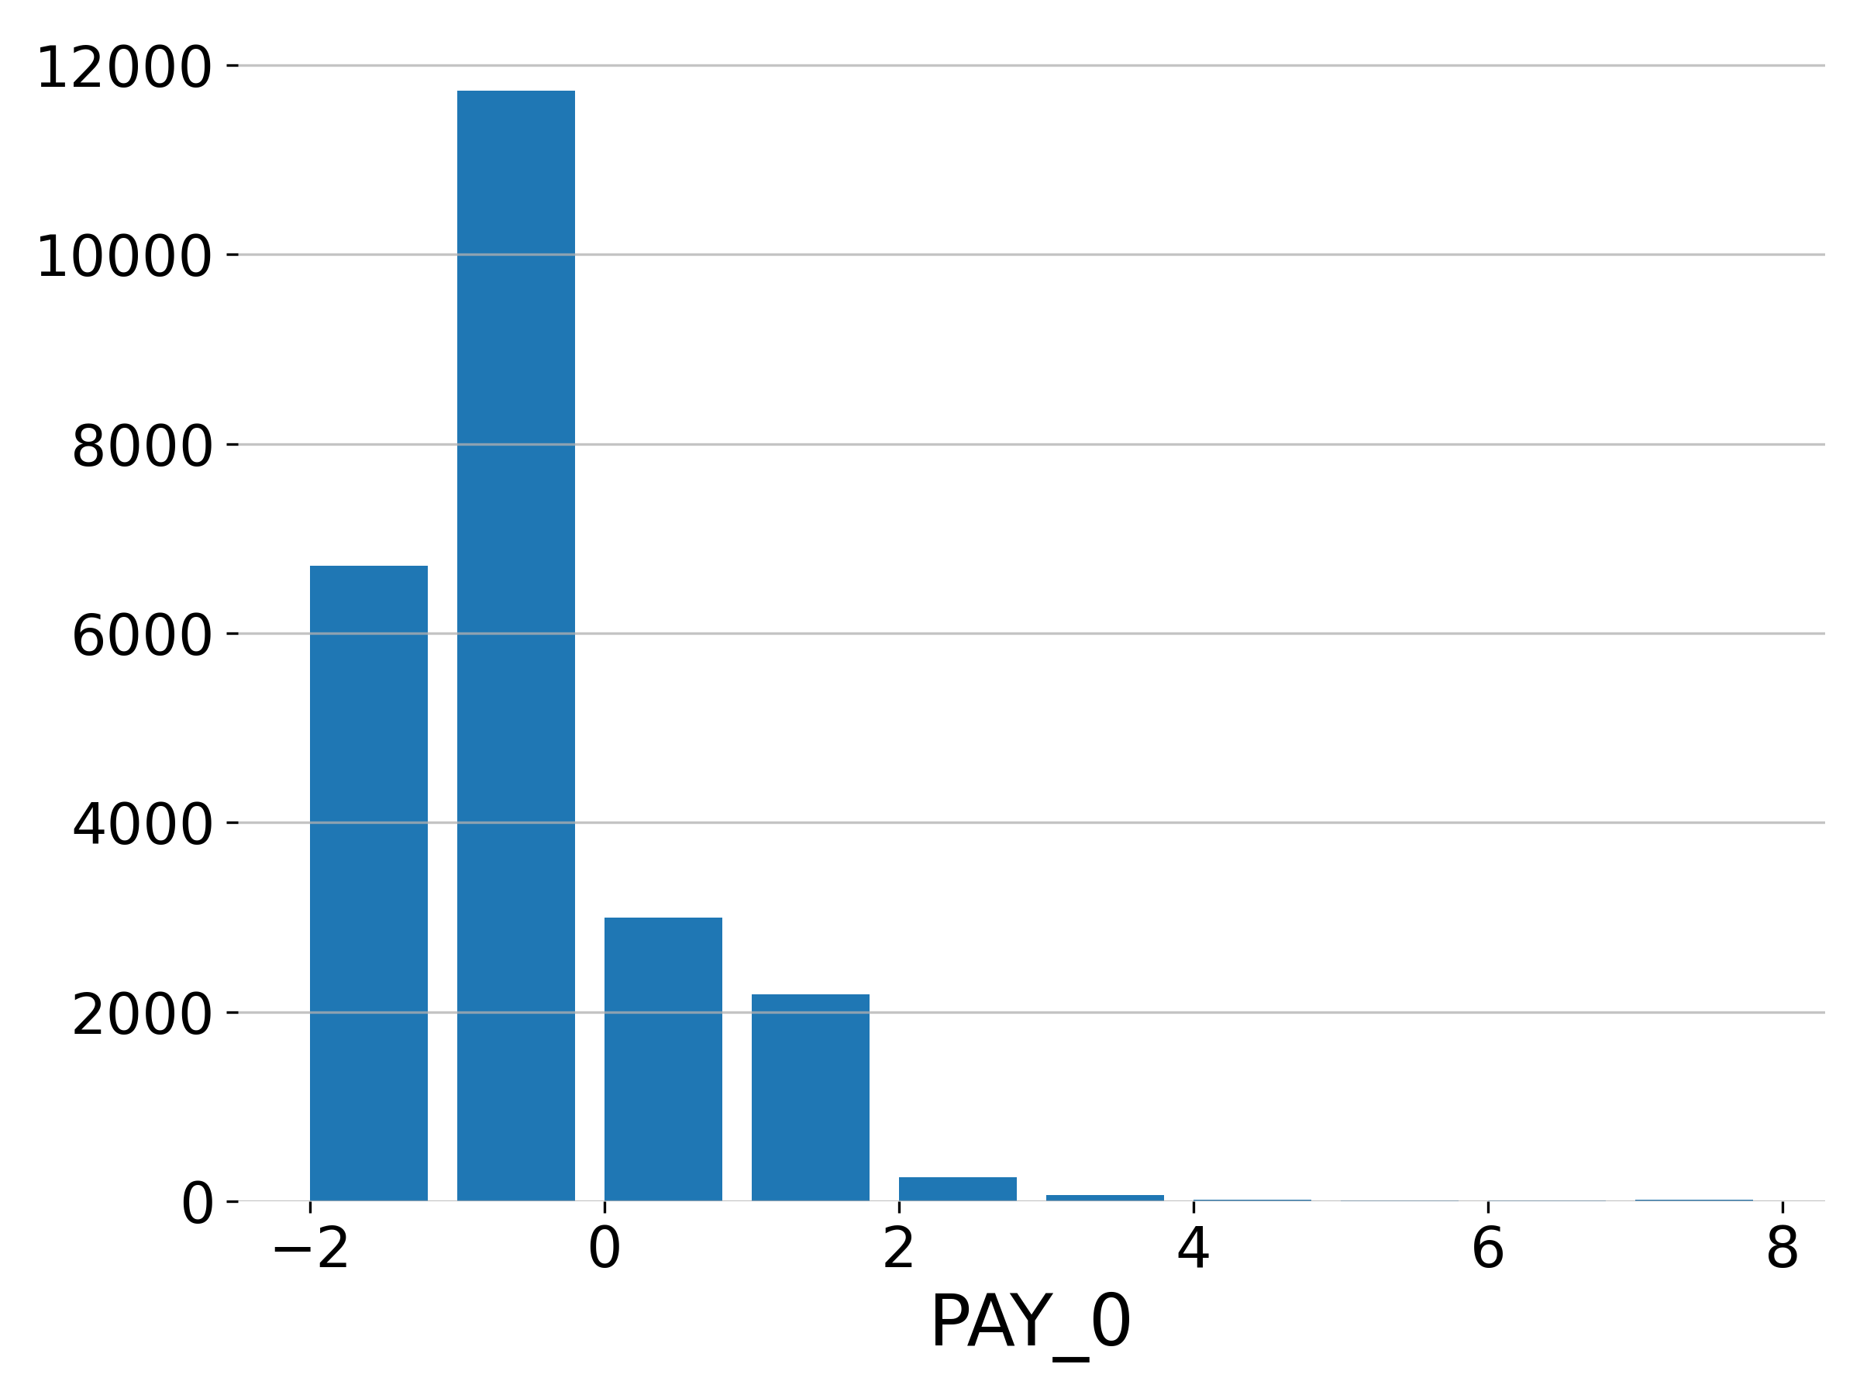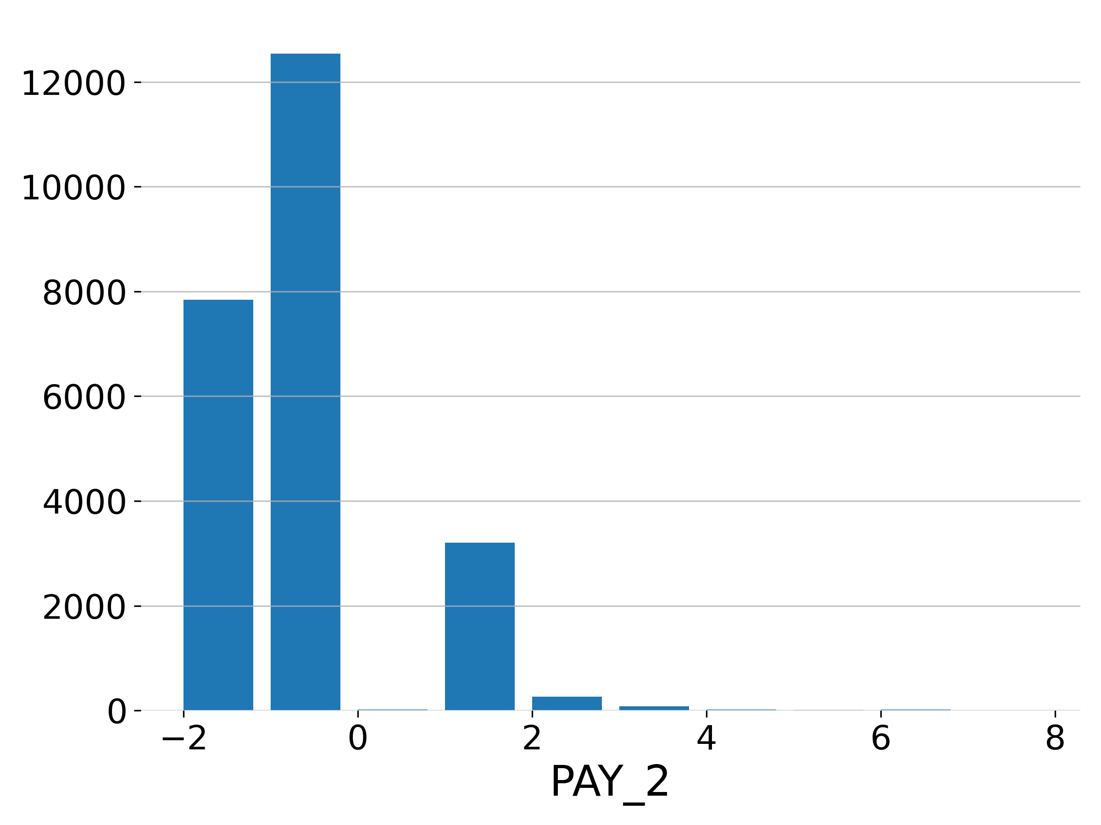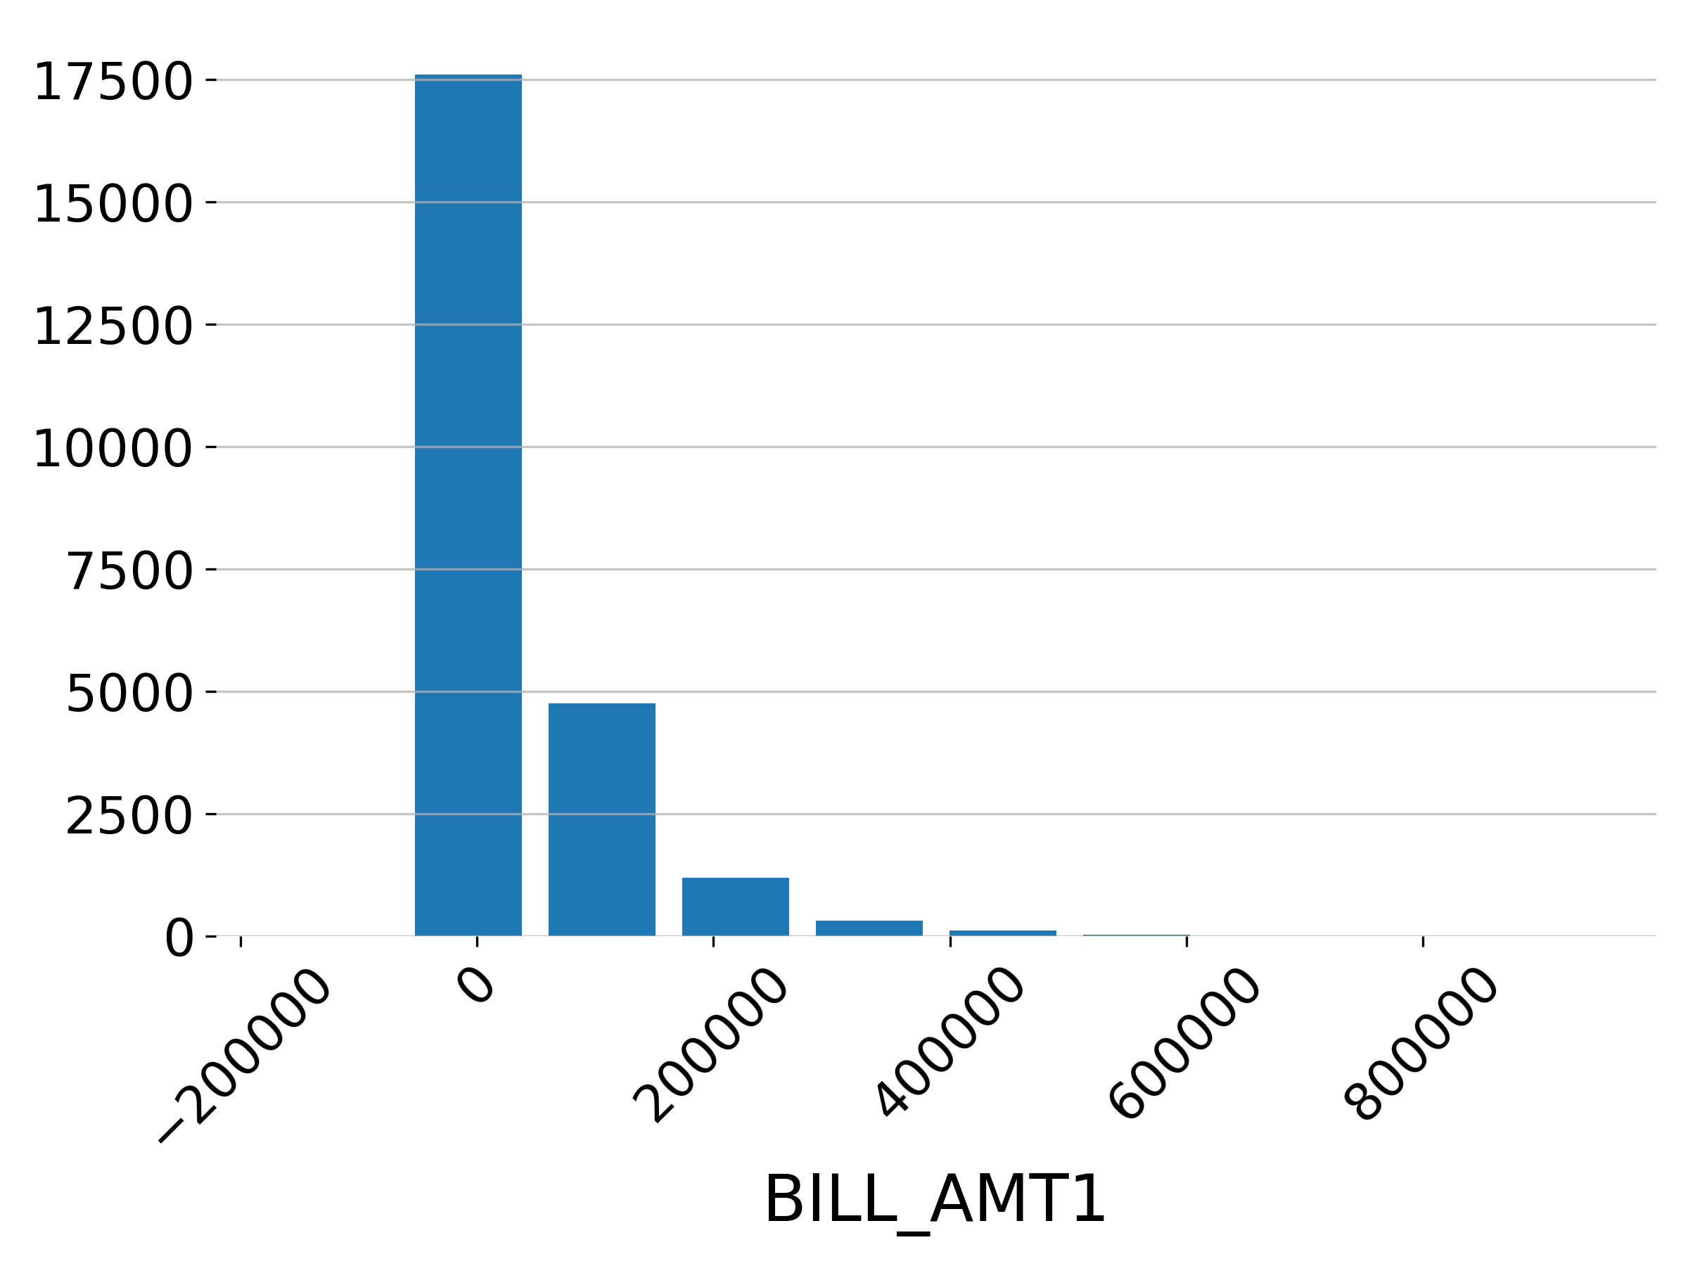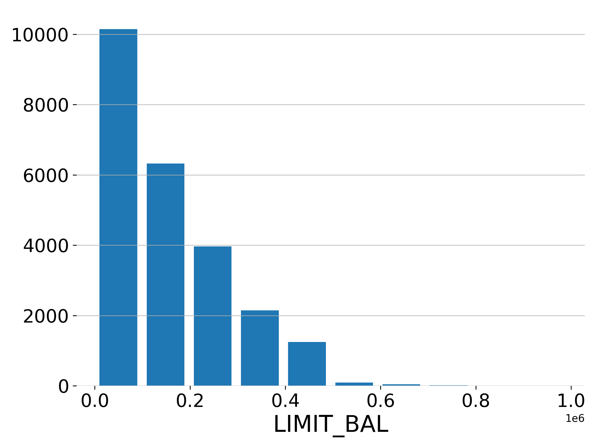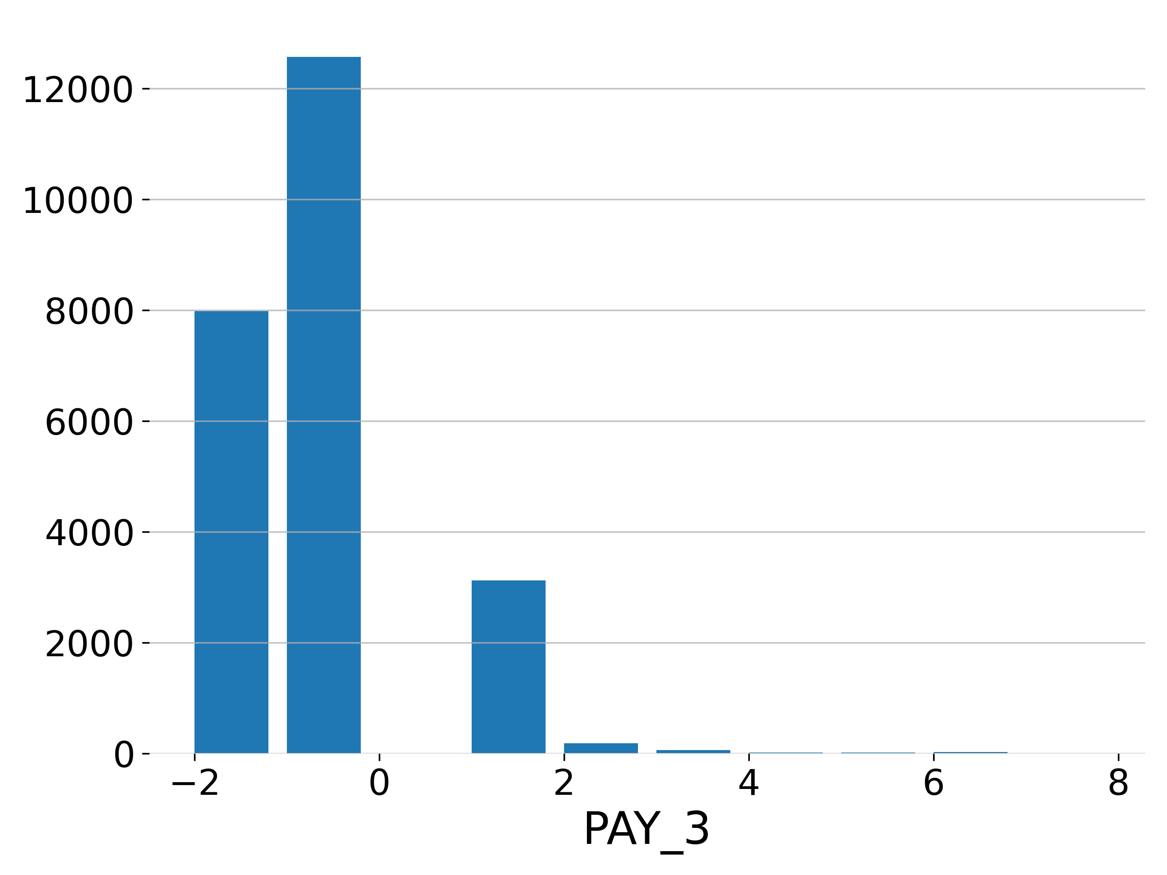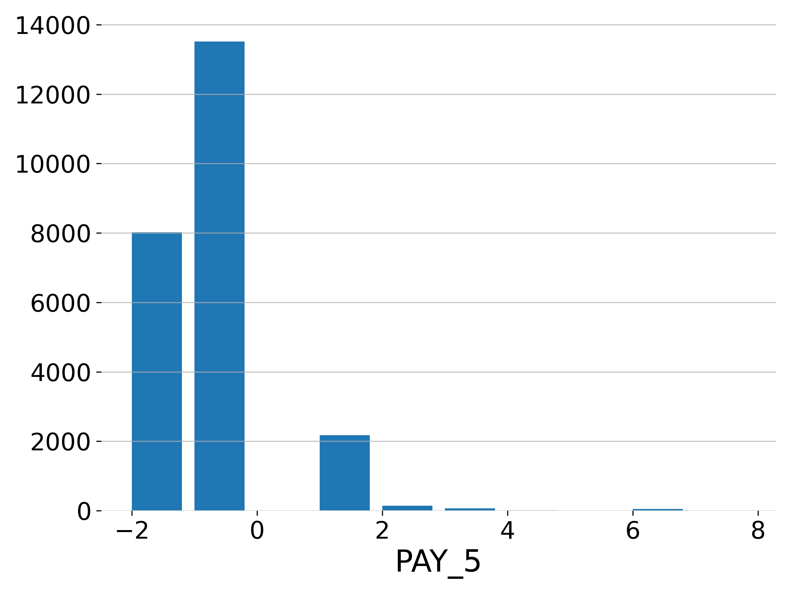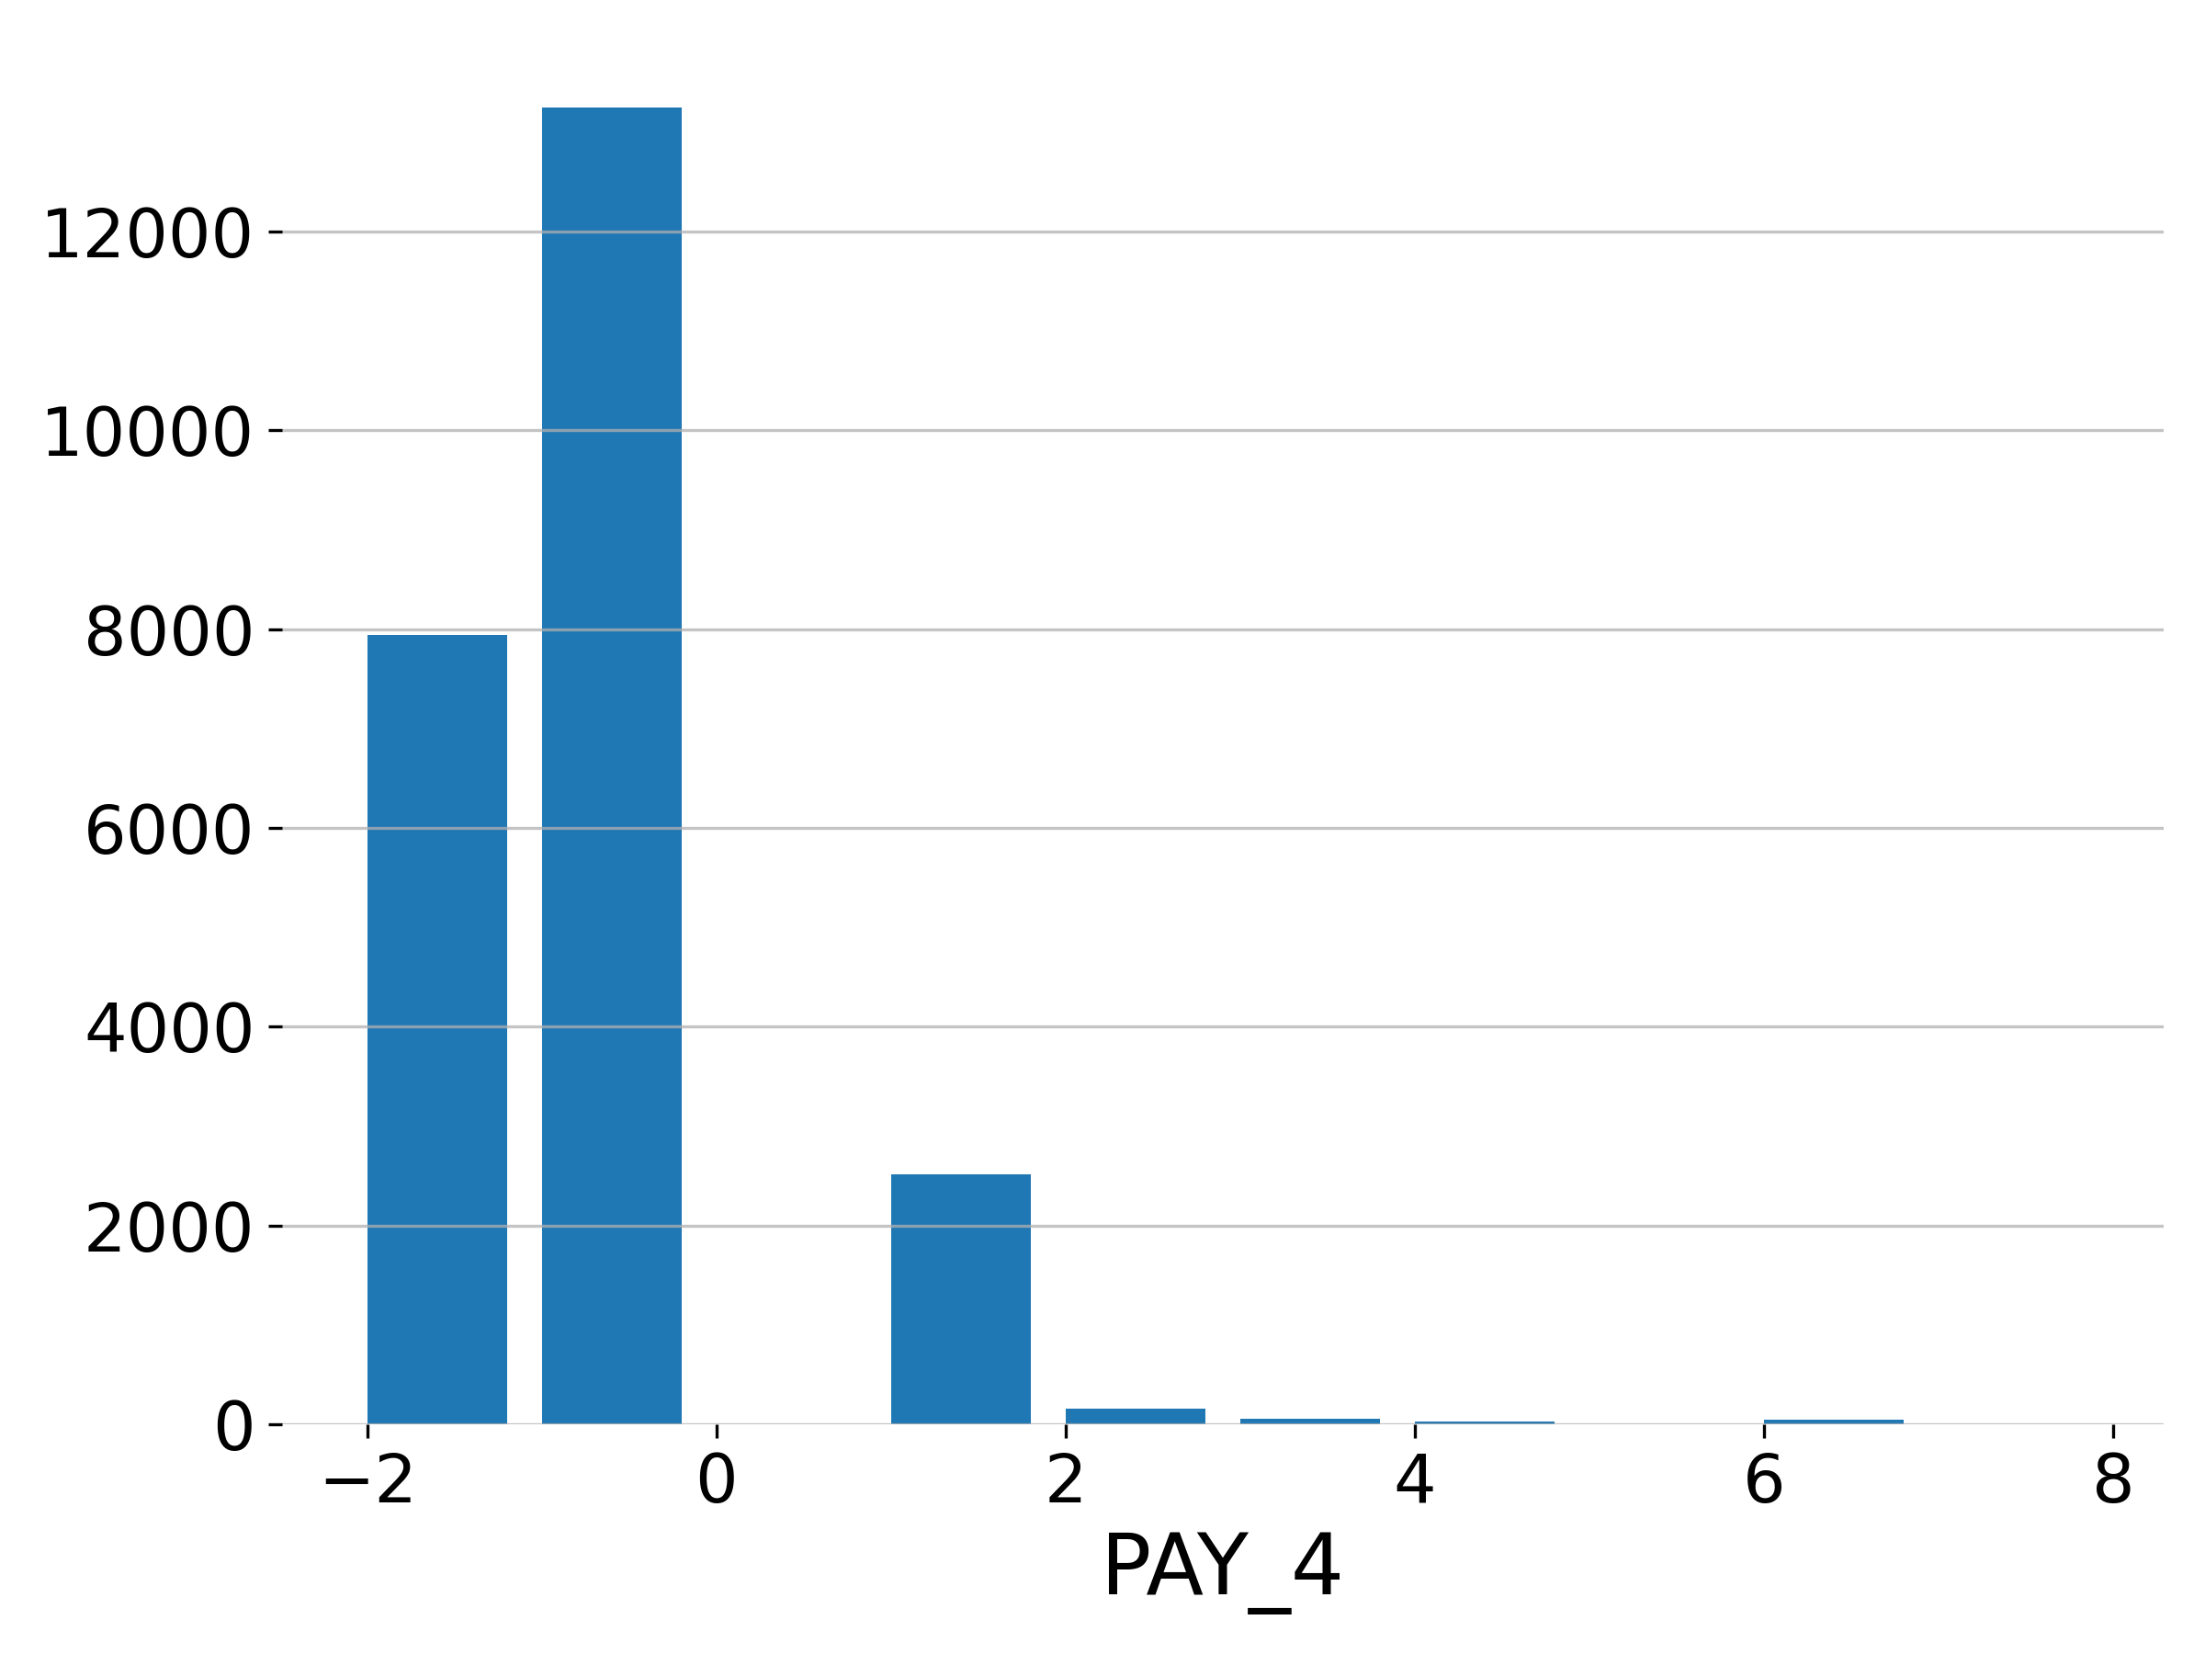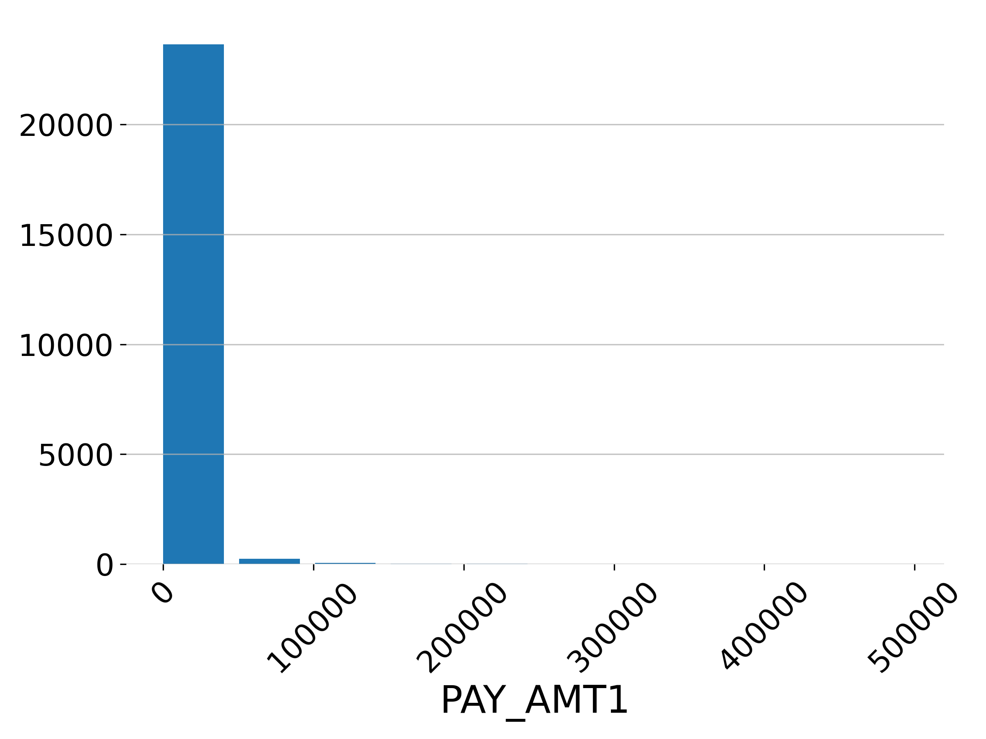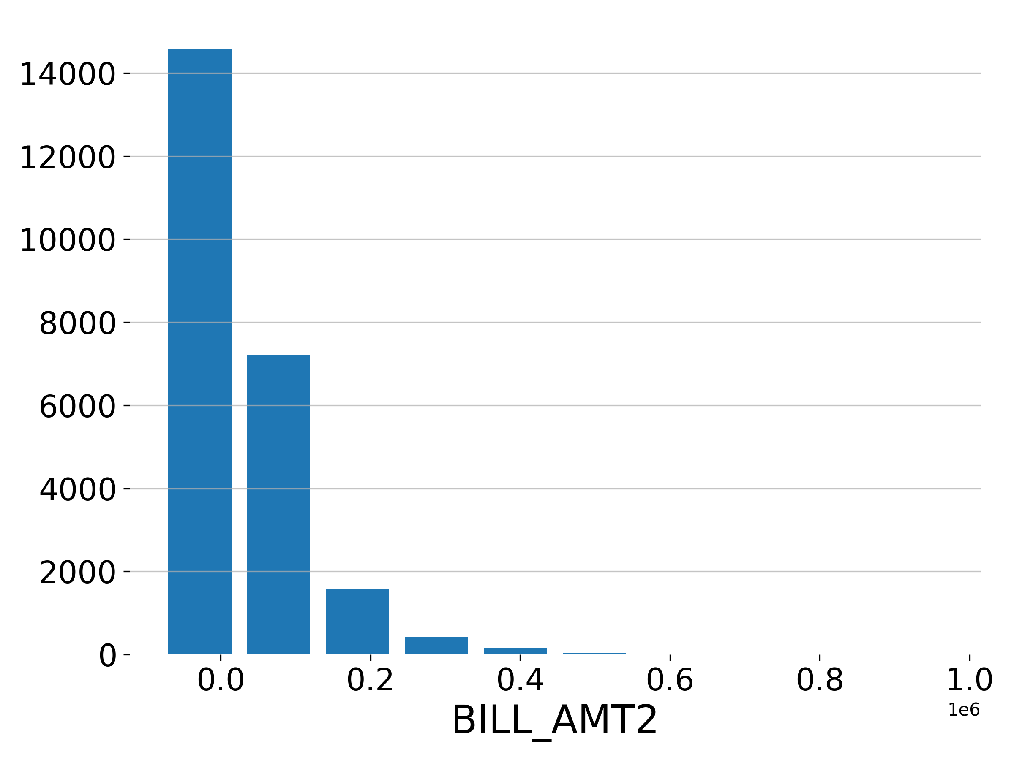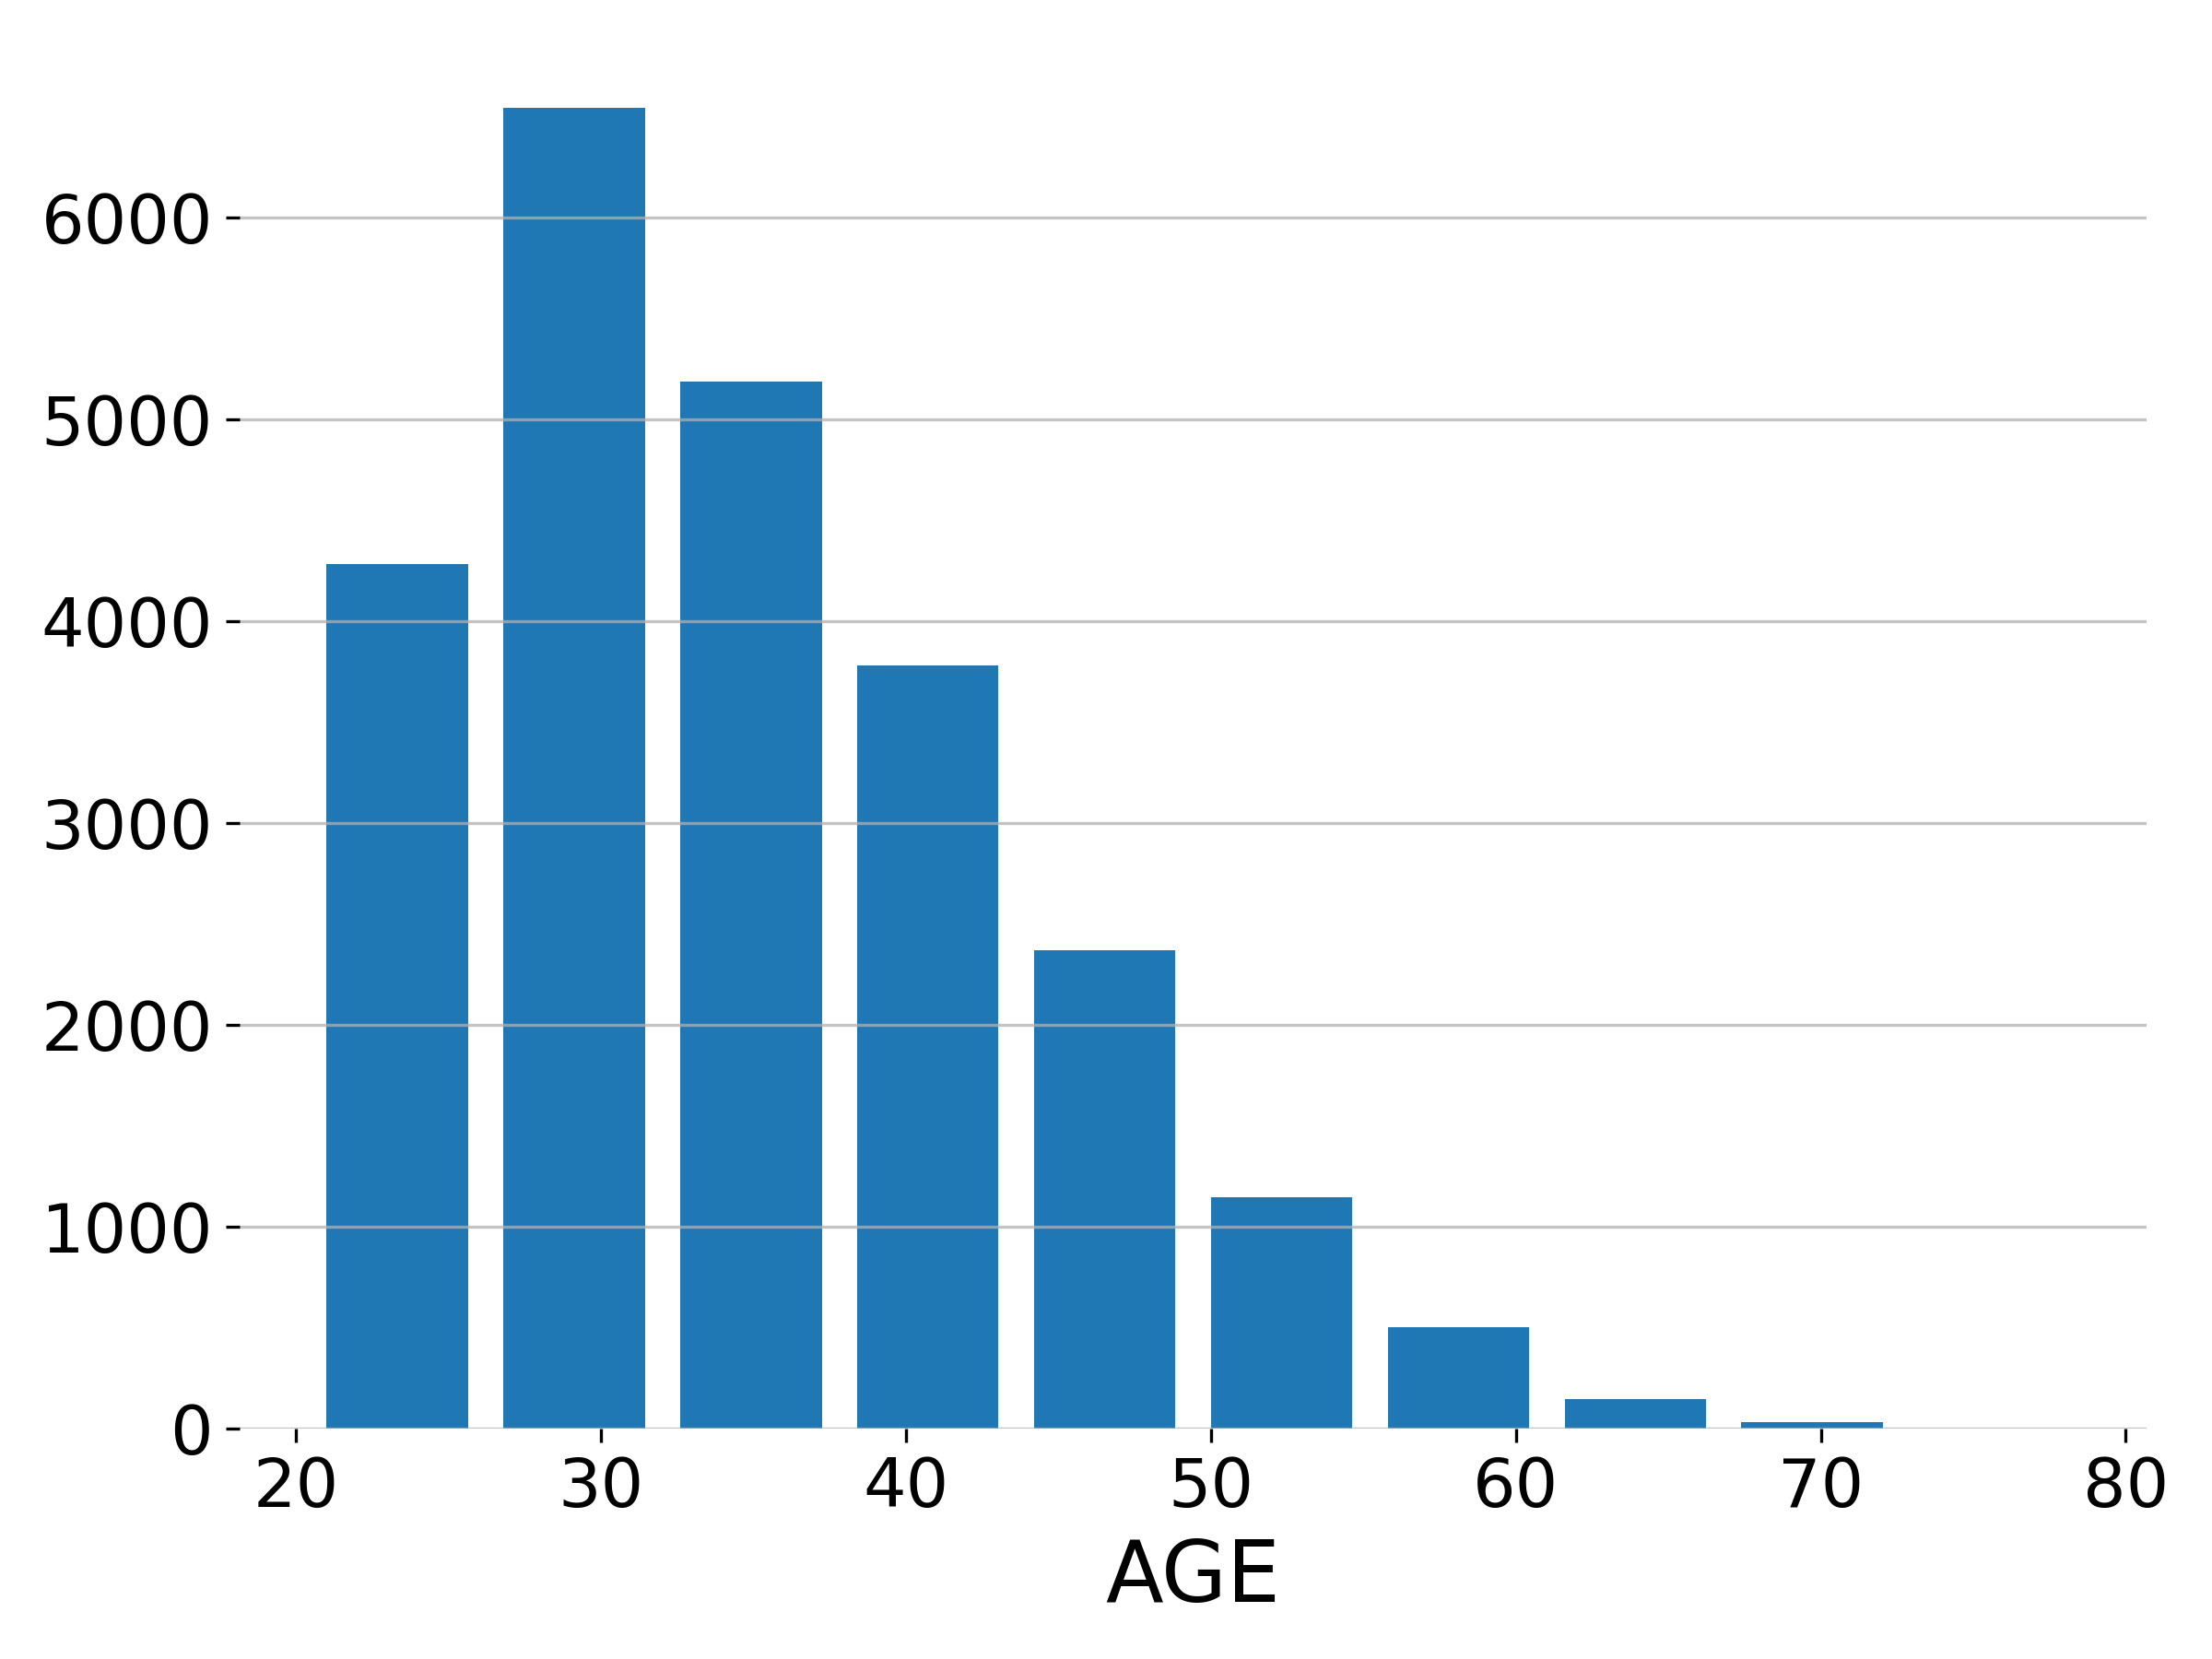

#### Target Summary

The target’s plot and summary statistics are shown below.

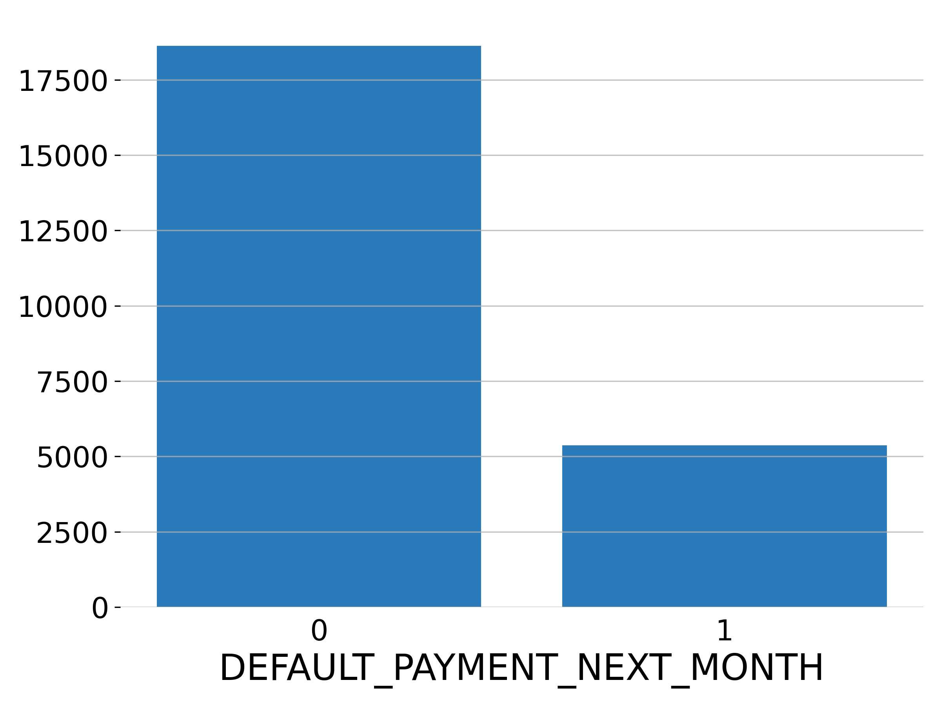

|  |  |  |  |
| --- | --- | --- | --- |
| **name** | **unique** | **top** | **freq of top value** |
| DEFAULT_PAYMENT_NEXT_MONTH | 2 | 0 | 18630 |

#### Validation Data

The validation data consists of both numeric and categorical columns.

The descriptive summary for each column is shown below:

**Numeric Columns**

|  |  |  |  |  |
| --- | --- | --- | --- | --- |
| **name** | **min** | **mean** | **max** | **std** |
| ID | 2.4e+04 | 2.7e+04 | 3e+04 | 1732 |
| LIMIT_BAL | 1e+04 | 1.754e+05 | 7.8e+05 | 1.319e+05 |
| AGE | 21 | 35.91 | 75 | 8.991 |
| PAY_0 | -2 | -0.071 | 8 | 1.124 |
| PAY_2 | -2 | -0.1748 | 7 | 1.183 |
| PAY_3 | -2 | -0.212 | 8 | 1.167 |
| PAY_4 | -2 | -0.2567 | 7 | 1.179 |
| PAY_5 | -2 | -0.3193 | 7 | 1.116 |
| PAY_6 | -2 | -0.3435 | 7 | 1.115 |
| BILL_AMT1 | -1.154e+04 | 5.373e+04 | 7.468e+05 | 7.741e+04 |
| BILL_AMT2 | -6.753e+04 | 5.131e+04 | 6.716e+05 | 7.429e+04 |
| BILL_AMT3 | -4.613e+04 | 4.96e+04 | 8.551e+05 | 7.374e+04 |
| BILL_AMT4 | -6.517e+04 | 4.684e+04 | 7.069e+05 | 6.904e+04 |
| BILL_AMT5 | -6.137e+04 | 4.155e+04 | 5.871e+05 | 6.256e+04 |
| BILL_AMT6 | -2.091e+05 | 4.01e+04 | 5.15e+05 | 6.111e+04 |
| PAY_AMT1 | 0 | 6146 | 8.736e+05 | 2.152e+04 |
| PAY_AMT2 | 0 | 6344 | 1.227e+06 | 3.04e+04 |
| PAY_AMT3 | 0 | 6251 | 8.89e+05 | 2.264e+04 |
| PAY_AMT4 | 0 | 5156 | 6.21e+05 | 1.847e+04 |
| PAY_AMT5 | 0 | 4863 | 4.265e+05 | 1.531e+04 |
| PAY_AMT6 | 0 | 5320 | 4.43e+05 | 1.836e+04 |

**Categorical Columns**

|  |  |  |  |
| --- | --- | --- | --- |
| **name** | **unique** | **top** | **freq of top value** |
| SEX | 2 | female | 3034 |
| EDUCATION | 4 | university | 2670 |
| MARRIAGE | 4 | single | 3087 |
| DEFAULT_PAYMENT_NEXT_MONTH | 2 | 0 | 4734 |

**Unseen Levels in the Validation Dataset**

The validation dataset does not contain any categorical levels that were not seen in the training dataset.

**Missing Values**

H2O-3 did not find any missing values in the validation dataset.

H2O-3

#### Shifts Detected

H2O-3 can perform shift detection between the training, validation, and testing datasets. It does this by training a binomial model to predict which dataset a record belongs to. For example, it may find that it is able to separate the training and testing data with an AUC of 0.8 using only the column: C1 as the predictor. This indicates that there is some sort of drift in the distribution of C1 between the training and testing data.

For this experiment, H2O-3 checked the train and validation data for any shift in distributions but found none. This indicates that all the predictors/columns in the train and validation data are from the same distribution.

1. Data inclusions and exclusions

* {Discuss observations included and excluded from the model development population.
* Discuss if the final data after exclusions are representative of the bank’s portfolio or other characteristics, or if assumptions are made to adjust the information.
* Include a flow chart or a waterfall diagram of the exclusion process (can be combined with overall process) and observation counts by significant segments (dates, sub-portfolios, etc.)}

1. Sampling approach

* {This section could be included in model development section if this is more integral to the development
* Describe, if applicable, the sample definition for the development dataset (e.g., repeated sampling), development validation sampling (hold-out, hold-out percentage, hold-out time window, out-of-sample, out-of-sample window, k-fold, k-fold percentages, or other).
* Discuss any judgmental or qualitative aspect of the process.
* Discuss the appropriateness of the sampling approach. RR1-2 models, discuss alternative sampling approach, if applicable.
* For vendor models, the sample design should be demonstrably relevant for Wells Fargo use.}

The model’s performance is evaluated using a validation dataset with shape (6000, 25).

Early stopping ends model training when the selected “stopping metric” does not improve for a specified number of training rounds, based on a simple moving average. For this model, early stopping is disabled during training.

1. Observation and performance windows

{This section could be included in model development section if this is integral to the development.

Include a discussion of the observations and performance windows and how they relate to the model’s purpose and use.

Discuss whether the observations and performance windows include a stressed/downturn environment or uncertain environment or other period of interest.

### Performance

|  |  |
| --- | --- |
| **Dataset** | **auc** |
| Validation Data | 0.801 |
| Test Data | NA |

1. Dependent variable(s) definition

* {Explain the process of determining the dependent variable definition, and other candidate forms that were considered.
* Include the process of incorporating any transformations, proxies, or derivations of the dependent variables. Discuss measurement error or censoring if applicable.
* Detail any judgmental or qualitative aspects of the process with rationale.
* Include a flow chart or a waterfall diagram of the dependent variable definition process and observation counts by significant segments (dates, subportfolios, etc.).
* Demonstrate that the data are representative of the bank’s portfolio. In case of vendor models, clearly define the vendor model dependent variable and justify how the vendor chosen definition is relevant to Wells Fargo’s business use.

1. Independent/predictive variable(s) definitions

* {Explain the process of creating the independent variables, including any third-party data and portfolio/account characteristics.
* Detail the process to treat missing or special values, outliers, and other assumptions, including methodologies used for any data imputation.
* Include the process of incorporating any transformations, proxies, forecast values, or derivations of the independent variables.
* Certain vendor models may include proprietary inputs or assumptions, which are not fully available to Wells Fargo. If full access cannot be obtained due to proprietary restrictions, model developers must clearly identify the restricted information and include enough information to demonstrate reasonableness of modeling choices related to assumptions and inputs.}

## Summary of data/inputs

* Provide a summary justification of data adequacy and pertinence given the objectives of model users, including limitations and applicable mitigating controls. Provide linkage to testing and analysis in subsequent sections, if needed.

# Model estimation/development/calibration/fitting

{This section discusses how the final model structure (parameter estimates, equations) is developed. Some discussion on performance is expected as it relates to the model fit, but performance analysis is discussed in detail in Section 5, Model testing and model performance. These subsections and topics must be completed to the extent that they are applicable to the model under consideration – most likely, not all the subsections apply to all models. For vendor models, if comprehensive detail cannot be obtained due to proprietary restrictions, model developers should include enough information to demonstrate a rigorous modeling process, clear documentation of assumptions and reasonableness of modeling choices. Include information on model components representing model adjustments/configuration/customization for Wells Fargo use.

## Model specification/structure

1. Model segmentation/components

{This section might be partially covered in Section 2.1 model framework and theory. If already fully covered or not applicable, skip this subsection.

* Provide details on the process and rationale/justification for separating and merging various portfolio segments or logic of model components (qualitative and quantitative). The discussion should focus on how/why the chosen segmentation scheme is consistent with regulatory reporting, risk management, and business objectives/requirements for the model.
* For vendor models, Include a discussion of the relevance, assumptions and limitations of model segmentation for Wells Fargo use
* Describe the customization choices for Wells Fargo use in detail, if any.
* Model documentation should demonstrate that model segmentation and components are adequate given the intended Wells Fargo use and risks, even if full transparency into model specification is constrained due to proprietary restrictions.
* In all cases, model developers should fully Document all assumptions and limitations and include enough information to demonstrate reasonableness of modeling process.
* If multiple segments/components are used, multiple subsections should be used to discuss the model fit/estimation/calibration for each segment/component where applicable in the following sections.}

1. Model specification

|  |  |  |  |
| --- | --- | --- | --- |
| Risk Rank 4 | Risk Rank 3 | Risk Rank 2 | Risk Rank 1 |
| Simple: *Key* developmental choices and key assumptions | All information necessary for replication and developmental choices and assumptions that have a material impact on the key model risks. | All information necessary for detailed challenge, including developmental choices and assumptions that have material impact on the key model risk | |

* Present the information and justification by segment and by use. Use subsections if multiple segments/uses/components are in a model and the flow of the report will be improved.
* Discuss the merits and limitations of the model methodologies and processing components that implement the theory.
* Describe and justify the mathematical specification and the numerical techniques and approximations. The depth of discussion should be commensurate with the requirements indicated at the beginning of this section.
* Justify the appropriateness of the development tools used.
* Present and justify intermediate results where appropriate.
* For vendor models, if full transparency into model specification is constrained due to proprietary restrictions, model developers should perform testing to elucidate as much as possible the model structure. Rigor of testing should be commensurate with risk of model.}
* For qualitative methodologies used for particular portfolios, segments, or scenarios:
* Provide explanation as to why a qualitative approach was used for this segment or portfolio in lieu of a quantitative approach
* Explain the methodology employed to calculate these segments or portfolios. Include any theoretical framework, numerical implementation, specific formulas, or segmentation methodology. If the methodology is used for different scenarios in regulatory Stress test, explain the methodology for all scenarios. If the methodology is meant to mirror regulatory guidance or actual laws/regulations, explain clearly, employing examples as appropriate.
* Describe any assumptions used and provide rationale supporting these assumptions. For segments that are impactful to the overall model, provide analysis or evidence supporting the appropriateness of these assumptions and describe how the assumption is periodically reviewed to ensure it remains adequate
* Describe the outputs of these methodologies, as well as the justification as to why these outputs are appropriate for use. Provide analysis or tests used to evaluate the appropriateness of these outputs.
* Provide backtesting results, as appropriate.
* For output used in regulatory stress tests, evaluate the outputs under each of the stress scenarios. Provide a brief overview of the reasonableness of the projection results relative to the stated macroeconomic scenarios.

H2O-3 built a Gradient Boosting Machine to predict DEFAULT_PAYMENT_NEXT_MONTH given 23 original features from the input dataset. This classification experiment completed in 4 seconds (0:00:04).

|  |  |
| --- | --- |
| **Parameters** | **Values** |
| model_id | gbm_model |
| auc_type | AUTO |
| balance_classes | False |
| categorical_encoding | Enum |
| class_sampling_factors | None |
| col_sample_rate | 1.0 |
| col_sample_rate_change_per_level | 1.0 |
| col_sample_rate_per_tree | 1.0 |
| distribution | bernoulli |
| fold_assignment | None |
| fold_column | None |
| histogram_type | UniformAdaptive |
| learn_rate | 0.1 |
| learn_rate_annealing | 1.0 |
| max_abs_leafnode_pred | 1.7976931348623157e+308 |
| max_after_balance_size | 5.0 |
| max_depth | 5 |
| max_runtime_secs | 0.0 |
| min_rows | 10.0 |
| min_split_improvement | 1e-05 |
| nbins | 20 |
| nbins_cats | 1024 |
| nbins_top_level | 1024 |
| ntrees | 50 |
| offset_column | None |
| pred_noise_bandwidth | 0.0 |
| response_column | DEFAULT_PAYMENT_NEXT_MONTH |
| sample_rate | 1.0 |
| sample_rate_per_class | None |
| seed | 1234 |
| stopping_metric | None |
| stopping_rounds | 0 |
| stopping_tolerance | 0.001 |
| weights_column | None |

## Variable selection and model estimation/calibration

Variable selection requirements

|  |  |  |  |
| --- | --- | --- | --- |
| Risk Rank 4 | Risk Rank 3 | Risk Rank 2 | Risk Rank 1 |
| Can be judgment based | Basic quantitative approach: Heavier reliance on judgment for prescreening and feature engineering is acceptable | | Advanced quantitative approach should be considered when possible for pre-screening and feature engineering |

* {Detail the variable selection process and rationale including consistency of signs, magnitudes, and lags with expected results.
* Explain if a specific selection algorithm is applied (e.g., stepwise or backward), and discuss any statistics used to select or eliminate variable combinations (cluster analysis, principal components, expert judgment and review, etc.)
* Discuss the pool of variable considered and tested. Include any discussions with the business lines that precluded certain variables from entering the final model. Discuss variable transformations, with emphasis on economic intuition and interpretation. (For example, one may determine loan-to-value is a better predictor of behavior than using loan amount and collateral value separately in an additive model.)
* Justification for variable selection of model drivers should be conceptually sound. Empirical evidence to support variable selection should be provided if available. It should always include, given model use, all key drivers considered (e.g. for stress test models, all macro-economic drivers with potentially significant impact).
* For RR1-2 models, provide a description of all variables considered (if many are used, use an appendix to list, describe, and discuss all variables. See instructions related to appendices under “Template instructions”).
* For vendor models, Include a discussion of the relevance, assumptions and limitations of variable selection for Wells Fargo use
* Describe in detail the customization choices for Wells Fargo use, if any.
* Demonstrate that variable selection is adequate given the intended Wells Fargo use and risks even if full transparency into model specification is constrained due to proprietary restrictions.
* In all cases, model developers should fully Document all assumptions and limitations and include enough information to demonstrate reasonableness of modeling process.

}

Model estimation:

* Define if applicable the objective or likelihood function that is to be maximized/minimized, such as R2 or absolute percentage error.
* Detail the estimation approach and outcome at the segment/component level, if applicable.
* Provide and compare profile and descriptive statistics of data that was fitted or calibrated (such as distribution including mean, min/max, missing) for development, in-time validation, and out-of-time samples, and by segments modelled or used.
* For models that are calibrated/fitted:
* Is the calibration or estimation one-time or ongoing? If ongoing, describe the frequency of the calibration or fit.
* Describe the data set chosen for calibration.
* What drove the choice of calibration method?
* Assess the quality of calibration and/or fit.
* How does the quality of calibration impact loss allowance, capital reserve, pricing/hedging, account decision-making, complaint classification or alert generation (as appropriate)?
* Describe any necessary calibration post-processing. For example, if a calibrated parameter or model input is not used directly, but is used to inform other model elements, describe such operations here.
* What ongoing monitoring will there be for calibration. This must also be described in Section 7, Ongoing performance monitoring.

H2O-3 models provide built-in variable importance (Native Importance) and can provide Shapley Importance for supported algorithms.

* **Native Importance:** Model-specific variable importance calculated with H2O-3’s varimp() function (H2O-3 documentation details [here](https://h2o-release.s3.amazonaws.com/h2o/rel-zipf/7/docs-website/h2o-docs/variable-importance.html)).
* **Scaled Native Importance:** Native Importance scaled between 0 and 1.
* **Shapley:** The mean absolute Shapley value of a feature, using TreeSHAP (SHAP documentation details [here](https://shap.readthedocs.io/en/latest/)).
* **Relative Shapley:** The feature’s mean absolute Shapley value divided by the largest Shapley value.

|  |  |  |  |  |  |  |
| --- | --- | --- | --- | --- | --- | --- |
|  | **Feature** | **Native Importance** | **Scaled Native Importance** | **Shapley** | **Relative Shapley** | **orig_name** |
| 0 | PAY_0 | 3278.1111 | 1.0 | 0.4045 | 1.0 | PAY_0 |
| 1 | LIMIT_BAL | 235.791 | 0.0719 | 0.1561 | 0.3859 | LIMIT_BAL |
| 2 | PAY_2 | 567.0049 | 0.173 | 0.1352 | 0.3343 | PAY_2 |
| 3 | BILL_AMT1 | 245.1739 | 0.0748 | 0.125 | 0.3089 | BILL_AMT1 |
| 4 | PAY_AMT1 | 120.3364 | 0.0367 | 0.1043 | 0.2579 | PAY_AMT1 |
| 5 | PAY_3 | 201.1064 | 0.0613 | 0.0807 | 0.1996 | PAY_3 |
| 6 | PAY_5 | 139.495 | 0.0426 | 0.0642 | 0.1587 | PAY_5 |
| 7 | PAY_AMT2 | 53.8554 | 0.0164 | 0.053 | 0.1311 | PAY_AMT2 |
| 8 | PAY_AMT3 | 60.9946 | 0.0186 | 0.0486 | 0.1201 | PAY_AMT3 |
| 9 | PAY_AMT4 | 73.9498 | 0.0226 | 0.0479 | 0.1185 | PAY_AMT4 |
| 10 | MARRIAGE | 35.4167 | 0.0108 | 0.0468 | 0.1157 | MARRIAGE |
| 11 | PAY_6 | 81.0877 | 0.0247 | 0.0434 | 0.1073 | PAY_6 |
| 12 | PAY_4 | 120.4323 | 0.0367 | 0.0414 | 0.1024 | PAY_4 |
| 13 | PAY_AMT5 | 66.5133 | 0.0203 | 0.0372 | 0.092 | PAY_AMT5 |
| 14 | BILL_AMT2 | 99.895 | 0.0305 | 0.0367 | 0.0908 | BILL_AMT2 |
| 15 | PAY_AMT6 | 49.6303 | 0.0151 | 0.0315 | 0.0779 | PAY_AMT6 |
| 16 | EDUCATION | 67.2093 | 0.0205 | 0.0246 | 0.0609 | EDUCATION |
| 17 | SEX | 20.7221 | 0.0063 | 0.0237 | 0.0587 | SEX |
| 18 | BILL_AMT3 | 30.2772 | 0.0092 | 0.0151 | 0.0372 | BILL_AMT3 |
| 19 | AGE | 95.7084 | 0.0292 | 0.015 | 0.037 | AGE |
| 20 | Others | 134.0352 | 0.0409 | 0.0355 | 0.0878 | BILL_AMT5BILL_AMT4BILL_AMT6 |

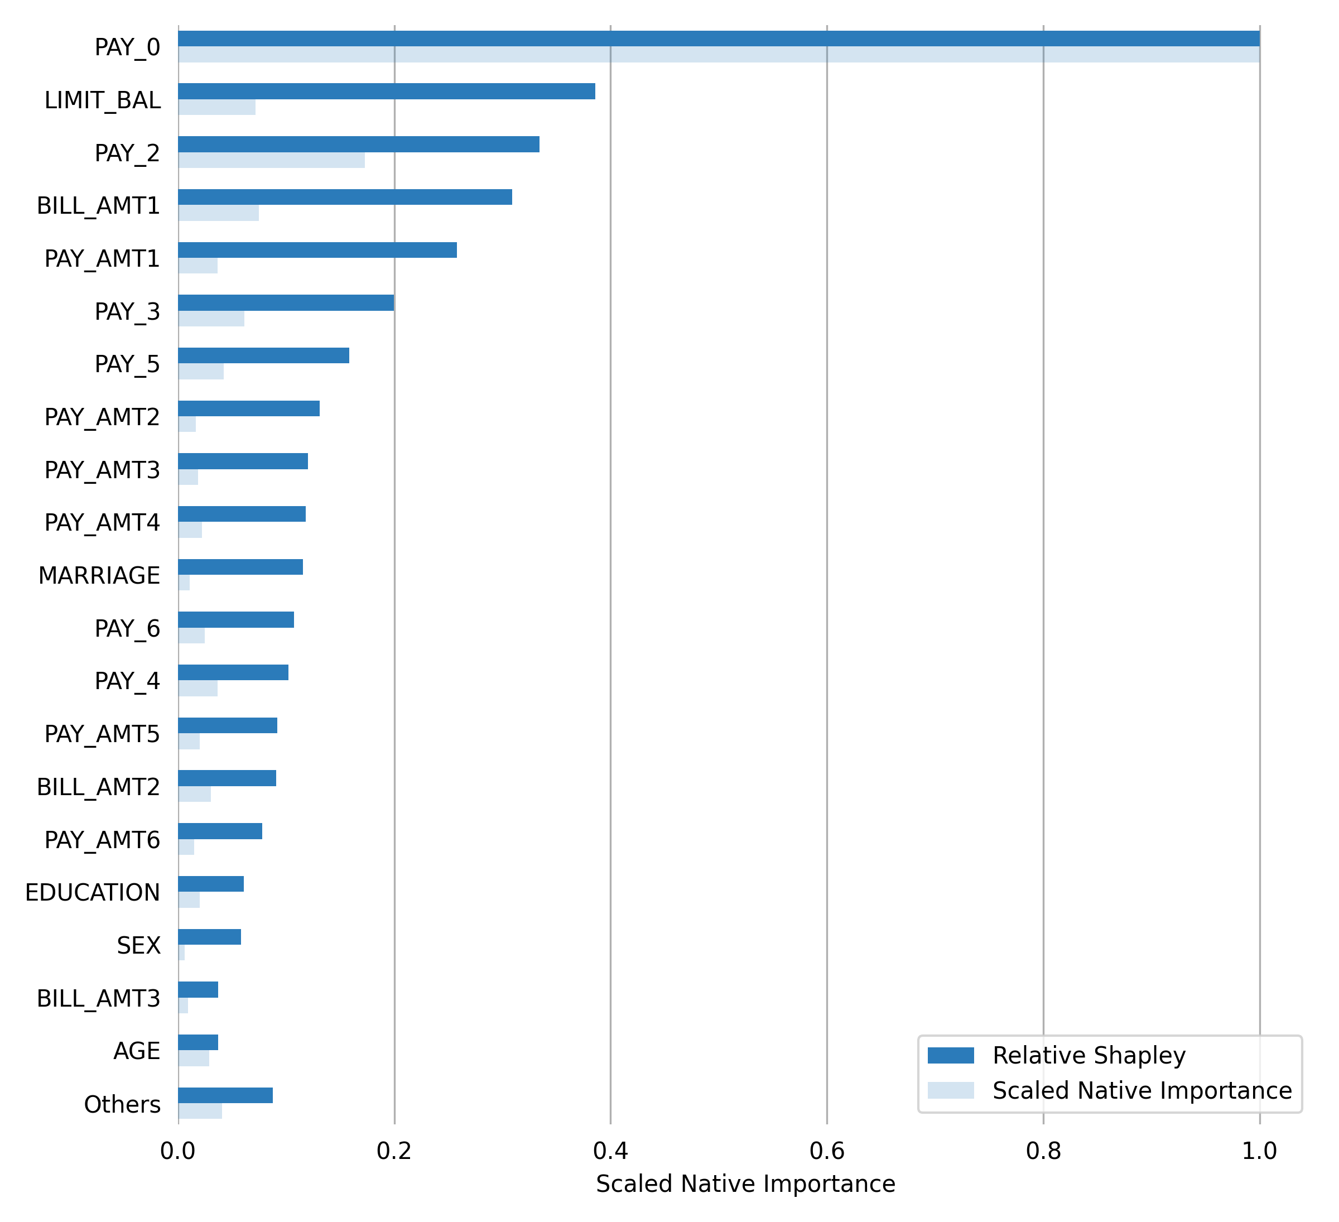

None

## Key model configurations and alternative specifications

* Detail key model development configuration settings and rationale, including those that are by default or chosen by model users.
* For vendor models, describe in detail the customization choices for Wells Fargo use including the quality/fit, adjustments and controls (e.g. controls around frequency of review and update).

|  |  |  |  |
| --- | --- | --- | --- |
| Risk Rank 4 | Risk Rank 3 | Risk Rank 2 | Risk Rank 1 |
| Optional | Basic: Subjective evaluation of alternatives | | Detailed: Analytic evaluation of alternatives |

* Discuss alternative specifications considered – include details in an appendix as needed (see instructions related to appendices under “Template instructions”).

## Final model form characterization

* {After the final model form is selected, provide details on the exact specification (e.g., coefficient estimates).

Table .. Summary of final model specification

| Variable name | Variable description | Variable transformation | Coefficient estimate |
| --- | --- | --- | --- |
|  |  |  |  |
|  |  |  |  |

* Where applicable:
* Provide interpretation of coefficients, signs, and evidence (e.g., goodness of fit measurement, bivariate plots). Provide a clear explanation of the appropriateness of the main coefficients or fitted parameters.
* Characterize model fitting errors, by segment, and assess acceptability given the model objectives and thresholds.
* If such tests satisfy the criteria laid out in section 5.3, Address assumption testing, such as testing around distributional assumptions, stationarity, auto-correlation of residuals, etc.
* For vendor models, if full transparency into model specification is constrained due to proprietary restrictions, model developers are expected to Perform additional testing to ensure reasonableness of final model form/specification
* Document the overall (global) importance of various model inputs
* Describe the expected model behavior for the typical and extreme situations encountered in actual use. These expected behaviors should in turn be tested, as described in Section 5.3.
* For mathematical models (e.g., Black-Scholes) or models that do not rely on empirical estimation (e.g., historical VaR):
* Describe expected model behavior (e.g., input support, first and second derivatives, inflection points, and potential discontinuity).
* Discuss model boundaries or limiting conditions.
* Use diagram and plots to illustrate model form, structure or behavior as appropriate.

**Performance of Final Model**

|  |  |  |
| --- | --- | --- |
| **scorer** | **training** | **validation** |
| AUC | 0.8116 | 0.8007 |
| ACCURACY | 0.831 | 0.833 |
| F1 | 0.5727 | 0.5501 |
| MCC | 0.4599 | 0.442 |
| LOGLOSS | 0.4087 | 0.4065 |

**Validation Confusion Matrix**

The confusion matrix shows how many observations the model correctly classified and misclassified. The first column contains the actual class labels; the first row contains the predicted class labels.

A positive prediction label (e.g., 1, True, or the second label in lexicographical order), is assigned to all observations where the predicted probability is greater than or equal to 0.2688 (the threshold for the highest F1 score on the validation dataset).

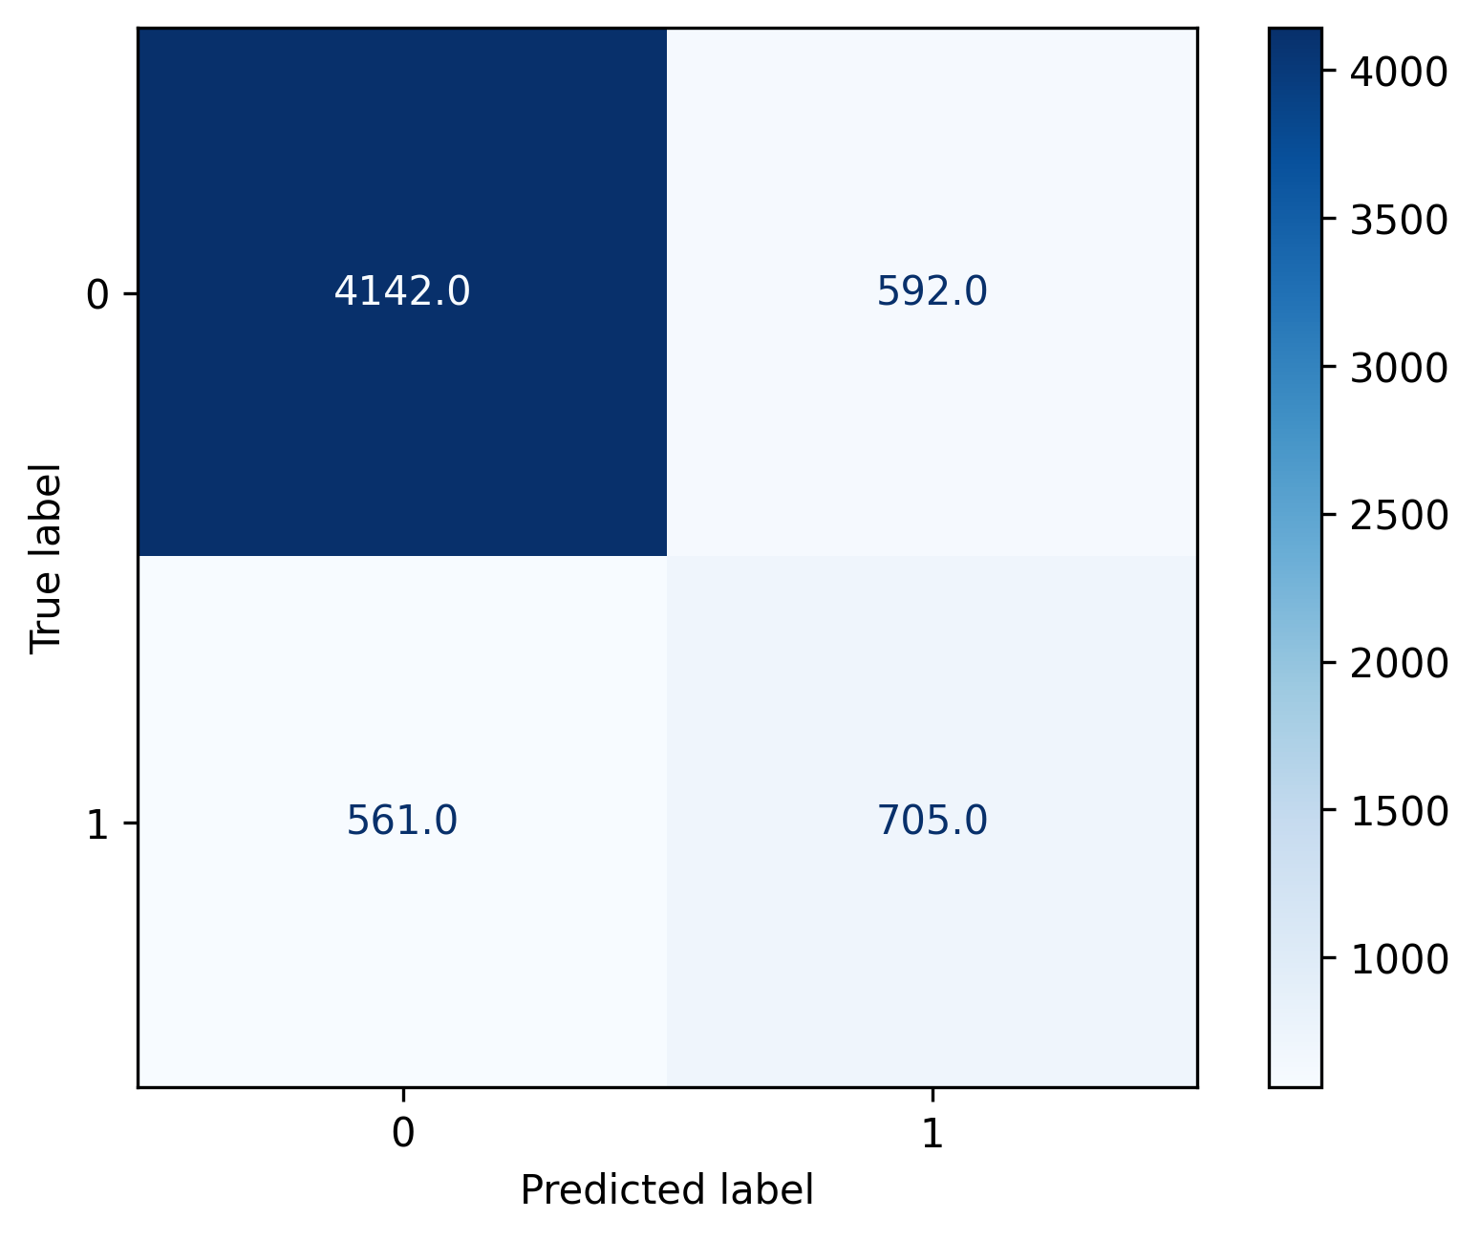

|  |  |  |  |  |
| --- | --- | --- | --- | --- |
| **Labels** | **0** | **1** | **Error** | **Rate** |
| 0 | 4142.0 | 592.0 | 0.1251 | (592.0/4734.0) |
| 1 | 561.0 | 705.0 | 0.4431 | (561.0/1266.0) |
| Total | 4703.0 | 1297.0 | 0.1922 | (1153.0/6000.0) |

**Scoring History**

The scoring history plot shows a model's performance at each iteration point. Typically, the performance will be worse at the beginning (the left side of the graph) and then improve as the model training completes and accuracy improves.

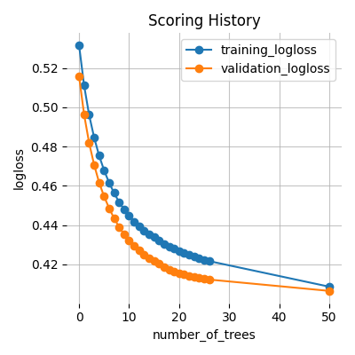

**Receiver Operating Characteristic Curve**

This plot shows the Receiver Operating Characteristic Curve. The area under this curve is called the AUC. The True Positive Rate (TPR) is the relative fraction of correct positive predictions, and the False Positive Rate (FPR) is the relative fraction of incorrect positive corrections. Each point corresponds to a classification threshold (e.g., YES if probability >= 0.3 else NO). For each threshold, there is a unique confusion matrix that represents the balance between TPR and FPR. In general, the most useful operating points are in the top left corner.

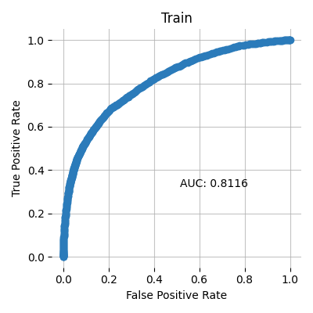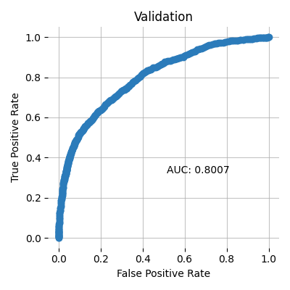

**Precision-Recall Curve**

This model metric is used to evaluate how well a binary classification model is able to distinguish between precision recall pairs or points. These values are obtained using different thresholds on a probabilistic or other continuous-output classifier.

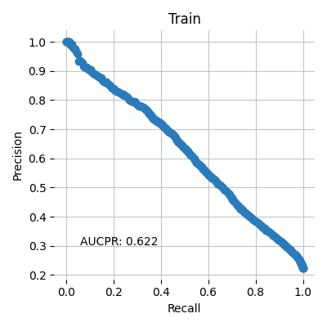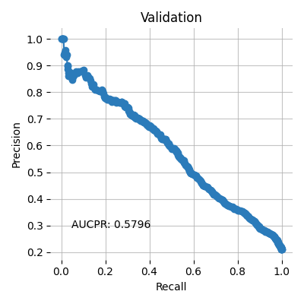

**Cumulative Gain**

This plot shows the cumulative gains. For example, "What fraction of all observations of the positive target class are in the top predicted 1%, 2%, 10%, etc. (cumulative)?" The gains at 100% are 1.0 by definition.

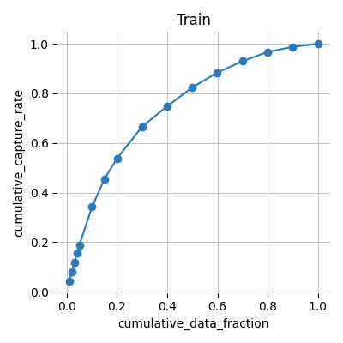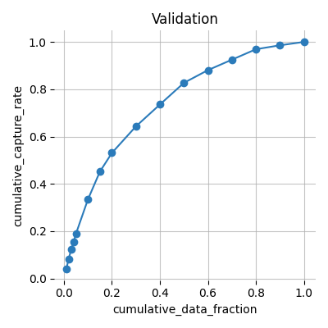

**Cumulative Lift**

This chart shows the cumulative lift. For example, "How many times more observations of the positive target class are in the top predicted 1%, 2%, 10%, etc. (cumulative) compared to selecting observations randomly?" By definition, the Lift at 100% is 1.0.

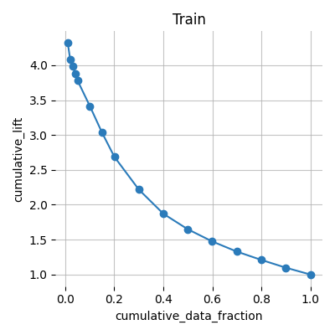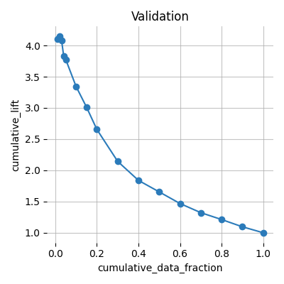

**Population Stability Index (PSI)**

Population Stability Index is a statistic used to describe a variable’s distribution shift. It can measure the shift between the training dataset’s model score distribution and any other given dataset (i.e. validation or test dataset).

A PSI value lower than 0.10 indicates a small shift in the model predictions, a value between 0.10 and 0.25 indicates a moderate shift, and a value greater than 0.25 indicates a strong shift. Strong shift values can indicate that the model trained on the training dataset might not be suitable for the provided validation or test datasets.

**Summary PSI table**

|  |  |
| --- | --- |
| **Dataset** | **PSI** |
| Validation | 0.0052 |

Details on the PSI calculations can be found in the Appendix.

**Prediction statistics**

The following tables and plots show the min, max, mean, and median quantile prediction values for each dataset split. Note: values are rounded to the fourth decimal place. For example, .000025 and .000010 would both appear as 0.0.

**Train**

|  |  |  |  |  |
| --- | --- | --- | --- | --- |
| **quantile** | **min** | **max** | **mean** | **median** |
| 0.05 | 0.0283 | 0.0607 | 0.0516 | 0.0527 |
| 0.1 | 0.0607 | 0.0721 | 0.0668 | 0.0671 |
| 0.15 | 0.0721 | 0.0815 | 0.0769 | 0.077 |
| 0.2 | 0.0815 | 0.0902 | 0.0858 | 0.0857 |
| 0.25 | 0.0902 | 0.0982 | 0.0942 | 0.0941 |
| 0.3 | 0.0982 | 0.1066 | 0.1024 | 0.1023 |
| 0.35 | 0.1066 | 0.1159 | 0.1112 | 0.1113 |
| 0.4 | 0.1159 | 0.1264 | 0.1211 | 0.121 |
| 0.45 | 0.1264 | 0.1369 | 0.1316 | 0.1315 |
| 0.5 | 0.1369 | 0.1475 | 0.1421 | 0.142 |
| 0.55 | 0.1475 | 0.159 | 0.1532 | 0.1534 |
| 0.6 | 0.159 | 0.1745 | 0.1664 | 0.1662 |
| 0.65 | 0.1745 | 0.196 | 0.1848 | 0.1849 |
| 0.7 | 0.1961 | 0.2204 | 0.2083 | 0.2084 |
| 0.75 | 0.2204 | 0.2559 | 0.2356 | 0.2349 |
| 0.8 | 0.2559 | 0.3169 | 0.2857 | 0.2856 |
| 0.85 | 0.3169 | 0.4048 | 0.354 | 0.3527 |
| 0.9 | 0.4049 | 0.5891 | 0.4888 | 0.4822 |
| 0.95 | 0.5893 | 0.7063 | 0.6561 | 0.6587 |
| 1.0 | 0.7063 | 0.9057 | 0.7596 | 0.7519 |

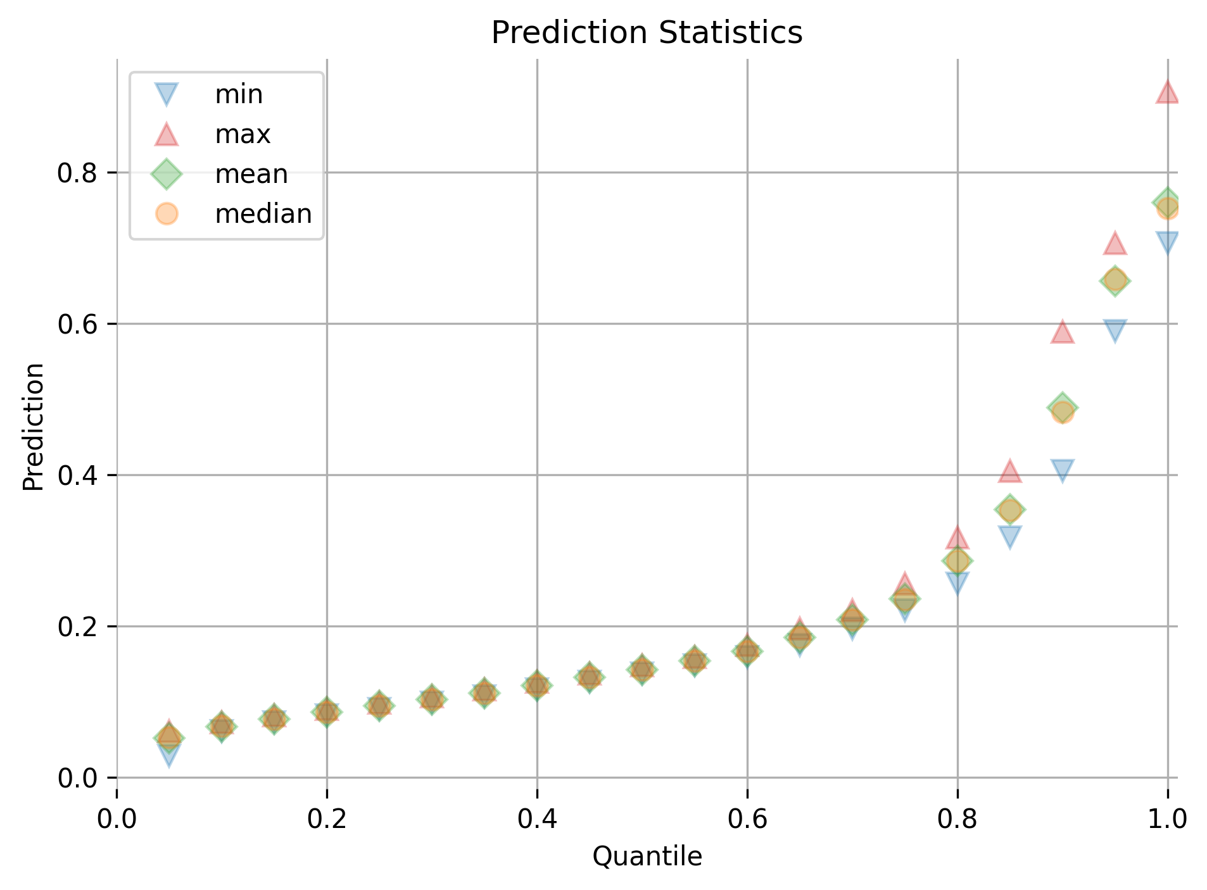

**Validation**

|  |  |  |  |  |
| --- | --- | --- | --- | --- |
| **quantile** | **min** | **max** | **mean** | **median** |
| 0.05 | 0.0361 | 0.0599 | 0.0509 | 0.0518 |
| 0.1 | 0.06 | 0.0715 | 0.0662 | 0.0667 |
| 0.15 | 0.0715 | 0.0806 | 0.0762 | 0.0764 |
| 0.2 | 0.0806 | 0.0891 | 0.085 | 0.0853 |
| 0.25 | 0.0891 | 0.0969 | 0.0931 | 0.0931 |
| 0.3 | 0.0969 | 0.1042 | 0.1004 | 0.1004 |
| 0.35 | 0.1042 | 0.1121 | 0.1079 | 0.1079 |
| 0.4 | 0.1122 | 0.1219 | 0.1171 | 0.1174 |
| 0.45 | 0.1219 | 0.1308 | 0.1264 | 0.1264 |
| 0.5 | 0.1309 | 0.1418 | 0.1361 | 0.1359 |
| 0.55 | 0.1418 | 0.1536 | 0.1474 | 0.1477 |
| 0.6 | 0.1536 | 0.1667 | 0.1597 | 0.159 |
| 0.65 | 0.1667 | 0.1847 | 0.175 | 0.1748 |
| 0.7 | 0.1847 | 0.2072 | 0.1947 | 0.1944 |
| 0.75 | 0.2072 | 0.2339 | 0.2198 | 0.2189 |
| 0.8 | 0.234 | 0.2885 | 0.2592 | 0.2578 |
| 0.85 | 0.2886 | 0.3635 | 0.322 | 0.3195 |
| 0.9 | 0.3637 | 0.5304 | 0.4312 | 0.4256 |
| 0.95 | 0.5308 | 0.6917 | 0.6283 | 0.6397 |
| 1.0 | 0.6918 | 0.9056 | 0.7495 | 0.7396 |

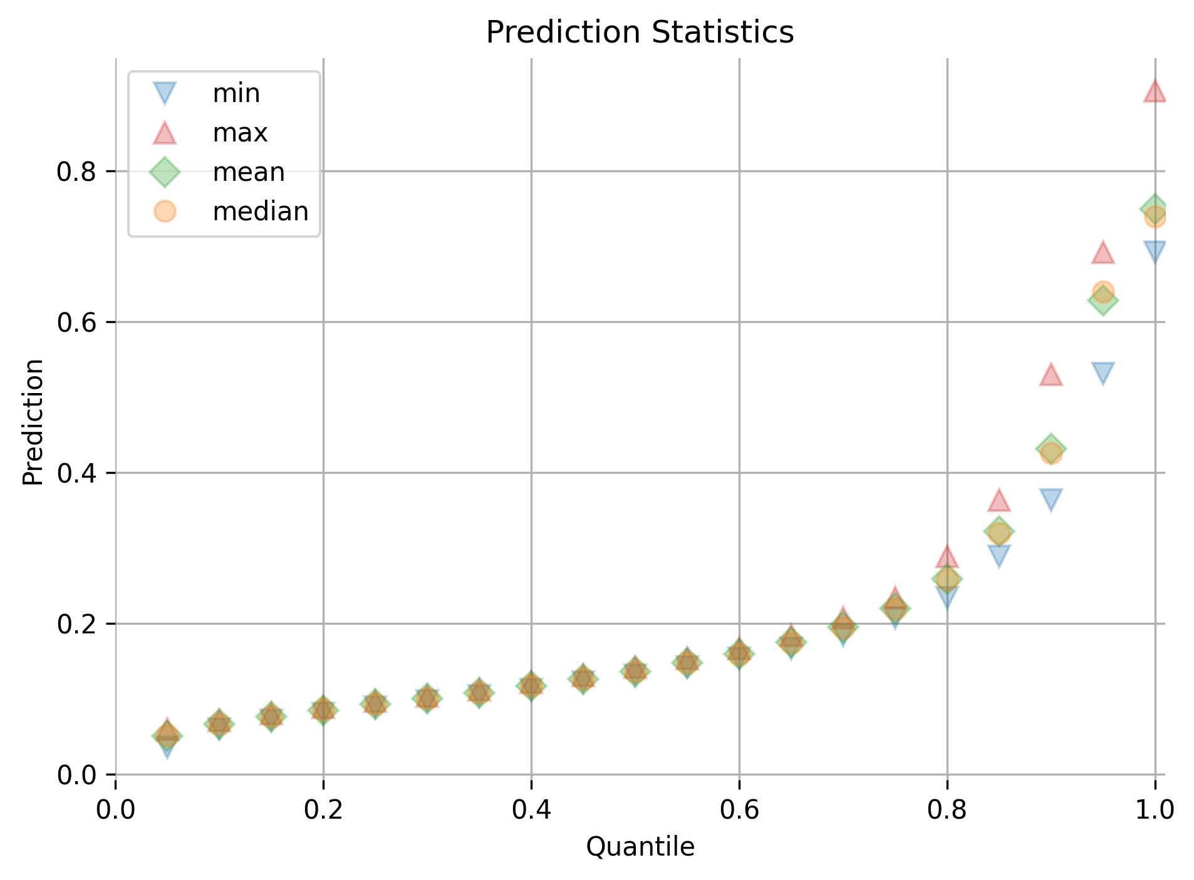

**Quantile Response Rates**

The response rate, for a given quantile, is equal to the number of positive-labeled data points divided by the total number of data points. Quantiles are sorted in decreasing order.

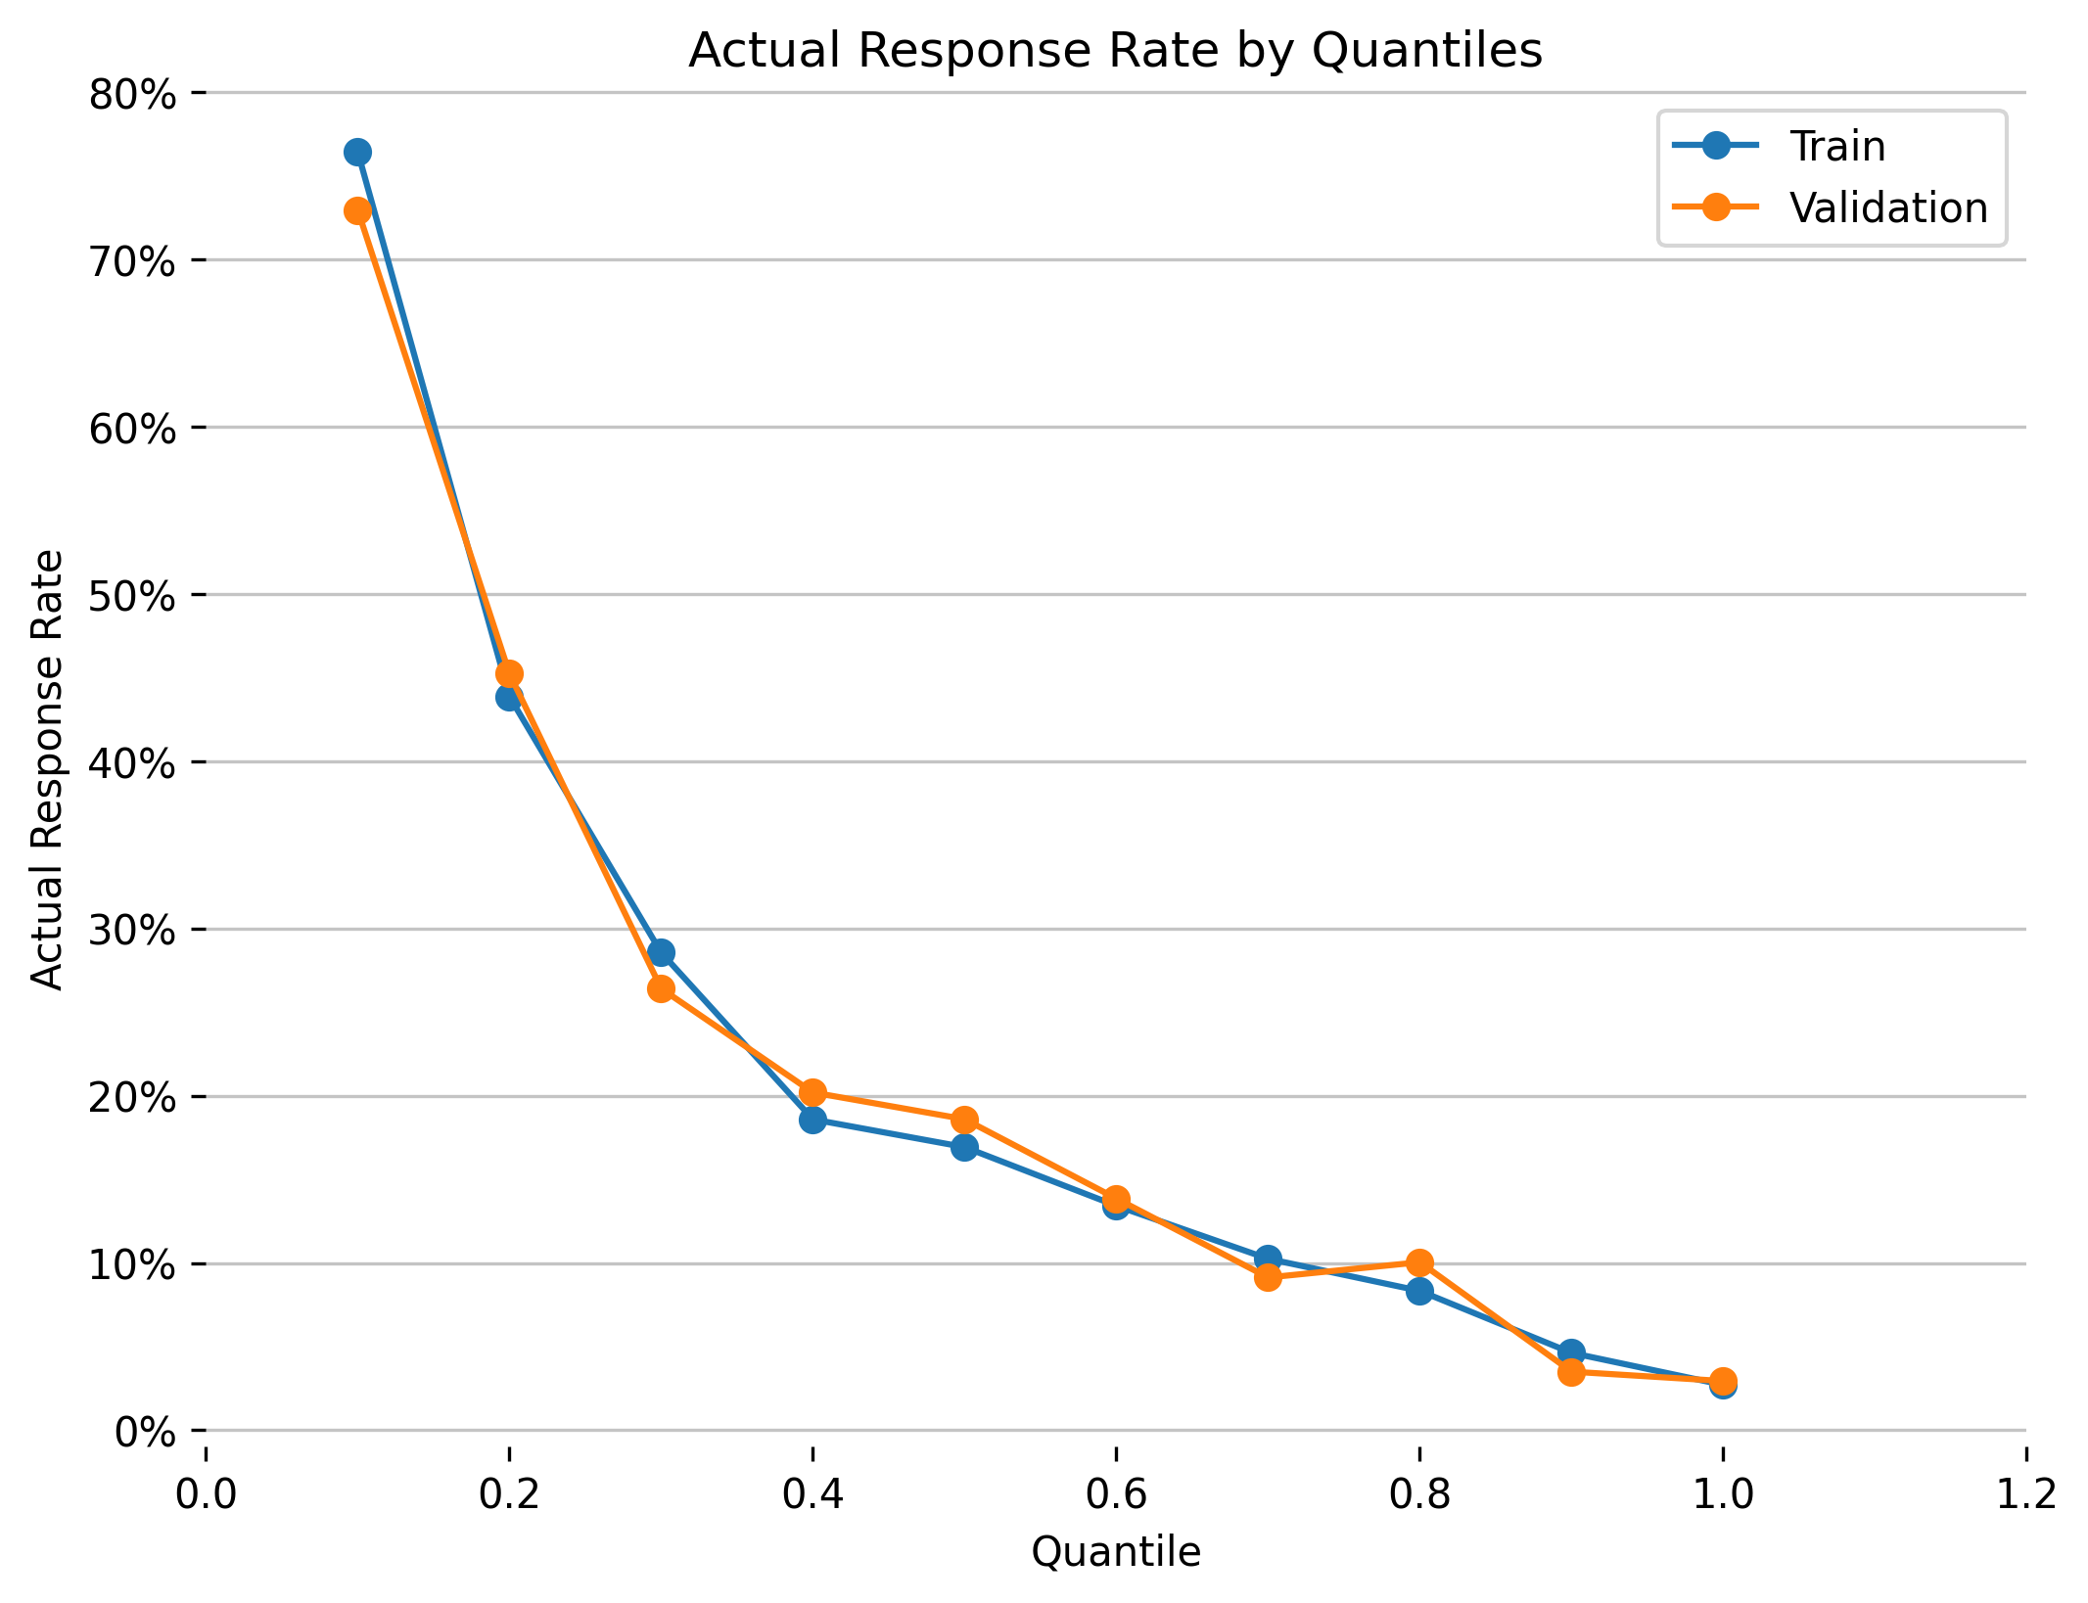

**Actual vs Predicted Probabilities**

This plot shows the alignment between the predicted and the actual probabilities. The predicted probabilities are binned into quantiles. For each, bin the average predicted value and the actual response rate (i.e., the number positive-labeled records divided by the total number of records within each bin) is calculated.

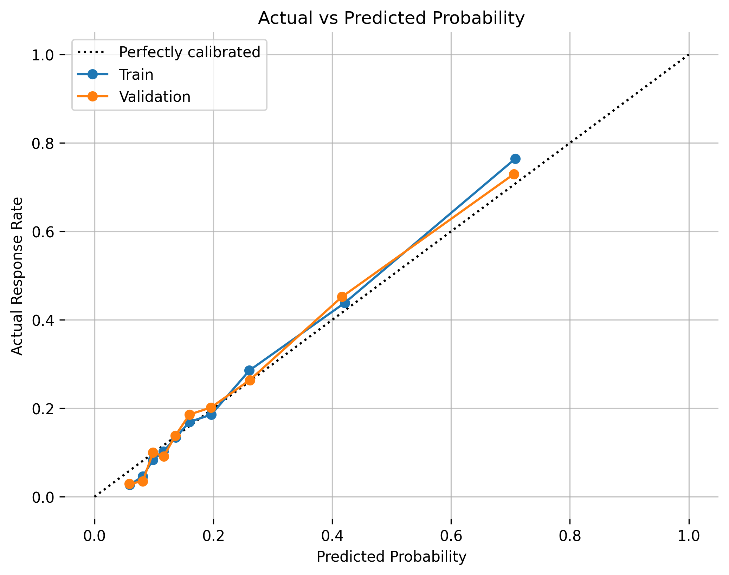

**Actual vs Predicted Log Odds**

This plot shows the alignment between the predicted and the actual probabilities within the log odds space. In this case, the log odds are the log transformation of the probability of a positive record divided by the probability of a negative record.

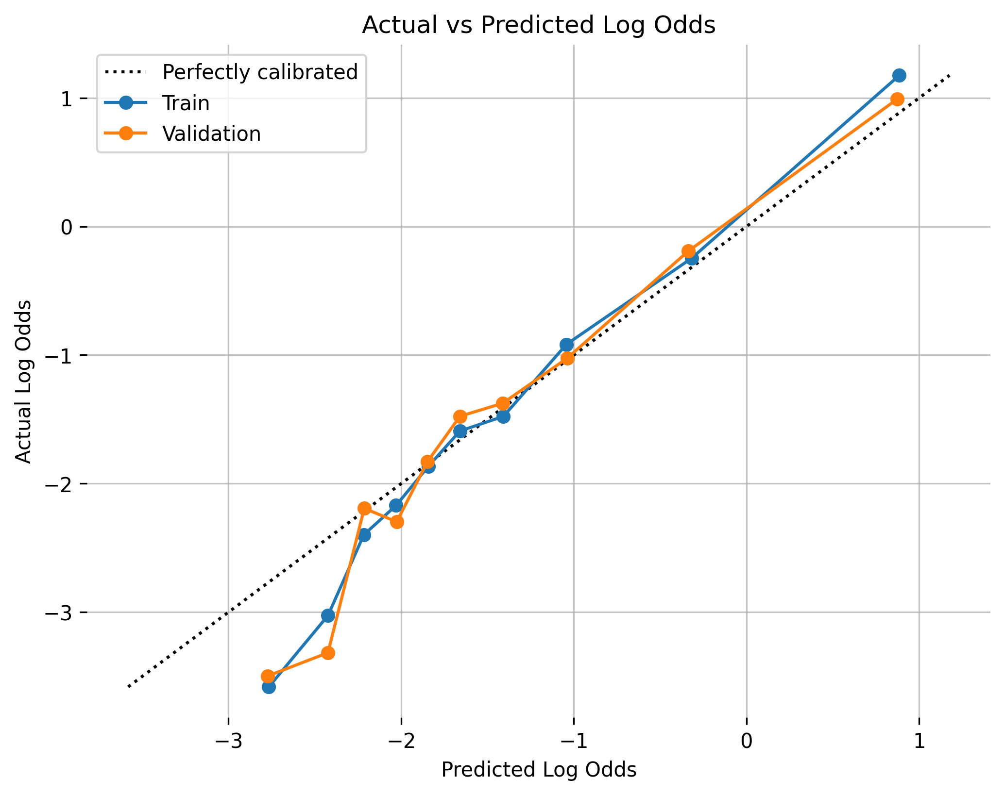

Details on the quantile-based plots’ calculations can be found in the Appendix.

|  |  |
| --- | --- |
| **Parameters** | **Values** |
| model_id | gbm_model |
| auc_type | AUTO |
| balance_classes | False |
| categorical_encoding | Enum |
| class_sampling_factors | None |
| col_sample_rate | 1.0 |
| col_sample_rate_change_per_level | 1.0 |
| col_sample_rate_per_tree | 1.0 |
| distribution | bernoulli |
| fold_assignment | None |
| fold_column | None |
| histogram_type | UniformAdaptive |
| learn_rate | 0.1 |
| learn_rate_annealing | 1.0 |
| max_abs_leafnode_pred | 1.7976931348623157e+308 |
| max_after_balance_size | 5.0 |
| max_depth | 5 |
| max_runtime_secs | 0.0 |
| min_rows | 10.0 |
| min_split_improvement | 1e-05 |
| nbins | 20 |
| nbins_cats | 1024 |
| nbins_top_level | 1024 |
| ntrees | 50 |
| offset_column | None |
| pred_noise_bandwidth | 0.0 |
| response_column | DEFAULT_PAYMENT_NEXT_MONTH |
| sample_rate | 1.0 |
| sample_rate_per_class | None |
| seed | 1234 |
| stopping_metric | None |
| stopping_rounds | 0 |
| stopping_tolerance | 0.001 |
| weights_column | None |

# Model testing and model performance

{Models should be tested for diverse product contractual terms, transaction types, activity attributes over a wide range of market, business, or process conditions. Testing and analysis should cover key model limitations identified in the modeling framework, assumptions, data, segmentation, estimation, etc. Explain testing design, justify model outcome, identify model weaknesses, and discuss acceptance rationale in the context of key model risk and related model tolerance thresholds.}

## Model outputs

* Explain the model output and any transformations required as part of the final deliverables.
* Include model reports.
* Explain whether the model outputs are consistent with the model objectives and requirements, as outlined in section 1.1
* For vendor models, clearly Outline any customization choices related to model output that are specific to Wells Fargo use of the vendor product.

## Sensitivity analysis and testing

|  |  |  |  |
| --- | --- | --- | --- |
| Risk Rank 4 | Risk Rank 3 | Risk Rank 2 | Risk Rank 1 |
| Leading order description / analysis is sufficient | | Higher order terms and interactions should be included as appropriate | |

{For each specific use, explain the model sensitivity to changes in key model variables or inputs. Discuss the design of the sensitivity testing, including the choices of scenarios and/or input values.

Provide the model outputs when key drivers are shocked. The magnitude of the shock should be within the context of business use and historical experience.

Provide the model forecasts under any applicable baseline and stress scenarios. Furthermore, comment on the reasonableness of the results, especially compared to past historical levels.

Given the characteristics of the product and the portfolio described in Section 1.2 and market risk factors described in Section 2.2, ensure all key market risk factors are tested.

For vendor models, sensitivity analysis should be comprehensive and discussed in detail

Include all testing conducted to confirm that the vendor model behavior is consistent with vendor claims, as well as Wells Fargo’s model use and needs.

Clearly state whether tests used Wells Fargo’s data, processes, and outcomes.

If limited or no Wells Fargo internal data was used in model testing, assess the applicability of testing conclusions for the intended use.

Partial dependence plots show the partial dependence as a function of specific values for a feature subset. The plots show how machine-learned response functions change based on the values of an input feature of interest, while taking nonlinearity into consideration and averaging out the effects of all other input features. Partial dependence plots enable increased transparency in a model and enable the ability to validate and debug a model by comparing a feature’s average predictions across its domain to known standards and reasonable expectations.

The partial dependence plots are shown for the top 20 original variables. The top 20 original variables are chosen based on their model specific variable importance.

**Plot Details**

In the H2O-3 PDP, the y-axis represents the mean response, and a shaded region (for numeric features) or shaded bar (for categorical features) represents ± 1 standard deviation.

Feature **PAY_0**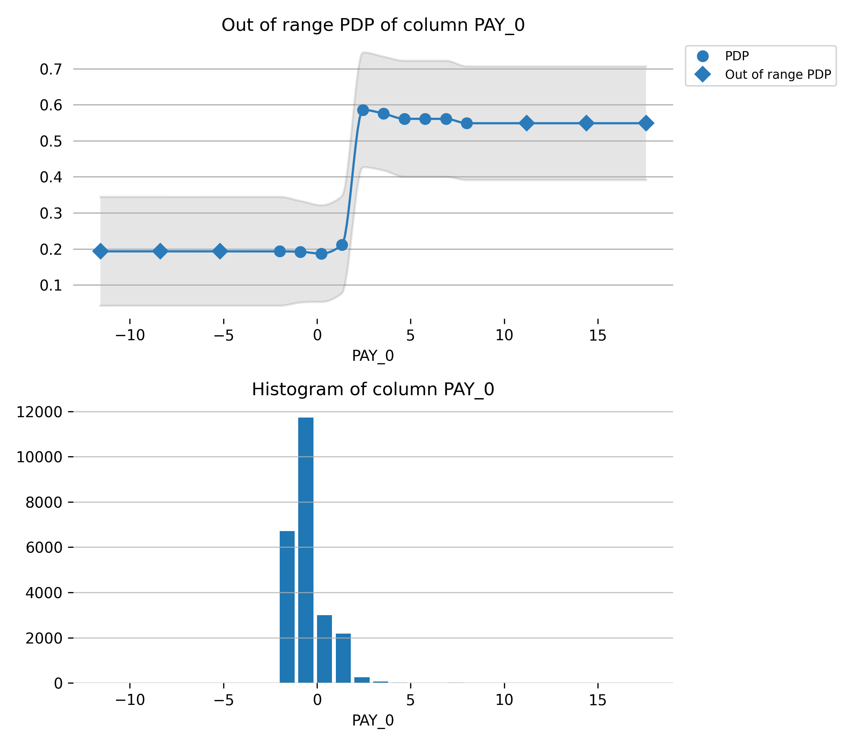

Feature **PAY_2**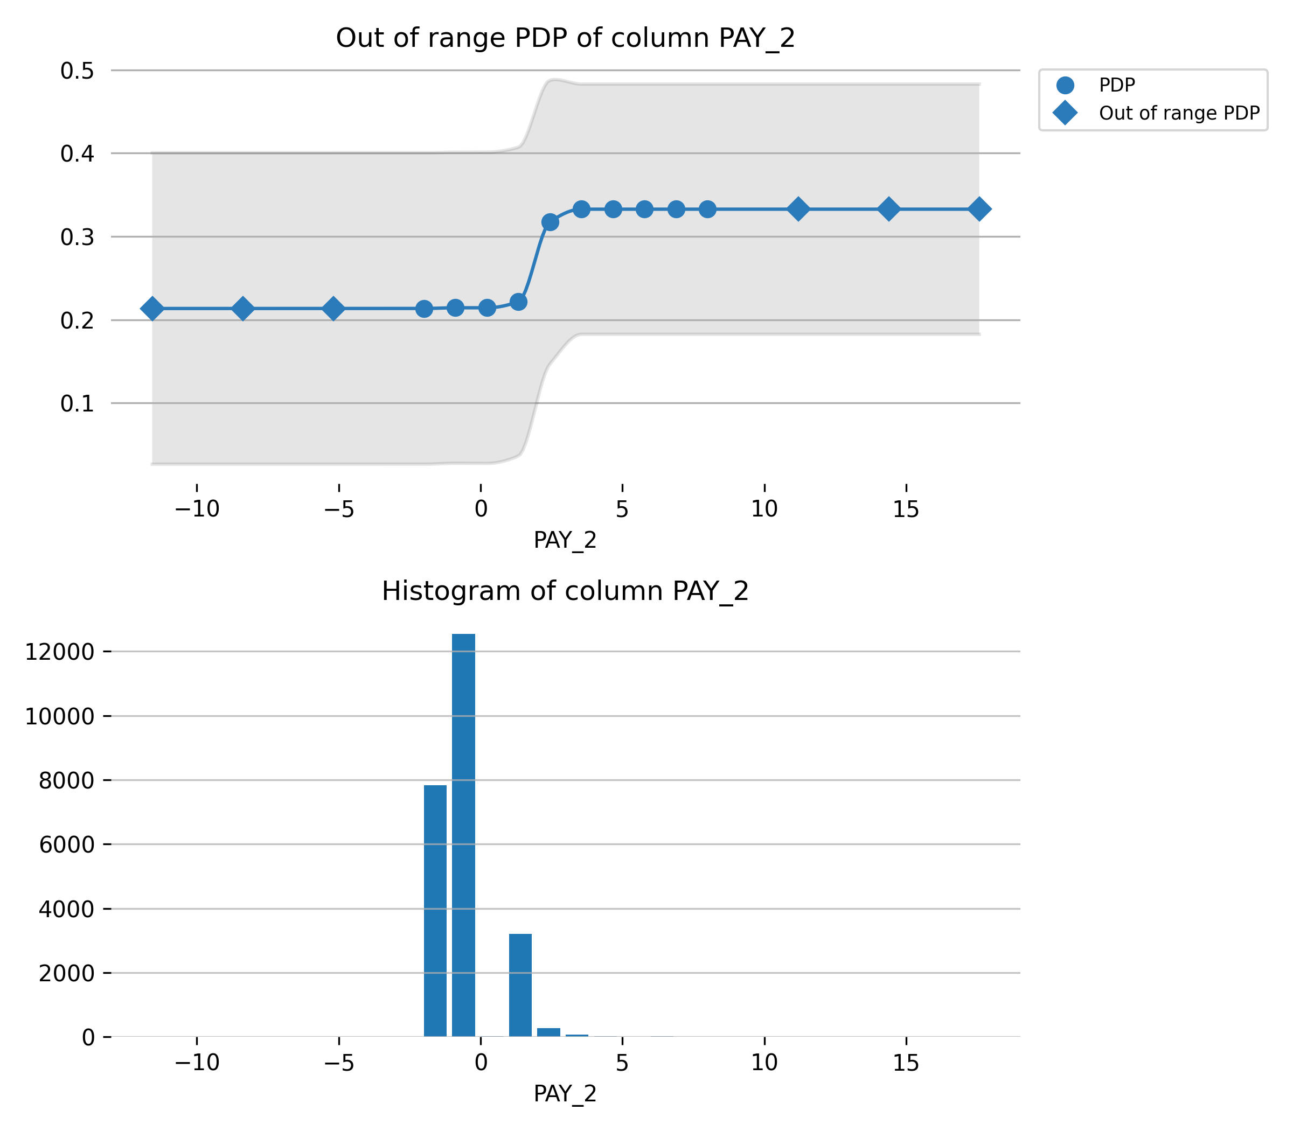

Feature **BILL_AMT1**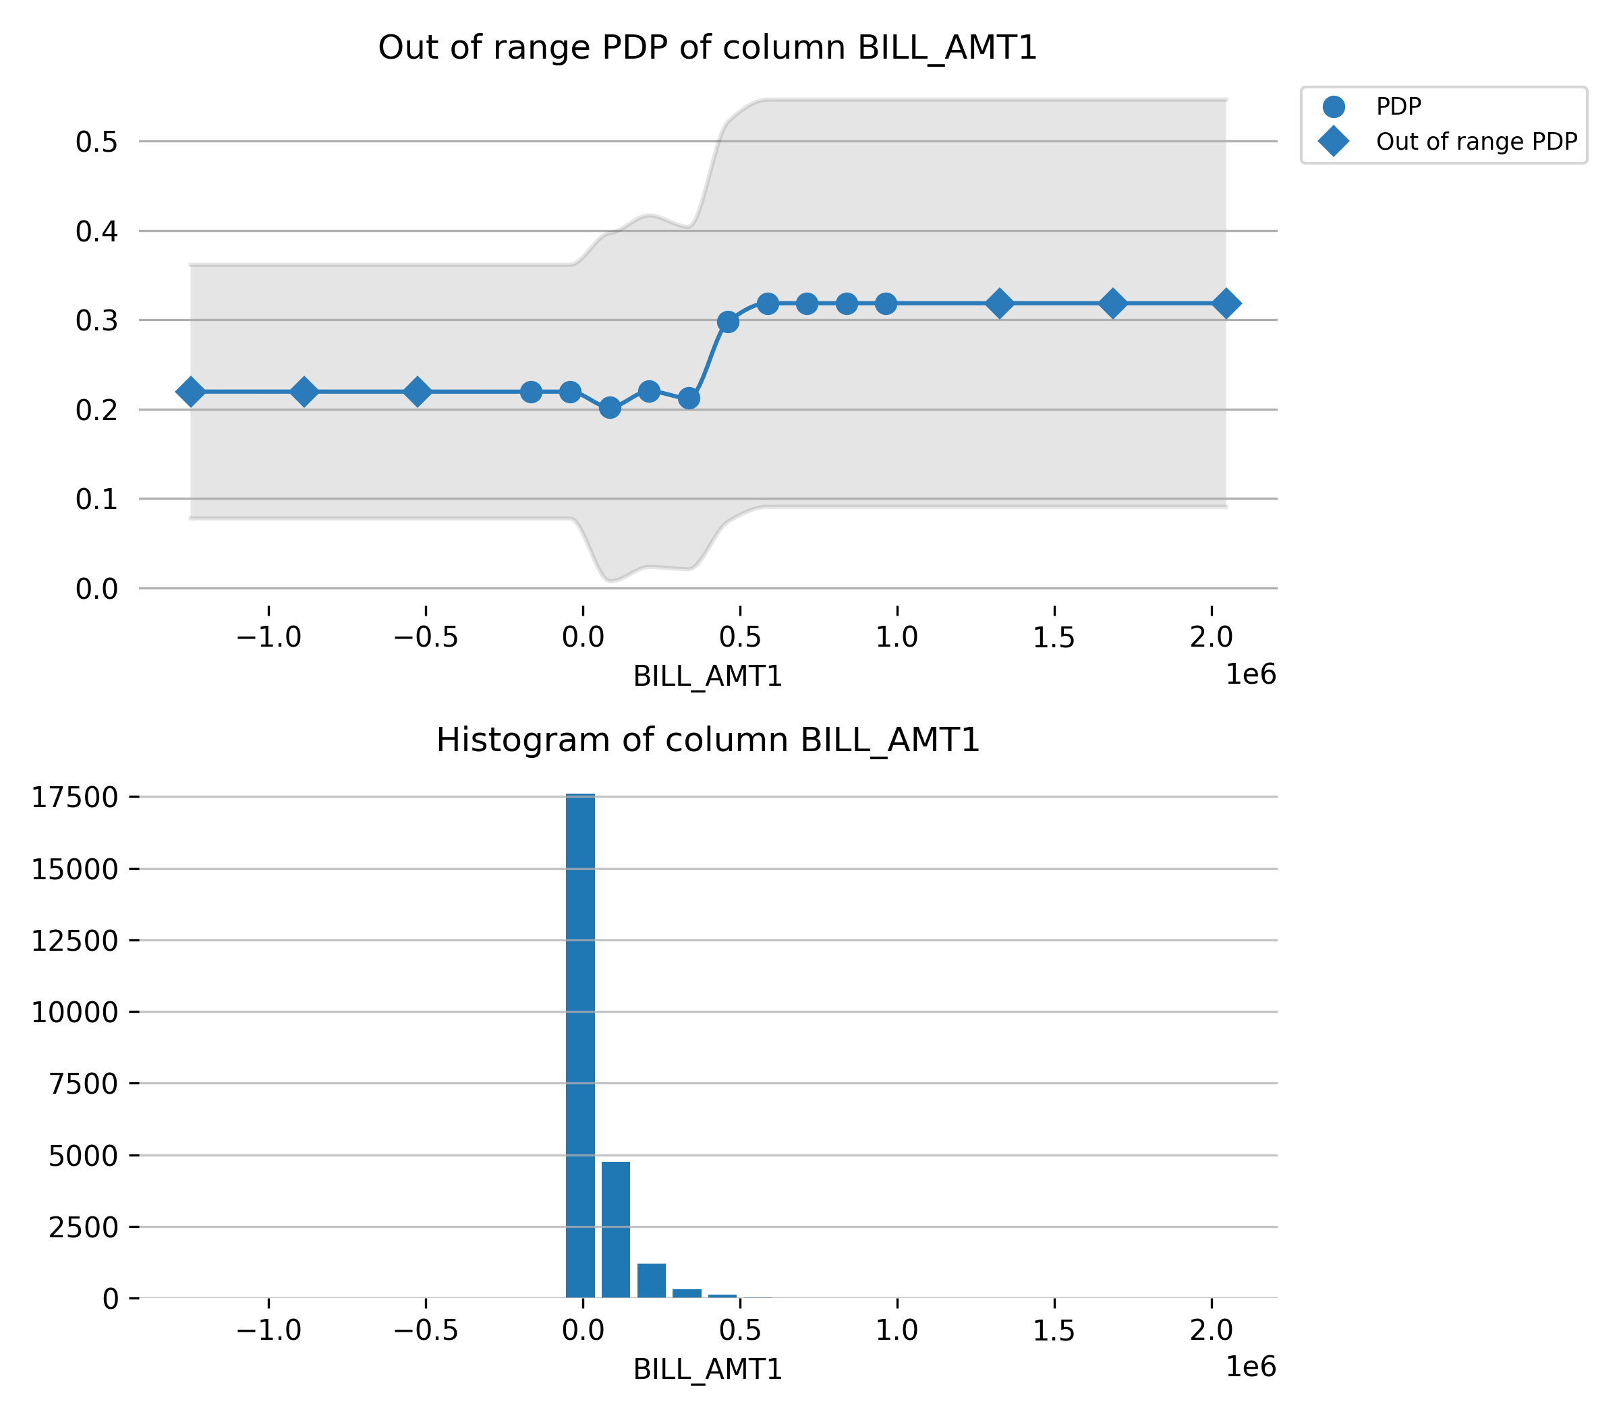

Feature **LIMIT_BAL**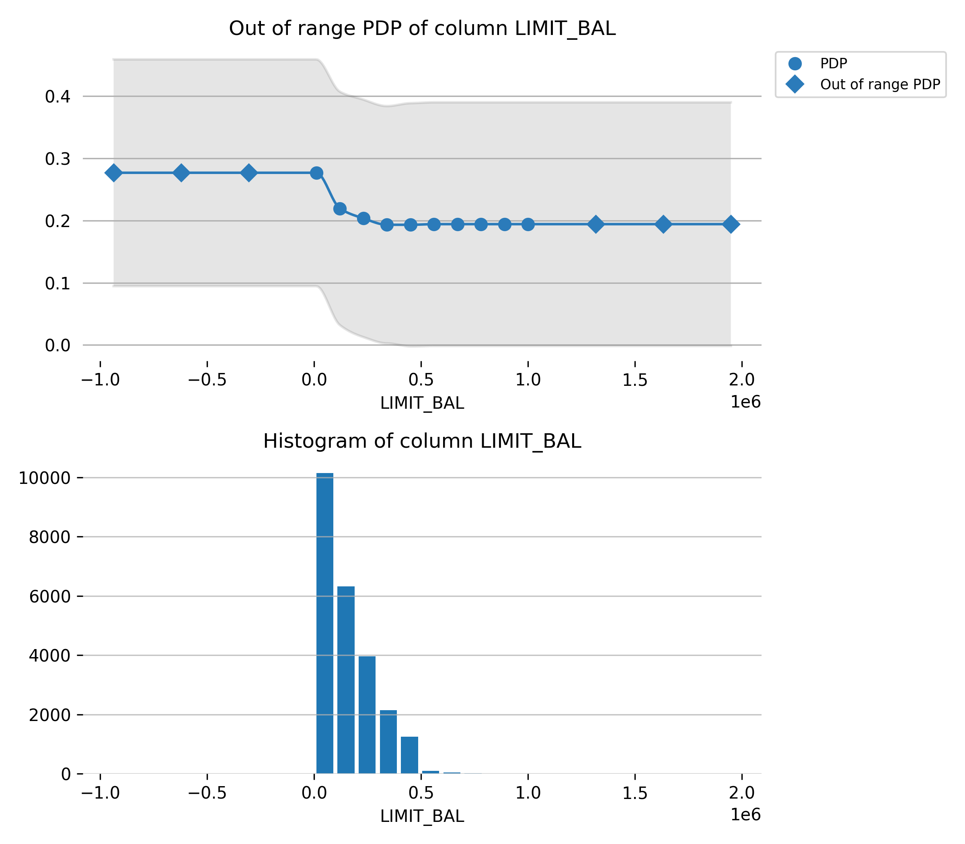

Feature **PAY_3**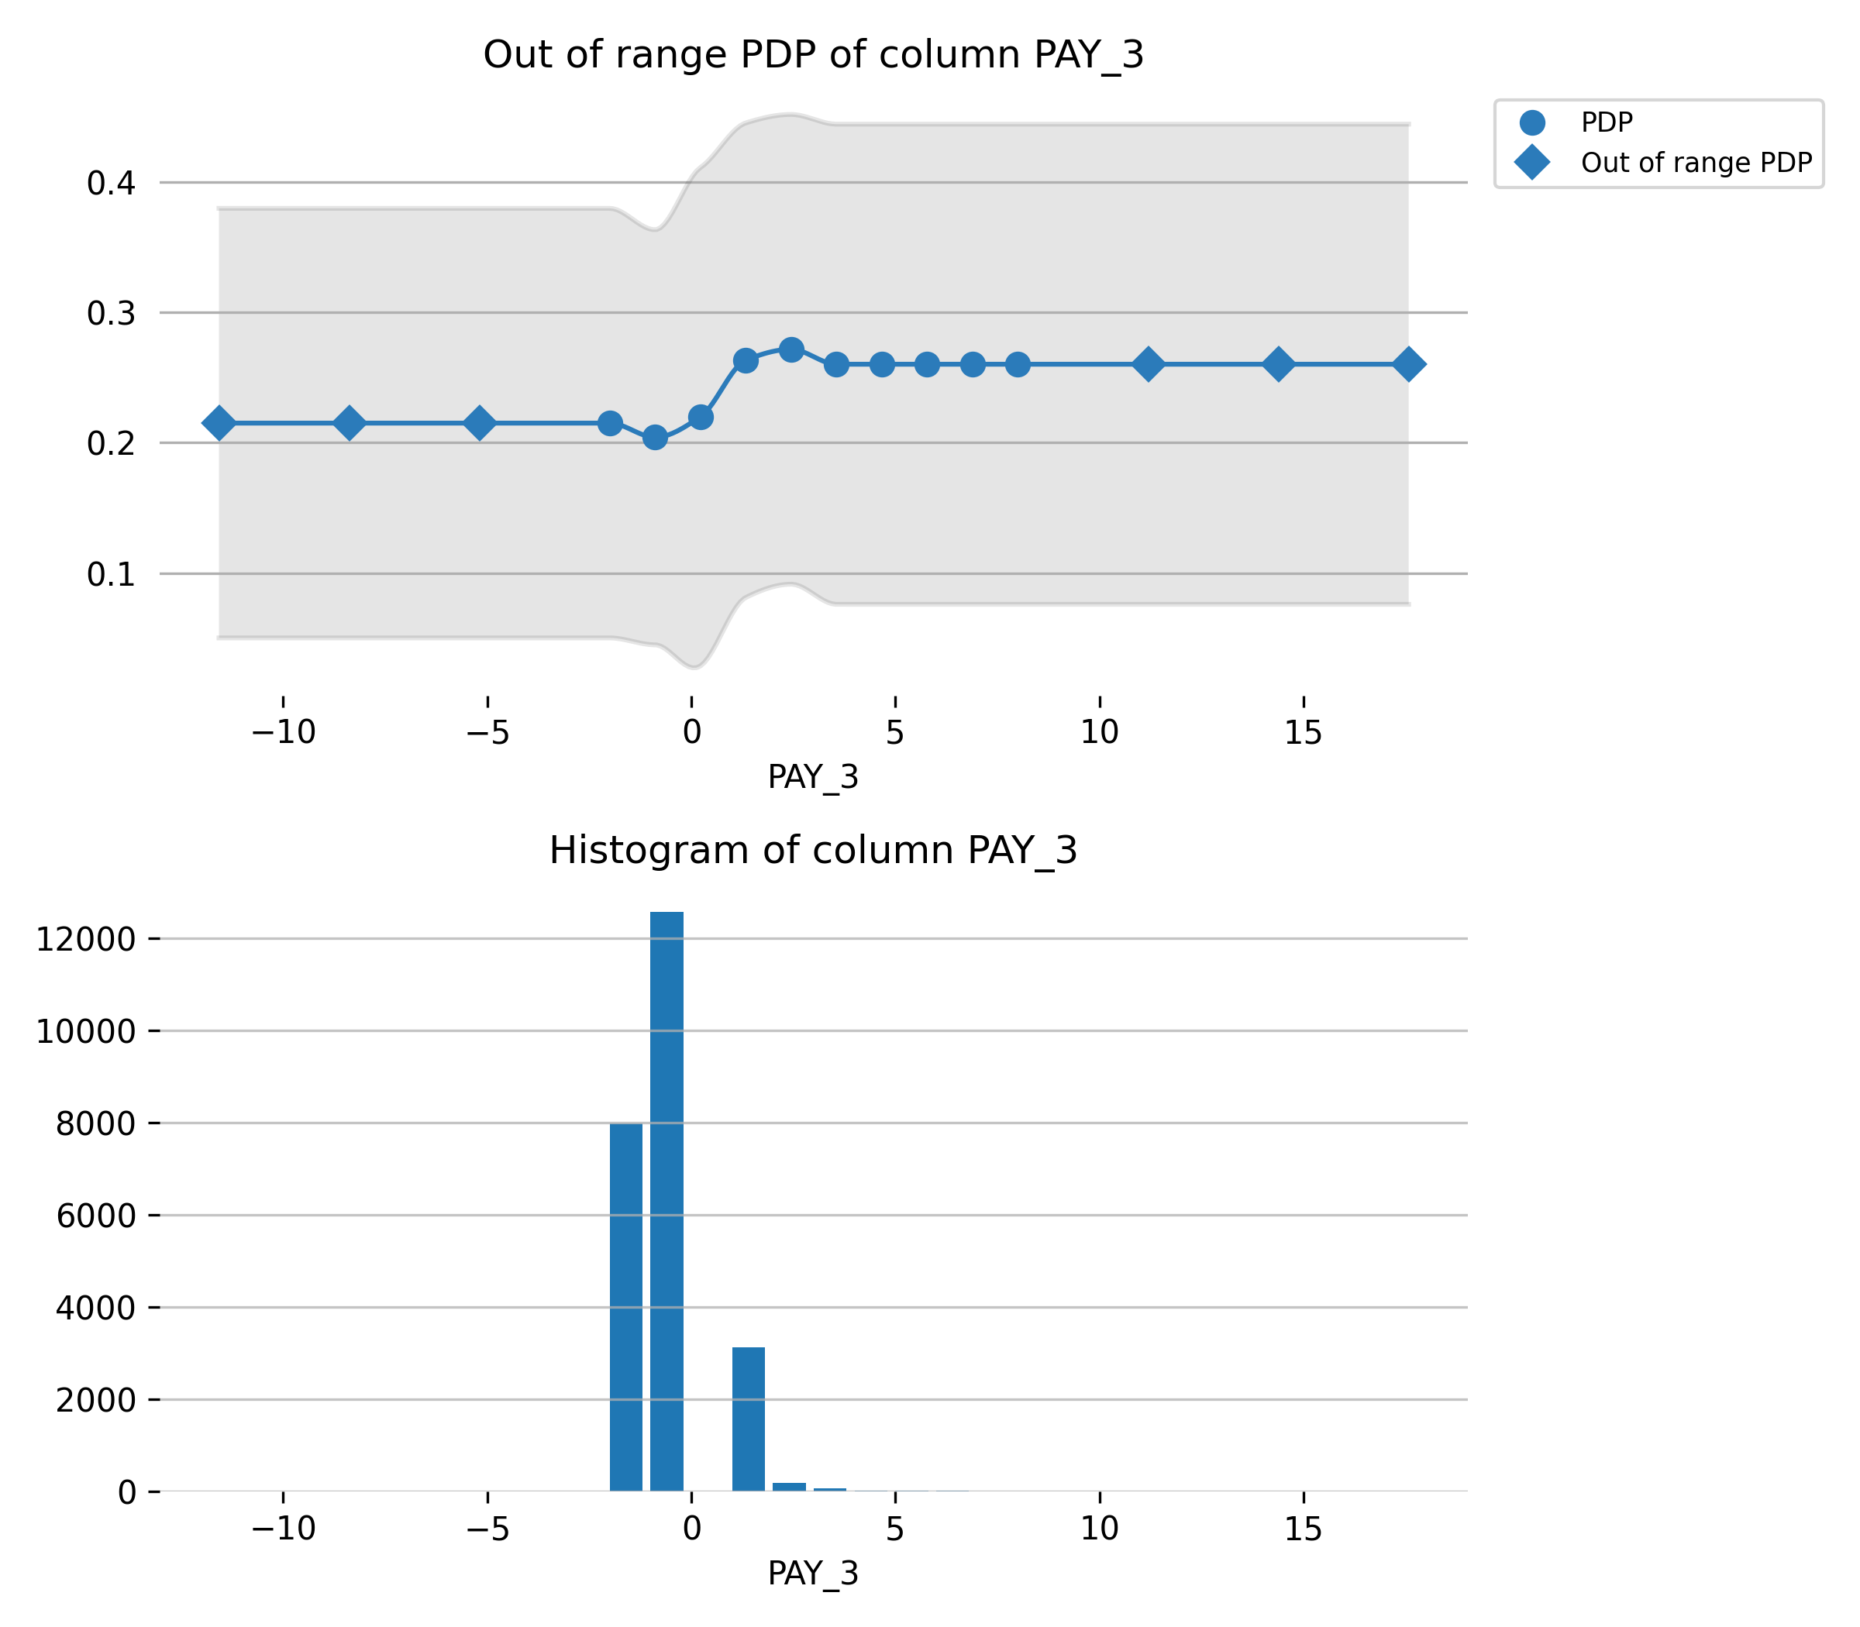

Feature **PAY_5**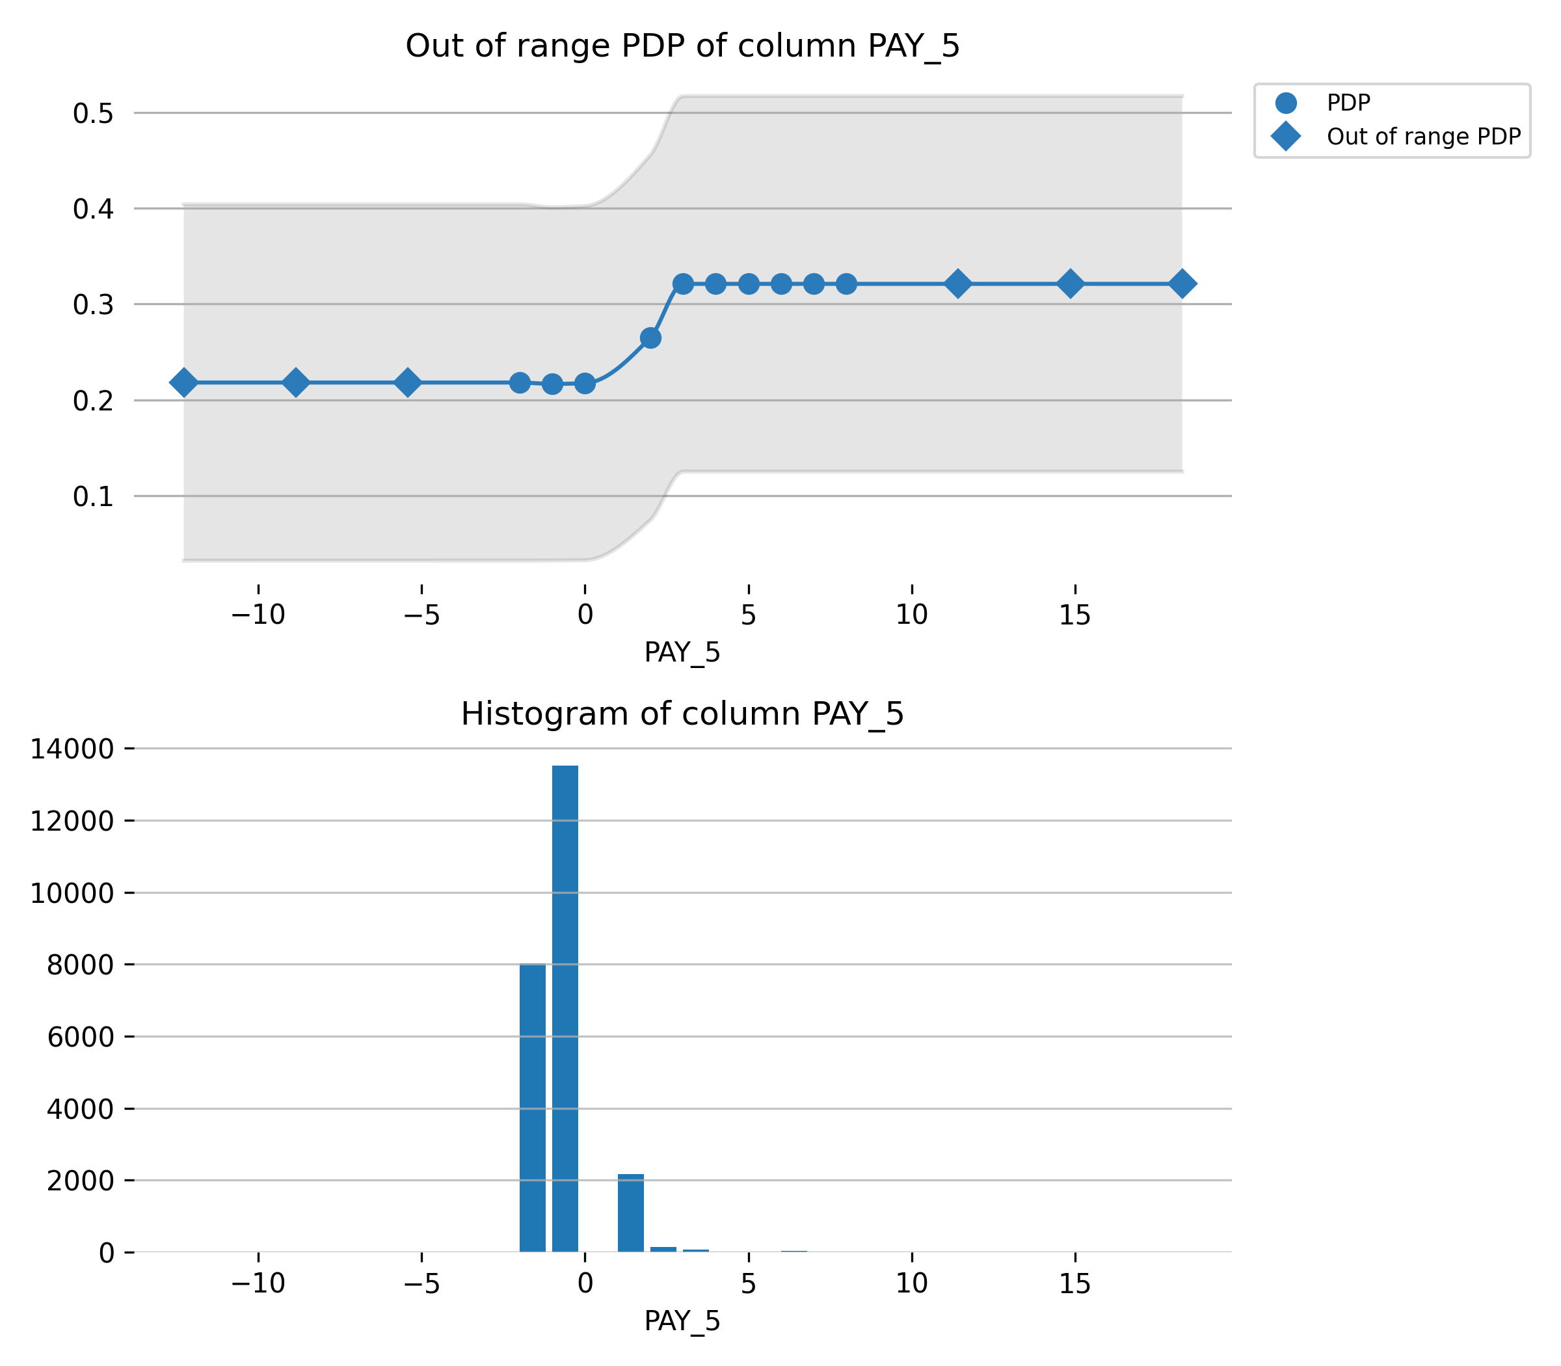

Feature **PAY_4**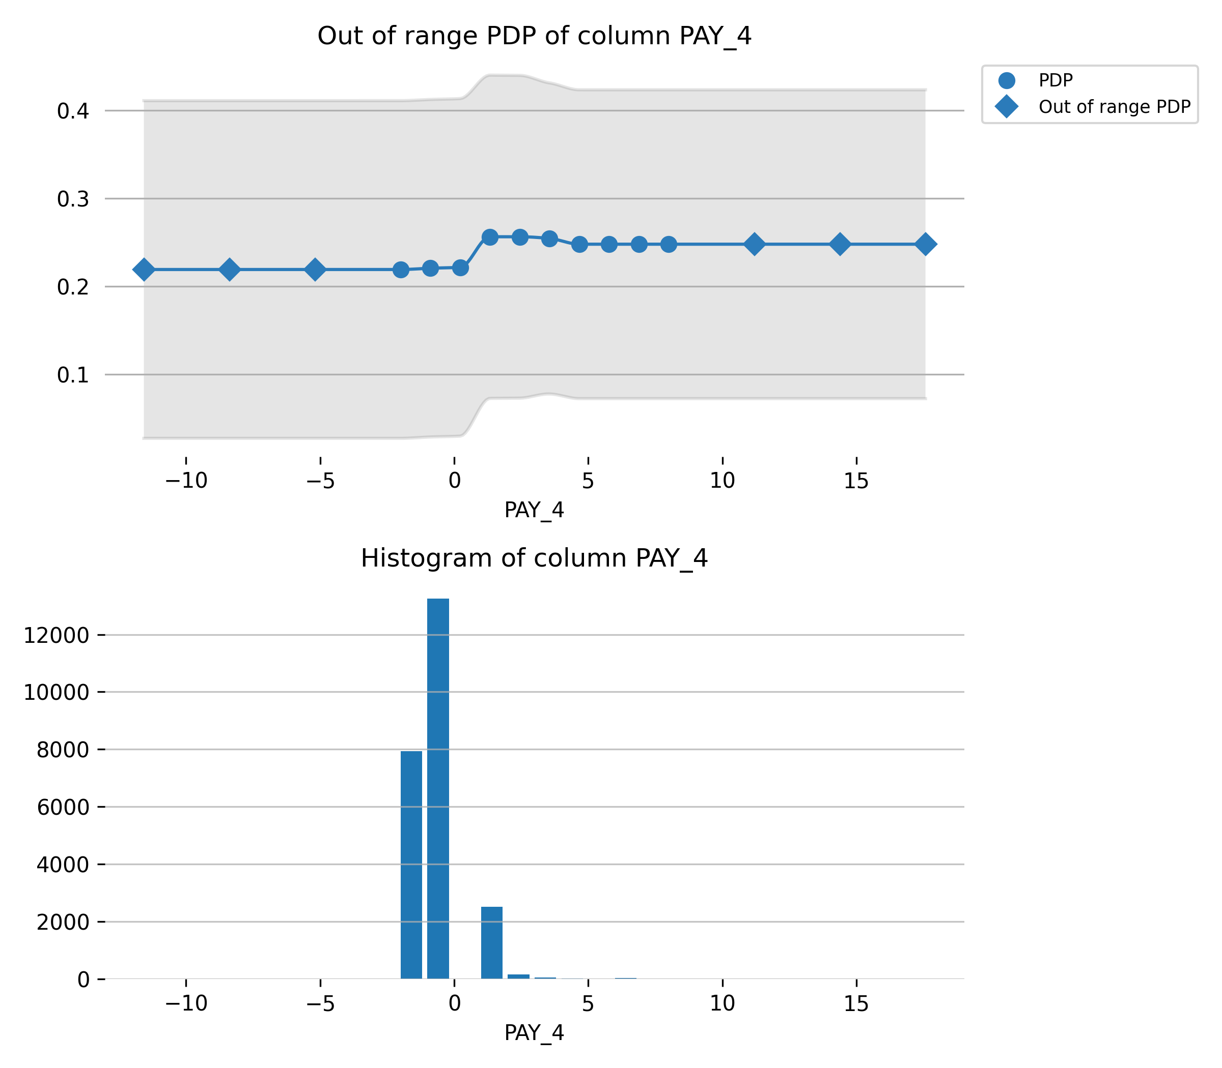

Feature **PAY_AMT1**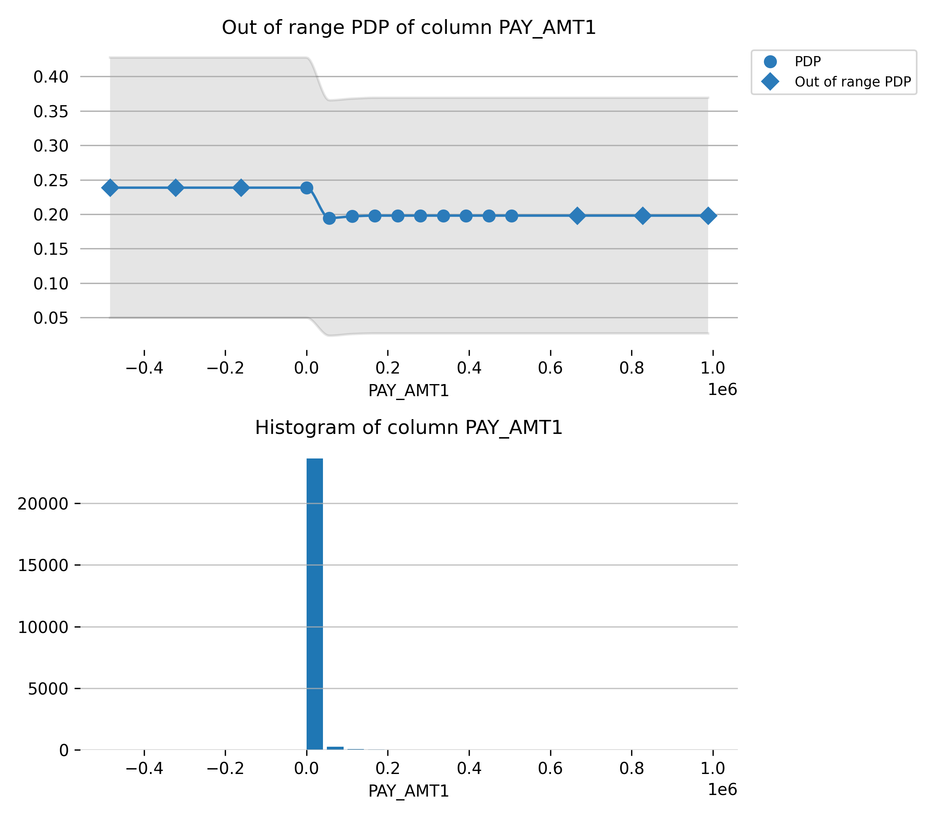

Feature **BILL_AMT2**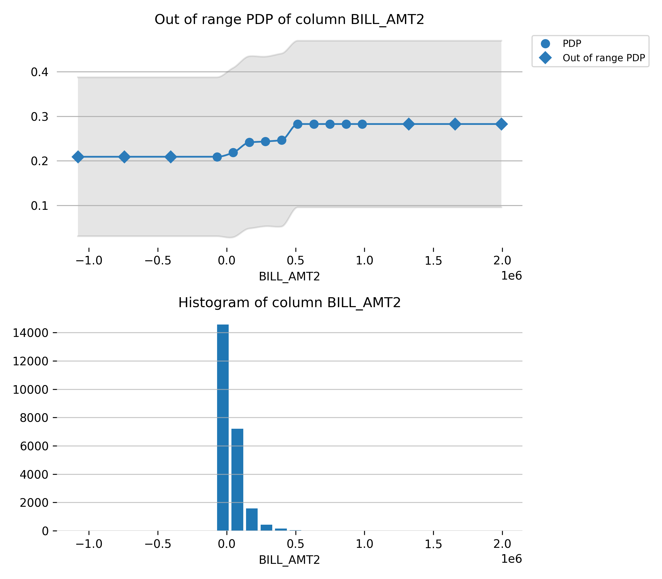

Feature **AGE**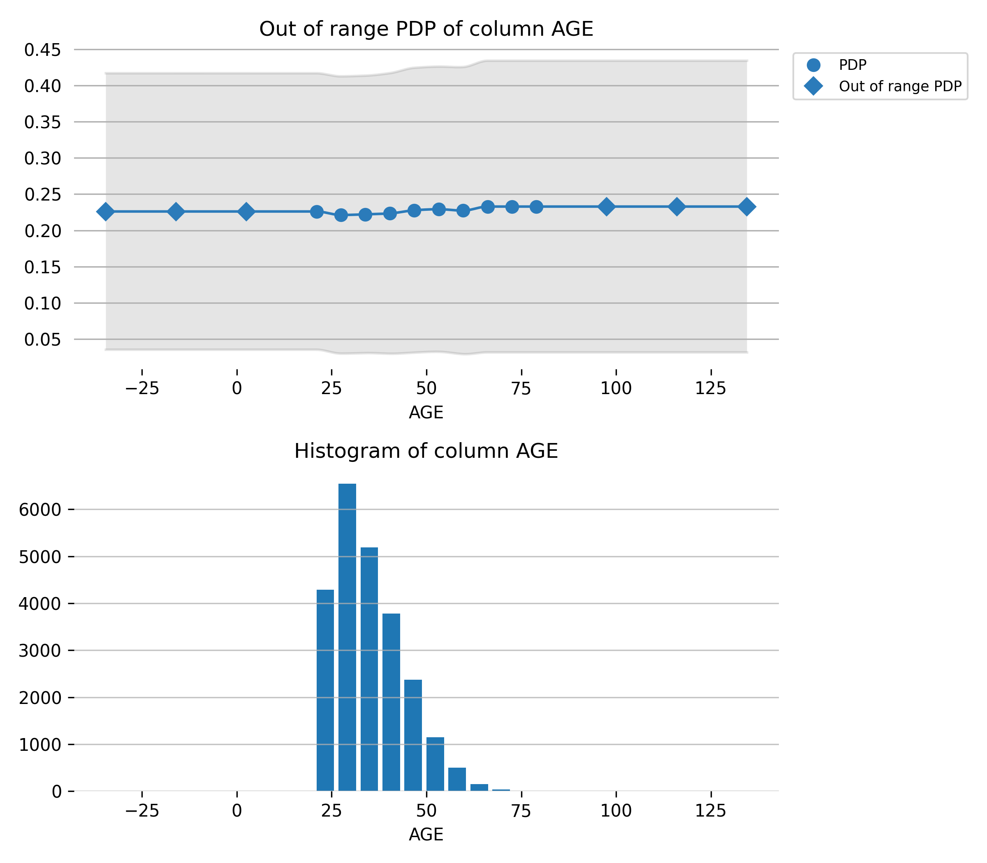

Feature **PAY_6**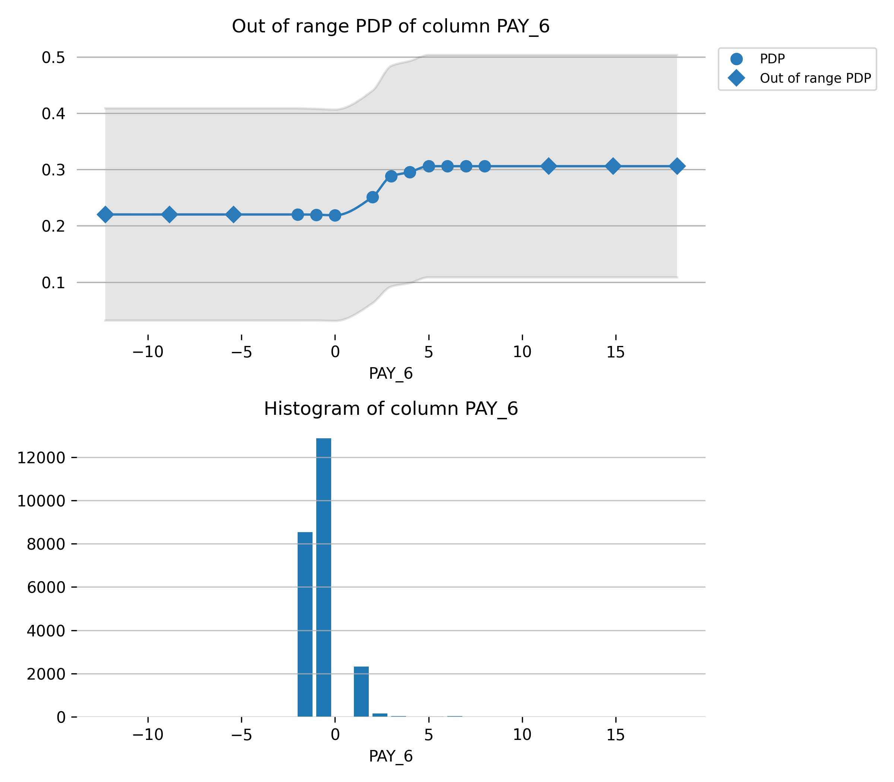

Feature **PAY_AMT4**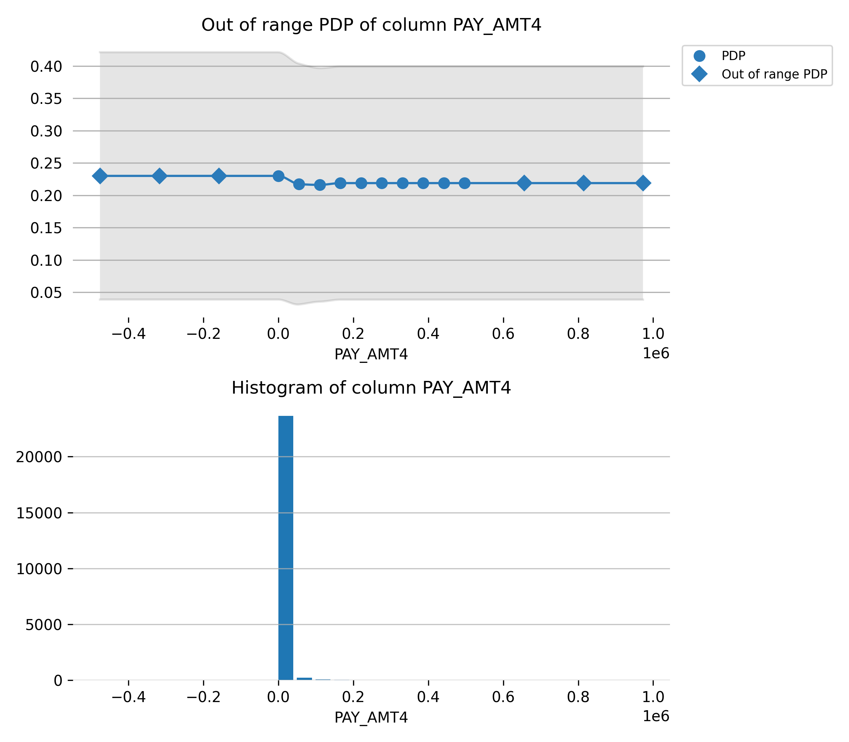

Feature **EDUCATION**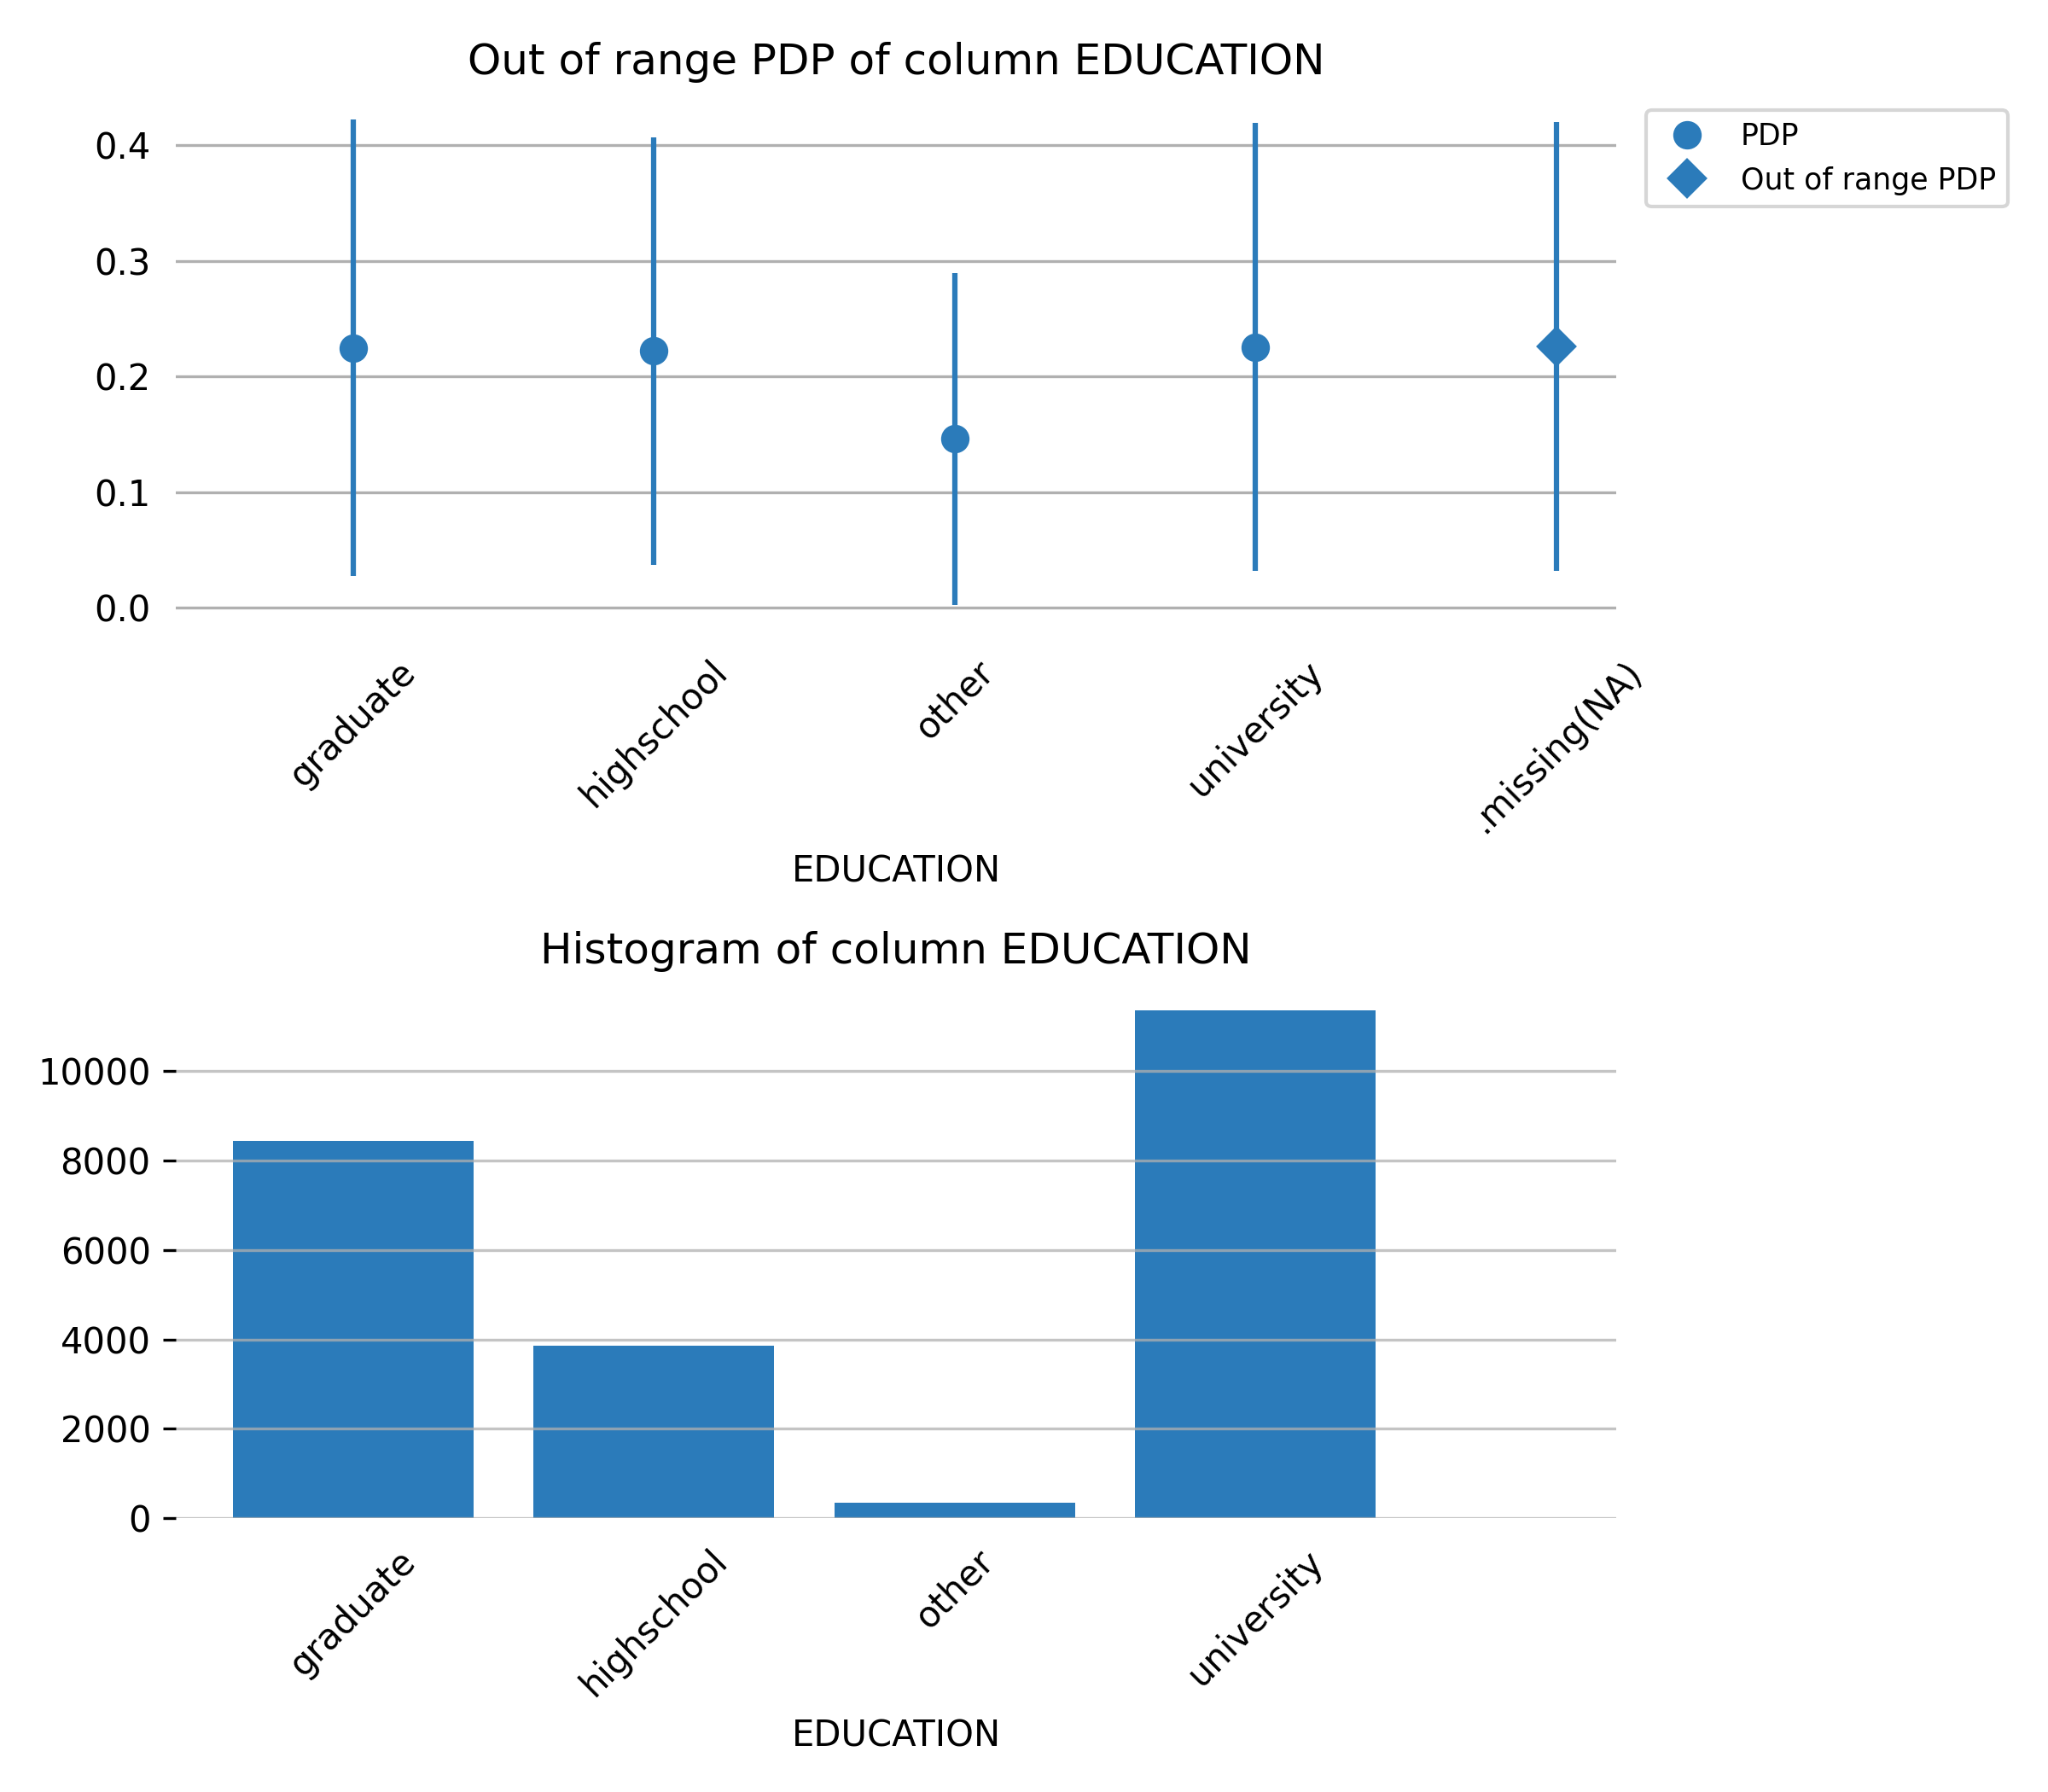

Feature **PAY_AMT5**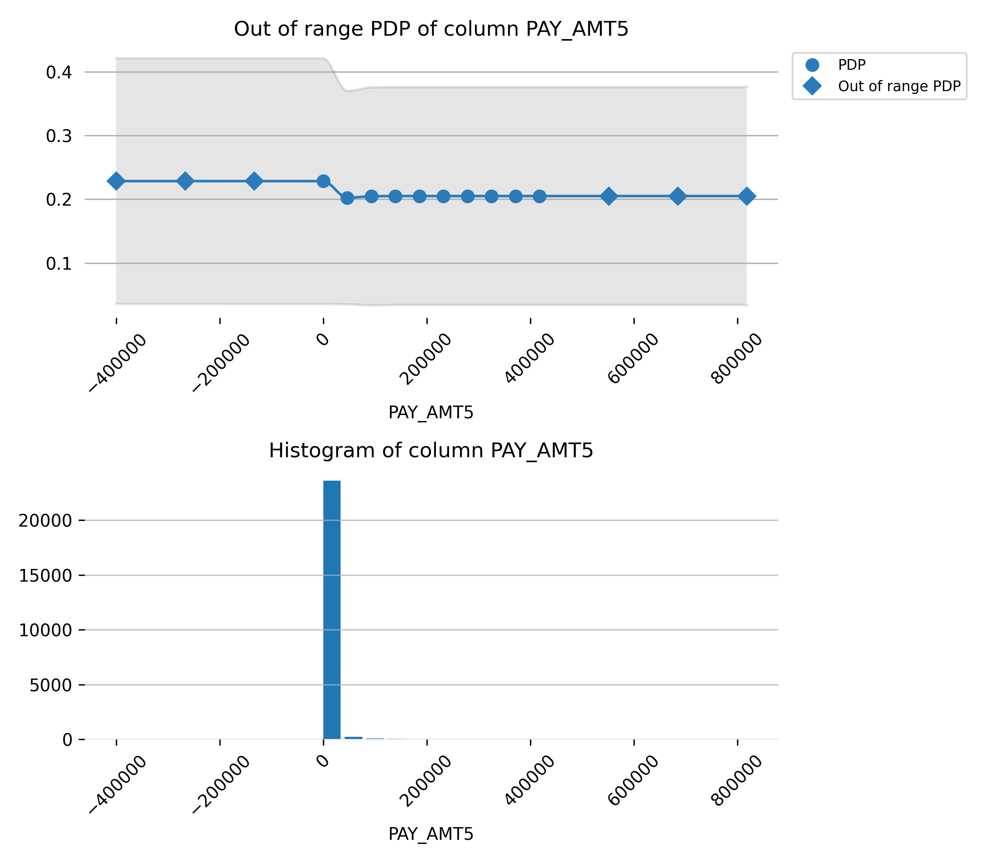

Feature **PAY_AMT3**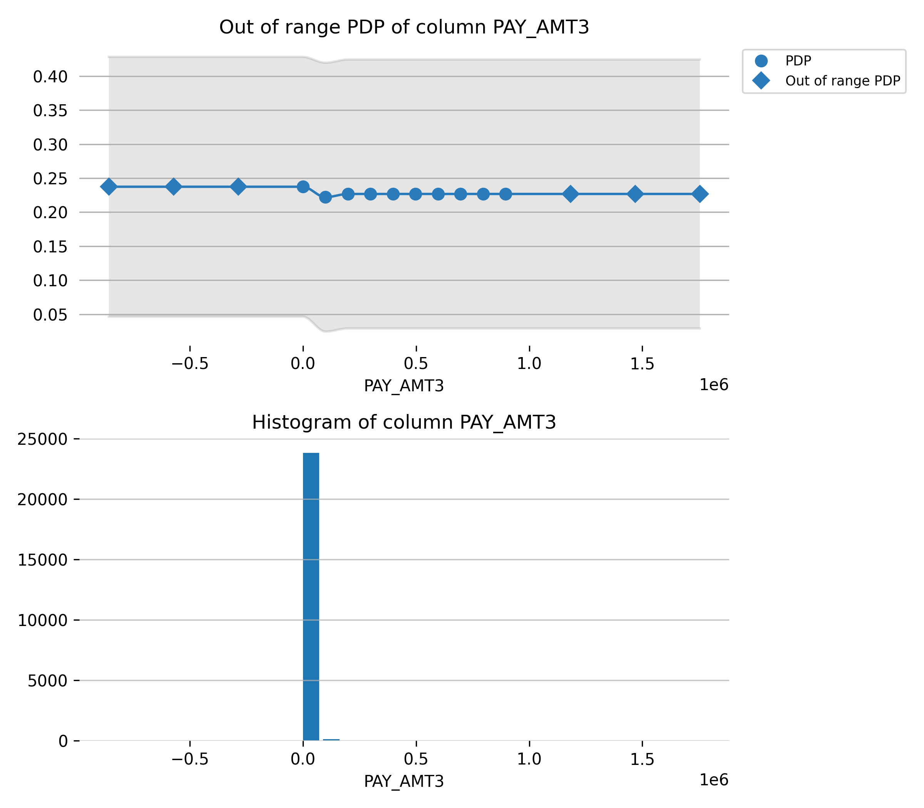

Feature **BILL_AMT6**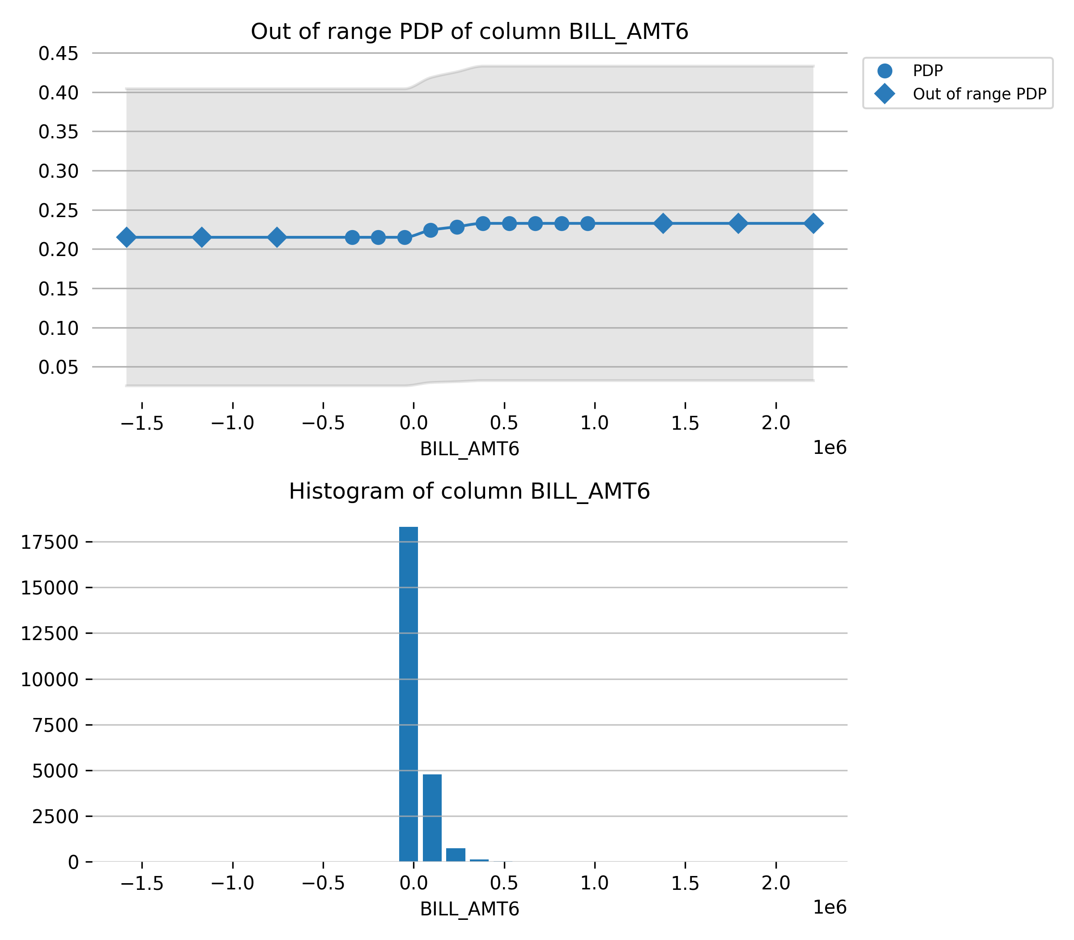

Feature **PAY_AMT2**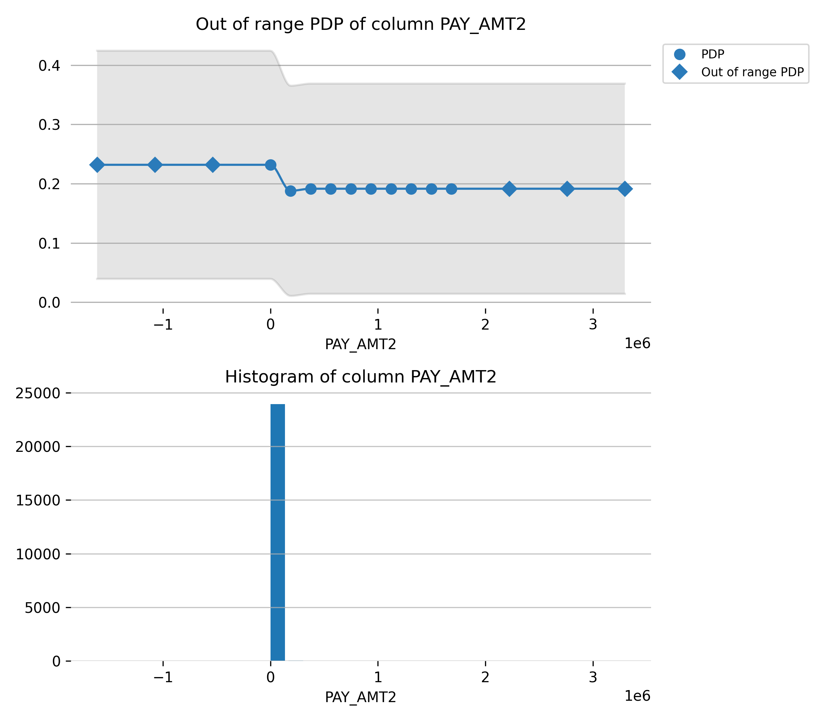

Feature **PAY_AMT6**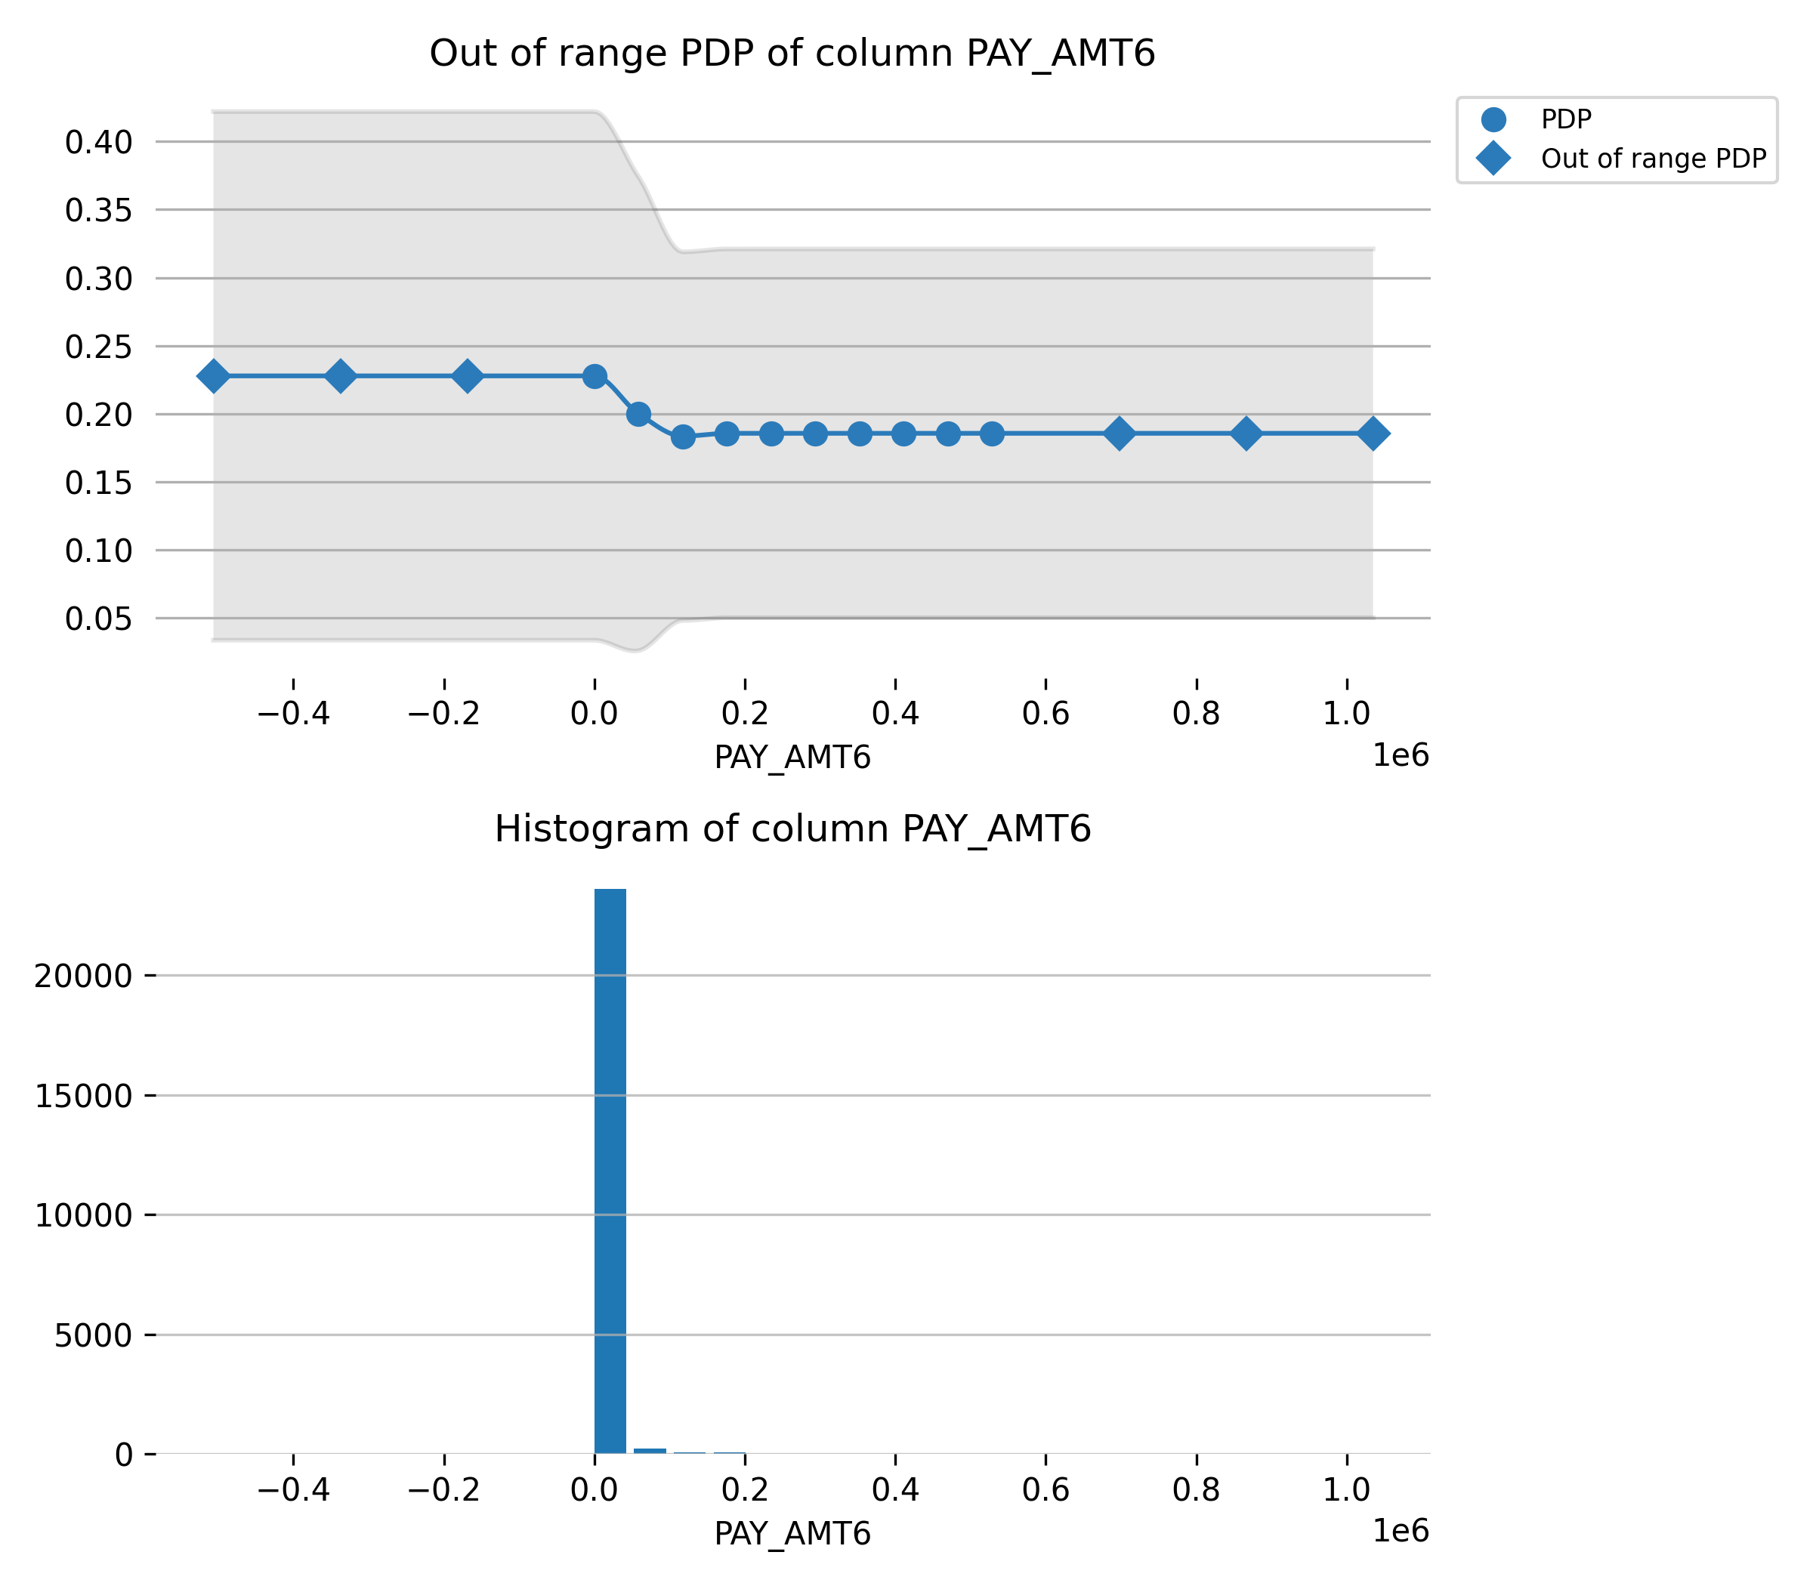

Feature **BILL_AMT5**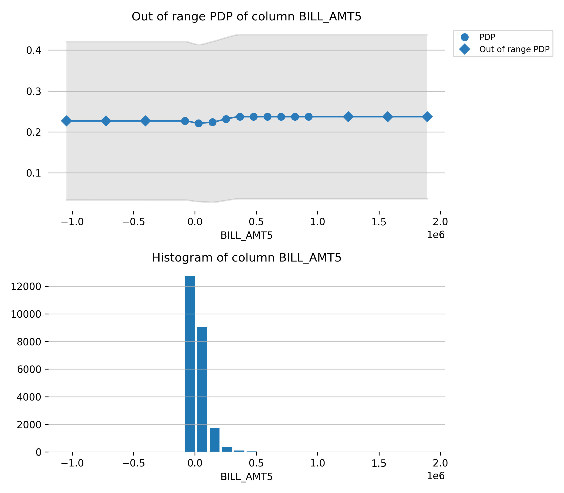

Feature **BILL_AMT4**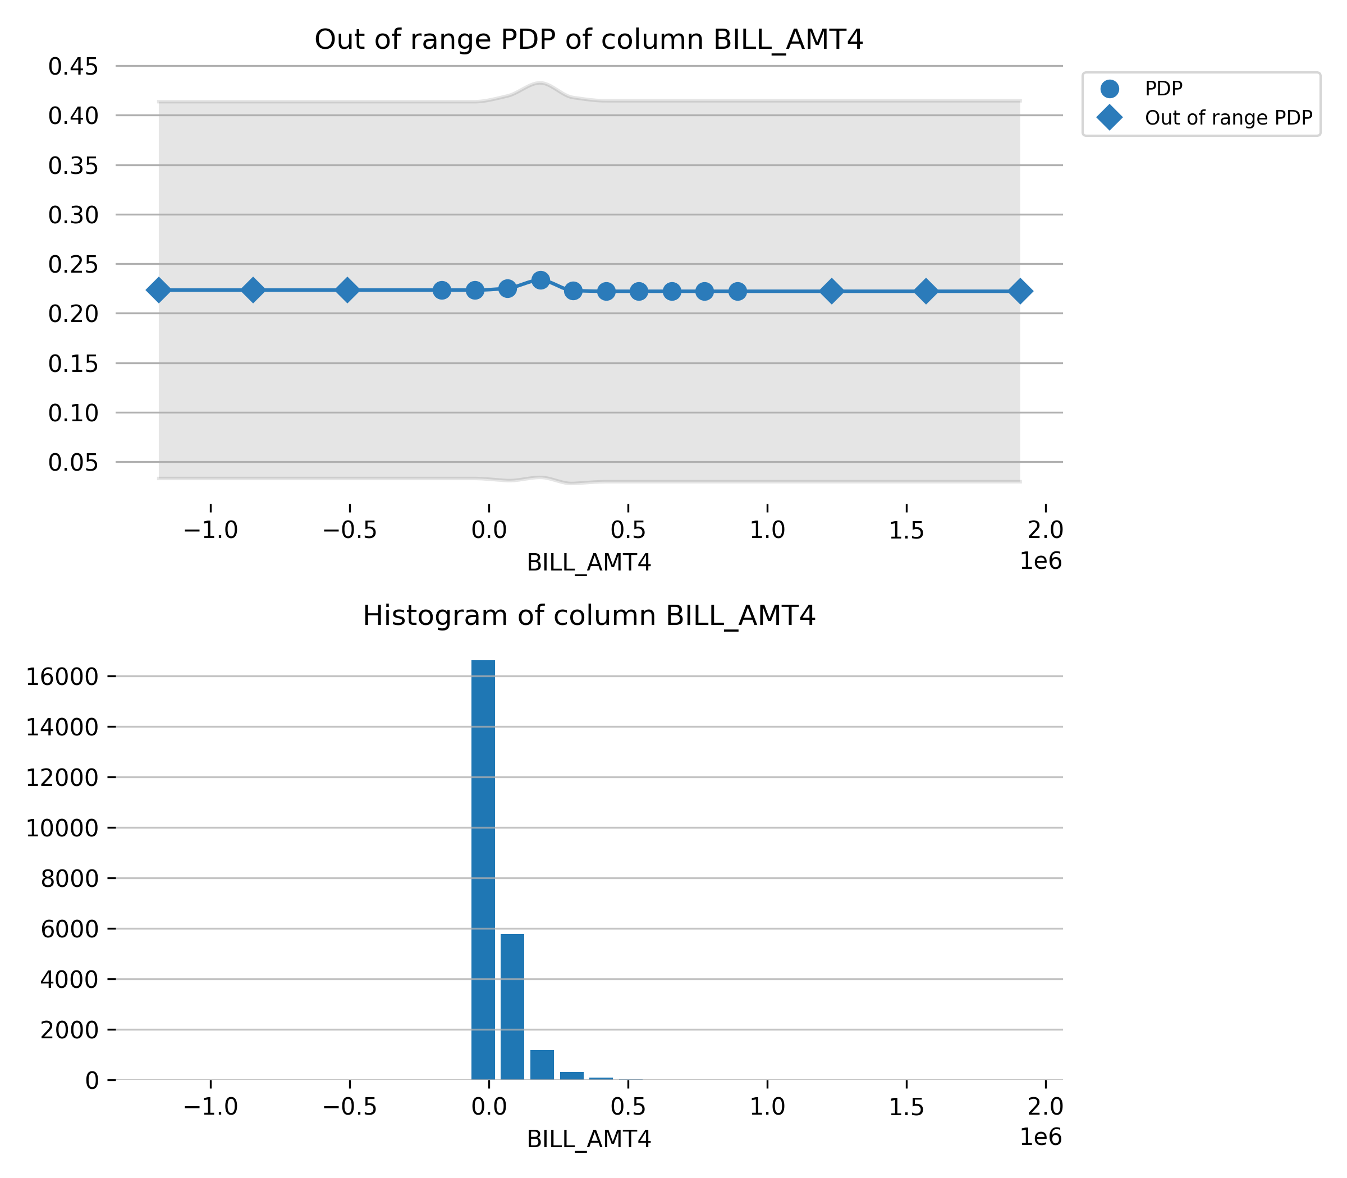

## Model outcome analysis and testing

{Describe the tests done during development. For each test conducted, provide the following:

* **Description of the test** (for example, error of x over y period at z segmentation level)
* **Justification for the test and evaluation criteria**. Justification for the tests and evaluation criteria should be tied to the regulatory compliance, risk management, and business objectives and requirements of the model in section 1.1.
* In particular, tests aimed at assessing the actual impact given use of key model configurations, limitations, and simplifications should be included.
* **Results and interpretation.** Conclusion regarding whether the test supports the model suitability for regulatory compliance, risk management, and business objectives and requirements.

The tests should demonstrate that the key market risk factors, as described in Section 2.2, are captured in the model and market risk factors excluded, if any, do not incur material model risk.

* State whether development tests used Wells Fargo’s own outcomes or not. If not, justify why not and discuss the applicability of performance testing conclusions for the intended use.

Wells Fargo’s exposure or use-case concentrations which are not captured or for which limited coverage is available in the vendor model sample should be identified. Applicability of test results, mitigating rationale and evidence should be provided.

## Performance on stress conditions/out-of-sample/extrapolated conditions/data

|  |  |  |  |
| --- | --- | --- | --- |
| Risk Rank 4 | Risk Rank 3 | Risk Rank 2 | Risk Rank 1 |
| Aggregate testing is sufficient | Aggregate testing and key components or segments should be individually tested | | Fully granular testing required on portfolios /products/segments |

{Generally, models should be assessed for the stability of the model specifications/ parameterizations through tests such as out-of-sample, out-of-time, cross validation, stress scenarios, etc. For each test conducted, provide the following:

* Description of the test (for example, error of x over y period at z segmentation level)
* Justification for the test and evaluation criteria. Justification for the tests and evaluation criteria should be tied to the regulatory compliance, risk management, and business objectives and requirements of the model in section 1.1.
* Results and interpretation. Concluding whether the test supports the model suitability for regulatory compliance, risk management, and business objectives and requirements.

For vendor models

Include all user testing conducted, whether vendor or internally generated, to confirm the reasonableness of model performance.

State whether development tests used Wells Fargo’s data, process, and outcomes.

If limited or no Wells Fargo internal data was used in the model performance review, explain why it was not used and assess the applicability of performance testing conclusions for the model’s intended use.}

## Developmental benchmarking

|  |  |  |  |
| --- | --- | --- | --- |
| Risk Rank 4 | Risk Rank 3 | Risk Rank 2 | Risk Rank 1 |
| Optional | If applicable and available, benchmarking should be designed to address uncertainties in outcome analysis (bias, low granularity, lack of data, etc.). Benchmarking to previous version of the model is strongly recommended for model updates.  Required for vendor models with limited information on conceptual soundness and where sensitivity analysis is not feasible and for models per Model Benchmarking Policy and references therein. | | |

{Provide benchmark(s) as appropriate and available with objectives. Several approaches are available:

* Build an alternative model using different data, assumption, methodologies, or implementation.
* Use market, industry or third-party data for similar product or portfolios or processes to compare the data with the model output or compare results with judgmental estimates by business experts.
* Test localized key model components, such as data, assumptions, or methodologies by using alternative approaches, placing focus on the overall impact to the model performance. This is important for areas with high uncertainty or model risk.

If applicable, provide the model results compared with any benchmark or alternative model. Comment on the differences between the results and add comments in the event of bias or divergence between the predictions. Comment on the differences between the model’s and the benchmark’s structure and assumptions.

If the model developed will replace an existing model, discussion of a comparison of model outputs between the new model and the existing model is strongly recommended.

Alternative models were not provided by the user.

For vendor models where final model specification is not accessible, benchmarking to other approaches is strongly recommended. Benchmarks should preferably adopt an internally developed approach (model or non-model) with demonstrably reasonable specification. If benchmarking to internally developed approach is not feasible, the model owner should consider alternative benchmarking strategies including comparing the model with relevant models developed by other credible vendors.

## Adjustments performed through qualitative methodologies

* Provide details on the qualitative management adjustments and /or methodologies and the supporting evidence for these adjustments, differentiated by model use, as appropriate. Documentation should include the following components:
* Describe the adjustment, the reason it is applied, and if there is a respective limitation of the model that it addresses
* Explain the methodology employed to calculate the adjustments. Include any theoretical framework, numerical implementation, specific formulas, or segmentation methodology.
* Describe any assumptions used and provide rationale supporting these assumptions. For Inputs that are impactful to the overall model, provide analysis or evidence supporting the appropriateness of these assumptions and describe how the assumption is periodically reviewed to ensure it remains adequate
* Describe the outputs of these adjustments or methodologies and explain why these outputs are appropriate for use. Provide analysis and tests used to evaluate the appropriateness of these outputs.
* Provide backtesting results, as appropriate.
* For output used in regulatory stress tests, evaluate the outputs under each of the stress scenarios. Provide a brief overview of the reasonableness of the projection results relative to the stated macroeconomic scenarios.
* Provide an impact assessment comparing outputs from the adjusted model and the raw model, as well as sensitivity analysis to key inputs or assumptions.

## Summary of testing and outcome analysis

* Summarize the outcome of testing and analysis in the context of conceptual soundness of the model and its key risks:
* The ability of the chosen framework or approach in achieving the objectives/requirements of the business process (as laid out in section 1.1).
* The manner in which key model risks, including the limitations listed in section 2.3, are assessed and brought under control or mitigated. Explain any need for mitigation control.
* Model robustness and stability
* Justify the model robustness and stability, based on the analysis performed.

# Model production implementation and control

## Model implementation

{This section lays out the implementation plan and tests performed to demonstrate that the model works as intended in its production environment. If the model is not in production yet, the testing plan to achieve such objectives should be provided even when another function, such as IT performs most of the task since the model owner bears the ultimate responsibility for the model production quality. The testing plan should include information on performance metrics, governance and approval process, and model implementation testing evidence should be provided to CMoR prior to model production use.}

1. Implementation specifications

Include all details available at the time of writing. Information not available at the time of initial development may be inserted later in full or by referring to an external document (e.g. UAT).

|  |  |  |  |
| --- | --- | --- | --- |
| Risk Rank 4 | Risk Rank 3 | Risk Rank 2 | Risk Rank 1 |
| Optional | Basic: Summary qualitative description | | Detailed |

* {Provide a list of developed functions or interfaces that the implementation will require. Examples could be specific SAS scripts, functions exposed in a quantitative analytics library, etc. All such descriptions must include descriptions of arguments, data types, acceptable ranges on inputs, among other descriptions.
* Discuss production data inputs, assumptions, and data integrity.
* Discuss the handling of exclusions, derived inputs, weights, scrubbing logic, etc., if applicable.
* Provide a plan for the handling of missing production data.
* Explain the supporting systems controls and integration processes.
* Discuss how the model will be blended or combined with other models in a production environment.
* if a production or implementation manual will be produced, describe the minimum requirements for the manual here.}

1. Implementation testing

|  |  |  |  |
| --- | --- | --- | --- |
| Risk Rank 4 | Risk Rank 3 | Risk Rank 2 | Risk Rank 1 |
| Testing can be specified at the aggregate level or for typical use cases | | Testing should cover a wide range of cases including possible extreme cases and rare observations | |

* {Describe any preimplementation review conducted on this model (such as a review on a recent population with no performance) to assess the expected shifts or changes to existing strategies due to implement the model.
* If there are any model adjustments as a result of this review process, the appropriateness and the scope of the adjustment should be articulated (affected population and duration).
* Describe implementation test, which should cover a wide range of cases and possible extreme cases and rare observations for all risk ranks.
* Provide details on any implementation and production testing programs, such as UAT and go-forward maintenance.
* Include discussion of ongoing production quality assurance and control tracking with standards for production data reconciliation and approval of final results.
* Include a discussion of any implementation checklists or testing plans and criteria for success.
* Provide quantitative comparisons of outputs between the model initially developed and the model implemented. Discuss and explain any differences (if applicable).
* Include reference to implementation testing documentation (if available).
* For vendor models, if comprehensive detail cannot be obtained due to proprietary restrictions, model developers should include enough information to demonstrate rigor of implementation testing.
* Describe data output controls in place for qualitative tools used to ensure output does not have errors and it is calculated per the qualitative tool requirements.

## Change control and adjustments management

{Discuss the model change management process/plans, by either providing details below or referencing the LOB standard procedure covering this model. For the latter, add model specific details, if needed.}

* {Provide a plan for the ongoing change control process. Include the events that would cause a change validation vs. an updated change.
* Specify the maintenance routine that may trigger validations if model maintenance will be performed on an ongoing basis.
* Provide details on the change log procedures (or planned procedures). Such procedures must include the description of all model changes, including applicable qualitative components and related decisions, such as assumption, variables and adjustments, rationale or evidence for any change, implementation tests for the change, and approval responsibilities
* Describe the past and anticipated future frequency of re-estimation/calibration and governance control of updated parameters. Monitor parameter stability over time with each maintenance calibration.
* Discuss ongoing model maintenance/calibration processes. Note the changes that will not require a validation (targeted scope).
* For vendor models:
* State the controls for model stability over time including Wells Fargo’s process and ability to reject vendor updates if needed. Provide evidence and artifacts as applicable.
* If Wells Fargo specific customizations are subject to change, describe how they are expected to change and the related Wells Fargo’s governance control process.
* Describe any plan to retire an existing model if it replaces a previous model.

## Security and control

Please confirm that adequate details on the security of model data, control of user access, recovery planning per firm’s Business Continuity Planning (BCP) mandates have been populated per requirements in the Model Control Tab for this model available in MoRS.

* Provide a link to a process guide document, if applicable. The document should provide instructions for users or user groups to operate the model.

# Model ongoing performance monitoring

{For newly developed model, performance monitoring program may not be available at the time of initial development and validation. The performance monitoring program should be developed and approved within 30 days after the model is in production. This section should be populated after the performance monitoring program is approved}.

Please provide summary information in the following table (not required for RR1-2 Initial Validation since Monitoring Plan is separately approved):

Table .. Key Performance Indicators

|  |  |  |  |  |  |
| --- | --- | --- | --- | --- | --- |
| KPI name | KPI short description | Rationale for KPI (linkage with key model risks) | Thresholds (yellow and red levels) | Rationale for thresholds, with linkages to model tolerance levels | Frequency, reporting lag and first reporting date |
|  |  |  |  |  |  |
|  |  |  |  |  |  |

Explain the applicable action plan when KPIs become red.

For each of the business processes the model supports, ongoing performance monitoring should include:

* Description of performance monitoring (for example, error of x over y period at z segmentation level, conducted every day/month/quarter/year/etc), and its main objective, such as an assessment metric or mitigating control over assumption, approximation, weakness, exposure, etc.
* Justification for the test and evaluation criteria (key performance metrics, thresholds, and frequency). Justification for the tests and evaluation criteria should be tied to the business objectives and requirements of the model in section 1.1.
* Expected actions to mitigate the model risk in the events of performance deterioration (in particular exceeding yellow and red levels).
* For vendor models, Performance tracking should use Wells Fargo’s own outcomes. If not feasible, assess the applicability of performance testing conclusions for the intended use.
* For vendor models, clearly distinguish between monitoring performed by vendor and that performed by Wells Fargo. For ongoing monitoring conducted by vendor, clearly indicate disclosure process, integrity and frequency of disclosure.
* Describe ongoing monitoring of qualitative modeling elements that can materially affect key model risk related to:
* Key independent variables obtained through qualitative methods
* Key management adjustments
* Additional key parameters obtained through qualitative methods}

Definition of terms

* If term definitions are not required, please remove this section.

**Fundamental assumptions:** They represent the most basic axiomatic modeling assumptions that are applicable to a class of models developed for similar purposes. For examples, the assumption that the trading market *is risk-neutral and arbitrage-free* applies to all derivative pricing and risk management models and the assumption that *relationship among economic variables implied from historical data persists to the future* applies to many empirical/statistical models.

**Technical assumptions:** They represent modeling choices with respect to the mathematical structure, functional form, variable distribution, or other technical aspect of a quantitative modeling framework.

**Business assumption/expert judgement:** They represent qualitative decision made by model owners and developers that are based on expert judgement, business process, or standard practices.

* The following are examples of a term definition:

|  |  |
| --- | --- |
| Term | Definition |
| **Exposure-at-default (EAD)** | EAD may have two meanings within the context of wholesale Basel II parameter quantification: (1) EAD refers to the Basel II Exposure-at-Default parameter value; that is, the assigned dollar value for any wholesale credit exposure representing the bank’s expected exposure at default; and (2) EAD may refer to the observed exposure-at-default; that is, the actual amount the bank is owed on a defaulted credit exposure |
| **Gini index** | A measurement of the income distribution of a country's residents. This number, which ranges between 0 and 1 and is based on residents’ net income, helps define the gap between the rich and the poor, with 0 representing perfect equality and 1 representing perfect inequality. <http://www.investopedia.com/terms/g/gini-index.asp#ixzz3fE2WvtVm> |

References

{Provide a list of all references cited in this document including internal policy or guidelines. Sources that are not explicitly cited in in the document but provide more insight into the mode should be put into a Bibliography or Related resources section.

* The following example is based on the *Chicago Manual of Style*, 16th edition:}

1. Choi, Stephen J., and G. Mitu Gulati. 2008. “Bias in Judicial Citations: A Window into the Behavior of Judges?” Journal of Legal Studies 37 (January): 87–129. doi:10.1086/588263.