STAR PAC INDIA LTD
Creating Standards

PACKAGING MACHINES AND AUTOMATION
Product Catalogue 2025
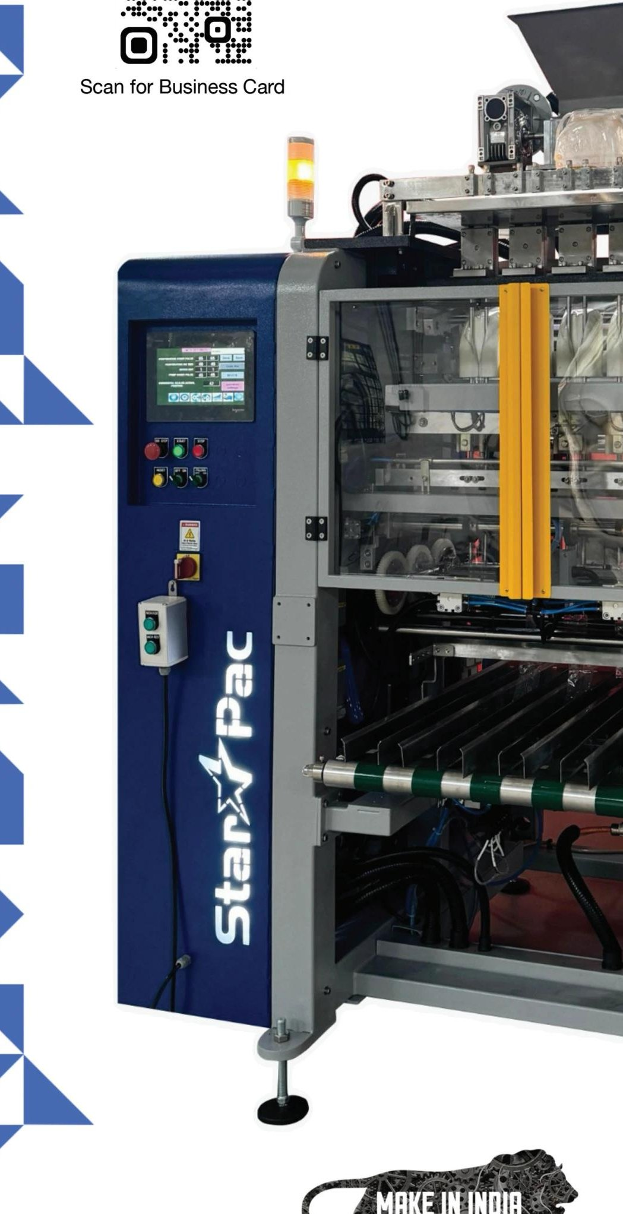
BMQR CE Certified | AIAO BAR Accredited | Make in India

2. PROFILE
Star Pac India Ltd was established in Chennai, India, in the year 1996 by two professionals with the main object of providing customised packaging and automation solutions to the industry.
Industry: Packaging has become the 'Fifth P' in the marketing mix. Advancements in packaging and automation technology have given organisations the much needed competitive advantage. To name a few path breaking pack types in packaging and branding: Brick, Stick, Zip lock, Spouted, Sachets, Curtain, Bubble, Pyramid, Shelf standing, Shaped, Semi rigid, and the recent addition of DUPLEX PACK.

The Range of Machines

We cater to a gamut of industries like Food, Pharma, Personal care, Home care, Engineering, Autoparts and Packaging Automation, with the following range of machines and customisations where needed.
- Single Lane Vertical FFS Machines for Center Seal, 3 side seal, 4 side seal, 4 corner seal Quattro and Doy packs
- Multi track Vertical FFS for Four Side seal, Center Seal and Three side Seal (Duplex pack, Patent Pending)
- Multi track Stick pack machines (For Center Seal, Off Center Seal and Three side Seal)
- VFFS machines for Tetrahedral and Dongle pack (patent pending)
- Pick Fill and Seal for Preformed Pouches
- Fill and Close machines for Jars, Bottles and Cans
- Horizontal Flow Wrapper
- Form Fill and Pick Fill seal machines with MAP for Trays and Thermoforms
- Form Fill and Seal for Vacuum and Brick Packs
- Band sealer (medium and heavy duty) for Preformed Pouches
- Stand alone filler for Powders, Liquids, Pastes and Granules
- Custom built material handling systems and Automation projects

Infrastructure

We have a 45,000 sft manufacturing facility in Thirumudivakkam with a workforce of 100 technicians. We have a dedicated production site for fabrication and a fully fledged CNC tool room.

Clientele

Apart from India, our machines have found good acceptance in Europe, Malaysia, Nepal, Saudi Arabia, UAE, Sri Lanka, Nigeria, Ghana, Malawi, Tanzania, and Kenya. We now have more than 2,000 installations.

A few leading brands using our machines include:

Unilever, Reckitt Benckiser, ITC Limited, ConAgra Foods, Nissin, General Mills, CavinKare, Bunge, Marico, KIVO, Dettol, GRB, Fanta, Mother's Recipe, Olam, Perfetti Van Melle, ESAB, MTR, Aachi, Dabur, Amul, Grandos, Pepsico, Everest, McRennett, Nilon's, VKL, Narasu's, Tata, Abbott, Levista Instant Coffee, ADF Foods, Panchwati, Monsanto, Goldiee, Sakthi Masala, Hexagon Nutrition, Bharat Masala, Rakesh Garam Masala, Strides Arcolab, Griffith Foods, Pushp Spices, Godrej, Wrigley, Empire Spices, Suhana, Agrana, Sil, McDonald's, Pizza Hut, Domino's, Rajesh Spices, BRU, Haldiram's, and Knorr.

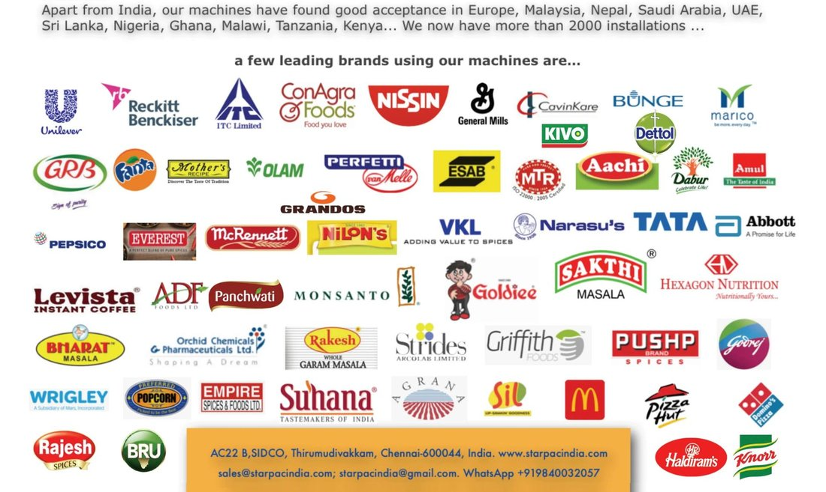

Address: AC22 B, SIDCO, Thirumudivakkam, Chennai 600044, India.

Web: www.starpacindia.com

Email: sales@starpacindia.com | starpacindia@gmail.com

WhatsApp: +91 98400 32057

3. CONTENTS

1. Front Cover Page

2. Profile

3. Contents and pack types possible (using our range of machines)

4. VFFS (range of Vertical Form Fill and Seal machines)

5. Multilane VFFS for THREE SIDE SEAL PACKS (Duplex), PATENTED

6. Multilane VFFS machines for CENTER SEAL PACKS, PATENT PENDING

7. Multilane VFFS machines for FOUR SIDE SEAL PACK (Curtain)

8. Multilane Stick Pack machine (Center seal or 3 side seal)

9. Flow wrappers

10. HFFS (Modular Horizontal Form Fill and Seal Machine), PATENT PENDING

11. PFS, Pick Fill and Seal Machine for Preformed Pouches

12. JFSR (Customised Rotary Jar, Bottle, Can Fill and Close Machines)

13. Electrode Packing Automation (Pack 2 Pallet)

14. Pop Corn Packaging (Complete packing line for Pop Corn in different pack formats)

15. Pack to Pallet automation (Primary packaging to Palletising lines)

16. StarCod Thermal Inkjet Printers and Cartridges

18. Notes

20. Rear Cover (Contacts Page)

Machines and Automation Systems for the Displayed Pack Formats

Below are the pack formats Star Pac machines can produce:

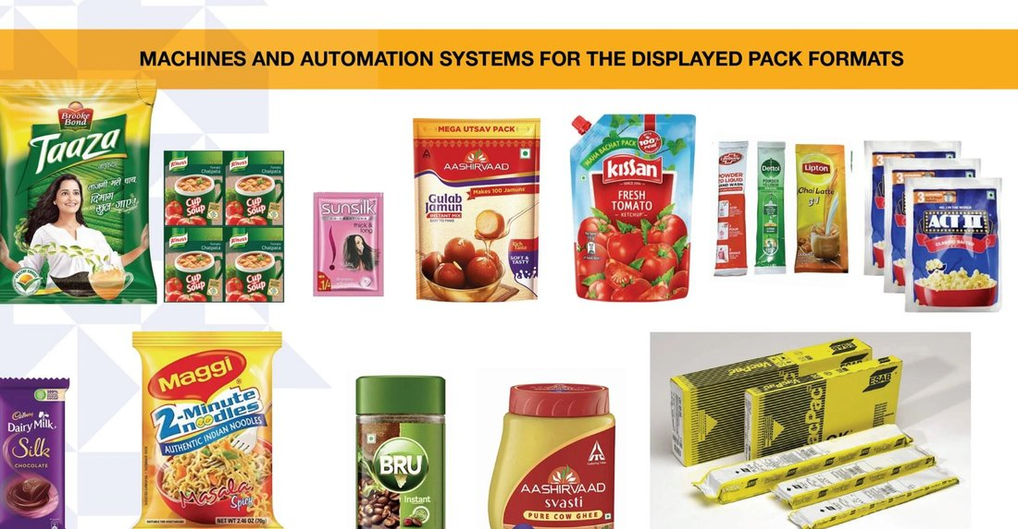

4. CONTINUOUS MOTION VERTICAL FORM FILL AND SEAL BAGGERS

Models: PSC400 / PSC600

This 5 axis servo machine, available in two models, is of a sturdy build to give optimal uptime and years of service. The footprint is among the best optimised in the industry. The machine is in a GMP enclosure with 100% access to all areas for operation and maintenance. The PLC tracks all the machine functions and is IOT enabled for remote diagnostics. The machine is ready for coding with Thermal Inkjet Printing of HP technology and can be supplied preinstalled. Machine can be integrated with Auger, Cup, Weigh or Liquid and Paste Fillers.

Built on the continuous motion draw seal technology these machines deliver hermetic seals due to higher dwell time. The machine design is compatible with sustainable laminates as well. Dry speed of the machine is 130 ppm and fill speeds depend on the model chosen and the product nature, grammage and pack dimensions.

This machine is available in Center Seal, Three side seal and Duplex pack (3 side seal) options.

Standard spares are available ex stock and can be shipped within 24 hours.

Specifications
- PLC based operation
- Touch Screen Controls
- Independent drive synchronized with PLC
- ISO Standards Wiring
- CGMP and CGEP Standards
- Sturdy Construction
- PID Temperature controllers
- CE Certified drive
- Photocell registration PLC based
- Servo driven mechanical drawbar for slip free film pulling
- Continuous rated
- Excellent sealing mechanism to ensure hermetic leak proof seals
- All contact parts are in SS 316

Optional Attachments
- Safety PLC
- Outfeed Conveyor
- Level Sensor
- Block bottom pack kit
- Four corner seal pack kit
- Vacuum brick pack kit
- Hopper Feeder
- Zipper Attachment
- Notching unit
- Gas Filling unit
- Static eliminator for dust free seal
- Dust extractor
- Stand up / Doy
- Header Formatting
- Holographic hot foil stamping
- Hole Punching Device (Round or Euro)
- Collating and over bagging device
- Jacketed hopper system for hot filled products
- Change pack for other pack types
- Profile Seal Unit
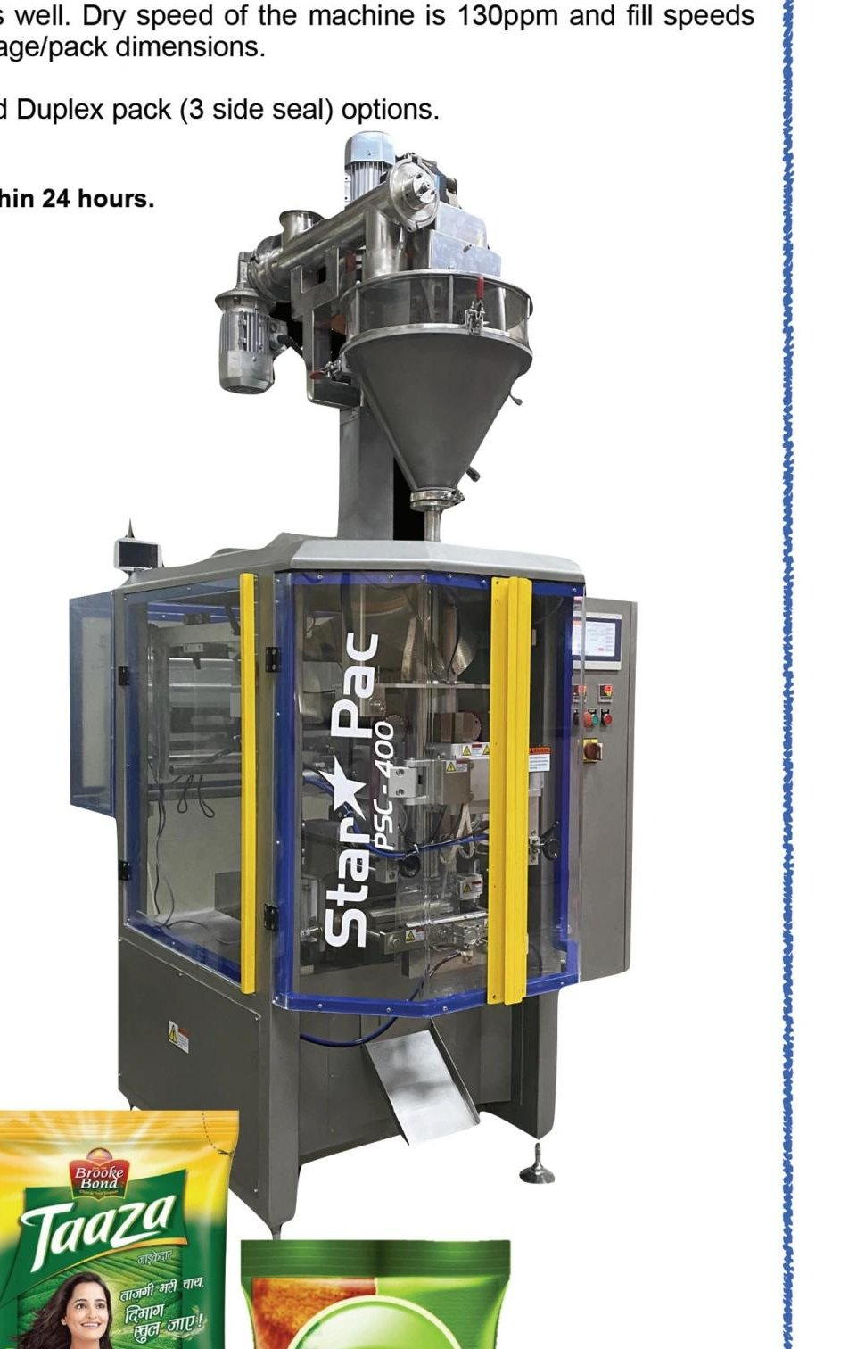

Technical Specifications (Subject to change for improvement)
Details / Model | PSC400 | PSC600
Packaging Capacity | 2000 cc | 4000 cc
Indicative speed range | 60, 130 ppm | 60, 100 ppm
Bag height | 80, 280 mm | 150, 450 mm
Bag width | 80, 200 mm | 150, 280 mm
Supply voltage | 3Ph, 415v, 50HZ | 3Ph, 415v, 50HZ
Connected load | 5 kw without fillers | 6 kw without fillers
Air pressure needed | 5.8 bar | 5.8 bar
Bagger weight | 1100 kgs | 1600 kgs

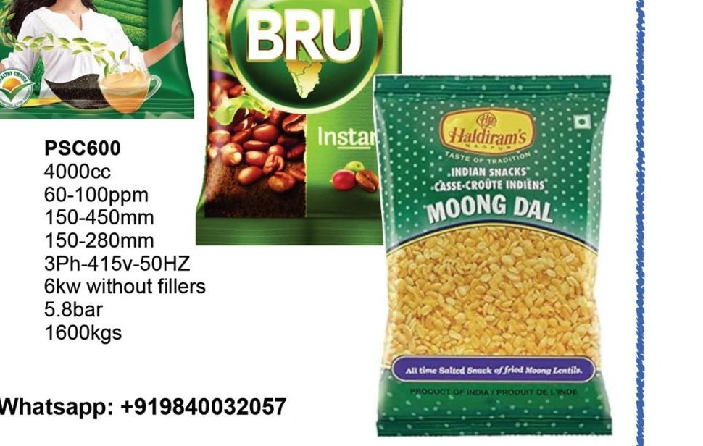

5. MULTITRACK VFFS FOR THREE SIDE SEAL PACKS

Models: MTD400 / MTD600 / MTD1200

These are a range of Continuous Motion Form Fill and Seal Machines to produce Three Side Sealed Packs. They are user friendly and adaptable for downstream automation and ideal for low downtime and meeting high production volumes. While designing our machines, importance is given to the optimal footprint, ergonomics, ease of maintenance and safety systems, apart from the accent on minimal product and packaging material loss. The machines are custom built for individual product specifications to guarantee the highest levels of precision, quality and efficiency regardless of the product packed, be it Powders, Granules, Liquids, Tablets or Objects.

All filling and dosing systems are constructed with proven technology to suit the product to be filled. We assess the products you intend packing and help choose the ideal dosing system. Technologies used in the machine feature precise weight control with focus on tight seals, a must for adequate and optimal production of valuable and sensitive products. Simplicity, endurance and quick size changeover are the strengths and the key to the success of these machines, guaranteeing at the same time the highest efficiency as well as simplified maintenance and user friendliness.

Packaging Materials

Most heat sealable laminated films can be used on this machine. Viz: PET / PE; PET / AL / PE; OPP / ALU / PE, OPP / PE and cold sealable materials. These machines are adaptable for sustainable structures as well.

MTD Machines are Available in 3 Versions
MTD-400 | Max reel width 400 mm
MTD-600 | Max reel width 600 mm
MTD-1200 | Max reel width 1200 mm

Speed of the machine: The dry speed of the machine is 100 to 120 strokes per minute. The maximum number of tracks depends on the sachet dimensions and the filled pack speed depends on product, film, dose, sachet format and many other factors.

Sachet Dimensions
Width | min 25 mm to 125 mm
Length | min 40 mm to 120 mm (optional special sizes)
Fill volumes | from 1 cc to 200 cc

Optional Attachments
- Gas flushing
- Multi product dosing
- Shaped pack
- T notch
- Corner rounding
- Inkjet Coding
- Laser coding
- Downstream collation and bundling
- Pick and place systems for cartoning
- In line check weighing
- Clean in place (CIP) systems
- Automatic cartoner system
- Header pack
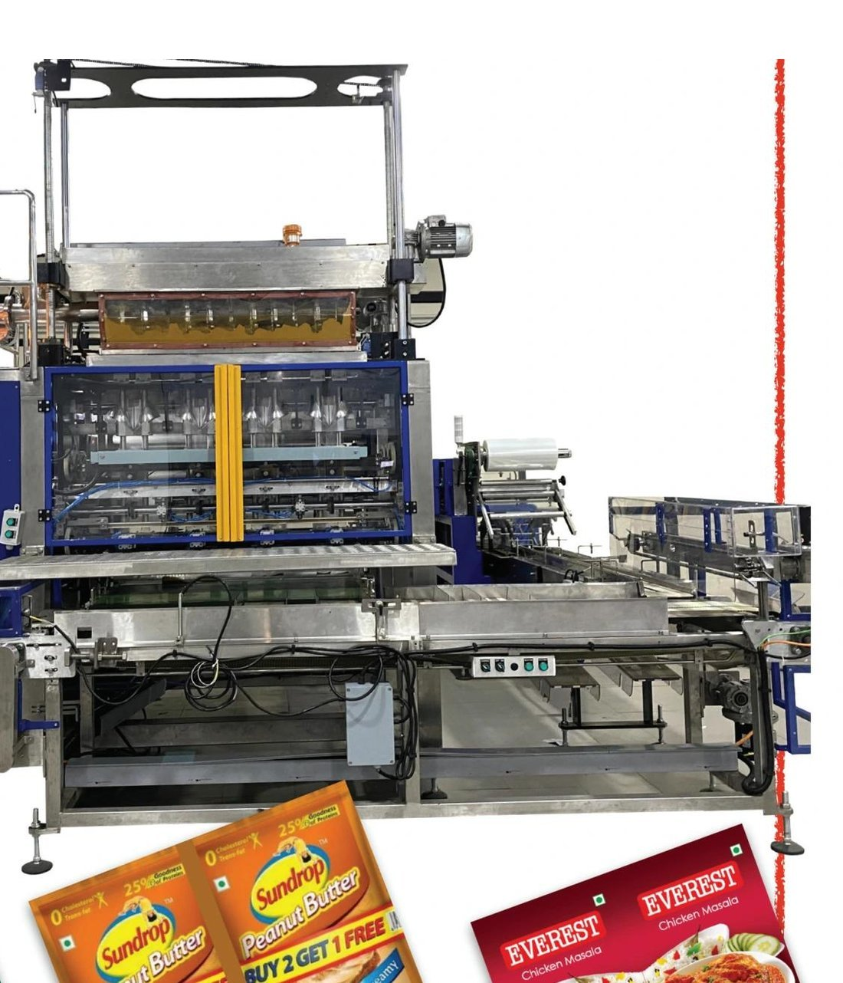
Sample pack formats produced on this machine:
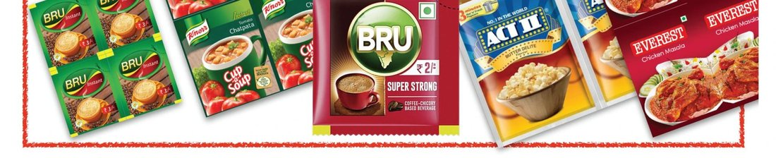

6. MULTILANE / TRACK VFFS FOR CENTER SIDE SEAL PACKS
Models: MTC600 / MTC1200
These are a range of Continuous Motion Form Fill and Seal Machines for producing Center Sealed Packs. They are user friendly and adaptable for downstream automation, have a low downtime and meet high production volumes. While designing our machines, importance is given to the optimal footprint, ergonomics, ease of maintenance and safety systems, apart from the accent on minimal product and packaging material loss. The machines are custom built for individual product specifications to guarantee the highest levels of precision, quality and efficiency regardless of the product packed, be it Powder, Granule or Flakes.
All filling and dosing systems are constructed with proven technology to suit the product to be filled. We assess the products you intend packing and help choose the ideal dosing system. Technologies used in the machine feature precise weight control with focus on tight seals, a must for adequate and optimal production of valuable and sensitive products. Simplicity, endurance and quick size changeover are the strengths and the key to the success of these machines, guaranteeing at the same time the highest efficiency as well as simplified maintenance and user friendliness.
Downstream Automation possibilities are strings or individual packs into bundles or case packing them directly. These can be customised to suit your requirements.

Packaging Materials

Most heat sealable laminated films can be used on this machine. Viz: PET / PE; PET / AL / PE; OPP / ALU / PE, OPP / PE and cold sealable materials. These machines are adaptable for sustainable structures as well.

MTC Machines are Available in 2 Versions
MTC-600 | Max reel width 600 mm
MTC-1200 | Max reel width 1200 mm

Speed of the machine: The dry speed of the machine is 80 to 100 strokes per minute. The maximum number of tracks depends on the sachet dimensions and the filled pack speed depends on product, film, dose, sachet format and many other factors.

Pack Dimensions
Width | min 50 mm to 190 mm
Length | min 40 mm to 350 mm
Fill range | from 10 cc to 2000 cc

Optional Attachments
- Gas flushing
- Multi product dosing
- Shaped pack
- Header pack
- T notch
- Corner rounding
- Inkjet Coding
- Laser coding
- Downstream collation and bundling
- Pick and place systems for cartoning
- In line check weighing
- Clean in place (CIP)
- Automatic cartoner
- Case packing
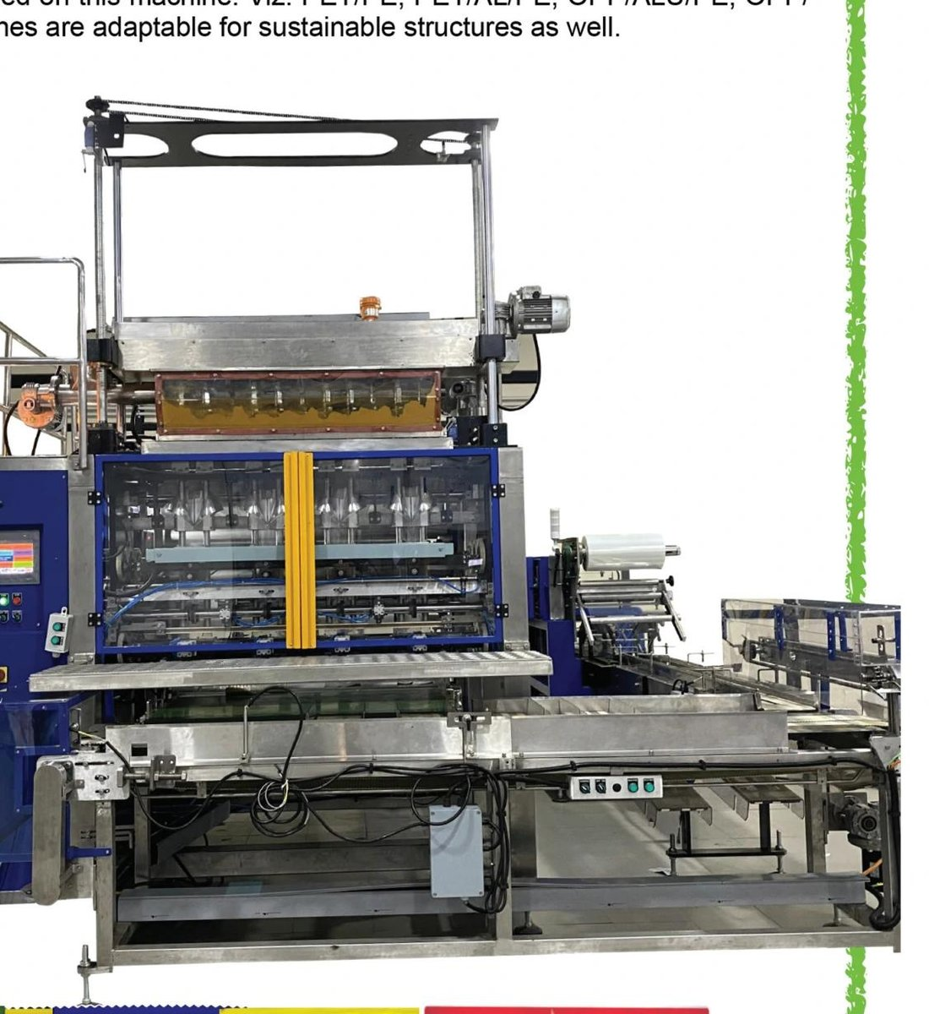
Sample pack formats:


7. MULTITRACK VFFS FOR FOUR SIDE SEAL PACKS
Models: MTR200 / MTR600 / MTR1200
MTR range of continuous motion machines for Four Side Sealed Sachets are user friendly and adaptable for downstream automation. These machines are ideal for low downtime and meeting high production volumes. While designing our machines, importance is given to optimal footprint, ergonomics, ease of maintenance and safety systems, apart from the accent on minimal product and packaging material loss. These machines are custom built for individual product specifications to guarantee the highest levels of precision, quality and efficiency regardless of the product packed, be it Powders, Granules, Liquids, Tablets or Objects.
All filling and dosing systems are constructed with proven technology to suit the product to be filled. We assess the products you intend to pack and help choose the most suitable dosing system for them from a wide range of options. Technologies used in the machine feature precise weight control with focus on tight seals, a must for adequate and optimal production of valuable and sensitive products. Simplicity, endurance and quick size changeover are the strengths and the key to the success of these machines, guaranteeing at the same time the highest efficiency as well as simplified maintenance and user friendliness.

Packaging Materials

Most heat sealable laminated films can be used on this machine, viz: PET / PE; PET / AL / PE; OPP / ALU / PE, OPP / PE and cold seal materials. These machines are adaptable for sustainable structures as well.

MTR Machines are Available in 3 Versions (according to required reel width)
MTR200 | Max reel width 200 mm
MTR600 | Max reel width 600 mm
MTR1200 | Max reel width 1200 mm

Speed of the machine: The idle speed of the machine is 100 to 150 strokes per minute. The maximum number of tracks depends on the sachet dimensions and the filled pack speed depends on product, packaging material, dosage, sachet format and many other factors.

Sachet Dimensions
Width | min 25 mm to max 200 mm
Length | min 40 mm to max 400 mm
Fill volumes | from 1 cc to 200 cc

Optional Attachments
- Gas flushing
- Multi product dosing
- Membrane pack for two component Hair Dye
- Shaped pack
- T notch
- Corner rounding
- Inkjet printing
- Laser printing
- Downstream collation and bundling
- Pick and place systems for cartoning
- In line check weighing
- Clean in place (CIP) systems
- Automatic cartoner system
- Header pack
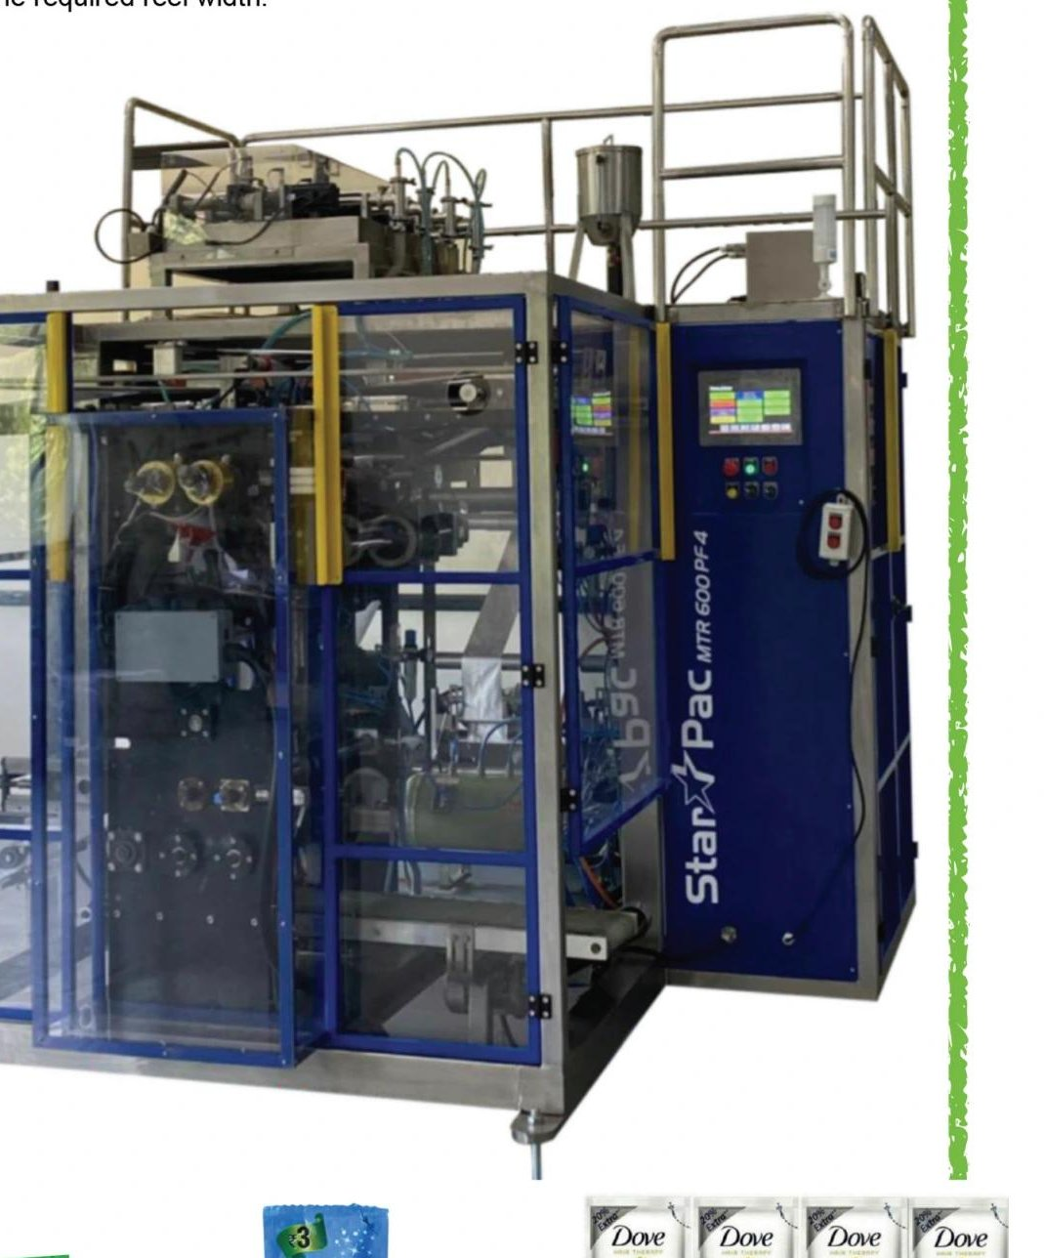
Sample pack formats:


8. MULTI LANE STICK PACK MACHINES
Series: MTSP / MTD (For Center Seal, Off Center Seal and Three Side Seal formats)

Salient Features
- User friendly Form Fill and Seal machines
- Available in intermittent and continuous motion versions
- Optimal footprint
- Ergonomic construction giving access to all operational areas for ease of maintenance
- Downstream automation for secondary packaging into Pouches, Cartons or Jars
- Stick packs can be produced in strings or individual packs
- Three side seal stick packs can be made in simplex and duplex formats for ease of handling
- Seals can be flat or profiled
- Filling systems can be Auger, Cup, Paste, Liquid or Count
- GMP version for Pharma industry
- Can handle a wide variety of packaging films including sustainable structures
- Choice of packaging films include Pet / Pe, Pet / Al / Pe, OPP / Al / Pe, OPP / Pe, MDOPe / Pe, Paper / Pe, Cold Sealable
- Machine is built for two reel widths: 600 mm and 1200 mm
- Stick widths can be 15 mm minimum and max 60 mm (other sizes can be customised)
- Fill volumes can be from 1 to 100 cc (can be customised to handle higher fill volumes as well)
- Up to 24 tracks are possible
- Speeds of up to 1800 ppm
- Batch coding options include Thermal Ink Jet, TTO or Laser
- Check weighing of each stick or string as an option
- Gas flushing
- Multiproduct Dosing
- Laser or mechanical scoring for easy tear
- Mechanical notching
- Corner rounding
- Shaping as per need
- Inline dispenser Carton Form Fill and Seal as a secondary pack
- Integrated collation and packing FFS for pouches
- Clean in place (CIP) option
- Built in operator and machine safety features
- Ease of installation with user manual on HMI
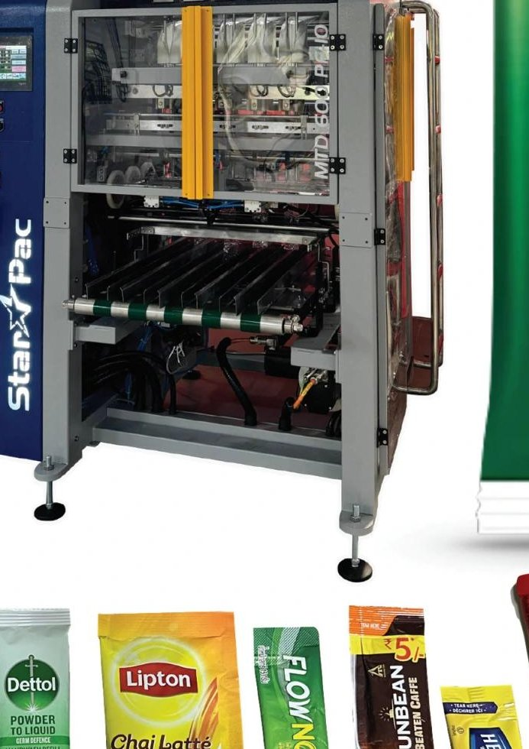
Profile seal options, seal pattern options, and pack end finish options:
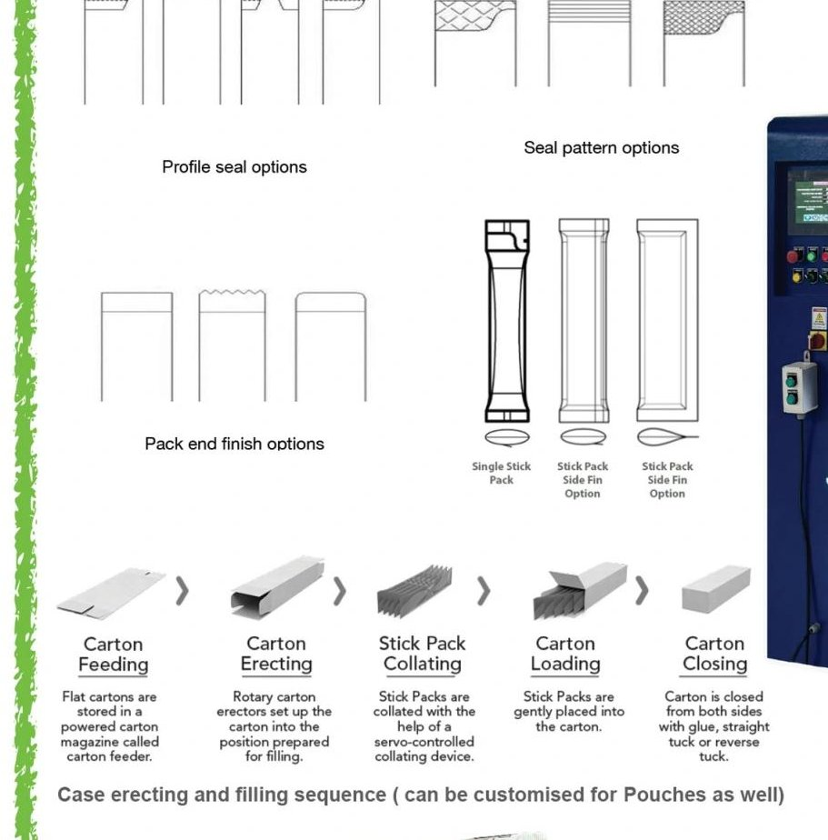

Case Erecting and Filling Sequence

(Can be customised for Pouches as well)
- Carton Feeding: Flat cartons are stored in a powered carton magazine called carton feeder.
- Carton Erecting: Rotary carton erectors set up the carton into the position prepared for filling.
- Stick Pack Collating: Stick Packs are collated with the help of a servo controlled collating device.
- Carton Loading: Stick Packs are gently placed into the carton.
- Carton Closing: Carton is closed from both sides with glue, straight tuck or reverse tuck.
Sample stick pack products:


9. FLOW WRAPPER SERIES
Models: MCW300 / MCW450 / MCW600WB / MCWI600WB
The range of flow wrappers comprises 4 models (3 with top roll feed and 1 with bottom roll feed) with options of 3 or 4 axis servo drives. All the models are available in Steel and Stainless Steel versions. We can custom build for larger reel widths of 820 mm and 1000 mm against specific requirements in both top and bottom roll feed versions.
All these models are built on a sturdy structure to give optimal uptime and years of service. A variety of feeders for products or packages can be custom designed for these machines. The footprint is among the best optimised in the industry. The machine is in a GMP enclosure with 100% access to all areas for operation and maintenance. The PLC tracks all the machine functions and is IOT enabled for remote diagnostics. The machine is ready for coding with Thermal Inkjet Printing of HP technology and can be supplied preinstalled.
Machine can be integrated with third party machines, Friction Feeders, Carton feeder, Magazine, Sachet feeder, Shrink Lines, Biscuit and Chocolate Lines etc. Built on the continuous motion rotary and draw seal technology, these machines deliver hermetic seals owing to a programmable dwell time. The machine design is adaptable with sustainable laminates as well. Idle speed of the rotary motion machines can reach up to 300 ppm and in the draw seal machines, up to 100 ppm. Speeds, however, are dependent on the model chosen and the product nature, product size and pack dimensions.
Standard spares are available ex stock and can be shipped within 24 hours.

Specifications
- PLC based operation
- Touch Screen Controls
- Independent drive synchronized with PLC
- ISO Standards Wiring
- CGMP and CGEP Standards
- Sturdy Construction
- PID Temperature controllers
- CE Certified
- Photocell
- Continuous rated
- Excellent sealing mechanism to ensure hermetic leak proof seals
- All contact parts are in SS 316

Optional Attachments
- Safety PLC
- Out feed Conveyor (extensions)
- No product no pack interlocks
- Friction feeder
- Zipper Attachment Device
- T Notch device
- Gas Filling unit
- Header Formatting
- Hole Punching Device (Round or Euro)
- Collating and over bagging device
- Profile Seal Unit
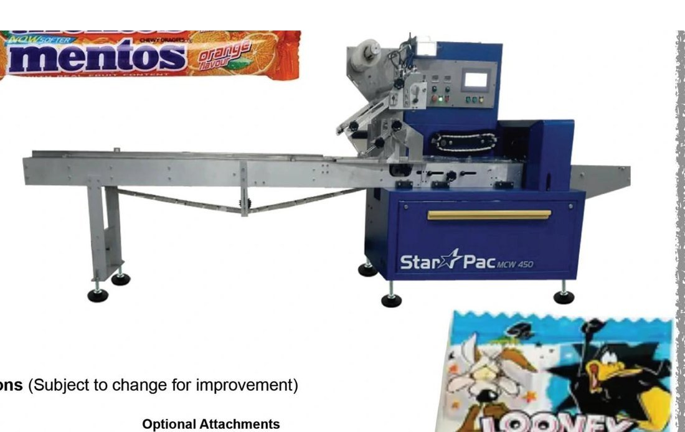

Technical Specifications (Subject to change for improvement)
Machine Model | MCW300 | MCW450 | MCW600 | IMCW600 | Custom Built
Film Feed type | Top roll | Top Roll | Top Roll | Bottom Roll | Top / Bottom
Servo axis | 3 to 4 | 3 to 4 | 3 to 4 | 3 to 4 | 4 to 5
Max Reel width (mm) | 300 | 450 | 600 | 600 | 820 / 1200
Max Reel dia (mm) | 320 | 320 | 320 | 320 | 320
Pack length range | 60 to 200 | 120 to 400 | 150 to 400 | 150 to 400 | Customised
Pack width range | 30 to 130 | 60 to 210 | 80 to 270 | 80 to 270 | Customised
Max product height | 40 | 90 | 100 | 100 | Customised
Speed range | 80 to 1200 | 50 to 200 | 30 to 100 | 30 to 100 | Customised

10. HORIZONTAL FORM FILL AND SEAL MACHINE (PATENT PENDING)

Model: HFS220

Horizontal Form Fill and Seal machine for Stand Up and Doy pouches (Options of fillers Auger, Hot filling for Liquids and Pastes, Ambient temperature Liquid and Paste, Weigh or Count based fillers).

Machine Structure
- Sturdy steel structure with powder coat finish
- Product and pack contact parts of SS304 / 316
- Wash down tray in SS304
- Safety door options for full cover or operational areas
- Mounting on wheels and levelling pads
- Two part machine structure
- Separate access to operator, electrician and mechanical sections
- Automated lubrication system

Reel Unwind and Forming
- Powered and independent unwind station
- Easy mounting for roll
- Real time Web aligner for precise edge matching
- Photocell
- Gusset hole punch adjustment
- Forming V adjustment (motorised as an option)

Sealing Station
- Cam driven
- Servo driven Film draw off for precise bag width
- Sturdy sealing arrangements for clean hermetic seals
- Sealing tool easy changeover with ergonomic operator access
- Precision scissor cutting

Pouch Handling, Filling and Sealing
- Walking beam for pouch transfer
- Precision cam system for grip and transfer
- Pouch opening assurance with vacuum, air and finger assistance
- Grippers designed to hold pouch weight of up to 2 kgs

Filler

Two stage filling for liquids and pastes and twin head auger for powders. Weigh or count filler as an option. Pouches get stretched with grippers before sealing to avoid wrinkles.

Control Panel and PLC

Control panel cabinet is swing type for ease of maintenance and handling. Air conditioning to maintain panel temperature.

Pouch Formats Possible

Stand up and Doy format. Suitable for sustainable laminates. Shaped pouches using die cut option.

Dimensions when Running Machine in Duplex Format
Width range | 70 mm to 100 mm
Height range | 110 mm to 300 mm
Fill volume | 500 cc
Speed | 50 to 65 strokes per minute (dry)

Dimensions when Running Machine in Simplex Format
Width range | 100 mm to 200 mm
Height range | 110 mm to 300 mm
Fill volume | 1000 cc
Speed | 50 to 60 strokes per minute (dry)

Process flow diagram:

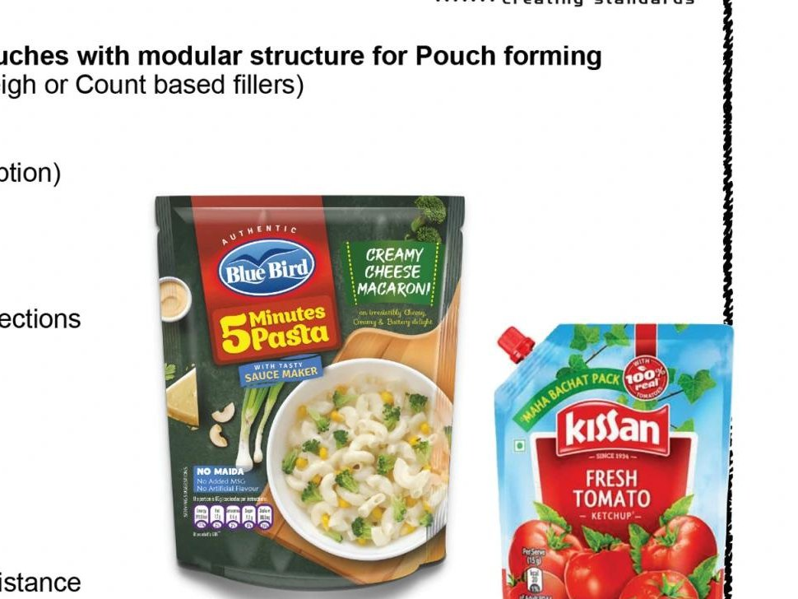

Sample pouch formats and machine view:

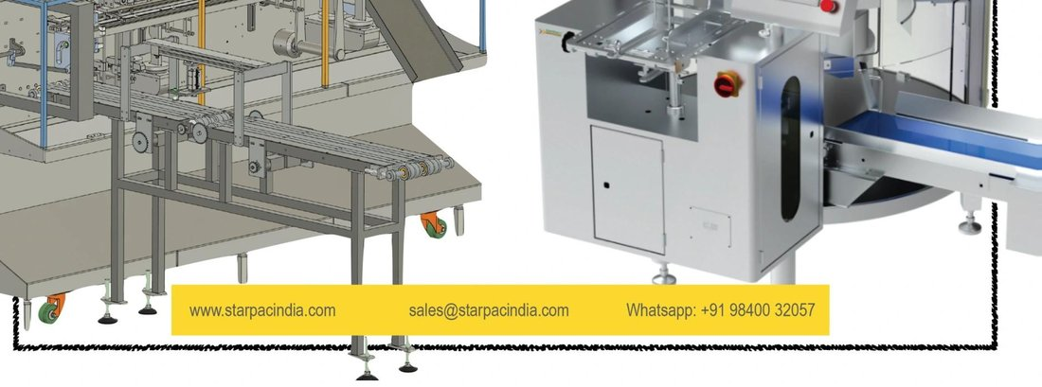

11. PICK FILL AND SEAL MACHINE FOR PREFORMED POUCHES

Models: PFSL220, PFSR260, PFSR400

Horizontal Pick Fill and Seal machine for Stand Up pouches with modular structure for Pouch forming. Filler Options: Auger, Hot or Ambient filling Liquid and Paste, Weigh or Count based fillers.

Machine Structure
- Sturdy Steel structure with powder coat finish (SS as an option)
- Product and pack contact parts of SS304 / 316
- Wash down tray in SS304 (optional)
- Safety door options for full cover or operational areas
- Mounting on wheels and levelling pads
- Separate access to operator, electrician and mechanical sections
- Automated lubrication system

Pouch Feeding Options

In feed magazine or In feed conveyor.

Pouch Handling, Filling and Sealing
- Linear or Rotary Walking beam for pouch transfer
- Precision cam system for grip and transfer
- Pouch opening assurance with vacuum, air and finger assistance
- Grippers can hold pouch weight 1 to 5 kgs depending on the model

Filler

1 or 2 stage filling for liquids and pastes and twin head auger for powders. Weigh or count filler as an option. Pouches get stretched by grippers before sealing to avoid wrinkles.

Control Panel and PLC

Control panel cabinet is swing type for ease of maintenance and handling. Air conditioning to maintain panel temperature.

Pouch Formats Possible

Standup format; Pouches with corner spouts; Pouch in pouch; Suitable for sustainable laminates; Shaped pouches using die cut option.

Pouch Dimensions Possible (model dependent)
Width range | 80 mm to 400 mm
Height range | 110 mm to 700 mm
Fill volume | 500 cc
Speed | 30 to 70 packs per minute (dry). Speeds with filling depend on packaging material, product flow and settling properties.

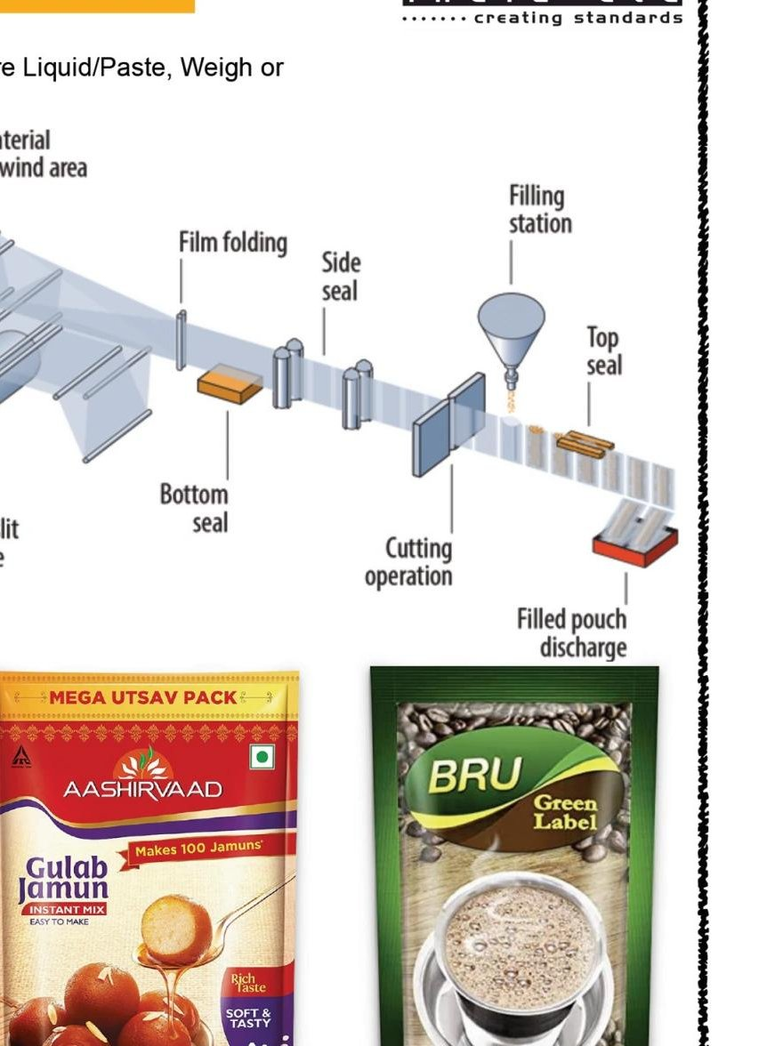

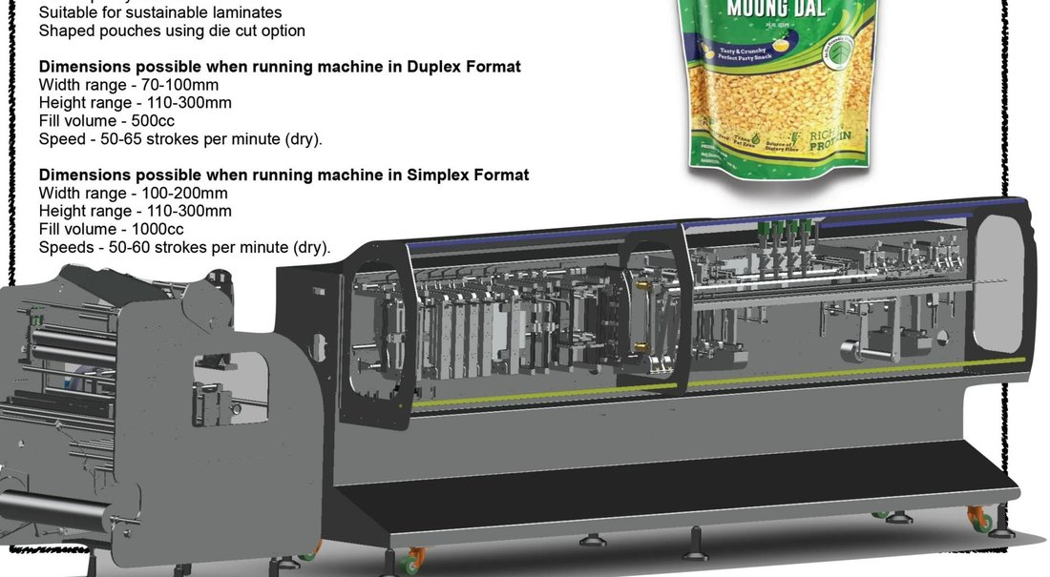

12. JARS / CAN / TUBS FILL AND CLOSE MACHINES

Model: JFSR

Different shapes, different materials, different closures, any product.

Metal Cans, Jars, Bottles, Cartons. This machine can handle them all. Continuous and intermittent models are there to choose from depending on the product and throughput desired.

WE CUSTOMISE THIS MACHINE TO SUIT YOUR PACK AND PRODUCT

Write to us your product and pack details along with speeds desired for us to send you a proposal.

Email: sales@starpacindia.com

WhatsApp: +91 98400 32057

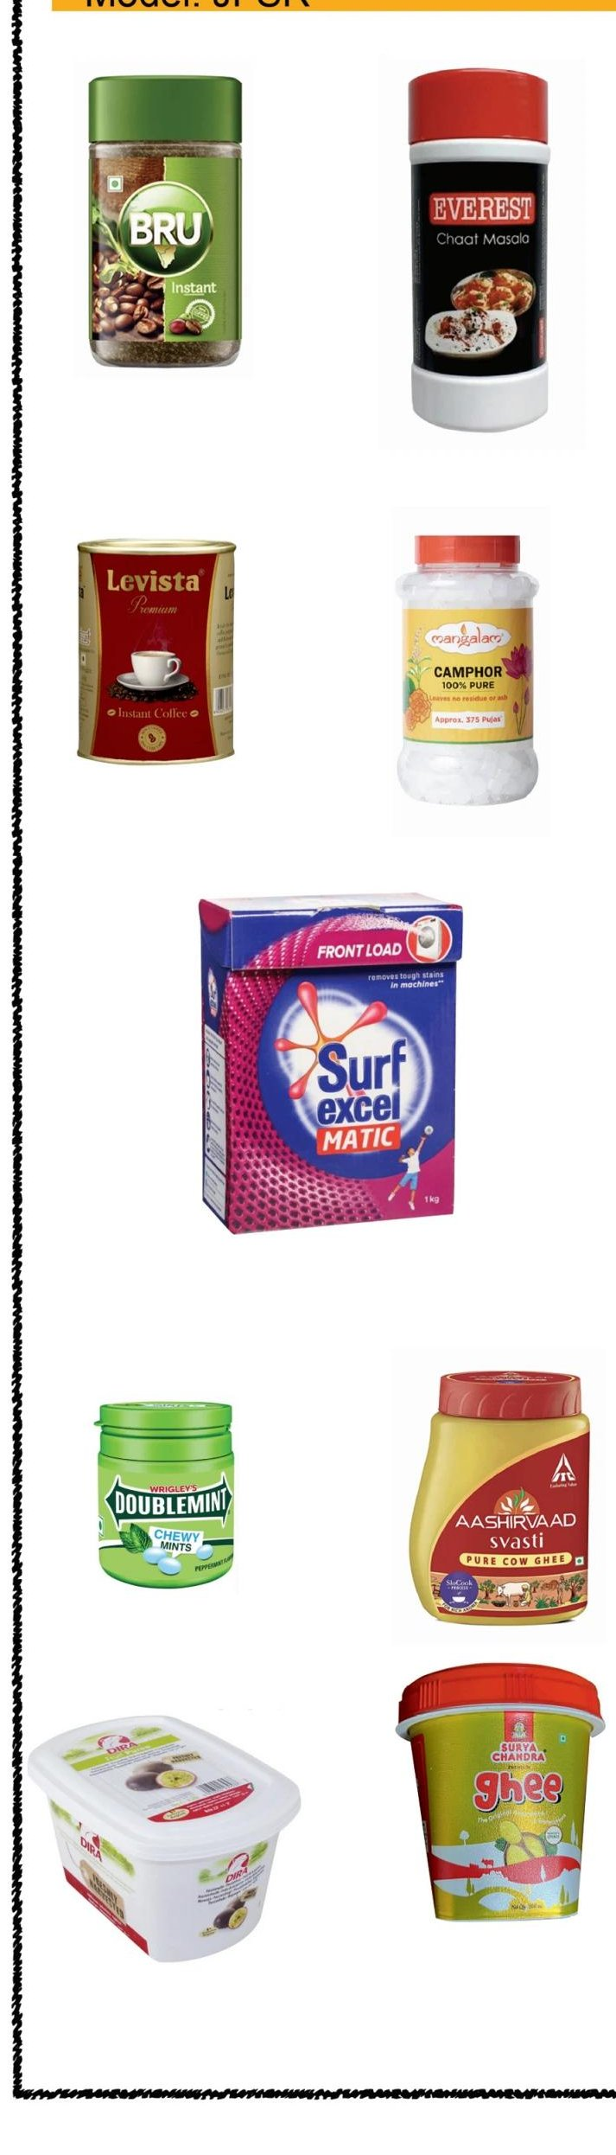

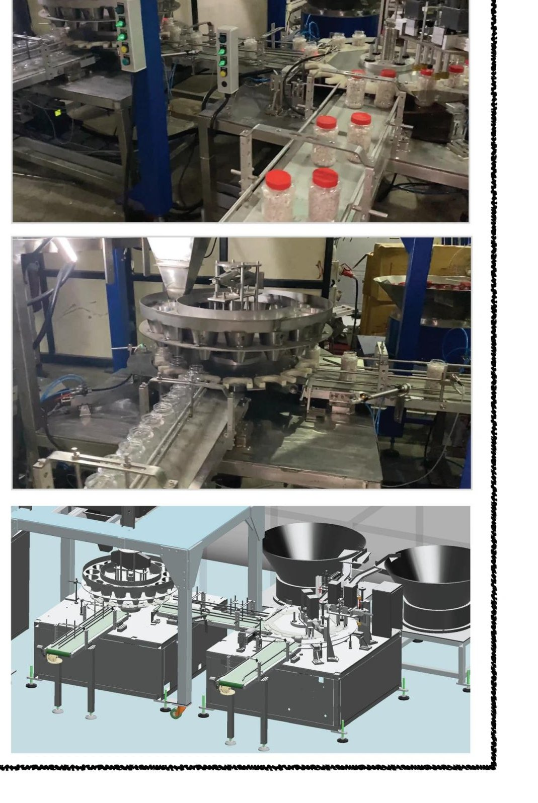

13. WELDING ELECTRODE PACKAGING AUTOMATION

Model: WEA1000

This sturdy automation line is built taking a modular approach. Custom designed for Electrode Packing Automation, this line can be operated with 2 persons. The speed of this line is 1000 to 1500 electrodes per minute in a balanced tandem feed format. The functional subsystems are:
- V HOPPER WITH CHAIN CONVEYOR: Electrodes to be packed need to be loaded on the V shaped hoppers provided on either side of the machine. This can be done manually with forklift. Chain conveyor travelling below the hopper picks up the electrodes and conveys them to the inspection table. The length of the inspection area is approximately 5 meters each.
- INFEED UNIT: The electrodes are fed onto the inspection conveyor which are then taken to the feed drum where the unscrambling of the electrodes takes place. The desired numbers are dropped into the primary carton which is formed by a cartoner. The dropping is by means of a special transfer unit to prevent chipping of electrodes.
- INSERTER AND HORIZONTAL CARTONER: The counted electrodes are transferred into an open carton. The cartonator uses pre cut and double creased open duplex board carton blank. The flap closing and gluing (with hot melt applicator) ensues online. Change parts may be required to handle different sizes and counts.
- IN LINE HORIZONTAL FLOW WRAP SYSTEM WITH USER SELECTABLE VACUUM PACKING FOR SS ELECTRODES: The flow wrap system can be used either with or without vacuuming (modified atmosphere packing). The flow wrapper also handles non vacuum operation with PE shrink films. When this is done the film can also be shrunk around the carton using the shrink tunnel.
- COLLATOR FOR FILLED CARTONS: Typically the individual cartons are collated and packed into a master carton. This station does the grouping as per your format for placement into the master carton.
- MASTER (SECONDARY) CARTON FORM FILL AND CLOSE SYSTEM: System to take the collated cartons and place onto a FFS shuttle CFC box former and move it to Hot melt glue applicator for carton closure.
- FORM FILL AND SEAL SHRINK STATION: Custom built for the above to handle Polyolefin and PE shrink films.
- ROBOTIC PALLETISING: This is an optional automation. This unit is provided to reduce human handling of the 20 kgs (approx) weight of each secondary carton; mainly to reduce operator fatigue. Omron, ABB or Fanuc robots are used in this process with line integration. Pallet handling is manual.
- COMMON CONTROL PANEL FOR THE ABOVE: Custom built with Schneider or Omron PLC and HMI with complete line, integrated and driven by Servo or conventional drives. Each of the above machines would have only ON, OFF, Emergency switches provided and cannot be supplied as a stand alone unit. Complete machine is interlinked with logic controllers, safety switches, guards and supplied as a turnkey project. Remote diagnostics system is built in for monitoring and maintenance of the machine from our server. This will enable the updation of software as and when we do upgrades and for any site modification or maintenance.
WRITE TO US FOR A DETAILED QUOTE GIVING YOUR ELECTRODE DIMENSIONS
sales@starpacindia.com or WhatsApp +91 98400 32057
Line photographs and General Assembly Drawing:
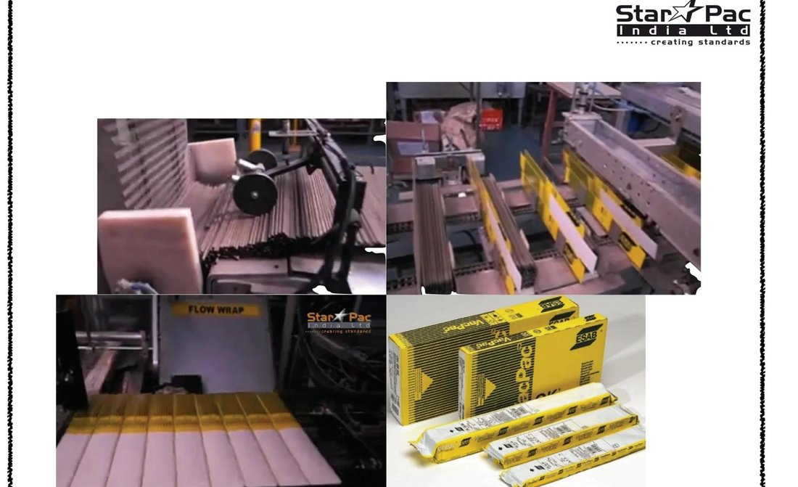
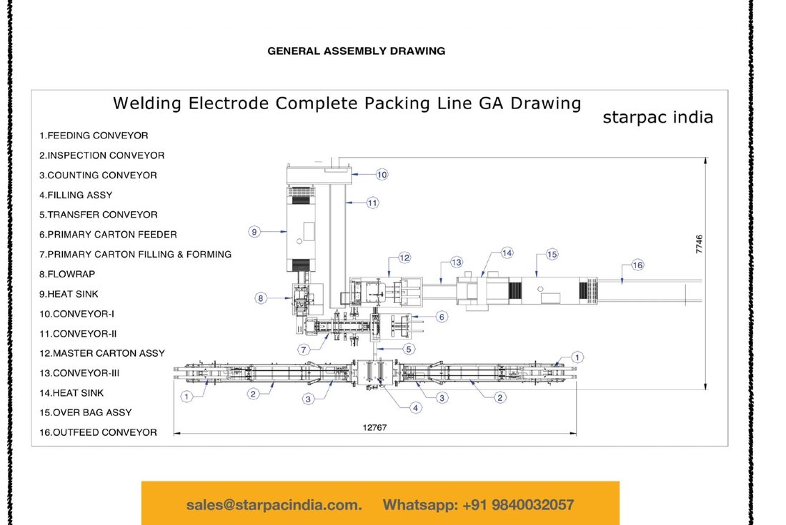

14. RANGE OF MACHINES FOR POPCORN PACKAGING

Ready to Cook (Instant Popcorn)

Single and Multilane machine options with speeds from 50 to 400 packs per minute. We provide complete turnkey packaging solution for this pack format in the form of slurry tank, seasoning dosage and corn. Downstream automations like collation, cartoning and case packing are options to consider.

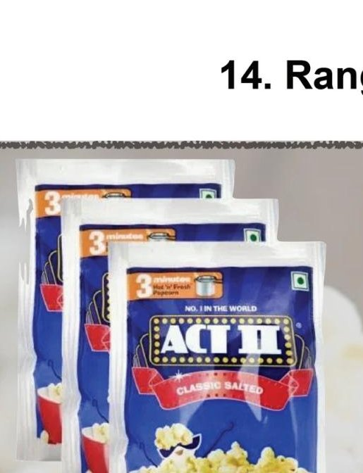

Microwave Popcorn Packaging Line

We offer single and twin head machines for this packaging with speeds from 30 to 120 packs per minute. Line is supplied with material handling and packaging system for Corn, Salt, Seasoning and Butter or Oil. Packaging includes the MW bag, outer pack and cartoning with optional case packing.

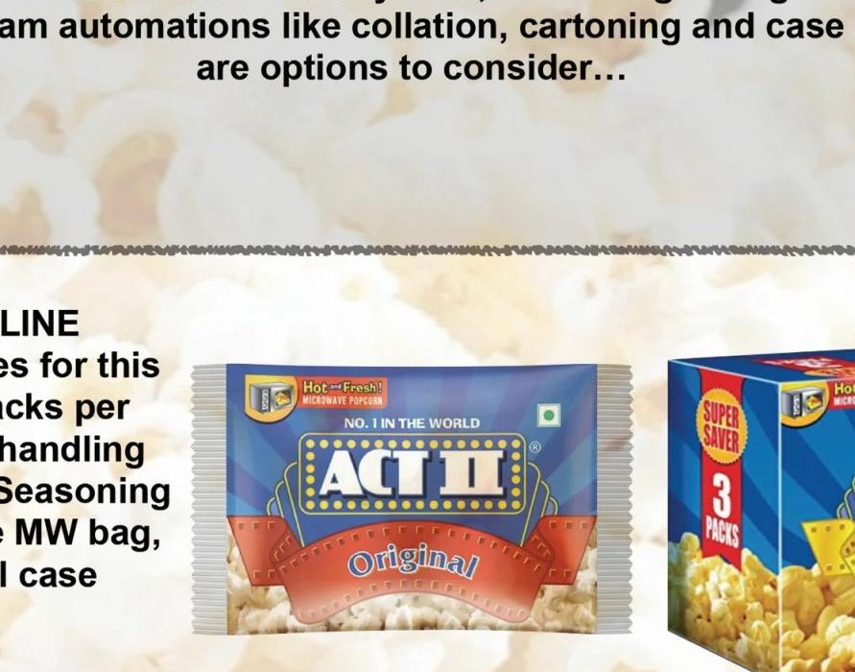

Ready to Eat Popcorn

Form fill and seal machines in single and multilane formats with speeds from 40 to 130 packs per minute are on offer. Center seal or tetrahedral pack formats can be considered. Product infeed, dusting pack additions and downstream automation are few of the added options.



Ready to Eat Popcorn in Standup Packs and Tubs

Machines for these formats operate at speeds of 40 to 80 packs per minute with a variety of dosing options to choose from. Downstream automation can include dispensers, case packing and palletising.



Mail us your requirements for a detailed offer on:

sales@starpacindia.com | WhatsApp +91 9840032057

15. PACK TO PALLET (P2P) AUTOMATION

For any Secondary or Tertiary packaging, the understanding of physics of the Primary packs is very essential. And physics of Primary packs depends on the behaviour of the products packed in them.

For over two decades we at Starpac have tested and mastered the science behind handling of a wide range of powders, granules, chunks, flakes, cakes, bars, liquids, pastes. This innate knowledge helped us in our foray into Secondary and Tertiary packaging, where the pack dynamics play an important role.

Armed with this, we now offer solutions for Pack to Pallet automation comprising but not restricted to:
- FFS, Fill and Seal
- Collating sachets, pouches, cartons, bottles, jars
- Bundling them into flexible packaging or cases individually or collectively
- Check weighing
- X ray or vision inspection
- Case packing
- Palletising with IOT backbone
DO CALL US OR EMAIL FOR A NO OBLIGATION STUDY OF YOUR PACKAGING LINE AND SUBMIT A PROPOSAL FOR END TO END AUTOMATION

Palletizing Options

Two approaches are available for this automation. One a Robotic option and the other a Gantry system. Both of them are custom built to suit the specific requirements and constraints of your operations and floor area. It is advantageous when you decide this automation with our primary or secondary packaging system, as it will save you on the cost of an additional panel and controller.

Gantry System for Palletising

This system is ideal for handling heavy cases and is amenable for high speed operation of up to 200 cycles per hour. This system is not limited by area of operation unlike a Robot, as the span of transfer is purely need based. Further this is flexible to handle one or two different types of cases or crates. Depending on the activities involved the conveyors and coordinate movements are designed. Pallet handling can be automated as well. Pallets can be fetched either by lateral pushers, roller transport or pick and place systems. The gripping tools in the case of pick and place is designed to avoid any damage to the crate. Depending on the matrix of the cases it is easy to change the palletising format. Safety grills can be built around the gantry for equipment and human safety.

Robotic Palletizing

Robots provide flexibility in installation not common with Gantry type. Being a standard item it has a quicker set up possibility. The robotic palletizing system is ideal for connecting several packaging lines with multiple SKUs. It is a flexible system allowing the pallet handling with different products and matrix simultaneously. Standard Robots from the market like ABB, Fanuc and Festo are used for these operations.

The same Robot can be used for pallet handling and case loading. The gripping tools are custom designed for each application. One robot can feed multiple pallets. Typically a Robot 270 deg sweep is used for Pallet handling and filling. The products are picked from an accumulation system to complete the cycle and position onto the pallet. Safety grills can be constructed as per site conditions.

Attributes Common to Both Gantry and Robotic Palletizing Options
- By employing Internet of Things and Augmented Reality these systems are optimised for safety and throughput.
- Cloud based engineering design system with a large and committed R&D team are instrumental in designing complex material handling requirements.
- In house fabrication and machining facility helps us deliver custom made systems with short turn around times.
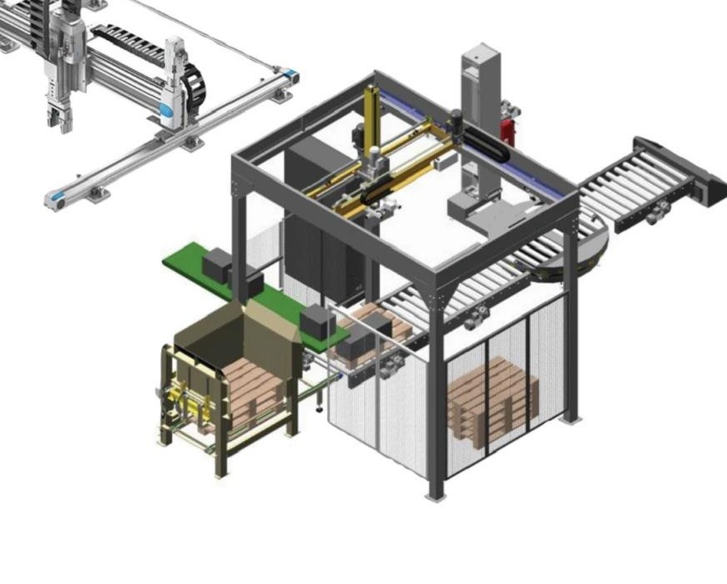
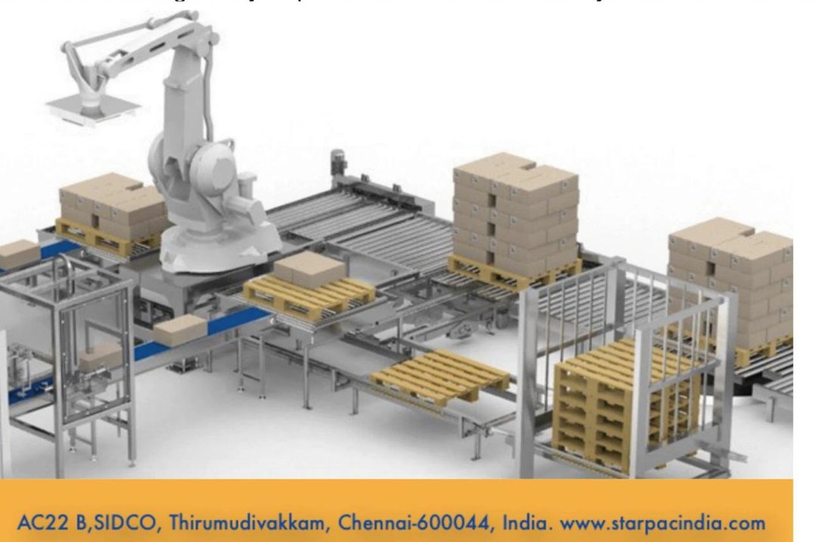
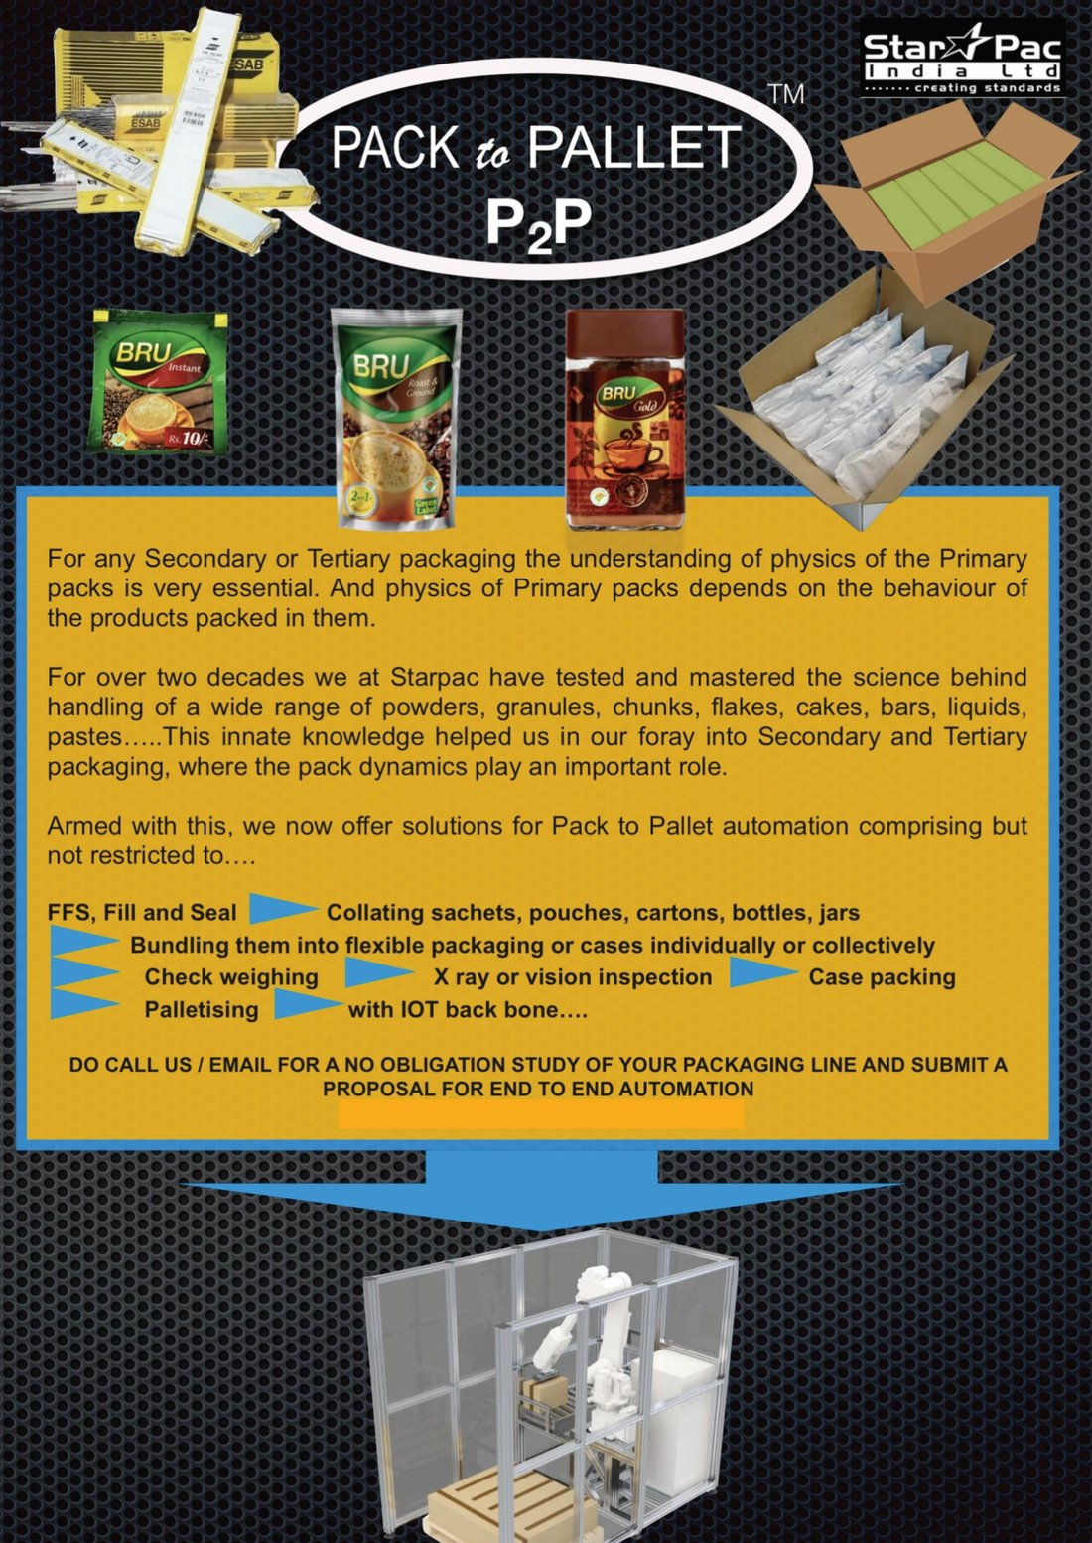

16. STARCOD HIGH RESOLUTION THERMAL INKJET PRINTERS
StarCod High Resolution Thermal Inkjet Printers (HRTIJ) provide a versatile and cost effective means to meet the need for variable data printing requirements of FFS, Carton, Tube and Jar machines. These are designed to be highly configurable allowing for multiple print lanes to be coded simultaneously. This is achieved without high maintenance print heads or expensive laser systems. The unit can be integrated into almost any VFFS machine, regardless of seal type whether Stick, Sachet, Pillow or Standup pouches. Longitudinal and horizontal printing can also be accommodated with ease. With a small footprint, a modular design and with no moving parts to consider, this coding solution gives MAXIMUM UPTIME TO THE PACKAGING EQUIPMENT with practically ZERO MAINTENANCE.
This is available in single and multi head formats making it an ideal fit for multi lane machines as well.

Better Throughput

Although STARCOD HRTIJs can print at line speeds of over 160 m per minute, this is not the major throughput enhancement. Instead it is the ease with which the print system can be running in a matter of seconds with minimal user intervention, maximum productivity at all times.

Salient Features
- Maximum up time at all time
- Be ready to print in seconds
- Single button start, plug and play

Cost Effective

With StarCod HRTIJ, you use only the ink you print. No overuse of ribbons as in TTO print systems and no messy and smelly CIJ printers venting solvents into your plant. And certainly much less expensive than complex Laser based systems with necessity of fume disposal systems. Hence take aways are:
- Reduced consumable costs
- No maintenance costs
- Longer time between changeover

Cleaner to Use

Unlike other print solutions such as CIJ and Thermal transfer (TTO), the StarCod HRTIJ is inherently clean, utilizing HP's solvent ink technology. The ink is contained in cartridges and is sprayed only on demand. Open frame design for easy cleaning and maintenance with HP based Thermal Inkjet technology keeps area mess free. No VOCs as part of the ink delivery system.

Pay Less, Get More

If you have used other print technologies, then you know how costly it can get. Why pay more when you can get better throughput, zero maintenance, simple installation and guaranteed performance. For example a complete system including industrial color, touch screens, print head assemblies, sensors and encoders can be obtained for a fraction of what you currently pay.
- Replaces CIJ: No shuttling heads, no mess, no smell.
- Replaces TTO: No ribbons, no replacing of print heads.
- Replaces Laser: No hardware cost, no extraction systems.
Contact: sales@starpacindia.com
AC22B, SIDCO Thirumudivakkam, Chennai 600044, India
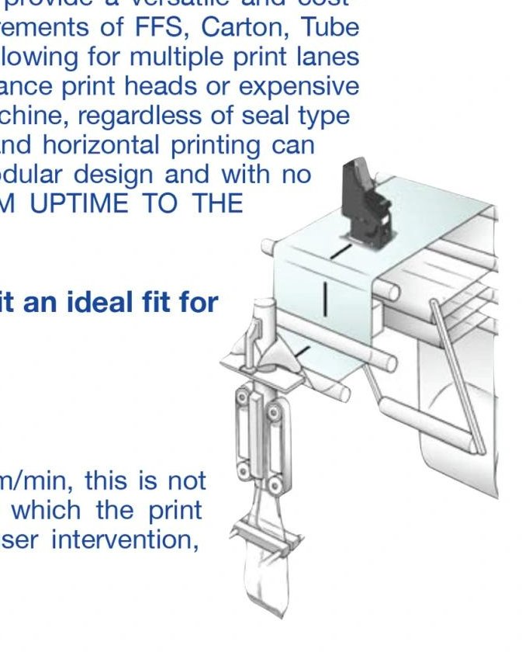
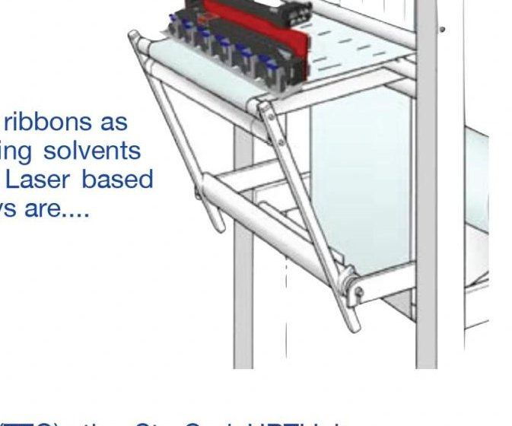
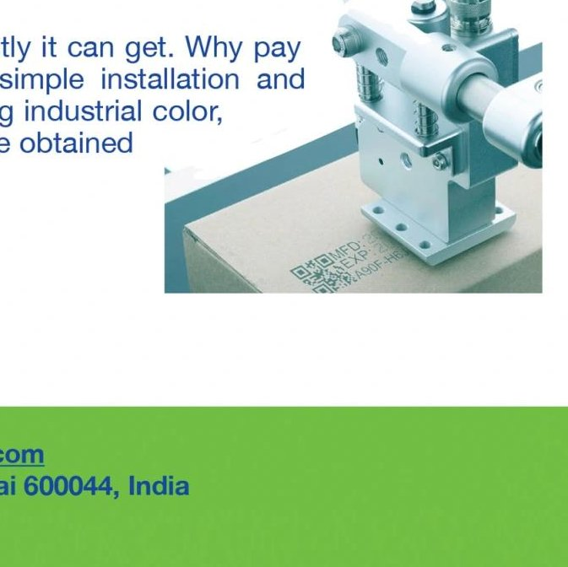

17. NOTES

STAR PAC INDIA LTD
Creating Standards
AC22B, SIDCO, Thirumudivakkam, Chennai 600044, INDIA
Web: www.starpacindia.com
Email: sales@starpacindia.com | starpacindia@gmail.com
WhatsApp: +91 98400 32057

Channel Partner: ___________________________________________

Certifications: BMQR CE Certified | AIAO BAR Accredited | CE | Make in India
