PRODUCT SALES AND ANALYSIS

INTRODUCTION :-

Analyzing product sales using machine learning involves leveraging algorithms to uncover patterns, trends, and insights from sales data. By applying ML techniques, businesses can make data-driven decisions, optimize pricing strategies, and enhance overall sales performance. This analysis typically includes predicting future sales, identifying key factors influencing sales, and recommending strategies for improvement. In this introduction, we'll explore the fundamental concepts and methodologies behind employing machine learning in product sales analysis.

USE OF MACHINE LEARNING :-

Machine learning techniques allows for predicting the amount of products/services to be purchased during a defined future period. In this case, a software system can learn from data for improved analysis. Compared to traditional demand forecasting methods, a machine learning approach allows you to,

* Accelerate data processing speed
* Provide a more accurate forecast
* Automate forecast updates based on the recent data
* Analyze more data
* Identify hidden patterns in data
* Create a robust system
* Increase adaptability to changes.

All industries aim to manufacture just the right number of products at the right time, but for retailers this issue is particularly critical as they also need to manage perishable inventory efficiently.

BUSINESS PROBLEM :-

Demand forecasting is the process of predicting what the demand for certain products will be in the future. This helps manufacturers to decide what they should produce and guides retailers toward what they should stock. Demand forecasting is aimed at improving the following processes,

* Supplier relationship management
* Customer relationship management
* Order fulfillment and logistics
* Marketing campaigns
* Manufacturing flow management

PUBLIC RESPIRATORY MATCHING THIS TOPIC :-

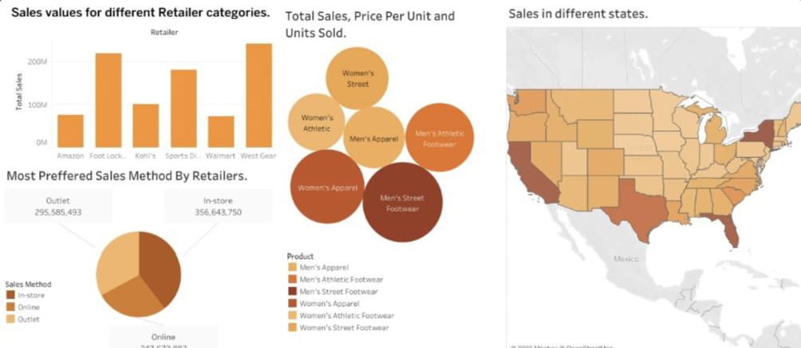

MACHINE LEARNING OF SALES ANALYSIS BY USING PYTHON LANGUAGE :-

* DATA LOADING:-

import pandas as pd

# Load data from Excel file

df = pd.read_excel('sales_data.xlsx')

* DATA EXPLORATION :-

# Display basic statistics

print(df.describe())

# Show first few rows

print(df.head())

* DATA VISUALIZATION :-

import matplotlib.pyplot as plt

import seaborn as sns

# Example: Bar chart

sns.barplot(x='Product', y='Sales', data=df)

plt.show()

* ANALYSIS WITH PYTHON LIBRARIES :-

from sklearn.linear_model import LinearRegression

from sklearn.cluster import KMeans

# Example: Linear Regression

model = LinearRegression()

X = df[['Advertising_Spend', 'Price']]

y = df['Sales']

model.fit(X, y)

* TIME SERIES ANALYSIS:-

from statsmodels.tsa.arima.model import ARIMA

# Example: ARIMA

model = ARIMA(df['Sales'], order=(1, 1, 1))

results = model.fit()

PRODUCT AND SALES ANALYSIS IN EXCEL SHEET :- 