1. Which UGC-funded institution has the largest number of undergraduate students throughout 10 years ?

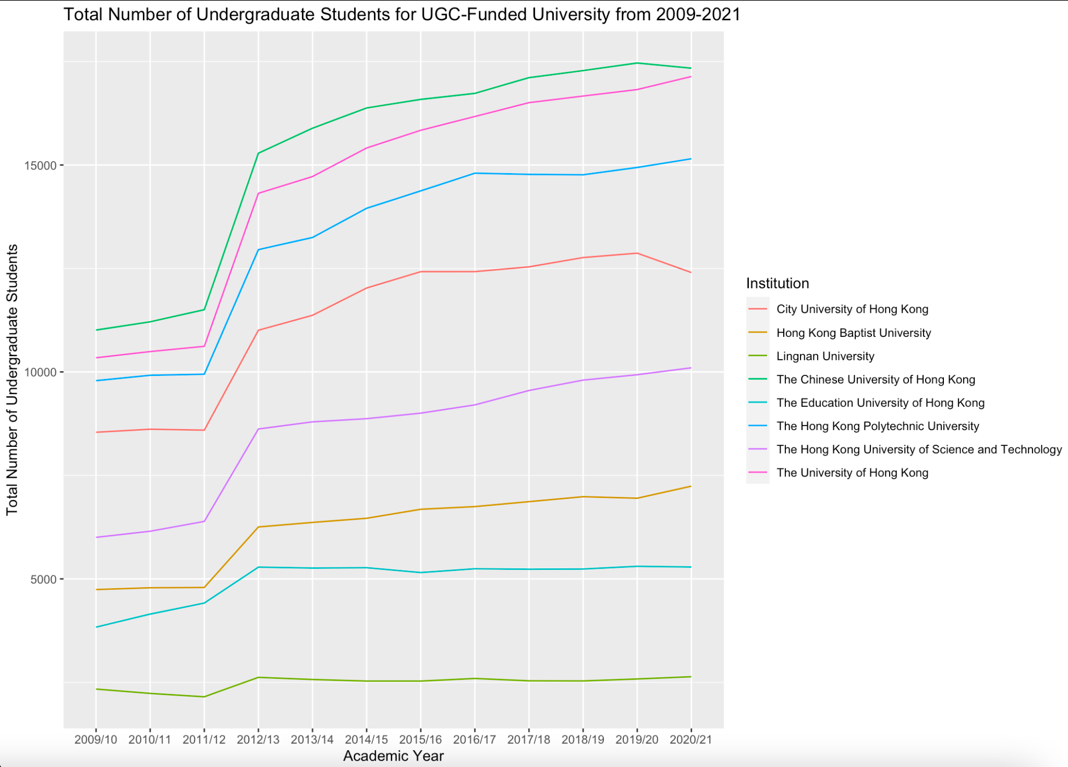

As seen from the graph, the number of UG students is increasing over the years for every UGC-funded institution. CUHK, CityU, and PolyU have the largest number of UG students in this decade, with CUHK at the top.

The increase in student numbers is evident especially from 2010/11 to 2012/13 when all universities in HK began to adopt HKDSE as the main admission scheme for local secondary school students.

1. What is the age distribution of first-year local JUPAS undergraduate student populations?

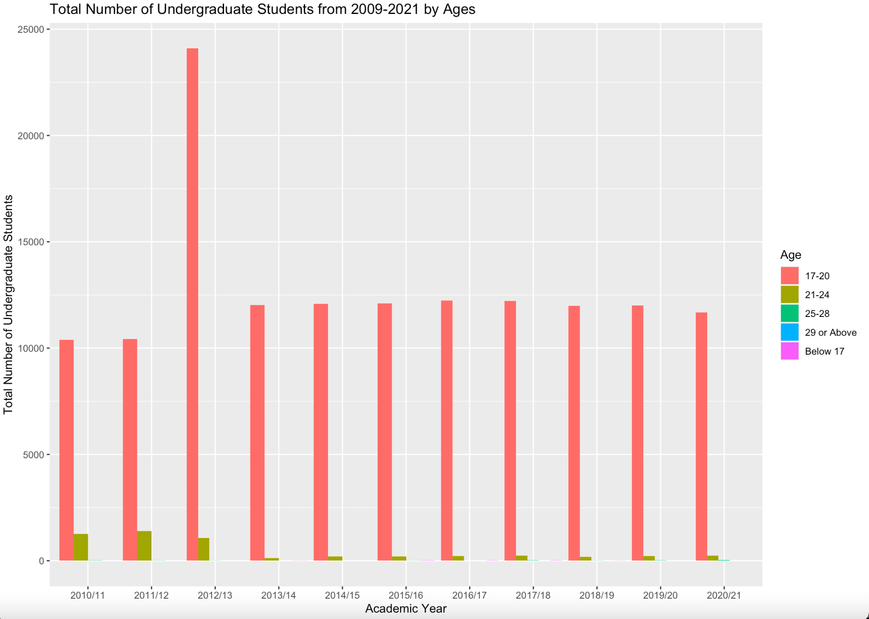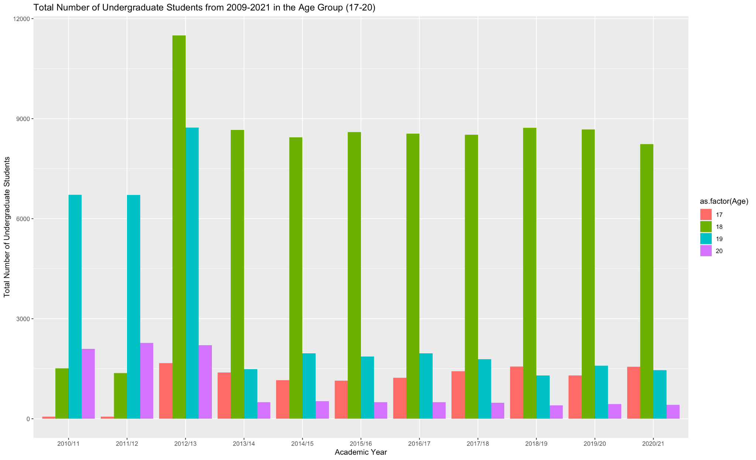

It can be seen that while most first year students entered UGC-funded institutions at 19 before 2013/14 and the number of students aged 19 culminated in 2012/13, the majority have enrolled one year younger since then. The reason is also due to the abolishment of HKALE and adoption of HKDSE.

1. Where do most first year undergraduates intakes come from? Is the number of mainland students increasing significantly over the years?

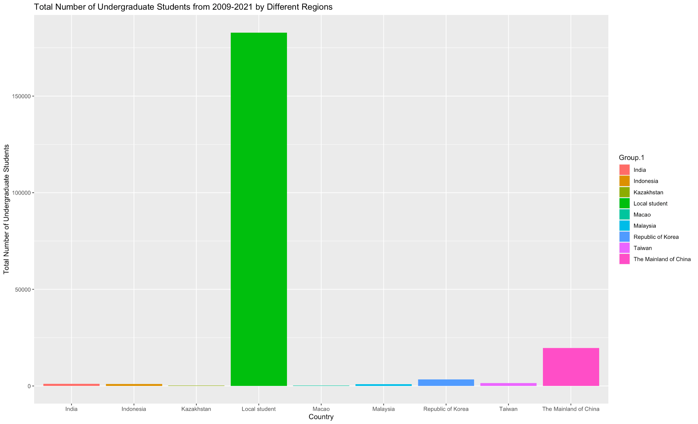

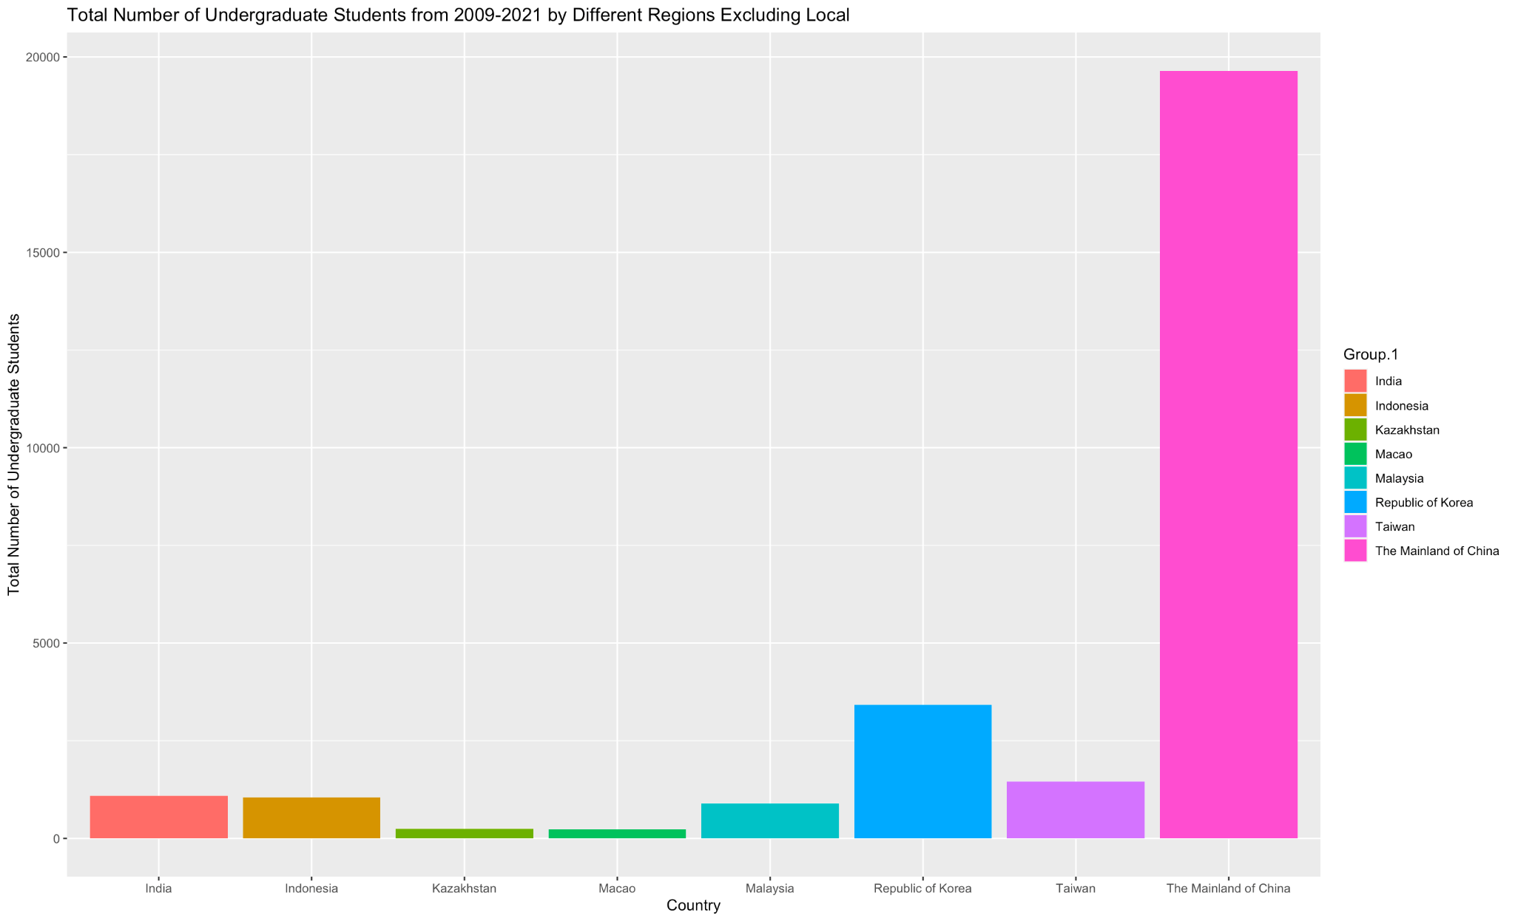

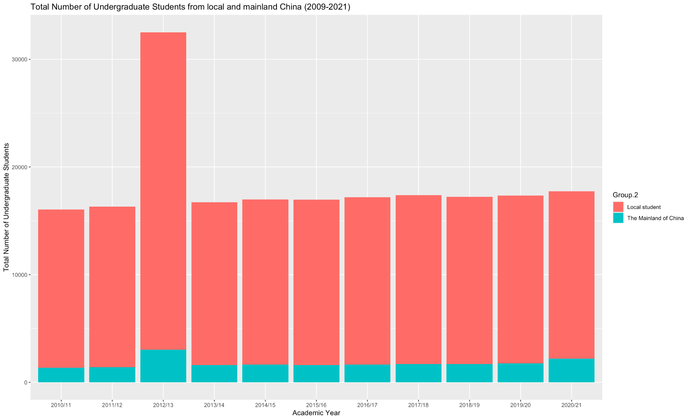

Throughout 10 years, local students dominate undergraduate populations. Among non-locals, Mainland China and Korean student populations have been significantly greater than the number of students from other areas.

The population ratio of local to mainland China students has been roughly constant throughout the years.

1. Which industry do most graduates work in? Among different schools, which school contributes the most to different sectors?

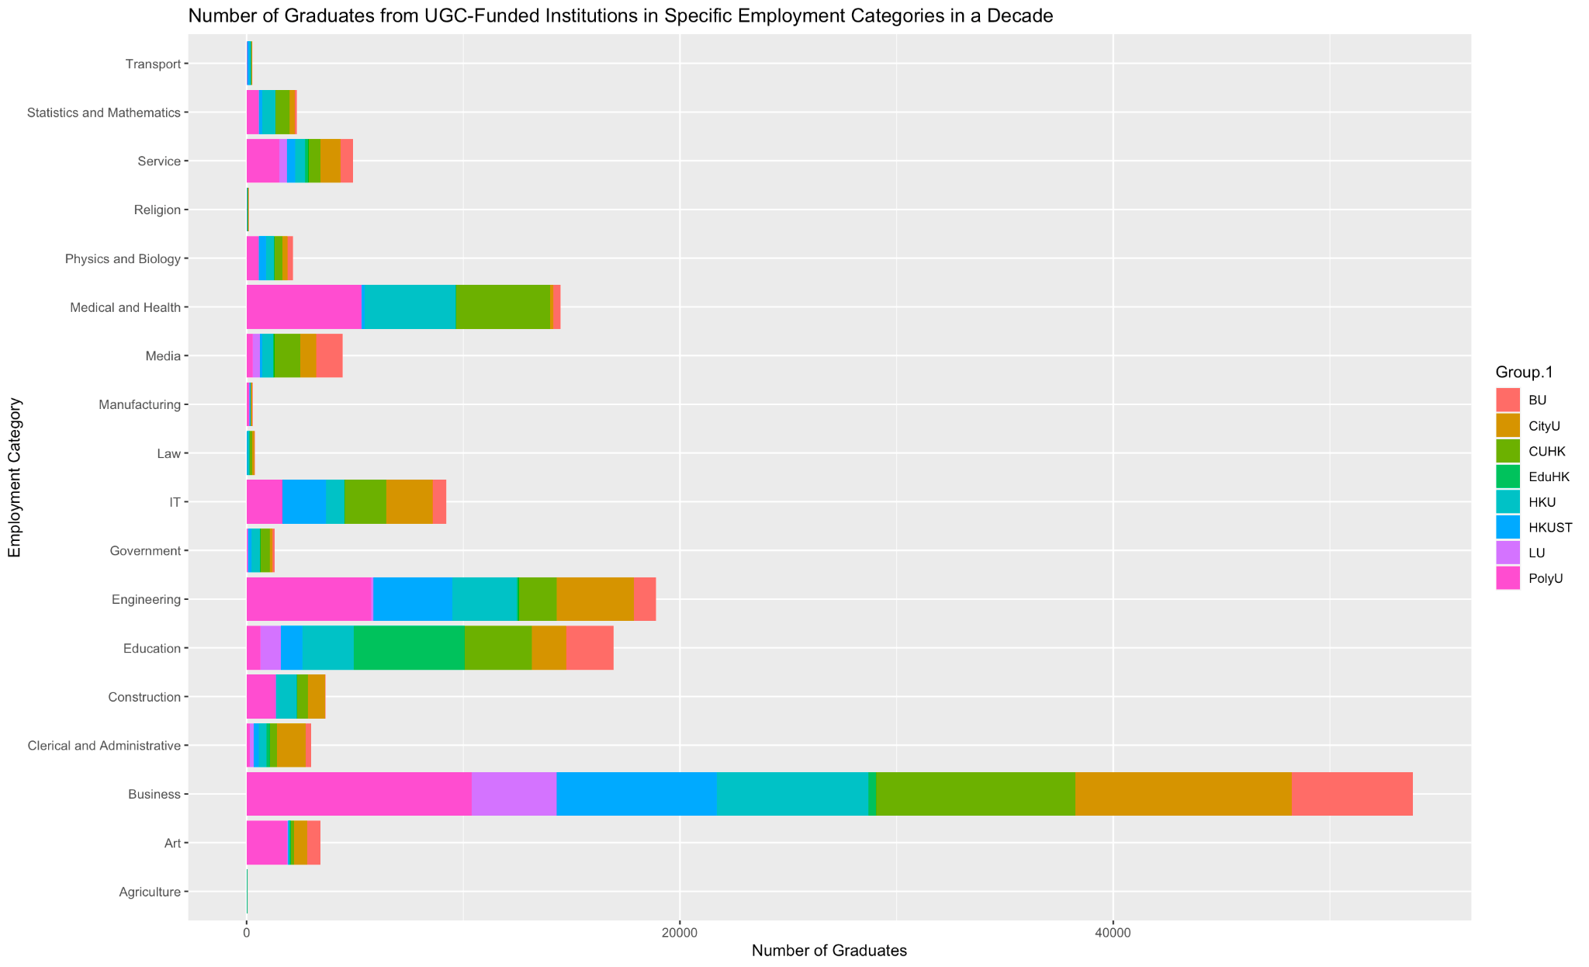

From this chart, we can see that the number of graduates working in business is far greater than that of graduates working in other industries.

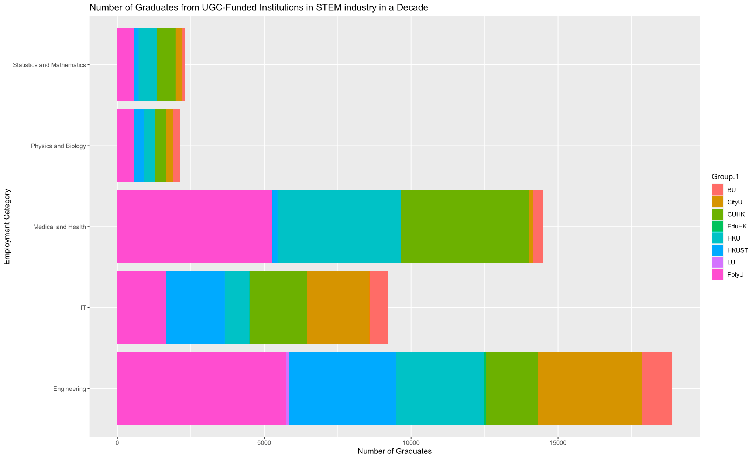

For the STEM industry, it’s also evident that graduates primarily work in engineering and medical and health. Simultaneously, significantly fewer graduates work as either IT or Mathematicians.

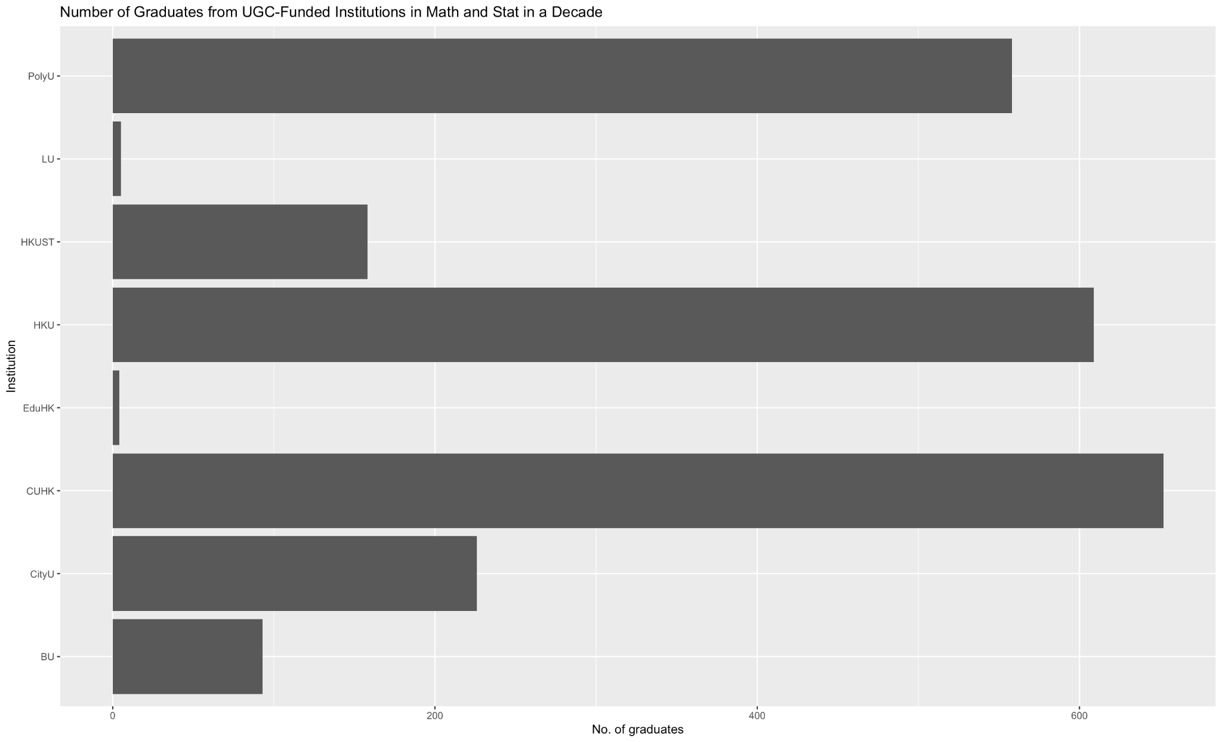

CUHK, HKU, and PolyU have produced most graduates who work in Math and Stat

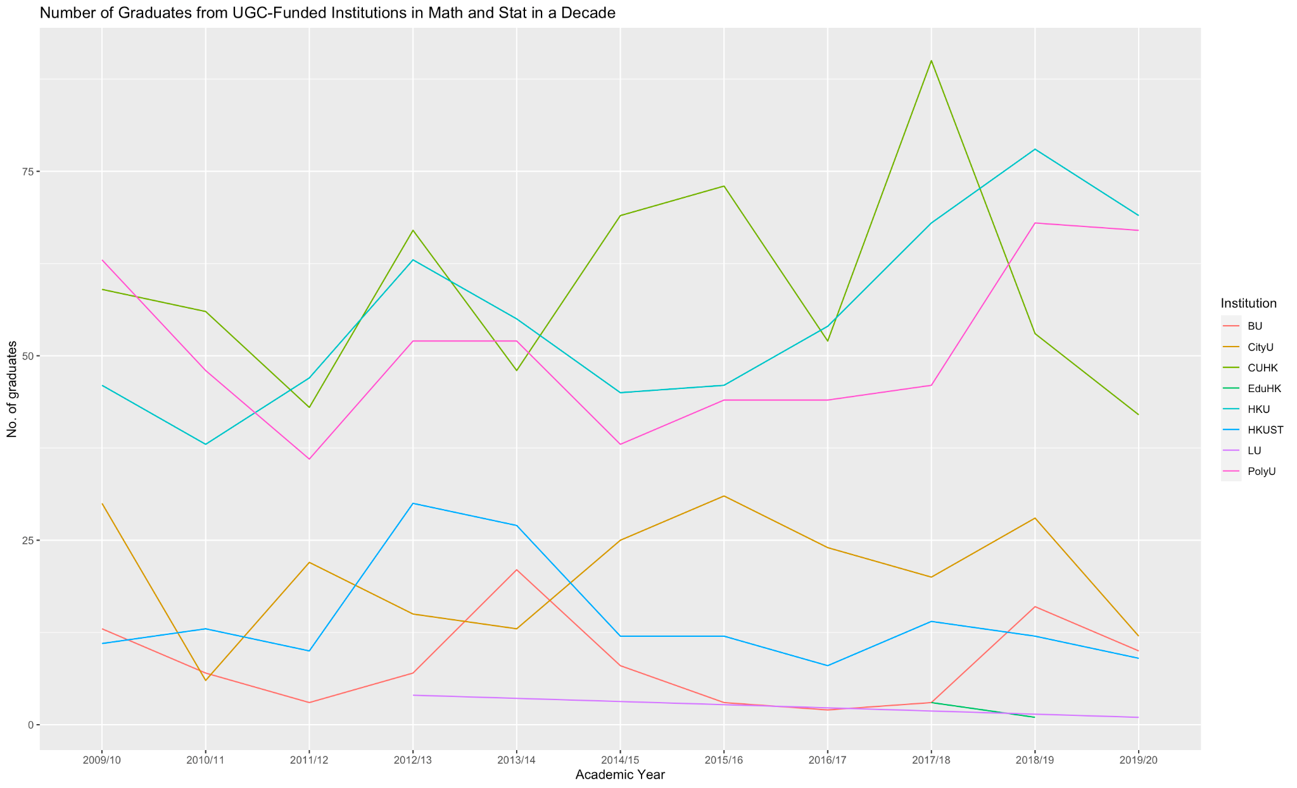

In recent 3 years, graduates who work in Math and Stat are overall increasing in numbers despite that the number in CUHK is decreasing.

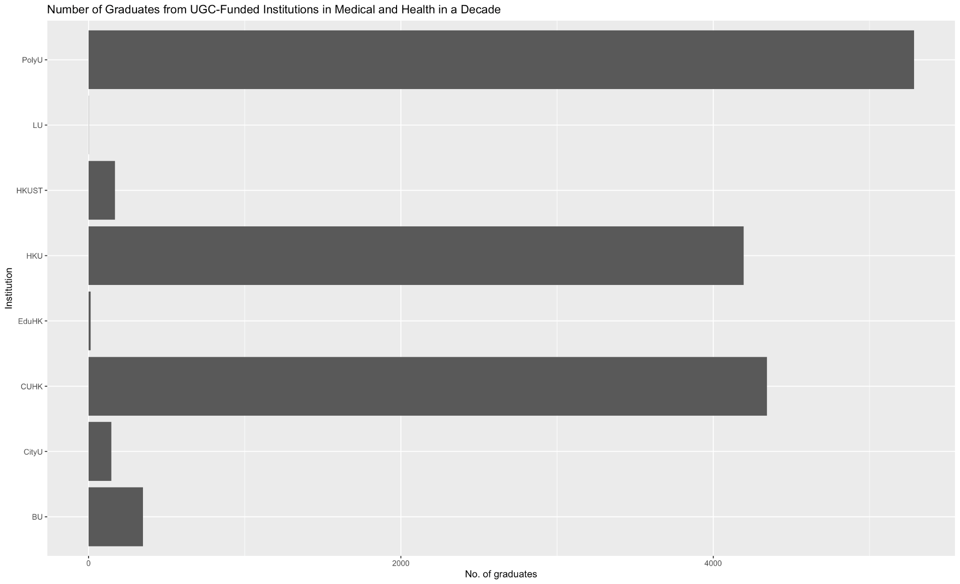

Medical and health professionals or workers mostly come from HKU, CUHK, and PolyU.

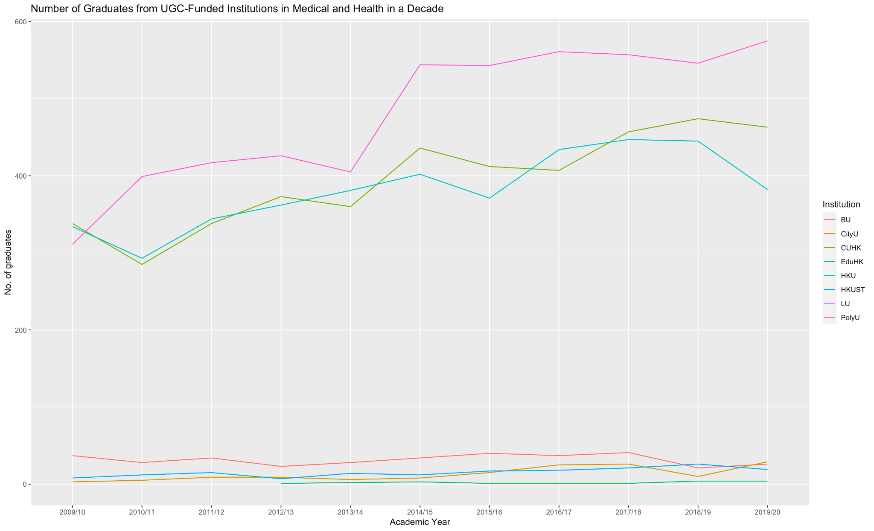

PolyU has been the institution where most Medical and Health workers come from.

The difference between HKU and CUHK has been similar and started widening since 2018/19 in terms of number of Medical and health professionals or workers.

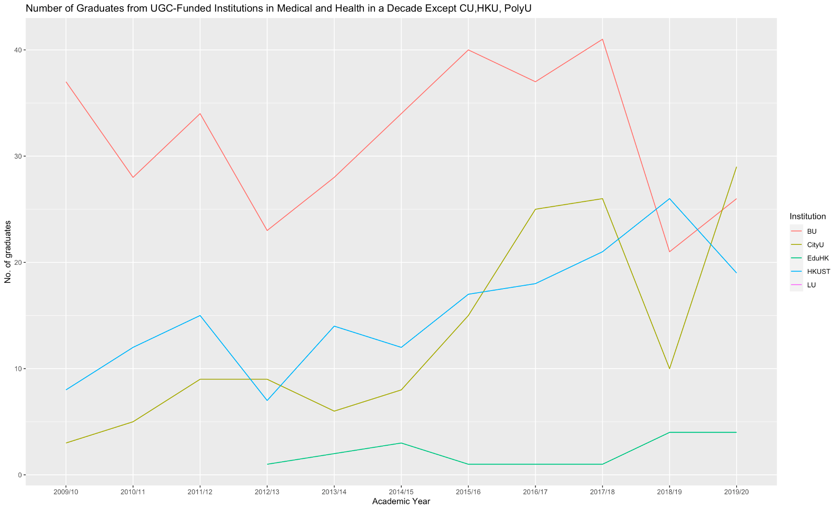

City U increases significantly

BU Decreased significantly and then increased mildly

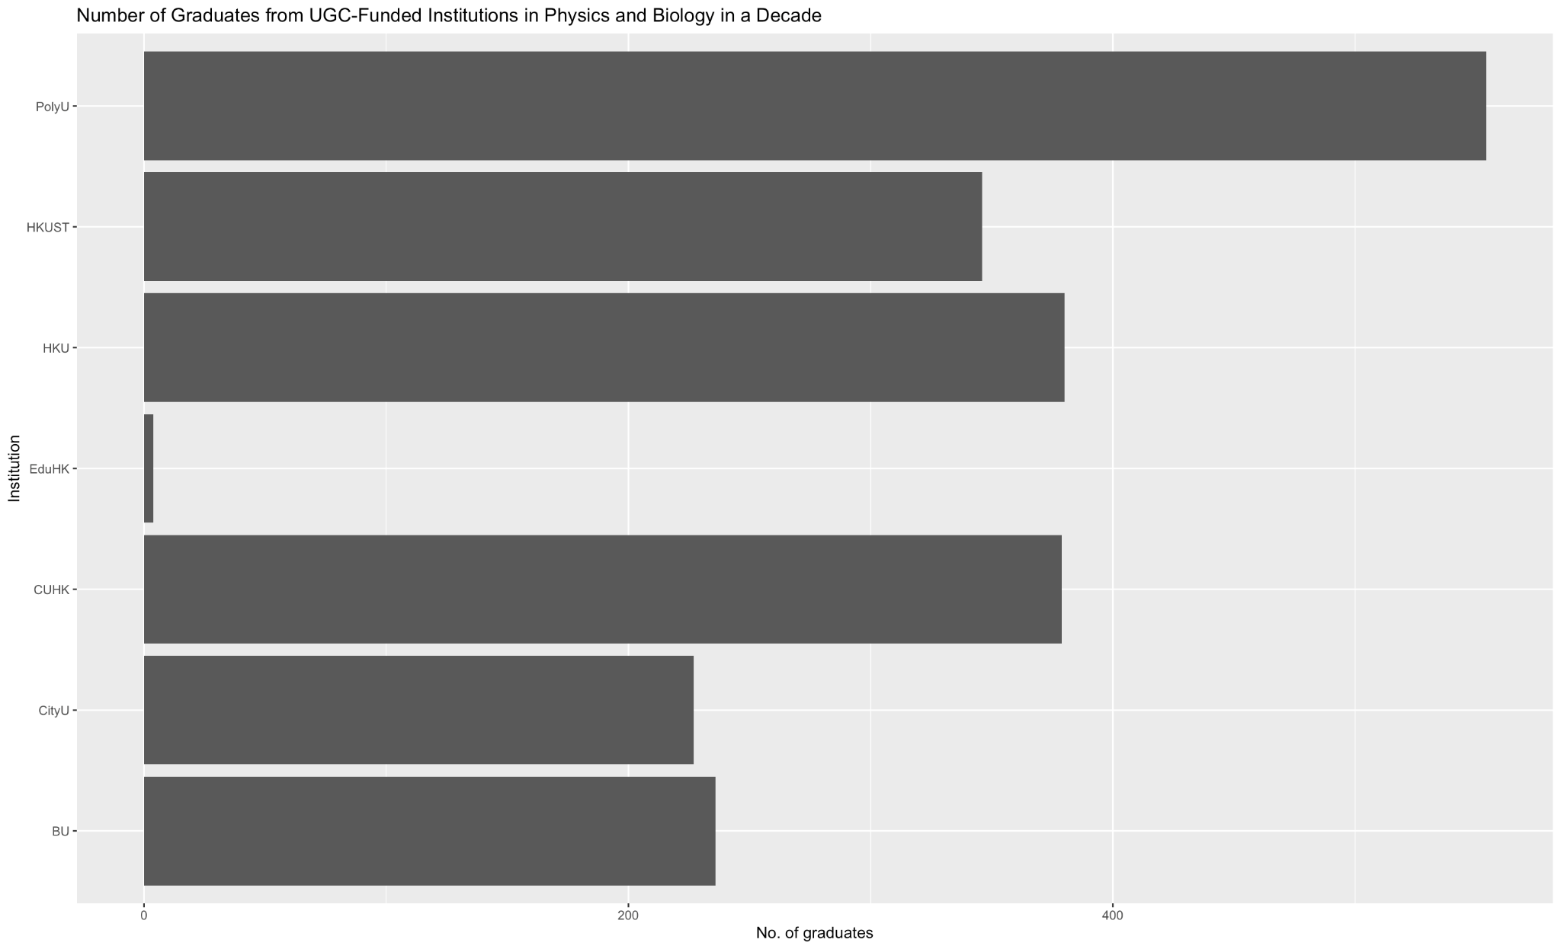

HKU, PolyU, and CUHK have produced most graduates working in Physics and Biology.

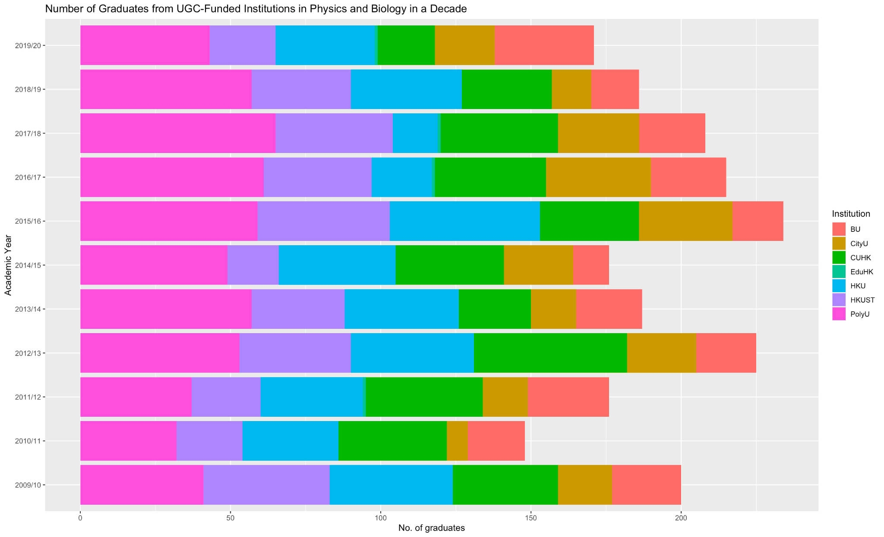

Graduates who work in Phy and Bio have remained at least 150 each year.

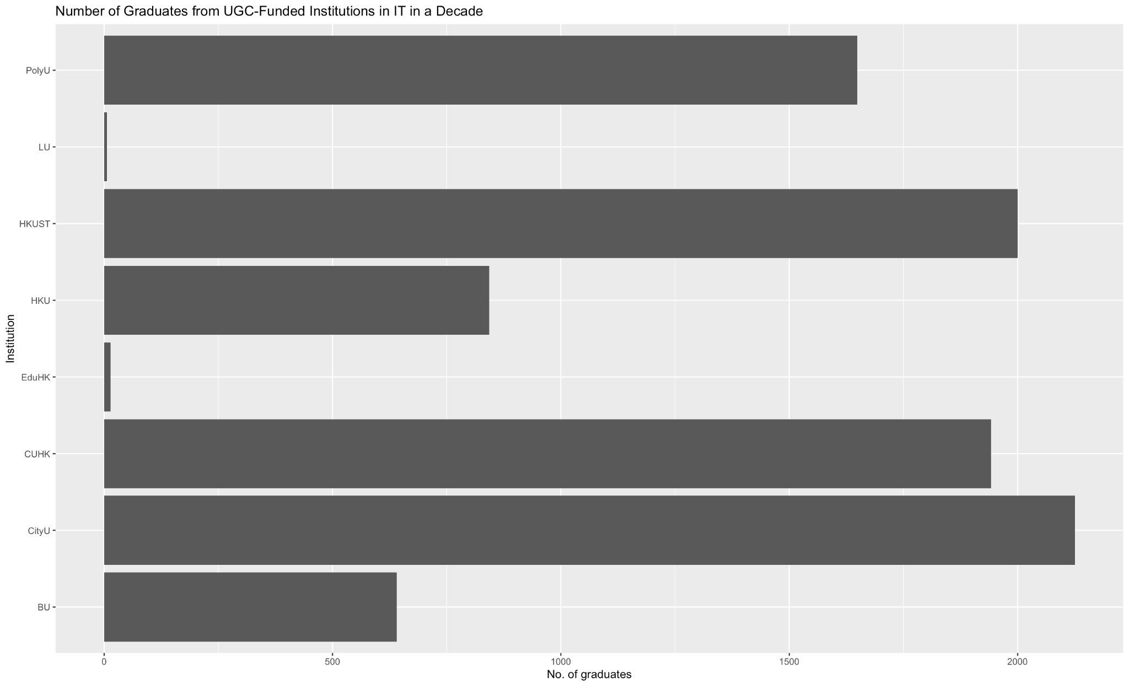

CityU, HKUST, and CUHK have produced most graduates working in IT.

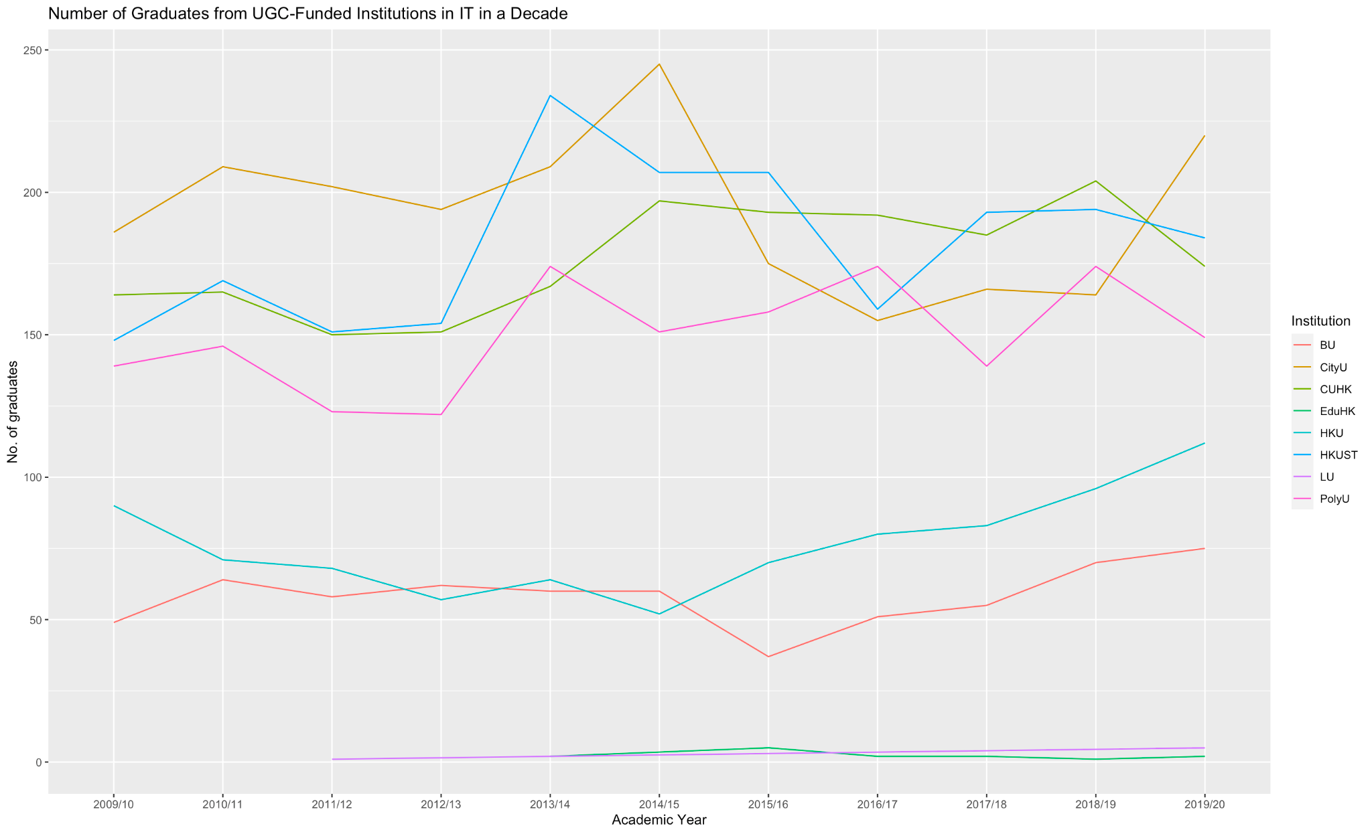

Number of graduates working in IT industries is increasing overall.

CityU overtook HKUST and CUHK from 2018/19.

HKU has been steadily growing starting from 2014/15.

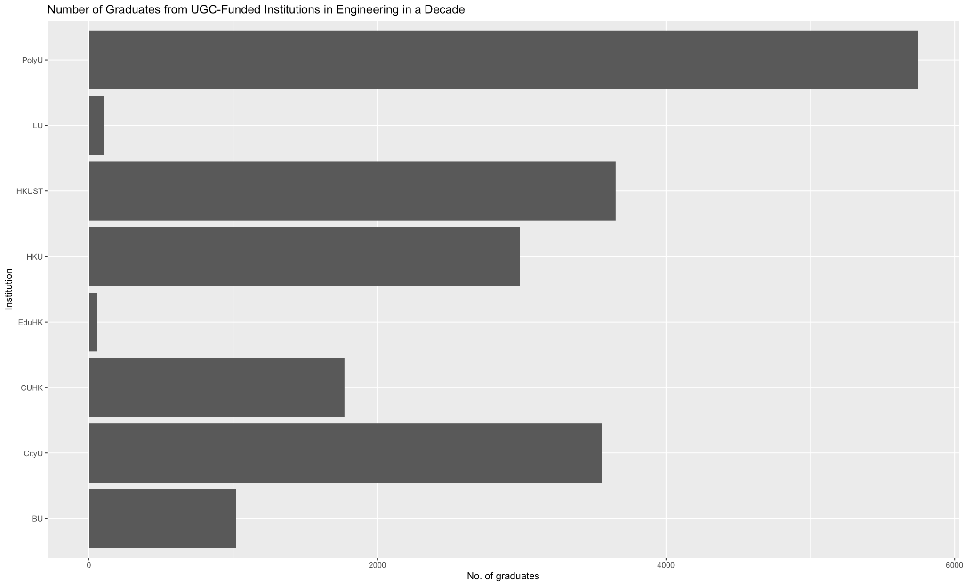

PolyU, HKUST, and CityU have produced most graduates working in Engineering.

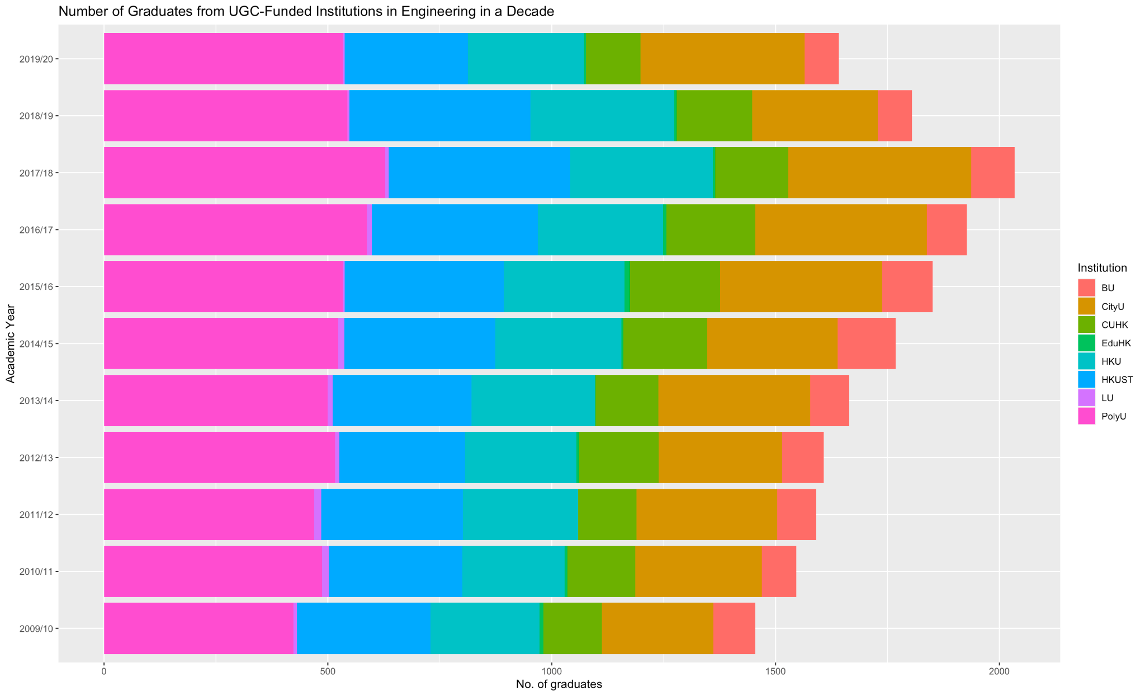

The portion of graduates in Engineering remains roughly constant for each school.

1. Is the number of students who discontinue their undergraduate studies increasing?

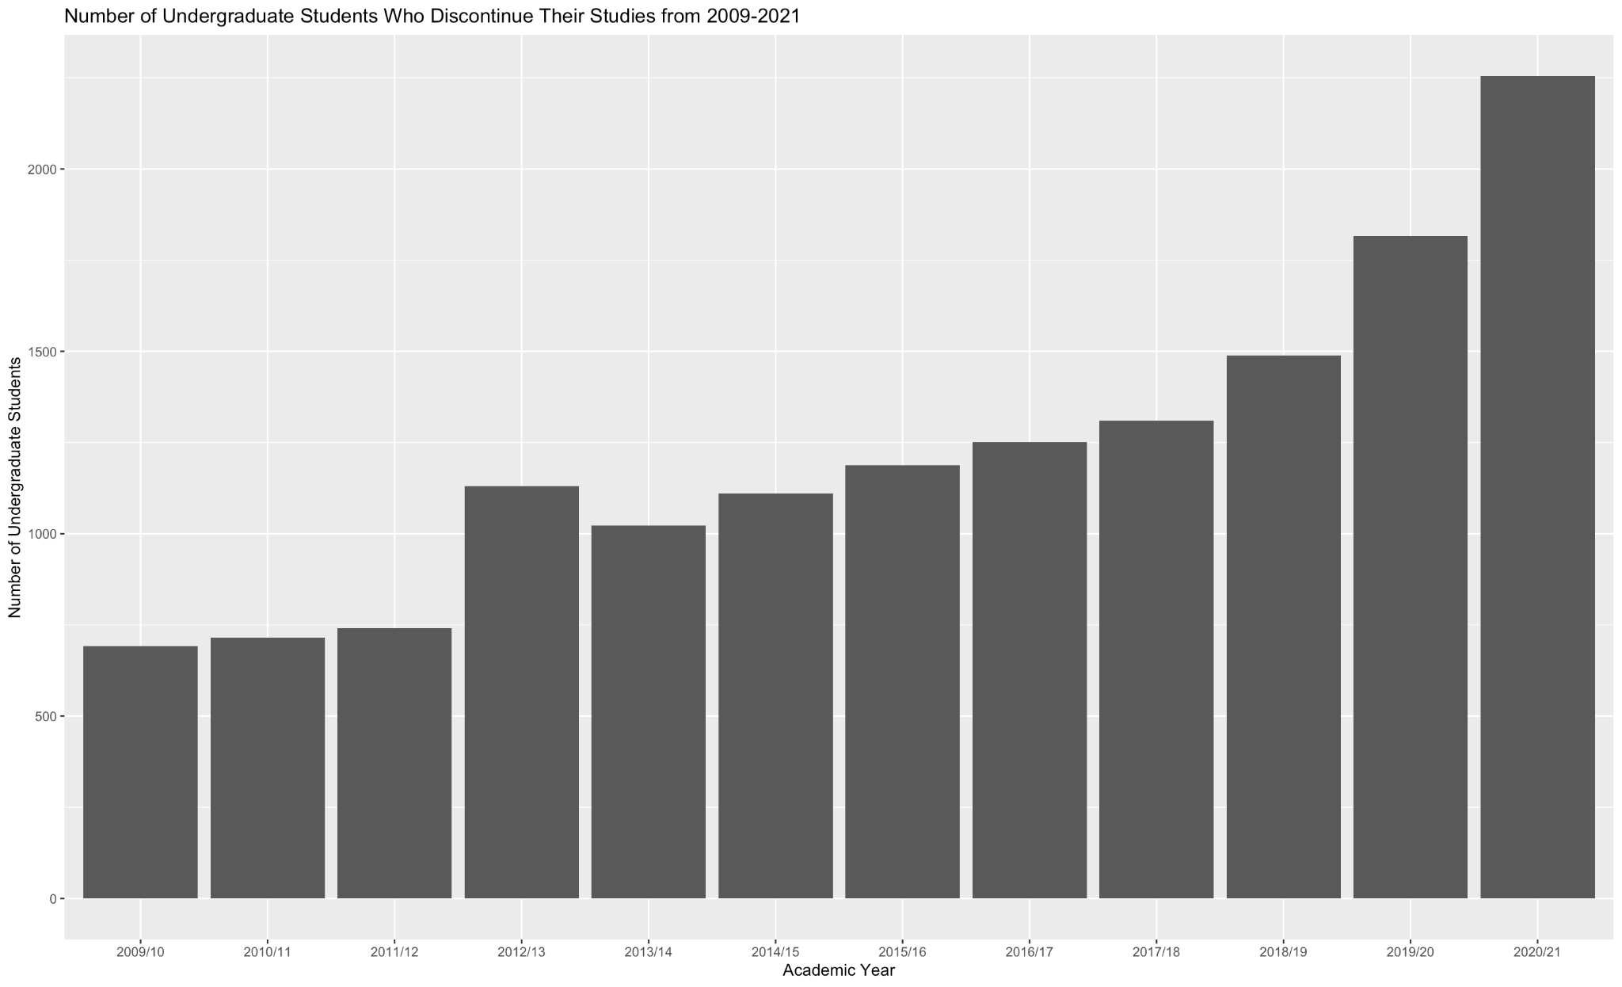

Yes. The number is increasing year by year.

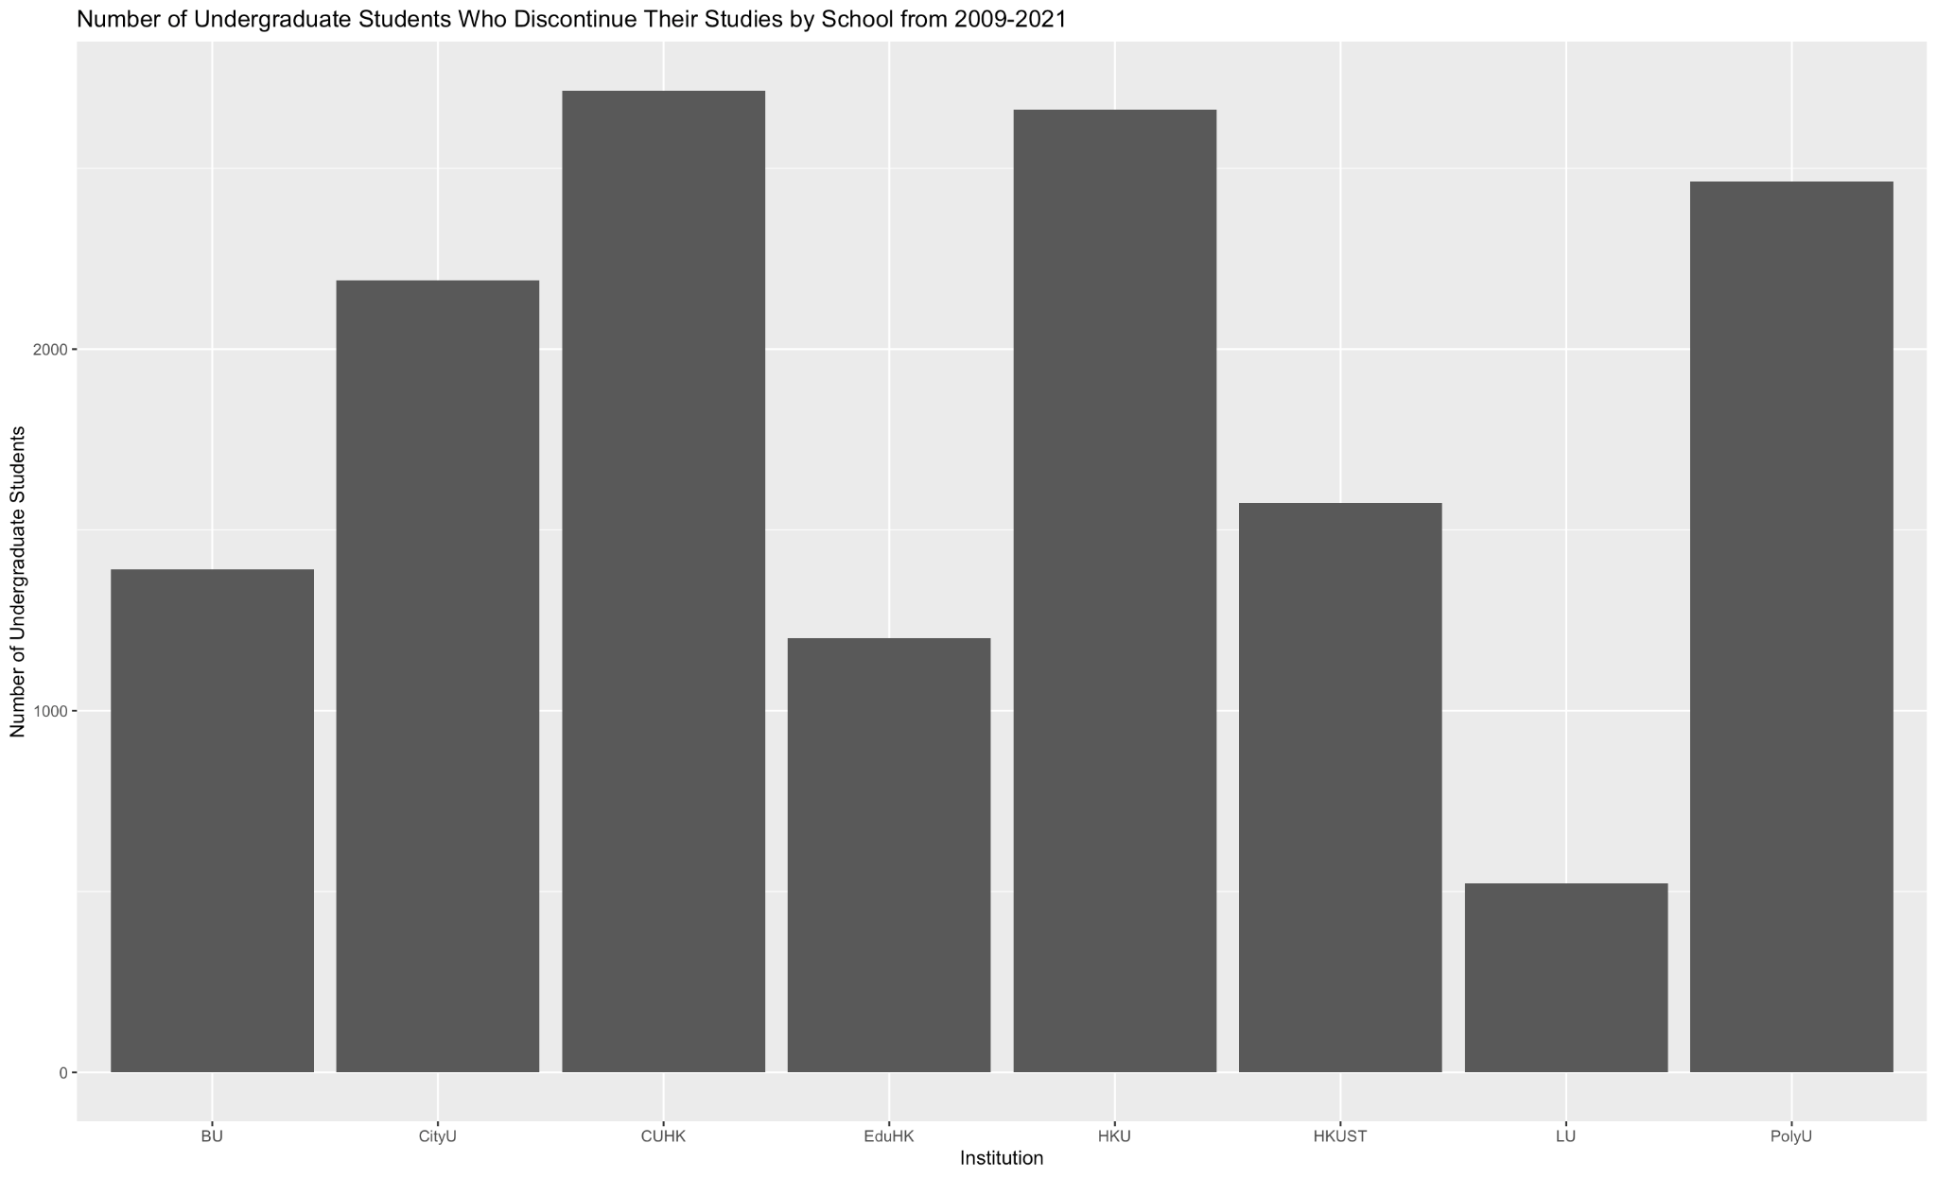

CUHK, HKU, and PolyU have the largest number of students who discontinued their studies.

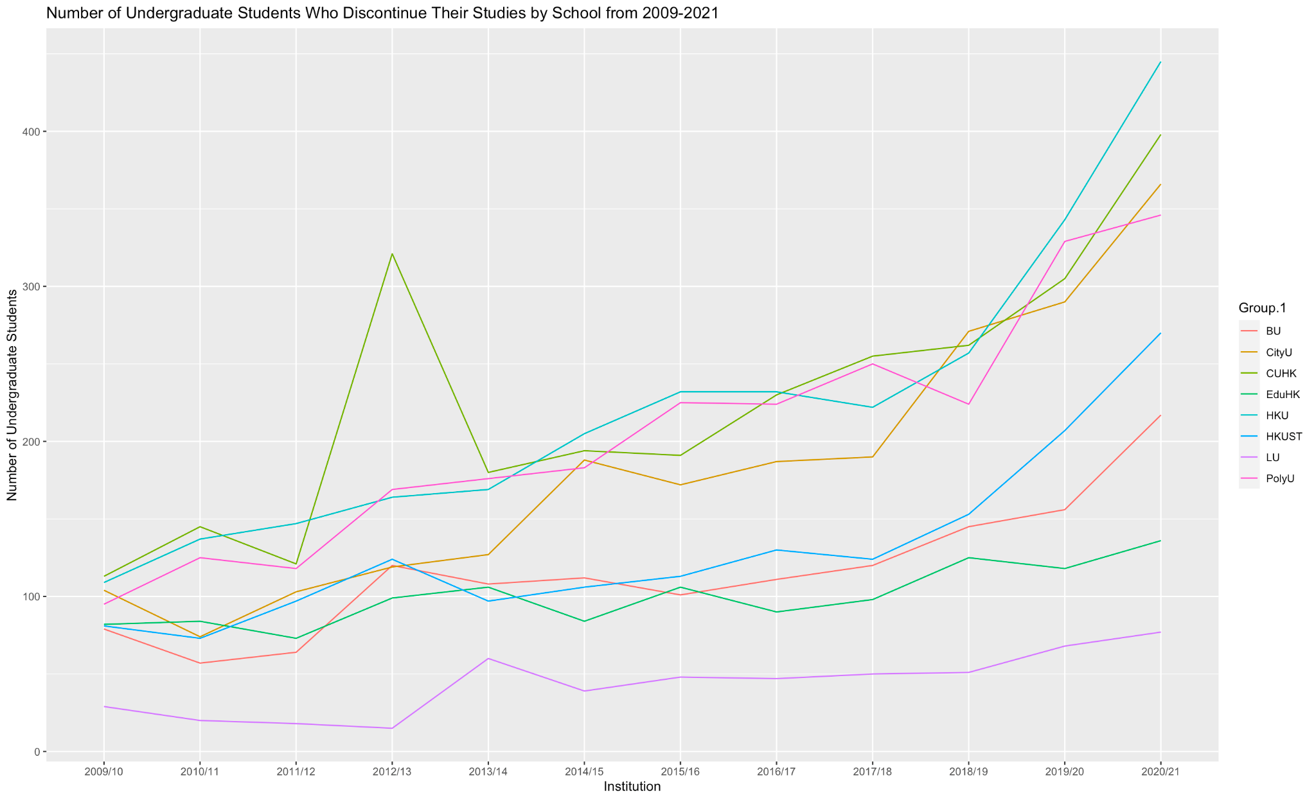

The upward trend started from 2018/19 for all institutions.

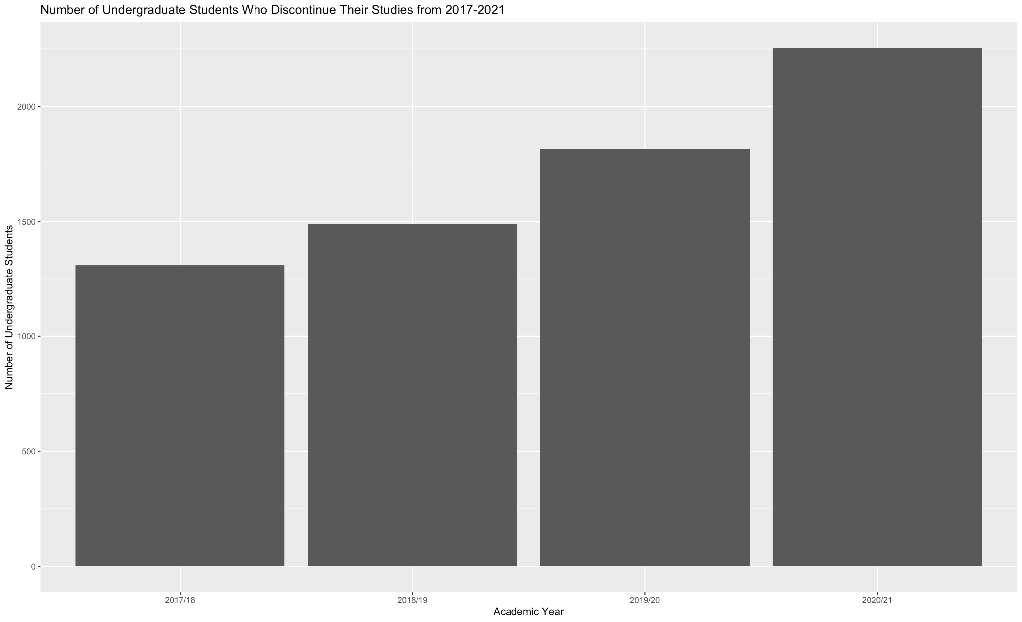

In 2020/21, the number of dropouts was nearly 500, which was doubled than the figure in 2019/20.

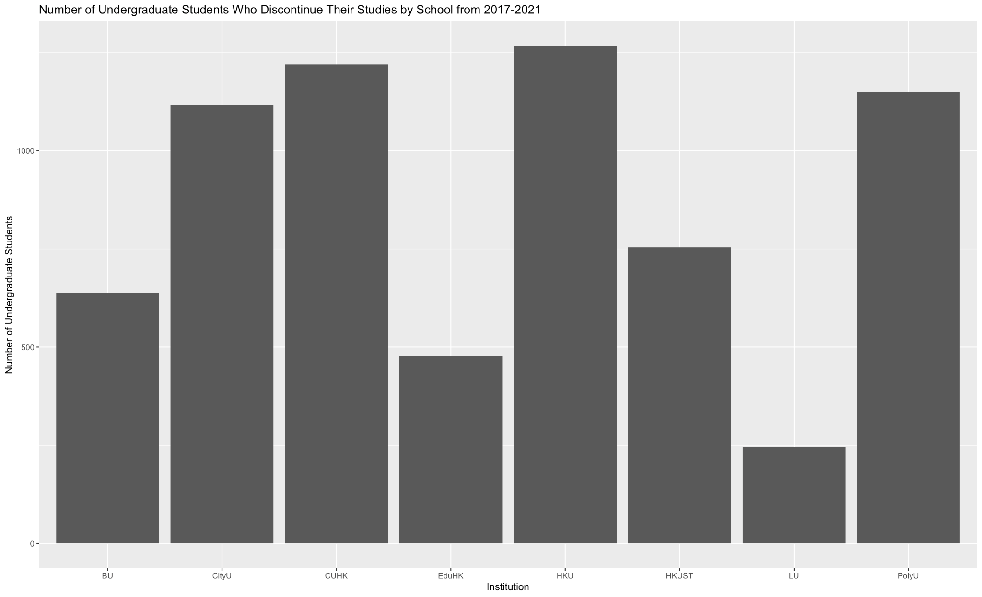

CUHK, HKU, and PolyU

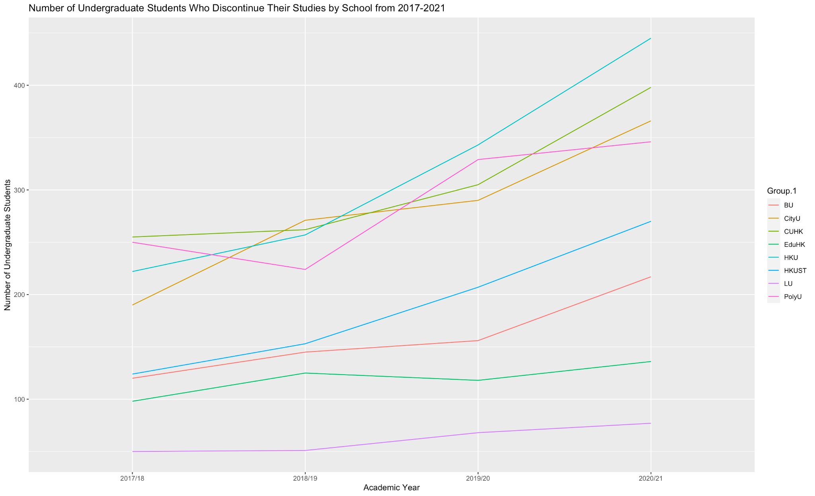

All increase

From 2018/19, the increase for HKU and CUHK will be more steep..