STEM (Science Engineering Technology and Mathematics) Takes Flight Professional Development Workshop Lesson Plan: May 2023
Location: NASA Facility: Wallops Island, Virginia
Instructor: Samuel Chukwuemeka B.Eng., A.A.T, M.Ed., M.S
Community College: Blue Ridge Community College (BRCC)
Department: Mathematics

Course: MTH 161: PreCalculus I
Topic: Quadratic Functions
NASA STEM Application: Sounding Rockets Program
VCCS (Virginia Community College System) Learning Objectives:
https://courses.vccs.edu/courses/MTH161-PreCalculusI/detail
- Identify quadratic functions and their transformations.
- Determine the general and standard forms of quadratic functions.
- Use formula and completing the square methods to determine the standard form of a quadratic function.
- Identify intercepts, vertex, and orientation of the parabola and use these to graph quadratic functions.
Extended Learning Objectives:
- Solve applied problems on quadratic functions.
- Determine the equation of the sample trajectory for a two-stage Black Brant IX sounding rocket.
Resources:
- Course website for the topic (https://precalculus.appspot.com/RelationsFunctions/relations-functions.html#quadraticFunctions)
- Solved examples on Quadratic Functions (https://precalculus.appspot.com/RelationsFunctions/quadraticFunctions.html)
- Word Problems on Quadratic Functions (https://precalculus.appspot.com/RelationsFunctions/quadraticFunctionsApplications.html)
- Solved Examples on Quadratic Models (https://precalculus.appspot.com/RelationsFunctions/quadraticModels.html)
- MyLab Math (MLM) eText
- MLM multimedia resources
- NASA resources (https://science.nasa.gov/heliophysics/programs/sounding-rockets/); and PowerPoint Presentation by David Miles (Thank you, Dave!): https://precalculus.appspot.com/RelationsFunctions/relations-functions.html#presentationNASA among others.
- Texas Instruments (TI)-series calculator.

Flipped Classroom: Read/Review these resources before the class.
Critical Thinking:
What is the difference between a Quadratic Function and a Quartic Function?
Example terms: Quadrilateral, Quadrant, Quadrangle, Quart, Quarter, etc.
Direct Questioning: Ask for prior knowledge: Rockets, Quadratic Functions.
List the vocabulary terms related to quadratic functions.
List the vocabulary terms related to rockets.
Define the terms related to quadratic functions.
Define the terms related to rockets.
What is the discriminant of a quadratic function?
How can you tell the nature of the roots of a quadratic function?
How can you tell the nature of the roots of a quadratic equation?
Incomplete Quadratic Equation:
What happens if the first term is missing?
What happens if the second term is missing? How do you solve it?
What happens if the third term is missing? How do you solve it?
Complete Quadratic Equation and Complete Quadratic Function:
What are the different ways to solve it / determine the zeros? …among others.

Creative Thinking:
Using suitable technology, draw a rocket.
Using suitable technology, draw/present the trajectory of a rocket.
Think – Pair – Share or Group to discuss the diagrams and the trajectories.
Collaboration:
Think – Pair – Share or Group to research and discuss the flight of a model rocket.
Discuss each section of the flight model.
Give several examples of vertical parabolas.
Give several examples of horizontal parabolas.
Is the vertical parabola a function? Why or why not? Explain.
Is the horizontal parabola a function? Why or why not? Explain.
Determine the vertex of a quadratic function.
Write a quadratic function in standard form.
Write a quadratic function in vertex form.
Express a quadratic function written in standard form to vertex form.
Express a quadratic function written in vertex form to standard form.
Interdisciplinary Connection in Physics: Discuss the concept of Projectiles.
Determine the formula for the maximum range of a projectile.
Determine the formula for the maximum height of a projectile.
Trigonometry: Projection angle to reach the maximum range? maximum height?

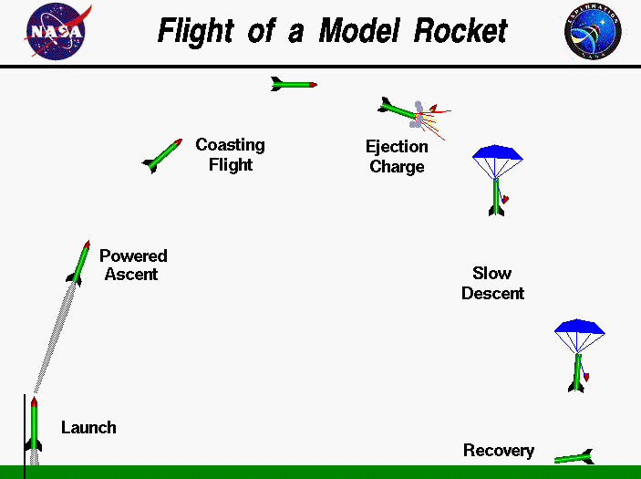

…among others.

Communication:
Each pair or group of students should present their work to the entire class.
Technology using the TI-calculator to develop a quadratic model.
Solve problems involving quadratic functions and equations.
Solve applied problems on quadratic functions.
Solve applied problems on quadratic models.
Assignment (Graded): MLM assignment sections on Quadratic Functions.
Assignment (Non-Graded but part of the Study Guide for Test): Review Number (7.) of Solved Examples on Quadratic Models before solving your question.
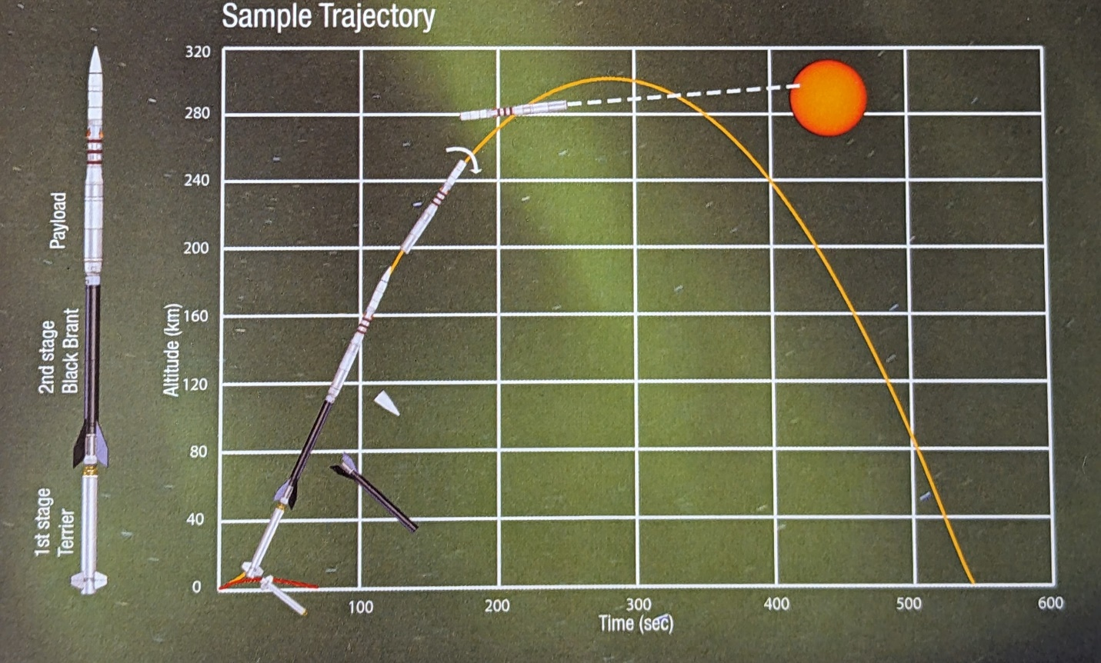
The diagram is the sample trajectory for a two-stage Black Brant IX sounding rocket carrying a solar telescope payload, shows altitude in kilometers versus time in seconds. When the fuel in each stage of the vehicle is expanded, the empty casing is dropped from the stack and the next stage is ignited. As the payload reaches the desired altitude, the ASC aligns the instrument with the science target, in this example, the Sun, and data collector starts. The data is transmitted to a ground station and recorded for later analysis by the researchers. All parts re-enter the atmosphere and land downrange from the launch site. Some payloads are equipped with parachutes and are recovered and reused.
Determine the equation of this sample trajectory.

