⁠E-Commerce Redesign

Introduction
Project Name: E-Commerce Redesign
Goal: To redesign the existing e-commerce platform to improve user
experience and ease of navigation.
Role: UX/UI Designer and Developer
Tools Used: Figma, Adobe XD
Team members:
1.K MATHESH KUMAR(TL)
2.A ABIBRISCKILLA
3.L ANITHA
4.K YUVARAJ
5.P SUNDAR

Problem Statement
The current e-commerce platform struggles with poor navigation and an
outdated interface.Users find it difficult to locate products and complete
their purchases smoothly.This results in lower user engagement and higher
cart abandonment rates. A redesign is needed to enhance usability,
satisfaction, and overall sales performance.

User Research:
User research was conducted to understand customer behavior, needs,
and pain points while shopping online.Surveys and interviews revealed that
users face difficulties in product search, slow loading times, and unclear
navigation.Most users prefer a clean, mobile-friendly interface with quick
checkout options.

Information Architecture:
1.The redesigned platform will have a clear and intuitive structure to help
users find products easily.
2.Main sections will include Home, Shop, Categories, Cart, Wishlist, and
Profile.
3.Subcategories under “Shop” will organize products by type, brand, and
price range for easier browsing.

User Flow / Journey:
1. Users start on the Home Page and browse or search
for products.
2. They open a Product Page to see details and add
items to the Cart.
3. Next, they go to Checkout to make payment and enter
delivery info.
4. The flow ends with an Order Confirmation page.

Wireframes:
1.Basic wireframes were created to show the layout of
key pages — Home, Product, Cart, and Checkout.
2. They focus on clean design, easy navigation, and clear
product presentation.
3. Each screen was planned to guide users smoothly
from browsing to purchase.

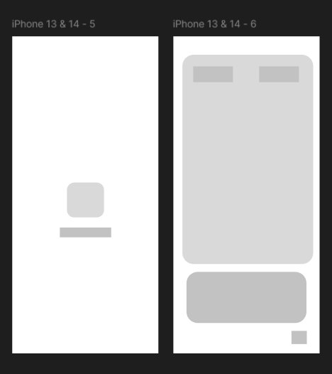

Prototype & Interactions:
1. An interactive prototype was created to show how users navigate the
platform.
2.It includes clickable buttons, product browsing, and checkout flow.
3.Smooth animations and transitions make the experience more engaging
and realistic.

UI Design:
1.The UI design uses a clean, modern look with simple
navigation and consistent colors.
2.High-quality images and readable fonts enhance the
shopping experience.
3.Buttons and icons are designed for easy use on both
mobile and desktop devices.

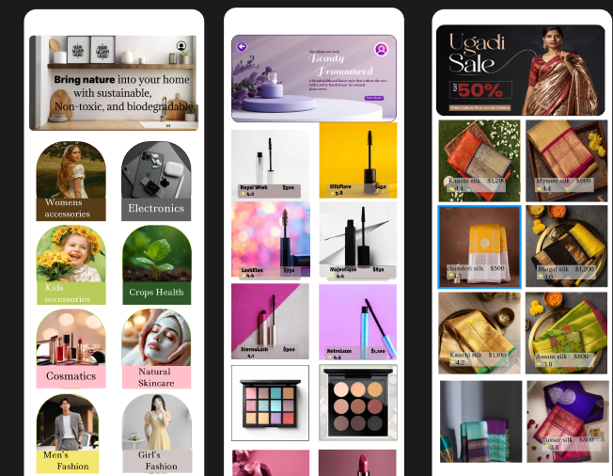

Conclusion:
1.The e-commerce redesign improved navigation, visuals, and overall user
experience.
2.Users can now find products faster and complete purchases more easily.
3.The new design increases satisfaction, trust, and sales performance.

