WASTE MANAGEMENT SYSTEM

# Mrs. E. Shanthini

Assistant Professor

Department of Electronics and Communication Engineering

Sri Ramakrishna Engineering College Coimbatore, India.

[shanthini.e@srec.ac.in](mailto:shanthini.e@srec.ac.in)

# H. P. Mathesh

UG Scholar

Department of Electronics and Communication Engineering

Sri Ramakrishna Engineering College Coimbatore, India.

[mathesh.2202131@srec.ac.in](mailto:mathesh.2202131@srec.ac.in)

# M. S. Praneshwaran

UG Scholar

Department of Electronics and Communication Engineering

Sri Ramakrishna Engineering College Coimbatore, India.

[praneshwaran.2202153@srec.ac.in](mailto:praneshwaran.2202153@srec.ac.in)

# 

# S. Praveen

# UG Scholar

Department of Electronics and Communication Engineering

Sri Ramakrishna Engineering College Coimbatore, India.

[praveen.2202157@srec.ac.in](mailto:praveen.2202157@srec.ac.in)

## *Abstract-* Sustainable environmental practices depend heavily on effective waste management, especially in sectors of the economy where garbage is produced and processed in significant quantities. Plastic bottles are one of the biggest challenges when it comes to waste materials because of their extensive use and environmental impact. garbage segregation is rendered inefficient by the frequent failure of traditional garbage sorting processes to provide the necessary speed and precision. The YOLOv8 object identification algorithm is used in this project's implementation of an enhanced waste sorting system to handle the problem. On a conveyor belt, the device reliably distinguishes and separates plastic bottles from other debris by utilizing machine learning and real-time image processing. The YOLOv8 algorithm outperforms conventional techniques and earlier models in terms of efficiency and efficacy. It is renowned for its great accuracy and precision in object detection. This system incorporates automatic sorting, guaranteeing that plastic waste is appropriately segregated for recycling, in contrast to previous methods that only concentrated on detection. This reduces contamination and improves overall waste management practices. This invention represents a substantial advancement in automated waste management by giving businesses a more dependable and expandable option.

## *Keywords:* Automated Waste Management System, YOLO, Conveyor Belt, Real Time Image Processing, Coonventional Techniques,

## INTRODUCTION

Efficient waste management has become a key task for communities worldwide due to growing environmental concerns and the volume of garbage created worldwide. In order to address this urgent problem, this research presents a novel automated garbage sorting system that is especially focused on separating recyclable plastic bottles from other types of waste. Manual labor is frequently used extensively in traditional waste sorting techniques, which can be expensive, time-consuming, and even dangerous. By using cutting-edge technology to automate and optimize the sorting of recyclable materials, our system seeks to completely transform this procedure. A conveyor belt system integrated with cutting-edge machine learning capabilities forms the foundation of our solution. This combination greatly improves the efficiency and accuracy of mixed trash processing by enabling continuous, high-speed processing.

The growing amount of waste produced globally and the growing worries about the environment have made efficient waste management a crucial global task. Innovative technologies that improve the separation of recyclable items from general waste while also streamlining waste processing are needed to address this urgent issue. Our research presents an innovative automated garbage sorting system that is specifically made to recognize and separate recyclable plastic bottles from other waste products in order to meet this need. Conventional garbage sorting techniques frequently rely significantly on physical labor, which is an expensive, time-consuming, risky, and labor-intensive process—especially in settings where workers are exposed to dangerous contaminants. The development of more automated systems is required due to the inefficiencies and possible risks involved with human sorting.

## RELATED WORKS

Testing the fruits with the naked eye whether they are diseased or not will not provide an accurate outcome. Machine learning algorithms can be used to identify the affected fruits more precisely. Generally, the diseases in fruits are identified by their color, shape, and size. To determine these specifications initially, the image of the fruit is captured. The algorithmic model is already trained with the images of the diseases in the fruits. The pre-processing techniques such as resizing and feature extraction of the image could be carried out to identify the particular fruit and the image cluster is determined using the K-means clustering algorithm. The disease is identified using the Convolutional Neural Network (CNN) algorithm by comparing it with the input image [1].

Detecting the diseases at the earliest stage and monitoring their growth parameters for storing accordingly for production is crucial and it includes the machine learning algorithm CNN and computer vision techniques. Every individual fruit has certain temperature and humidity conditions for it to survive up to a certain period. The temperature and humidity sensor is integrated with the CNN algorithm together with the controller. The camera is used to capture the image of the fruit and the CNN algorithm is used to find the shelf life and recognize if the fruit is affected by a disease. According to the type of disease, the controller propels the sensor to find the optimum temperature and humidity for storing the fruits. All these features are integrated with the IoT platform and the parameters are presented via a web dashboard that enables the farmers and retailers to monitor the environment and take required actions if necessary. This is mainly focused on detecting the disease early and making way for storing it to enable flawless production [2].

Since the manual identification of diseased fruits consumes a lot more time and work, a deep-learning algorithm model is trained in such a way as to identify the diseased fruits with more accurate results. This process is carried out using the image processing technique thereby capturing the image and then using the CNN algorithm to classify the fruit with all the pre-processing methods to extract its features. The trained model is compared and concluded with true input for retrieving the precise outcome [3-4].

The concentration of disease detection for the fruits has begun from the detection of diseases from the plants which started the identification of the same using the machine learning algorithms. Various algorithms were tested for the parts of the plants mainly leaves. This plant disease detection was an integration of a machine learning algorithm with the computer vision image processing technique. One of the efficient algorithms like CNN is being used to arrive at the best and most accurate possible outcome. This experiment produced the expected accurate result and further on it was extended for fruits, vegetables, and other perishable items that have been continuously in circulation for production [5-9].

Apart from plant disease detection, fruit disease detection has become commonplace. Diseases are identified using computer vision image processing techniques combined with a machine learning algorithm to obtain a precise result that can aid in early detection and allow for preventative measures. The CNN algorithm is used to detect disease in fruits by taking in visuals as input, which are then classified based on multiple aspects of the CNN's pre-processing techniques, yielding a maximum accuracy of 97% [10-11].

Computerized methods have been widely developed and evaluated for a variety of samples, with accuracy and precision characteristics. In this case, improved localization models such as You Only Look Once (YOLO) and Open Exchange Neural (ONNX) models, which are subsets of CNN models, are utilized to detect diseases in fruits and vegetables with 95% accuracy [12].

Generally, citrus fruits are susceptible to illness and can spread rapidly if no precautions are taken. Diseases such as blackspots, canker, and greening are frequent in citrus fruits, and they can be recognized early on using the CNN method, which captures images and extracts characteristics using several layers producing an accuracy of 94.55% [13].

Machine learning technologies and intense learning approaches like the CNN algorithm are being utilized on fruits to detect diseases caused by diverse pests and climatic circumstances. The upper surface of the fruit is quickly impacted, so the disease can be detected by capturing an image thereby using various image processing techniques to achieve the desired result. In the first phase,

the fruits that are easily prone to the disease are chosen, and commonly here the orange and apple fruits are taken as a sample to test whether the algorithm is operating to deliver the intended outcome. [14-15].

1. METHODOLOGY

### Existing Method

The proposal of a problem statement is always derived from the references that describe the past details about the technologies or methods adopted to bring the best possible results. Fruit disease detection originated from the identification of sickness in leaves. Initially identifying the diseases in plants through the leaves came into the picture. Later on, it was subsequently extended to fruits, vegetables, and other edible items. In the beginning, fruit disease diagnosis was carried out using the K-means clustering algorithm and it was eventually paired with the CNN algorithm in upcoming moves to retrieve more accurate results. The system will contain the trained dataset of numerous kinds of diseases in fruits. The image processing method is used to identify the fruit. It is resized appropriately and various pre-processing procedures are carried out to determine the size, shape, color, and image cluster using the KNN algorithm. The CNN algorithm is utilized to figure out if the fruit is sickly or not.

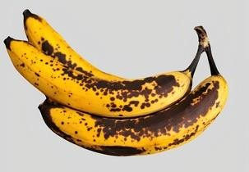

Fig 1. Common Anthracnose disease in Banana fruit.

The above figure (Fig 1) shows the common anthracnose disease that affects the banana fruit. It is a common infection in banana fruit as the fungal spores grow larger within a short period.

1. YOLOv8

Input Image:

An input image I is passed through the neural network, which outputs a prediction tensor T.

𝐼→𝑇

Prediction Tensor T: The output tensor T contains information about bounding boxes, class probabilities, and objectness scores.



Where:

𝐵𝑥,𝐵𝑦 are the coordinates of the bounding box center.

𝐵𝑤,𝐵ℎ are the width and height of the bounding box.

C is the class probability vector.

𝑃𝑜 is the objectness score.

Bounding Box Calculation:

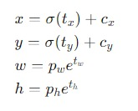For each bounding box prediction, the coordinates (𝑥,𝑦) are computed relative to the grid cell location on the image.

Where:

tx,ty,tw,th are the predicted offsets by the network.

𝞼 is sigmoid function

Cx,Cy are the top left co-ordinates of the grid cell.

Pw,Ph are the anchor box dimensions.

𝑃𝑜 is the objectness score.

The confidence score 𝑆 combines the objectness score 𝑃𝑜​ with the class probability 𝐶𝑖 for the detected object class 𝑖.

𝑆=𝑃𝑜×max(𝐶𝑖)

YOLOv8 optimizes a custom loss function $L$ that combines three main components : Localization loss loc , confidenceloss conf, classification loss cls.

Where:

= locloc + confconf + clscls

loc is the localization loss (e.g., IoU loss) penalizing the difference between predicated and true bounding box coordinates

conf is the confidence loss that measures the difference between predicted and actual objectness scores.

cls is the classification loss that measures the accuracy of class predictions.

### Proposed Method

## The automated waste sorting device that has been suggested combines strong mechanical engineering and cutting-edge machine learning to effectively separate plastic bottles from mixed waste streams. Its main component is a sturdy, speed-adjustable conveyor system with a specially made separator mechanism that uses air jets and mechanical agitation to separate garbage into distinct pieces. After being separated, the items move into an imaging chamber that has several high-resolution cameras and constant LED lighting to take detailed pictures of every item. A customised YOLO (You Only Look Once) algorithm, specifically trained on a broad dataset of plastic bottles in various situations, analyses these photos after they have undergone real-time preprocessing. The YOLO model offers accurate localisation information in addition to plastic bottle identification. Encoder data from the conveyor drive system is used to track the position of bottles once they are detected. The bottle is subsequently directed into a recycling container by a high-speed pneumatic sorting process that uses precisely timed, individually regulated air jets. The system has an intuitive interface for real-time monitoring and control and continuously logs data for ongoing optimisation. Error handling systems and emergency stop mechanisms are just two examples of the integrated safety features. Future improvements, like more sorting stages or enhanced material detection capabilities, may be easily scaled thanks to the modular design. By utilising cutting-edge technology, this all-inclusive approach tackles major waste management difficulties and holds the potential to greatly improve recycling efficiency and responsiveness to changing waste management requirements.

## WORKING PRINCIPLE

Based on a series of interrelated concepts, the automated waste sorting system separates recyclable plastic bottles from mixed waste streams with accuracy and efficiency. It makes use of the continuous flow principle, processing garbage continuously via a conveyor belt that runs nonstop. Through a specialised mechanism that individualises waste objects and ensures clear visibility for detection, a critical item separation concept is put into practice. The system makes extensive use of image-based detection, capturing comprehensive photos of each item with high-resolution cameras and controlled lighting. One essential idea is real-time processing, which allows for quick analysis and decision-making without slowing down the system. The machine learning-based object recognition approach, which uses a customised YOLO algorithm developed especially for plastic bottle identification, lies at the heart of the detection process. Adaptive learning is incorporated into the system, which enables the model to evolve with time and adjust to shifting waste compositions. Pneumatic pushers that are timed to precisely divert selected bottles are utilised in precision mechanical intervention sorting. A data-driven approach serves as the foundation for the entire operation, consistently gathering and evaluating performance data for continuing optimisation. The entire system is designed with safety and dependability principles in mind, and several security measures guarantee reliable and secure functioning. Ultimately, the system follows the principles of modularity and scalability, which make it simple to maintain, upgrade, and potentially expand its capabilities. This guarantees the system's applicability and efficacy in changing waste management environments.

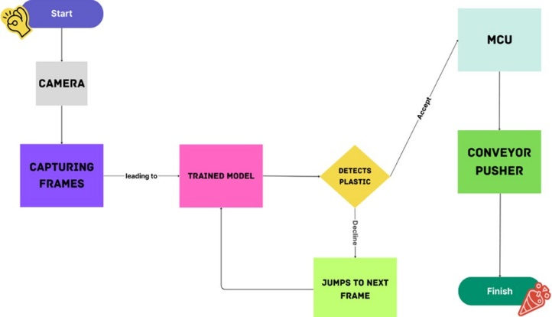

Fig 2. General Block diagram.

The above diagram (Fig 2) illustrates the entire process flow of the proposed work. The presence of the waste in the conveyor belt is detected by the ultrasonic sensor as a result the camera is turned on. After the completion of all the pre-processing steps, the control is transferred to ESP 32. If the fruit is a sickly one then the IR sensor takes the count and switches on the servo motor to push it into the relevant container. If not so, the good fruit is pushed to the respective place for carrying out the production process.

1. *Comparison Chart of the Algorithm*

|  |  |  |
| --- | --- | --- |
| **Trained Image 10464** | | |
| Train Set | **70%** | 7324 |
| Valid Set | **20%** | 2098 |
| Test Set | 10% | 1042 |

## Table I. Dataset

|  |  |  |
| --- | --- | --- |
| **Algorithm** | **Accuracy** | **Precision** |
| Random Forest | 0.89 | 0.87 |
| Naïve Bayes | 0.85 | 0.83 |
| ResNet50 | 0.95 | 0.92 |
| EfficientNet | 0.96 | 0.94 |
| Faster R-CNN | 0.97 | 0.95 |
| YOLOv5 | 0.96 | 0.94 |

Table II. Comparative analysis of various learning algorithms.

## In the above comparison chart, Table I specifies the number of images taken for the trained and the validation dataset for the proposed model. Table II specifies the accuracy and precision comparison of various algorithms that are applied to the proposed model.

### Development Procedure

STEP 1: Spyder software is used to train the model where a Python code for the training dataset and validation dataset is integrated and implemented to acquire the accuracy. The training dataset consists of images of both good fruits as well as the ones that are sickly.

STEP 2: The LCD attached will display all of the steps that take place during the process. The mobile hotspot is activated to connect Wifi to the microcontroller (ESP 32). The DC motor receives power from the SMPS to run the conveyor.

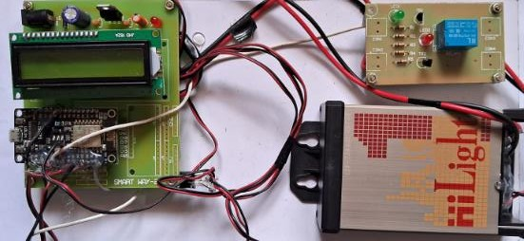

STEP 3: The fruit to be examined is placed on a running conveyor model. The ultrasonic sensor detects the presence of an object (in this case, fruit). Once the object is spotted, the webcam is activated to capture an image of the fruit.

STEP 4: The image of the fruit undergoes a pre-processing process which involves the work of multiple convolutional layers that extract the features of the image and then it is compared with the trained dataset where the CNN algorithm is used to detect the infected fruit.

STEP 5: When the disease is recognized, the fruit is routed through the conveyor and stopped at the IR sensor, where the count is taken. After counting the diseased fruit, the servo motor is activated to push them aside. The count taken by the IR sensor is displayed on an LCD for indication.

STEP 6: If the fruit has no disease, it is promptly sent to the packaging unit for production.

1. RESULTS AND DISCUSSION

The machine learning domain has been split into multiple categories for applications in which various techniques are applied to a dataset to determine whether the trained model works well with the validation model. The machine learning approach employed here maximizes accuracy and provides prediction and validation outputs that match the user's expectations without interference. This proposed work began with the application of the Internet of Things (IoT), followed by Machine learning algorithms, and ended with the function of the mechanical system. All the integration processes of the mentioned domains may appear to be arduous yet they provide flawless output. As only the detection process is carried out so far using the machine learning approaches, the addition of the segregation part provides better results in the production industries thereby minimizing the involvement of laborious activities.

|  |  |  |
| --- | --- | --- |
| **Models** | **Traditional Model** | **Proposed Model** |
| Accuracy | 0.97 | 0.98 |
| Precision | 0.93 | 0.97 |

Table III. Comparison summary

From the above comparison summary (Table III), it is evident that the accuracy of the traditional model and the proposed model is the same as the CNN algorithm used in both cases. The traditional and the proposed models are similar; the difference is that the proposed model is primarily focused on the segregation process whereas the traditional model has restrictions only to the detection segment. Therefore, considering the accuracy criteria for segregation, the machine learning algorithm is used in the proposed model.

Fig 3. Hardware setup

The above figure (Fig 3) is the hardware setup that serves as the control unit of the entire system.

## 

## Fig 4. The initial condition is displayed in LCD.

The above figure (Fig 4) Shows the initial condition when the system is given a power supply. The ultrasonic distance is initially zero which interprets that no fruit is present in the conveyor.

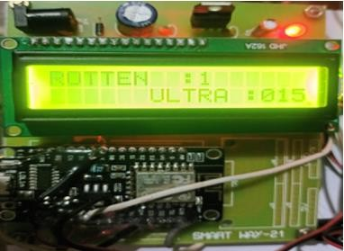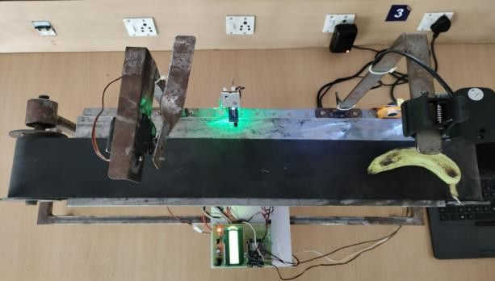

## Fig 5. The ultrasonic sensor detects the presence of fruit.

The above figure (Fig 5) shows the detection of the object (here Banana) on the conveyor by the ultrasonic sensor. The distance range of the ultrasonic sensor is given as 10cm which is the width of the conveyor belt. Therefore, the fruit anywhere within that range will be detected. Once the object is detected the camera is turned on.

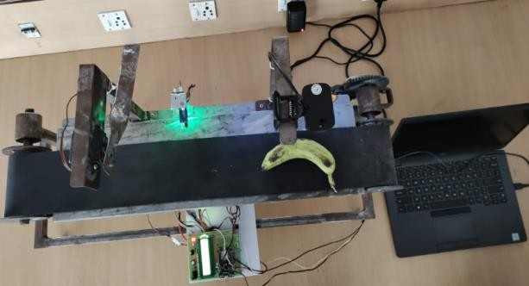

## Fig 6. The camera captures an image of the fruit.

In the above figure (Fig 6) the presence of the fruit in the conveyor model is detected by the ultrasonic sensor after which the fruit moves near the camera, and the top view of the image is captured.

## Fig 7. The sickly fruit is pushed by the servo motor

In the above figure (Fig 7) after the application of various image processing techniques, disease prediction takes place. If the predicted fruit is a sickly one then the count of the fruit is taken by the IR sensor and the servo motor pushes the fruit aside.

## Fig 8. Count of the affected fruit.

The above figure (Fig 8) shows the count of the affected fruit on the LCD. The IR sensor is used to take the count of the infected fruit when it passes via the conveyor.

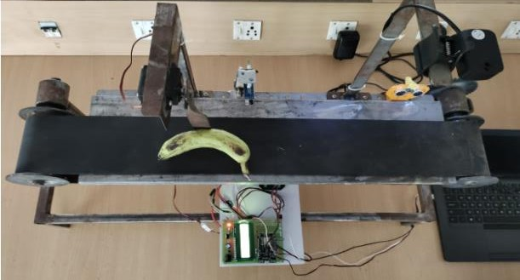

## FUTURE SCOPE

This Waste management initiative has a broad future scope, with the possibility of growing into other areas of recycling and environmentally sustainable practices. With the advancement of technology, the system has the potential to identify and classify a broader variety of recyclable materials, including paper, glass, and metals, thereby decreasing the need for manual sorting procedures. Enabling real-time monitoring and data analytics through integration with Internet of Things (IoT) devices and smart sensors could optimize waste collection routes and boost overall efficiency. This method is also adaptable, making it a useful tool in the global endeavor to manage garbage more efficiently in a variety of situations, such as residential neighborhoods, industrial operations, and municipal waste facilities. The system might also be linked to sustainability, since society places a greater emphasis on it.

### REFERENCES

[1] Yang L1, “A Comprehensive Review Of AI Applications In Plastic Waste Managment”, IEE Transactions On Environmental Informatics, Volume:09 Issue:01, e-ISSN: 2395-0056 p-ISSN: 2395-0072, 2022.

[2] Patel A1, “Challenges And Opportunities In AI-Enabled Waste Sorting ”, IEEE Transactions On Sustainable Computing, Volume 11 Issue 6, ISSN:2320-2882, 2023.

[3] Kim H1, “Emerging Trends In Computer Vision For Plastic Waste Detection”, International Journal on Sensors, Volume:09 Issue:08, e-ISSN: 2395-0056, p-ISSN: 2395-0072, 2022.

[4] Gupta S1, “Limitations Of Current Plastic Sorting Systems : A Critical Analysis”, International Journal On Industrial Electronics, ISSN: 2147-6799, 2024.

[5] Chen X1, “Robotic Vision For Dynamic Waste Streams : Challenges And Solutions”, IEEE Robotics And Automation Letters , Volume 11 Issue 5, ISSN: 2320-2882, 2023.

[6]Wang Q1, “Ethical Considerations in AI-Driven Waste Management Systems”,IEEE Technology And Society Magazine , Volume 11 Issue 6, ISSN: 2320-2882, 2023.

[7] Zhang Y“Integration Of Machine Learning And Edge-Computing for Real-Time Plastic Wave Recognition”, IEEE Transactions On Industrial Informatics 25 (2023) 100643.

[8] Li J, “Advancing Plastic Waste Through Explainable AI Sensors”,IEEE Transactions On Explainable AI , Vol. 9 Issue 10, ISSN: 2278-0181, 2020.

[9] Park S, “Impact Of Data Quality on AI-Driven Plastic Waste Recognition”,IEEE Data Engineering Letters CFP20P17-ART; ISBN: 978-1-7281-5821-1.

[10] Chen W“Human-Centric Design In AI-Enhanced Waste Sorting Systems”, IEEE Transactions On Human-Machine System