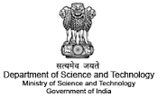 **PSNA COLLEGE OF ENGINEERING AND TECHNOLOGY**

**Department of Information Technology**

*Big Data Initiatives Division (BDI)*

*Department of SCIENCE & TECHNOLOGY (DST)*

*Sponsored*

*Ten Days Training Programme on*

***BIG DATA ANALYTICS***

Feedback Form

1. About the Course :
2. About the speakers :
3. About the Session :
4. Any other improvement :

(About course)

Signature of the Participant