CRSS 8010 – Midterm 1

Please fill out this exam with your answers for each question. (For multiple-choice, you can highlight the correct answers, delete the incorrect ones, or any other method that works for you.) The point values for each question are mostly guidelines for how difficult/involved each question is, and how to judge it when doing your self-evaluation of how well you know the material.

Question 1 (1 point)
Which of the following are valid R variable names?
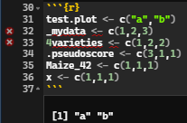
- test.plot
- _mydata
- 4varieties
- .pseudoscore
- x
- Maize_42

Question 2 (1 point)
What does the following Boolean expression evaluate to?

((True OR False) AND NOT(False AND True)) OR ((False OR False) OR (True AND NOT False))

For this exercise I’ll break down the expression into different parts, The result of the parts are in green color.

True or False = True AND NOT (False AND True) - NOT False = True = True and True = TRUE

OR

((False OR False) = False OR (True AND NOT False)) = True = False OR True = TRUE

True OR True = True

- True
- False
- NA

Question 3 (1 point)
When using the plot() command in R, what argument would you include to do a basic stairstep plot? (No, we have not covered this in class.)

To create a basic stairstep plot, the only argument we need to change is the type inside the plot() function, we need to set it as “s”, so then the function understands wee want to create a stairplot.
I had to go through some links to find the argument (https://r-coder.com/plot-r/#R_plot_type ; The 'type' parameter in R plot function - Stack Overflow).

Question 4 (1 point)
After designing your experiment, you want to know how big of an effect you’ll have to see for it to count as significant. You know you’ll have 5 DOF for your treatment (fertilizer) and 30 for your residuals/error. What is the minimum F-statistic you need to get a p-value of 0.01 or better?
3.699019
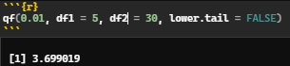

Question 5 (1 point)
You have set up an herbicide tolerance experiment in the greenhouse with 12 varieties of alfalfa in a RCBD where each variety is in 4 pots (=48 pots total) and each pot has 3 plants of the same variety. Resistance scores are measured on individual plants 2 weeks after herbicide application. After subtracting 1 for the grant mean, how many total DOF are there available in this experiment?

The 48 pots represents 48 total experimental units. So after subtracting one from the grant mean we would have 47 DOF total.

Question 6 (1 point)
Open the data file named "midterm1_rcbd" (in either text or Excel format; the data is the same). This data is supposed to be a randomized complete block design. What is wrong with the layout, and how would you fix it?

What is wrong with the layout is that the variety is not well randomized independently across the blocks, we can clearly observe a standard going from Sundance to Challenger then from Challenger to Sundance and repeating again until the fourth block. To fix this, the option available is to use the function sample() in R, that will randomly shuffle the treatments inside each block.

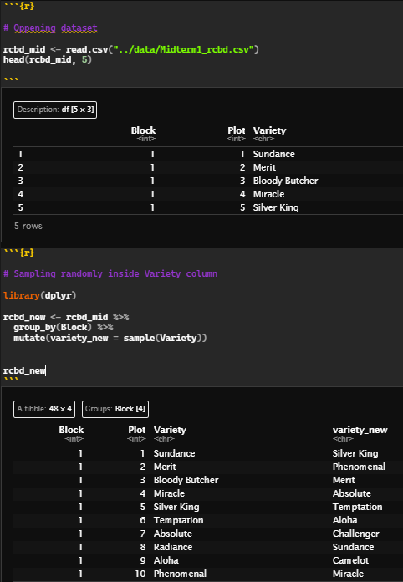 | 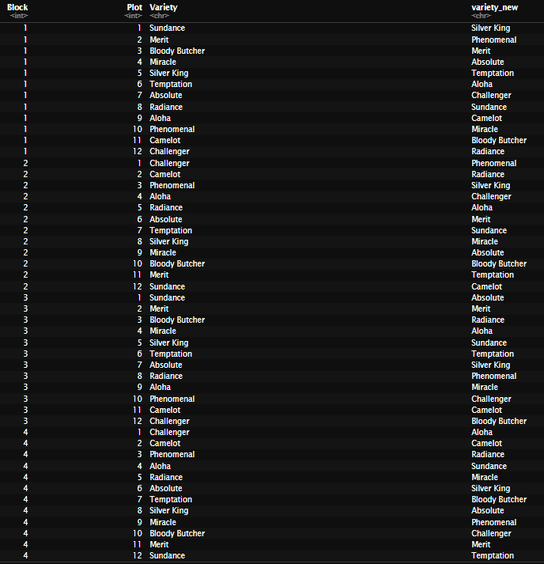
Code | Output

Question 7 (3 points)
Complete the following incomplete ANOVA table:

 | DOF | SS | MS | F | p
Variety | 3 | 21.47 | 7.156667 | 1.581001 | 0.2453815
Residuals | 12 | 54.32 | 4.526667

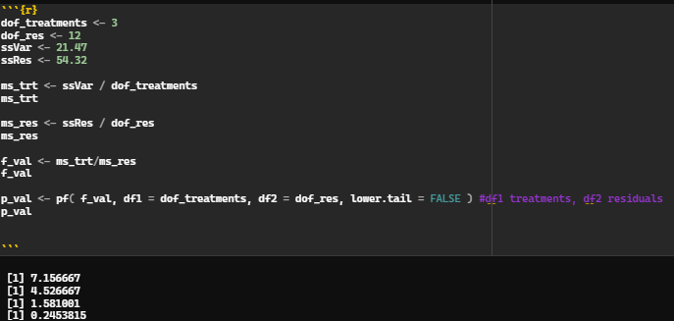

Question 8 (1 point)
Which design gives you the most degrees of freedom for error?

The design that gives us the most degrees of freedom for error is complete randomized design (CRD), which is simpler than the RCBD and gives the maximum DOF for error.

Question 9 (2 points)
Which of the following are categorical variables?
- Tomato fruit color scored on a scale of 0 (dark green) to 5 (bright red)
- Wheat yield in kilograms per hectare
- Buckwheat germination counts as the fraction of seeds that germinated
- Clover herbicide resistance scored as “resistant” or “susceptible”
- Maize disease susceptibility scored as percent of leaf area affected
- Apple insect resistance scored as a count of mites per 10 leaves

Categorical variables are variables that can be placed into groups or categories,

Question 10 (1 point)
A major component of how much power your analysis has is how many degrees of freedom remain for error. Given this, why do we focus so much on complex designs that put our degrees of freedom into other terms?

As mentioned in the class, the objective in selecting designs that put our DOF into other terms is to gain more than you lose, so we gain “control” of the spatial variability, we can

Question 11 (1 point)
Your labmate wants to test the effectiveness of two new pesticides on blueberries. They show you the design they have in mind: a randomized complete block with three replicates. Explain to them why this is probably a bad idea, and what changes you’d recommend to improve it.

I’d probably tell my labmate to increase the number of blocks, since blocking already causes DOF loss for error, I’d suggest at least one more resulting into 4 – 6 blocks but no more than that. This would provide more spatial control, the blocks won’t have heterogeneity between them since it’s not a huge blocking.

Question 12 (1 point)
What are the two foundations of experimental design?

Randomization for breaking the relationships between design and treatment and Replication to accurately estimate the error of your experiment.

Question 13 (1 point)
What is the term for when you treat measurements that aren't independent as if they were?

The term is “Pseudoreplication”, and the problem with this is that they aren’t true replications, and any biases in the big unit are probably still there, causing problems in the analysis process.

Question 14 (1 point)
When calculating variance, why do we divide by N (sample size) for the population variance but N-1 for the sample variance?

We divide by N-1 for sample variance due to the degree of freedom we used in first calculating the mean, and we don’t use it for the population mean because the mean is already known. A sample is an estimate from the population, and this is why samples will have more uncertainty in their variance and this is why we divide when calculating the variance.

Question 15 (2 points)
Which of the following are assumptions of ANOVA analysis?
- Each group has an equal number of data points
- The residuals are normally distributed
- Groups have the same variance as each other
- The raw data is normally distributed
- Each observation is independent of the others

The next several questions all deal with the data present in "midterm1_potatoes.csv." Please load this data and analyze it as we have in class.

Question 16 (1 point)
What is the design used for this experiment?

Follows RCBD design, with 6 blocks.

Question 17 (1 point)
How many degrees of freedom are there for error?

There are 6 treatments, so DOF for treatments is 5, there are 8 blocks, so DOF for blocks are 7. So, the total DOF for error will be 35.

Question 18 (2 points)
What is the treatment sums-of-squares for the just the variety Sugargate?

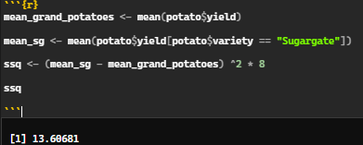
13.60681

Question 19 (2 points)
If a farmer asked you which variety/varieties to plant based on the results of this experiment, which would you recommend?
- AfricaQueen
- DixieLand
- LaterFry
- Sugargate
- Supreme
- SweetJenny

Both cultivars are grouped as a (LaterFry) and a/b (AfricaQueen), meaning that they doesn’t differ statistically.

Question 20 (2 points)
Name 3 “desirable difficulties” in learning and why they help people remember things better.

Change context – Study or put effort in what you need to put but in different places, contexts, situations, and viewing the situation from a different perspective. It helps create better access to the memorized information and prevents the memory from creating ties with the studying routine\.
Test yourself – Try practice questions, retrieve information without looking into the material and other methods, this also helps you to fix better the content you are trying to learn.
Space things out – Study during several sections but with breaks between them, instead of lock in for a long time. This helps the remembering process and strengthens long-term memory since you forget some material and must put more effort into remembering it later.

