**How to use this ModelProject**

1 – Request infra team to create the following for your project:

* + - Developer database;
    - QA database;
    - QA folder for web publishing;
    - And TFS structure to upload.

2 – Connect to Developer database and execute both scripts from **_SQLScripts** folder.

**ATTENTION:** Before executing the “02-001-sqlInsertsBasicData.sql” script, change the user data to your own user, so you will be able to login into the application with all permissions granted.

I think organizing scripts with numeric naming prefix helps on script execution on deployments:

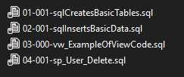

Where each number is composed by a group followed by a 3 digit sequence:

01 for CREATE and ALTER table, columns, indexes, triggers or anything related to table structure;

02 for data manipulation, inserts or updates.

03 for views.

04 for stored procedures. I recommend the use of stored procedures rather than Entity Framework code due to performance improvement.

On Views and Stored Procedures scripts, please DO NOT use the ALTER COMMAND. Always create the script as in those examples, so the CREATION datetime is saved by the SQL Server and can be useful to identify last object “modification”.

3 – Copy project structure/files from TFS **ModelProject**. It includes a recommended project structure with User control with profile using Metso AD, multiple plant and multiple language.

4 – With the source code in your project folder, from Visual Studio you can FIND and REPLACE the text YourProjectName with your **real project name**. You MUST also rename all projects names inside the solution to you **real project name** and also re do the references on each project. Also rename inside each Project properties:

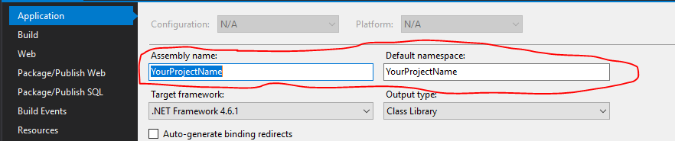

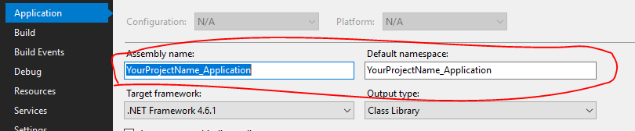

A – Close Visual Studio and go to your project Folder. Remove the YourProjectName.sln and YourProjectName*.csproj from all folders, so remains only files with the name of your current project.

B – Rename all folders replacing the text YourProjectName with your **real project name.**

C – Open the sln file from main folder and do a Find/Replace with your **real project name** and Save and Open it in Visual Studio.

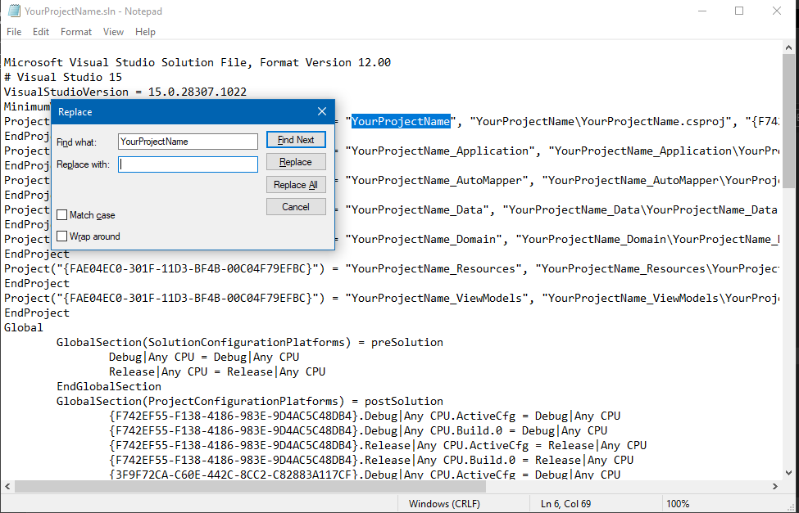

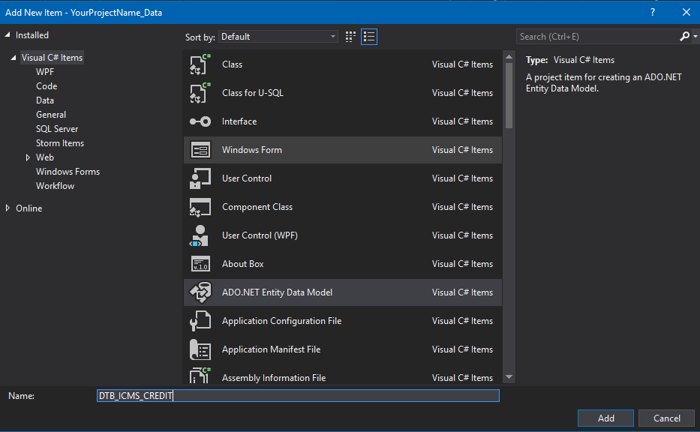5 – On the XXXX_Data project, on Context folder, create a new Entity Data Model referencing your data base and remove the existing one. To create a new one, I suggest you use the Database name:

6 – You MUST select EF Designer from database option:

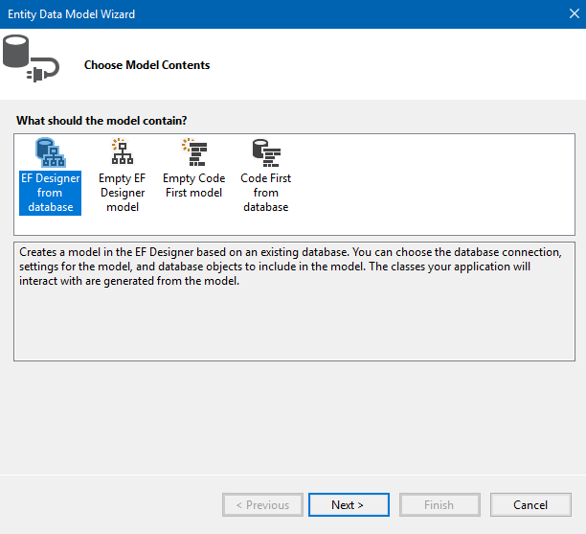

7 – Setup the connection string to your database:

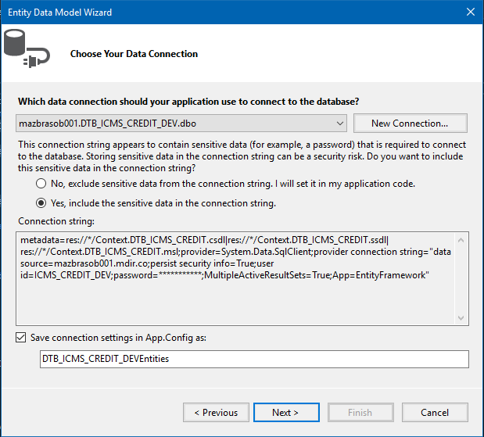

If you get this error message, you must update your Visual Studio to the newest version:

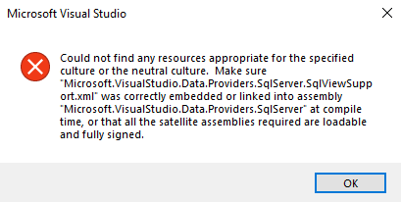

8 – Select Table, View and Stored Procedures items so it will create all basic items in your Model:

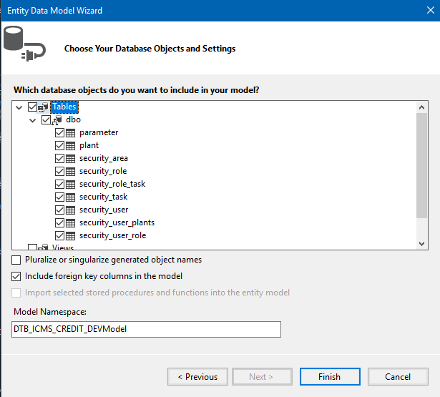

9 – Click on Finish so it will create your Model with all basic tables on it:

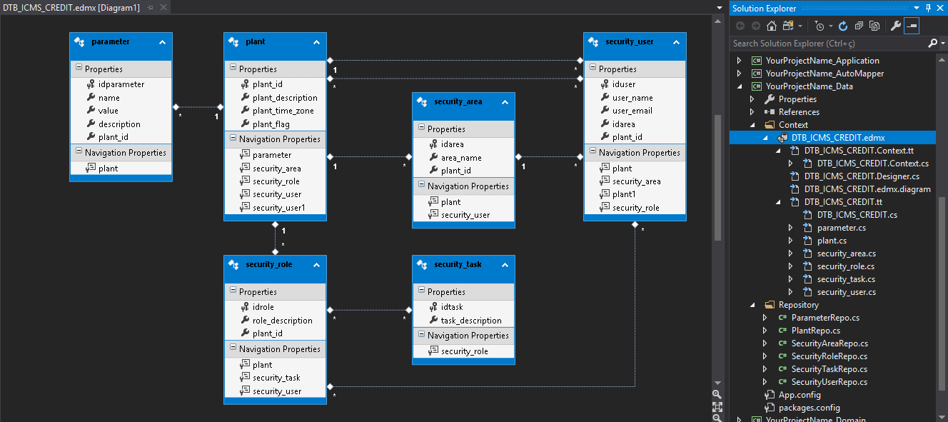

10 – Now change all your Repository classes with the new Context name. It will appear in red with a red square on scroll bar on code:

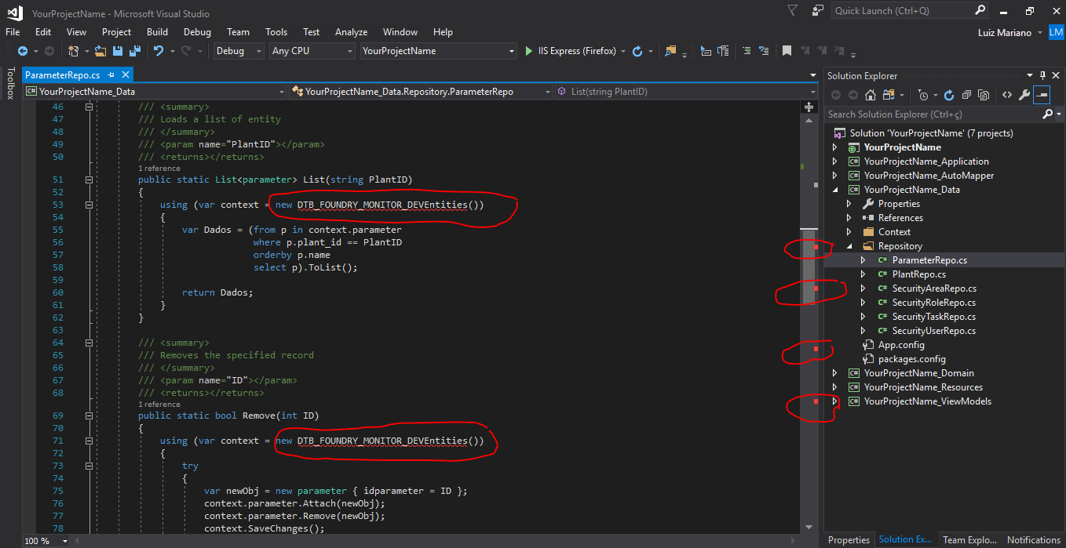

You can change it all easily with FIND and REPLACE in **Current Project** selection:

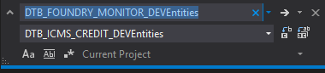

11 – Remove everything from the **\bin** folder (Clean Solution) so your application will generate all new named files avoiding conflicts during start-up like this one:

**Multiple types were found that match the controller named 'Home'.** This can happen if the route that services this request ('{controller}/{action}/{id}') does not specify namespaces to search for a controller that matches the request. If this is the case, register this route by calling an overload of the 'MapRoute' method that takes a 'namespaces' parameter.

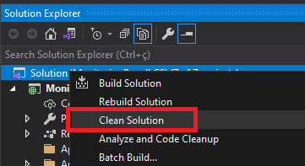

12 – Open Source Control Explorer in Visual Studio and ADD you project folders. Attention there to add from **Excluded Items** the files in **Libraries** folder on MVC project. Select those three files and click the **Include items** button.

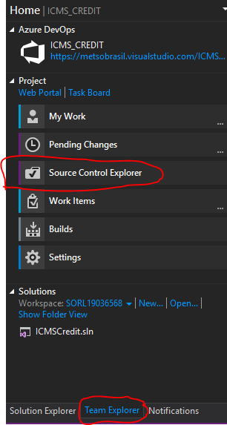 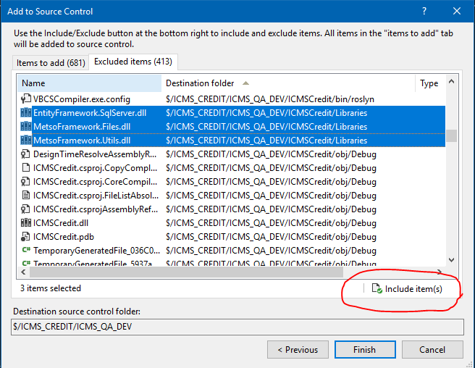

Finally, you can proceed developing your project.

I tried to create an easy copy and paste structure for each new database CRUD screen.

Try to make your application as much parametrized as possible.

Also feel free to suggest any improvements on the **ModelProject**.

Luiz Alberto Mariano

Sorocaba, January 11st, 2022