Example Use-Case Model Elaboration Phase

Introduction
This is an example of a Use-Case Model as it would appear in Elaboration. Primary actors and use cases are identified, and key scenarios (those that will be implemented first) are detailed. Each use case has an associated use-case specification.

Overview
The Automated Teller Machine is a remote unit connected to the bank computer systems. The purpose of the system is to bring regular bank services closer to the customer and increase the working hours to around the clock. It is also important to decrease the amount of bank cashiers. An ATM withdrawal is less expensive for the Bank than a withdrawal from a teller.
The ATM system requires that each bank customer has an ATM card and remembers his PIN code. The whole security of this system builds on the PIN code.

Use-Case Diagram
Figure 1 shows the use-case diagram for the ATM.

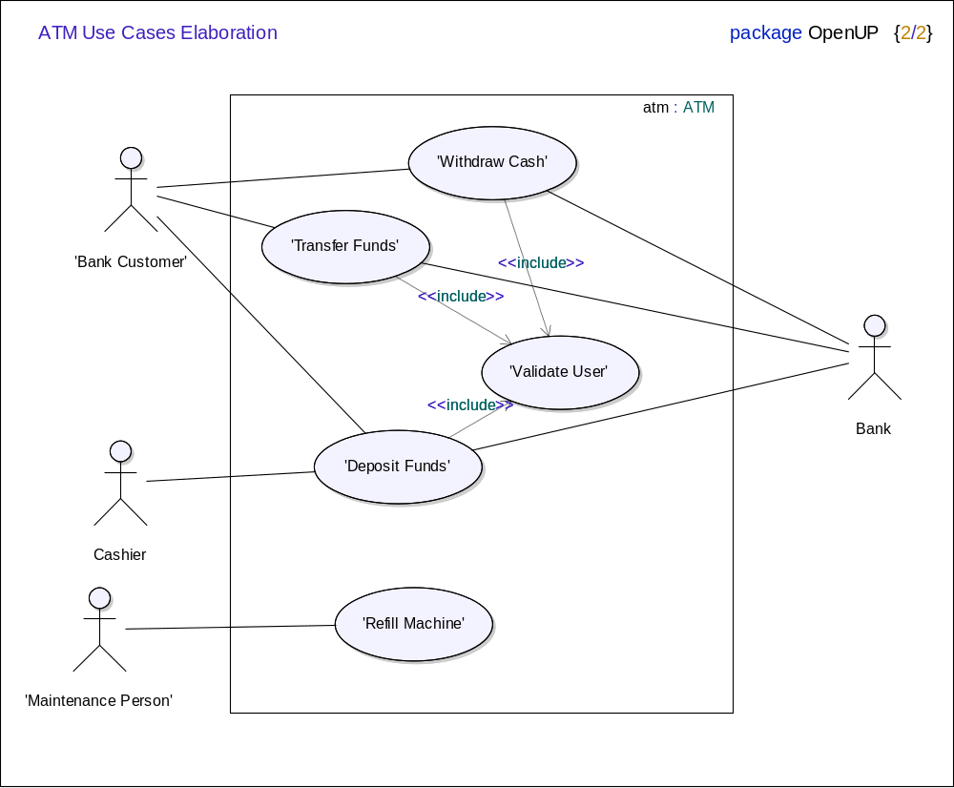
Figure 1. ATM Use-Case Diagram

Actors

Bank Customer
This actor represents a person with a valid Bank Card. The Bank Card is theirs and they know the PIN Code.

Cashier
From the ATM system point of view, the Cashier's only responsibility is to count the money in the security box to verify all deposits.

Bank
This actor represents the financial institution that provides services to the ATM. Responsible for verifying Bank Customers, authorizing transactions and recording completed transactions.

Maintenance Person
This actor represents the person responsible for maintaining the Automated Teller Machine, refilling paper, and replenishing cash.

Use Cases

Validate User
This use case describes general behavior for the ATM to validate the Bank Customer. It includes all steps that are the same no mater what kind of transaction the Bank Customer does.

Withdraw Cash
This use case describes how the Bank Customer uses the ATM to withdraw money his/her bank account.

Transfer Funds
This use case describes how the Bank Customer uses the ATM to transfer money between different bank accounts.

Deposit Funds
This use case describes how the Bank Customer deposits money to an account.

Refill Machine
This use case describes how the Maintenance Person refills money, receipt paper and envelopes.

