***How to link Android Studio with Github***

***Fonte:*** ***https://medium.com/code-yoga/how-to-link-android-studio-with-github-312037a13b99***

[[](https://medium.com/@divu1666?source=post_page-----312037a13b99--------------------------------)](https://medium.com/@divu1666?source=post_page-----312037a13b99--------------------------------)

[[Code Yoga](https://medium.com/code-yoga?source=post_page-----312037a13b99--------------------------------)](https://medium.com/code-yoga?source=post_page-----312037a13b99--------------------------------)

[Diviya](https://medium.com/@divu1666?source=post_page-----312037a13b99--------------------------------)

·

[Follow](https://medium.com/m/signin?actionUrl=https%3A%2F%2Fmedium.com%2F_%2Fsubscribe%2Fuser%2Ff10f20478444&operation=register&redirect=https%3A%2F%2Fmedium.com%2Fcode-yoga%2Fhow-to-link-android-studio-with-github-312037a13b99&user=Diviya&userId=f10f20478444&source=post_page-f10f20478444----312037a13b99---------------------post_header-----------)

Published in

[Code Yoga](https://medium.com/code-yoga?source=post_page-----312037a13b99--------------------------------)

·

3 min read

·

Apr 15, 2018

1.8K

8

This article is for github beginners or for those who find it difficult to upload android projects on github.



1. ***Install Git on your computer***

*Visit this*[*official site*](https://git-scm.com/book/en/v2/Getting-Started-Installing-Git)*to download git on your computer. Once you do that, you can start using it with android studio.*

***2. Enable Version Control Integration on android studio***

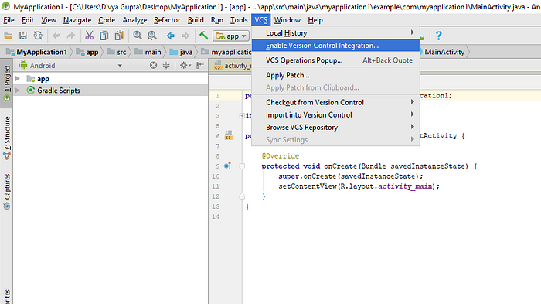

***Go to Menu>VCS>Enable Version Control Integration***

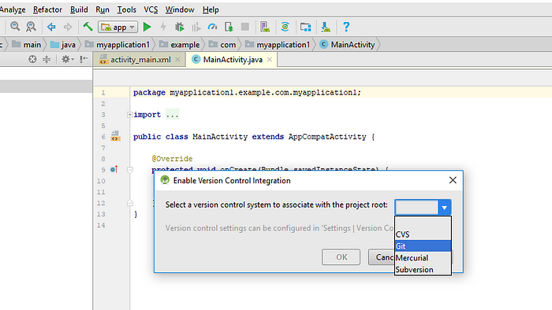

***After that,select Git as your version control system***

*> On doing this,you will notice that all your files will turn red.*

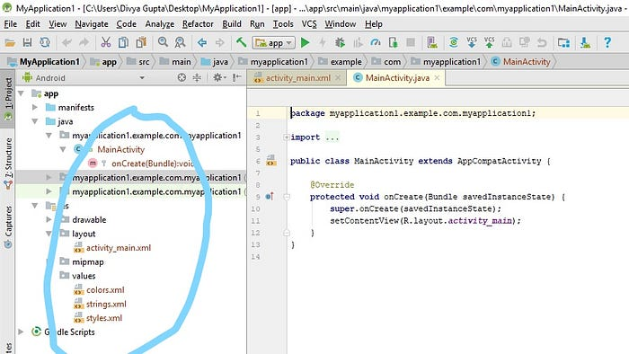

***3. Share on Github***

*Now ,go to VCS>Import into Version Control>Share project on Github*

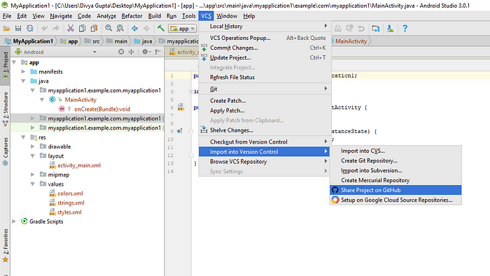

*Now give a name to your repository and write a description if you want.*

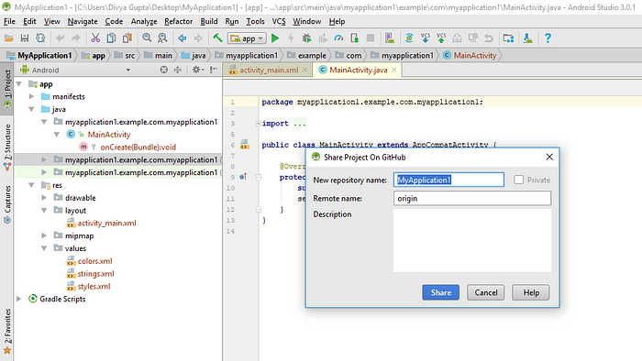

*4.****Push your project files on Github***

*Now select the files you want to share and press Ok . You can also write a specific commit message and after you do so,all your files will turn white.*

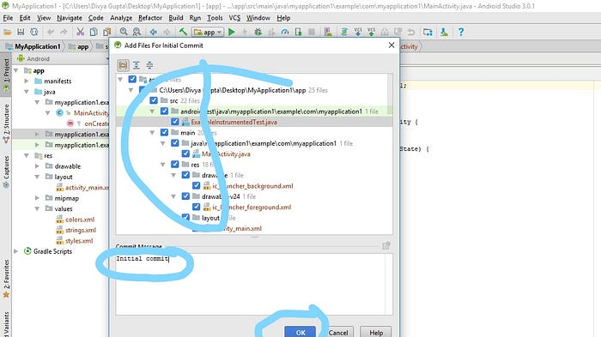

***5. Make changes***

*Your project is now under version control and shared on Github ,you can start making changes to commit and push. You can see I added a new****ImageView reference****to the****MainActivity.java****. Notice that after I made the change, the****MainActivity.java****file turned blue. That means the file now has uncommitted changes (and it doesn’t match the file in the Github repository).*

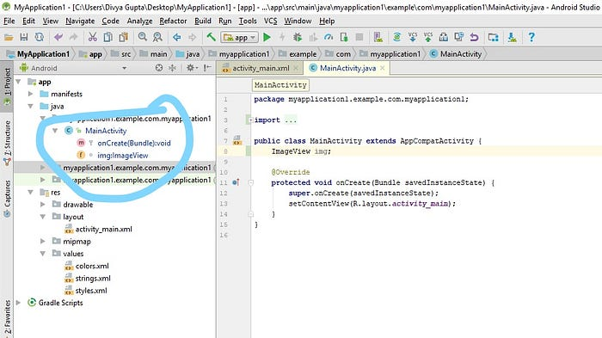

***6. Commit and Push***

*Its upto you now when you want to do commit and push. You can do it after every new change or after a lot of changes.*

*To commit and push,go to Menu>VCS(with green up arrow)*

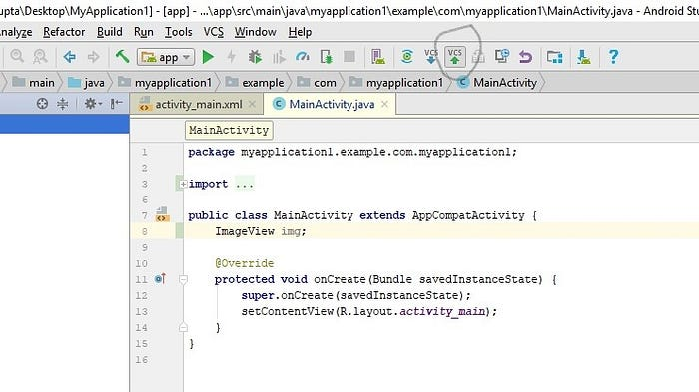

*After that,you will see a commit changes window and you have to write a commit message (mandatory) and then press on commit and push.*

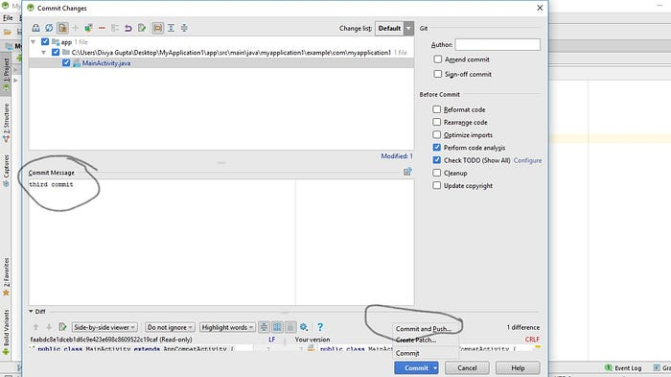

*After that,you will see another push window. Just press on push button and all your changes will be reflected in you repository.*

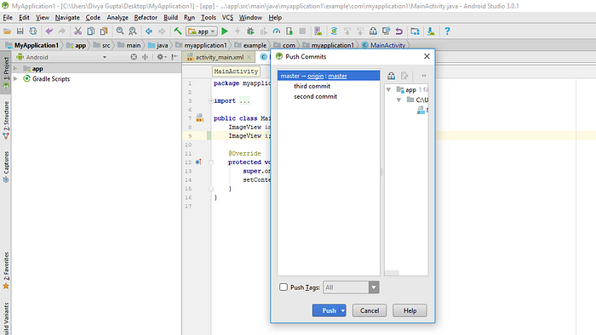

**Congratulations on setting up your first project with version control . Yayyyyy!!!**