# Data Scientist

Job description and person specification

## 1. Job details

Job title: Data scientist

Responsible to: Research and insight manager

Team: Strategic communications and insight

## 2. Job purpose

The primary purpose of the role is to support NCVO’s research and insights activity, and wider organisational strategy by:

* collecting and synthesising data from a wide range of sources
* producing statistical analyses
* managing databases
* developing a data dashboard.

## 3. Dimensions

The post holder will lead on data collection and analysis to support NCVO’s research and insights activity.

The post holder will:

* use programming languages such as Python (pandas, numpy, scikit-learn) and SQL to gather and collate charity data from different sources and produce statistical analyses. This includes:
* improving existing procedures for gathering and collecting data through the use of data engineering techniques
* improving existing statistical analysis through the use of data analytical tools such as Jupyter notebooks, statistical knowledge and machine learning techniques
* lead on data-related projects and product development to contribute to the team’s quantitative research programme
* support with ad-hoc data needs for quantitative data projects
* engage with a range of internal and external stakeholders to ensure the effective delivery of projects, seeking opportunities for new projects and presenting research findings
* manage databases that are used to produce the required analyses
* use software development processes such as coding standards, version control, testing and documentation to improve existing code and future team productivity
* work closely with the digital and IT teams to build on our prototype/MVP of an Almanac data dashboard which would be integrated with the NCVO website.

The post holder manages no staff.

## 4. Organisation chart

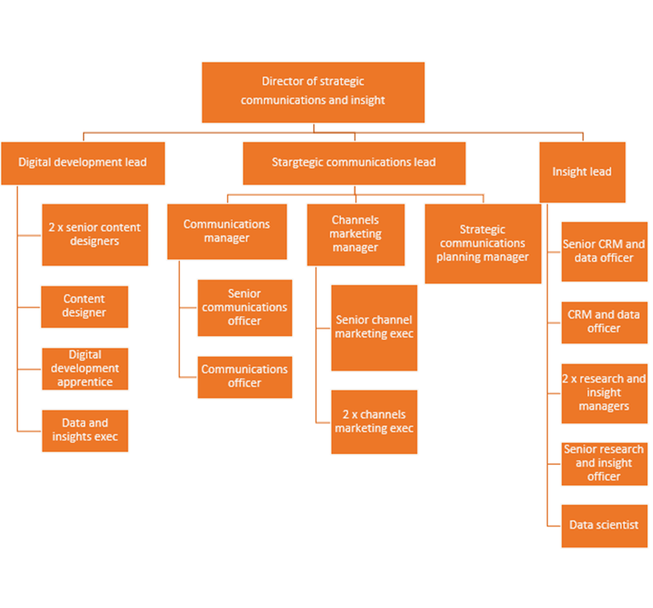

This role sits within the Insights Hub.

## 5. Main accountabilities of the post

* Responsible for data production mainly on the [Almanac](https://www.ncvo.org.uk/news-and-insights/news-index/uk-civil-society-almanac-2023/#/) and also other quantitative research and data projects to improve NCVO’s influencing work and to support the organisation’s wider strategy.
* Act as a source of go-to expertise in data engineering and statistical analysis.
* Support the analysis and manipulation of data by other members of the team.
* Play a key role in re-developing and delivering the Almanac data dashboard output by working closely with relevant colleagues.
* Play a main role in contributing and implementing plans to develop the future of Almanac and other quantitative research projects on the finances, workforce and volunteering in the voluntary sector.
* Support other projects in the team where data science and statistical techniques can be used.
* Liaise with external and internal stakeholders on specific projects to ensure the delivery of timely and relevant analysis products.
* Work closely with IT and digital teams to ensure database systems are fully functional and integrated.
* Support an inclusive culture at NCVO, that values diversity.

## 6. Work context

At NCVO, our mission is to support volunteering and charities. We believe that the work of volunteers and charities make our communities stronger and the world around us better, for everyone. Our members are at the heart of our mission. We work collaboratively with our 17,000-strong network of national and local organisations.

Our newly formed Insight Hub sits under the strategic communications and insight directorate. It combines the research, CRM and data functions at NCVO, and works closely with the policy, campaigns, digital, practical support and membership teams.

Through our work, we want to contribute to two big shifts:

* improve national and local **policy** that affects charities and volunteering
* improve and strengthen the **practice** of charities and volunteer-involving organisations.

We do this in three main ways.

1. Strengthening our knowledge, understanding and insight of NCVO members and the wider charity and voluntary sector through research and insights. These insights drive evidence-based decision making for our members, the wider charity and voluntary sector, and civil society influencing.
2. Supporting our members with evidence-based insights.
3. Using data and research to influence members, government bodies, charity sector regulators, public policy lobbying and influencing, and supporting NCVO with data-driven excellence in all we do.

We work in a fast-paced environment, frequently responding to issues of the day, while ensuring we support organisations tackle long-term challenges and embrace opportunities.

## 7. Autonomy and decision-making

The post holder is responsible for managing their own workload, in collaboration with other members of the team and within the context of NCVO’s strategic priorities.

Makes regular decisions independently on day-to-day data related technical problems.

Works openly and in collaboration with colleagues across the organisation.

## 8. Communications

The post holder communicates both internally and externally with a wide range of people and organisations, including stakeholders in the sector such as the ONS and the Charity Commission.

The post holder needs good communications skills with the ability to communicate technical information to a non-technical audience.

## 9. Main areas of difficulty

* Understanding NCVO’s Almanac database and the technical processes used to populate and maintain this.
* Providing solutions to technical problems, often independently.
* Communicating quantitative research findings to non-specialists.
* Managing time and prioritising workload and deadlines, due to multiple and often competing demands on time.

## 10. Knowledge and skills required

### Knowledge

* Strong knowledge of SQL to query and manage databases.
* Strong knowledge of programming languages, especially data science libraries such as pandas, numpy and scikit-learn in Python, and quantitative research methods.

### Skills

* Excellent attention to detail.
* Work on own initiative, proactively identifying and solving potential difficulties.
* Communications skills, including the ability to translate technical information for non-technical audiences.

### Experience

* Working with large datasets in a variety of formats, particularly SQL databases.
* Research and data analysis using Python.
* Working as part of a team.
* Active commitment to equity, diversity and inclusion.

### Desirable

This is a highly quantitative role. So Mathematics or Statistics or similar quantitative background in a related discipline in either Masters’ or Bachelors’ degrees is desirable.

## 11. General information

To, at all times, adhere to NCVO’s policies.