High speed Galvo System
AXJ-V20 close-loop scanner

(PLEASE READ THIS MANUAL CAREFULLY BEFORE INSTALLATION)

Technical Data:
- System:Closed Loop Moving Magnet Scanner
- Input resistance:200K ohms,differential
- Signal Input voltage：±5V
- Input voltage requirements: +15V/1.0A，-15V/0.6A
- Operating temperature range:0～50 degrees C
- Optical angle：±30° max
- Scanner speed:>20Kpps(ILDA testpattern ，±20°optical)
- Mirror dimensions WxL: 7mm*11mm*0.6mm（wide wave-length）
- Board size:8.0cm(long)*5.0cm(wide)*2.8cm(high)
Laser Safeboard reference:
- Power supply: +/-15V@100mA.
- Signal monitor: feedbacks and control signals of XY Galvo position.
- Output: output 3 channels TTL signal to control laser, like RGB.
- Reacting time:100ms
- Safe Protected: motor system fault, driver fault and itself fault.
- Board size:6.0cm(long)*3.8cm(wide)

The measuring procedure
The AXJ -20 was measured with PANGOLIN QM2000 card. Running at the desired output speed. Using the standard ILDA test pattern. Laboratory power supply at +/-15VDC,room temperature. Windows PC with Pangolin,12/30k ILDA testframe，full size. 7x11x0.6mm mirror was used during measuring period. The galvos is fixed in the standard mounts on an aluminmum baseplate, no forced cooling.

Delflection angle | Operating voltage | Speed@ Mirrors size
20 optical delfection | +/-15V | 20Kpps @ 7*11*0.6
15 optical delfection | +/-15V | 22Kpps @ 7*11*0.6
10 optical delfection | +/-15V | 25Kpps @ 7*11*0.6
8 optical delfection | +/-15V | 30Kpps @ 7*11*0.6
5 optical delfection | +/-15V | 35Kpps @ 7*11*0.6

Topview
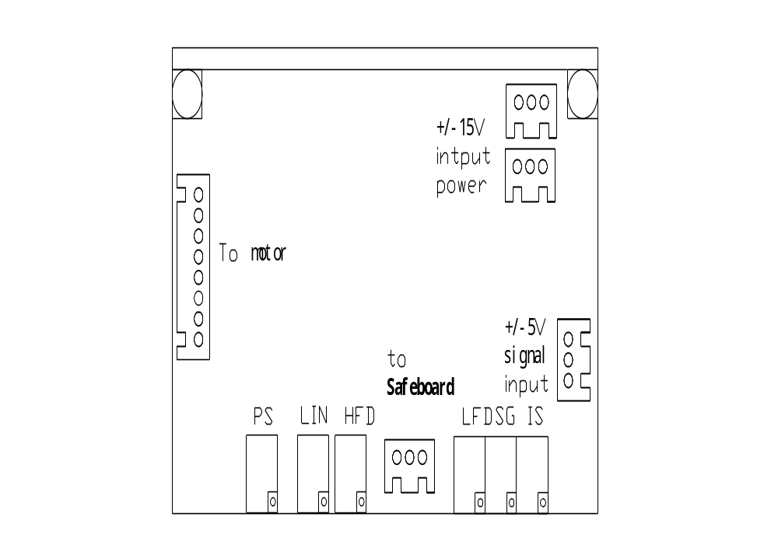
Potentiometer description:
- IS Input scale (adjusted only in factory)
- SG Servo gain (power of the feedback signal for internal PID controller
- LFD Low frequency damping (correct overshoot)
- HFD High frequency damping (correct undershoot)
- LIN Zero offset (electrical offset of the driver, adjusted only in factory)
- PS Position scale (increases or decrease input sensitivity of the computer, DO NOT change it)
input connector
Power input
XH-3  Connector pins | Description | Remark | Cable color
3 | +VCC | +15V/1.0A | RED，24AWG
2 | GND |  | BLACK，24AWG
1 | -VEE | -15V/0.6A | WHITE，24AWG
Signal Input
3 | Control signal + | -5V~+5V anolog signal
2 | S-GND | Ground
1 | Control signal - | -5V~+5V anolog signal

