Criar

1 -

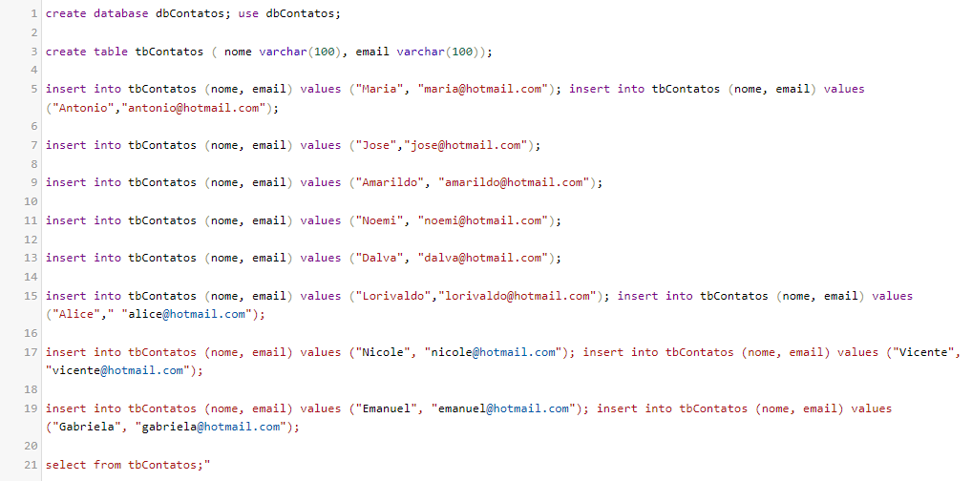

2-

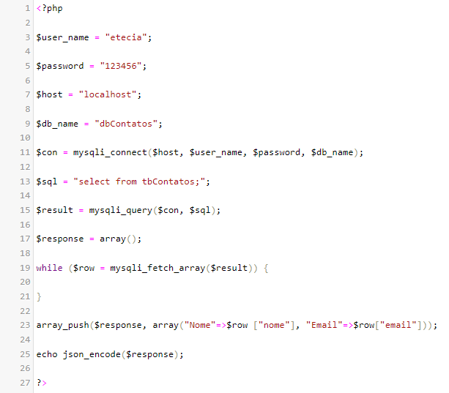

3-

a) POST Matheus FROM values WHERE tbContatos;

b) POST Fernado FROM values WHERE tbContatos;

c) POST Davi FROM values WHERE tbContatos;

d) POST Jonatas FROM values WHERE tbContatos;

e) POST Isaque FROM values WHERE tbContatos;

4-

a) PUT Nicole FROM values WHERE tbContatos;

b) PUT Jose FROM values WHERE tbContatos;

c) PUT Vicente FROM values WHERE tbContatos;

5-

a) DELETE Dalva FROM values WHERE tbContatos;

b) DELETE Noemi FROM values WHERE tbContatos;

6-

GET Matheus FROM values WHERE tbContatos;

GET Fernado FROM values WHERE tbContatos;

GET Jonatas FROM values WHERE tbContatos;

GET Isaque FROM values WHERE tbContatos;

GET Nicole FROM values WHERE tbContatos;

GET Jose FROM values WHERE tbContatos;

GET Vicente FROM values WHERE tbContatos;

GET Dalva FROM values WHERE tbContatos;

GET Noemi FROM values WHERE tbContatos;