Evaluation of Structural Integrity for Transport Aircraft Encountering Severe Atmospheric Turbulence

Ray C. Chang
Associate Professor
Department of Aviation Mechanical Engineering
China University of Science and Technology
Email: raychang@cc.hc.cust.edu.tw

C. Edward Lan
J. L. Constant Distinguished Professor, Emeritus
Department of Aerospace Engineering
The University of Kansas
Lawrence, Kansas, 66045
Email: vortex@ku.edu

and

Wen-Lin Guan
Director
Investigation Laboratory
Aviation Safety Council, ISASI CP0174
Taipei, Taiwan, R.O.C.
Email: michael@asc.gov.tw

Dr. Ray C. Chang received a Ph.D. degree in aerospace engineering from University of Kansas in 1985. He was a wind-tunnel test engineer, fighter aircraft designer, Deputy Director, and Director of Aerodynamics Department in Aeronautical Research Laboratory, Aero Industrial Development Center (AIDC), Taiwan in the years of 1985~1996. He has been teaching at the Department of Aviation Mechanical Engineering, China University of Science and Technology, Taiwan since 2003. He has had extensive experiences in working on aircraft configuration design, wind-tunnel test and flight test data analyses. Currently, his research focus is on aircraft flight safety issues related to aerodynamics, flight dynamics, and engine operations. He has managed a large number of National Science Council-sponsored research projects since 2004, mostly in aircraft flight safety.

Abstract
The transport aircraft experience frequently higher loads than what are designed for, in particular, in unusual flight conditions, such as encountering severe atmospheric turbulence, sudden evasive motion in avoiding air collision, and hard landings. The structural damage, fatigue cracking, or non-typical structural deformation may be caused by these high loads. A method based on the concept of static aeroelastic effects on stability and control derivatives to indirectly determine the structural integrity of aircraft will be presented in this paper. Aerodynamic models are established through fuzzy-logic modeling of the flight data extracted from Flight Data Recorder (FDR). Stability and control derivatives with static aeroelastic effects are then estimated by using these aerodynamic models. A twin-jet transport aircraft under study has encountered severe atmospheric turbulence in revenue flight. Comparison of static aeroelastic effects on longitudinal aerodynamics for this twin-jet transport before and during severe atmospheric turbulence will be presented. Qualitative evaluation of the aeroelastic effects on the wing and tail is based on the second derivatives of normal force and pitching moment coefficients with the angle of attack and dynamic pressure, respectively. It is found that the aeroelasitc effects in cruise with atmospheric turbulence are significant in twist-down deformation. Because this method employs the flight data stored in the FDR, intrusive structural testing can be avoided. The present method can be used to assist airlines to monitor the structural integrity as a complementary tool to improve aviation safety, and operational efficiency.

Keywords：unusual flight conditions; aeroelastic effects; fuzzy-logic modeling; Flight Data Recorder (FDR); atmospheric turbulence

Nomenclature
a_{x}, a_{y}, a_{z} acceleration components along the (x, y, z)-body axes of aircraft, respectively, g
b wing span, m
C_{x}, C_{z}, C_{m} longitudinal aerodynamic force and moment coefficients
C_{y}, C_{l}, C_{n} lateral-directional aerodynamic force and moment coefficients
mean aerodynamic chord, m
h altitude, m
I_{xx}, I_{yy}, I_{zz} moments of inertia about the x-, y-, and z-axes, respectively, kg∙m²
I_{xy}, I_{xz}, I_{yz} products of inertia, kg∙m²
k₁, k₂ longitudinal and lateral-directional reduced frequencies, respectively
M Mach number
m aircraft mass, kg
p, q, r body-axis roll rate, pitch rate, and yaw rate, respectively, deg/sec
dynamic pressure, kpa
S wing reference area, m²
T_{x} thrust term along the x-body axes of aircraft, N
T_{m} thrust term in the pitching equation of motion, N
t time, sec
W aircraft weight in flight, N
α, angle of attack, deg and time rate of angle of attack, deg/sec., respectively
β,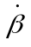 sideslip angle, deg and time rate of sideslip angle, deg/sec., respectively
δ_{a}, δ_{e}, δ_{r} control deflection angles of aileron, elevator, and rudder, respectively, deg
δ_{s} stabilizer angle, deg
φ, θ, ψ Euler angles in roll, pitch, and yaw, respectively, deg
γ climbing angle, deg

1. Introduction
In the island environment, such as in Hawaii and Taiwan, structures are corroded in a faster rate. As a result, structural material degradation often happens, especially when the aircraft is loaded beyond its designed capabilities [1]. The number of takeoff and landing cycles should also be factored in. Especially the empennage structure requires close monitor to ensure flight safety. Any empennage with deformation under fatigue may change the effective setting of pitching controls [2]. In other words, if the empennage suffers fatigue and deformation effects, it will cause the stabilizer or elevator to have abnormal offset and flight control power to have unusual changes.

Aircraft structures are not completely rigid, and aeroelastic phenomena arise when structural deformations induce changes on aerodynamic forces. Aeroelasticity involves not only the external aerodynamic loads and the way they change but also the structural, damping and mass characteristics of the aircraft. Static aeroelasticity studies the interaction between aerodynamic and elastic forces on an elastic structure. Mass properties are not significant in the calculations of this type of phenomena. When the aircraft sustains a sudden high load, this high load causes an increase in the structural deformations, which leads to changes of aerodynamic forces in a feedback process. These interactions may become smaller until a condition of equilibrium is reached, or may diverge catastrophically if resonance occurs.

A hard landing occurs when the aircraft impacts the ground with a greater vertical speed and force than in a normal landing. The average vertical speed in a landing is around 120 m per minute (around 400 ft per minute). Anything above is classed as 'hard'. When an aircraft has experienced a hard landing it has to be checked for damage before its next flight. Although the aircraft sustains a sudden high load due to the impact in hard landing, the static aeroelastic effects are not significant because the dynamic pressure is small in landing. The effect of impact loads is more important.

Far Eastern Air Transport flight EF 306, Boeing 757-200/Thai Airways Flight TG659, Boeing 777-300 had a near collision at an altitude of 34,000 ft and 99 NM South of Jeju Island, Korea on Nov. 16, 2006. Four passengers of flight EF 306 suffered serious injury during the avoidance maneuver [3]. The transport aircraft of flight EF 306 sustained an instantaneous high load due to sudden evasive motion in avoiding air collision, but the static aeroelastic effects were not significant because the dynamic pressure was not high during the descending.

Jet commercial aircraft in flight are frequently subject to atmospheric turbulence resulting in rapidly varying aerodynamic and flight dynamic characteristics. The sudden plunging motion in severe turbulence is the major reason to cause the flight injuries [4 & 5]. These varying characteristics not only pose threats to flight safety, but also may cause structural damages and reduce fatigue life. A method based on the concept of aeroelastic effects on stability and control derivatives to indirectly determine the structural integrity of transport aircraft will be presented. The method is based on the flight data of the FDR. Aerodynamic models are established through fuzzy-logic modeling of the flight data. Stability and control derivatives with aeroelastic effects are then calculated by using these aerodynamic models. The aeroelastic effects in severe atmospheric turbulence of cruise phase and under high dynamic pressures in climb phase will be compared as the study case in the present paper.

2. Theoretical Development

2.1 Fuzzy-Logic Algorithm
In earlier development of the fuzzy-logic algorithm, Zadeh [6] used the fuzzy sets to simulate physical parameters with membership functions. The disadvantage in this approach is that the predicted curves in the functional approximation tend to be piecewise continuous. Therefore, it is not suitable when derivatives of the function are needed. The present development based on FLM technique is capable of correlating multiple parameters without assuming explicit functional relations. A detailed description of the FLM algorithm is available in reference [7] and is summarized in the following.

The internal functions are assumed to be linear functions of input parameters as follows:
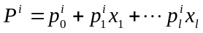 (1)
where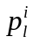are the coefficients of internal functions andis number of input variables (x).

The values of each fuzzy variable, such as the angle of attack, are divided into several ranges, each of which represents a membership function. The membership functions allow the membership grades of the internal functions for a given set of input variables to be calculated. The ranges of the input variables are all transformed into the domain of [0, 1]. Generally, overlapped triangles are the shapes used to represent the grades in the present paper. A fuzzy cell is formed by taking one membership function from each variable. The output of the fuzzy-logic model is the weighted average of all cell outputs.

To identify the best structure of fuzzy cells of the model, i.e. to determine the best number of membership functions for each fuzzy variable [7], the multiple correlation coefficient (R²) is maximized:
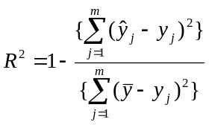 (2)
On the other hand, the coefficients of the internal functions in Eq. (1) are calculated with the Newton gradient-descent method by minimizing the sum of squared errors (SSE):
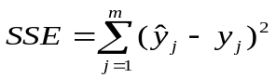 (3)
where 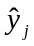 is the output of the fuzzy-logic model, y_{j} is the measured data, and is the average value of all data. Minimization is achieved by the Newton gradient-descent method with iterative formulas defined by:
for r = 0,
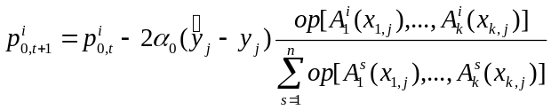 (4)
and for r = 1, …, k,
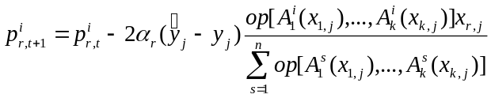 (5)
Once the aerodynamic models are set up, one can input to the models the influencing variables to describe the flight conditions under analysis. In the present paper, all static and dynamic derivatives are all computed with central differences through the aerodynamics models.

2.2 Static Aeroelasticity Theory
A method based on the concept of static aeroelasticity is described in [8]. The idea is that any aircraft structural deformation in flight due to flight loads will change some aerodynamic parameters with a certain trend under normal conditions. The concept is summarized as follows. Note that although the following discussion is based on a panel or finite-element method, the results to be presented are obtained by modeling the FDR data, not the theoretical method.

If an aircraft surface is divided into N panels, then the panel forces would be:

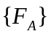=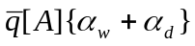 (6)

where A is the aerodynamic influence coefficient matrix defined as the aerodynamic load per unit dynamic pressure per unit area at one panel due to a unit angle of attack at some other panel. The aerodynamic forces acting on the structure will cause the structural deformation:

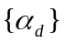=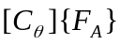 (7)

where C_{θ} is the so-called structural flexibility matrix, being defined as the local angle of attack change at one panel due to a unit load at some panel. Combination of these two equations gives:

=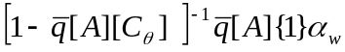 (8)
Summing over all panels, the total force coefficient can be obtained:

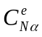 =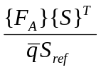=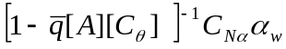 (9)
where 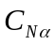=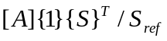 and S is a vector consisting of panel areas.
Therefore, the elastic derivative:
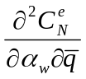
can be used to demonstrate the magnitude of aeroelastic effects, mainly of the wing.

Similarly, the derivative:
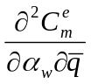
indicates the relative magnitude of empennage aeroelastic effects. The reason for using the second derivatives is that the first derivatives with the dynamic pressure is not sensitive enough to exhibit the changes and tends to be too small. These derivatives are all calculated with a central difference formula by using the numerical models.

3. Fuzzy-Logic Modeling
3.1 Compatibility Analysis
Typically, the longitudinal, lateral, and vertical accelerations (a_{x}, a_{y}, a_{z}) along the (x, y, z)-body axes of aircraft, angle of attackα, and the Euler angles (φ, θ, and ψ), as well as all control deflections are available and recorded in the FDR of all transport aircraft. Since the recorded flight data may contain errors (or called biases), compatibility analysis is performed to remove them by satisfying the following kinematic equations:
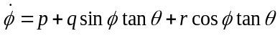 (10)
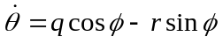 (11)
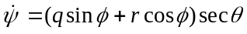 (12)
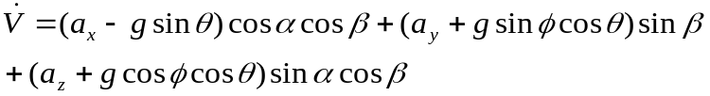 (13)
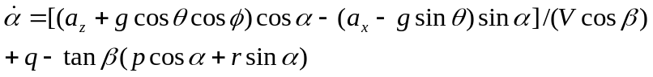 (14)
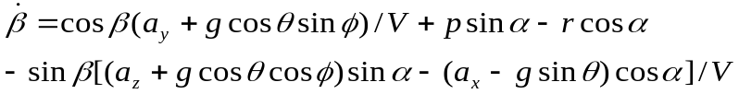 (15)
where g is the gravitational acceleration and V is the flight speed. Let the errors be denoted by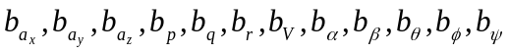, respectively for a_{x}, a_{y}, a_{z}, etc. These errors are estimated by minimizing the squared sum of the differences between the two sides of the above equations (Eqs. 10~15). These equations in vector form can be written as:

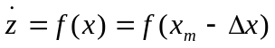 (16)
where
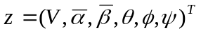 (17)
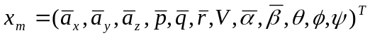 (18)
(19)
where super fix “－” stands for the mean value and the subscript “m” indicates the measured or recorded values. The cost function is defined as:

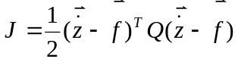 (20)
where Q is a weighting diagonal matrix with elements being 1.0 except the one for the slowly varying flight speed being 10.0 and is calculated with a central difference scheme with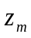, which is the measured value of. The steepest descent optimization method is adopted to minimize the cost function. As a result of the analysis, variables not present in the FDR, such asβ, p, q and r, are also estimated.

Note that since all flight variables recorded are based on the body axes, it is more convenient to estimate the force and moment coefficients for aircraft on the same axes system. Therefore the latter are obtained from the following flight dynamic equations [9]:
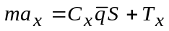 (21)
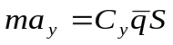 (22)
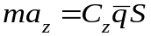 (23)
C_{l}S b = I_{xx}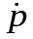 – I_{xz} + qr(I_{zz} –I_{yy}) – I_{xz} pq (24)
C_{m}S = I_{yy} + rp(I_{xx} –I_{zz}) + I_{xz} (p² – r²) – T_{m} (25)
C_{n}S b = – I_{xz} + I_{zz} + pq(I_{yy} – I_{xx}) + I_{xz}qr (26)
where m is the aircraft mass;is the dynamic pressure; S is the wing reference area; C_{x}, C_{z}, and C_{m} are the longitudinal aerodynamic force and moment coefficients; C_{y}, C_{l}, and C_{n} are the lateral-directional aerodynamic force and moment coefficients; and I_{xx}, I_{yy}, and I_{zz} are the moments of inertia about x-, y-, and z-axes, respectively. The products of inertia, I_{xy}, I_{xz}, and I_{yz}, are assumed zero in the present case; but are included in the equations because non-zero values may be available in other applications. The terms, T_{x}, and T_{m}, represent the thrust contributions to the force in the direction of x-axes, and to the pitching moment, respectively.

3.2 Longitudinal Main Aerodynamic Models
Modeling means to establish the numerical relationship among certain variables of interest. In the fuzzy-logic model, more complete necessary influencing flight variables can be included to capture all possible effects on aircraft response to structure deformations. The longitudinal main aerodynamics is assumed to depend on the following ten flight variables, the models are assumed to be of the form [10]:

C_{z}, C_{m} = f (α,, q, k₁, β, δ_{e}, M, p, δ_{s},) (27)
where the left hand side represents the coefficients of normal force (C_{z}), and pitching moment (C_{m}), respectively. The variables on the right hand side of Eq. (27), where q is the pitch rate, k the reduced frequency, δ_{e} the elevator angle, M the Mach number, p the roll rate, δ_{s} the stabilizer angle, andthe dynamic pressure.

Note that all derivatives are calculated with the established aerodynamic models at the instantaneous conditions of nonzero flight variables as the local slopes, not around the trim conditions as usually done in the conventional method. It should be noted that the stabilizer angle (δ_{s}) is included here, because it varies, though slowly, in flight to provide pitch trim (i.e. reducing the total static pitching moment to 0.0). The roll rate is included here because it is known that an aircraft under high aerodynamic loads at transonic speeds may have its longitudinal stability derivatives affected when additional disturbance due to roll rate is imposed.

4. Numerical Results and Discussions
4.1 Aerodynamic Environment
To examine the aeroelastic effects on longitudinal aerodynamics for the twin-jet transport during severe atmospheric turbulence, it is imperative to understand the flight environment first. The corresponding flight data are presented in Fig. 1. The variation of normal acceleration (a_{z}) is presented in Fig. 1(a), showing the highest a_{z} being 1.75 g around t = 3930 sec and the lowest being 0.02 g around t = 3932 sec. Fig. 1(b) shows that α is approximately in phase with a_{z} and α reaches about 7 deg, which is well above the cruise value in transonic flight. Therefore, compressibility effect is important. It should be noted that the turbulent vertical wind field was not measured or estimated in the FDR; but is included in the totalα. When the aircraft is rapidly plunging downward with the altitude (h) reaching the lowest as shown in Fig. 1(c), a_{z} becomes the highest (around t = 3930 sec). The Mach number (M) drops from 0.81 to 0.72 in Fig. 1(d). The aeroelastic effects can be expected to be very significant under the circumstances of high g loads and rapidly changing a_{z} in transonic flight. Note: the magnitude of a_{z} is changed rapidly due to the sudden plunging motion, not the other way around.

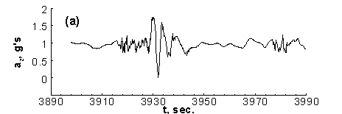
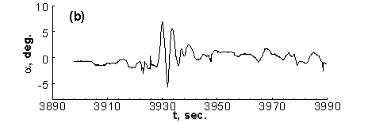
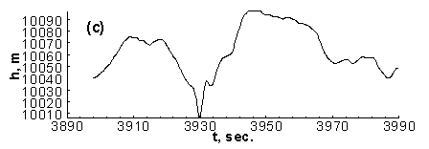
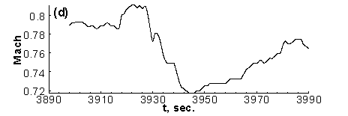
Fig. 1 The time history of flight variables for a twin-jet transport in severe atmospheric turbulence at the altitude around 10,050 m in transonic flight

4.2 Flight Data for Modeling
Two datasets are employed for comparative analysis of static aeroelastic effects on longitudinal aerodynamics for the twin-jet transport before and during severe atmospheric turbulence. One dataset is the aircraft response data to turbulence recorded in the FDR. Fig. 2 presents the time history of main flight variables for the twin-jet transport in severe atmospheric turbulence at the altitude around 10,050 m in cruise phase. The variations of flight altitudes and angles of attack are indicated in Fig. 2(a) and 2(b), respectively. The detailed aerodynamic environment has been described in section 4.1. The highest dynamic pressure is 11,972 N/m² (250 lb/ft²) before encountering turbulence and the magnitudes are decreased during the period of encountering turbulence in the period time of t= 3927~3940 sec, as indicated in Fig. 2(c).

Usually, the datasets in climb phase are more suitable for the study of static aeroelastic effects, because the aircraft passes through the high dynamic pressure region before reaching the cruise altitude. Fig. 3 presents the time history of main flight variables for the transport aircraft in climb phase. The dynamic pressure is above 14,367N/m² (300 lb/ft²) in time segment at t = 280~860 sec; while the range of flight altitudes is 4,572m~8,534m.

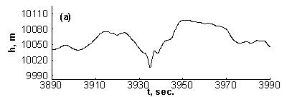
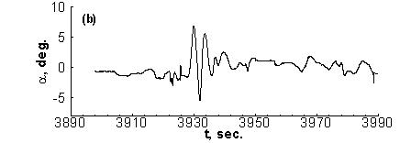
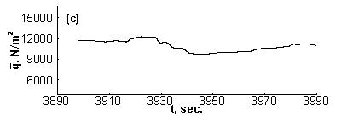
Fig. 2 The time history of main flight variables for the twin-jet transport in severe atmospheric turbulence at the altitude around 10,050 m in cruse phase

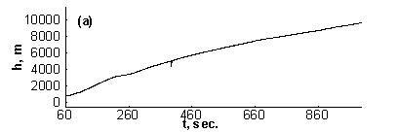
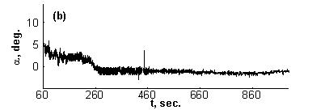
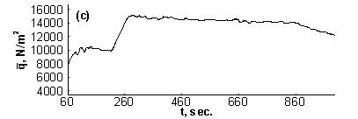
Fig. 3 The time history of main flight variables for the transport aircraft in climb phase

The main aircraft geometric and inertial characteristics are taken to be:
W (take-off) = 1,431,800 N (321900 lb)
S = 260 m² (2798.7 ft²), = 6.608 m (21.68 ft), b= 44.827 m (147.08 ft)
I_{xx} = 10,710,000 kg-m² (7,899,900 slugs-ft²), I_{yy} = 14,883,800 kg-m² (10,978,000 slugs-ft²)
I_{zz} = 25,283,271 kg-m² (18,648,470 slugs-ft²), I_{xz} = 0.0 kg-m²

These two datasets for modeling are extracted from the FDR of the same flight. The necessary data through modeling to determine the aerodynamics are time (t), CAS, pressure altitude (h), roll attitude (φ), pitch attitude (θ), magnetic heading (ψ), normal acceleration (a_{z}), lateral acceleration (a_{y}), longitudinal acceleration (a_{y}), angle of attack (α), aileron deflection (δ_{a}), elevator (δ_{e}), rudder (δ_{r}), stabilizer (δ_{s}), engine EPR, outside air temperature, wind speed, wind direction, and fuel flow rate. Since only the normal acceleration is recorded in 8-Hz resolution (i.e. 8 points per second), all other parameters are interpolated with a monotone cubic spline to the same sampling rate.

4.3 Analysis of Model Predictions
In the present study, the accuracy of the established unsteady aerodynamic models with six aerodynamic coefficients through FLM algorithm is estimated by the sum of squared errors (SSE) and the square of multiple correlation coefficients (R²). The elastic derivatives in the study of structural integrity are calculated with these aerodynamic models of aerodynamic coefficients.

In climb phase, initial modeling shows that the squared correlation coefficient (R²) of the normal force C_{z} and pitching moment C_{m} models can only reach 0.9882 and 0.7862, respectively. This may imply that uncertainties due to structural vibration, the estimated thrust, or some other unknown factors exist. Since eventually derivatives of C_{z} and C_{m} will be taken, scattered C_{z} and C_{m} data will result in scattered derivatives. At the same time, the computing time can be minimized after the number of data points being reduced. For this purpose, the data reduction by model-based filtering [11] is applied. Firstly, the model structure is determined with all data included. After R² remaining unchanged, all data points that deviate from the model-predicted values by more than a fixed percentage, such as 10% for the present C_{z} and C_{m} data, will be deleted.

In order to avoid the accuracy of the model prediction being degraded, the number of points to be removed each time should not exceed more than 10% of the previous points. In the next run, the fixed percentage is reduced, and so on, until R² reaches a value greater than a preset value. According to the experience in aerodynamic modeling, the value of R² for C_{z} is usually higher. The value in the climb phase reaches 0.99. The value of R² for C_{m} is lower than that of C_{z}. To avoid too many points being removed, the preset value is 0.95. Since the present modeling is based on the least-square method, the final estimated model will not be affected by this type of filtering. Reducing the number of data points by keeping one record for every two points proves to be ineffective in increasing R². In climb phase, the R² of C_{z} and C_{m} models reach from 0.9882 to 0.9948 and from 0.7862 to 0.9606, respectively, after 10% deviated data being removed, with the number of data points reduced from an original number of 940 and 940 to 854 and 624, respectively.

The predicted normal force C_{z} and pitching moment C_{m} coefficients for climb and cruise phases are presented in Fig. 4 and Fig. 5, respectively. The squared correlation coefficients (R²) of C_{z} and C_{m} for these two phases are shown in Table 1.

Table 1 Squared Correlation Coefficients of Numerical Models
R² for model | Climb | Cruise
R² for C_{z} (%) | 99.48 | 97.89
R² for C_{m} (%) | 96.06 | 95.79

Note that R² = 0.9948 implies that 99.48% of the data can be explained and represented by the established numerical model [12]. These high correlation coefficients are reflected in the good agreement of the model-predicted results with the data.
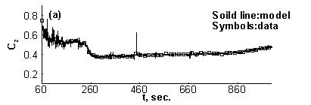
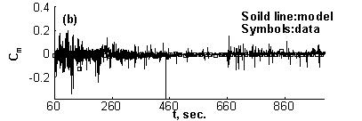
Fig. 4 Predicted longitudinal aerodynamic coefficients in climb phase based on FDR data

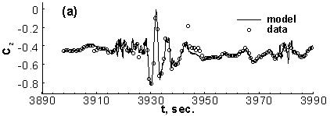
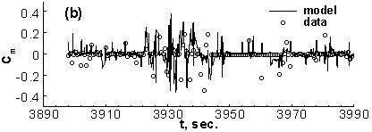
Fig. 5 Predicted longitudinal aerodynamic coefficients in cruise phase based on FDR data

4.4 Analysis of Aeroelastic Affects
Fig. 6 presents the time history of aeroelastic effects on longitudinal aerodynamics in climb phase within the time span of 900 sec. The aeroelastic effects on longitudinal aerodynamics in cruise phase within the time span of 92 sec are presented in Fig. 7.

Based on static aeroelastic effects, deformation under aerodynamic loads for a conventional normal aircraft structure would decrease 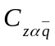 and make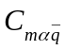more negative, in such a way that the aerodynamic center would shift back [3]. This is also related to aeroelastic stability. For example, if is positive, it means the wing would twist up under load, and the load would further increase.

In Figs.7(b) and 7(c), it is seen that there is a large variation for both magnitudes of andin the severe turbulence encountered in the period time of t= 3927~3940 sec. The magnitude ofin cruise phase (Fig. 7b) is decreased in comparison with that of climb phase (Fig. 6b), except the portion in turbulence encounter. The magnitude of after the plunging motion becomes less negative, implying the wing structure having less twist-down or more twist-up. Twist-down under high loadings is normal for a typical sweptback wing. The magnitude of is in a nominal positive value in climb phase, as indicated in Fig. 6(c), probably due to the strong wing wake effect on the horizontal tail. The magnitude ofin cruise phase is in more negative value in comparison with that of climb phase, as shown in Fig. 7(c), except the portion in turbulence encounter. This implies that the static aeroelastic response of the empennage of aircraft in cruise phase is larger than that of climb phase. Note that for a new wing these two derivatives are nearly zero. If the magnitude is too large, no matter whether the sign is positive or negative, the aeroelastic effect should be judged to be undesirable. If the derivatives are positive, then there may be aeroelastic instability.
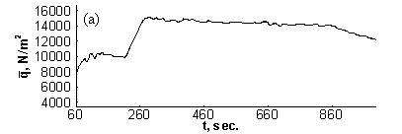
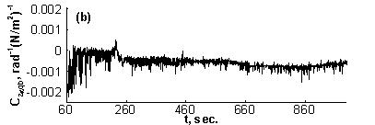
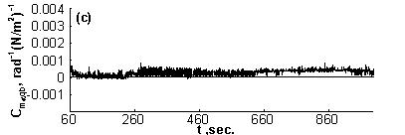
Fig. 6 Aeroelastic effects on longitudinal aerodynamics in climb phase within the time span of 900 sec
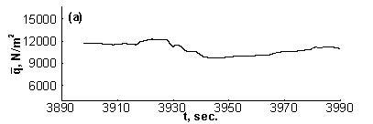
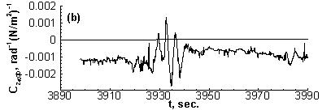
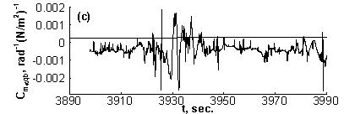
Fig. 7 Aeroelastic effects on longitudinal aerodynamics in cruise phase within the time span of 92 sec

5. Concluding Remarks
The main objective of this paper is to present an evaluating method of structural integrity for a twin-jet transport in severe atmospheric turbulence. The method was based on the flight data extracted from the FDR to predict the aeroelastic effects. The aeroelastic effects of the wing and empennage in severe atmospheric turbulence were significant due to the structural deformation under high g loads in transonic flight, and were found to be larger than that in climb phase without turbulence effects. Because this method employed the flight data stored in the FDR, intrusive structural testing could be avoided. In essence, the normal force and pitching moment derivatives were used to estimate qualitatively the aeroelastic effects on the wing and the tail, respectively. This method could be used to assist airlines to monitor the structural integrity as a complementary tool to improve aviation safety, and operational efficiency.

Acknowledgments
This research project is sponsored by a grant, NSC 99-2221-E-157 -002-, from National Science Council (NSC). The accomplishment in this project is part of the requirements set by the Aviation Safety Council (ASC), Taiwan (R.O.C.).

References
[1] Cunningham, A., “The Role of Non-Linear Aerodynamics in Fluid-Structure Interaction,” AIAA Paper 98-2423, 1998.
[2] Lan, C. E., Chang, R. C., and Guan, W. L., "Evaluation of Structural Integrity of Transport Aircraft Based on Flight Data," Journal of Aeronautics, Astronautics and Aviation, Series A, Vol. 38, No. 3, Sept. 2006, pp. 159-166.
[3] Aviation Safety Council, Far Eastern Air Transport Flight EF 306, Boeing 757-200/Thai Airways Flight TG659, Boeing 777-300, Nov 16, 2006, Aviation Final Report, August 2008.
[4] Chang, R. C., Ye, C. E., Lan, C. E., and Guan, W. L., "Flying Qualities for a Twin-Jet Transport in Severe Atmospheric Turbulence," AIAA Journal of Aircraft, Vol. 46, No. 5, Sept.-Oct. 2009, pp. 1673-1680.
[5] Chang, R. C., Ye, C. E., Lan, C. E., and Guan, W. L., "Hazardous Levels of Commercial Aircraft Response to Atmospheric Turbulence," Transactions of the Japan Society for Aeronautical and Space Sciences, Vol. 52, No. 178, Feb., 2010.
[6] Zadeh, L. A., "Outline of a New Approach to the Analysis of Complex Systems and Decision Processes," IEEE Transactions on Systems, Man, and Cybernetics, Vol. SMC-3, No. 1, 1973, pp. 28-44.
[7] Chang, R. C., Ye, C. E., Lan, C. E., and Lee, Y. L., “Nonlinear and Dynamic Aerodynamic Models for Commercial Transport Aircraft with Adverse Weather Effects,” Mathematical Problems in Engineering, Volume 2010, Article ID 924275, doi:10.1155/2010/924275.
[8] Roskam, J. and Lan, C. E., “A Parametric Study of Planform and Aeroelastic Effects on Aerodynamic Center, α- and q-Stability Derivatives,” NASA CR-2117, Apr. 1973.
[9] Roskam, J., Airplane Flight Dynamics and Automatic Flight Controls, Part I, DAR Corporation, Lawrence, Kansas, 2003.
[10] Chang, R. C., Ye, C. E., Lan, C. E., and Guan, W. L., "Stability Characteristics for Transport Aircraft Response to Clear-Air Turbulence," Journal of Aerospace Engineering, Vol. 23, No. 3, July 2010, pp.197~204.
[11] Lan, C. E., Bianchi, Silvia, and Brandon, Jay M., “Estimation of Nonlinear Aerodynamic Roll Models for Identification of Uncommanded RollingMotions,” Journal of Aircraft, Vol. 45, No. 3, May–June 2008, pp. 916-922.

[12] Barnes, J. W., Statistical Analysis for Engineers and Scientists, McGraw-Hill, Inc. 1994, p.218.

