Aluno: Matheus Ximenes Ferreira (95666)

Trabalho 1 – Organização de Computadores

Mapa de Karnaugh – Maior Igual 2 Bits

|  |  |  |  |  |  |  |  |  |  |
| --- | --- | --- | --- | --- | --- | --- | --- | --- | --- |
|  | Ai | Ai+1 | Bi | Bi+1 |  |  |  | Mi | Ii |
|  |  |  |  |  |  |  |  |  |  |
| linha | X3 | X2 | X1 | X0 |  |  |  |  |  |
| 0 | 0 | 0 | 0 | 0 |  |  |  | 0 | 1 |
| 1 | 0 | 0 | 0 | 1 |  |  |  | 0 | 0 |
| 2 | 0 | 0 | 1 | 0 |  |  |  | 0 | 0 |
| 3 | 0 | 0 | 1 | 1 |  |  |  | 0 | 0 |
| 4 | 0 | 1 | 0 | 0 |  |  |  | 1 | 0 |
| 5 | 0 | 1 | 0 | 1 |  |  |  | 0 | 1 |
| 6 | 0 | 1 | 1 | 0 |  |  |  | 0 | 0 |
| 7 | 0 | 1 | 1 | 1 |  |  |  | 0 | 0 |
| 8 | 1 | 0 | 0 | 0 |  |  |  | 1 | 0 |
| 9 | 1 | 0 | 0 | 1 |  |  |  | 1 | 0 |
| 10 | 1 | 0 | 1 | 0 |  |  |  | 0 | 1 |
| 11 | 1 | 0 | 1 | 1 |  |  |  | 0 | 0 |
| 12 | 1 | 1 | 0 | 0 |  |  |  | 1 | 0 |
| 13 | 1 | 1 | 0 | 1 |  |  |  | 1 | 0 |
| 14 | 1 | 1 | 1 | 0 |  |  |  | 1 | 0 |
| 15 | 1 | 1 | 1 | 1 |  |  |  | 0 | 1 |

Ii

Mi

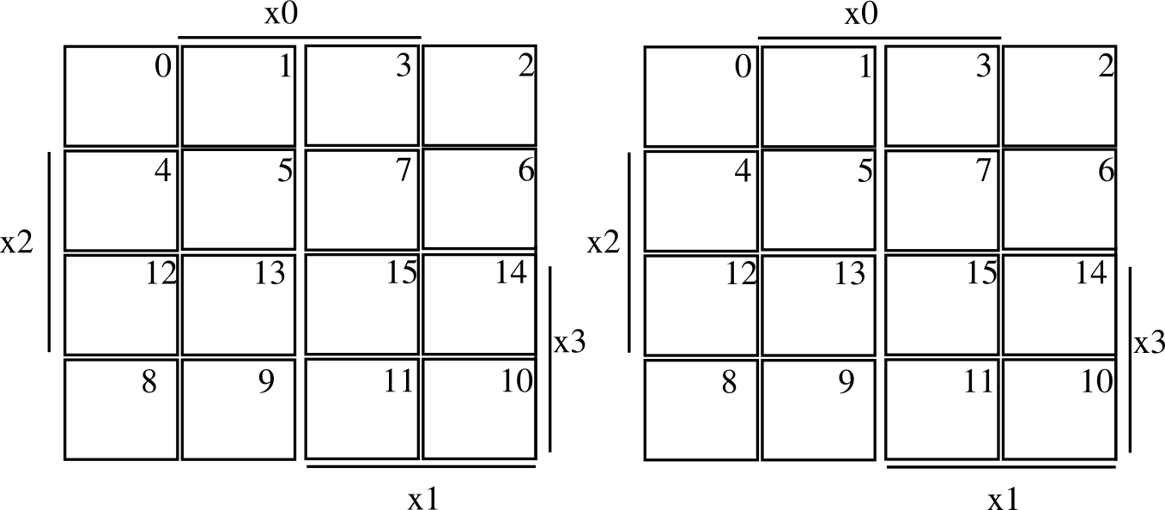

1

1~x0 &

1

1

1

1

1

1

1

1

Grupos Mi – (12, 13, 8, 9), (12, 4), (14)

Mi = x3&~x1 | x2 & ~x0 & ~x1 | x3 & x2 & x1 & ~x0

Grupos Li – (5), (0), (15), (10)

Li = ~x0 & ~x1 & ~x2 & ~x3 | x2 & x0 & ~x1 & ~x3 | x0 & x1 & x2 & x3 | ~x2 & ~x0 & x1 & x3

Mapa de Karnaugh - Árvore

|  |  |  |  |  |  |  |  |  |  |
| --- | --- | --- | --- | --- | --- | --- | --- | --- | --- |
|  |  |  |  |  |  |  |  | Mi | Ii |
|  | Me | Ie | Md | Id |  |  |  |  |  |
| linha | X3 | X2 | X1 | X0 |  |  |  |  |  |
| 0 | 0 | 0 | 0 | 0 |  |  |  | 0 | 0 |
| 1 | 0 | 0 | 0 | 1 |  |  |  | 0 | 0 |
| 2 | 0 | 0 | 1 | 0 |  |  |  | 0 | 0 |
| 3 | 0 | 0 | 1 | 1 |  |  |  | X | X |
| 4 | 0 | 1 | 0 | 0 |  |  |  | 1 | 0 |
| 5 | 0 | 1 | 0 | 1 |  |  |  | 0 | 1 |
| 6 | 0 | 1 | 1 | 0 |  |  |  | 0 | 0 |
| 7 | 0 | 1 | 1 | 1 |  |  |  | X | X |
| 8 | 1 | 0 | 0 | 0 |  |  |  | 1 | 0 |
| 9 | 1 | 0 | 0 | 1 |  |  |  | 1 | 0 |
| 10 | 1 | 0 | 1 | 0 |  |  |  | 1 | 0 |
| 11 | 1 | 0 | 1 | 1 |  |  |  | X | X |
| 12 | 1 | 1 | 0 | 0 |  |  |  | X | X |
| 13 | 1 | 1 | 0 | 1 |  |  |  | X | X |
| 14 | 1 | 1 | 1 | 0 |  |  |  | X | X |
| 15 | 1 | 1 | 1 | 1 |  |  |  | X | X |

Mi Ii

x

1

x

x

x

x

x

x

x

x

x

x

x

1

1

1

1

x

x

Grupos Mi: (8, 9, 10, 11, 12, 13, 14, 15), (3, 7, 11, 15), (4,12)

Mi: x3 | x1 & x0 | x2 & ~x1 & ~x0

Grupos Li: (12, 13, 14, 15), (3, 7, 11, 15), (5, 7, 13, 15)

Li: x2 & x3 | x1 & x0 | x0 & x2