

CSE-439s
Design of Compilers
Project Test Snapshots
Team #24

Names | ID
Mathew Mina Youssef | 2300910
Martin Amgad Zakaria | 2200751
Radwa Yasser Ahmed | 2200239
Hanya Ibrahim Aref | 2201045
Nouran Mohamed El-Sayed | 2201382
Andrew Ehab Tharwat | 2200249

Test Case 1

Input

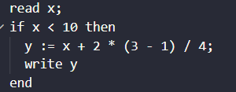

Output

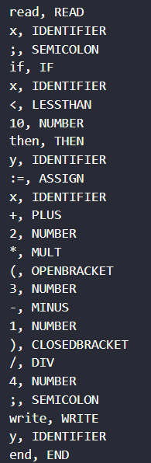

Test Case 2

Input
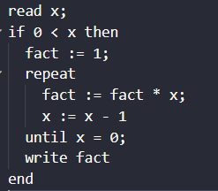

Output

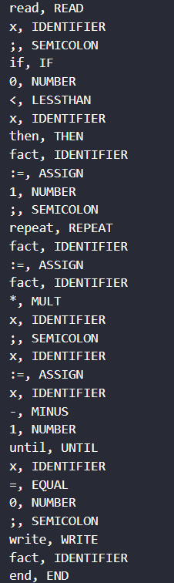

Test Case 3

Input
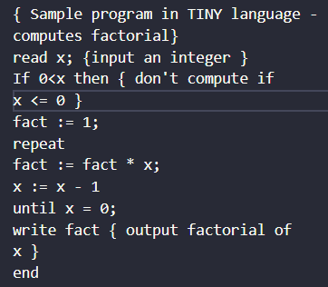

Output


