Survive the Night Capstone Planning Document

## Description:

For my Capstone Project, I want to create a post-apocalyptic forest environment in which the player scent has been picked up by nearby zombies. The scene should amplify the feelings of fear and loneliness as you try and survive the night.

To begin the experience, players are staged in the middle of the dark forest, lit only by moonlight and the torch you have just dropped with fright and your cabin in the woods.

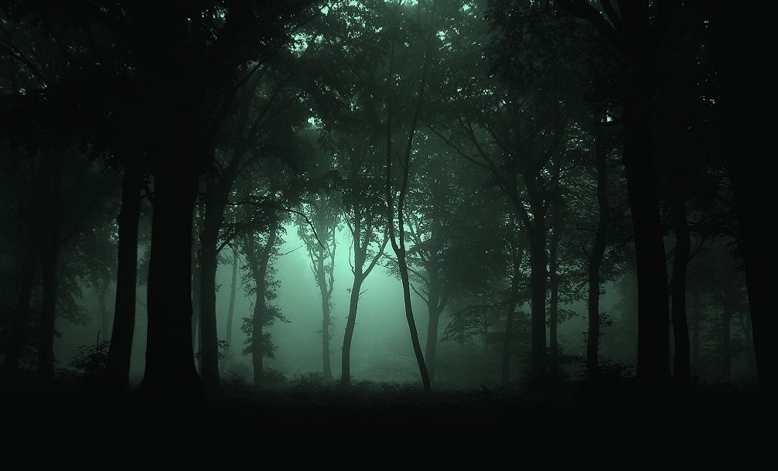

Armed with a bow and arrow strapped to your back, your challenge is to fight off hordes of zombies for as long as you can and scoring points along the way.

Players may have the opportunity to wield other possible weapons in the scene.

When you eventually meet your demise, you can play again and attempt to improve your survival time.

## Features And Dependencies:

### 3D Models + Animations (Reference Images)

* 1. 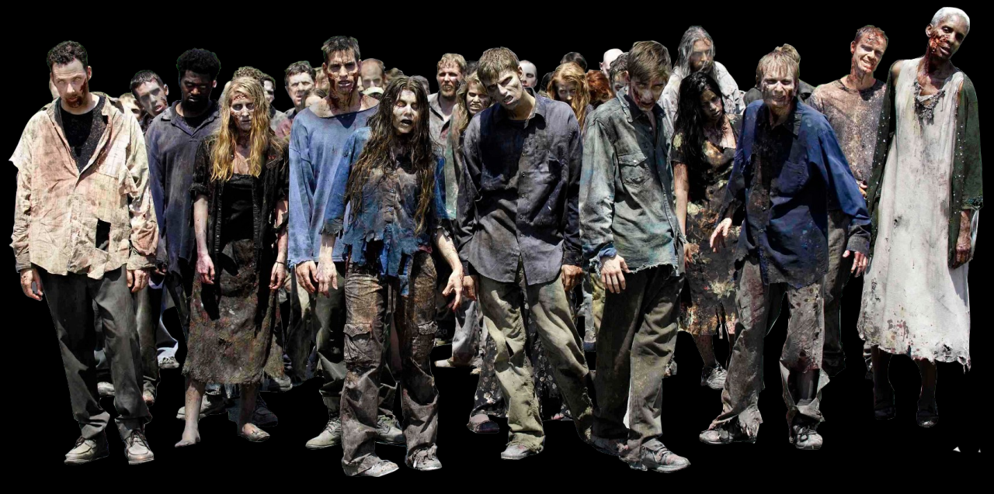Zombie horde animated to move, attack and be killed.
  2. Weaponry/Usables
     1. 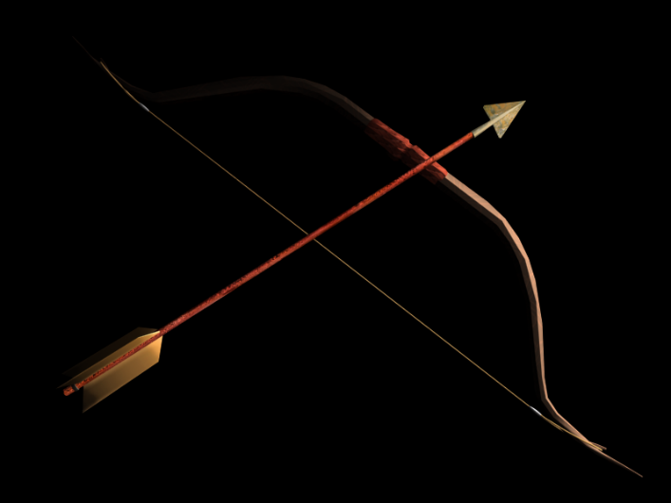Bow and Arrow.
     2. 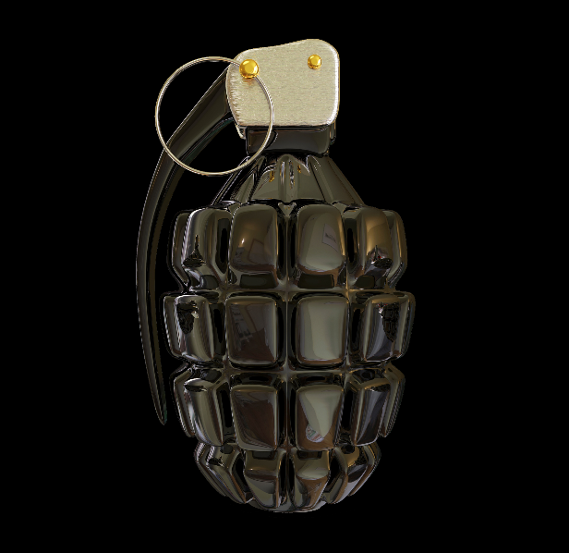Grenade
     3. Hand Gun

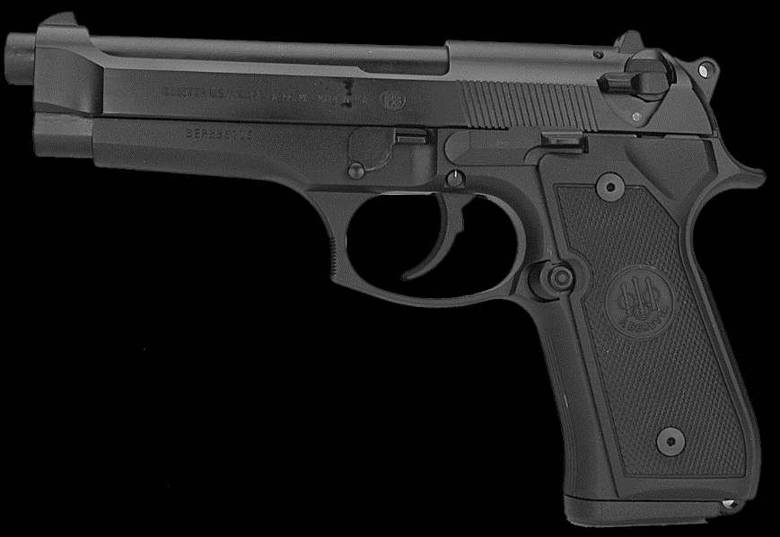

* + 1. 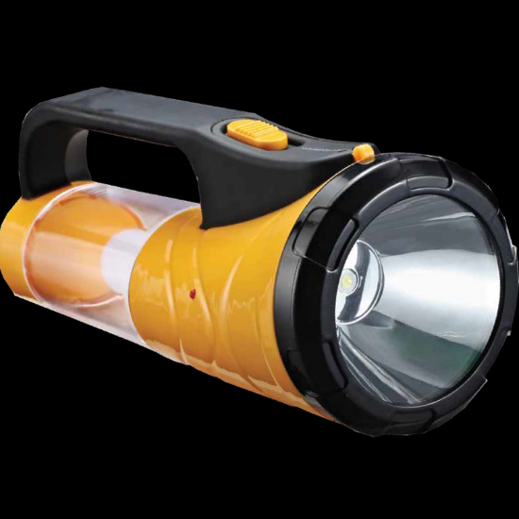Torch
  1. Environment
     1. Starry night skybox
     2. 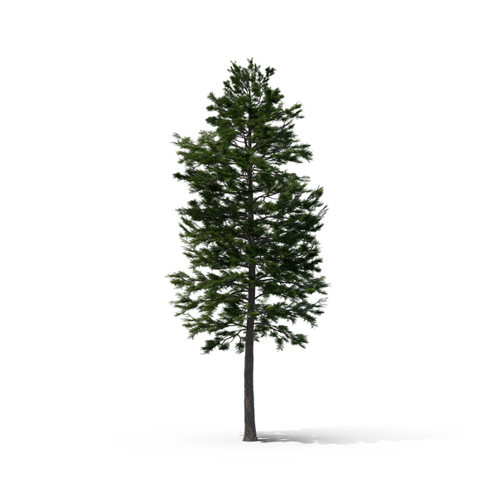Forest

* + 1. 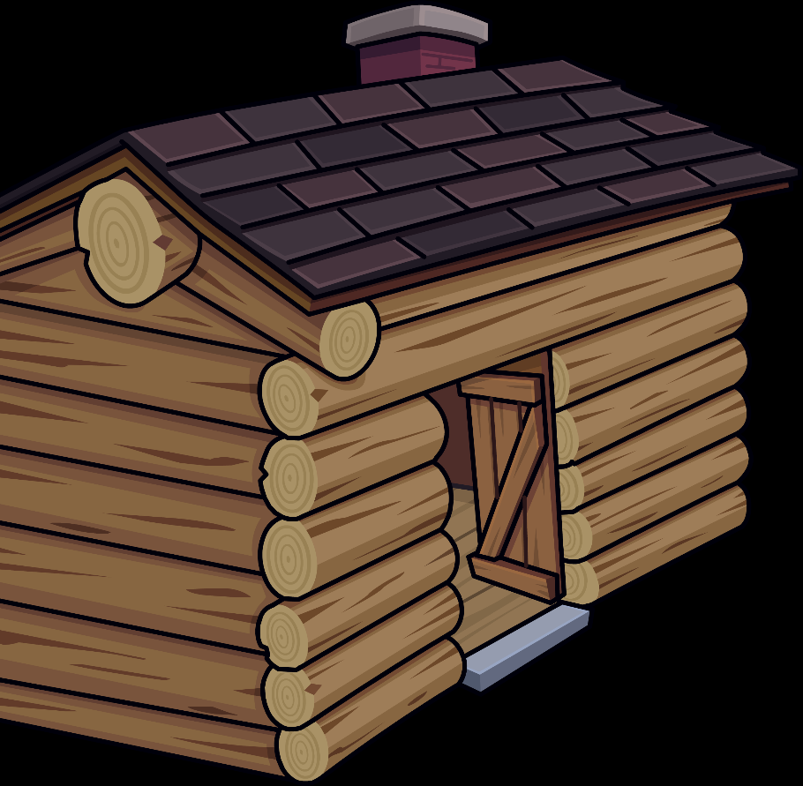Cabin
    2. Shipping Container

### Game Loop

* 1. Player goes out and tries to kill as many zombies as they can!
  2. Bow and arrow is usable with infinite ammo.
  3. More weapons to be available in game.
  4. Once game has ended, player can reset and try again.

### Other Effects

* 1. Dark Lighting used to unnerve the user.
  2. Explosions on cannisters and grenades when used helping bright the dimly lit scene.
  3. Spatial Sound effects for snapping twigs for incoming enemies and also for explosions.
  4. Procedural navigation mesh for enemy movement as no assets purchased.

Scoping

## Features And Dependencies:

### 3D Models + Animations

* 1. Grenade
     1. **Revised: Removed from the scene until a later date. I had issues with the grenade object flying off into the distance, after pulling the pin and trying to throw. Other than that.**
  2. Hand gun
     1. **Revised: Removed as I couldn’t work it properly. I will have to watch more video’s online for this.**
  3. Torch
     1. **Revised: Originally, I was going to have a moveable torch in which the player could pick it up and move along with the Gun to find the zombies. After struggling with the gun, I decided to use the bow and arrow as the user’s main weapon, and to statically place the torch. I found statically placing in the scene increased the fear factor when playing.**