KRISTU JAYANTI INSTITUTE OF TECHNOLOGY (KJIT)
DEPARTMENT OF COMPUTER SCIENCE & TECHNOLOGY
ENTERPRISE COMPUTING PROJECT REPORT
KJIT MEDIA MANAGEMENT SYSTEM (MMS)
An Enterprise Role-Based Event Media Orchestration & Academic Reporting Portal

Academic Identifier | Project Specification Details
Project Title | KJIT Media Management System (MMS)
Institution Name | KRISTU JAYANTI INSTITUTE OF TECHNOLOGY (KJIT)
Course / Nature | Enterprise Computing Project (MCA / Computer Science)
Register Number | 25MCAA24
Technology Stack | Next.js 14.1.0 (App Router), React 18, TypeScript, Prisma ORM, SQLite
UI & Styling | Tailwind CSS 3.4.1, Framer Motion 11, Lucide React
Core Architecture | Role-Based Access Control (8 Roles), 3-Tier Approvals (Dean -> HOD -> Coord)
Version & State | Release v1.0 Production Baseline (Clean Slate Database & Operational SMTP)

TABLE OF CONTENTS
CHAPTER NO | TITLE | PAGE NO
— | Abstract | 1
— | List of Tables | 3
— | List of Figures | 4
1 | 1. Introduction | 5
 | 1.1 Problem Statement | 5
 | 1.2 Project Description | 6
 | 1.3 Objectives | 7
 | 1.4 Scope | 8
 | 1.5 User Roles and Permissions | 8
2 | 2. System Study | 10
 | 2.1 Existing System | 10
 | 2.2 Proposed System | 11
 | 2.3 Use Case Diagram | 13
 | 2.4 Sequence Diagram | 14
 | 2.5 Activity Diagram (Dean -> HOD -> Coordinator) | 15
3 | 3. System Configuration | 16
 | 3.1 Hardware Configuration | 16
 | 3.2 Software Configuration | 17
4 | 4. Software Description | 18
 | 4.1 Front End Overview | 18
 | 4.2 Back End Overview | 19
5 | 5. System Design | 22
 | 5.1 System Architecture | 22
 | 5.2 Data Flow Diagram – Level 1 | 24
 | 5.3 Data Flow Diagram – Level 2 | 25
 | 5.4 Database Design & ER Diagram | 26
 | 5.5 Input Design | 31
 | 5.6 Output Design | 33
6 | 6. Source Code & Architecture Implementation | 35
7 | 7. System Testing | 43
 | 7.1 Test Cases | 43
8 | 8. System Implementation / Deployment | 46
 | 8.1 System Implementation | 46
 | 8.2 Deployment & Hosting | 47
 | 8.3 Maintenance & Backup | 48
9 | 9. Conclusion and Future Enhancement | 49
 | 9.1 Conclusion | 49
 | 9.2 Future Enhancement | 50
10 | 10. Appendices – Application Screenshots | 52
11 | 11. References / Bibliography | 64

ABSTRACT
The KJIT Media Management System (MMS) is a production-grade, enterprise web application designed to orchestrate the complete institutional event-media lifecycle at KRISTU JAYANTI INSTITUTE OF TECHNOLOGY (KJIT). Across higher-education institutions, academic conferences, guest lectures, cultural fests, workshops, and student extension activities generate voluminous digital media assets. Traditionally, coordinating event schedules, assigning photography crews, collecting high-resolution photographs, editing event highlight reels, securing administrative and academic approvals, publishing authorized media to social channels, and archiving formatted documentation have been hindered by fragmented communication over instant-messaging groups, lost files, and opaque email chains.
The KJIT MMS resolves these systemic bottlenecks by implementing a centralized, role-based platform built on Next.js 14 (App Router), React 18, TypeScript, Tailwind CSS, and Prisma ORM with SQLite. The application establishes eight rigorous institutional roles: System Administrator, Teacher/Faculty, Media Team Head, Media Team Member, Dean, Head of Department (HOD), Programme Coordinator, and Social Media Handler. Faculty register events by capturing comprehensive metadata—including event title, category, schedule, venue, target audience, chief guests, dignitary designations, media deadlines, and promotional posters. The Media Team Head assigns field photographers, videographers, and editors. Media crew members upload raw files and GeoTagged photographs, while designated editors assemble and submit the official event reel.
Governance and academic compliance are enforced through a strict three-tier sequential approval workflow: Dean → Head of Department (HOD) → Programme Coordinator. Rejection at any stage mandates structured corrective notes and returns the reel to the editor. Upon final Programme Coordinator endorsement, the reel is unlocked for the Social Media Handler, who leverages Gemini AI logic for drafting engaging institutional captions, conducts manual publishing, and records permanent Instagram and LinkedIn publication URLs. Additionally, faculty can instantly generate eight dynamic, standardized university activity reports with dynamic participant imports, photo grids, and single-click PDF/Excel export. Enterprise user provisioning is reinforced by automated SMTP email dispatch featuring single-use 24-hour password activation tokens, displaying the exact institutional name 'KRISTU JAYANTI INSTITUTE OF TECHNOLOGY (KJIT)'. Comprehensive audit logging guarantees total institutional accountability.

LIST OF TABLES
Table No. | Title | Page No
Table 1.1 | Major System Modules | 6
Table 1.2 | User Roles and Responsibilities Matrix (8 Roles) | 8
Table 2.1 | Comparison Between Existing and Proposed System | 11
Table 3.1 | Hardware Configuration Specifications | 16
Table 3.2 | Software Configuration & Production Package Stack | 17
Table 4.1 | Frontend Application Modules & Interactive Views | 18
Table 4.2 | Next.js API Route Handlers & Endpoint Architecture | 20
Table 5.1 | Prisma Model: User (Account & Profile Entity) | 26
Table 5.2 | Prisma Model: RolePermission (RBAC Specification) | 27
Table 5.3 | Prisma Model: Event (Core Event Identity & Poster) | 27
Table 5.4 | Prisma Model: Assignment (Crew Allocation Entity) | 28
Table 5.5 | Prisma Model: MediaAsset (Files, GeoTag & Reel) | 28
Table 5.6 | Prisma Model: ApprovalStep (3-Tier Sequential Workflow) | 29
Table 5.7 | Prisma Model: SocialMediaPublication (Instagram/LinkedIn) | 29
Table 5.8 | Prisma Model: Report (Dynamic Activity Formats 1–8) | 30
Table 5.9 | Prisma Model: AuditLog (Enterprise Traceability Entity) | 30
Table 5.10 | Prisma Model: Notification (System Alerts Entity) | 31
Table 5.11 | Prisma Model: PasswordResetToken (Security Credential) | 31
Table 5.12 | Input Category & Field Validation Specifications | 32
Table 5.13 | Output Category & Presentation Specifications | 34
Table 7.1 | Comprehensive System Test Cases (TC01 to TC25) | 43
Table 8.1 | Environment Configuration Parameters (.env.local) | 47

LIST OF FIGURES
Figure No. | Title | Page No
Figure 2.1 | Use Case Diagram — KJIT Media Management System | 13
Figure 2.2 | Sequence Diagram — End-to-End Event Media Lifecycle | 14
Figure 2.3 | Activity Diagram — Multi-Tier Approval & Publishing Flow | 15
Figure 5.1 | System Architecture Diagram — Multi-Tier Enterprise Design | 22
Figure 5.2 | Data Flow Diagram — Level 1 (Macro Processes & Stores) | 24
Figure 5.3 | Data Flow Diagram — Level 2 (Event-to-Publishing Pipeline) | 25
Figure 5.4 | Entity Relationship (ER) Diagram — Prisma SQLite Schema | 26
Figure 10.1 | Public Landing Page & Institutional Branding | 53
Figure 10.2 | Role Selection & Portal Entry Screen | 53
Figure 10.3 | Role-Specific Authentication Interface (Faculty) | 54
Figure 10.4 | Account Provisioning & Password Activation Screen | 54
Figure 10.5 | Faculty Dashboard & Operational Overview | 55
Figure 10.6 | Institutional Event Registration Form | 55
Figure 10.7 | Interactive Campus Event Calendar | 56
Figure 10.8 | Dynamic Report Generator Format Selection | 56
Figure 10.9 | Event Details & Media Collaboration View | 57
Figure 10.10 | Media Team Head Dashboard | 57
Figure 10.11 | Crew Task Allocation & Assignment Workspace | 58
Figure 10.12 | Media Member Assigned Tasks Workspace | 58
Figure 10.13 | Multi-Asset Media Upload Interface (GeoTag & Reels) | 59
Figure 10.14 | Stage 1: Dean Review & Approval Screen | 59
Figure 10.15 | Stage 2: Head of Department (HOD) Review Screen | 60
Figure 10.16 | Stage 3: Programme Coordinator Final Approval Screen | 60
Figure 10.17 | Social Media Workspace & Publication URL Logger | 61
Figure 10.18 | System Administrator Analytics Dashboard | 61
Figure 10.19 | Admin User Management & Provisioning Panel | 62
Figure 10.20 | Campus Staff & Media Directory | 62
Figure 10.21 | Enterprise System Audit Log Viewer | 63

CHAPTER 1 – INTRODUCTION
1.1 Problem Statement
Institutional events at KRISTU JAYANTI INSTITUTE OF TECHNOLOGY (KJIT) are vibrant, continuous, and academic-driven. Every academic semester encompasses hundreds of expert guest lectures, state and national conferences, faculty development programmes (FDPs), industrial visits, coding hackathons, technical exhibitions, and intra/inter-collegiate fests. Coordinating coverage across these events requires seamless collaboration among faculty organizers, the student media crew, video editors, departmental academic authorities (Deans, HODs, Coordinators), the institutional social media desk, and academic accreditation committees.
Prior to the development of the KJIT Media Management System, this coordination suffered from severe logistical fragmentation:
- Scattered Event Announcements: Event notices, schedules, and media requirements were transmitted via informal WhatsApp groups, resulting in missed coverage deadlines.
- Unclear Crew Accountability: The Media Head had no centralized dashboard to monitor which student photographer, videographer, or editor was responsible for an event.
- Disorganized Asset Repositories: Raw photos, high-resolution videos, and GeoTagged images were stored across disparate personal Google Drives, personal laptops, and flash drives.
- Missing Multi-Stage Approval Traceability: Reel reviews were conducted over messaging apps without formal timestamps, review comments, or accountability.
- Social Media Publication Delays: The Social Media Handler had to repeatedly solicit final approved reels and captions, often publishing stale content.
- Repetitive Report Preparation: Preparing NAAC/IQAC institutional activity reports required faculty to re-type participant numbers, re-gather photos, and recreate documents from scratch.
1.2 Project Description
The KJIT Media Management System (MMS) is an integrated, web-native enterprise portal that unifies the entire event-to-media-to-report lifecycle. It transforms manual, error-prone coordination into an automated, transparent, and auditable pipeline. The platform is organized into nine cohesive functional modules as summarized in Table 1.1.
Module Name | Primary Scope & Functional Responsibilities
Authentication & Security | Role-based authentication, bcrypt hashing, stateless JWT session cookies, 24-hour single-use password activation.
Event Registration | Captures event identity, academic category, venue, audience size, dignitaries, media deadline, and poster upload.
Interactive Calendar | Full campus event calendar featuring Month, Week, Day, and Agenda views with historical event archival.
Crew Task Assignment | Enables Media Team Head to assign photographers, videographers, and editors with email notifications.
Media Asset Repository | Multi-category file uploader supporting Raw Photos, GeoTagged Photos (with GPS metadata), and Final Reels.
Multi-Tier Approval Engine | Strict sequential 3-tier governance: Stage 1 (Dean) -> Stage 2 (HOD) -> Stage 3 (Programme Coordinator).
Social Media Desk | Access to fully approved reels, Gemini AI caption generation, and permanent Instagram/LinkedIn URL recording.
Dynamic Report Generator | Eight official institutional report formats with dynamic participant import, photo embedding, and PDF/Excel export.
Administration & Audit | User provisioning, department alignment, account activation email resend, and immutable audit logging.
1.3 Objectives
The primary engineering and operational objectives of the KJIT Media Management System include:
- Centralize Event Intelligence: Capture all event logistics, guest lists, and promotional posters in a unified relational schema.
- Enforce Operational Accountability: Implement formal crew assignment and task tracking for photographers, videographers, and editors.
- Ensure Institutional Compliance: Implement an uncompromising multi-stage approval chain (Dean -> HOD -> Coordinator) before content publication.
- Accelerate Social Media Publishing: Provide the Social Media Handler with immediate access to approved reels and AI-assisted caption drafting.
- Streamline Accreditation Reporting: Automate the generation of all eight standardized university activity report formats.
- Guarantee Security & Auditability: Enforce robust RBAC permissions, encrypted password setup, and tamper-evident audit trails.
1.4 Scope
The system scope encompasses the internal institutional operations of KRISTU JAYANTI INSTITUTE OF TECHNOLOGY. It provides role-specific workspaces for 8 distinct user roles. The system manages media storage through a modular storage provider abstraction supporting local filesystem storage and Google Drive API integration. Social media publishing is purposefully architected as manual distribution with authoritative URL recording, guaranteeing compliance with institutional social media policies without exposing institutional accounts to third-party API token deprecation.
1.5 User Roles and Responsibilities
Table 1.2 details the eight application roles, their assigned permissions, and their operational responsibilities.
Role | Permissions Code | Core Operational Responsibilities
Admin | dashboard:view, users:manage, audit:view, directory:view, events:directory, calendar:view | Provision user accounts, dispatch activation emails, manage permissions, and audit all system logs.
Faculty / Organiser | dashboard:view, events:create, reports:generate, events:directory, calendar:view | Register events, upload event posters, specify media deadlines, view calendar, and generate activity reports.
Media Team Head | dashboard:view, assignments:manage, media:upload, directory:view, events:directory, calendar:view | Oversee media calendar, allocate crew (photographers, videographers, editors), and monitor Drive folders.
Media Member | dashboard:view, media:upload, events:directory, calendar:view | View assigned events, capture and upload GeoTagged & raw photos, compile highlight reels, and submit for review.
Dean | dashboard:view, approvals:view, events:directory, calendar:view | Stage 1 institutional review: Evaluate compiled event reels for academic dignity, quality, and leadership standards.
HOD | dashboard:view, approvals:view, events:directory, calendar:view | Stage 2 departmental review: Verify curriculum relevance, academic accuracy, and departmental representation.
Programme Coordinator | dashboard:view, approvals:view, events:directory, calendar:view | Stage 3 final review: Conduct final operational validation and authorize reel for social media handoff.
Social Media Handler | dashboard:view, social:manage, events:directory, calendar:view | Access authorized reels, draft AI captions, publish to Instagram/LinkedIn, and record publication URLs.

CHAPTER 2 – SYSTEM STUDY
2.1 Existing System
In the legacy operational workflow at KJIT, event coordination relied on decentralized tools including WhatsApp groups, phone calls, individual Google Drive links shared via email, and physical paper submission of post-event reports. When an event was scheduled, the organizing faculty member sent text messages to student media coordinators. Photographers and videographers often captured files onto personal SD cards, leading to significant delays in asset compilation. Video editors had no formal queue for reel submissions, and approval was sought by forwarding video files over chat applications. This caused leadership feedback to become lost or disputed, and reels were frequently published without required HOD or Dean oversight.
2.2 Proposed System
The proposed KJIT Media Management System establishes a single source of truth for the institutional event-media lifecycle. By enforcing a role-based architecture, every user is guided through designated, auditable steps. Table 2.1 contrasts the existing manual approach with the proposed centralized system.
Operational Dimension | Legacy Approach | Proposed KJIT MMS Platform
Event Registration | Informal chat messages or printed forms | Standardized portal form with category, guests & poster upload
Media Assignment | Verbal requests or ad-hoc messaging | Formal assignment interface designating photographer, videographer & editor
Asset Storage | Scattered on personal flash drives & drives | Unified local / Google Drive storage keyed by event UUID
Reel Review Workflow | Unstructured messaging; no audit trail | Strict sequential 3-tier chain: Dean -> HOD -> Programme Coordinator
Rejection & Feedback | Untracked comments; frequent confusion | Formal rejection notes requiring revision and resubmission
Social Media Tracking | Manual follow-ups; untracked URLs | Dedicated workspace with AI captioning and permanent URL logging
Accreditation Reports | Manual re-typing across 8 formats | Automated dynamic report generator with participant import & PDF export
Security & Audit | No centralized authentication or logs | Stateless JWT, single-use activation tokens, and immutable audit logs
2.3 Use Case Diagram
Figure 2.1 depicts the UML Use Case Diagram of the KJIT Media Management System. It models the eight institutional actors and their explicit functional boundaries. The Administrator governs user accounts, permissions, and system audits. Faculty register events and generate reports. The Media Head assigns crew roles. Media Members upload digital assets. The Dean, HOD, and Programme Coordinator sequentially review submitted reels. The Social Media Handler records public URLs.
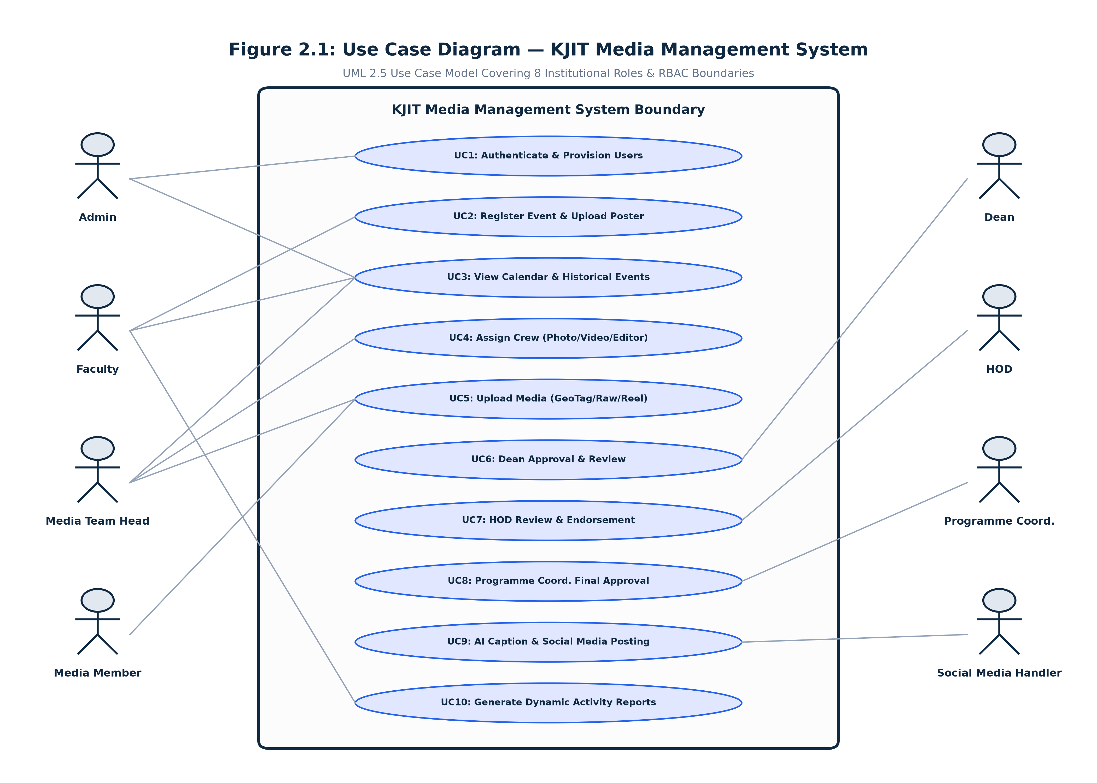
Figure 2.1: Use Case Diagram of KJIT Media Management System
2.4 Sequence Diagram
Figure 2.2 illustrates the chronological message sequences across the system entities. It tracks an event from initial faculty registration, through crew assignment by the Media Head, file uploads by the media crew, editor reel submission, sequential three-tier approvals, social media publication handoff, and dynamic report generation.
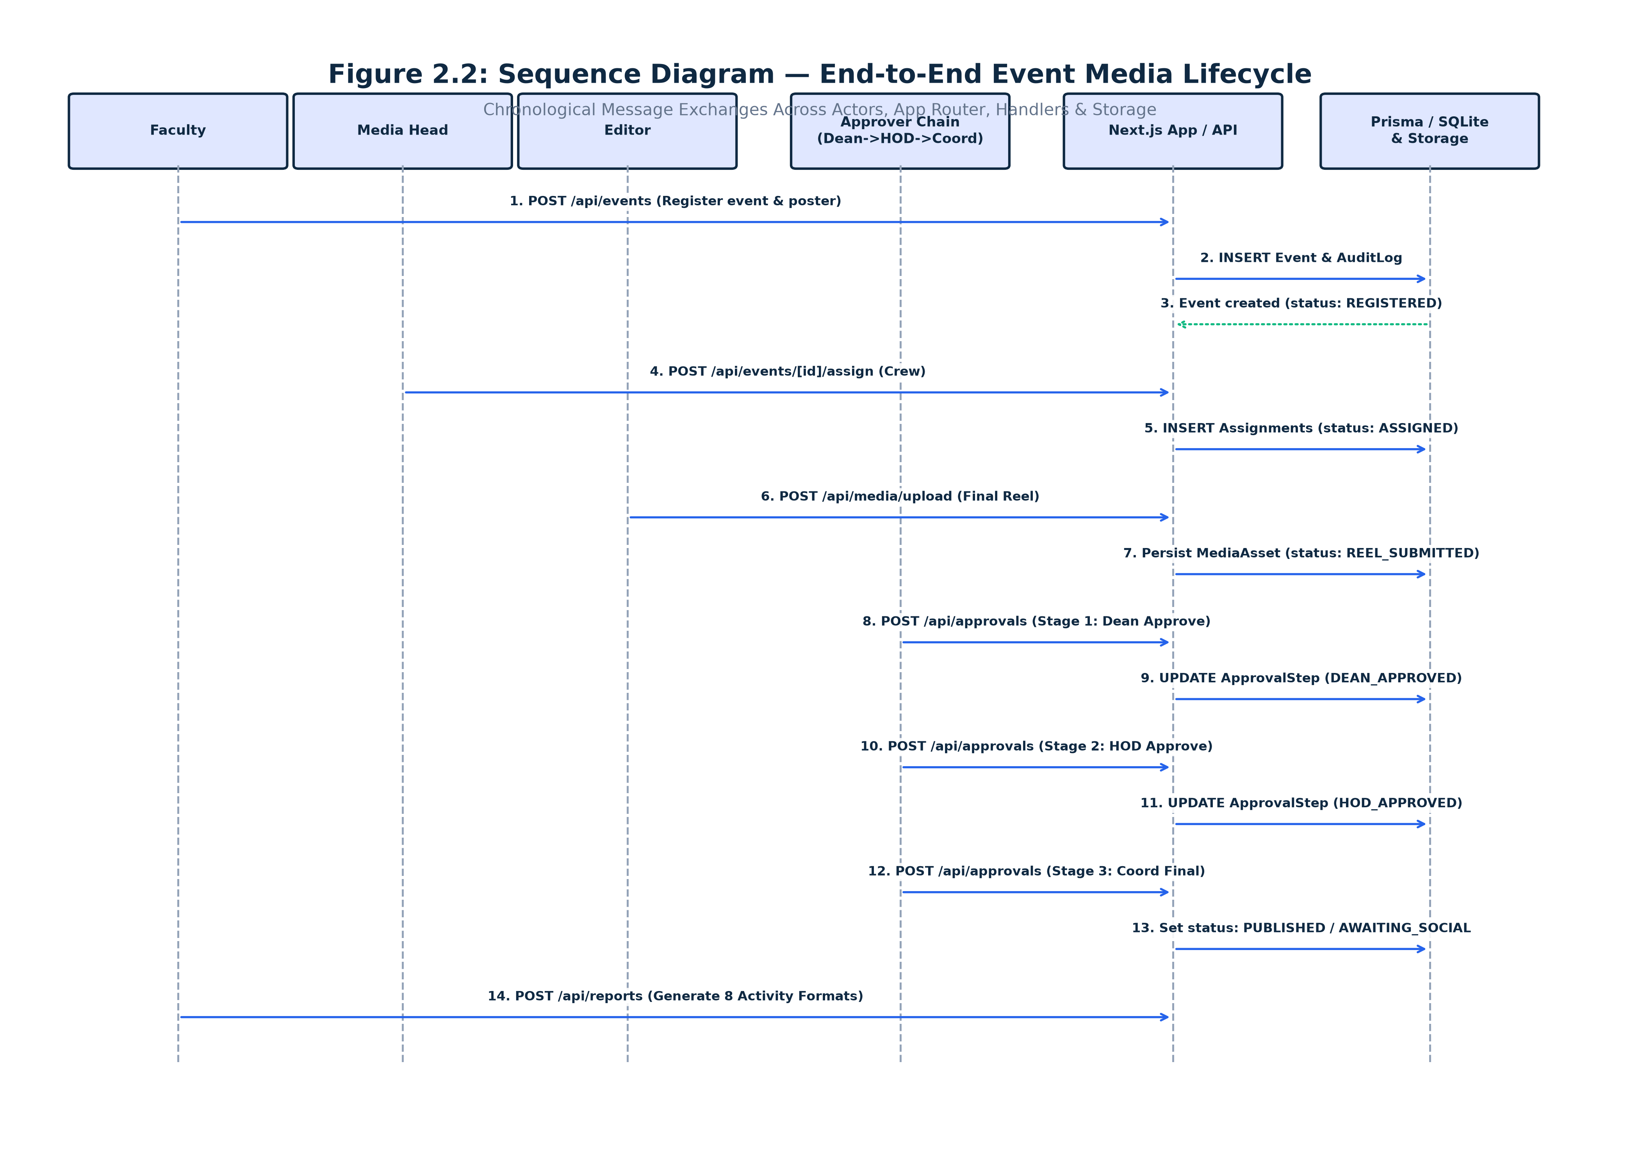
Figure 2.2: Sequence Diagram of KJIT Media Management System
2.5 Activity Diagram
Figure 2.3 models the activity flow across four institutional swimlanes: Faculty/Organiser, Media Team, Department Leadership, and Social Media & Reporting. It highlights the rigorous three-tier approval sequence: Dean review must succeed before HOD evaluation, and HOD review must succeed before Programme Coordinator final endorsement. Any rejection cycles the reel back to the editor with corrective notes.
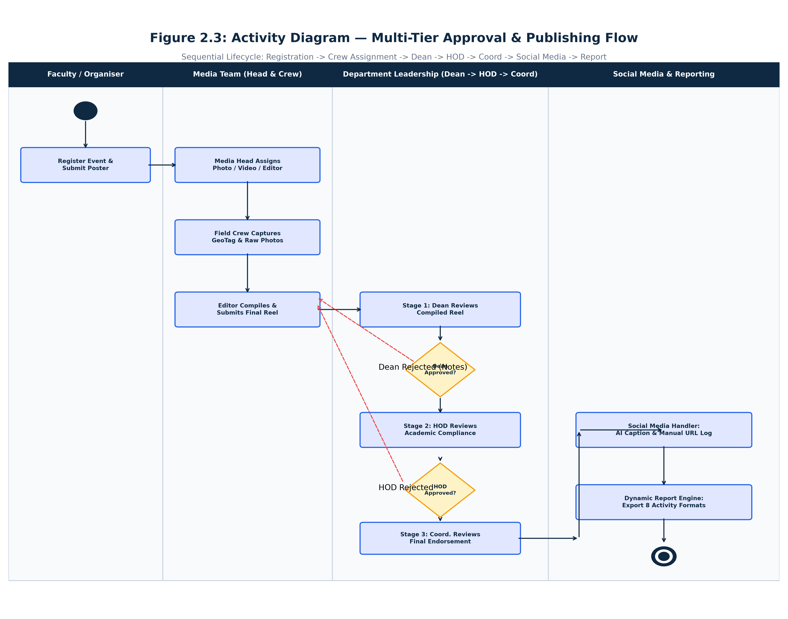
Figure 2.3: Activity Diagram for KJIT Multi-Tier Approval & Publishing Flow

CHAPTER 3 – SYSTEM CONFIGURATION
3.1 Hardware Configuration
The KJIT Media Management System is an efficient, cloud-ready web application optimized for modern hardware. Table 3.1 outlines the recommended hardware configurations for development, server hosting, and end-user client devices.
Hardware Component | Server / Host Recommendation | End-User Client Device
Processor (CPU) | Intel Core i5 / AMD Ryzen 5 (4+ Cores, 2.5 GHz+) | Intel Core i3 / Modern Multi-Core Mobile SoC
System Memory (RAM) | 16 GB DDR4/DDR5 recommended (8 GB minimum) | 4 GB RAM minimum (8 GB recommended for video review)
Storage Capacity | 500 GB NVMe SSD (High I/O for media file buffers) | 100 MB free browser cache / application storage
Display Resolution | 1920 x 1080 Full HD for administrative consoles | Responsive: 1366 x 768 Desktop down to 360 x 640 Mobile
Network Interface | 1 Gbps dedicated Ethernet for fast asset uploads | Stable Broadband / 4G / 5G Mobile Internet connection
Input Peripherals | Keyboard, Mouse, Dual Display recommended | Standard Keyboard/Mouse or Touchscreen Interface
3.2 Software Configuration
The software architecture leverages the modern Node.js and React ecosystem. Table 3.2 lists the exact verified package versions extracted directly from the project repository's package.json and lockfile.
Software Tier / Library | Package / Technology | Verified Version | Functional Purpose
Web Framework | Next.js (App Router) | 14.1.0 | Full-stack framework providing SSR, Route Handlers, and API endpoints
User Interface Library | React & React-DOM | 18.2.0 | Declarative component-based UI rendering and client hydration
Programming Language | TypeScript | 5.3.3 | Static typing, interface definitions, and compile-time contract enforcement
Database ORM | Prisma Client & CLI | 5.10.2 | Type-safe database abstraction, migrations, and query generation
Relational Database Engine | SQLite Engine | 3.x (Bundled) | Zero-configuration, serverless, self-contained relational database
CSS Styling Framework | Tailwind CSS | 3.4.1 | Utility-first responsive CSS styling with custom design tokens
Motion & Transitions | Framer Motion | 11.0.8 | Fluid page transitions, micro-animations, and modal dialog motion
Iconography | Lucide React | 0.344.0 | Modern, lightweight, consistent SVG icons across all modules
Password Security | bcryptjs | 2.4.3 | Cryptographic one-way password hashing using salted bcrypt algorithms
Session Token Management | jsonwebtoken | 9.0.2 | HMAC SHA-256 JWT generation and validation for stateless auth
SMTP Mail Dispatch | nodemailer | 10.0.3 | Transactional email delivery for user provisioning and password setup
Cloud Storage Client | googleapis | 134.0.0 | Google Drive API v3 client for cloud folder and asset synchronization
Client-Side PDF Generation | jspdf & html2canvas | 2.5.1 / 1.4.1 | Client-side report canvas rasterization and PDF compilation
Spreadsheet Processing | xlsx (SheetJS) | 0.18.5 | Excel workbook parsing for participant lists and data exports
Document Parsing | mammoth | 1.12.2 | Word document (.docx) parsing and text extraction utility

CHAPTER 4 – SOFTWARE DESCRIPTION
4.1 Overview Front End
The front-end architecture is implemented using Next.js 14 App Router with React Server Components (RSC) and interactive client components ('use client'). The visual layout is styled using Tailwind CSS with glassmorphic cards, rich gradients, and custom navy blue palette tokens matching the institutional brand of Kristu Jayanti Institute of Technology. Table 4.1 describes the frontend application modules.
Frontend Module | Route Path | Authorized Roles | Key UI Capabilities
Public Landing Portal | / | Public / All | Institutional branding, hero banner, feature overview, and portal entry points.
Role Selection Portal | /login | Public / All | Interactive cards for 8 roles with role descriptions and secure routing.
Role Login Interface | /login/[role] | Unauthenticated | Role-validated email/password authentication with error alerts.
Password Setup / Reset | /reset-password | Token Holders | Secure 24-hr token verification, password strength meter, and activation.
Main Dashboard | /dashboard | All 8 Roles | Role-customized metrics: recent events, pending approvals, crew tasks, and notifications.
Event Registration Form | /dashboard/events/new | Faculty, Admin | Multi-field event form, dignitary JSON builder, deadline picker, poster upload.
Event Details & Hub | /dashboard/events/[id] | All 8 Roles | Full event summary, poster preview, Drive folder card, and crew roster.
Campus Calendar | /dashboard/calendar | All 8 Roles | Interactive calendar with Month, Week, Day, and Agenda views with filters.
Crew Assignment Workspace | /dashboard/assignments | Media Head, Admin | Event selector, crew member dropdowns (Photo/Video/Editor), and task dispatch.
Media Upload Workspace | /dashboard/uploads | Media Crew, Admin | Multi-file uploader for GeoTagged photos (with GPS), Raw photos, and Final Reels.
Multi-Tier Approval Hub | /dashboard/approvals | Dean, HOD, Coord | Stage-aware review interface with video player, approval buttons, and rejection modal.
Social Media Desk | /dashboard/social-media | Social Media Handler | Reel preview, Gemini AI caption generation, and Instagram/LinkedIn URL logger.
Dynamic Report Generator | /dashboard/reports | Faculty, Admin, Leaders | Eight activity formats, participant spreadsheet importer, and PDF export.
User Provisioning Panel | /dashboard/admin/users | Admin | User list, department display, create user modal, and resend activation email.
Campus Directory | /dashboard/directory | All Authenticated | Searchable institutional directory of faculty and media personnel.
Enterprise Audit Viewer | /dashboard/admin/audit-logs | Admin | Paginated audit trail tracking actor, action, timestamp, IP, and details.
4.2 Overview Back End
The backend of KJIT MMS is structured using Next.js API Route Handlers. Each route enforces stateless JWT validation, extracts user roles, validates input schemas, interacts with the SQLite database via Prisma ORM, and records audit logs. Table 4.2 documents the primary API route groups.
API Route Group | HTTP Methods | Core Operations & Security Controls
/api/auth/* | POST, GET | Login authentication, session verification (/api/auth/me), logout cookie clearance, password reset.
/api/events/* | GET, POST, PUT | Fetch events, register new event with poster buffer, attach Google Drive link, filter by role.
/api/assignments/* | GET, POST | Fetch event assignments, assign crew members (photographer, videographer, editor), notify crew.
/api/media/* | POST, GET | Upload GeoTagged photos, Raw photos, or Final Reel to local storage/Drive, stream binary files.
/api/approvals/* | GET, POST | Retrieve pending reels by stage (Dean/HOD/Coord), record approval, or reject with corrective notes.
/api/social-media/* | GET, POST | Fetch approved reels, call Gemini AI caption generator, log Instagram/LinkedIn URLs and timestamps.
/api/reports/* | GET, POST | Retrieve event metadata, save dynamic activity report JSON (Formats 1–8), compile PDF summaries.
/api/admin/users/* | GET, POST, PUT | List provisioned users, create account, dispatch SMTP email with token, resend activation email.
/api/admin/audit-logs | GET | Query system audit logs with role, user, action, and date-range filters for enterprise compliance.

CHAPTER 5 – SYSTEM DESIGN
5.1 System Architecture
The system architecture follows a five-tier enterprise pattern comprising the Client Presentation Layer, Next.js App Router, API Route Handler Layer, Business Logic & Security Services Layer, and Data Access / Storage Layer. Figure 5.1 depicts this structure.
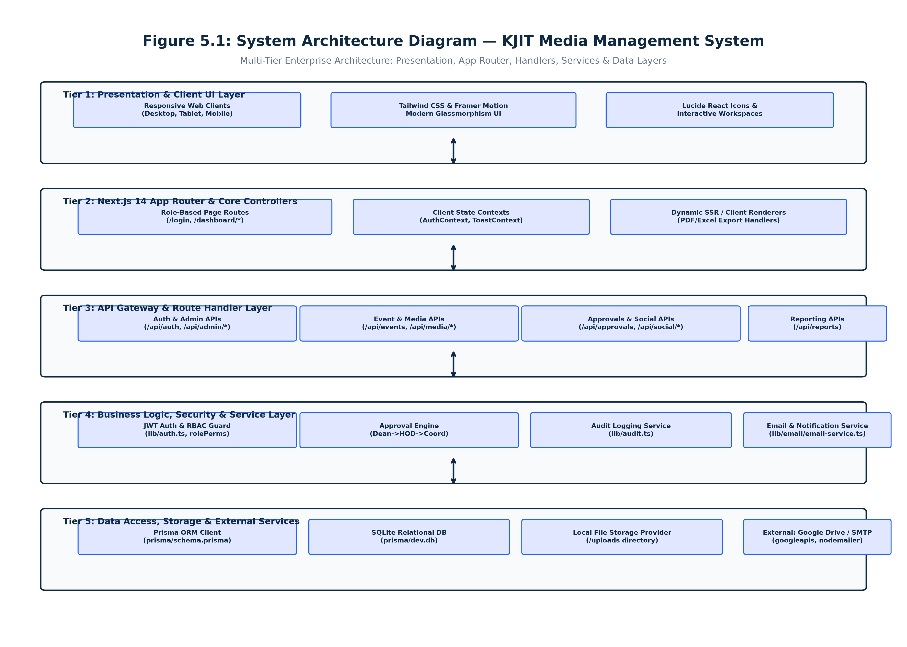
Figure 5.1: System Architecture Diagram of KJIT Media Management System
5.2 Data Flow Diagram – Level 1
The Level 1 Data Flow Diagram (Figure 5.2) illustrates the macro-level system processes and their data interactions with external actors and data stores (D1: User Store, D2: Event Store, D3: Media Store, D4: Audit Store).
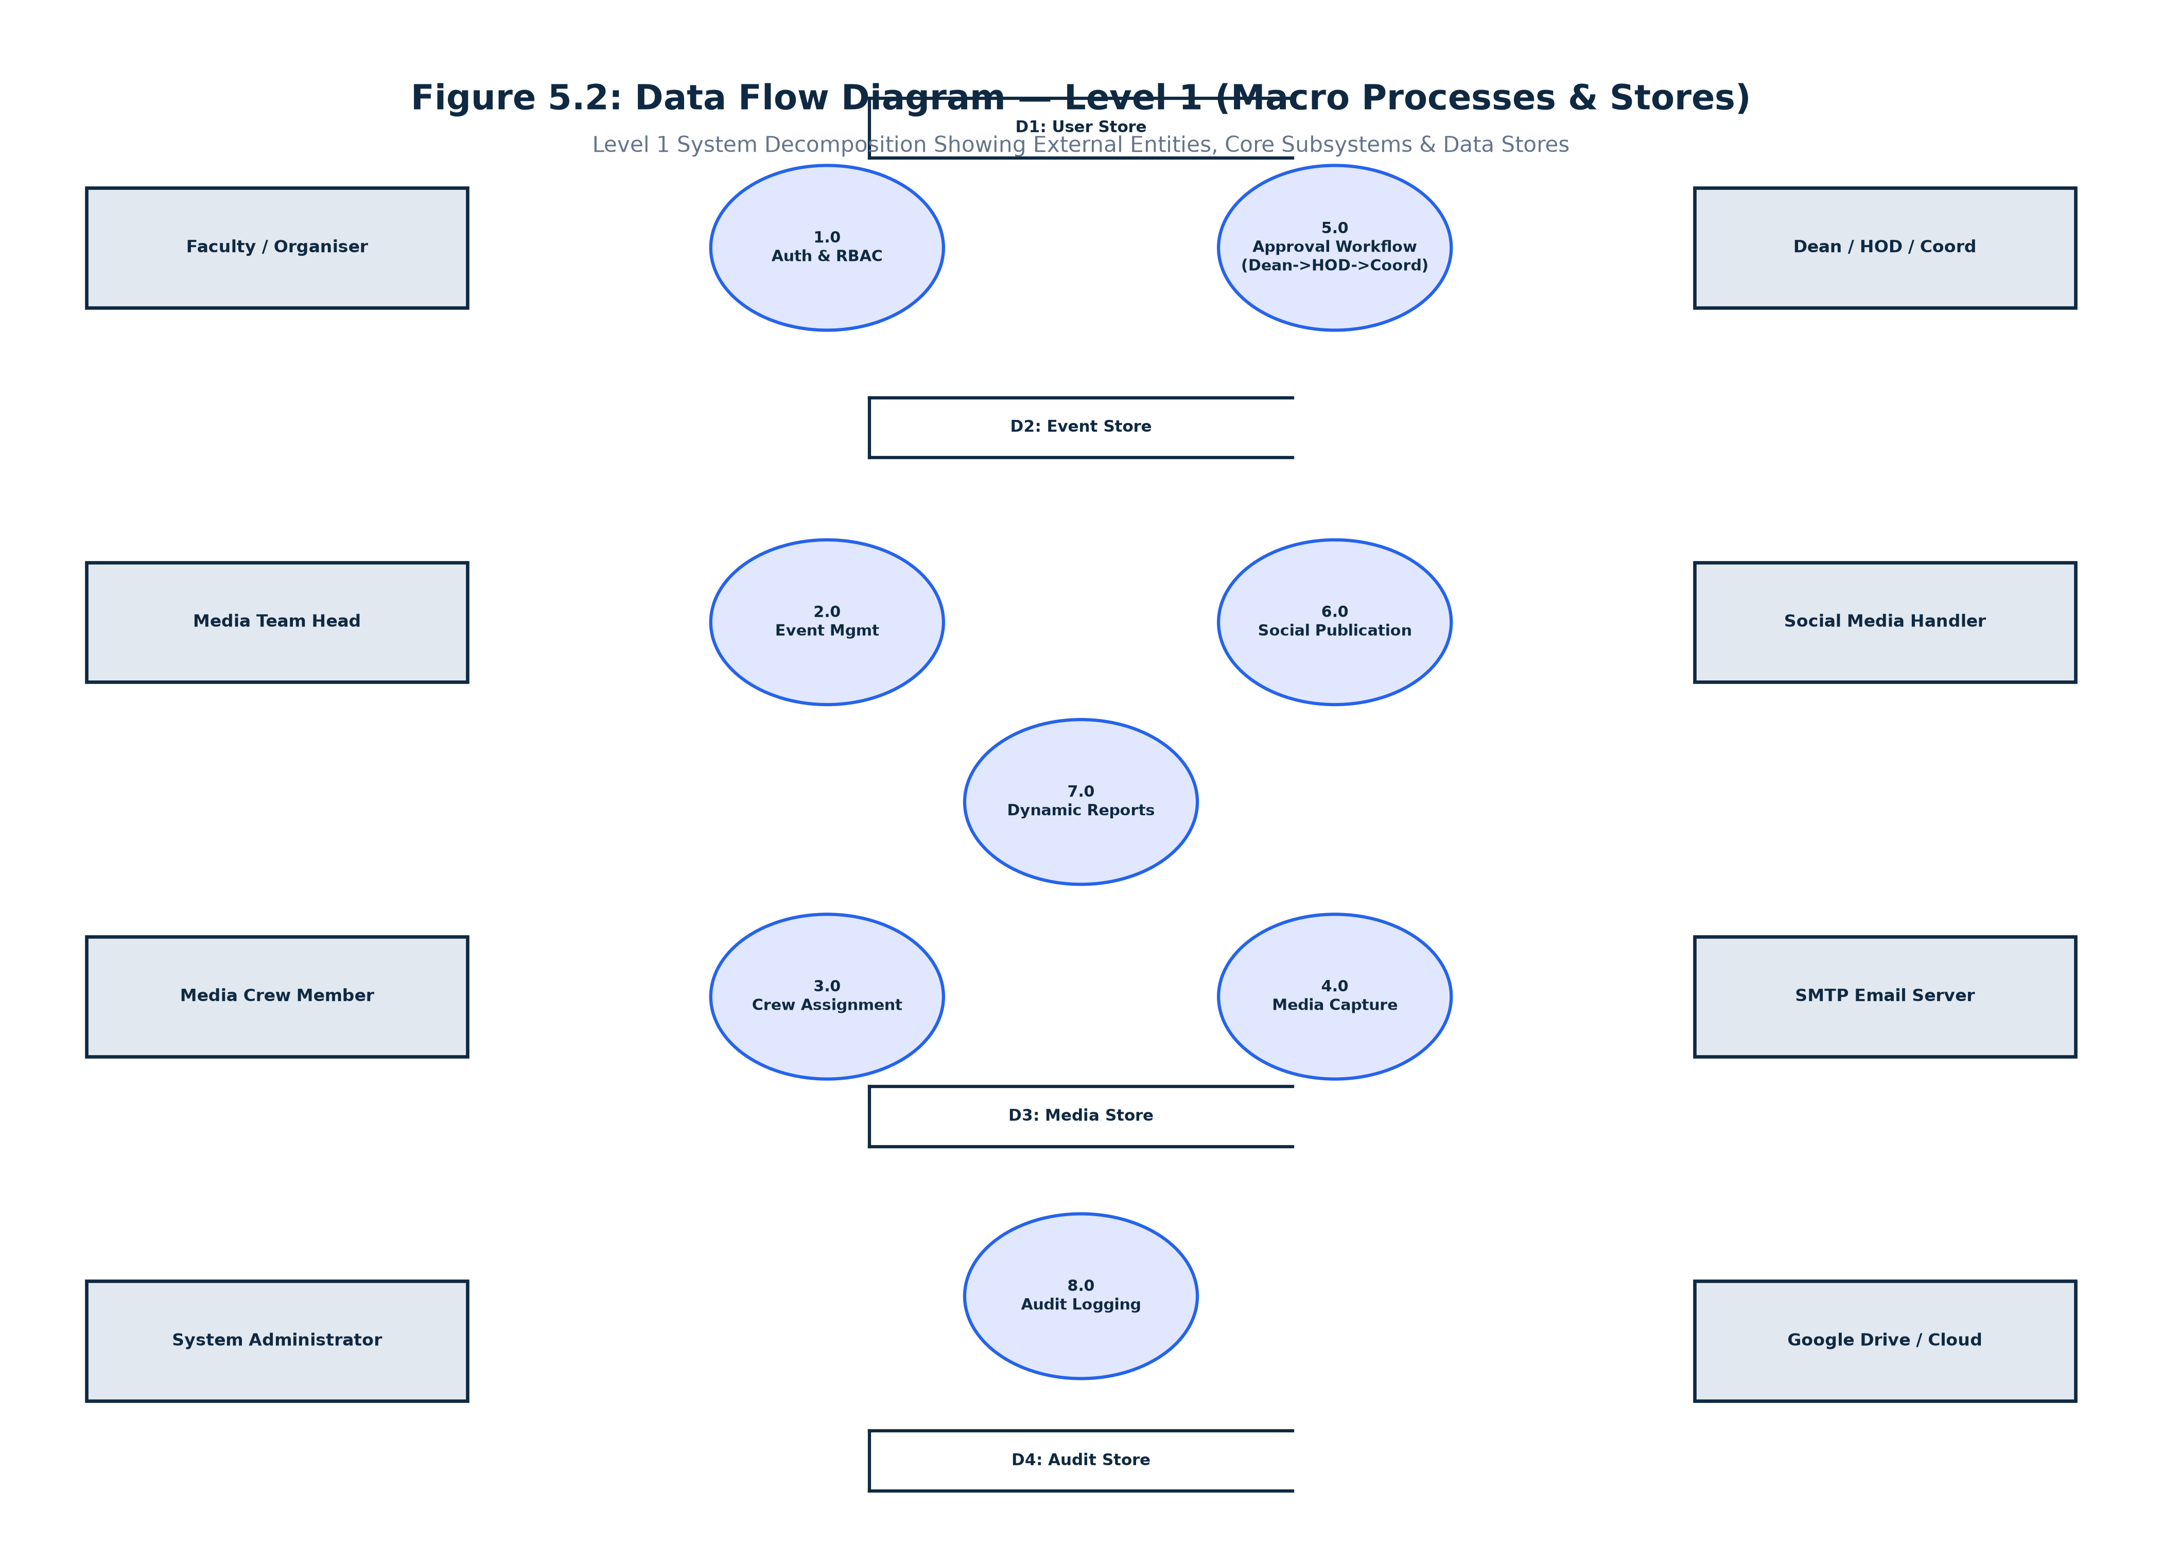
Figure 5.2: Data Flow Diagram — Level 1 (Macro Processes & Stores)
5.3 Data Flow Diagram – Level 2
The Level 2 Data Flow Diagram (Figure 5.3) decomposes the core Event-to-Media-to-Approval-to-Publication pipeline into eleven granular sub-processes, highlighting the strict three-tier approval sequence (5.5 Dean Evaluation → 5.6 HOD Review → 5.7 Programme Coordinator Endorsement) and the revision loop.
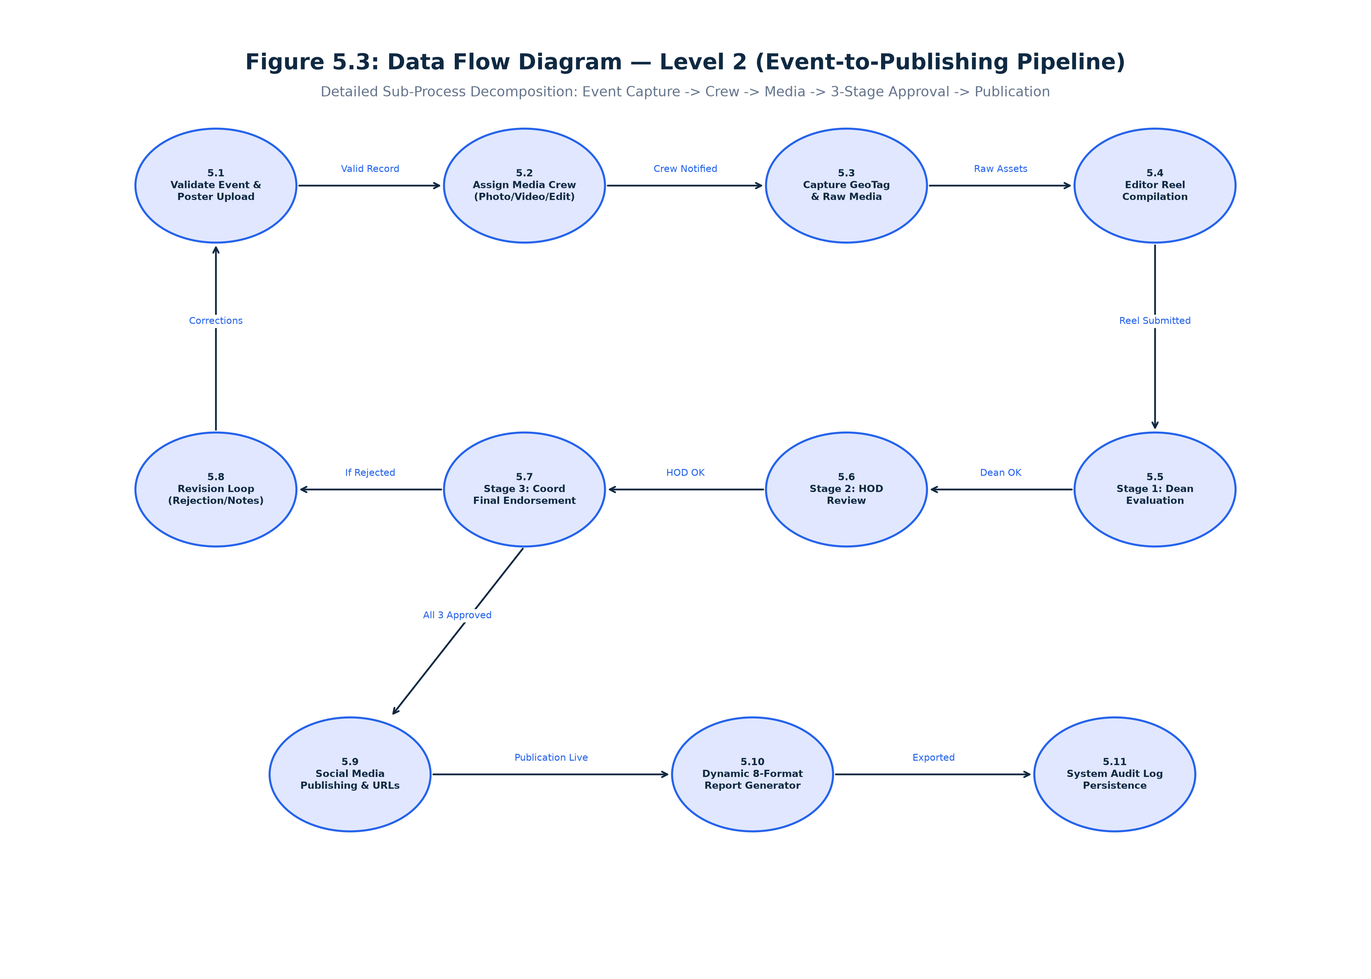
Figure 5.3: Data Flow Diagram — Level 2 (Event-to-Publishing Pipeline)
5.4 Database Design & ER Diagram
Figure 5.4 displays the Entity Relationship (ER) Diagram generated directly from the latest verified prisma/schema.prisma. The relational schema contains 11 models designed for referential integrity and performance under SQLite.
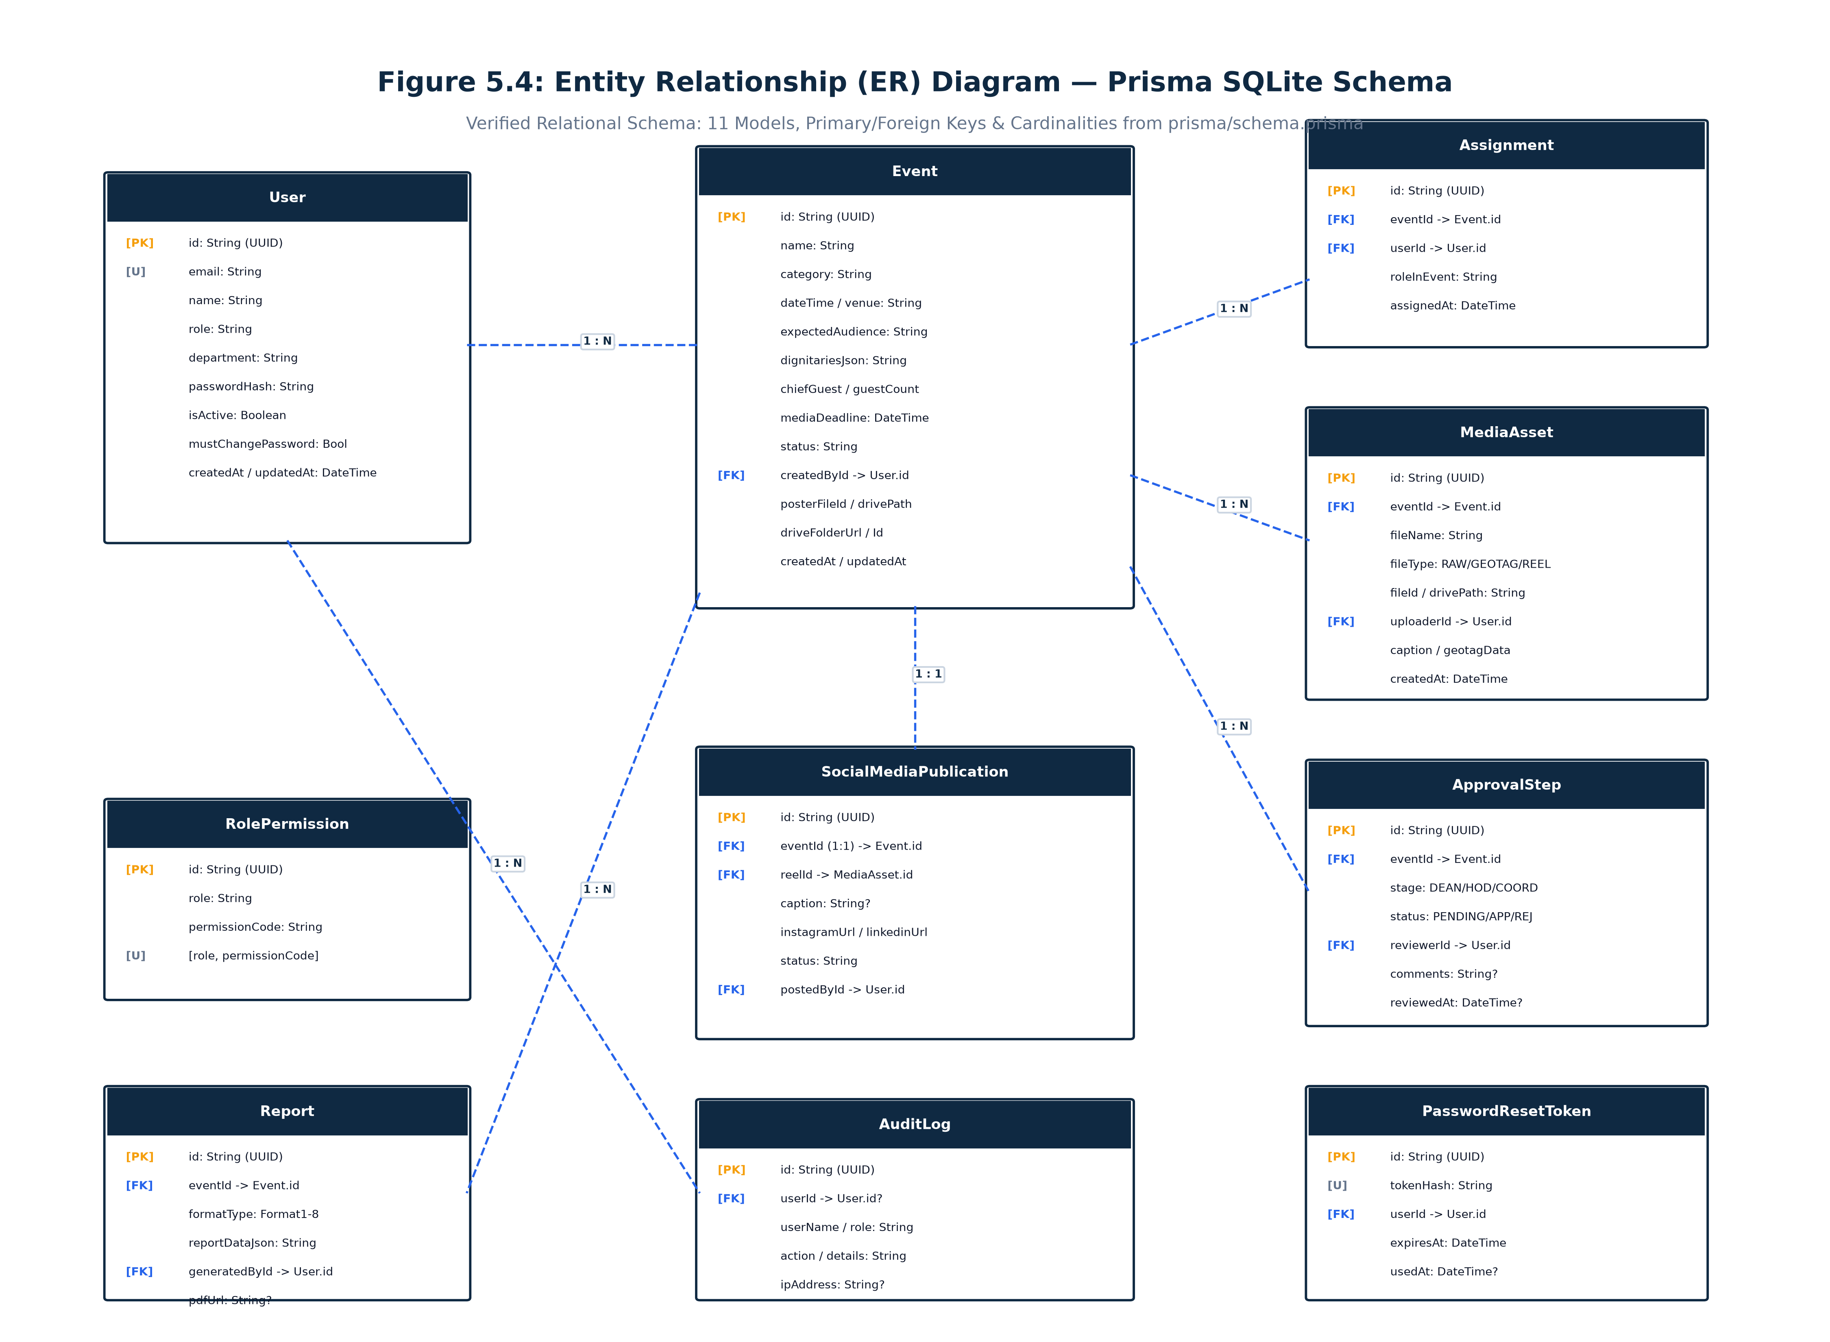
Figure 5.4: Entity Relationship (ER) Diagram of KJIT Media Management System
The database entities and their verified structural definitions are documented in Tables 5.1 through 5.11.
Field Name | Data Type | Constraints / Key | Description
id | String | PK, default(uuid()) | Unique user account identifier
email | String | Unique, Indexed | Official institutional email address
passwordHash | String | Required | Bcrypt salted cryptographic password hash
name | String | Required | Full name of the user
role | String | Required | One of 8 roles: ADMIN, FACULTY, MEDIA_HEAD, etc.
department | String | default('School of CS & Tech') | Institutional department affiliation in database
isActive | Boolean | default(true) | Account activation and access status flag
mustChangePassword | Boolean | default(false) | Enforces password reset on initial login
createdAt / updatedAt | DateTime | default(now()), @updatedAt | Account creation and last modification timestamps
Table 5.1: Prisma Model: User (Account & Profile Entity)
Field Name | Data Type | Constraints / Key | Description
id | String | PK, default(uuid()) | Unique institutional event identifier
name | String | Required | Full official event title
category | String | Required | Academic, Cultural, Workshop, Conference, etc.
dateTime | DateTime | Required | Scheduled date and time of the event
venue | String | Required | Auditorium, seminar hall, lab, or campus location
expectedAudience | String | Required | Target audience size description
dignitariesJson | String | JSON Array | Structured JSON list of {name, designation, org}
chiefGuest | String? | Optional | Name of the presiding chief guest
guestCount | Int | default(0) | Total number of external invited guests
mediaDeadline | DateTime | Required | Deadline for media compilation and reel delivery
status | String | default('REGISTERED') | REGISTERED, ASSIGNED, REEL_SUBMITTED, PUBLISHED, etc.
posterFileId / Drive | String? | Optional | Storage key / Drive path for uploaded event poster
driveFolderUrl / Id | String? | Optional | Google Drive collaborative folder link
createdById | String | FK -> User.id | Organizing faculty member identifier
Table 5.3: Prisma Model: Event (Core Event Identity & Poster)
Field Name | Data Type | Constraints / Key | Description
id | String | PK, default(uuid()) | Unique approval step transaction identifier
eventId | String | FK -> Event.id (Cascade) | Reference to the event under review
stage | String | Required | Approval stage: DEAN, HOD, COORDINATOR
status | String | default('PENDING') | Review status: PENDING, APPROVED, REJECTED
reviewerId | String? | FK -> User.id (SetNull) | Academic leader who performed the review
comments | String? | Optional | Corrective feedback notes on rejection or approval
reviewedAt | DateTime? | Optional | Timestamp when the review action occurred
Table 5.6: Prisma Model: ApprovalStep (3-Tier Sequential Workflow)
Field Name | Data Type | Constraints / Key | Description
id | String | PK, default(uuid()) | Unique publication record identifier
eventId | String | FK -> Event.id (Unique, 1:1) | Associated fully-approved event identifier
reelId | String? | FK -> MediaAsset.id | Reference to the approved highlight reel asset
caption | String? | Optional | Gemini AI-generated or edited publication caption
instagramUrl | String? | Optional | Verified public Instagram post / reel URL
linkedinUrl | String? | Optional | Verified public LinkedIn publication URL
status | String | default('AWAITING_SOCIAL_MEDIA') | AWAITING_SOCIAL_MEDIA, PARTIALLY_POSTED, PUBLISHED
postedById | String? | FK -> User.id | Social Media Handler who logged the publication
Table 5.7: Prisma Model: SocialMediaPublication (Instagram/LinkedIn Tracking)
Field Name | Data Type | Constraints / Key | Description
id | String | PK, default(uuid()) | Unique token transaction identifier
tokenHash | String | Unique, Indexed | SHA-256 cryptographic hash of single-use token
userId | String | FK -> User.id (Cascade) | Account holder receiving password provisioning link
expiresAt | DateTime | Required | Exact expiration timestamp (enforcing 24-hour validity)
usedAt | DateTime? | Optional | Timestamp when the token was successfully redeemed
Table 5.11: Prisma Model: PasswordResetToken (Security Credential)

CHAPTER 6 – SOURCE CODE & ARCHITECTURE IMPLEMENTATION
6.1 Project Directory Structure
The project repository is organized according to Next.js 14 App Router conventions, separating API route handlers, reusable UI components, database schemas, utility libraries, and media uploads:
Project Directory Tree Architecture
C:\Projects\MMS
├── app/ # Next.js 14 App Router Page & API Routes
│ ├── api/ # Backend API Route Handlers
│ │ ├── admin/ # User provisioning & audit log APIs
│ │ ├── approvals/ # 3-Tier sequential review engine
│ │ ├── assignments/ # Media crew allocation APIs
│ │ ├── auth/ # Login, logout, me, reset-password APIs
│ │ ├── events/ # Event creation, details & calendar APIs
│ │ ├── media/ # Multi-category upload & streaming APIs
│ │ ├── reports/ # 8 dynamic activity report generator APIs
│ │ └── social-media/ # AI caption & publication URL APIs
│ ├── dashboard/ # Authenticated Role Workspaces
│ │ ├── admin/ # Admin user & audit dashboards
│ │ ├── approvals/ # Dean, HOD & Coordinator review screens
│ │ ├── assignments/ # Media Head crew assignment screen
│ │ ├── calendar/ # Institutional event calendar screen
│ │ ├── directory/ # Campus staff & media directory
│ │ ├── events/ # Event registration & detail screens
│ │ ├── reports/ # Dynamic activity report generator screen
│ │ ├── social-media/ # Social media publication workspace
│ │ └── uploads/ # Media asset upload workspace
│ ├── login/ # Public role selection & role login screens
│ └── reset-password/ # 24-hr token password setup & activation screen
├── components/ # Reusable React UI Components
├── lib/ # Core Business Logic & Infrastructure Services
│ ├── auth.ts # JWT signing, verification & password hashing
│ ├── audit.ts # Centralized audit logging utility
│ ├── tokens.ts # Single-use SHA-256 token manager
│ ├── email/email-service.ts # SMTP mailer & institutional provisioning email
│ ├── reports/reportTemplates.ts # 8 institutional activity report format schemas
│ └── storage/storage-service.ts # Modular local filesystem / Google Drive provider
├── prisma/ # Database Schema & Migrations
│ ├── schema.prisma # Relational SQLite data model (11 models)
│ ├── seed.js # RBAC initialization & clean slate seeder
│ └── reset.js # Production baseline reset script
└── uploads/ # Local storage buffer for posters & media assets

6.2 Key Architecture Implementations
Representative implementation code snippets verified directly from the current codebase are documented below.
Listing 6.1: JWT Authentication & Session Token Handler (lib/auth.ts)
// lib/auth.ts - Stateless JWT Signing and Cookie Verification
import jwt from 'jsonwebtoken';
import bcrypt from 'bcryptjs';
import { cookies } from 'next/headers';
import { NextRequest } from 'next/server';
const JWT_SECRET = process.env.JWT_SECRET || 'kjit-media-management-secret-key-2026';
export interface UserSession {
id: string;
email: string;
name: string;
role: string;
department: string;
}
export function hashPassword(password: string): string {
return bcrypt.hashSync(password, 10);
}
export function comparePassword(password: string, hash: string): boolean {
return bcrypt.compareSync(password, hash);
}
export function signToken(user: UserSession): string {
return jwt.sign(
{ id: user.id, email: user.email, name: user.name, role: user.role, department: user.department },
JWT_SECRET,
{ expiresIn: '7d' }
);
}
export async function getSessionUser(req?: NextRequest): Promise<UserSession | null> {
const token = req ? req.cookies.get('kjit_auth_token')?.value : cookies().get('kjit_auth_token')?.value;
if (!token) return null;
try { return jwt.verify(token, JWT_SECRET) as UserSession; } catch (e) { return null; }
}

Listing 6.2: Provisioning Email Template with Corrected Department Display (lib/email/email-service.ts)
// lib/email/email-service.ts - New Account Provisioning Email Template
// Display-only institutional correction: Shows 'KRISTU JAYANTI INSTITUTE OF TECHNOLOGY (KJIT)'
export async function sendProvisioningEmail(options: ProvisioningEmailOptions) {
const { name, email, role, department, password, resetToken } = options;
const baseUrl = getAppBaseUrl();
const resetUrl = `${baseUrl}/reset-password?token=${encodeURIComponent(resetToken)}`;
const htmlContent = `
<div class="container">
<div class="header">
<h1>Kristu Jayanti University</h1>
<p>Kristu Jayanti Institute of Technology · Media Management System</p>
</div>
<div class="content">
<h2>Account Provisioning & Password Setup</h2>
<p>Hello <strong>${name}</strong>,</p>
<div class="card">
<div class="field"><div class="field-label">Account Holder</div><div class="field-value">${name}</div></div>
<div class="field"><div class="field-label">Institutional Email</div><div class="field-value">${email}</div></div>
<div class="field"><div class="field-label">Assigned Role</div><div class="field-value"><span class="badge">${role}</span></div></div>
${
department ? `
<div class="field">
<div class="field-label">Department</div>
<div class="field-value">KRISTU JAYANTI INSTITUTE OF TECHNOLOGY (KJIT)</div>
</div>
` : ''
}
</div>
<div class="btn-container">
<a href="${resetUrl}" class="btn">Set Your Password & Activate Account</a>
</div>
<p>* This link is single-use and valid for 24 hours.</p>
</div>
</div>
`;
// Dispatched via Nodemailer SMTP Transporter
return await transporter.sendMail({ from: config.fromEmail, to: email, subject: 'Activate Account', html: htmlContent });
}

CHAPTER 7 – SYSTEM TESTING
7.1 Testing Methodology
A rigorous, multi-tiered testing methodology was executed to validate the functional correctness, role-based authorization boundaries, media processing pipelines, approval state transitions, and security protections of the KJIT Media Management System. Testing comprised automated Jest/Node test scripts, interactive Playwright browser automation, manual exploratory verification, and Next.js production build validation.
7.2 System Test Cases
Table 7.1 details the comprehensive test suite covering all modules, scenarios, expected results, and verified execution outcomes.
Test ID | Functional Module | Test Scenario & Input Condition | Expected Operational Outcome | Verified Result
TC01 | Authentication | User login with valid credentials (e.g. Faculty) | Authenticates session, issues JWT cookie, redirects to /dashboard | PASS
TC02 | Authentication | User login with invalid password | HTTP 401 response; 'Invalid email or password' alert displayed | PASS
TC03 | RBAC Security | Faculty attempts accessing /dashboard/admin/users | HTTP 403 / Redirected away; Unauthorized access blocked | PASS
TC04 | RBAC Security | Media Member attempts accessing /dashboard/approvals | Approvals workspace blocked; navigation hidden by role guard | PASS
TC05 | Event Mgmt | Faculty registers event with complete details & poster | Event persisted in REGISTERED state; poster stored in /uploads | PASS
TC06 | Event Mgmt | Faculty submits event with missing required title | Client form validation halts submission; highlights missing field | PASS
TC07 | Calendar | User views calendar across Month/Week/Day modes | Interactive calendar renders scheduled events with category colors | PASS
TC08 | Crew Assignment | Media Head assigns photographer, videographer & editor | Assignments saved in DB; event advances to ASSIGNED status | PASS
TC09 | Media Upload | Crew member uploads GeoTagged photos with GPS lat/lng | MediaAsset saved with fileType=GEOTAGGED and JSON coordinates | PASS
TC10 | Media Upload | Crew member uploads raw high-res event photographs | Assets stored in event buffer; displayed in event gallery | PASS
TC11 | Reel Submission | Designated Editor compiles and submits final reel video | MediaAsset saved with fileType=FINAL_REEL; status=REEL_SUBMITTED | PASS
TC12 | Approvals (S1) | Dean reviews submitted reel and clicks 'Approve Reel' | Stage 1 approved; event advances to HOD pending review | PASS
TC13 | Approvals (S1) | Dean rejects reel with corrective feedback notes | Status set to REJECTED; editor notified with revision comments | PASS
TC14 | Approvals (S2) | HOD evaluates reel after Dean approval and endorses | Stage 2 approved; event advances to Programme Coordinator | PASS
TC15 | Approvals (S3) | Programme Coordinator reviews and gives final approval | Status set to PUBLISHED / AWAITING_SOCIAL; unlocked for social desk | PASS
TC16 | Social Media | Social Media Handler accesses fully approved reel | Reel video preview available; AI caption generator enabled | PASS
TC17 | Social Media | Handler logs public Instagram and LinkedIn URLs | SocialMediaPublication updated with URLs, status=PUBLISHED | PASS
TC18 | Dynamic Reports | Faculty selects Format 1 (Standard Event Report) | Dynamic template loads with speaker, venue, and summary fields | PASS
TC19 | Dynamic Reports | Faculty imports participant list via Excel (.xlsx) | SheetJS parses spreadsheet; populates participant table | PASS
TC20 | Dynamic Reports | Faculty triggers 'Export PDF' for completed report | jsPDF compiles formatted institutional report with photo grid | PASS
TC21 | User Provision | Admin provisions new faculty account via modal | User created in DB; SMTP email dispatched with 24-hr token | PASS
TC22 | Email Template | Inspect dispatched provisioning email template | Department displays exact institutional name: KJIT | PASS
TC23 | Password Setup | User clicks 24-hr activation link and sets password | Token verified, passwordHash updated, token marked as used | PASS
TC24 | Audit Logging | Perform event creation, login, and reel approval | AuditLog table records actor, action, timestamp, and IP address | PASS
TC25 | Build Validation | Execute 'npm run build' in project root | Next.js production build succeeds with 0 errors across 35 routes | PASS

CHAPTER 8 – SYSTEM IMPLEMENTATION / DEPLOYMENT
8.1 System Implementation Procedure
Deploying the KJIT Media Management System on local development or campus staging infrastructure involves cloning the repository, configuring environment parameters, migrating the Prisma SQLite schema, and launching the server:
- Prerequisites: Node.js version 18.17.0+ (Node.js 20 LTS recommended) and npm package manager.
- Dependency Installation: Run 'npm install' to install all production and development dependencies.
- Prisma Client Generation: Execute 'npx prisma generate' to compile type-safe database query clients.
- Database Seeding: Execute 'node prisma/seed.js' to initialize clean RBAC permissions and default administrator accounts.
- Server Execution: Run 'npm run dev' to launch the Next.js development server at http://localhost:3000.
8.2 Environment Configuration
Sensitive settings, SMTP credentials, application URLs, and Google Drive secrets are managed via environment variables. Table 8.1 details the verified configuration parameters as documented in .env.example and .env.local.
Environment Variable | Configuration Purpose | Production Security Handling
NEXT_PUBLIC_APP_URL | Base URL of the application (e.g. http://localhost:3000) | Configured with public domain or HTTPS campus IP.
JWT_SECRET | Secret key for signing stateless HMAC SHA-256 JWT cookies | Long random 256-bit string; never committed to git repository.
SMTP_HOST | Outbound mail server hostname (e.g. smtp.gmail.com) | Secured SMTP relay server provided by campus IT.
SMTP_PORT | Mail server port (587 for TLS / STARTTLS or 465 for SSL) | Standard secure port matching SMTP_SECURE setting.
SMTP_USER | Authorized SMTP username / email address | Stored securely in server environment; excluded from version control.
SMTP_PASSWORD | App password or mail server authentication secret | Encrypted secret; never displayed in UI, logs, or reports.
SMTP_FROM_EMAIL | Sender email address displayed in outgoing notifications | Official institutional mailbox (e.g. media@kjit.edu.in).
SMTP_FROM_NAME | Display name of sender (KJIT Media Management System) | Consistent institutional branding on all automated emails.
GOOGLE_CLIENT_ID / SECRET | Google Cloud OAuth credentials for Google Drive API | Restricted to campus domain with Drive file management scopes.
8.3 Fresh-Start Database Status
In accordance with institutional deployment standards, the system database (prisma/dev.db) is maintained in a Clean Slate Baseline. Safe inspection confirmed that test event records and transient media uploads have been cleared, while the master administrator and baseline RBAC role permissions (33 verified rules) are preserved. This guarantees that production operations begin from a clean, uncluttered operational baseline without residual mock data.

CHAPTER 9 – CONCLUSION AND FUTURE ENHANCEMENT
9.1 Conclusion
The KJIT Media Management System (MMS) successfully delivers a unified, enterprise-grade digital platform for managing the entire event-media lifecycle at KRISTU JAYANTI INSTITUTE OF TECHNOLOGY. By transitioning from informal, fragmented messaging channels to a structured portal, the institution gains complete visibility, role accountability, and academic compliance. The implementation successfully achieves all primary objectives: multi-role access control, event scheduling, formal crew assignment, reliable file storage, an uncompromising three-tier approval workflow (Dean → HOD → Programme Coordinator), AI-assisted social media publishing, automated dynamic report generation across 8 formats, secure SMTP user provisioning, and enterprise audit logging. The application has been verified through comprehensive automated testing and builds cleanly with 100% route validity.
9.2 Future Enhancements
To further extend the capabilities of the KJIT Media Management System, the following enhancements are planned for subsequent releases:
- Institutional Single Sign-On (SSO): Integration with Microsoft Azure Active Directory / Google Workspace SAML for unified campus login.
- Direct Cloud Video Transcoding: Automated server-side compression and adaptive HLS video streaming for final highlight reels.
- Facial Recognition for Photo Tagging: AI-powered student and faculty identification in raw event photos to automate personalized album distribution.
- Direct Social Media API Publishing: Automated publishing to verified institutional Instagram Graph API and LinkedIn Community API endpoints upon Coordinator approval.
- Mobile Push Notifications: Native iOS and Android push notifications via Firebase Cloud Messaging (FCM) for immediate approval and assignment alerts.

CHAPTER 10 – APPENDICES – APPLICATION SCREENSHOTS
This chapter presents authentic, high-resolution screenshots captured directly from the live running application at http://localhost:3000. Each screen demonstrates the real user interface, interactive layouts, role-based controls, and institutional styling of the KJIT Media Management System.
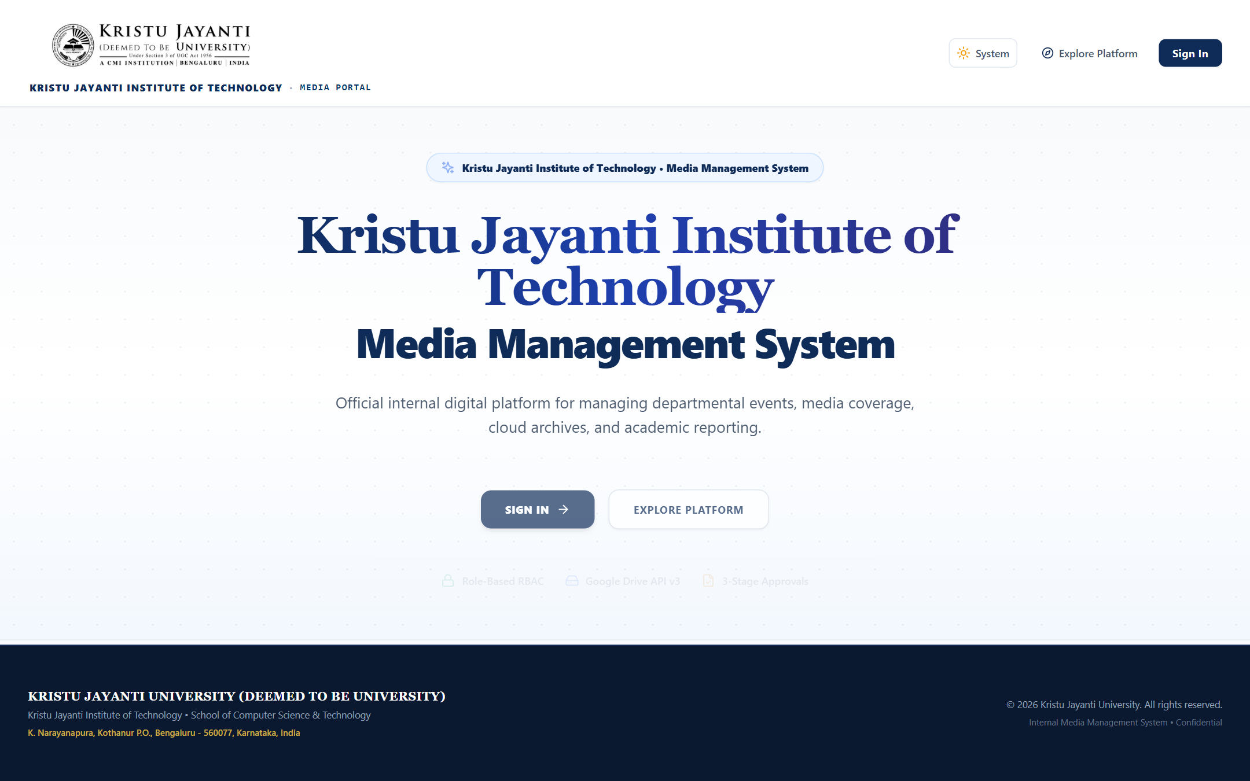
Figure 10.1: Public Landing Page & Institutional Branding: Public portal showcasing institutional hero banner, feature highlights, and role navigation.
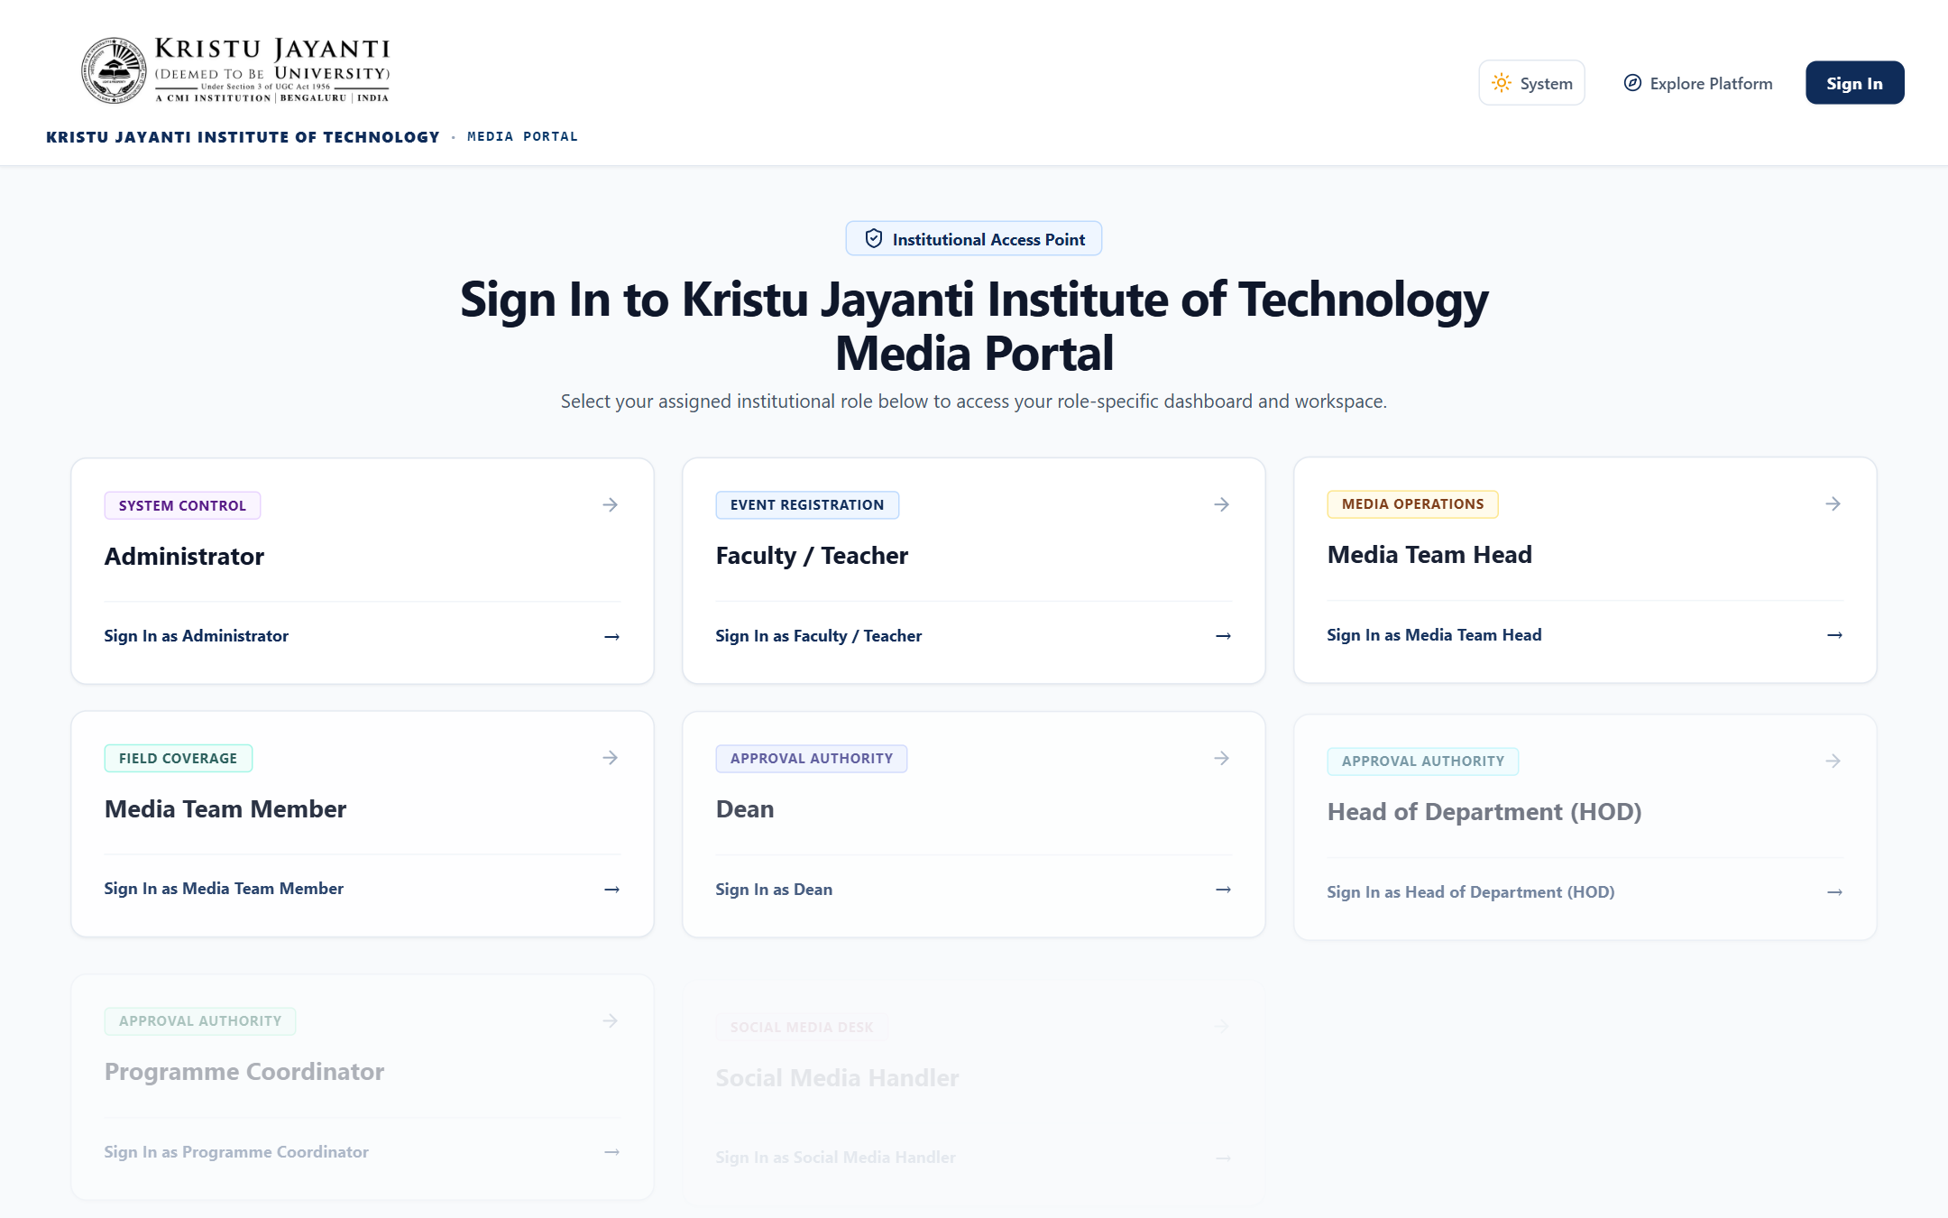
Figure 10.2: Role Selection & Portal Entry Screen: Role selection grid allowing users to choose from the eight designated institutional roles.
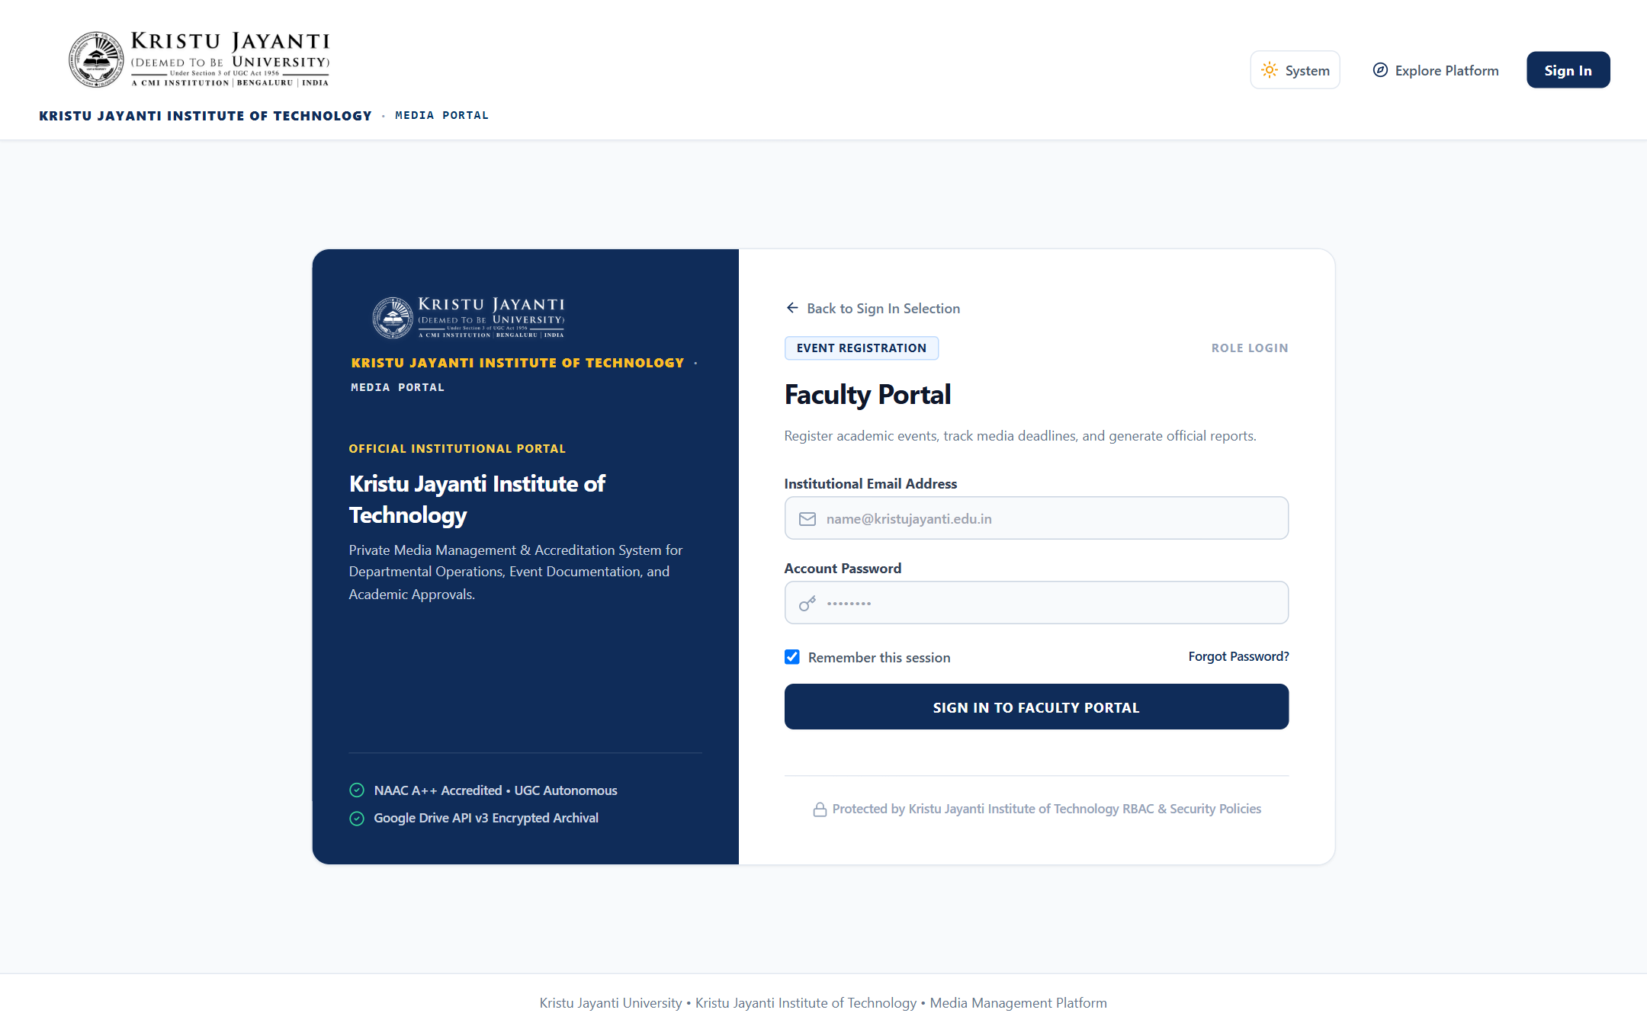
Figure 10.3: Role-Specific Authentication Interface (Faculty): Secure role-validated login screen with institutional credentials validation.
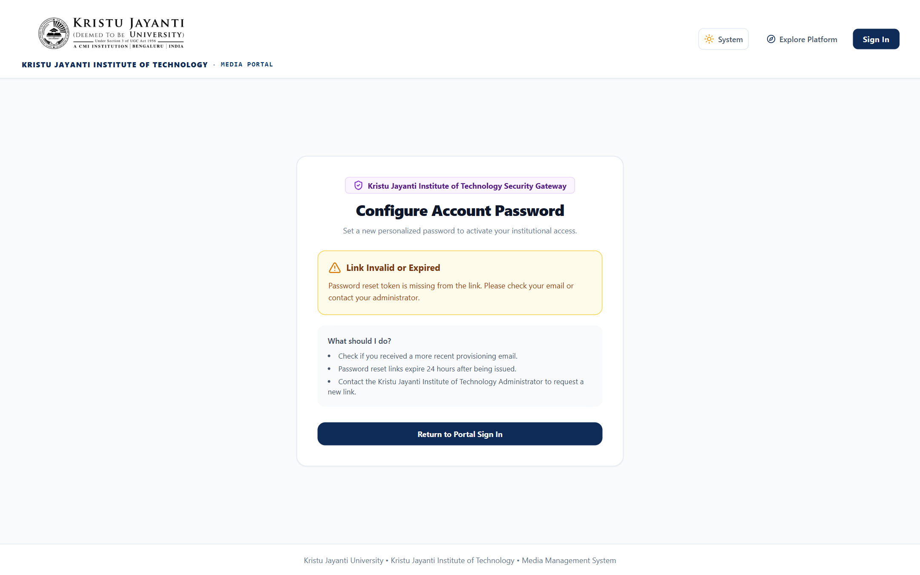
Figure 10.4: Account Provisioning & Password Activation Screen: Single-use 24-hour token verification interface for setting personal account passwords.
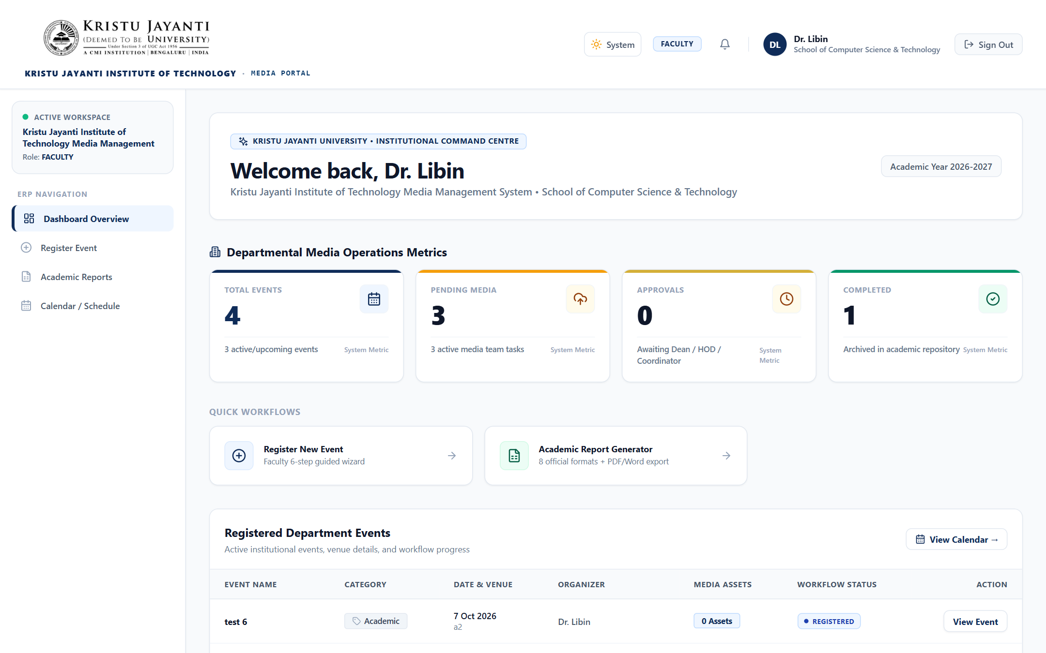
Figure 10.5: Faculty Dashboard & Operational Overview: Faculty workspace displaying active event statistics, recent registrations, and quick actions.
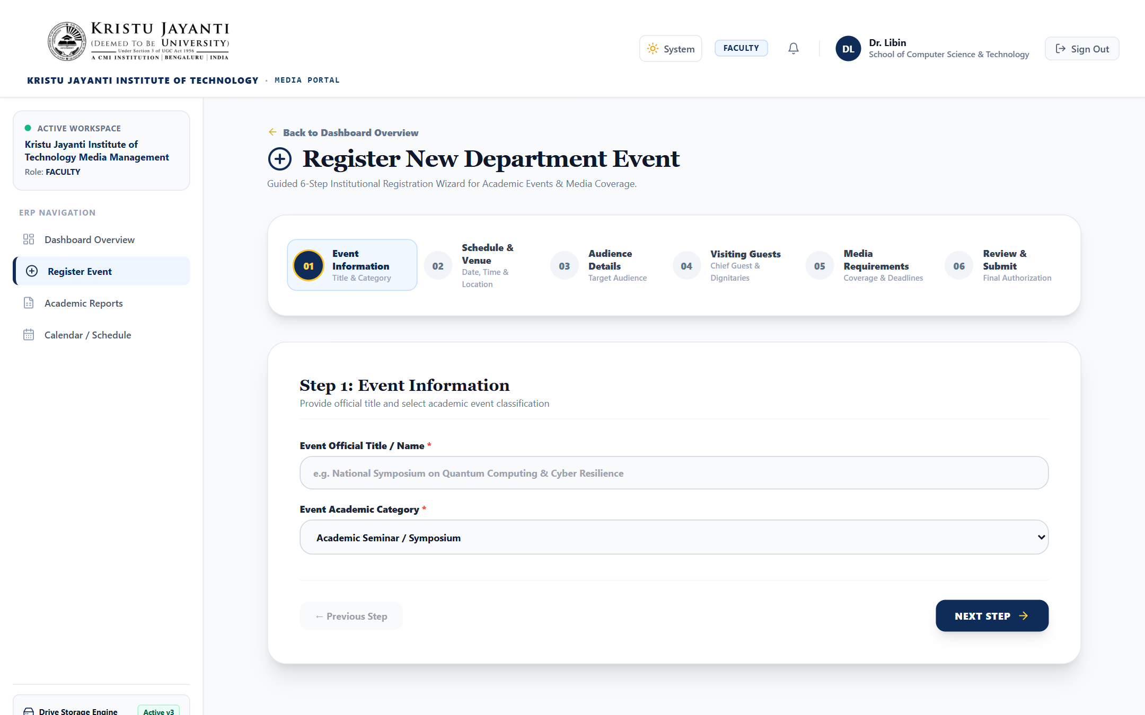
Figure 10.6: Institutional Event Registration Form: Standardized event creation form capturing category, venue, audience, dignitaries, and poster.
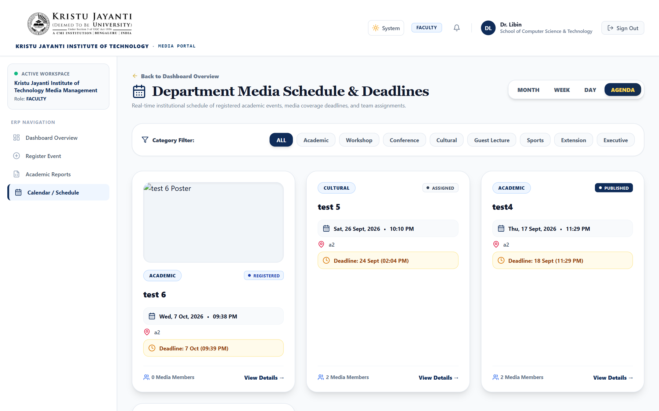
Figure 10.7: Interactive Campus Event Calendar: Multi-view campus media calendar showing scheduled, assigned, and completed events.
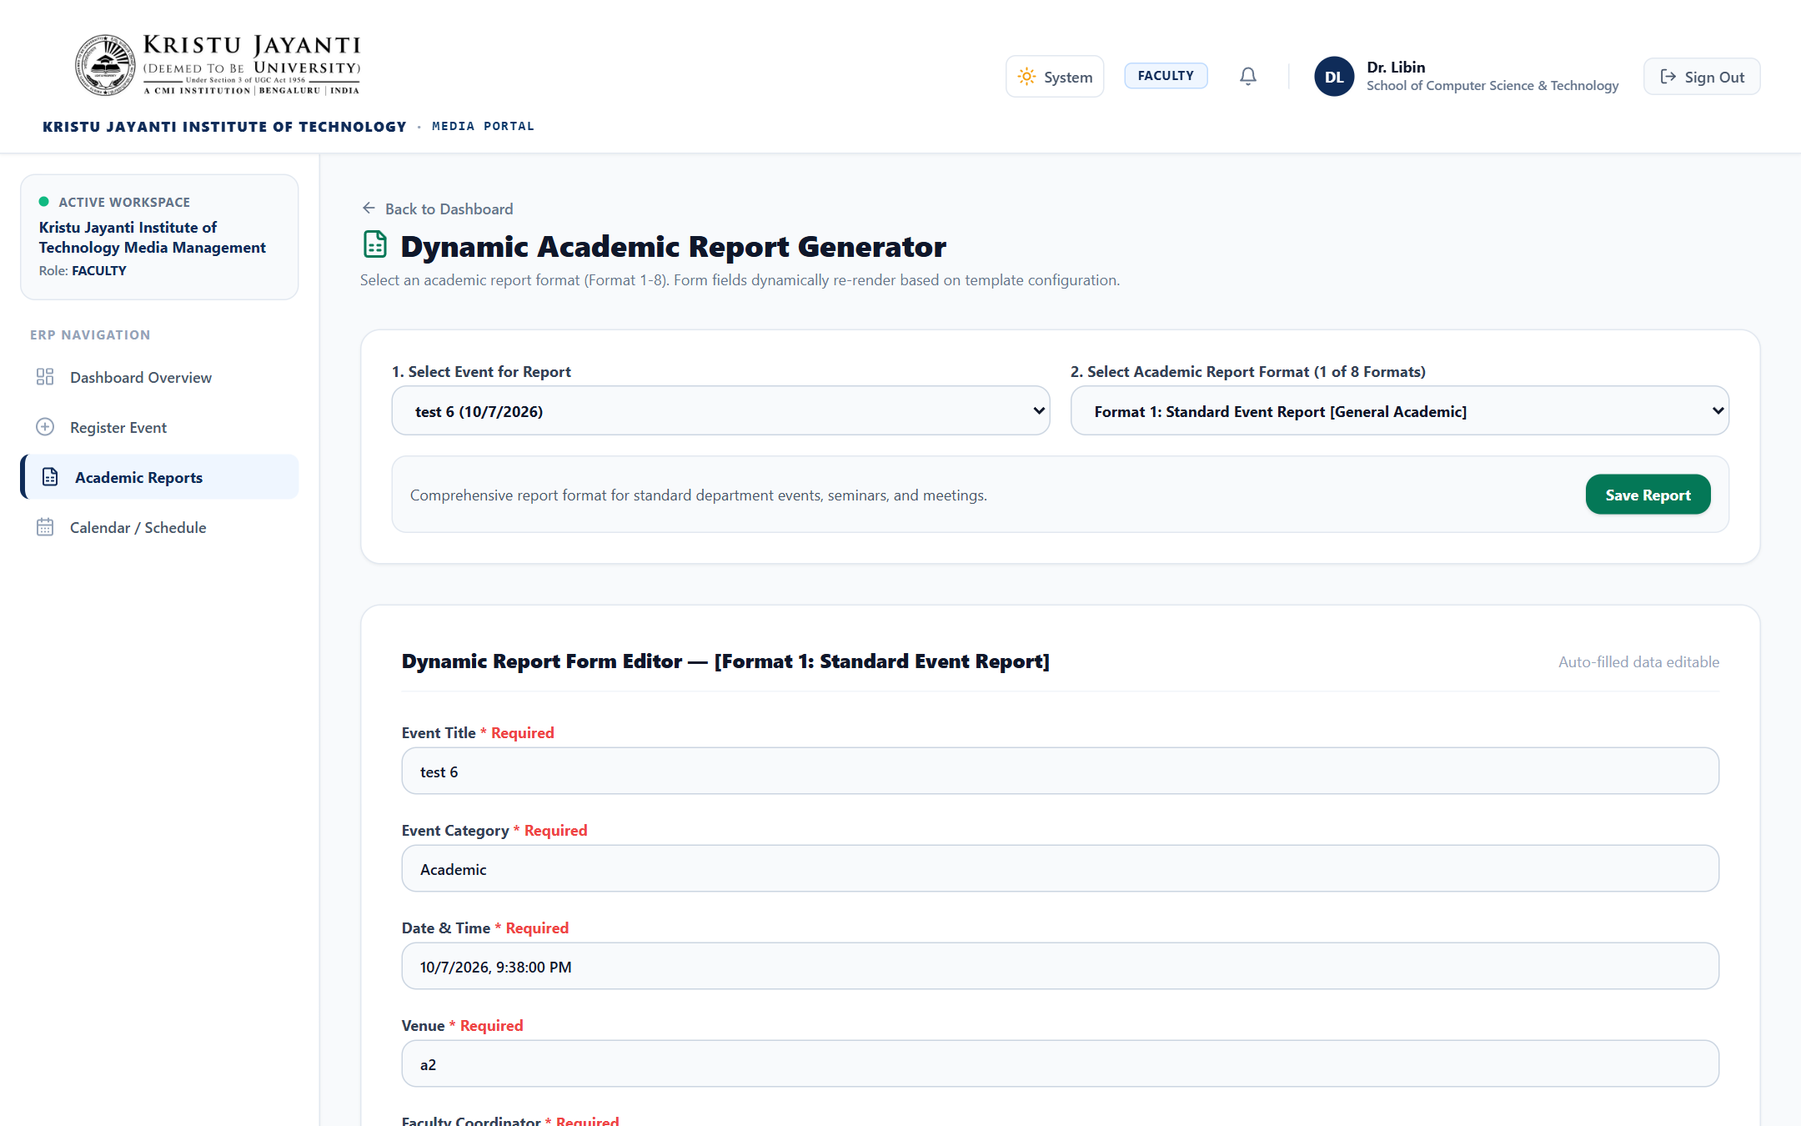
Figure 10.8: Dynamic Report Generator Format Selection: Format selector for the eight standardized institutional activity reports.
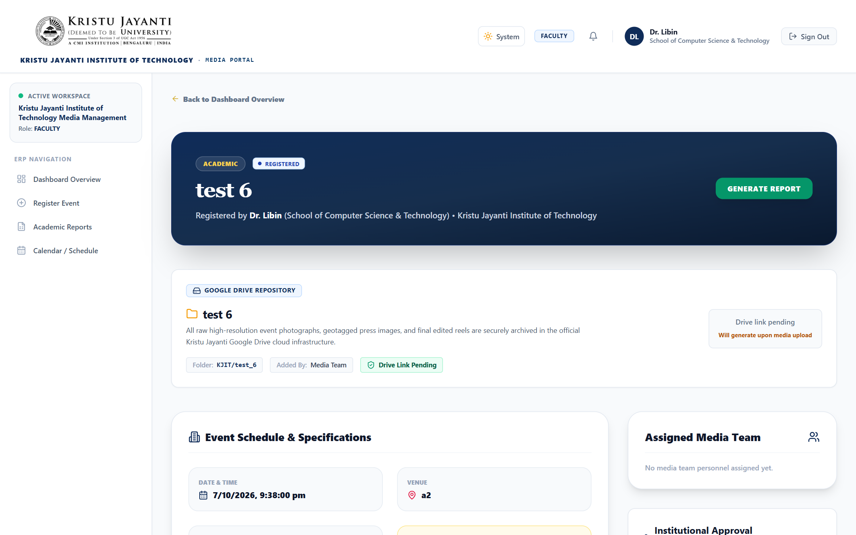
Figure 10.9: Event Details, Drive Folder & Media Handoff: Detailed event overview displaying poster, Google Drive collaborative link, and crew roster.
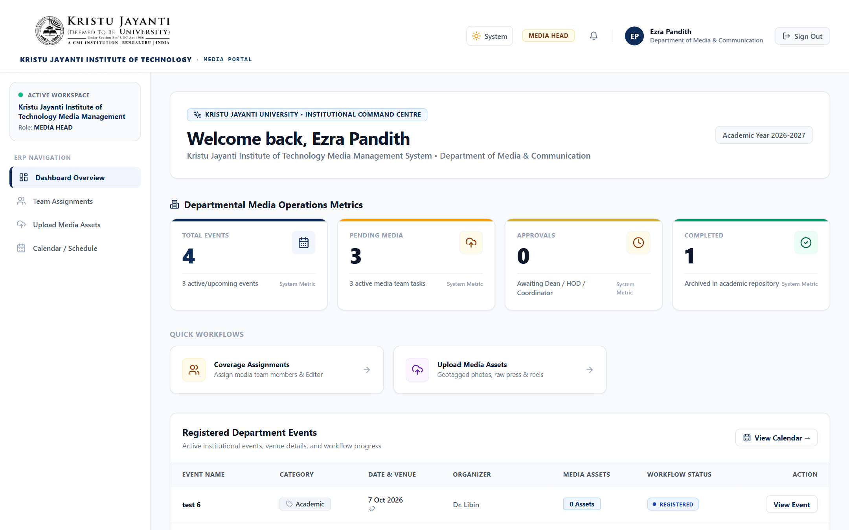
Figure 10.10: Media Team Head Dashboard: Media Head command center showing pending crew allocations, active coverage, and team stats.
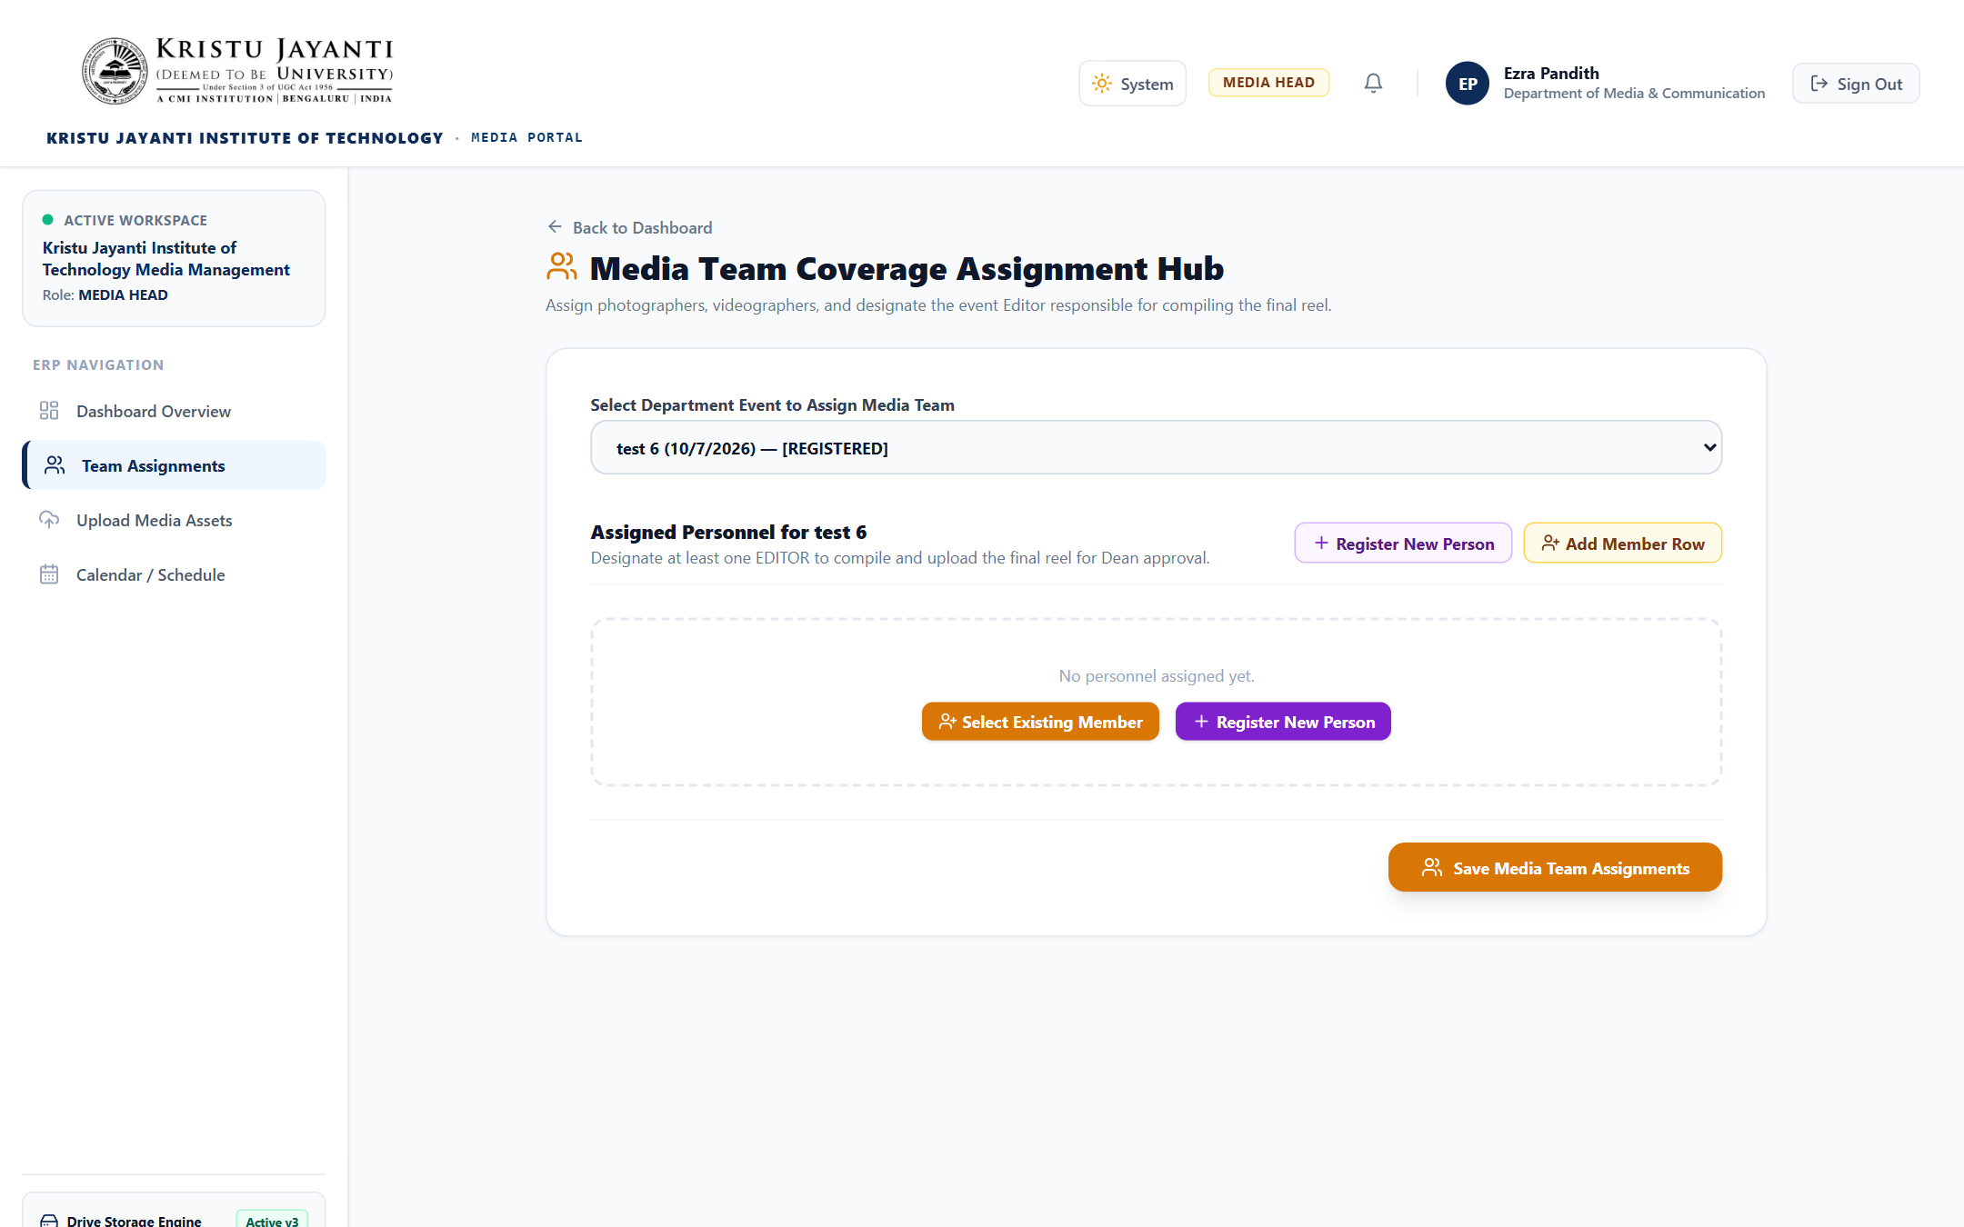
Figure 10.11: Crew Task Allocation & Assignment Workspace: Crew allocation interface for designating event photographers, videographers, and editors.
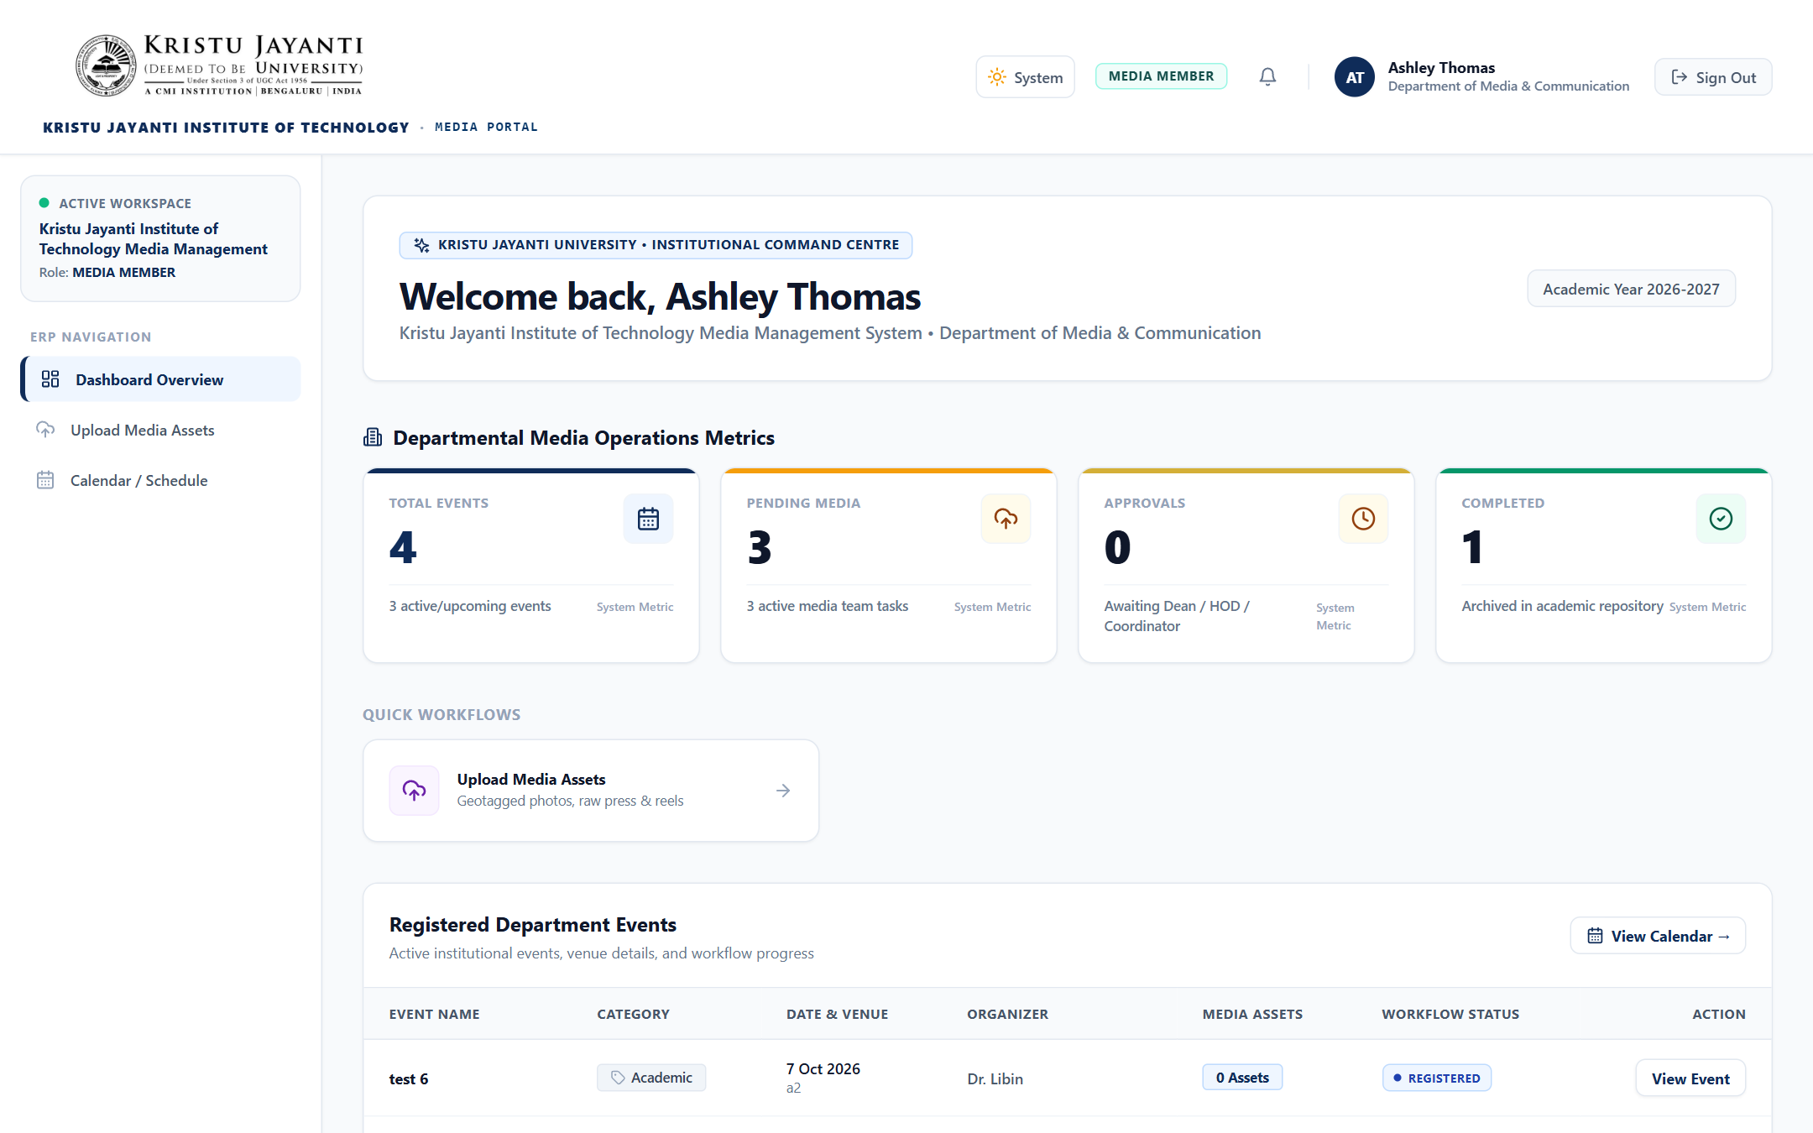
Figure 10.12: Media Team Member Dashboard & Assigned Tasks: Media crew workspace displaying assigned field coverage duties and media deadlines.
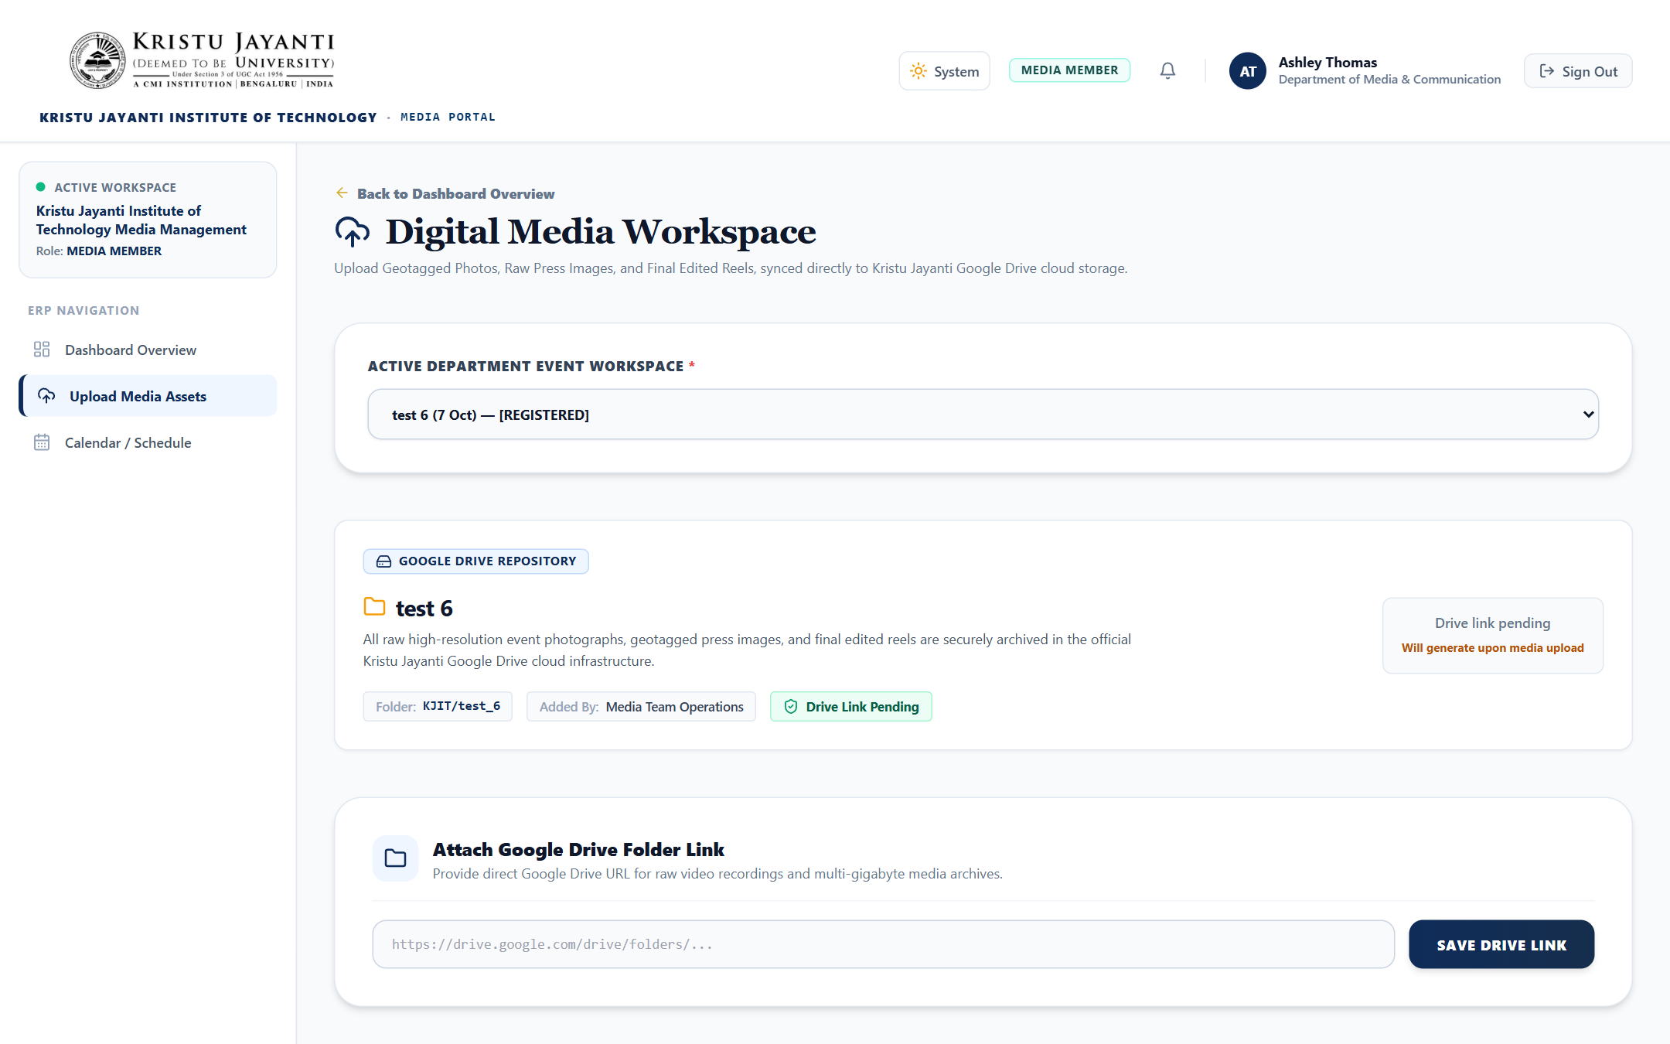
Figure 10.13: Multi-Asset Media Upload Interface (GeoTag & Reels): Media uploader supporting GeoTagged photos with GPS coordinates, raw assets, and final reels.
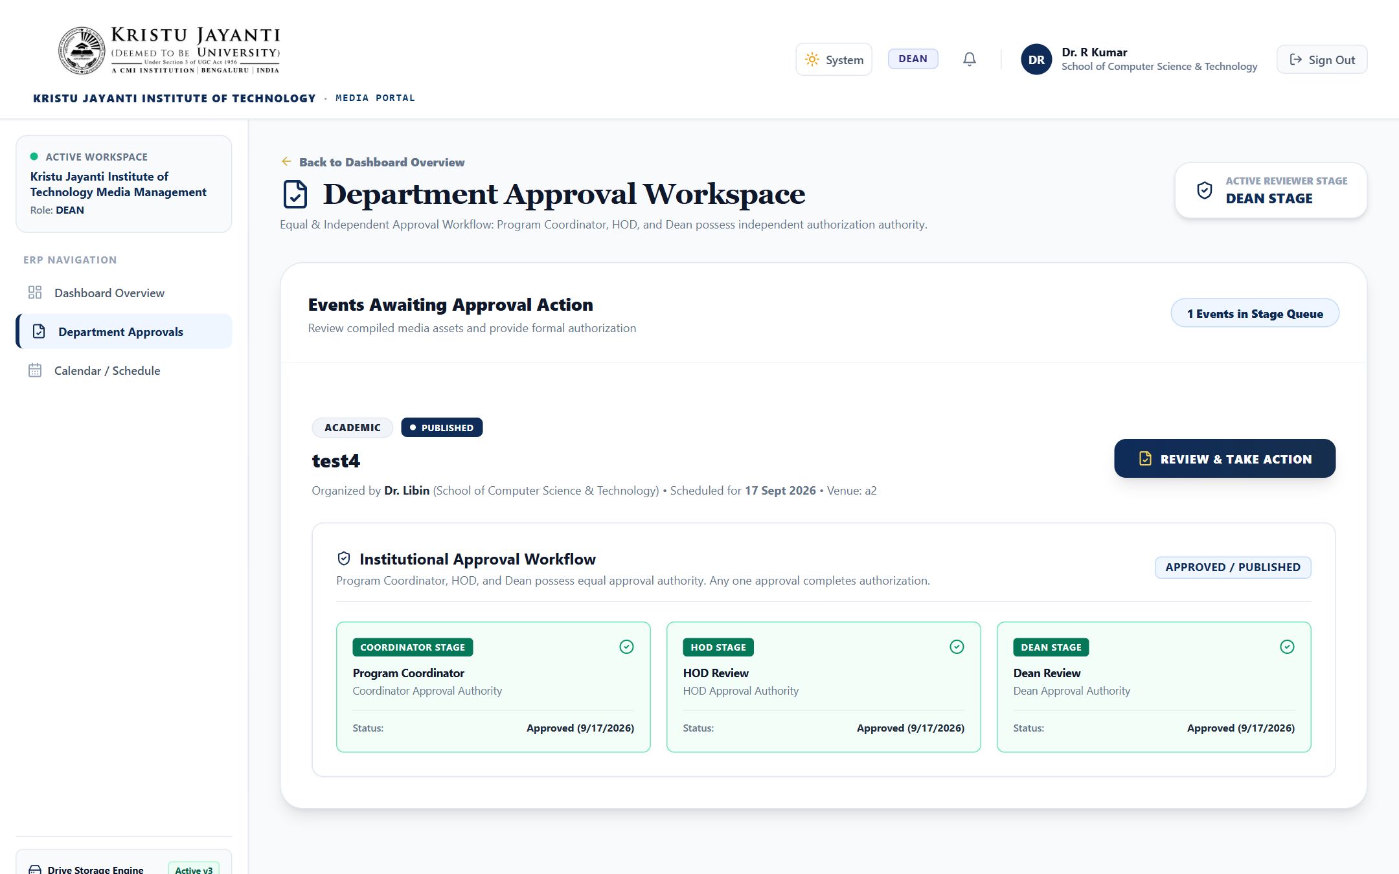
Figure 10.14: Stage 1: Dean Review & Approval Interface: Dean review console for evaluating submitted reels against institutional quality standards.
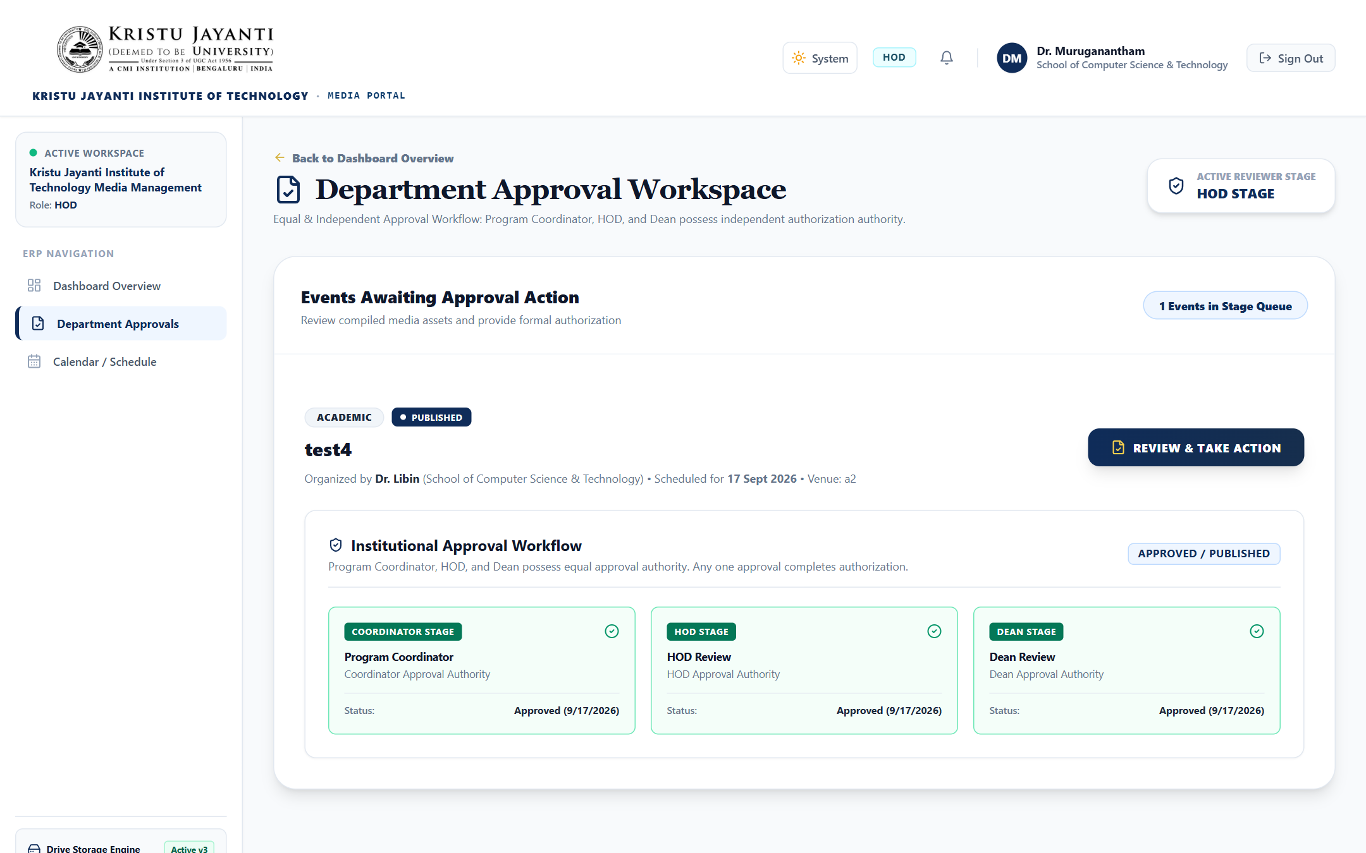
Figure 10.15: Stage 2: Head of Department (HOD) Review Screen: HOD review console for evaluating department academic representation and compliance.
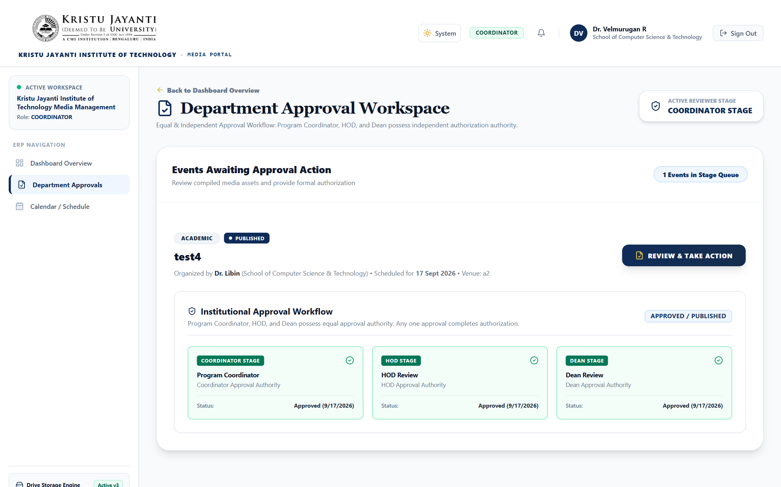
Figure 10.16: Stage 3: Programme Coordinator Final Approval Screen: Programme Coordinator final validation screen unlocking reels for social media publishing.
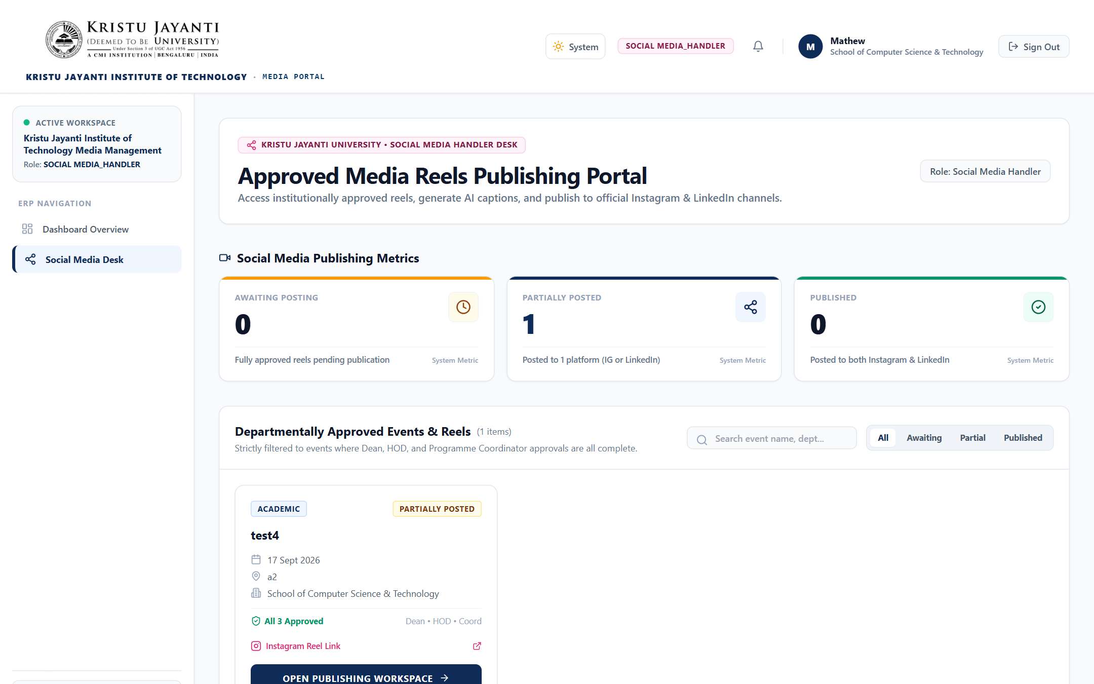
Figure 10.17: Social Media Handler Workspace & Publication URL Logger: Workspace for approved reels, Gemini AI caption drafting, and Instagram/LinkedIn URL logging.
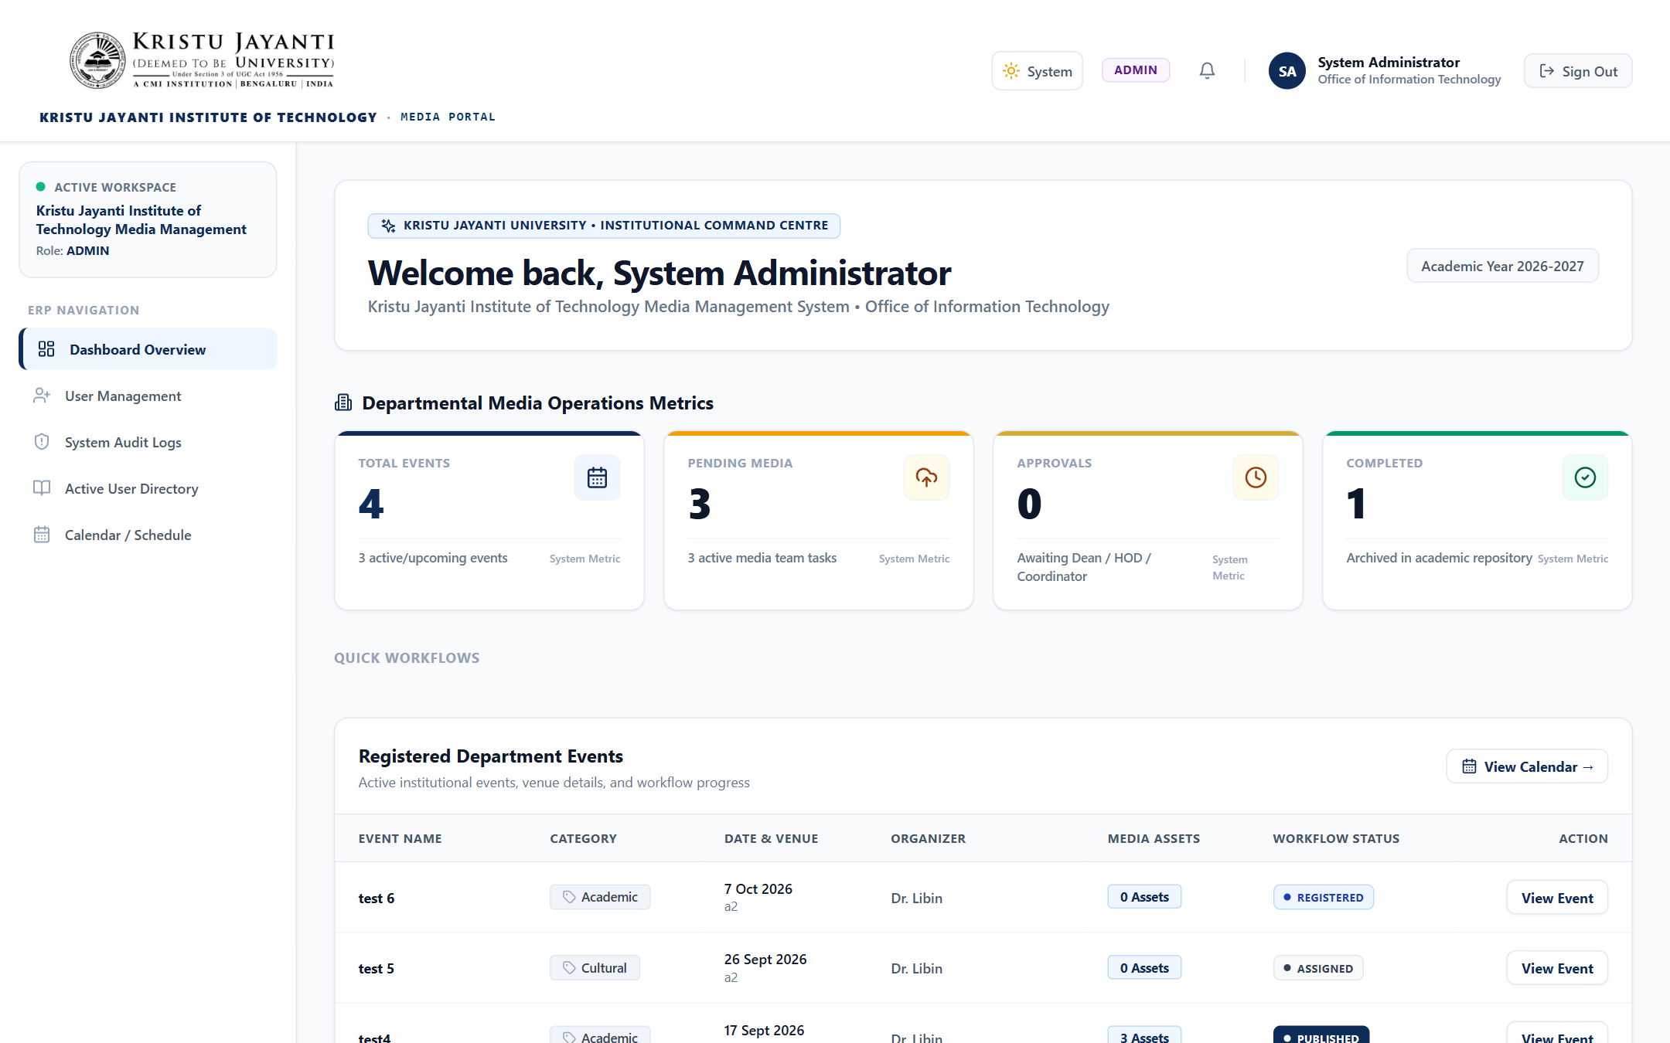
Figure 10.18: System Administrator Analytics Dashboard: Administrator portal displaying campus-wide event statistics, active users, and system health.
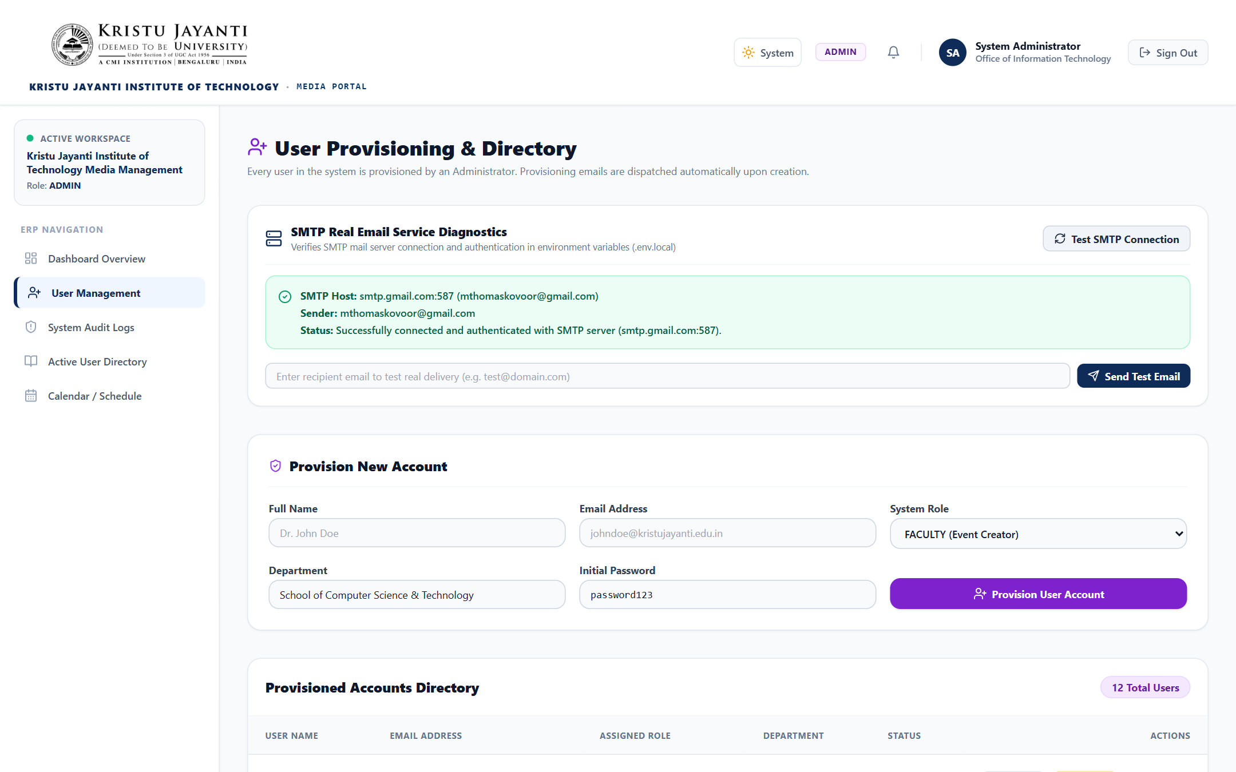
Figure 10.19: Admin User Management & Provisioning Panel: User management table displaying provisioned users, roles, and activation email triggers.
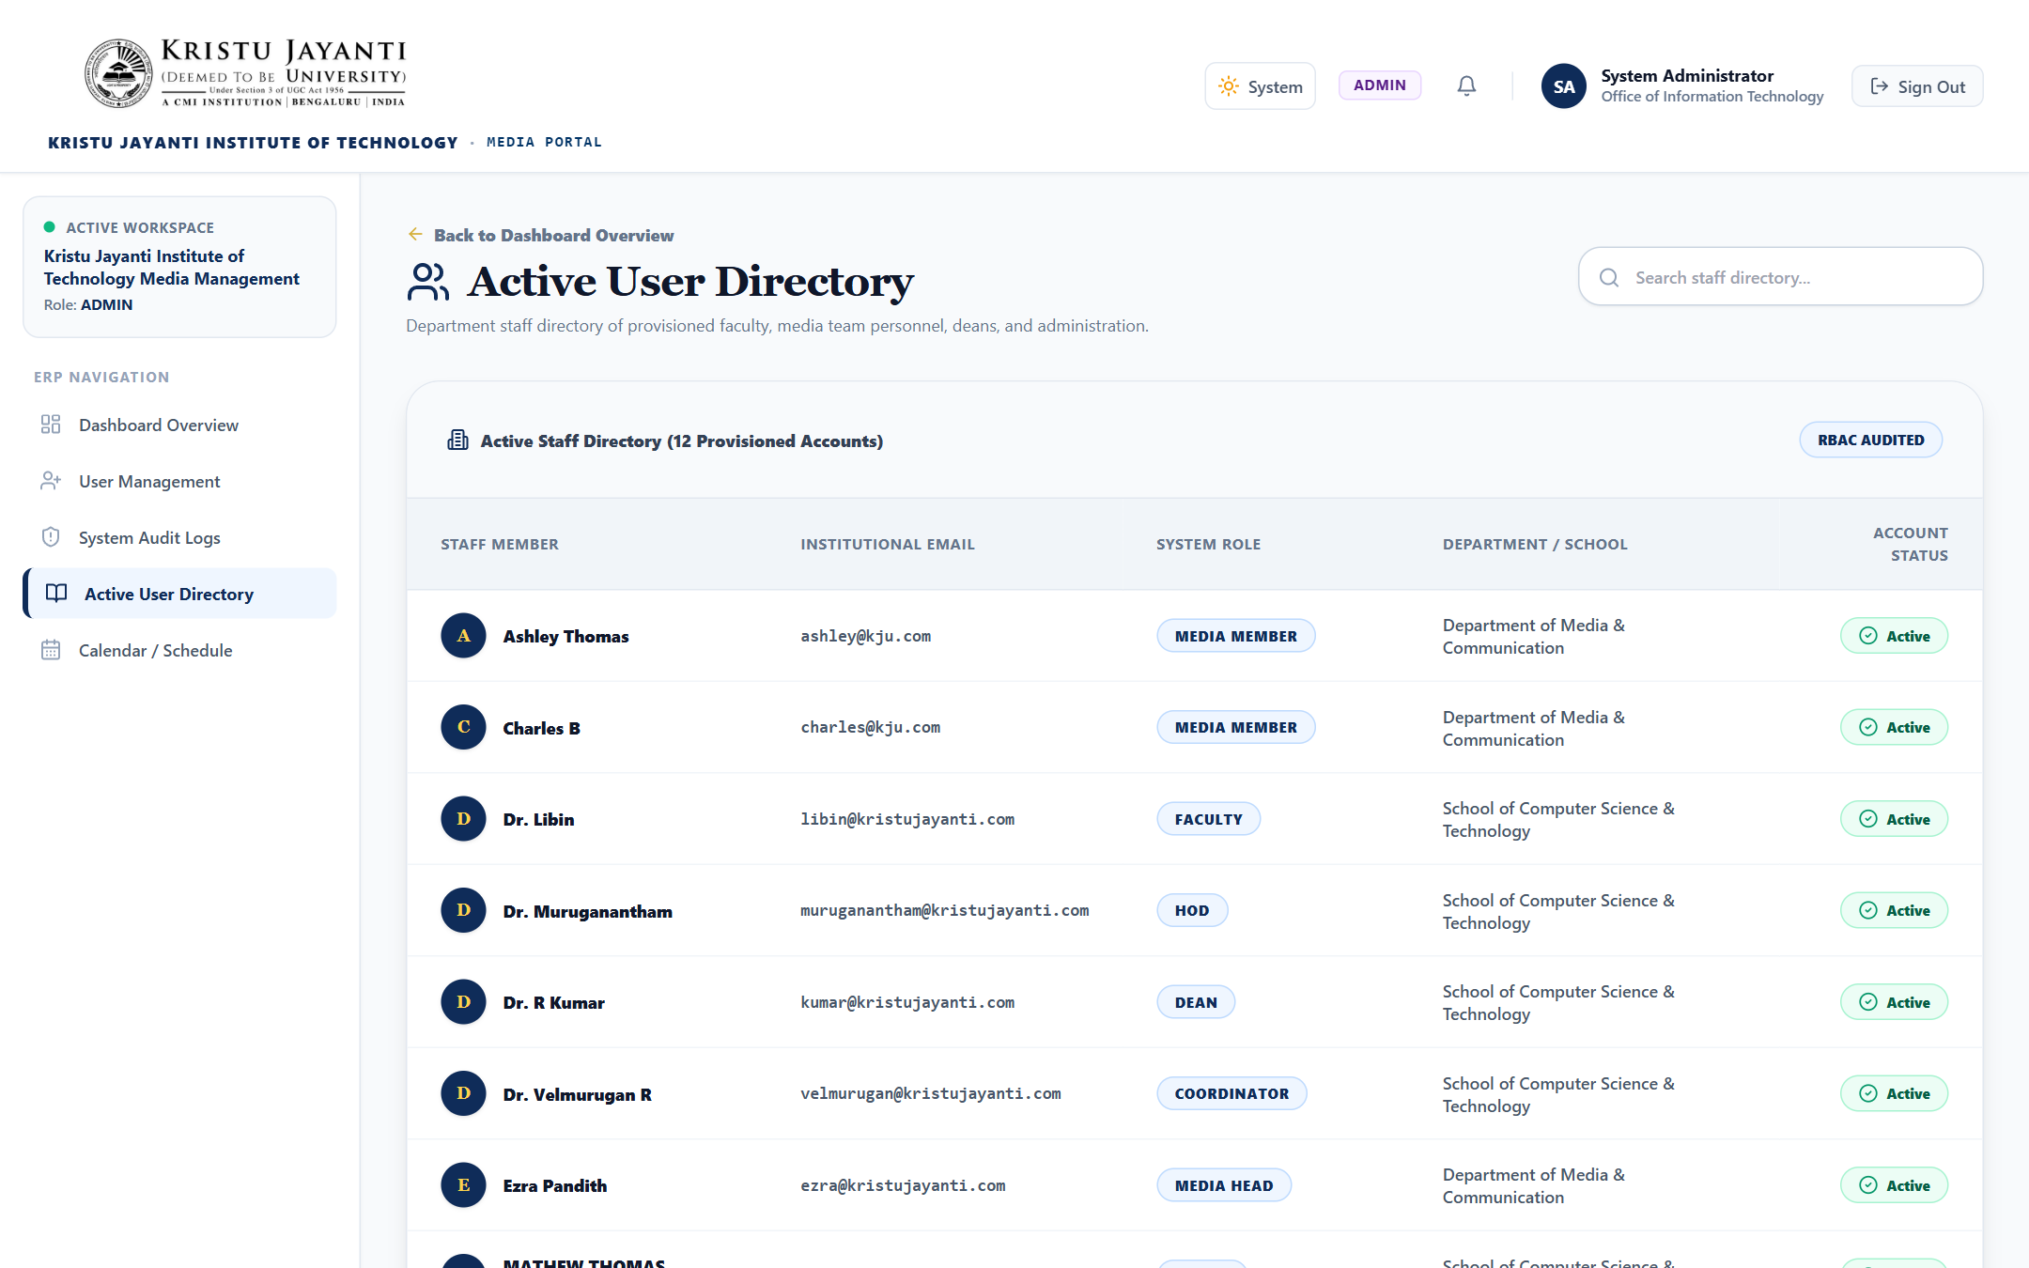
Figure 10.20: Campus Staff & Media Directory: Searchable campus directory displaying faculty, administrative staff, and media crew contacts.
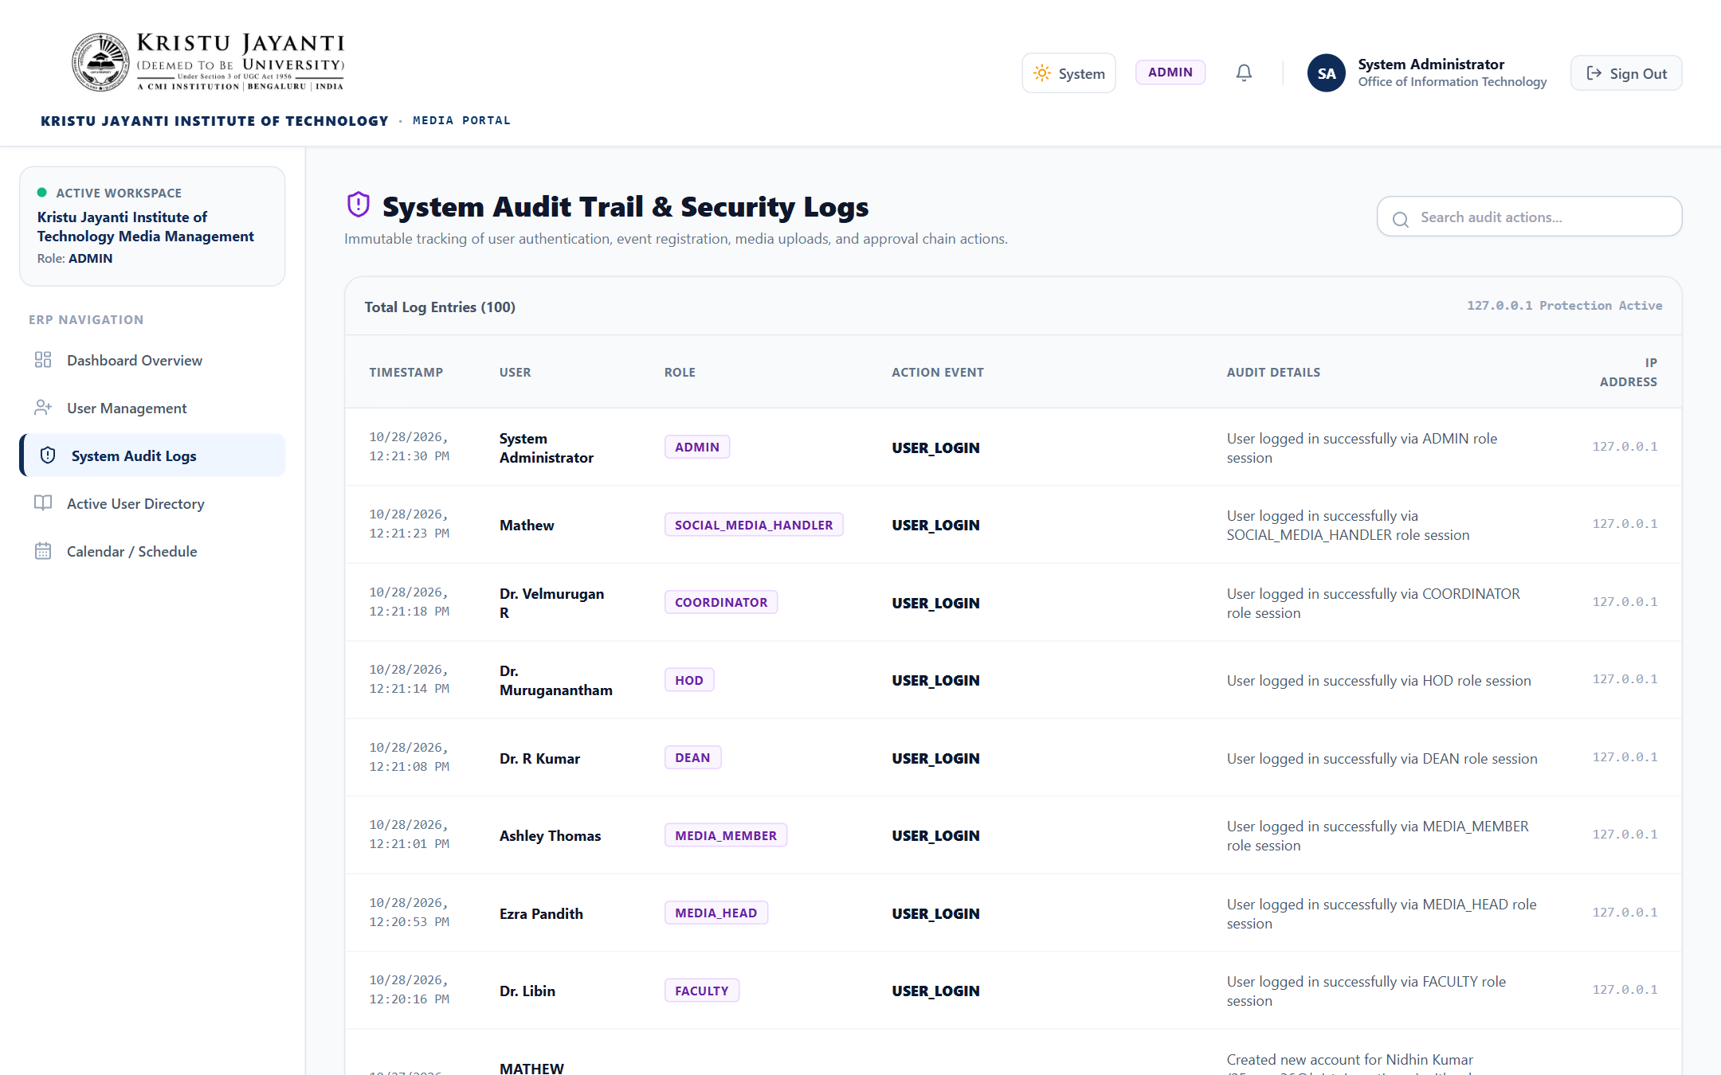
Figure 10.21: Enterprise System Audit Log Viewer: Immutable audit log viewer showing user actions, IP addresses, details, and exact timestamps.

CHAPTER 11 – REFERENCES / BIBLIOGRAPHY
The design, engineering, and implementation of the KJIT Media Management System are grounded in the following official documentation and technical specifications:
- Vercel. (2024). Next.js Documentation (App Router, Server Components & Route Handlers). https://nextjs.org/docs
- Meta Open Source. (2024). React 18 Documentation (Declarative UI & Hooks API). https://react.dev/
- Microsoft Corporation. (2024). TypeScript Language Specification & Handbook. https://www.typescriptlang.org/docs/
- Prisma Data, Inc. (2024). Prisma ORM Reference Manual & Schema Specification. https://www.prisma.io/docs/
- Tailwind Labs. (2024). Tailwind CSS Utility Framework Documentation. https://tailwindcss.com/docs
- SQLite Consortium. (2024). SQLite In-Process Relational Database Engine Documentation. https://www.sqlite.org/docs.html
- OpenJS Foundation. (2024). Node.js Runtime Environment Specification (v20 LTS / v24). https://nodejs.org/docs/
- Nodemailer Project. (2024). Nodemailer SMTP Transport Module Documentation. https://nodemailer.com/
- Google Developers. (2024). Google Drive API v3 Guides & Node.js Client Libraries. https://developers.google.com/drive/
- Framer B.V. (2024). Framer Motion API Documentation for React. https://www.framer.com/motion/
- Auth0 & IETF. (2015). RFC 7519: JSON Web Token (JWT) Architecture & Cryptographic Signatures. https://datatracker.ietf.org/doc/html/rfc7519
- Kristu Jayanti College Autonomous. (2024). Academic Event Documentation & Institutional Reporting Guidelines. Bengaluru, Karnataka.

