BDA400 - Data Science Tools and Techniques
Assignment 6
Technical Analysis using R, Visualization Phase

Mathew Alleyne
Student ID: 664429889
Submitted: 29 October 2026

Project description
An interactive R Shiny portfolio dashboard that downloads stock prices from Yahoo Finance, shows them as candlestick, line or area charts for any date range and daily, weekly or monthly time frame, overlays the technical indicators built in Assignment 5 (each switchable on and off), applies a choice of trading rules and annotates the Buy and Sell bars on the chart.

Repository: https://github.com/MathewAlleyne-crypto/TechnicalAnalysis/tree/main/Assignment6

AI Assistance Declaration: I used Claude (Anthropic, Claude Opus 5.5, Claude desktop app, 29 Oct 2026) to help draft the Shiny dashboard code, the screenshot script and this documentation. I verified the outputs by running the app, checking every chart type, time frame, indicator toggle and trading rule, confirming that each Buy/Sell label sits exactly on the bar where the rule's condition occurs (make_screenshots.R), and testing the offline fallback and invalid-ticker handling. I am responsible for the accuracy and originality of this work.

1. How to run
- Install R 4.x (RStudio recommended).
- Download or clone the repository and open Assignment6/app.R in RStudio.
- Click "Run App" (or run shiny::runApp("Assignment6") from the repository folder). Missing packages (shiny, ggplot2, quantmod, patchwork, bslib) are installed automatically the first time.
- Choose a symbol, date range, time frame, chart type, indicators and trading rule in the sidebar. The parameter sliders are under "Indicator & rule parameters".

2. Implementation by step
Step (marks) | What was implemented | Where in app.R
1 - Data collection and setup (/20) | Packages are checked, installed if missing and loaded. Prices come from Yahoo Finance with quantmod::getSymbols() for any symbol and date range, with extra history before the start date so indicators are ready at the first visible bar. Errors are caught: if Yahoo cannot be reached the app falls back to stock_data_2025.csv (second data source) and shows a notice; an invalid ticker shows a clear message. | STEP 1, fetch_stock()
2 - Visualizing stock data (/30) | Shiny ui/server skeleton with a Flatly theme. Widgets: symbol (portfolio list or any typed ticker), dateRangeInput, time frame (Daily / Weekly / Monthly via to.period), chart type (Candlestick / Line / Area). ggplot2 draws the price chart; bars are placed side by side so weekends do not leave gaps. Tabs show the chart, signals, a portfolio overview and the data. | STEP 2, build_chart(), ui, server
3 - Overlay technical indicators (/25) | Indicators come from the Assignment 5 base-R functions: SMA short and long, EMA, Bollinger Bands (sma + stdev), linear-regression trend line (linreg) on the price panel; RSI, MACD (line, signal, histogram) and volume in panels below. Each one is switched on or off with the "Technical indicators" checkboxes; every period is adjustable with a slider. | STEP 3, add_indicators(), build_chart()
4 - Trading rules and annotations (/25) | Four rules (MA crossover, RSI zones, MACD cross, combined MACD + RSI + trend) with customizable parameters. Each bar gets Buy, Sell or Hold using crossover()/crossunder() from Assignment 5; signals alternate. Buy bars are marked with a green triangle and label, Sell bars with a red one. The Signals tab lists every signal and back-tests the rule against buy-and-hold. | STEP 4, generate_signals(), backtest(), build_chart()

Trading rules
Rule | Buy when | Sell when
Moving Average crossover | short SMA (20) crosses above long SMA (50) | short SMA crosses below long SMA
RSI zones | RSI rises back above the oversold level (30) | RSI falls back below the overbought level (70)
MACD cross | MACD crosses above its signal line | MACD crosses below its signal line
Combined | MACD crosses up and RSI < 70 and close > long SMA | MACD crosses down or RSI falls below 70

3. Screenshots
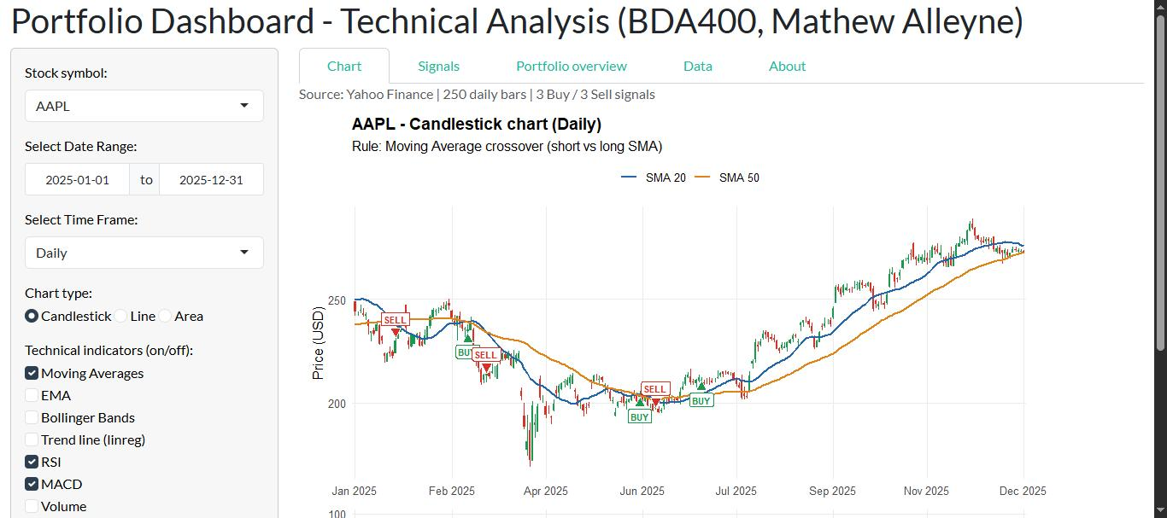
Figure 1 - The running dashboard: AAPL candlestick chart, SMA 20/50, MA crossover signals.
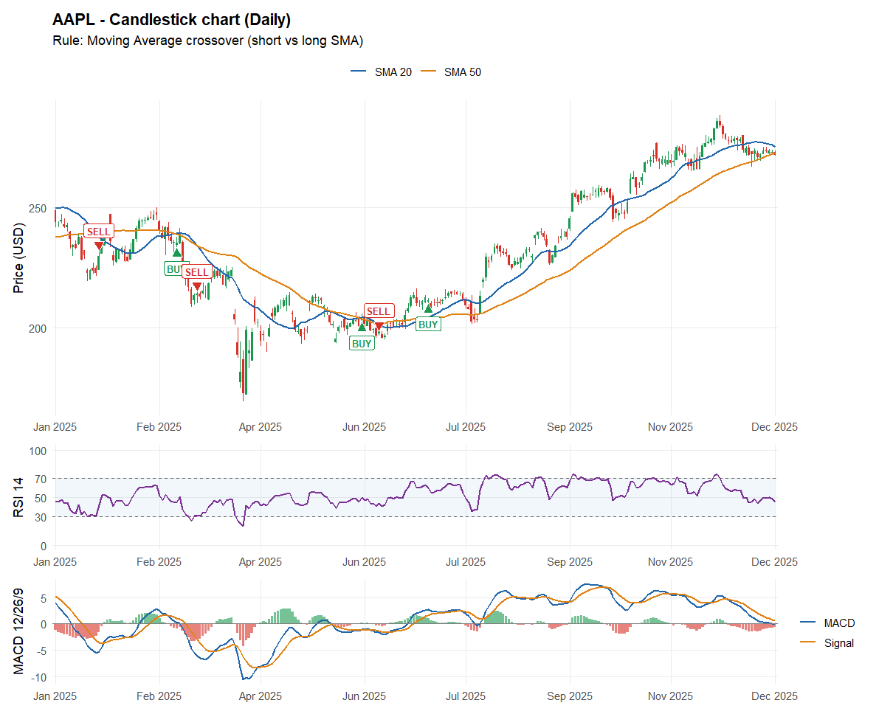
Figure 2 - AAPL 2025, candlestick, daily, Moving Averages + RSI + MACD panels, MA crossover rule.
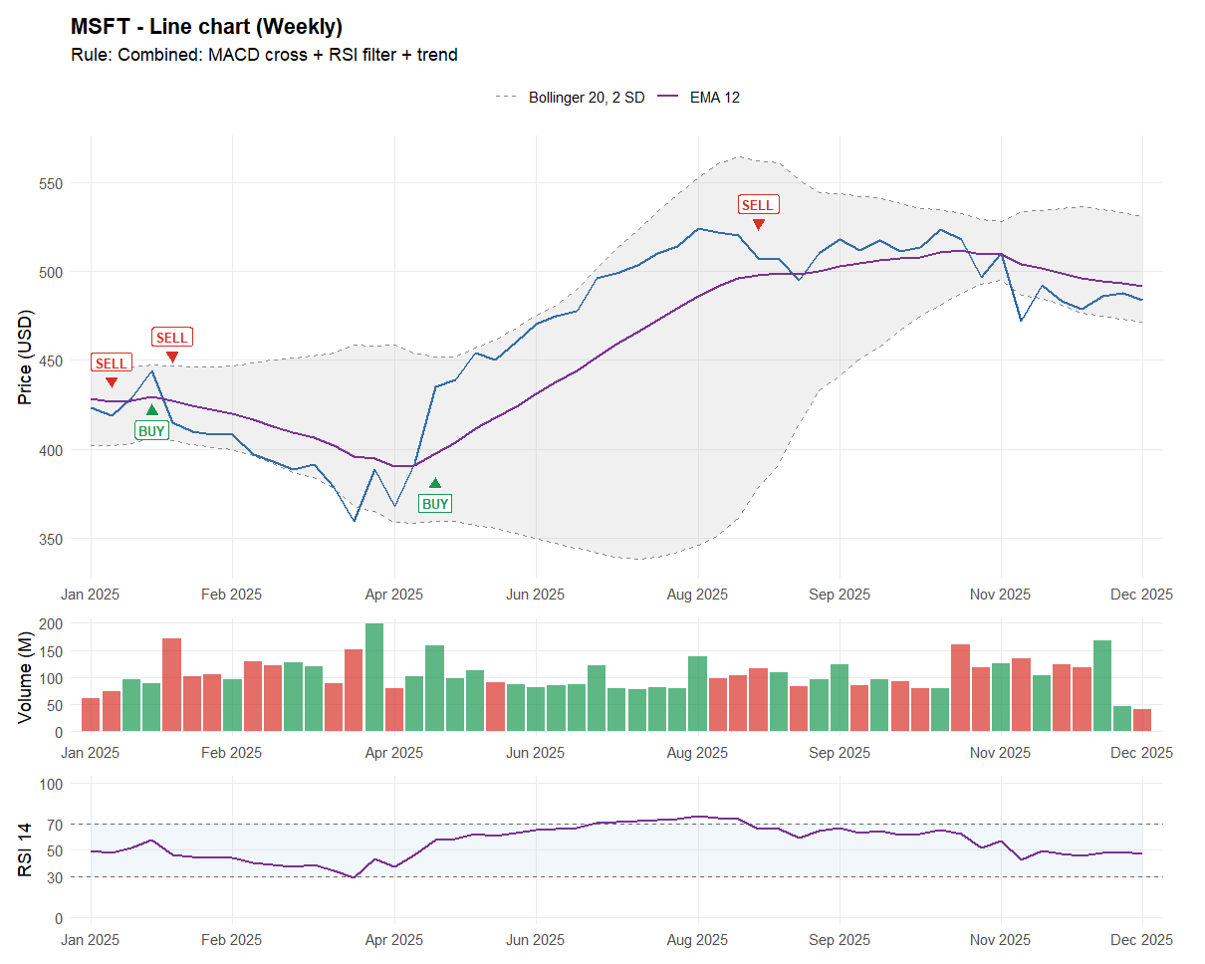
Figure 3 - MSFT 2025, line chart, weekly, EMA + Bollinger Bands + volume + RSI, combined rule.
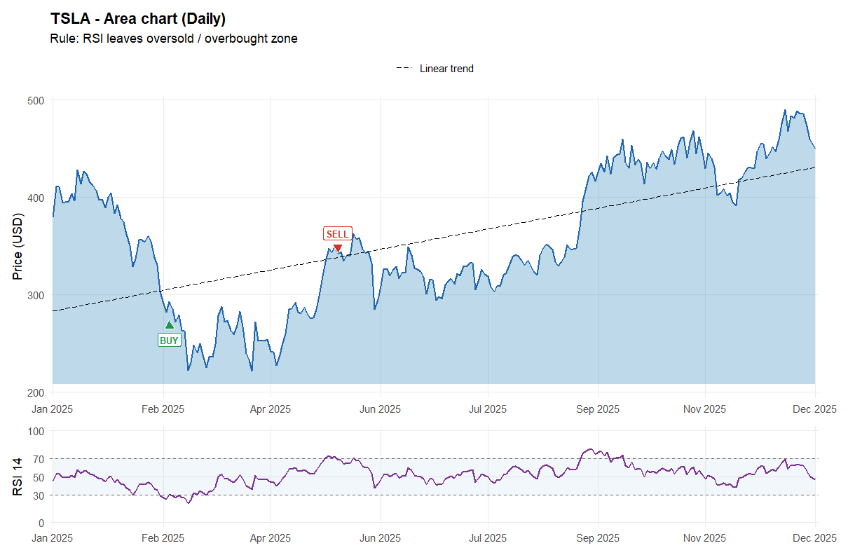
Figure 4 - TSLA 2025, area chart, daily, linear trend line + RSI, RSI rule.
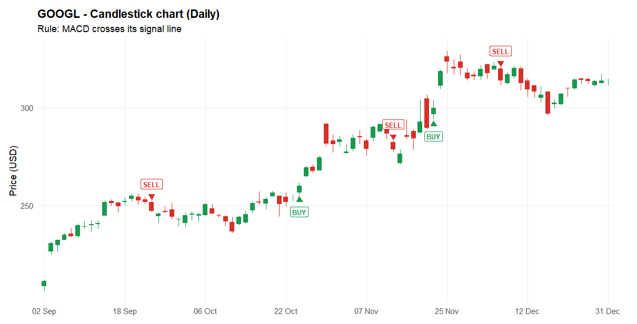
Figure 5 - GOOGL Sep-Dec 2025, all overlays switched off, MACD rule signals.
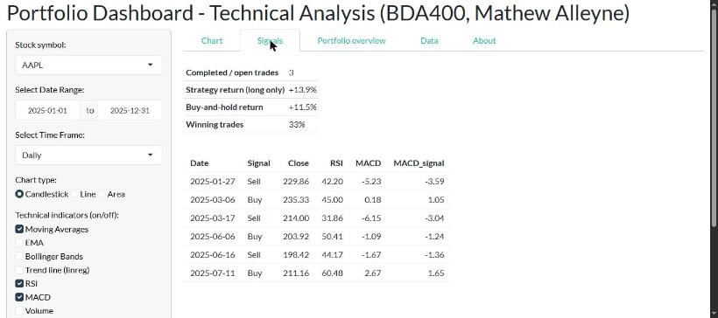
Figure 6 - Signals tab: every Buy/Sell signal and the back-test summary.
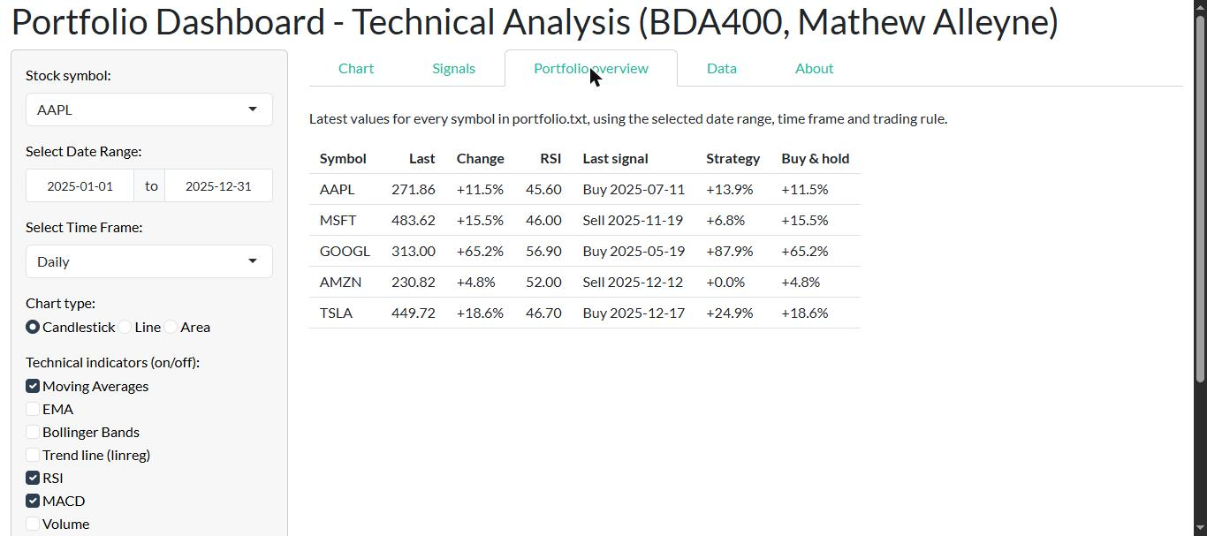
Figure 7 - Portfolio overview for all five symbols.

4. Testing
- make_screenshots.R confirms that, for AAPL 2025, every Buy bar is exactly a bar where SMA 20 crosses above SMA 50 and every Sell bar one where it crosses below (both checks TRUE).
- All three chart types, all three time frames, each indicator on and off and all four rules were run without errors; the app was opened in Chrome and the Chart, Signals and Portfolio overview tabs checked.
- Offline test: with Yahoo Finance made unreachable the app loaded MSFT from stock_data_2025.csv and showed the notice; an invalid ticker produced a readable message instead of an error.
- Input validation: the app refuses a short SMA period that is not smaller than the long one, a MACD fast period not smaller than the slow one, and a start date after the end date.
Example (2025) | Bars | Buy | Sell | Strategy | Buy & hold
AAPL, candlestick, daily, MA crossover | 250 | 3 | 3 | +13.9% | +11.5%
MSFT, line, weekly, combined rule | 53 | 2 | 3 | +8.9% | +14.2%
TSLA, area, daily, RSI rule | 250 | 1 | 1 | +16.8% | +18.6%
GOOGL, candlestick, daily (Sep-Dec), MACD | 85 | 2 | 3 | +12.2% | +48.1%

The back-test is a simple long-only illustration and not investment advice; it shows, for example, that the MACD rule exited GOOGL early in a strong rally.

