Assignment 2 Report: Technical Analysis using R, Preliminary Stage
Mathew Alleyne (Student ID: 664429889)
BDA400 - Data Science Tools and Techniques
AI Assistance Declaration: I used Claude (Sonnet 5.5, 29 Oct 2026) to draft the R functions, the R Markdown file and the structure of this report. Prompts used: “Write R functions using quantmod to load stocks from portfolio.txt, compute moving average, mean, mode, median and standard deviation, and display the data and charts.” I verified outputs by running the code in RStudio, reading every line, and checking the statistics against a manual calculation in a spreadsheet. I am responsible for the accuracy and originality of this work.

1. Introduction
This is stage one of a three-stage technical analysis project. The goal is to set up GitHub, R and RStudio, install the packages for technical analysis, and write functions that import stock data, compute basic statistics and display the results.

2. Setting up a GitHub account and repository
- Go to https://github.com and sign up (or sign in if you already have an account).
- Install Git by following https://docs.github.com/en/get-started/quickstart/set-up-git.
- Create a new repository named TechnicalAnalysis.
- Create a subdirectory for each assignment (for example Assignment2) and upload the files into it.
Screenshot 2.1: GitHub account / sign-in page after sign-up.
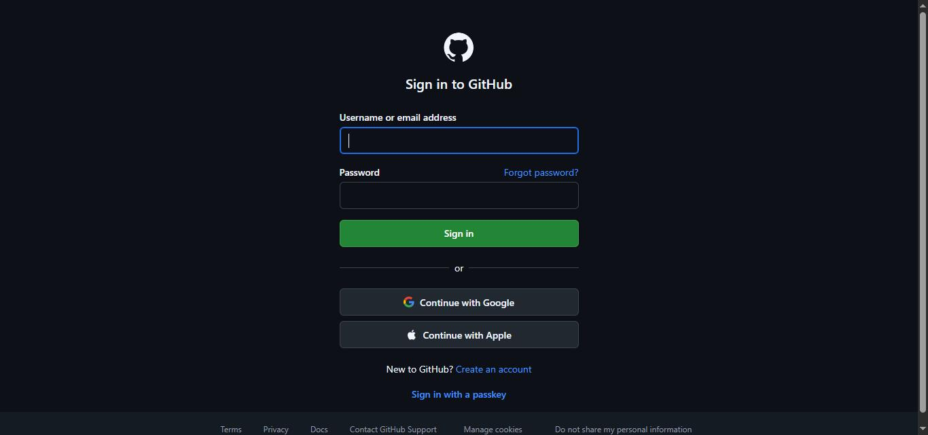
Screenshot 2.2: Git installation or setup.
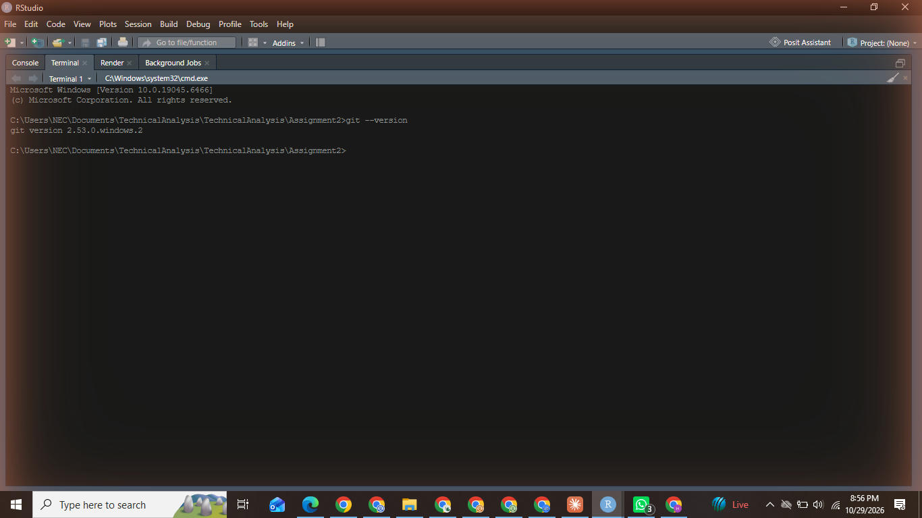
Screenshot 2.3: “Create a new repository” form with the name TechnicalAnalysis.
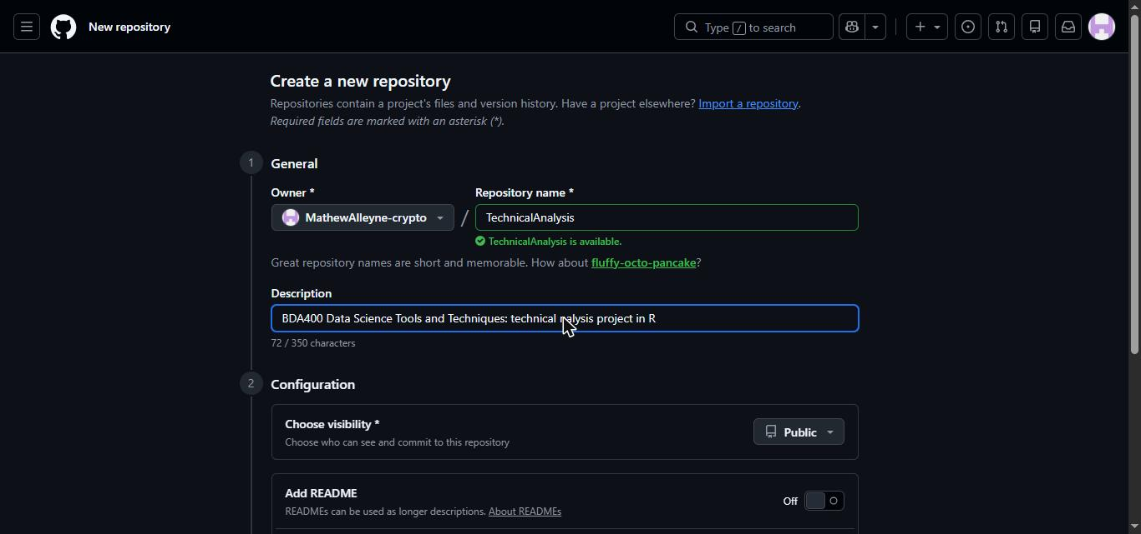
Screenshot 2.4: The new empty repository page.
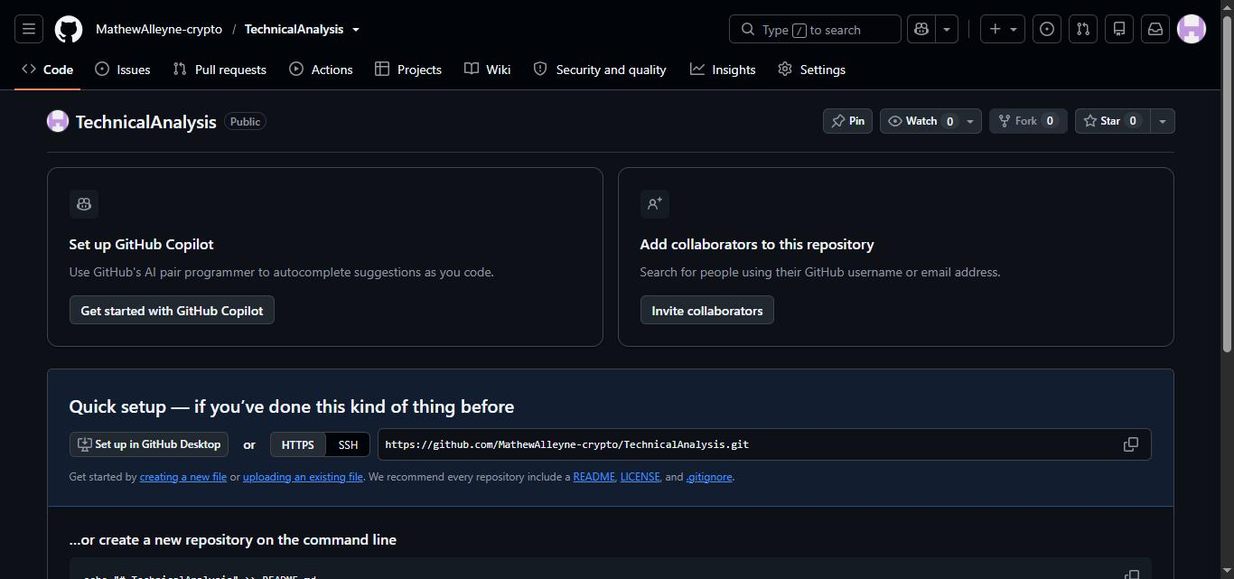

3. Installing and configuring R and RStudio
- Download and install R from CRAN: https://cran.rstudio.com/.
- Download and install RStudio Desktop from Posit: https://posit.co/download/rstudio-desktop/.
- Open RStudio and confirm that the R version prints in the console.
Screenshot 3.1: CRAN download page for your operating system.
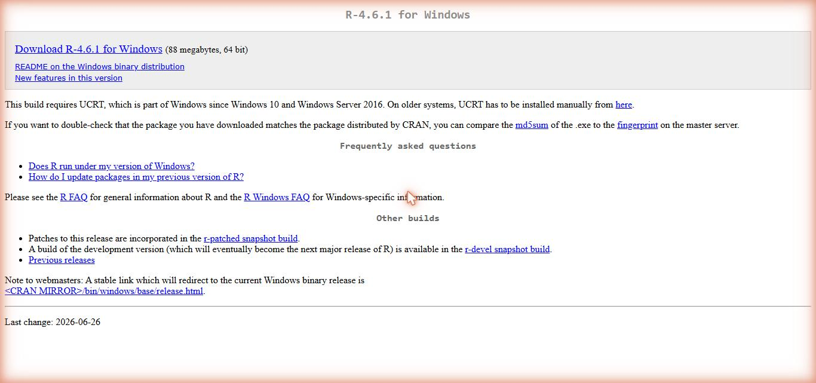
Screenshot 3.2: R installer running.
Note: R 4.6.1 was already installed on this computer, so the installer screens could not be captured. Screenshot 3.4 shows the installed R version.
Screenshot 3.3: RStudio download page and installer.
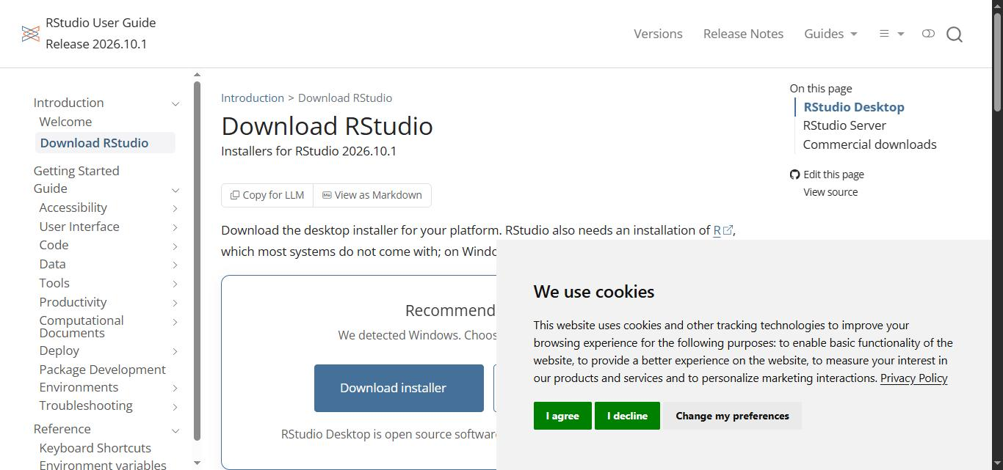
Screenshot 3.4: RStudio open, showing the R version in the console.
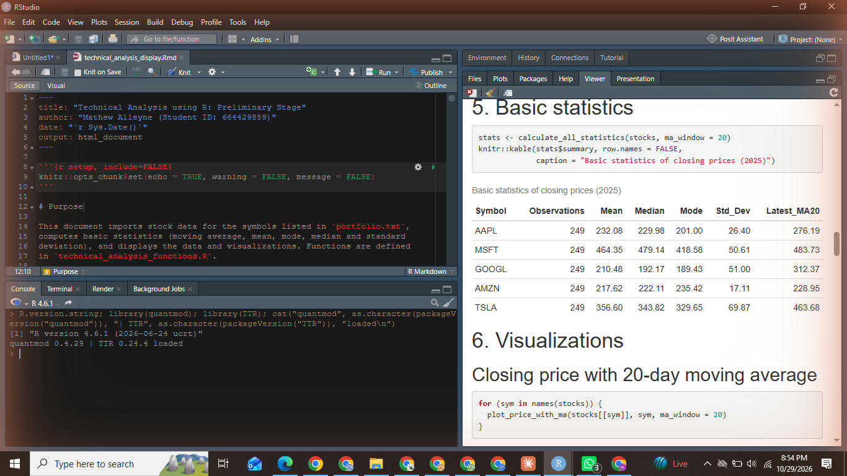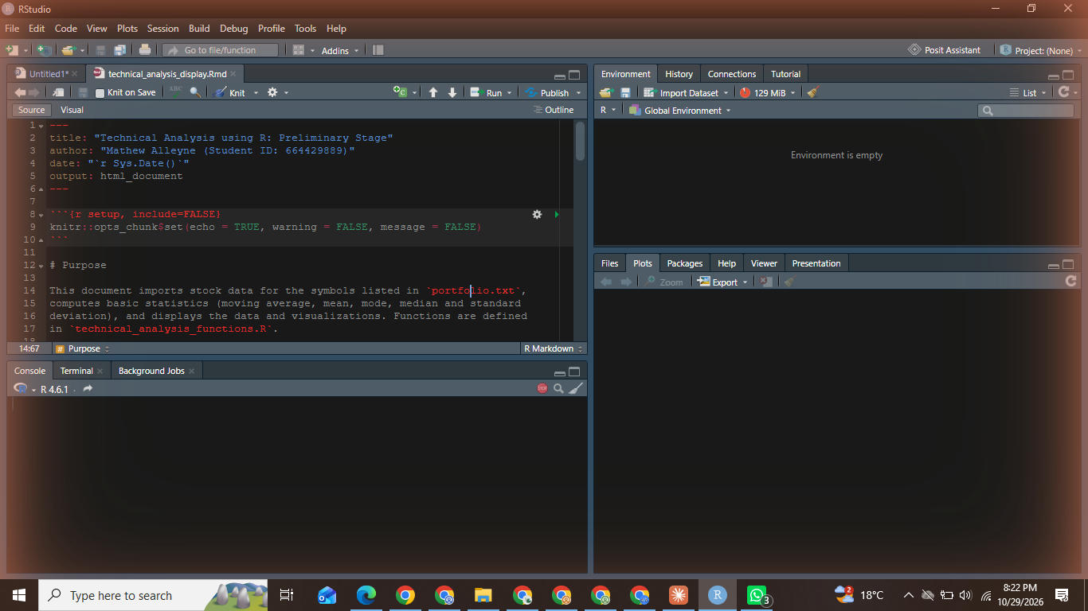

4. Installing R packages
Run this in the RStudio console:
install.packages(c("quantmod", "TTR", "rmarkdown", "knitr"))
- quantmod: imports stock data from Yahoo Finance.
- TTR: technical trading rules (moving averages and more).
- rmarkdown and knitr: knit the .Rmd file to HTML.
Then confirm that they load:
library(quantmod)
library(TTR)
Screenshot 4.1: install.packages() running in the console. The packages were already installed, so this install-if-missing check confirmed their versions instead of reinstalling them.
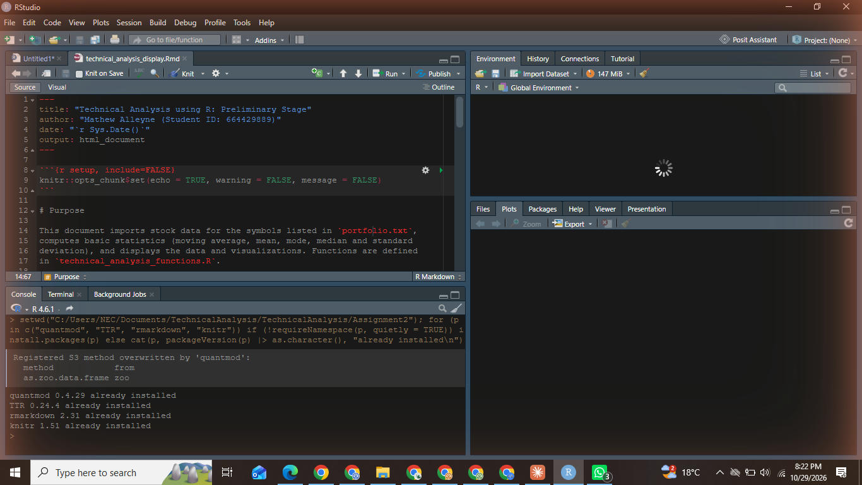
Screenshot 4.2: library(quantmod) and library(TTR) loaded with no errors.

5. Project configuration: portfolio.txt
A text file named portfolio.txt lists the portfolio symbols, one per line:
AAPL
MSFT
GOOGL
AMZN
TSLA
Symbol | Company
AAPL | Apple Inc.
MSFT | Microsoft Corporation
GOOGL | Alphabet Inc.
AMZN | Amazon.com, Inc.
TSLA | Tesla, Inc.
Screenshot 5.1: portfolio.txt open in RStudio or a text editor.
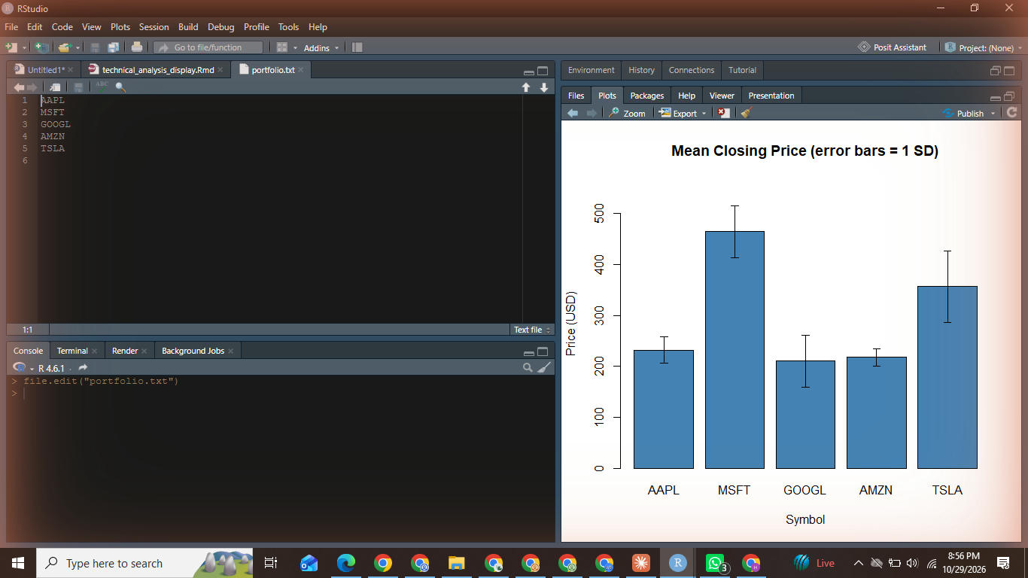

6. Function to import stock data: load_stock_data()
load_stock_data() reads portfolio.txt (through the helper read_symbols()), downloads each symbol with quantmod::getSymbols() for 1 January to 31 December 2025, and stores each stock as its own data frame (Date, Open, High, Low, Close, Volume, Adjusted) in a named list. A symbol that fails to download produces a warning and is skipped, so one bad symbol does not stop the others.
stocks <- load_stock_data("portfolio.txt",
from = "2025-01-01", to = "2025-12-31")
names(stocks)
The full code is in technical_analysis_functions.R.
Screenshot 6.1: the load_stock_data() code in RStudio.
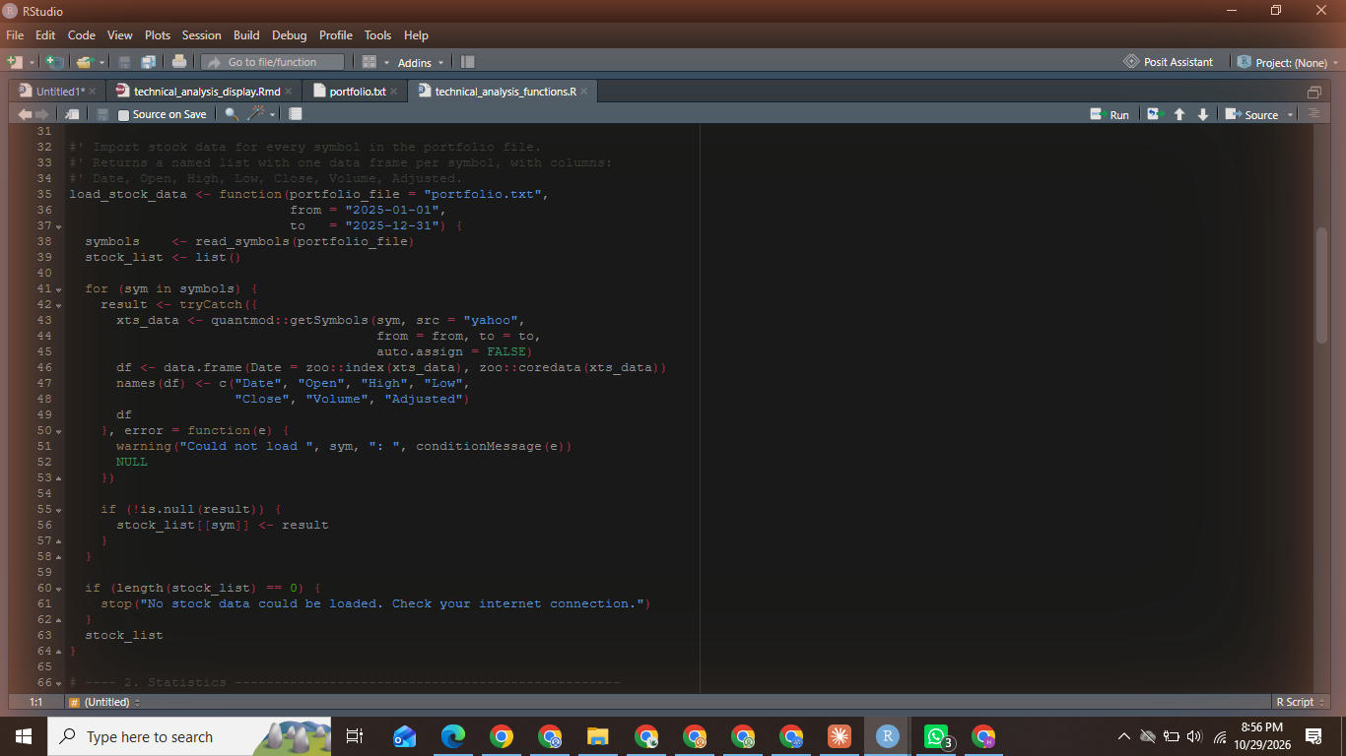
Screenshot 6.2: console output of names(stocks).
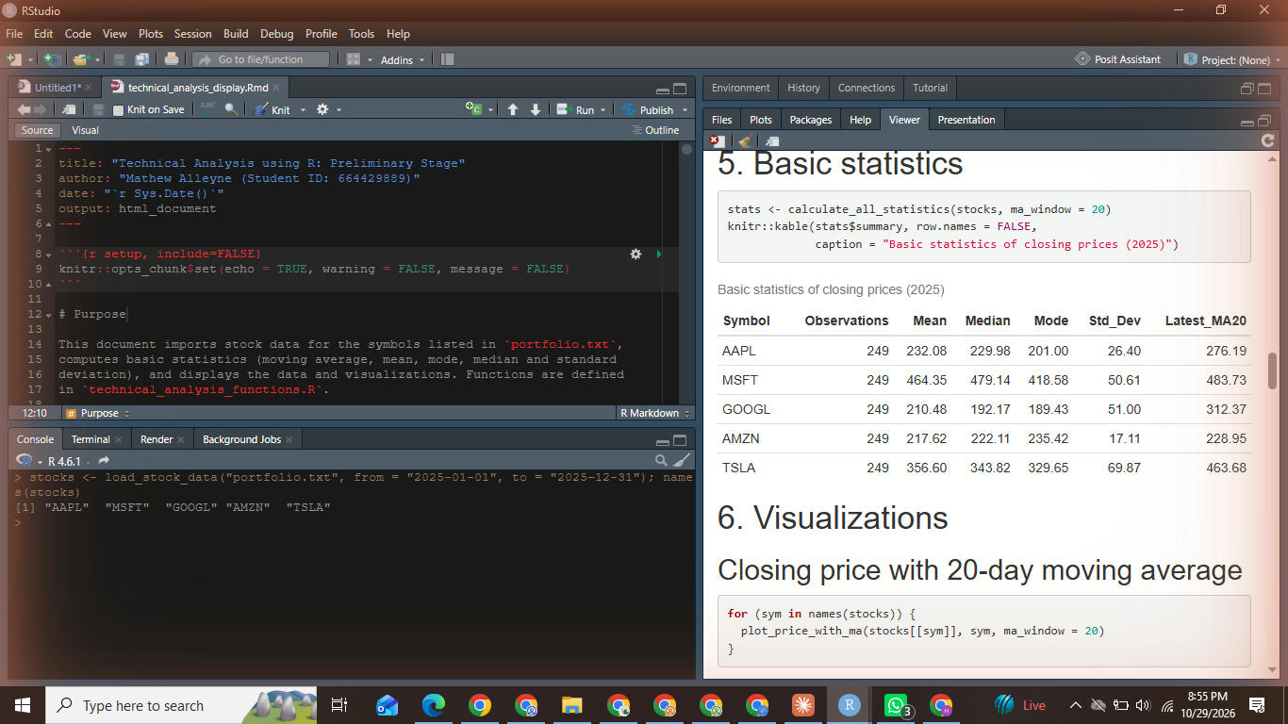

7. Functions to compute basic statistics
calculate_statistics() takes one stock data frame and computes statistics on the closing price:
Statistic | How it is calculated
Moving average | TTR::SMA(), 20-day simple moving average
Mean | mean()
Median | median()
Mode | custom get_mode() (most frequent closing price, rounded to 2 decimals), since base R has no mode function
Standard deviation | sd()
calculate_all_statistics() applies this to every stock and returns one summary table plus the moving-average series. The results are stored in a list holding a data frame.
stats <- calculate_all_statistics(stocks, ma_window = 20)
stats$summary
Screenshot 7.1: statistics code in RStudio.
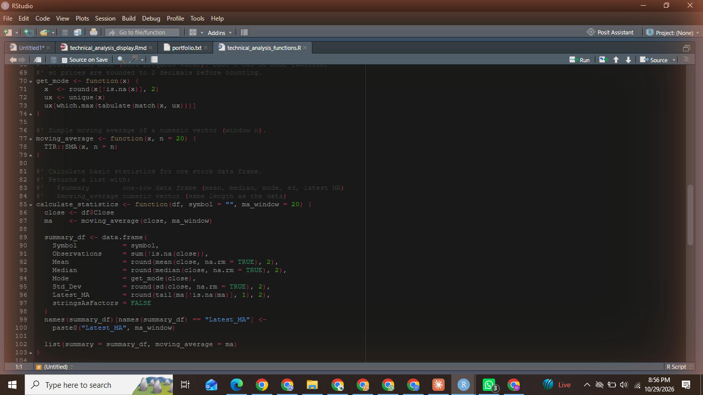
Screenshot 7.2: the summary table printed in the console.
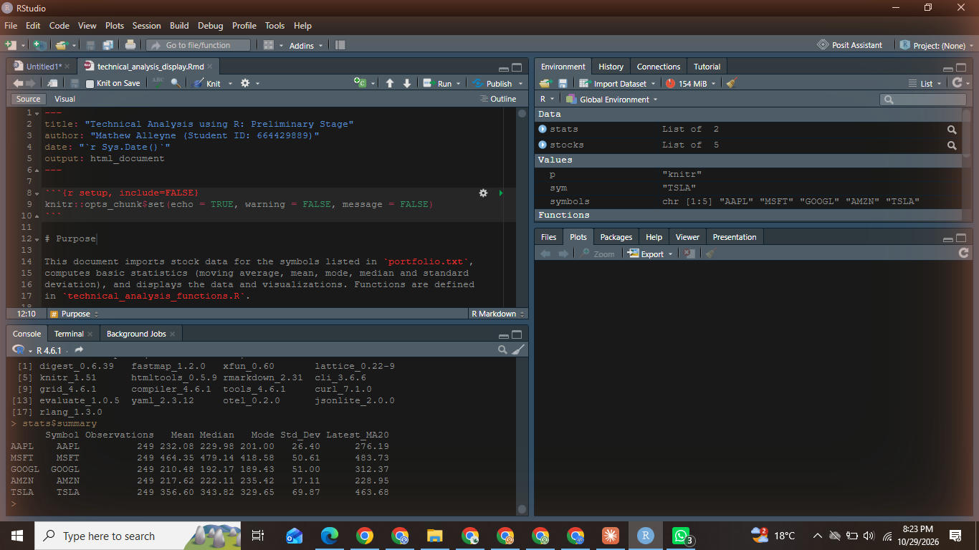

8. Utilities to display output
Function | Output
display_stock_data() | structure, first rows and last rows of each stock’s data frame
plot_price_with_ma() | closing price with its 20-day moving average
plot_volume() | daily trading volume
plot_statistics_summary() | mean closing price with standard deviation error bars for every stock
Stock data is commonly shown on sites such as Yahoo Finance as a table of daily Open, High, Low, Close, Adj Close and Volume values, and as a line or candlestick price chart with a volume chart underneath. The functions above reproduce the table and line/volume views.
Screenshot 8.1: printed data frames for each stock.
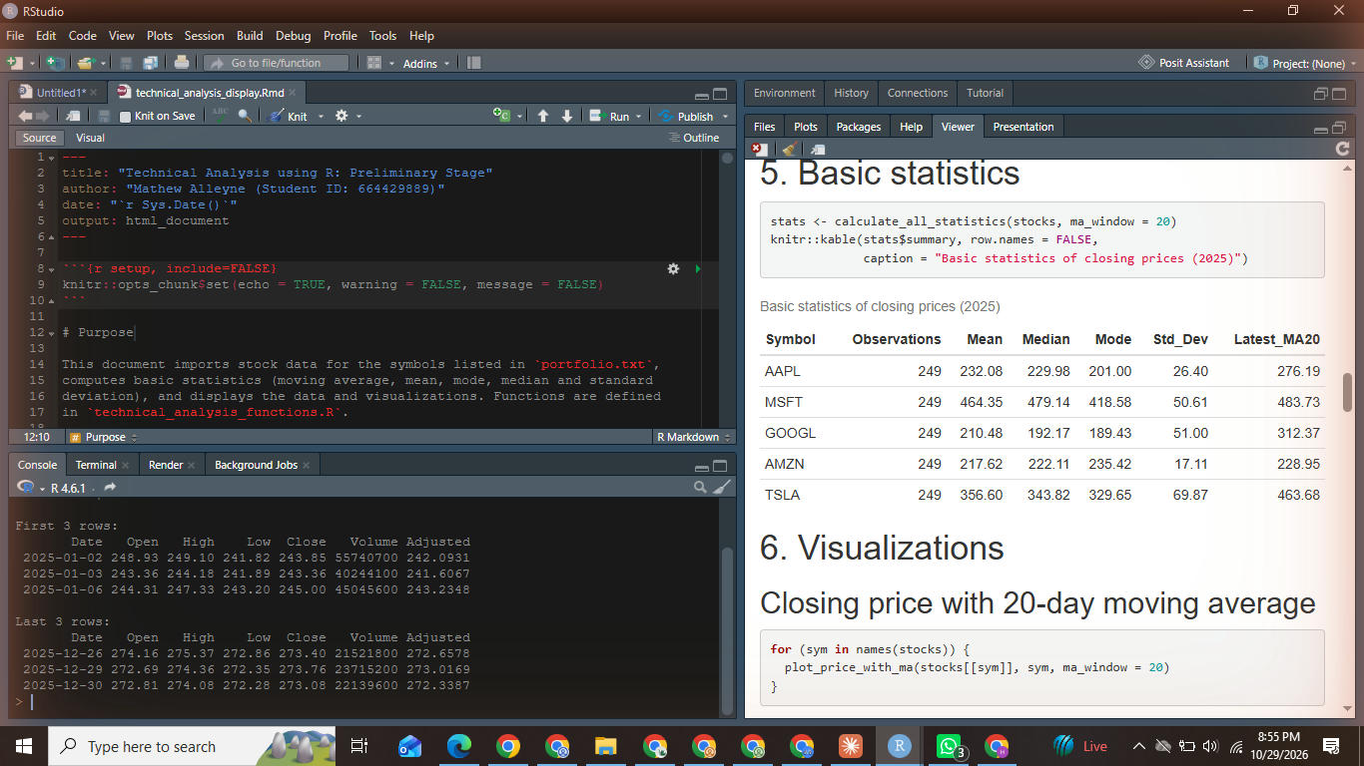
Screenshot 8.2: price and moving-average chart.
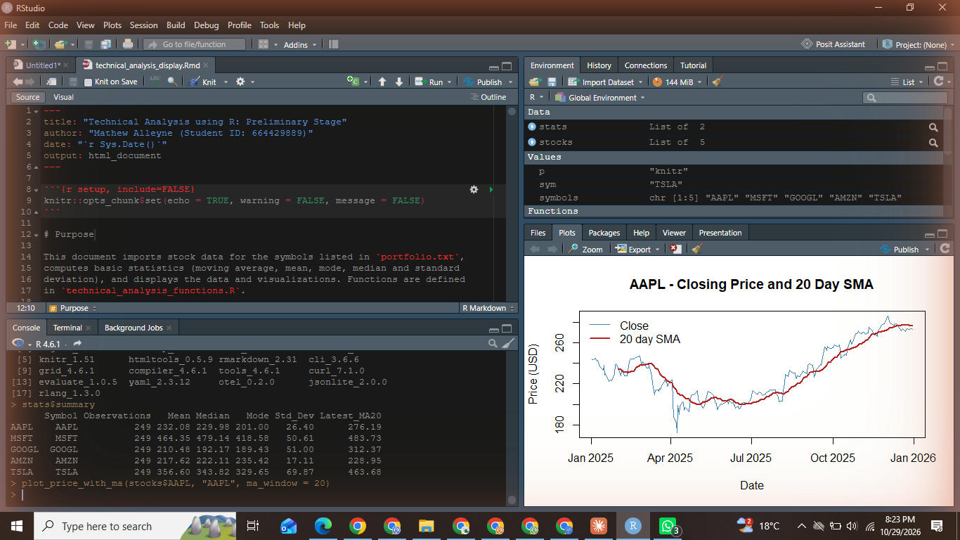
Screenshot 8.3: volume chart.
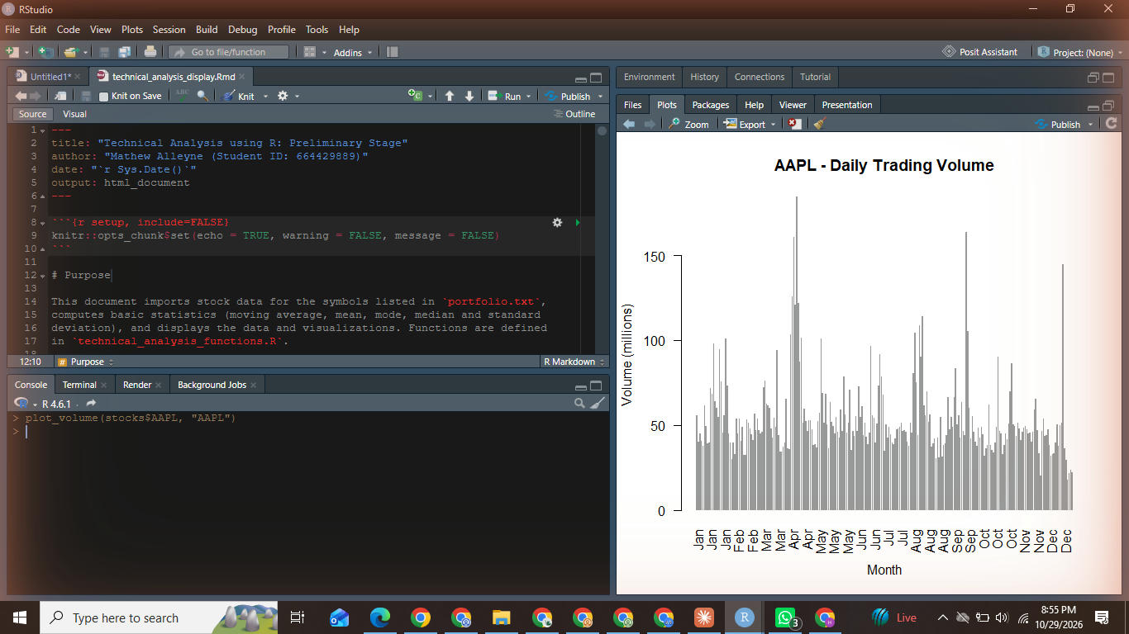
Screenshot 8.4: statistics comparison chart.
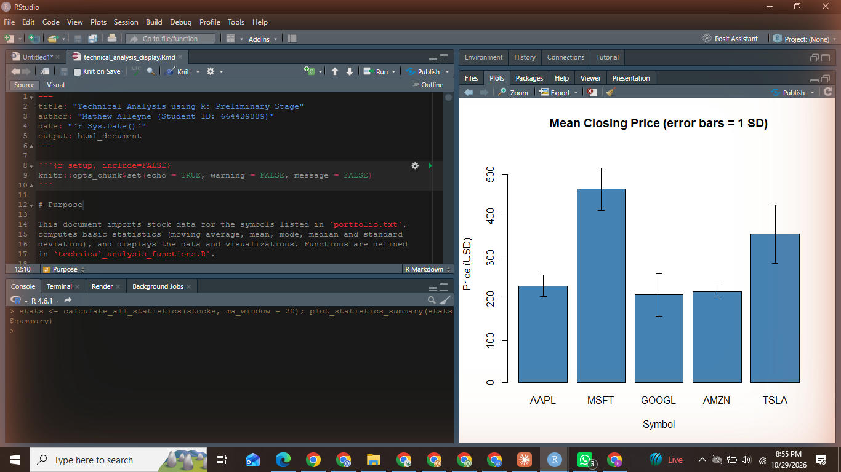
Screenshot 8.5: knitted technical_analysis_display.Rmd (HTML output).
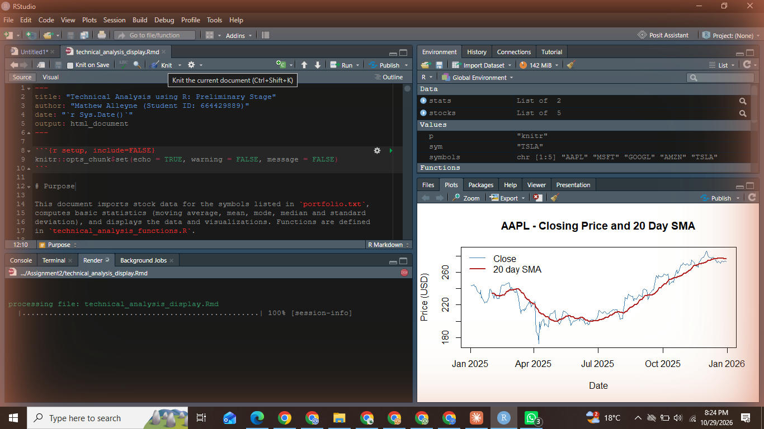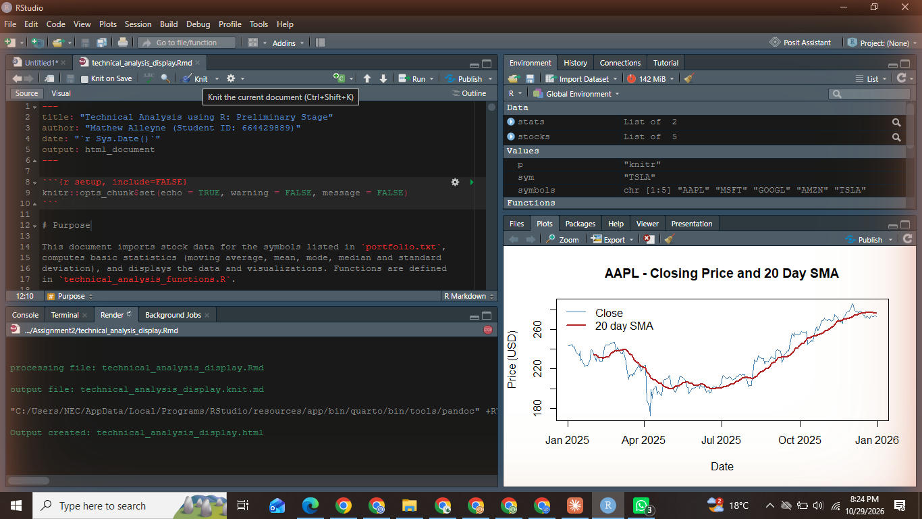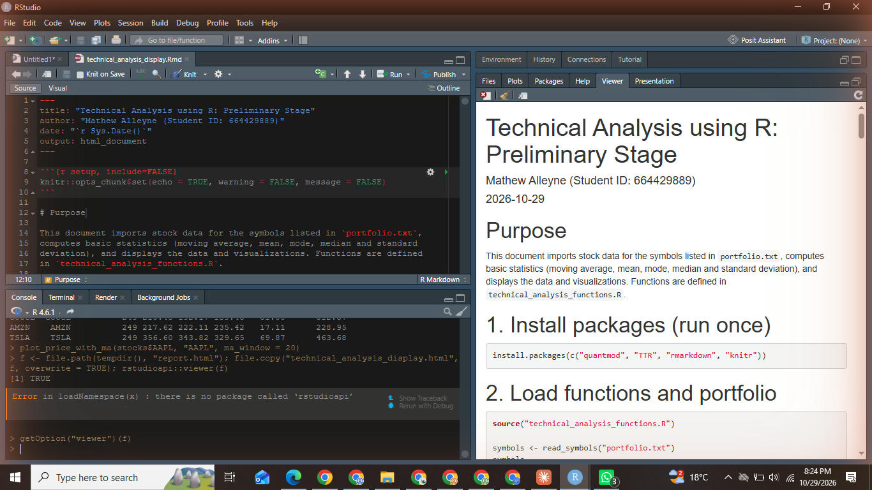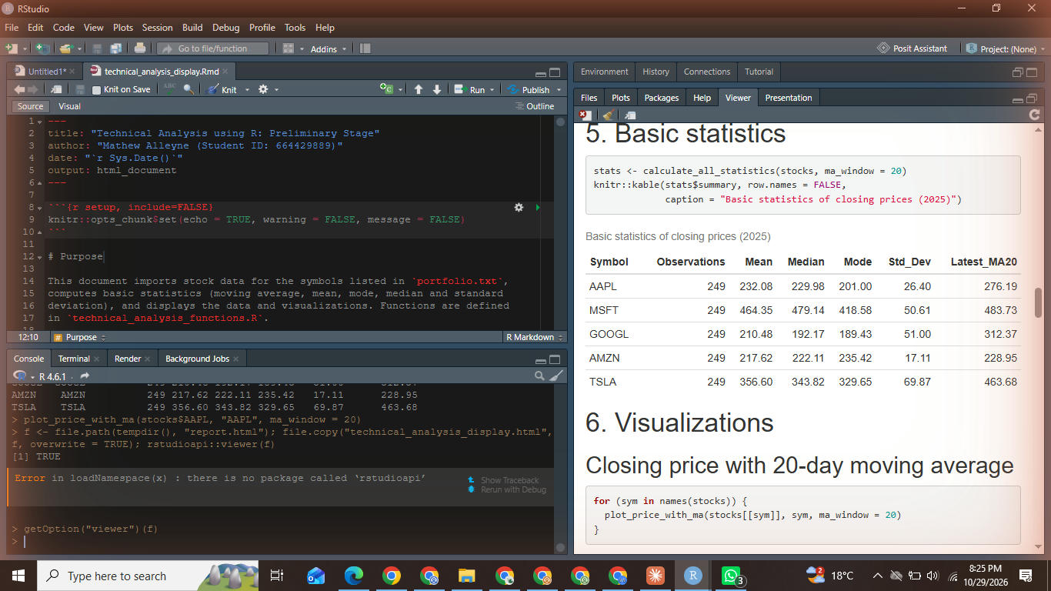

9. Uploading to GitHub
Upload portfolio.txt, technical_analysis_functions.R, technical_analysis_display.Rmd and this report into the Assignment2 folder of the TechnicalAnalysis repository, then share the repository link on the cover page.
Screenshot 9.1: the Assignment2 folder in the GitHub repository.
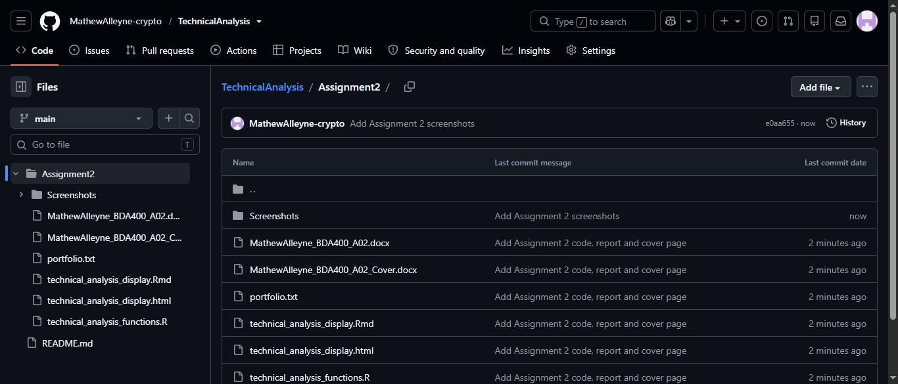

10. Verification
- Ran the .Rmd in RStudio and confirmed that all chunks execute and the plots render.
- Checked the mean, median and standard deviation for one stock against a spreadsheet calculation of the same closing prices.
- Confirmed the moving average starts at day 20 (earlier values are NA) as expected for a 20-day window.

11. Conclusion
The setup is complete: GitHub repository, R and RStudio, technical analysis packages, a portfolio file, and functions to import, analyse and display stock data. These functions will be extended in the next stages of the project.

