Femi, Dylan, Tam, Alyssa, Matthew

CMPT305- Demo 1

[Document subtitle]

Quick representation of the UI for our application

Otto Wallach Albrecht Kossel

 

Paul Heyse Johannes Diderik van der Walls

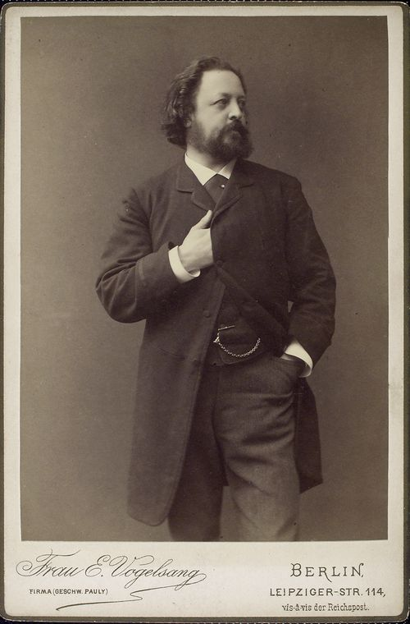 

Max von Laue Robert Barany

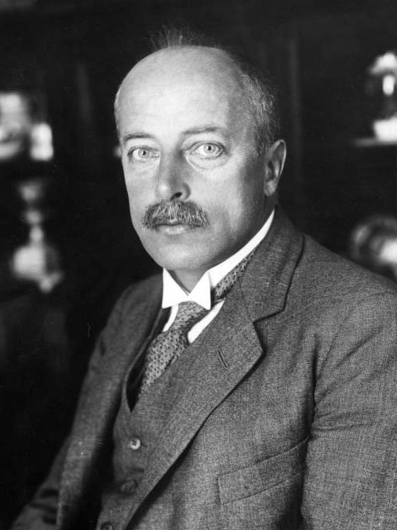 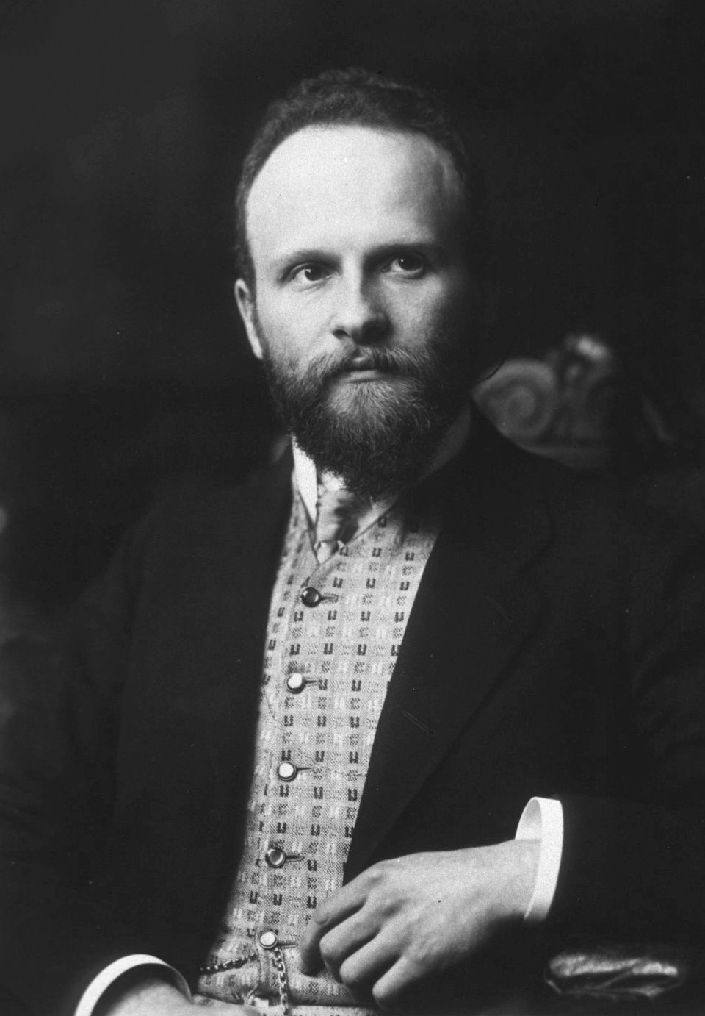

Theodore William Richards



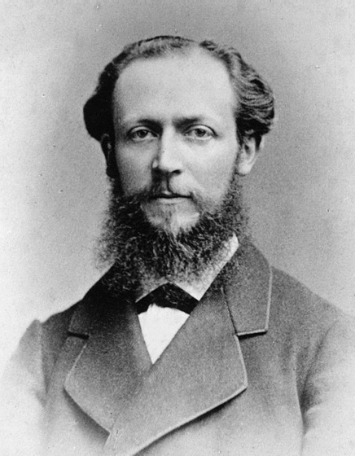

[This Photo](https://en.wikipedia.org/wiki/Otto_Wallach) by Unknown Author is licensed under [CC BY-SA](https://creativecommons.org/licenses/by-sa/3.0/)

Male

Female

v

v

v

v

v

v

v

v

v

v

v

v

v

v

v

v

1900s

1910s

1920s

1930s

1940s

1950s

1960s

1970s

1980s

1990s

2000s

2010s

Prize

v

v

v

Year

Affiliation

Country

Gender

**Nobel Prize Database**



[This Photo](https://en.wikipedia.org/wiki/Otto_Wallach) by Unknown Author is licensed under [CC BY-SA](https://creativecommons.org/licenses/by-sa/3.0/)