# Inspiration and High Level Design Choices

The game is aesthetically inspired by classic JRPG titles such as Final Fantasy and Crono Trigger.

The game features traditional turn based combat, akin to Final Fantasy, borrowing features from Bravely Default and Octopath Traveller. In these games, the player can store some form of resource that allows them to take more action in a single turn, or empower an action. This adds a significant amount if depth to a normally predictable combat system. This game does this with the **momentum** mechanic (name subject to change). This resource can be spent to add additional effects to abilities. An example is that the base healing spell many only provide a turn-for-turn regenerative effect, empowering the attack with **momentum** provides both the regen and a burst of healing, now acting as a traditional **Cure** spell.

This combat is contained within a Rogue-like framework, borrowing from games such as Darkest Dungeon and FTL. The player assembles a group of adventurers and sends them out to complete a **quest**. These **quests** can be travelling across a world map, or through a dungeon to complete an objective, but both function as a series of nodes connected with conceptual “hallways”.

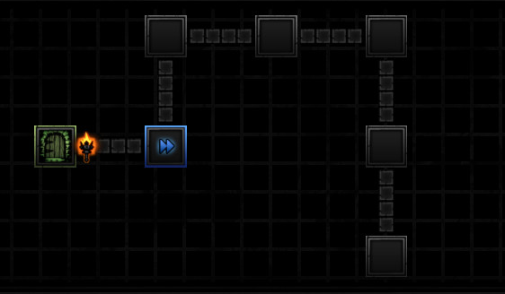

*Darkest Dungeon – Dungeon Navigation Screen*

Moving from one node to another happens automatically, with random events occurring during this travelling phase. The most notable of these is traditional RPG style random encounters.

Players traditional dread random encounters in RPG’s as they’re too repetitive or frequent. This is often because the encounters are too easy, and have no meaningful impact on how the player approaches their immediate objective. For example: mashing the attack button to end the fight as quickly as possible, immediately entering the menu and healing the party up to full HP and acting like nothing ever happened.

The aim of random encounters in this game is similar to that of Darkest Dungeon. They’re designed to wear the players party down, not just to provide a punching bag. Prior to travelling, the player is given an assessment of what dangers they are likely to face in between point A and B, and can make preparations based on that knowledge.

This leads into **Camping**! Camping is what occurs when a player has arrived at a Node, which is considered a safe-zone. From here, they can perform party management actions such as healing, cooking, re-equipping, and re-ordering their party. Similarly they also gain a view of the surrounding area: which nodes they can travel to next, and a risk assessment of travelling to that node. This risk assessment is based on the skills and traits of the party that they have brought with them. For example, a **Ranger** type class would provide insight into the potential number of encounters, and information about monsters that they may see on the way.

This introduces an element of **Party Balancing.** The player has to consider this before even setting out on the quest. Two distinct playstyles would be to disregard supportive abilities and go for high combat prowess and healing ability, and simply brute force your way through objectives. A smarter more measured approach would be to take less combat proficient characters with supportive skills that are used in the Overworld/Travelling screen, in order to mitigate risks and avoid combat. Examples of skills are Scouting, Cooking, Praying, Information Gathering (if in a town/village).

# Quests

A ‘Quest’ is dictated as an objective that the player must complete. They do this by assembling a party of adventurers to send out on the Quest. This party will be faced with many challenges on the way:

* Enemies to fight
* Environmental hazards
* Fatigue
* Navigation

At a high level, this section plays similar to the navigation sections of F.T.L. The player inhabits a node, and decides which node that they want to travel to.

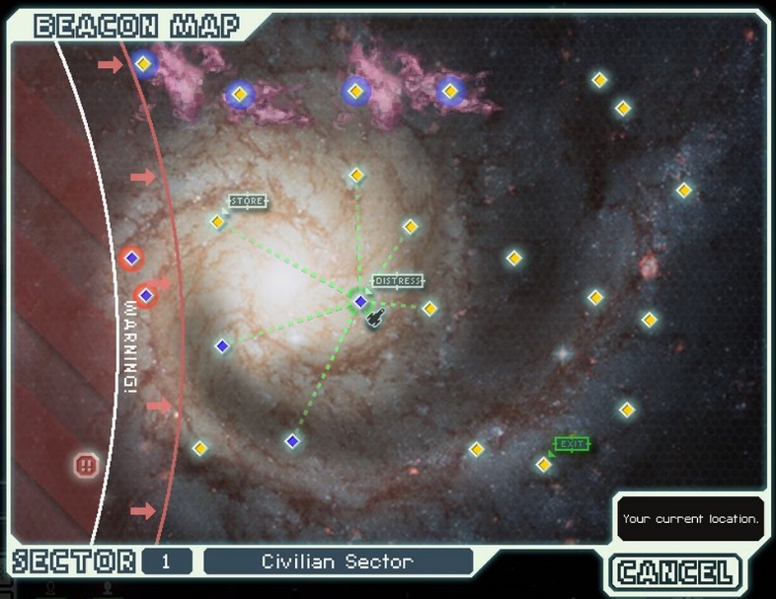

*F.T.L System Navigation Screen.*

## Quest Objectives

The following is a list of proposed functional objectives for the player. These may be presented in different contexts in order to simulate variety:

* Reach a target node.
* Discover an undisclosed node.
* Kill X of a certain enemy(s).
* Find X of a certain item(s).

### Player Motivation

Quests are a tertiary goal for the player designed to facilitate the growth of their party, and progression of their HQ. They facilitate the core gameplay of resource management, survival and turn-based combat.

We want the player to feel the push back of taking ‘the long route’ during a quest, heightening the risk and pushing their party to the limit.

Rewards for exploration should feel more valuable to the player than rewards for completing the quest. To that end, exploration-based rewards should not be truly random (such as item drops from enemies). Drop-rates will increase for each encounter that is finished, where an item of a Rare/Epic/Legendary was not dropped.

## Budget

Before embarking, the player must decide how much of a budget that the Party will have access to on their journey. The core of this is that without money, it is unlikely that the Party will be able to finish the mission, as they will wear down over time if they cannot replenish their supplies.

Current ideas for the budget are:

1. Gold-based Budget

A numeric value indicating the party’s funds. This exists in independent of the party’s inventory.

1. Inventory-based Budget

Gold takes up a physical space in the party’s inventory, with the amount of gold per inventory slot capped. The higher budget, the less inventory space the party has for other supplies.

Some skills/perks may increase the maximum amount of gold per stack. Pack-mule, Moneybags, etc.

## Overworld Phases

The Overworld/Quest sections are broken down into the following phases:

* Rest/Camping
* Travelling
* Pit-stop
* Combat

### Rest/Camping

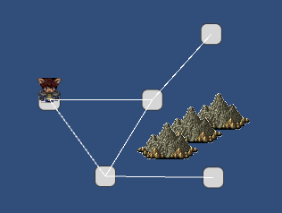 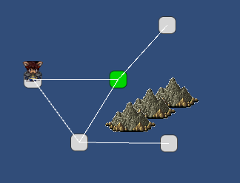

This phase takes place at the beginning of the quest, or when the player arrives at a new node.

This phase ends when the player has selected a destination node, and initiated the travel phase. (Clicking the big fat TRAVEL button!)

During this phase the player can do the following actions:

#### Cooking

Requires a party member to have the ‘Chef’ skill. With this skill, they can prepare a meal from a list of known recipes for the party to enjoy during their rest. The meals provide a variety of effects for the next leg of the journey:

* Restore HP and MP to the party
* Generate Momentum points to use on empowering abilities
* Buff the party
  + Elemental resistances
  + Base state increases
  + Provide temporary access to abilities to use in battle
* Travelling Buffs
  + Reduce/increase encounter rate
  + Faster travelling
  + Lures to attract certain enemy types

#### Resupply

Requires that the node contains a **Village**. The party can spend their **Budget** on additional supplies, equipment, or services that the **Village** may provide.

#### Use Class Skill

Some characters may have access to skills that can be used during the rest phase. These will usually provide additional information to the player that could influence their next travel destination, or whether additional preparations should be made.

* Scout

Provides additional information about the monsters that might be encountered on the route. The monsters levels, elemental weaknesses, item drops can be discovered.

* Orienteer

The character maps out the landscape ahead and provides information about the environment. This allows the player to know in advance if there are any **environmental hazards** that could impact them, and allow for necessary preparations!

* Scavenge

Choose a route. The acting character investigates safely investigates that route alone, discovering any treasure along that path. Useful for when the player plans to head in the opposite direction, but doesn’t want to lose out on loot!

*Can be used in Town rest areas only:*

* Perform

Play a music or regale with a story; performing for the locals can provide the party with additional gold which is added to their Budget. Useful if the party is short on cash.

* Gather Information

Talk with the locals to gather information about the surrounding area. Reveals unknown quest locations, discovers side-quests, reveals recruitable character locations, discovers specific monster locations.

### Travelling

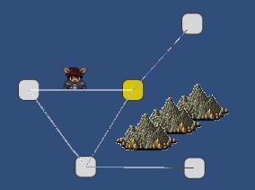

The travelling phase is when a player is moving from their current Rest Node to a target node. No journey is without danger and hardship, and so the player is expected to make necessary preparations before setting off.

#### Phase Objective

The player must reach the destination node with at least member of the party not KO’d. If all four party members are wiped out during a fight, it is assumed that the two *reserve* members negotiate their retreat back to the previous Rest node.

Failing a travelling phase inflicts one **Strike** on the party. Generating three **Strikes** results in failure of the overall quest.

Standard random encounters do not yield any rewards for the player, and as such they would seek to minimise the possible number they may encounter during that leg of the journey. Trying to keep the travel time as low as possible is the main objective.

#### Travel Events

While travelling, there is a chance of the player encountering events. These events can be Passive, or Active.

* *Passive*

An event that occurs ‘in the background’ and does not interrupt the process. The player receives a notification that something has occurred, and may choose to respond if they wish. These are usually inconsequential

* *Active*

The player character token stops at its current position and the user is presented with a prompt requiring input. This is usually a decision that the player has to make. Such encounters include coming across a merchant, whose wares you can browse; or a make-shift toll gate set up by bandits – do you pay, negotiate, or fight?

#### Environmental Events

The player’s party has encountered some sort of environmental hazard or shortcut that affects their progress. These can be scouted in advance, which means that the player might be able to make preparations to deter the effects. For example, a player could equip their characters with Mud Boots to negate the effects of a swamp, which would otherwise increase the amount of time spent travelling.

#### How the Player Can Affect Travelling

Adventurer skills, equipment, magic and rest-zone preparations can affect the base total travel time.

* Adventurer ‘Speed’ Stat

The total of the party’s ‘Speed’ stat provides a modifier to the travel time.

* Adventurer Traits

Certain traits are designed to increase how quickly the party travels. These traits can be natural, or achieved through certain equipment.

* Cooking

Certain meals provide the party with just the boost they need for a swift journey!

* Knowledge of Area

Obtained through the ‘information gathering’ and ‘scouting’ actions.

## Pit-stop

A pit-stop is when the party is in the travelling phase, but has stopped for a break. These are not substantial breaks, and don’t provide the party with a suitable rest. It’s more to allow minor reconfigurations, using items after fights, etc.