Notation

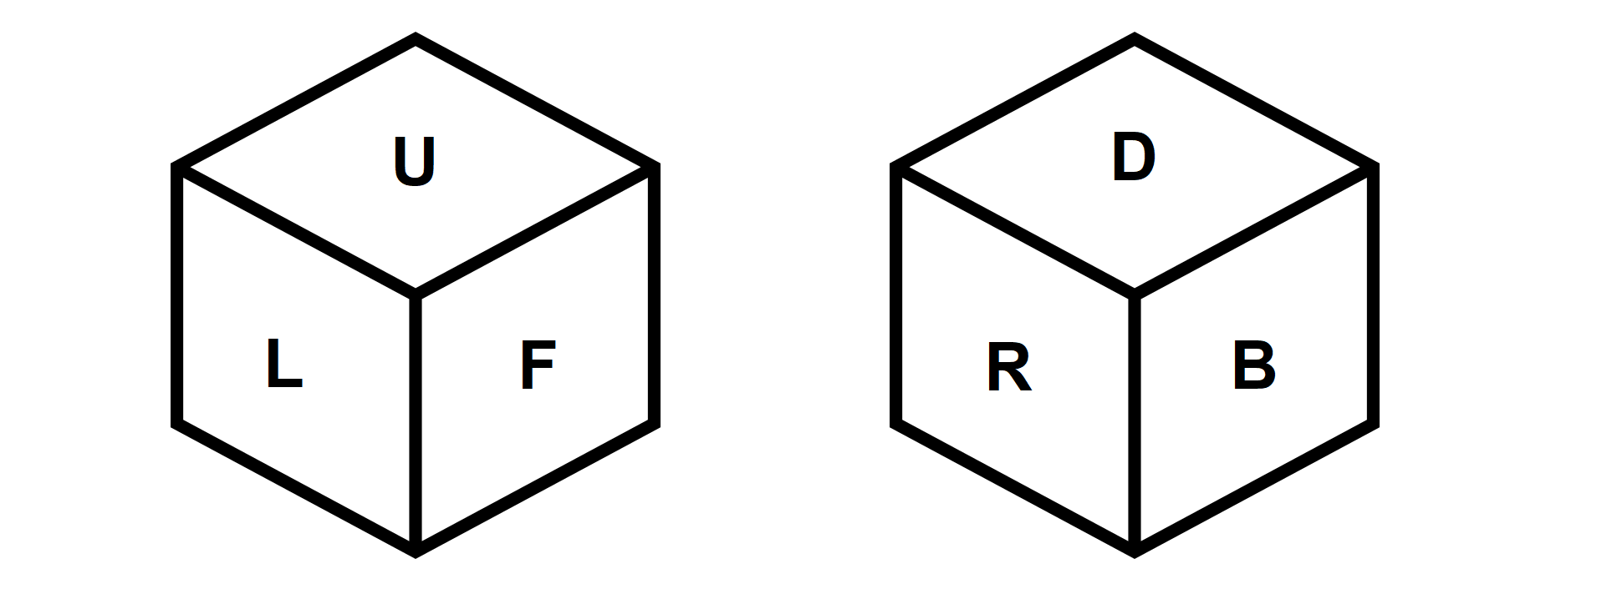

U – up

D – down

L – left

R – right

F – face

B – back

I – inverted

Standard notation for Rubik’s cubes apply here

F rotates the face clockwise

FI rotates the face anticlockwise

and so on

TL (turn left) turns the cube such that F becomes L

TR (turn right) turns the cube such that F becomes R

RF (roll forward) turns the cube such that F becomes D

RB (roll back) turns the cube such that F becomes U