CO2

1. Program to Sort strings.

package sort;

import java.util.*;
public class sort {
public static void main(String[] args) {
int n;
Scanner s=new Scanner(System.in);
System.out.println("Enter the limit: ");
n=s.nextInt();

String[] ar=new String[n];
System.out.println("Enter the strings:");
for(int i=0;i<n;i++)
{
ar[i]=s.next();
}
System.out.println("\nBefore sorting the Strings are:");
for(int i=0;i<n;i++)
{
System.out.println(ar[i]);
}

String temp;
for(int i=0;i<n;i++)
{
for(int j=i+1;j<n;j++)
{
if (ar[i].compareTo(ar[j]) > 0)
{
temp = ar[i];
ar[i] = ar[j];
ar[j] = temp;
}
}
}

System.out.println("\nAfter sorting the Strings are:");
for(int i=0;i<n;i++)
{
System.out.println(ar[i]);
}
}
}

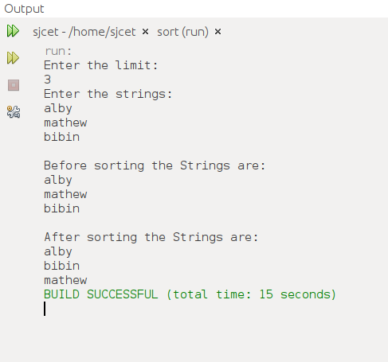
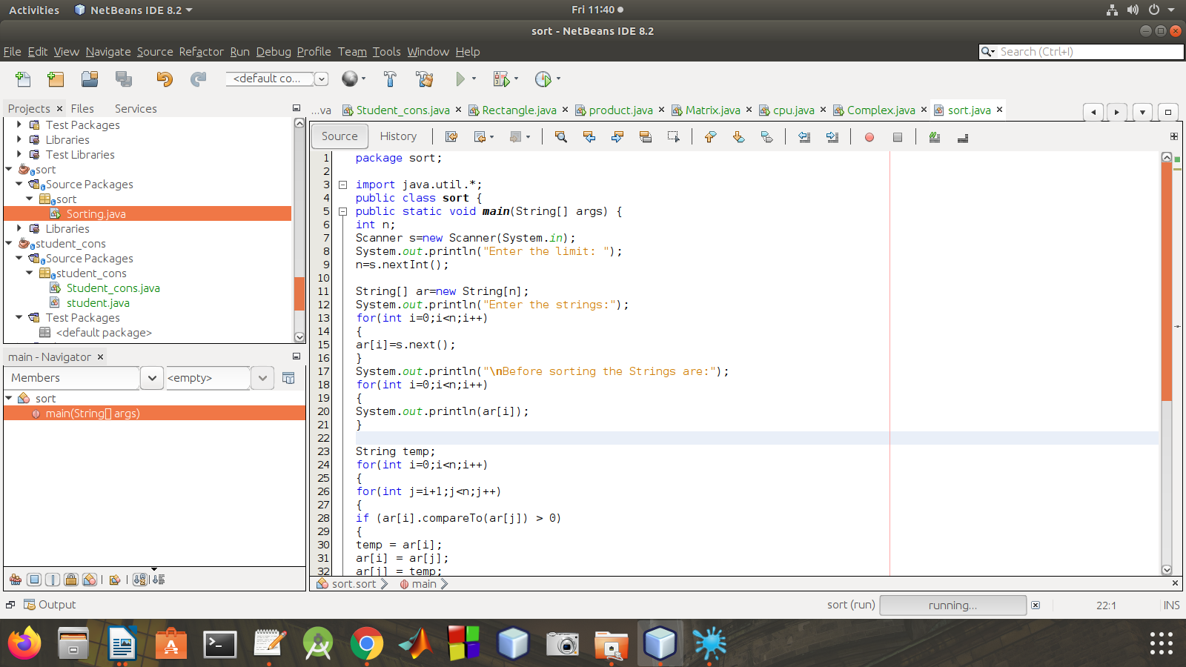

2.Perform string manipulations

package manp;

import java.util.Scanner;
public class manp {
String str1,str2;
manp(String s1,String s2){
str1=s1;
str2=s2;
}
public void strLen(){
System.out.println("\n The length of string-1 :"+str1.length());
System.out.println("\n The length of string-2 :"+str2.length());

}
public void strConcat(){
System.out.println("\n Concatenated String-1 and String-2:"+(str1.concat(str2)));
}
public void compare(){
System.out.println("\n Compare String-1 and String-2 "+(str1.equals(str2)));
}
public void LowerCase(){
System.out.println("\n lowercase of String-1 "+(str1.toLowerCase()));
}
public void UpperCase(){

System.out.println("\n uppercase of String-1 "+(str2.toUpperCase()));
}

public static void main(String[] args) {
String s1,s2;
Scanner sc =new Scanner(System.in);
System.out.println("Enter the String-1");
s1=sc.nextLine();
System.out.println("Enter the String-2");
s2=sc.nextLine();
manp s=new manp(s1,s2);
s.strLen();
s.strConcat();
s.compare();
s.LowerCase();
s.UpperCase();

}
}

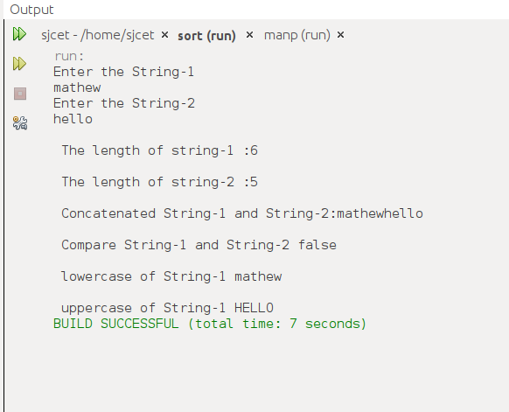
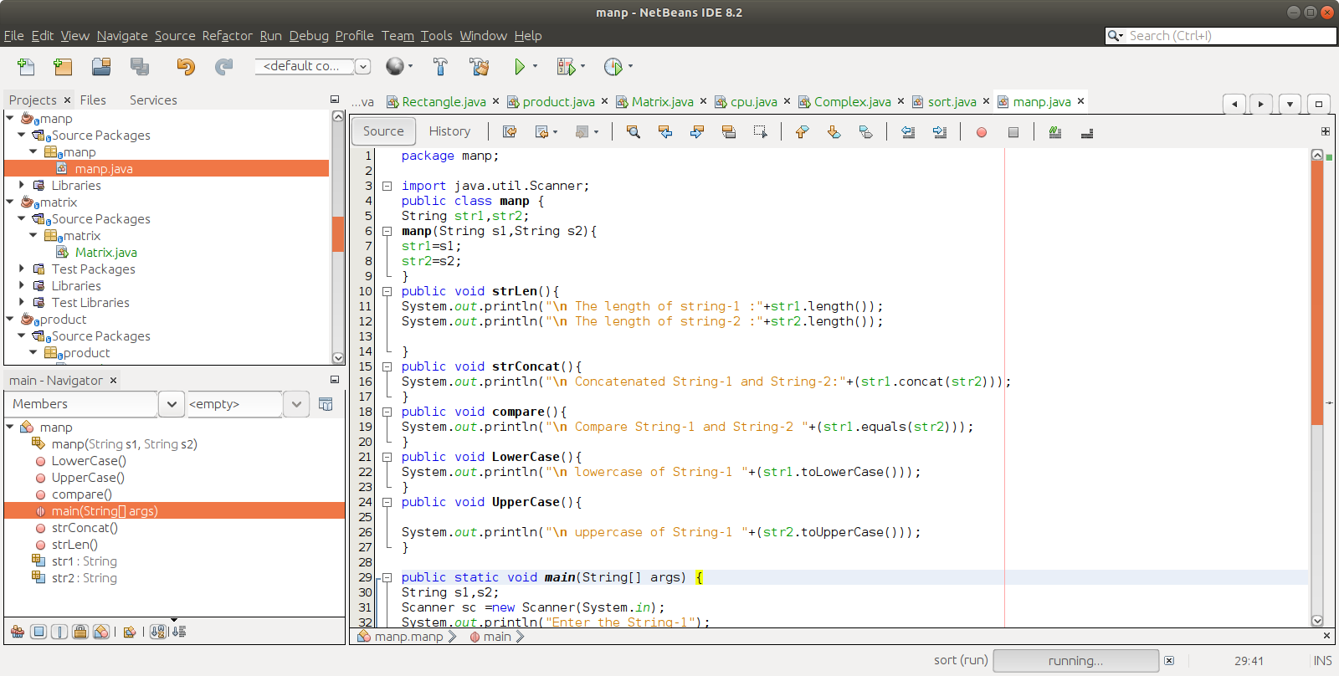

3.Program to create a class for Employee having attributes eNo, eName eSalary. Read employ information and Search for an employee given eNo, using the concept ofArray ofObjects.

package emp;
import java.util.Scanner;
class Emp
{
int id;
String name;
float salary;
public static void main(String args[])

{
Scanner sc = new Scanner(System.in);
System.out.print("Enter the number of employees");
int n = sc.nextInt();
Emp emp[] = new Emp[n];
for (int i = 0; i < n; i++) {
emp[i] = new Emp();
System.out.println("Enter details of employee " + (i + 1)
);
System.out.print("Enter employee id :");
emp[i].id = sc.nextInt();
System.out.print("Enter employee name :");
emp[i].name = sc.next();
System.out.print("Enter employee salary :");
emp[i].salary = sc.nextFloat();
}
System.out.println("\n\n********* All Employee Details are:*********\n");
for (int i = 0; i < n; i++) {
System.out.print("\nEmployee Id :" + emp[0].id );
System.out.print("\nEmployee Name :" + emp[i].name );
System.out.print("\nEmployee Salary :" + emp[i].salary );
}
}
}

