43008: Reinforcement Learning
Assignent-3, Part-E Project Report

Project Title: Train Schedule Optimisation under Disruptions

Team Name and Project Number: RailTech (Project #27)
Team Members: Daniel James Martirosov(24948933), Ziheng Deng (25595315), Laurean Lim (25049863)
Date: 26 October 2026

Table of Contents
Abstract 3
1. Introduction and Background 4
2. Overview of the architecture/system 7
3. Results and Evaluation 12
4. Discussion and Conclusions 20
5. References 21
Appendices 22

Abstract
<Add a short abstract...no more than 10 lines!>

1. Introduction and Background

1.1 The problem you tried to solve
Railway scheduling involves coordinating multiple trains across shared infrastructure, including tracks, junctions and crossovers, while maintaining safe and reliable operations (Li et al., 2021). As railway infrastructure has limited capacity, delays affecting individual services can lead to conflicts in train schedules and propagate across interconnected railway networks, creating significant challenges for railway planners and train controllers (Li et al., 2021). These disruptions can result from various unpredictable factors, including equipment failures, signalling faults, fluctuations in passenger demand and adverse weather conditions (Li et al., 2021). The impact of these challenges remain evident in Sydney's railway network, where suburban train punctuality averaged 87.5% in 2024–25, falling below the established 92% target (Sydney Trains, 2025). Recent incidents also highlight the network’s susceptibility to operational disruptions. In June 2024, a signalling at Harris Park resulted in delays that exceeded one hour (Roberts, 2024), while an overhead wiring failure near Strathfield in May 2025 disrupted train services for more than 24 hours (Gorrey et al., 2025).
Managing train movements under these conditions presents a complex real-time scheduling problem, particularly when multiple services must share limited track capacity. Train controllers must consider infrastructure availability, potential conflicts between train movements and the potential for decisions to generate further delays (Zhu & Goverde, 2019). In response to these challenges, this project explores the application of reinforcement learning to railway scheduling and rerouting. Using simulated railway environments, the study examines how different reinforcement learning strategies coordinate train movements and respond to both normal operating conditions and unexpected disruptions.

1.2 Motivation
Improving railway scheduling is essential for maintaining reliable passenger services and ensuring the efficient utilisation of existing railway infrastructure (Šemrov et al., 2016; Zhu & Goverde, 2019). Delays and disruptions can negatively affect passenger journeys, increase travel-time uncertainty and reduce overall efficiency of railway networks, particularly in interconnected metropolitan railway systems (Li et al., 2021). Given the capacity constraints of railway infrastructure, the development of reliable timetables alone may not be sufficient to address unexpected disruptions (Li et al., 2021). Effective scheduling and rerouting strategies are therefore necessary to strengthen operational resilience, minimise delay propagation and maintain service continuity (Zhu & Goverde, 2019). Exploring alternative methods of coordinating train movements may provide insights into improving railway operations without necessarily requiring additional infrastructure investment (Šemrov et al., 2016).
Reinforcement learning (RL) presents a promising approach to this problem because railway scheduling involves sequential decision-making in dynamic and often unpredictable operating conditions (Šemrov et al., 2016). Unlike approaches that rely exclusively on predefined decision rules, RL agents can learn strategies through interactions with an environment and feedback from their actions (Sutton & Barto, 2018). This learning process makes RL a potential solution for railway scheduling, where train movements must be continually adjusted in response to changing network conditions and emerging conflicts.
Furthermore, simulation provides a controlled and repeatable environment in which scheduling strategies can be investigated without interfering with live railway operations. By modelling different railway layouts and disruption scenarios, scheduling strategies can be evaluated under consistent conditions, allowing their relative strengths and limitations to be examined before considering potential real-world applications. Therefore, to explore this potential, the project uses the Flatland railway simulation environment to model train scheduling and rerouting across selected Sydney railway corridors (Mohanty et al., 2020). Three RL algorithms—Proximal Policy Optimisation (PPO), Advantage Actor-Critic (A2C) and Deep Q-Network (DQN)— are evaluated under both normal and disrupted operating conditions to compare their relative performance in coordinating train movements.

1.3 Application
The primary application of this project is an RL-based train scheduling and rerouting system developed within the Flatland simulation environment. Using simplified representations of selected Sydney railway corridors, the system enables different reinforcement learning algorithms to be evaluated under normal and disrupted operating conditions. Through simulated train movements and comparative performance results, the system aims to identify the relative strengths and limitations of different scheduling strategies in managing delays, congestion and successful train arrivals. The results may offer valuable insights for researchers, developers and railway planners exploring adaptive railway traffic management and decision-support systems. However, the system is evaluated entirely through simulation and is not intended for direct deployment on operational railway networks.

1.4 Dataset/Environment
Flatland is a multi-agent railway simulation environment designed to investigate train coordination and decision-making problems (Mohanty et al., 2020). In this environment, individual trains are represented as agents navigating a grid-based railway network consisting of interconnected tracks, switches and designated destinations (Mohanty et al., 2020). Agents must coordinate their movements while accounting for shared infrastructure and potential conflicts with other trains (Mohanty et al., 2020). The environment also supports simulated malfunctions and disruptions, enabling the evaluation of scheduling and rerouting strategies under varying operating conditions (Mohanty et al., 2020).
For this project, two railway scenarios were developed to represent selected sections of Sydney's metropolitan railway network: the Central–Strathfield corridor (Scenario 1) and the Granville–Harris Park corridor (Scenario 2). Each scenario incorporates railway track layouts and timetable information to model train routes and movements within the simulation environment. Both normal operating conditions and delayed scenarios are considered to investigate how different scheduling approaches respond to disruptions. Figures 1 and 2 illustrate the simulated railway environments used in the project.

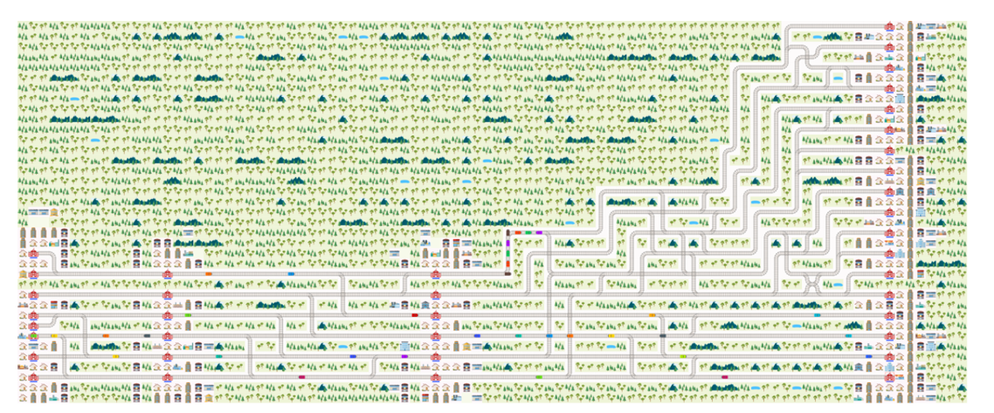

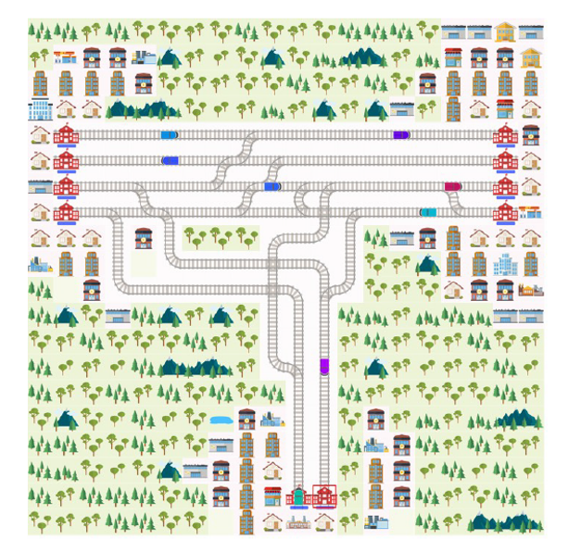
Figure 1: Flatland implementation of the Central-Strathfield corridor (Scenario 1)

Figure 2: Flatland implementation of the
Granville–Harris Park corridor (Scenario 2).

2. Overview of the architecture/system
The system is a simulation-based reinforcement-learning pipeline rather than a deployed control system. It has four layers. A fixed data layer holds the two Flatland levels and their timetables, extracted once from the Transport for NSW GTFS feed and shipped with the code, so that every reported number is measured against exactly the same inputs. An environment layer turns a level into a multi-agent Markov decision process: it builds the scenario, installs the disruption regime, defines the observation, the action space and the reward, and wraps the result for vectorised training. A learning layer trains one policy that is shared by every train with PPO, A2C or DQN. An evaluation layer scores each policy with the assessment metric on held-out seeds and writes the evidence files used in Section 3. The notebook train_schedule_optimisation.ipynb is the deliverable and the reference implementation for all four layers; the command-line trainers reach the same environment by executing its cells (nb_harness), so the scenario, observation, regime and reward cannot drift between the notebook and the reported runs, while the paired evaluation behind Section 3 is scripts/eval_pair.py. Figure 3 shows the end-to-end workflow and Figure 4 the module layout.

2.1 Flow Diagram and Workflow
The workflow runs in six stages, each with a defined input and output.
Stage 1: Service extraction and pre-processing. The GTFS static feed (1.47 GB of trips, stop_times and shapes) is filtered to Thursday 15 October 2026 and to the 16:00–19:00 peak. Each service becomes a sequence of scheduled stops, and for the junction a traversal test on the published shape geometry (nearest approach within 250 m) decides which services actually use the Y-link.
Stage 2: Scenario construction. Two Flatland levels and two timetables are written: the four-track corridor (87 × 8, 52 movements) and the Y-link junction (20 × 20, 126 movements). Arrival deadlines are calibrated against a reference rollout and the episode budget is derived from the last scheduled arrival.
Stage 3: MDP construction. The level, the timetable and the disruption regime form the multi-agent MDP. Each train observes a 1030-dimensional vector (a depth-3 tree with a 50-cell radius plus ten conflict features), chooses one of five rail actions, and is rewarded with the assessment metric paid densely as a potential difference.
Stage 4: Vectorisation and training. Two environment copies for PPO (one for A2C and DQN), one sub-environment per agent, shared policy parameters. All three algorithms act per train: SuperSuit gives the vectorised environment the action space of a single agent, so every arm sees Discrete(5) per slot - PPO over two copies of the fleet (104 slots on the 52-train corridor, 252 on the 126-agent junction), A2C and DQN over one (52 and 126 respectively). PPO runs for 3 M summed environment steps on the corridor and 2 M on the junction; A2C and DQN for 1.5 M agent steps.
Stage 5: Checkpoint selection. Every 250 k steps on the corridor and every 200 k on the junction, the policy is evaluated on four unseen seeds and a checkpoint is kept when it improves on the lexicographic key (completion, score). Completion ranks first because the metric can otherwise be improved by parking the fleet.
Stage 6: Paired evaluation and reporting. Each arm and the baseline run on the same 30 held-out seeds (3000–3029), with the score, total lateness, on-time share and completion rate reported and a two-sided exact sign test on the per-seed differences.
The dashed arrow in Figure 3 is deliberate: every change to the observation, reward or disruption regime was re-evaluated on the same protocol before it was adopted, and Section 3.1 reports the settings that survived those iterations.
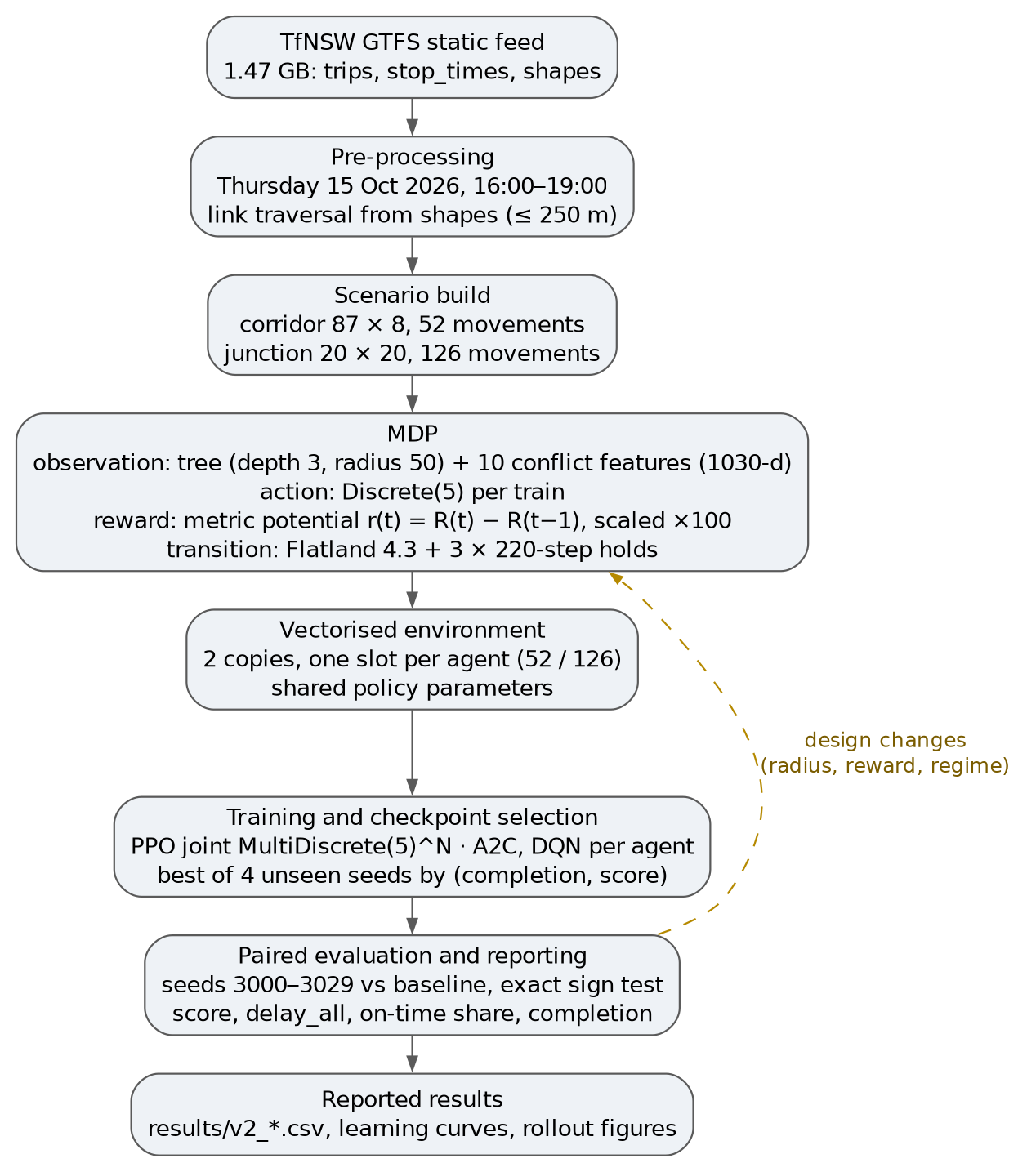
Figure 3: End-to-end workflow of the system. Each stage consumes the artefact produced by the previous one; the dashed edge shows the design loop in which changes to the MDP were re-tested through the same evaluation protocol. The training box shows the wiring and reward scaling as first implemented; the reported arms act per train with per-agent Discrete(5) slots and divide the reward by 100 (§2.2). The results box names results/v2_*.csv; the corridor DQN row comes from results/v3_dqn_compact.csv (Section 3.3).

2.2 System Architecture Design
The notebook is both the deliverable and the assembly point. It installs the dependencies, defines the two scenarios, trains (or replays) the three algorithms and prints the evaluation tables; with the FULL_RUN flag off it prints the recorded results instead of retraining, so it executes end to end in a few minutes while still exercising the real environment code.
The shared modules in scripts/ carry the logic that must not be re-implemented: the notebook imports them instead of duplicating them, and the command-line trainers reach the same environment through nb_harness, so the code that trains, the code that evaluates and the report cannot drift apart. The module map is below.
Module | Responsibility | Used by
nb_harness | Executes the notebook's own cells into a namespace, so the CLI trainers see exactly the environment class the report describes | train_ppo, eval_pair, train_algo, diag
s2_env | Assembles Scenario 2 at runtime from the Scenario2 notebook (its .mpk carries no agents) | CLI trainers, notebook
regimes | One disruption regime per scenario, shared by training, evaluation and the notebook | train_ppo, eval_pair, train_algo, notebook
disruptions | Zone-driven incident placement with fixed-length holds, direction-balanced per episode | regimes
metric_rewards | The assessment metric re-expressed as a per-step potential, with optional shaping | train_ppo, train_algo
priority_obs | The ten conflict features appended to the tree observation | every training and evaluation path
hinted_obs | One-hot advice from the distance-map controller (--hint arm) | optional arm
masking | Action-mask wrapper for MaskablePPO around supersuit's ConcatVecEnv (--mask arm) | optional arm
progress_rewards | Competition progress objective (--reward progress arm) | optional arm
train_ppo | PPO over the 104-slot Discrete(5) vector env, dense reward, evaluator and checkpoint selection | CLI, notebook
train_algo | A2C and DQN on the per-agent Discrete(5) wiring | CLI
eval_pair | Paired seeds and the two-sided exact sign test | CLI
diag_action_collapse | Action-distribution diagnostic that separates a collapsed policy from an unlearned one | CLI
verify_rewards | Per-agent and per-term identity check between the metric and the potential | CLI
The learning layer uses one shared multi-layer perceptron for all trains: 1030 inputs, one head per action, and two hidden layers (256 units for PPO, 128 for A2C and DQN, Table 2). All three arms act per train: SuperSuit's MarkovVectorEnv takes its action space from a single agent, so the vectorised environment is Discrete(5) over agent slots - 104 for PPO and 52 for A2C and DQN on the corridor, 252 and 126 on the junction. The only wiring difference between the arms is the copy count. At a scheduled stop the environment enforces the dwell and replaces the chosen action with STOP_MOVING for the booked dwell, so the policy is consulted only where a real decision exists; this is part of the transition model, not post-processing. The reward is the metric potential plus an arrival bonus of 50 and a stuck penalty of 1, divided by 100 - a constant divisor, so the optimal policy is unchanged and the value targets stay of order one - during training, while every reported score is computed by the environment's own metric, never by the training reward.
Four design experiments fixed this architecture before the reported matrix was run. First, the reward form: the library's terminal reward pays almost everything at the terminal step of an episode of up to 999 steps, so the signal arrives with only 37 % of its weight at a discount of 0.999 and 0.004 % at 0.99, so the metric was re-expressed as a potential and verified to reproduce the original total per agent and per term. Second, the observation radius: the default radius of 2 binarises every distance feature in the tree block (three distinct values), whereas radius 50 keeps the ordinal cell distance (tens of levels), so a train can tell a blocked cell three cells away from one forty cells away, which is what allows a train to see a blocked cell far enough ahead to react. Third, disruption placement: a reactive rule that waited for a chosen train to dwell at a platform fired between zero and one of three incidents, silently turning the delayed evaluation into a normal one, whereas the zone-driven band and a fixed 220-step hold fire all three incidents on every seed tested, for any policy that dispatches (a fleet that never departs never reaches the band, which is the confound discussed in Section 3.3). Fourth, the copy count: PPO trains on two copies of the fleet and A2C/DQN on one, which is the only wiring difference between the arms; the scenario, regime, observation and reward are identical.
The final architecture is therefore: Flatland 4.3.0 as the simulator, a 1030-dimensional tree-plus-conflict observation, five rail actions per train, the assessment metric as a dense reward, a shared perceptron (256–256 for PPO, 128–128 for A2C and DQN), PPO over two copies of the fleet and A2C/DQN over one, evaluated by paired 30-seed runs against a schedule-following baseline.
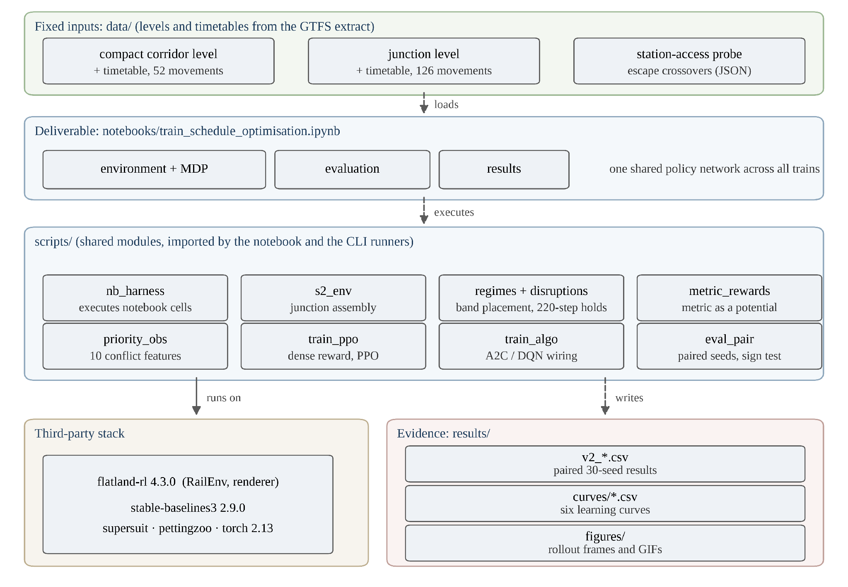

Figure 4: System architecture. The notebook is the single entry point; the shared modules hold the scenario, dynamics, representation, learning and evaluation logic; the third-party stack supplies the simulator and the algorithms; results/ holds the evidence quoted in Section 3. The stack box lists the development versions; the versions behind the reported numbers are given in Section 3.1.

2.3 GUI/Environment Design
Flatland's own renderer is the interface. The assessment permits a renderer in place of a separate GUI, and using it has a practical advantage: every frame is produced from the same level files and environment class that are trained and evaluated, so the figures cannot show a different map from the one the numbers describe. The renderer has two backends: an interactive window used for live demonstration, and a headless PIL/SVG backend that produces every still and animated rollout in this report. The animated policy rollouts ship in results/figures/ and are regenerated by scripts/render_policy_gif.py; the disruption stills come from the same backend but were rendered with the delay-rendering script used during development, which is not shipped, so those stills are reproducible in method rather than by a single command. The interactive window shows the same scene and component set but is not used for any figure.
The renderer shows the rail grid with its switches and crossovers, one coloured marker per train (each agent has its own colour), station buildings on the platform columns, the target marker of each train, and a black cross over any train held by an injected failure. One simulation step corresponds to 20 seconds of the timetable, which is why a 220-step hold models roughly an hour of single-track blockage.
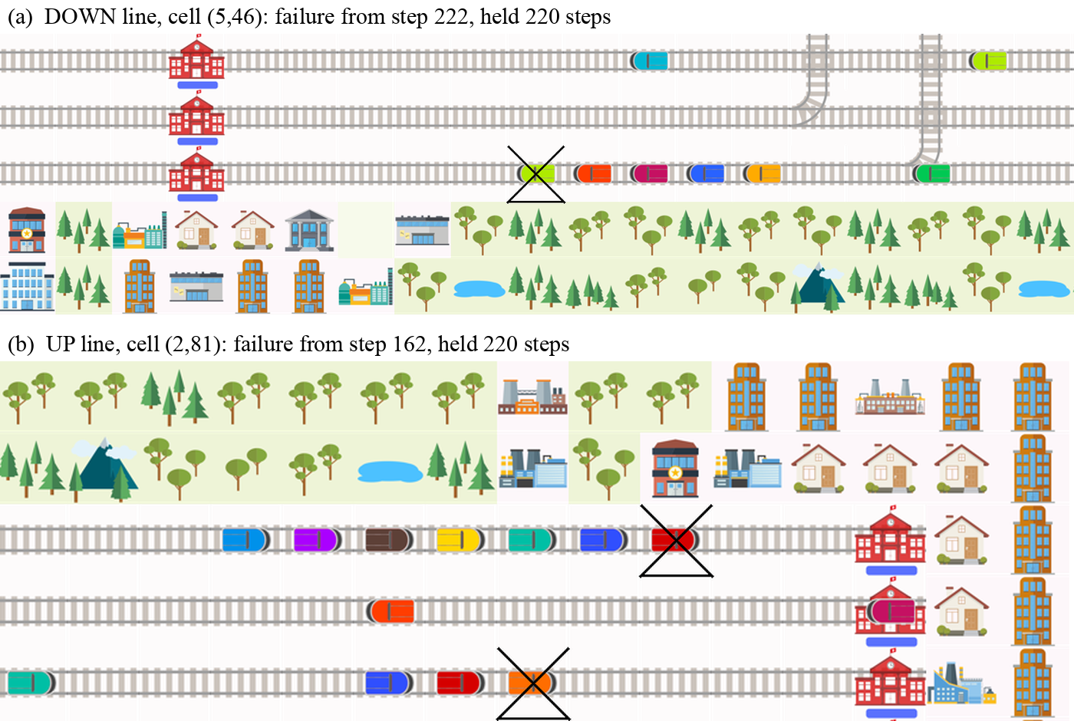
Figure 5: The corridor under the disruption regime, zoomed on two of the three incidents of one episode. The black cross marks the train held by the injected failure and the trains behind it are queued. The two panels are the two directions of travel, which is what the direction-balanced placement is meant to produce.
Figure 5 is the view that matters for the delayed condition: a single held train removes a track for 220 steps, and the queue behind it is what the policy has to manage. Figure 6 shows the same mechanism on the junction, where the queue is far longer because the branch converges onto two tracks.
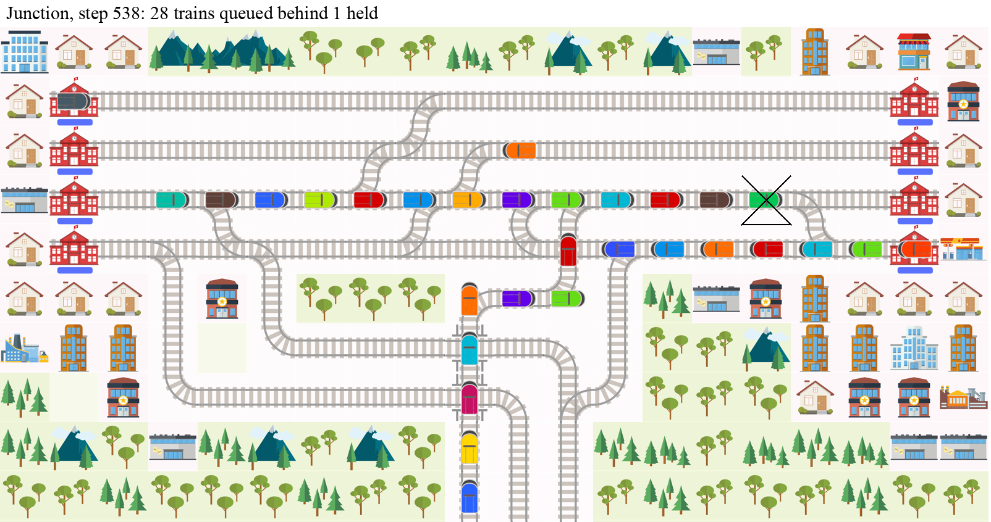
Figure 6: The junction at step 538 of a scripted rollout: one train held at cell (6, 14) and 28 trains queued behind it along the suburban pair and down the branch. The junction concentrates delay far more than the corridor does.
Because the corridor is 87 cells wide and 8 deep, a full-map still is a strip, so Figures 5 and 6 are zoomed in-episode renders from the same backend: Figure 5 crops the failure and its queue at the step the incident fired, and Figure 6 the junction at step 538, so neither is a crop of the initial-state renders in Figures 1 and 2. Every still is produced from the same backend at a fixed seed.

3. Results and Evaluation
This section reports the delayed condition, which is the only condition with headroom. On both maps the baseline is already at the ceiling under normal operations (the notebook records -0.0006 on its seed, i.e. zero at the reported precision, with completion 1.000), because the calibrated deadlines are reachable without any disruption; the disrupted condition is where a policy can differ. Every number below is a paired test on 30 held-out seeds that were not used for training or for checkpoint selection.

3.1 Experimental Settings
Two scenarios are used (Table 1). The corridor carries 52 scheduled movements on four adjacent through tracks between Strathfield and Central, with stops at Strathfield, Burwood, Redfern and Central; the junction carries 126 movements across the three links it models (58 on the main pair, 54 on the suburban pair, 14 through the Y-link itself), with no intermediate stops, so it is a pure arbitration problem. One step is 20 seconds of timetable time. The corridor budget is 999 steps, and every train has arrived by step 796; the junction budget is 757, which the scripted baseline reaches at step 715. The metric normalises by the budget, not by the arrival step.
The score is the assessment metric normalised to [−1, 0]: for each train the metric cost is capped at one episode length, summed over trains and divided by (episode length × number of trains), so 0 means every train arrived on time and −1 means every train was charged the maximum. Three secondary measures are reported beside it: delay_all (the sum over every train of actual minus scheduled arrival, charging trains that never arrive up to the end of the episode), the on-time share (trains arriving no later than scheduled) and the completion rate.
Disruptions are deterministic and identical in kind on both maps: three failures per episode, each a fixed 220-step hold. On the corridor the failures are placed in the band strictly between a stop's escape crossover and its platform, so a train upstream of the crossover can still change track, and never on the crossover itself or at a station. On the junction they are placed mid-block in a six-cell band on the third track row. Which cells host the failures is drawn from the episode seed: on the corridor the draw is balanced across directions, while the junction band occupies a single block of row 6 and is therefore not direction-balanced. The seed still changes the episode on both maps. The 220-step hold is a calibrated choice: at 300 steps and above the junction deadlocks and completion falls to about 0.65, which would score cancellations instead of delay, while shorter holds can be absorbed inside the schedule slack and produce a seed with no delay at all.
The baseline is a schedule-following controller, not a learned policy. On the corridor it is the forward-only reflex (always move forward), which is exactly optimal on one-way through tracks and is what the trained policies have to beat. On the junction it is the scripted route follower that reads the turn sequence out of the timetable, because a forward-only policy cannot take the Y-link or branch turns at all and completes only 71 of 126 trains even without disruptions.
All arms are evaluated with deterministic actions on seeds 3000–3029. Because the baseline and the arm see the same episode, the comparison is paired per seed, and a two-sided exact binomial sign test is applied to the signs of the 30 differences; ties are dropped. The shipped files carry one caveat: the first version of the disruption regime accumulated a firing history across episodes, so an episode could depend on the episodes before it in the same process. The forward-only baseline consequently differs between the two arm files that back the corridor rows on 14 of the 30 seeds (by up to 0.02 in score on seed 3003, and by at most 0.005 on the rest), which moves the paired mean by about 0.0005. The regime now clears that state on every reset, and the means quoted here are the ones the shipped files contain. The software is Flatland 4.3.0 with Stable-Baselines3 2.9.0 on PyTorch 2.14.1, Python 3.11.17. Training ran on the CPU of the RTX 3080 host (Stable-Baselines3 2.9 is configured with device=cpu, so the GPU itself was not used); the 3 M-step PPO corridor arm takes about 35 minutes and the 1.5 M-step A2C and DQN arms are of the same order.
Table 1: Experimental settings. Both maps use the same observation, action space, regime length and evaluation protocol.
 | Corridor (Scenario 1) | Junction (Scenario 2)
Grid / tracks | 87 × 8, four through tracks | 20 × 20, Y-link and branch
Scheduled movements | 52 | 126
Episode budget | 999 steps of 20 s (all trains done by 796) | 757 steps of 20 s
Observation | 1030 = tree (depth 3, radius 50) + 10 features | same
Actions | Discrete(5) per train | Discrete(5) per train
Disruption regime | 3 holds of 220 steps, band between crossover and platform | 3 holds of 220 steps, mid-block band on row 6
Baseline | forward-only reflex | scripted route follower
Evaluation seeds | 3000–3029 (30 paired) | 3000–3029 (30 paired)
Checkpoint seeds | 9001–9004 | 9001–9004

Table 2: Training settings. All three algorithms share the same environment, observation, regime and evaluation; only the action wiring, optimiser settings and network width differ.
Setting | PPO | A2C | DQN
Action wiring | per agent Discrete(5), 2 copies (104 corridor / 252 junction) | per agent, 1 copy (52 / 126) | per agent, 1 copy (52 / 126)
Learning rate | 3e-4, linear decay | 7e-4 | 1e-4
Discount γ | 0.999 | 0.99 | 0.999
Rollout / batch | n_steps 512, batch 2048 | n_steps 5 | buffer 200 k, batch 64
Updates | 4 epochs | every 5 steps | every 4 steps, target 1 000
Entropy | 0.001 | 0.01 | ε 1.0 → 0.02 over 20 %
Network | 256–256 | 128–128 | 128–128
Env copies | 2, one slot per agent | 1, one slot per agent | 1, one slot per agent
Budget | 3.0 M corridor / 2.0 M junction summed steps | 1.5 M agent steps | 1.5 M agent steps
Reward | potential +50 arrival, -1 stuck, then /100 | potential +50 arrival, -1 stuck, then /100 | potential +50 arrival, -1 stuck, then /100

3.2 Pre-Processing
Eight preprocessing steps sit between the published timetable and a training environment. Each was added because a defect downstream made it necessary.
• Service extraction. The TfNSW static feed (1.47 GB) is filtered with the Thursday service flag and calendar_dates rather than a generic weekday rule, which under-counts services, and then to the 16:00–19:00 window. For the junction, which services use the Y-link cannot be read from stop sequences alone (the three stations form a topological triangle), so traversal is inferred from the shape geometry: a service counts if its shape passes within 250 m of the link. The result is 126 junction movements across the three modelled links (14 of them on the Y-link) and the 26 corridor services that stay on the suburban/local pairs (52 movements including return legs).
• Corridor level. The corridor is represented on four adjacent through tracks (up and down suburban, up and down local) with stations at columns 1, 14, 40 and 84. The condensation is what makes the problem tractable: a full corridor map is dominated by long one-way runs where no decision exists, and the episode is long enough that a 5 M-step budget covers only a few hundred updates.
• Junction level. The junction is a hand-built 20 × 20 level derived from the published track plan: four through tracks for the Main and Suburban pairs, the Old Main South and the Y-link converging onto a two-track branch to Merrylands. Both levels were replayed end to end against the full timetable before training; that replay found two defects, a blocked straight-through on the down suburban track and a dangling curve left by an earlier edit, which were fixed in the level files.
• Deadlines and episode budget. The prebuilt levels carry arrival deadlines computed from straight-line station distances, which are unreachable on a grid, so each deadline is recomputed from a reference rollout plus one slack unit. The episode budget is set from the last scheduled arrival plus 200 steps, and it is re-applied after every reset because the level file reinstates its own value: without that fix, 15 of the 126 junction trains arrived after the 500-step limit and were scored as never-arrived no matter what the policy did (the scripted follower completed 111 of 126 instead of 126).
• Multi-cell targets. A train's target group is collapsed to its first cell when the level is serialised, so trains booked onto the other track of the same station could never finish. The target set is rebuilt from each train's own waypoints after every reset, which restores completion to 52 of 52 on the corridor.
• Observation normalisation. The tree observation normalises every distance feature by the observation radius, so at the default radius of 2 those features take only three distinct values and an oncoming train three cells away is indistinguishable from one eighty cells away. Radius 50 keeps the ordinal cell distance; ten conflict features (distance to the first occupied cell on the route, oncoming traffic, malfunctioning trains on the route, own malfunction countdown, speed, slack, slack rank, route length, an on-map flag and queue depth ahead) are appended, giving the 1030-dimensional observation.
• Dense reward. The metric is re-expressed as a potential, r(t) = R(t) − R(t−1), where R(t) is the cost the metric would charge if the episode ended at t. Summed over an episode this telescopes to the metric total exactly; the identity was checked per agent and per term against the library metric on forward-only, greedy and random rollouts, with a maximum difference of 2 × 10⁻¹³. A never-departing rollout is the one case that does not match exactly: it differs by about 1 % of the cancellation lump, because the metric charges that lump at episode end while the potential charges it at the first step, and the shipped verifier reports the discrepancy rather than hiding it. The check ships as scripts/verify_rewards.py and, on the forward-only corridor rollout, reports 1.4 × 10⁻¹⁴ per agent and 0.0 per term. The reward is divided by 100 so that an episode return is of order one (about -0.57 per agent on the corridor).
• Metric hygiene. The old total-delay statistic became NaN when no train finished and negative when few did, which made a collapsed policy look punctual. It was replaced by delay_all, which charges every train that has not arrived up to the end of the episode and therefore never shrinks when the fleet is parked.

3.3 Experimental Results
Table 3 reports the main result, each trained arm against its baseline on the same 30 seeds, together with the operational measures behind the score.
Table 3: Paired results on 30 held-out seeds (3000–3029) and the operational measures behind them. Δ is the mean per-seed difference in score (positive is better); p is a two-sided exact sign test with ties dropped. delay_all charges every train that has not arrived up to the end of the episode; the corridor DQN row was re-run after the placement fix described in Section 3.1, so its baseline reads -0.0577 rather than -0.0583; the on-time share is computed over the trains that arrived, so it is undefined when none does and it can read 1.000 for a policy that cancelled most of the fleet.
Map | Arm | Score  base → arm | Δ  arm − base | W/T/L | p | delay_all  steps | On-time  share | Completion  base → arm
Corridor | PPO | −0.0583 → −0.0473 | +0.0109 | 23 / 0 / 7 | 0.0052 | 2886 → 2344 | 0.601 → 0.467 | 1.000 → 1.000
Corridor | A2C | −0.0583 → −0.0583 | −2.1e−05 | 0 / 29 / 1 | 1.0000 | 2886 → 2887 | 0.601 → 0.601 | 1.000 → 1.000
Corridor | DQN γ 0.999 | −0.0577 → −0.0461 | +0.0116 | 24 / 0 / 6 | 0.0014 | 2858 → 2278 | 0.597 → 0.469 | 1.000 → 1.000
Junction | PPO | −0.1769 → −0.0251 | +0.1518 | 30 / 0 / 0 | < 0.001 | 16799 → 57980 | 0.595 → n/a | 1.000 → 0.000
Junction | A2C | −0.1769 → −0.0251 | +0.1518 | 30 / 0 / 0 | < 0.001 | 16799 → 57980 | 0.595 → n/a | 1.000 → 0.000
Junction | DQN γ 0.999 | −0.1769 → −0.0208 | +0.1561 | 30 / 0 / 0 | < 0.001 | 16799 → 47070 | 0.595 → 1.000 | 1.000 → 0.183

On the corridor, PPO improves the score from −0.0583 to −0.0473, a mean paired gain of +0.0109 that is positive on 23 of 30 seeds (p = 0.0052), while both policies complete every train on every seed. The gain is therefore punctuality, not a reduction in cancellations. In absolute terms it is 542 late steps removed across the fleet with no train saved or lost, so the practical reading is a modest punctuality gain inside the same timetable rather than a new operating regime. The operational measures show how it is obtained: total lateness falls from 2886 to 2344 steps, yet the on-time share falls from 0.601 to 0.467. The trained policy removes one long blockage at the cost of more small delays: the number of late trains rises from about 21 to 28, so mean lateness among the late trains falls from about 139 to 85 steps. Because the metric charges each late train its own lateness and gives no credit for early arrival, this redistribution lowers the assessed cost even though a conventional on-time KPI would read it as a regression.
A2C reproduces the reflex baseline almost exactly (−2.1e−05, 0 wins and 29 ties from 30), which is a useful control: it shows that the corridor reward is learnable to the level of the schedule follower but that not every algorithm finds the extra punctuality. DQN needs the same discount adjustment, and at 0.999 it completes every train on every seed and scores -0.0461 against the baseline's -0.0577 (mean paired difference +0.0116 on 24 of 30 seeds, p = 0.0014). An earlier file shipped for this row was a relabelled copy of the PPO evaluation rather than an independent DQN run, so it has been replaced: the numbers in Table 3 and in results/v3_dqn_compact.csv now come from a fresh 30-seed evaluation of the DQN checkpoint, and the earlier claim that the two policies coincide is withdrawn. At the Stable-Baselines default discount of 0.99 DQN's effective horizon is about one hundred steps, shorter than a 220-step hold, so parking the fleet looked free and it collapsed to zero completion at every checkpoint. A2C runs the same discount and does not collapse, so the binding constraint is that horizon combined with DQN's off-policy target rather than the discount alone.
Checkpoint selection uses completion first for the same reason. During training the corridor PPO arm oscillates between three completion modes (every train completing, roughly a third completing, and none) because one stranded train can move the score by up to 0.019 - its charge capped at one episode length and divided by 52 trains - which is already twice the effect being measured, and the internal evaluation is only four episodes. Selecting on score alone therefore keeps parked checkpoints, so the shipped trainer ranks on (completion, score); the six training curves are shipped as results/curves/*.csv and plotted against the 30-seed result in Figure 9. The two junction arms nevertheless evaluate at exactly their initialisation value, while their recorded curves contain evaluations at a higher completion; the shipped artefacts do not settle what happened between the two, so Section 3.4 reports it as an unresolved limitation rather than as a result.
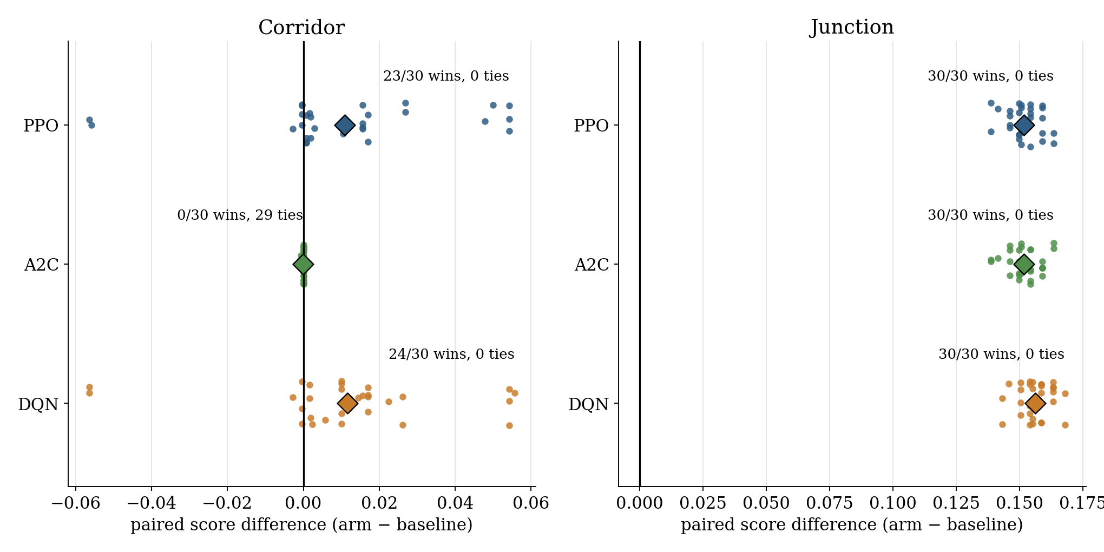
Figure 7: Per-seed paired differences (arm minus baseline) for the six arms; the diamond is the mean. The corridor effect is small but one-sided for PPO and DQN, while the junction differences are large and uniform, in the direction that the next paragraph shows is the wrong one.
The junction result is a negative result and is reported as such. The baseline scores −0.1769 while completing all 126 trains on every seed; PPO and A2C score −0.0251 while completing none, and DQN scores −0.0208 while completing 18%. All three arms therefore beat the baseline on 30 of 30 seeds (p < 0.001), yet PPO and A2C complete no train at all and DQN completes 18 %. The mechanism is a property of the metric: a train that never departs is charged a cancellation of roughly its travel time, while a train dispatched into a jammed junction is charged the full delay it accumulates, so parking the fleet is the value-optimal behaviour for a weak policy. Table 3 makes the contradiction explicit: the PPO arm's score of −0.0251 corresponds to about 19 cost units per train, while delay_all says every train is on average 460 steps late. The cap is one episode length per train (757 steps) and does not bind here: the -0.0251 comes from charging each train its cancellation, about 19 cost units, so the score cannot see that the same fleet is on average 460 steps late.
A second effect makes the junction comparison weaker still: the regime is zone-driven, so a policy that never dispatches never reaches the firing band and its episode contains no incident at all. The rollout of the selected PPO checkpoint shows this directly (Figure 8): no failure has fired because no train has departed, so the arm is being scored on an undisturbed episode that it still fails to run. This is a limitation of the arm, not of the baseline, but it means the junction sign test measures the metric's preference for inaction rather than the quality of the learned policy.
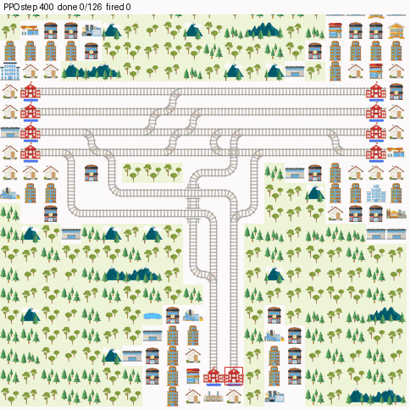
Figure 8: A rollout of the selected PPO checkpoint on the junction at step 400: no train has departed, so none of the three scheduled failures has fired either. The arm scores better than the baseline by doing nothing.
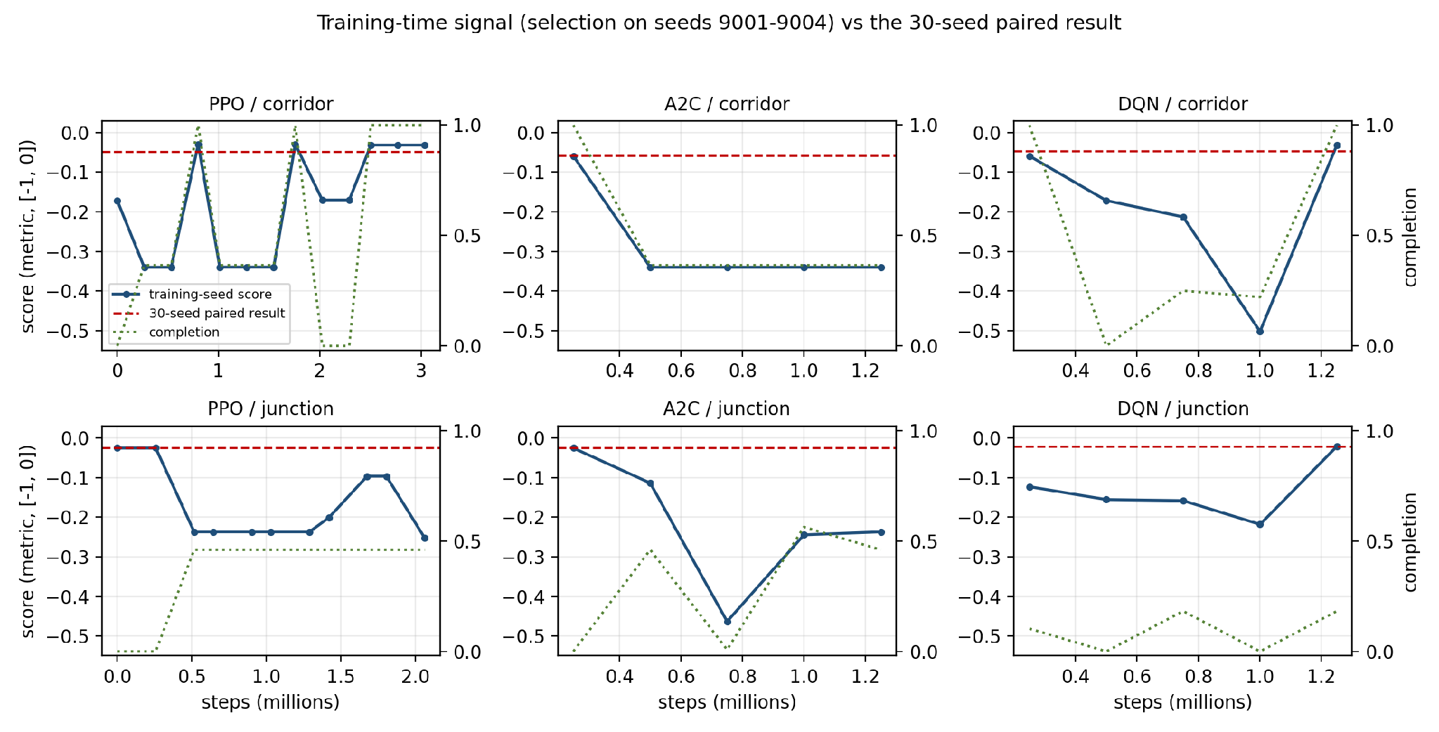
Figure 9: All six learning curves, from the four-episode internal evaluation used for checkpoint selection (seeds 9001–9004), against the 30-seed paired result (dashed red). The corridor PPO arm oscillates between three completion modes (all, about a third, none); the corridor A2C arm is at its best at the first evaluation and then completes about a third of the fleet and strands the rest; the junction curves sit at or below the parked-fleet score for most of training and only the DQN arm's final evaluation edges past it, which is the metric pathology described above.

3.4 Limitations
• Effect size and training signal. The corridor gain is small (+0.011 on a score bounded below by −1) and the training signal is noisy at the two-to-four-episode scale used for model selection, so the result rests on the 30-seed paired test rather than on any single checkpoint or curve. Checkpoint provenance is unresolved for the junction: both arms evaluate at their initialisation while their recorded curves contain evaluations at a higher completion, so the shipped checkpoint is not demonstrably the best logged one.
• Two scenarios, one map variant each. Each scenario is represented by one condensed map. The corridor keeps the four suburban/local tracks and 52 movements; the main-track services are outside the model, so the conclusions apply to suburban/local operation rather than to the corridor as a whole.
• Metric pathology. The metric rewards cancellation less than a jammed dispatch, which is why the junction arms can win the score while running no trains. A deployment would have to replace the objective or constrain the action space, for example with a mandatory departure or a global signaller that holds trains before they enter a junction.
• Disruption volume. The disruption volume is a modelling choice, not data: three fixed 220-step holds per episode were calibrated to keep completion at 1.000 while making every victim late. Incident rates and durations were not fitted from the feed, and the hold length is uniform.
• Comparability of the arms. The arms share the observation, regime and reward, and all three act per train with Discrete(5); they differ in the number of environment copies (two for PPO, one for A2C and DQN), in the network width, and in their optimiser settings (Table 2), including the discount, which is 0.999 for PPO and 0.99 for A2C, because DQN cannot reuse the PPO rollout buffer. Part of the PPO/A2C gap may therefore come from the copy count, the width or the discount rather than from the algorithm, and a single training run per arm leaves the seed-to-seed variance of the training process unmeasured.
• Simulation only. Evaluation is entirely simulated. The timetable and track layout are real, but there is no validation against recorded recovery times, passenger load or signaller behaviour, and the policy is not intended for operational use.
• Reproducibility constraints. The 1.47 GB GTFS extract and the model checkpoints are not shipped with the code, so a full reproduction requires the original feed and roughly 35 minutes of CPU time per PPO arm; with FULL_RUN off the notebook replays the recorded results instead of retraining, and retraining the reported arms needs only the shipped levels and timetables, not the feed. The GTFS extraction, level build and station-access probe that produce the shipped levels are not shipped as scripts either, so the first three preprocessing steps are reproducible in method rather than by a command.

4. Discussion and Conclusions
[Summarize your project, results, etc. Suggest future extensions and improvements.]

5. References
Gorrey, M., Segaert, A., Ganko, J., & Kaine, E. (2025, May 21). ‘Delay all non-essential travel’: Commuters warned to expect more train chaos. The Sydney Morning Herald. https://www.smh.com.au/national/nsw/major-disruptions-expected-as-power-failure-halts-trains-20250520-p5m0t1.html
Li, B., Guo, T., Li, R., Wang, Y., Ou, Y., & Chen, F. (2021). Delay propagation in large railway networks with data-driven Bayesian modeling. Transportation Research Record, 2675(11), 472-485.
Mohanty, S., Nygren, E., Laurent, F., Schneider, M., Scheller, C., Bhattacharya, N., Watson, J., Egli, A., Eichenberger, C., & Baumberger, C. (2020). Flatland-rl: Multi-agent reinforcement learning on trains. arXiv preprint arXiv:2012.05893.
Roberts, M. ( 2024, June 17). Signal repairs cause train disruption in Sydney during Monday morning commute ABC News. https://www.abc.net.au/news/2024-06-17/nsw-sydney-trains-harris-park-service-repair-delay-commute/103985636
Šemrov, D., Marsetič, R., Žura, M., Todorovski, L., & Srdic, A. (2016). Reinforcement learning approach for train rescheduling on a single-track railway. Transportation Research Part B: Methodological, 86, 250-267.
Sutton, R. S., & Barto, A. G. (2018). Reinforcement Learning, second edition: An Introduction. MIT Press. https://books.google.com.au/books?id=uWV0DwAAQBAJ
Sydney Trains. (2025). Sydney Trains Annual Report
https://www.transport.nsw.gov.au/system/files/media/documents/2025/sydney-trains-annual-report-2024%E2%80%9325-volume-1.pdf
Zhu, Y., & Goverde, R. M. (2019). Railway timetable rescheduling with flexible stopping and flexible short-turning during disruptions. Transportation Research Part B: Methodological, 123, 149-181.

Appendices

A. Individual Contribution
Each group member should write half-page (max) about his or her contribution in the project development activities.

B. Individual Contribution Split
Team Member Name | Percentage
Daniel James Martirosov | 33.33%
Ziheng Deng | 33.33%
Laurean Lim | 33.33%
All the team members have discussed and agreed on the above individual contribution to the project.
Daniel James Martirosov : Daniel James Martirosov
Ziheng Deng : Ziheng Deng
Laurean Lim : Laurean Lim

