**CLOUD APPLICATION DEVELOPMENT GROUP 3**

**PHASE 3**

**INTRODUCTION:**

Building a big data analysis solution with IBM Cloud Databases enables efficient storage and analysis of extensive datasets. This journey begins by selecting the right database service (e.g., Db2, PostgreSQL, MongoDB), creating and configuring your database securely, ingesting and transforming data, analyzing and presenting insights using visualization tools. Scalability and security measures ensure data integrity and compliance. This streamlined process empowers organizations to unlock the potential of big data, making informed decisions and gaining a competitive edge.

**CREATE AN IBM CLOUD ACCOUNT:**

* Visit IBM Cloud: Go to https://www.ibm.com/cloud.
* Sign-Up: Click "Sign Up" on the homepage.
* Provide Info: Enter your name, email, and password. Also add the unique feature code provided beforehand in the course module
* Email Verification: Verify your email by clicking the link sent by IBM Cloud.
* Additional Data: Fill in any requested information, such as your phone number and organization details.
* Accept Terms: Review and accept IBM Cloud's terms and privacy policy.
* 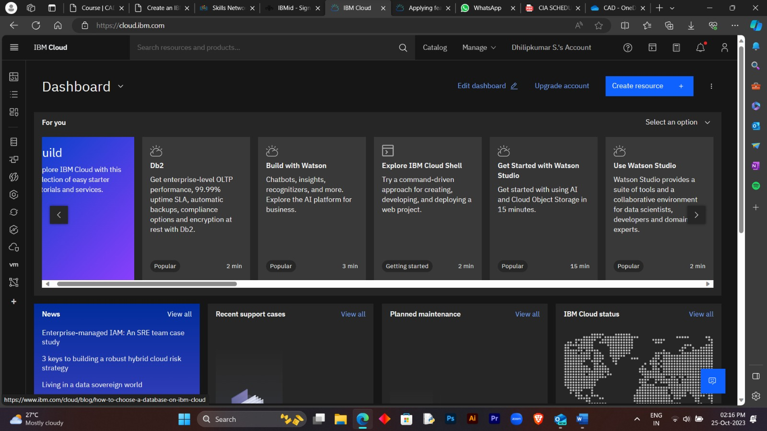Account Creation: Your IBM Cloud account is now created.

**CHOOSE THE APPROPRIATE DATABASE SERVICE IN DB2**

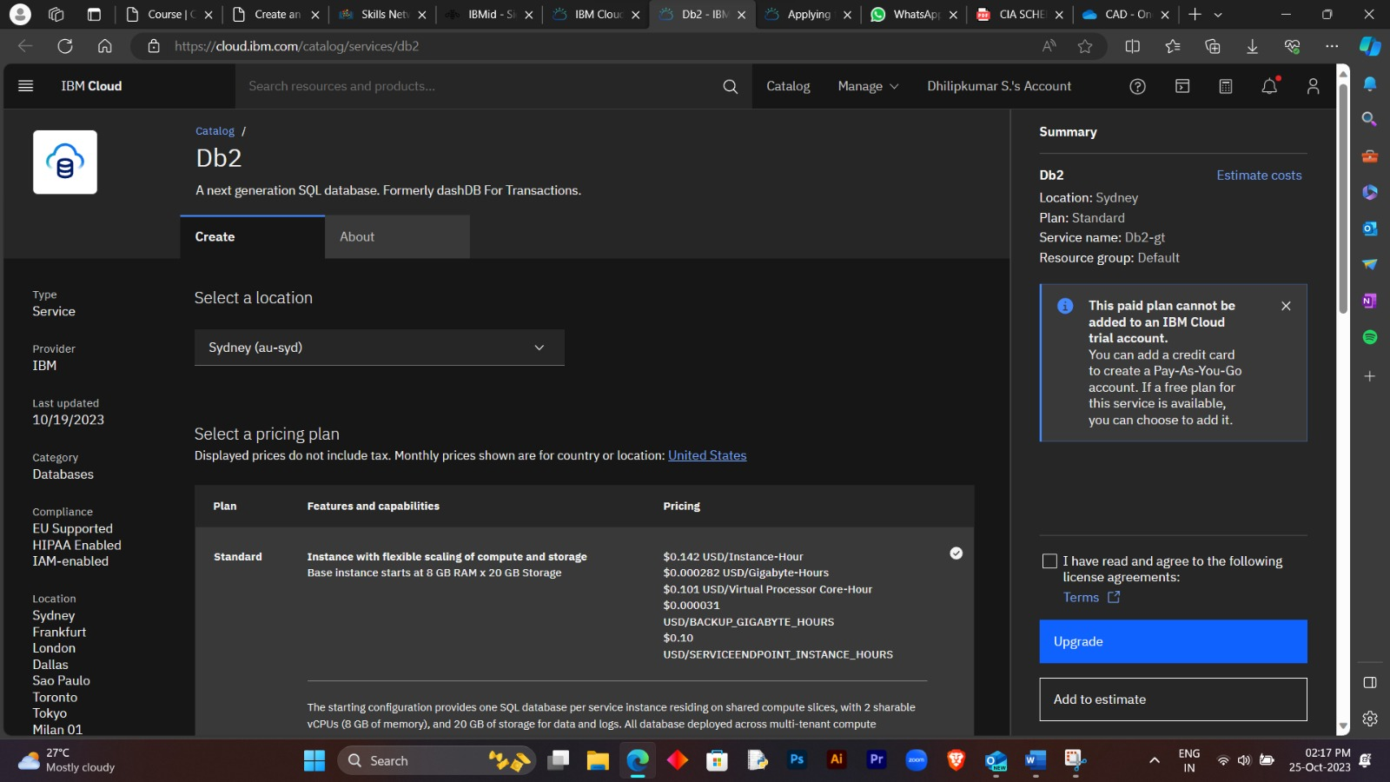In IBM Cloud, the appropriate database service for Db2 is "IBM Db2 on Cloud." This service provides a highly reliable and scalable relational database management system (RDBMS) that's well-suited for applications requiring structured data storage and complex querying. It's an ideal choice for enterprise-level applications, financial systems, and projects where maintaining strong ACID compliance and data integrity are paramount. IBM Db2 on Cloud offers a range of features to manage, secure, and optimize your database, making it a versatile choice for a wide array of applications with complex data requirements appropriate database service

**SETTING UP A DB2 DATABASE INSTANCE:**

Install Db2 software following IBM's instructions.

Initialize the instance, setting options like database name and memory allocation.

Create the database, define schema, tables, and data objects.

Configure security, authentication, and access control.

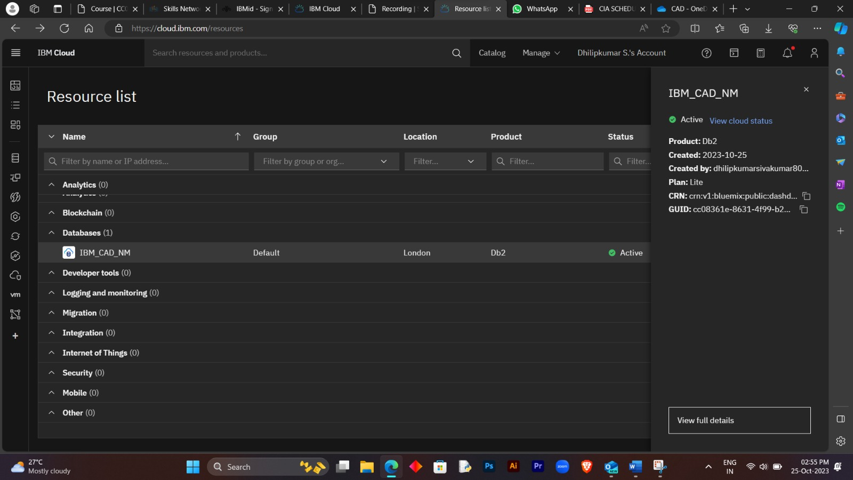

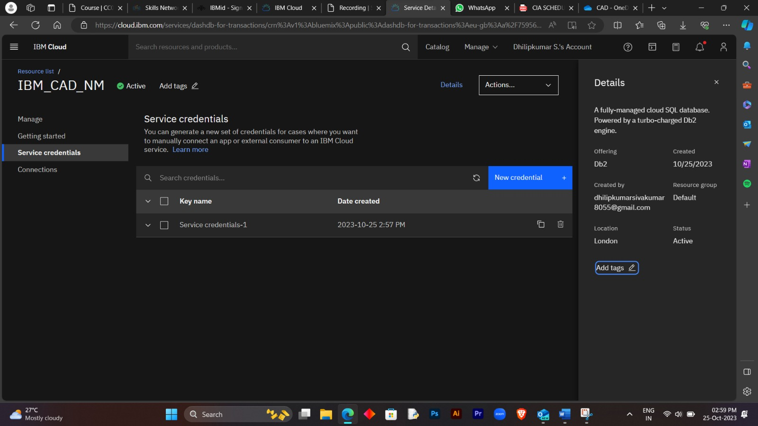

**DATA EXPLORATION AND ANALYSIS IN BIG DATA ANALYSIS SOLUTION USING IBM CLOUD DATABASES.**

Data exploration and analysis are critical steps in big data analysis solutions, even when using IBM Cloud Databases. Here's a simplified overview of how to perform data exploration and analysis using IBM Cloud Databases:

Data Ingestion:Ingest or import your large datasets into IBM Cloud Databases. Depending on your specific use case, you may choose a database service like Db2, PostgreSQL, or another suitable option.

Data Preparation:Clean and preprocess the data to handle missing values, outliers, and inconsistencies. This step ensures that the data is in a suitable format for analysis.

Connect to the Database:Use appropriate tools or programming languages to establish a connection to your IBM Cloud Database. Common choices include Python, R, or SQL.

Exploratory Data Analysis (EDA):Conduct EDA to understand the data's characteristics. This involves statistical summaries, data visualization, and identifying patterns or trends. IBM Cloud offers analytics and visualization tools for this purpose.

**Basic data cleaning and transformation**

Basic data cleaning and transformation is a critical step in the data analysis process. It involves identifying and rectifying inaccuracies, inconsistencies, and missing values in your dataset. This may include tasks like removing duplicate entries, handling outliers, standardizing data formats, and inserting missing values. The objective is to ensure that the data is in a consistent, usable format, ready for analysis. Effective data cleaning and transformation enhance the quality of your analysis, leading to more accurate and reliable insights from your data.