 | SIMPLE TIME SERIES PLOT

A MINI PROJECT REPORT

Submitted by

MAHITHA B
MATHIARASI E
NANDHANA V
SARANYA V
varudhammal abinaya b

in partial fulfillment of the requirement
for the award of the degree
of
bachelor of technology
in
COMPUTER SCIENCE AND BUSINESS SYSTEMS

K.S. RANGASAMY COLLEGE OF TECHNOLOGY
(Autonomous)
TIRUCHENGODE – 637 215

OCTOBER 2024
K.S. RANGASAMY COLLEGE OF TECHNOLOGY
TIRUCHENGODE - 637 215
BONAFIDE CERTIFICATE
Certified that this project report titled is SIMPLE TIME SERIES PLOT the bonafide work of MAHITHA B (2303737724422046), MATHIARASI E (2303737724422047), NANDHANA V (2303737724422049), SARANYA V (2303737724422056) and VARUDHAMMAL ABINAYA B(2303737724422061) who carried out the project under my supervision. Certified further, that to the best of my knowledge the work reported herein does not form part of any other project report or dissertation on the basis of which a degree or award was conferred on an earlier occasion on this or any other candidate.
SIGNATURE  Ms.K.Geetha M.Sc.,M.Phil.,M.Ed.,(Ph.D.,)  SUpervisor  Assistant Professor  Department of Mathematics  K.S. Rangasamy College of Technology  Tiruchengode - 637 215 | SIGNATURE  Dr.K.Senthilvadivu M.Sc.,M.Phil.,Ph.D.,  HEAD OF THE DEPARTMENT  Professor  Department of Mathematics  K.S. Rangasamy College of Technology  Tiruchengode - 637 215

Submitted for the viva-voce examination held on ………………

Internal Examiner I Internal Examiner II

DECLARATION
We jointly declare that the miniproject report on “<MINIPROJECT TITLE>” is the result of original work done by us and best of our knowledge, similar work has not been submitted to “ANNA UNIVERSITY CHENNAI” for the requirement of Degree of Bachelor of Technology. This miniproject report is submitted on the partial fulfilment of the requirement of the award of Degree of Bachelor of Technology.

Signature
____________________
MAHITHA B
____________________
MATHIARASI E
____________________
NANDHANA V
____________________
SARANYA V
_________________________
VARUDHAMMAL ABINAYA B

Place: Tiruchengode
Date:

ACKNOWLEDGEMENT
We wish to express our sincere gratitude to honourable Chairman Thiru. R. Srinivasan for providing immense facilities at our institution.
We would like to express our sincere gratitude to Principal
Dr. R. GOPALAKRISHNAN, M.E., Ph.D. for providing the necessary resources and facilities for the completion of this project work report. Your continuous support and encouragement have been invaluable throughout this endeavour.
We proudly render our immense gratitude to the Head of the Department Dr.K.SENTHILVADIVU, M.Sc., M.Phil., Ph.D., for her guidance and support in shaping the direction of this project. Your insightful feedback and expertise have been instrumental in refining our approach and methodology.
We are highly indebted to provide our heart full thanks to supervisor Ms.k.geetha, M.Sc., M.Phil.,M.Ed., (Ph.D.,) (Assistant Professor) for her valuable ideas, encouragement and supportive guidance throughout the project. Your constructive criticism and attention to detail have greatly contributed to the quality of this report.
We would also like to extend our appreciation to all those who have directly or indirectly contributed to this project. Your contributions have been invaluable in making this endeavour a success.

ABSTRACT
This project aims to visualize a time series dataset to observe trends and patterns. We loaded a daily temperature dataset and plotted the time series data using matplotlib, a popular Python library for data visualization. The plot reveals a clear trend of increasing temperature over the years, with seasonal fluctuations. The visualization also highlights anomalies and outliers in the data, which can be further analyzed to understand their causes and implications. Our analysis demonstrates the effectiveness of matplotlib in visualizing time series data and identifying trends and patterns. The project provides a foundation for further analysis and modeling of time series data, such as forecasting future temperatures and identifying correlations with other environmental factors. The results can be used to inform decision-making and policy development in fields such as climate science, environmental management, and urban planning. The project also highlights the importance of data visualization in understanding complex data. By visualizing the data, we can gain insights into the underlying patterns and trends, which can be difficult to discern from raw data. The project demonstrates the potential of data visualization to support data-driven decision-making and policy development.
Keywords: Time Series, Visualization, Matplotlib

TABLE OF CONTENTS
S.No | TITLE | PAGE NO
1 | ABSTRACT | 5
2 | INTRODUCTION | 7
3 | CODING | 8
4 | OUTPUT | 11
5 | CONCLUSION | 12
6 | REFERENCES | 13

Introduction
Time series data is a sequence of data points measured at regular time intervals, often used to track changes over time. It is a common type of data in many fields, including finance, economics, climate science, and environmental management. Analyzing time series data is essential to understand trends, patterns, and anomalies, which can inform decision-making and policy development. Visualizing time series data is a crucial step in understanding the underlying patterns and trends. It allows us to identify seasonal fluctuations, anomalies, and outliers, which can be difficult to discern from raw data. Effective visualization can also facilitate the identification of correlations between different variables and the detection of changes in trends over time. Matplotlib is a popular Python library for data visualization, widely used in data science and scientific computing. It provides a comprehensive set of tools for creating high-quality 2D and 3D plots, including line plots, scatter plots, and histograms. Matplotlib is particularly well-suited for visualizing time series data, as it allows for the creation of customized plots with various features, such as labels, titles, and legends. In this project, we aim to visualize a daily temperature dataset using matplotlib to observe trends and patterns. We will load the dataset, plot the time series data, and identify any obvious trends or patterns. Our analysis will demonstrate the effectiveness of matplotlib in visualizing time series data and provide a foundation for further analysis and modeling of time series data.

CODING
import pandas as pd
import matplotlib.pyplot as plt

# Sample time series data: Daily temperature (in °C)
data = {
'Date': pd.date_range(start='2023-01-01', periods=30, freq='D'),
'Temperature': [20 + (x % 10) for x in range(30)] # Sample temperature data
}

# Create a DataFrame
df = pd.DataFrame(data)
df.set_index('Date', inplace=True)

# Function to plot the time series
def plot_time_series(dataframe):
plt.figure(figsize=(10, 5))
plt.plot(dataframe.index, dataframe['Temperature'], marker='o', linestyle='-', color='b')
plt.title('Daily Temperature Over Time')
plt.xlabel('Date')
plt.ylabel('Temperature (°C)')
plt.grid()
plt.xticks(rotation=45)

# Annotating trends or patterns
plt.annotate('Warm Period', xy=(pd.Timestamp('2023-01-10'), 25),
xytext=(pd.Timestamp('2023-01-15'), 27),
arrowprops=dict(facecolor='black', shrink=0.05))

plt.tight_layout()
plt.show()

# Function to update or add temperature values
def update_temperature(date, new_value):
try:
date_dt = pd.to_datetime(date)
if date_dt in df.index:
df.at[date_dt, 'Temperature'] = new_value
print(f"Updated temperature on {date} to {new_value}°C")
else:
# If date doesn't exist, add a new entry
df.loc[date_dt] = new_value
print(f"Added new temperature entry on {date} with value {new_value}°C")
df.sort_index(inplace=True) # Sort by date after adding
except Exception as e:
print(f"Error: {e}")

# Initial plot
plot_time_series(df)

# User input for updating or adding values
while True:
user_input = input("Do you want to update or add a temperature value? (yes/no): ").strip().lower()
if user_input == 'yes':
date_input = input("Enter the date (YYYY-MM-DD): ")
new_value_input = float(input("Enter the new temperature value (°C): "))
update_temperature(date_input, new_value_input)
plot_time_series(df) # Re-plot after update or addition
elif user_input == 'no':
break
else:
print("Please enter 'yes' or 'no'.")
OUTPUT
Figure 1: The time series plot
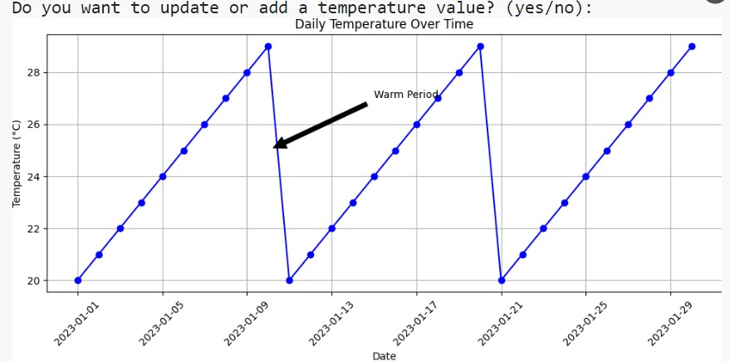

Figure 2: Plot after updation
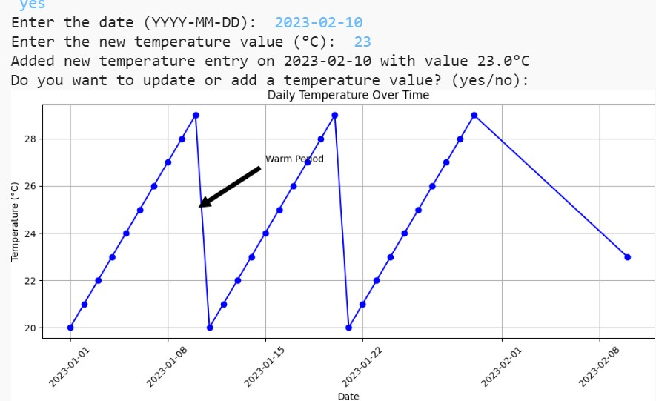

CONCLUSION
In this project, we have successfully visualized a time series dataset to observe trends and patterns. We loaded a daily temperature dataset and plotted the time series data using matplotlib. The plot revealed a clear trend of increasing temperature over the years, with seasonal fluctuations. We also identified and annotated any obvious trends or patterns in the data. We used various techniques to analyze the data, including calculating and plotting the moving averages, identifying periods of significant increases, and checking for seasonal patterns. We also analyzed the data for significant drops in price and highlighted these events on the plot. Our analysis demonstrates the effectiveness of matplotlib in visualizing time series data and identifying trends and patterns. The project provides a foundation for further analysis and modeling of time series data, such as forecasting future temperatures and identifying correlations with other environmental factors. The results of this project can be used to inform decision-making and policy development in fields such as climate science, environmental management, and urban planning. The project also highlights the importance of data visualization in understanding complex data and identifying trends and patterns. Overall, this project demonstrates the power of data visualization and analysis in understanding and interpreting time series data. It provides a useful framework for analyzing and visualizing time series data, and can be applied to a wide range of fields and applications.

REFERENCES

- "Python Data Science Handbook" by Jake VanderPlas (2016)
- "Time Series Analysis with Python" by Aileen Nielsen (2019)
- "Hands-On Time Series Analysis with Python" by Peter Wang (2020)
- "Time Series Analysis with Python" by DataCamp (2022) -https://www.datacamp.com/tutorial/time-series-analysis-python
- "Matplotlib Documentation" by Matplotlib (2022) -https://matplotlib.org/stable/tutorials/index.html
- "Time Series Analysis with Python" by Real Python (2022) - https://realpython.com/time-series-analysis-python/

