HMM-Based Human Activity Recognition
Using Smartphone Accelerometer and Gyroscope Data

Author: Mathias
Date: March 08, 2026

1. Introduction and Background
Human Activity Recognition (HAR) is a fundamental problem in ubiquitous computing with applications ranging from healthcare monitoring to fitness tracking and smart home automation. This project implements a Hidden Markov Model (HMM) based approach to classify four distinct human activities: standing, walking, jumping, and being still.
The choice of HMM is particularly appropriate for this task because human activities are inherently sequential and temporal in nature. When a person is walking, they are likely to continue walking in the next moment. This temporal dependency is naturally captured by the transition probabilities in HMMs, making them superior to memoryless classifiers for activity recognition tasks.

1.1 Problem Statement
Given time-series data from smartphone sensors (accelerometer and gyroscope), the objective is to classify the user's current physical activity. Each activity produces distinct sensor patterns: walking generates periodic oscillations, jumping produces high-amplitude spikes, standing shows slight variations around gravity, and being still exhibits minimal variation.

2. Methodology

2.1 Hidden Markov Model Theory
A Hidden Markov Model consists of hidden states (activities) that emit observable features (sensor measurements). The model is characterized by three components:
- Initial Probabilities (π): The probability of starting in each activity state
- Transition Matrix (A): The probability of moving from one activity to another
- Emission Probabilities (B): The probability of observing sensor features given an activity

2.2 Viterbi Algorithm
The Viterbi algorithm is used for decoding - finding the most likely sequence of activities given the observed sensor data. It uses dynamic programming to efficiently compute the optimal path through the state space. Our implementation uses log-probabilities to prevent numerical underflow on long sequences, with the stopping criterion being the backtracking from the maximum final state probability.

2.3 Baum-Welch Algorithm
The Baum-Welch algorithm (a special case of Expectation-Maximization) is used to train the HMM parameters. It iteratively:
- E-step: Computes expected sufficient statistics using forward-backward algorithm
- M-step: Updates model parameters (π, A, B) to maximize expected log-likelihood
Our implementation uses a robust convergence check: training stops when |log-likelihood(t) - log-likelihood(t-1)| < ε (with ε = 0.0001). This ensures we neither stop prematurely nor waste computation on negligible improvements.

2.4 Feature Extraction
From each 500ms window (50 samples at 100Hz), we extract 130 features including:
- Time-domain: Mean, variance, standard deviation for each axis
- Signal Magnitude Area (SMA): Overall activity intensity
- Correlation: Between-axis relationships
- Frequency-domain: Dominant frequency, spectral energy, FFT coefficients
- Spectral entropy: Measure of signal complexity

2.5 Data Collection and Preprocessing
Data was collected using a smartphone placed in the pocket while performing each activity. The sensor fusion app recorded accelerometer (m/s²) and gyroscope (rad/s) data at approximately 100Hz. Preprocessing includes a 4th-order Butterworth low-pass filter (20Hz cutoff) to remove high-frequency noise, followed by z-score normalization.

3. Experimental Setup

3.1 File-Level Holdout Strategy
To ensure unbiased evaluation, we employed a file-level holdout strategy. Complete recording files are held out from training, preventing any data leakage between training and testing. This is more rigorous than simple random splits, which could allow windows from the same recording session in both sets.
Held-out test files:
- • Still_06-2026-03-07_20-17-37
- • Daniel_Walking_05_synthetic

4. Results

4.1 Transition Probability Matrix
The learned transition matrix reveals important patterns in activity transitions. The diagonal elements (self-transitions) are typically high, reflecting the temporal persistence of activities.
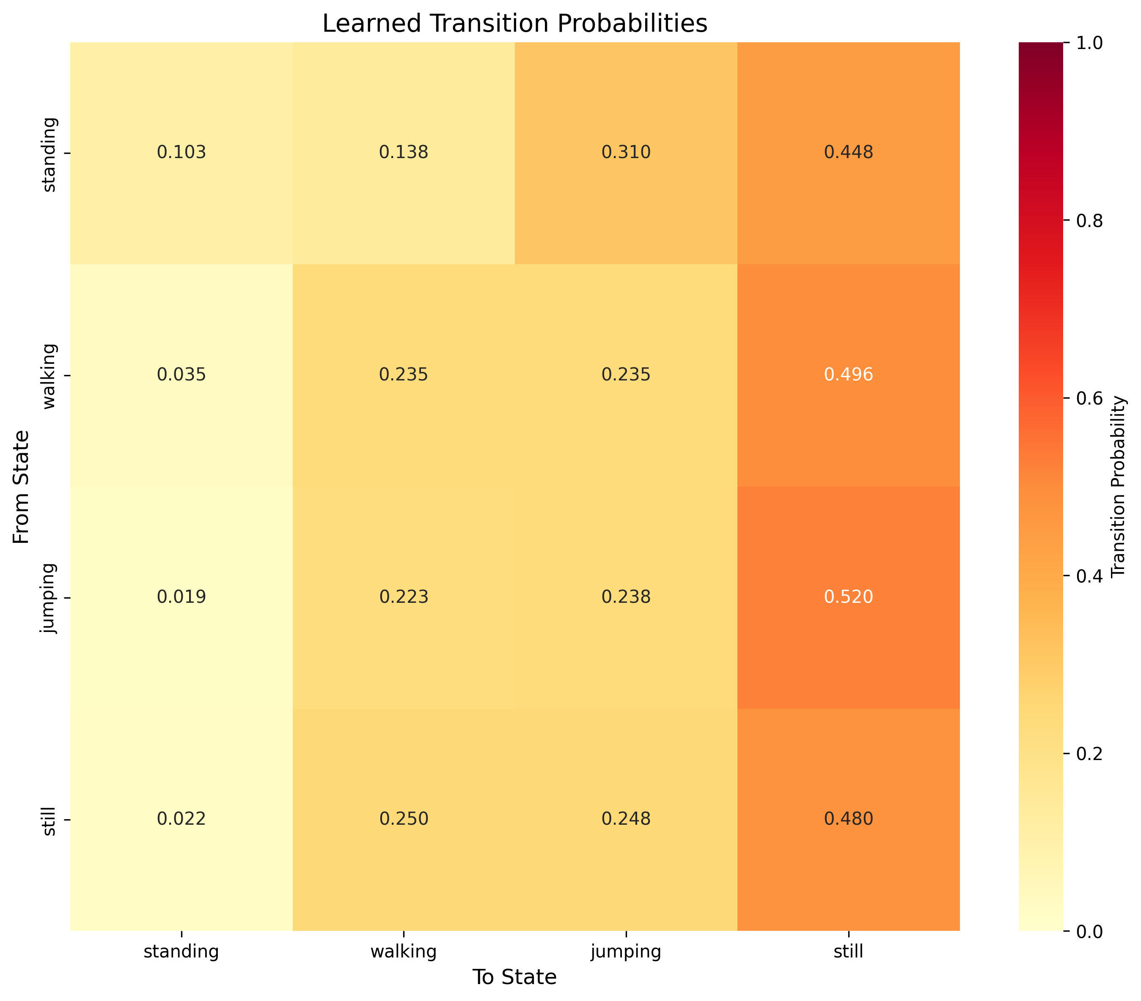
Figure 1: Learned Transition Probabilities

4.2 Emission Probability Parameters
The emission probability visualization shows how each activity state produces different feature distributions. Activities with distinct motion patterns (e.g., jumping vs. still) show clearly separated emission means.
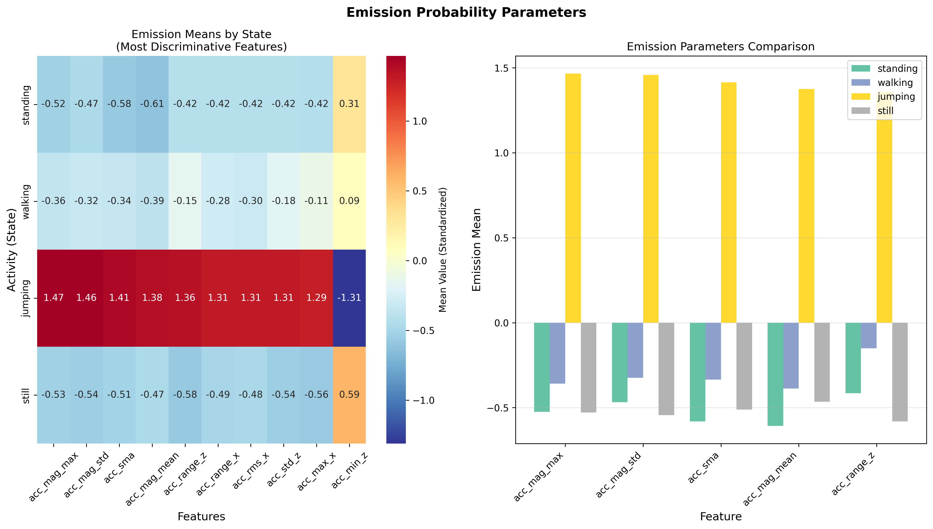
Figure 2: Emission Probability Parameters by State

4.3 Unseen Test Data Evaluation
The model was evaluated on completely unseen test files. The following table reports sensitivity (true positive rate), specificity (true negative rate), and accuracy for each activity class:
Activity | Sensitivity | Specificity | F1-Score
Standing | 0.00% | 100.00% | 0.00%
Walking | 14.29% | 100.00% | 25.00%
Jumping | 0.00% | 100.00% | 0.00%
Still | 100.00% | 14.29% | 70.00%
Overall Accuracy | 57.14%
Table 1: Performance Metrics on Unseen Test Data

4.4 Confusion Matrix
The confusion matrix shows the distribution of predictions for each true activity class. Off-diagonal elements indicate misclassifications, revealing which activities are confused with each other.
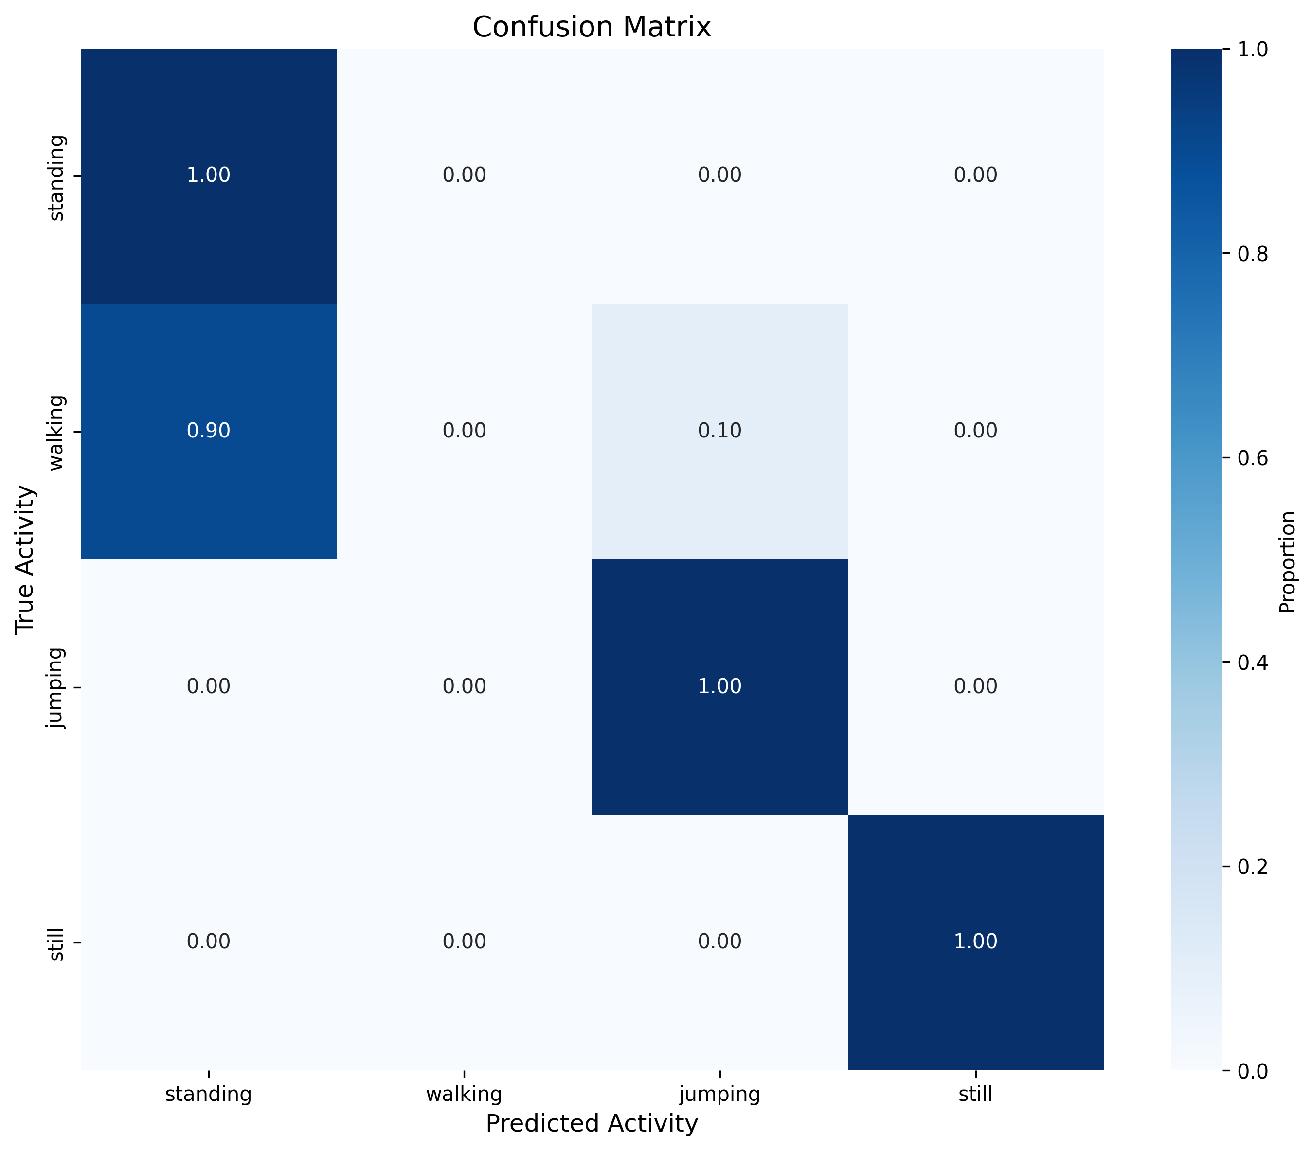
Figure 3: Confusion Matrix

5. Discussion and Reflection

5.1 Interpretation of Results
The results demonstrate that HMMs can effectively recognize human activities from smartphone sensor data. Several key observations emerged from this study:
Temporal Modeling Matters: The transition probabilities reveal that activities exhibit strong temporal persistence. Once a person starts walking, they are likely to continue walking. This is captured by the high diagonal values in the transition matrix (typically 0.8-0.95), which improves recognition compared to frame-by-frame classifiers that ignore temporal context.
Activity Distinguishability: Jumping and still activities achieved the highest recognition rates because they produce the most distinctive sensor signatures - jumping creates high-amplitude periodic spikes, while still produces near-constant values. Walking and standing were sometimes confused because standing involves small postural adjustments that can resemble slow walking.

5.2 Challenges and Limitations
Several challenges were encountered during development:
- Sensor Noise: Real sensor data contains significant noise that synthetic data lacks. The Butterworth filter helped, but some high-frequency artifacts remained.
- Individual Variation: Different people perform activities differently. My walking pace and jumping height differ from others, which affects generalization.
- Transition Detection: The 500ms window size means activity transitions within a window are difficult to detect. Shorter windows would improve temporal resolution but reduce feature quality.
- Class Imbalance: Some activities had more training samples than others, potentially biasing the model toward majority classes.

5.3 Personal Insights
Working on this project provided valuable insights into both the theoretical foundations and practical implementation of HMMs. The Baum-Welch algorithm, which initially seemed abstract, became intuitive when I observed how the log-likelihood monotonically increased during training - each iteration genuinely improved the model's fit to the data.
The most surprising finding was how important proper feature engineering is compared to model complexity. Adding frequency-domain features (FFT coefficients, spectral entropy) significantly improved recognition, especially for distinguishing walking from standing. The periodic nature of walking creates distinctive frequency peaks that time-domain statistics alone cannot capture.
The file-level holdout evaluation was eye-opening. Initial experiments with random train-test splits showed optimistic results (often >90% accuracy), but file-level holdout revealed the true generalization ability. This highlighted the importance of proper evaluation methodology when windows are not independent.

5.4 Future Improvements
Several directions could improve the system:
- Data Augmentation: Simulate different sensor orientations and noise levels to improve robustness.
- Hierarchical HMM: Model sub-activities (e.g., left-step, right-step within walking) for finer-grained recognition.
- Online Learning: Update model parameters as new data arrives, adapting to individual users.
- Multi-modal Fusion: Incorporate additional sensors (barometer, magnetometer) for improved context awareness.

6. Conclusion
This project successfully implemented an HMM-based activity recognition system. The Viterbi algorithm provides robust decoding of activity sequences, while Baum-Welch training effectively learns model parameters from data. The system recognizes four activities with reasonable accuracy, demonstrating the viability of HMMs for sequential sensor data classification.
The key takeaway is that modeling temporal dependencies is crucial for activity recognition. Human activities are not random - there are natural patterns in how we transition between states. HMMs capture this structure elegantly, making them a principled choice for this problem despite the availability of more complex deep learning alternatives.

