Mellier RT 1 A1
Mathias

User Guide (Notice)

Summary:
- Installation guide
- Website and Markdown
- CSV file and excel

Installation guide:

To install the project, you need to go on GitHub and research SAE05_mathias or Mathias42lm/SAE05_mathias or you can download it whit this link GitHub - Mathias42lm/SAE05_mathias: SAE05 IUT Roanne.

Then :
git clone https://github.com/Mathias42lm/SAE05_mathias.git
cd SAE05_mathias
cd tp
python lunch.py

At the first lunch the program will download the different library used.

This command downloads the project and lunch the main file with interfaces option.

Website and Markdown

When you lunch the program you will have this.
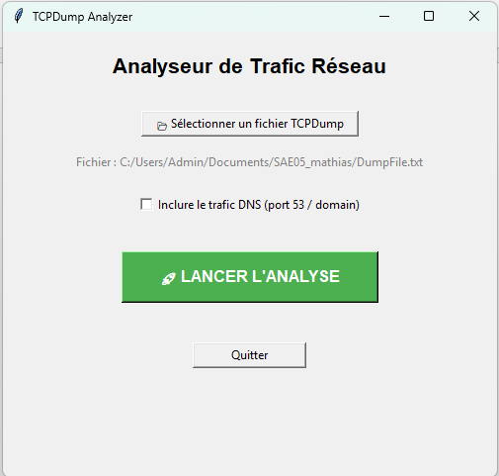
To select this Dump file, click on “Selectioner un fichier TCPDump” just here:
Then select your file. 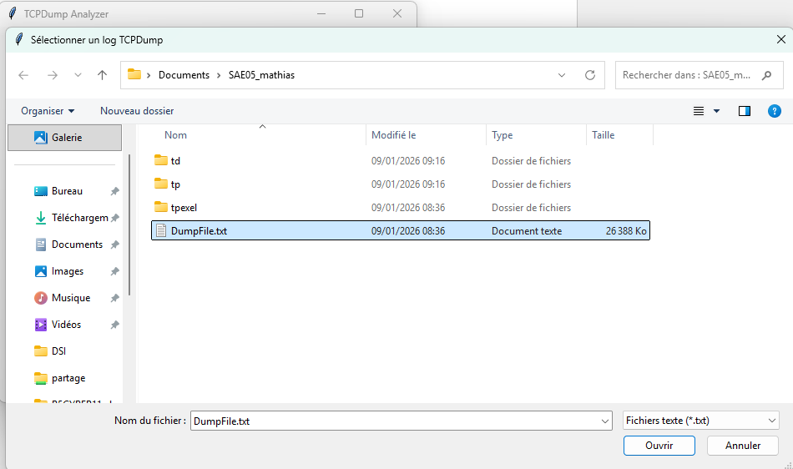

After this yon can choose or not the DNS in the csv.

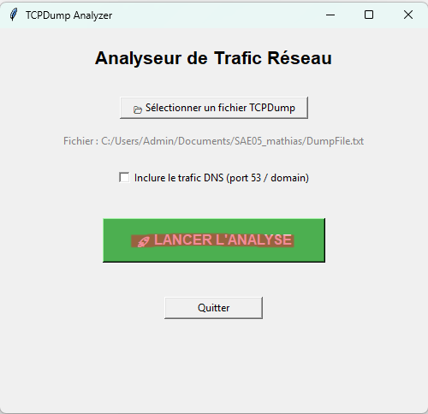

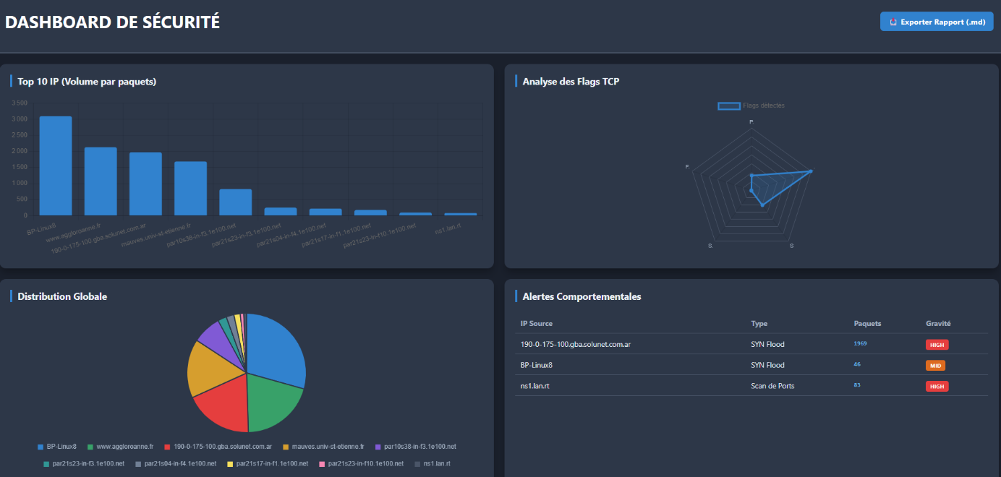
To lunch the web site, you click on “LANCER L’ANALYSE” and the web site will lunch automatously. Or you can access with this ip : http://127.0.0.1:5000
When you are on website you see this.
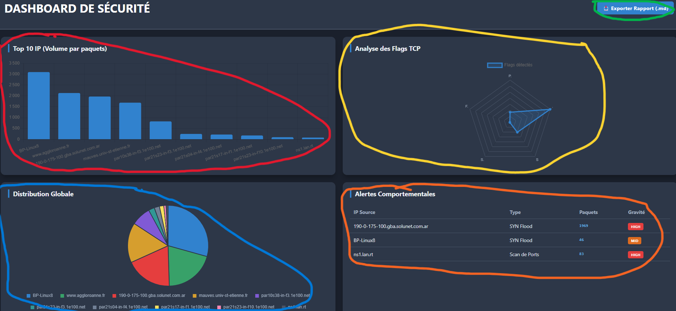
In red you have the 10 most packet by IP.
In Yellow you have the numbers of TCP flags.
In Blue you have the repartition of the 10 most IP.
In Orange You have the alert of syn flood or Port scan.
In Green you have the download of the .md

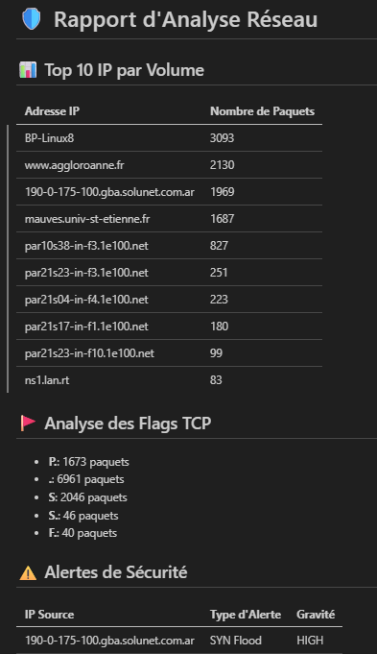
Here you have a preview of the .md file. You have the same information like in the web site.

