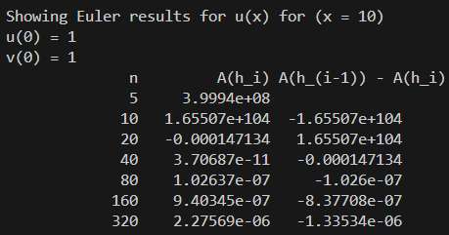

Needs more iterations to converge

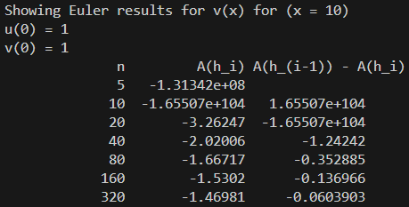

Needs more iterations to converge

