# CS 255 System Design Document Template

## UML Diagrams

### UML Use Case Diagram

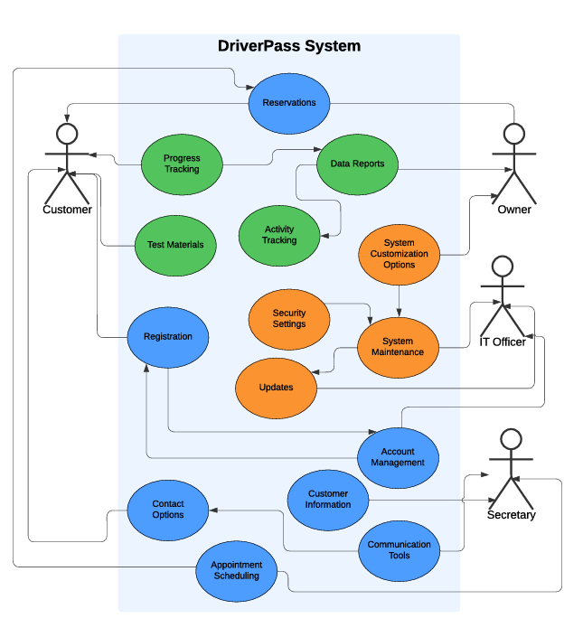

### UML Activity Diagrams

Package Purchased

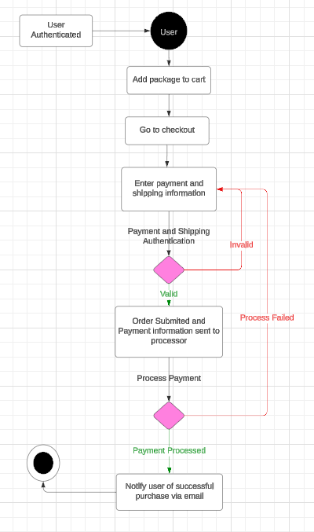

### Login and Registration

### UML Sequence Diagram

Package Purchase Sequence

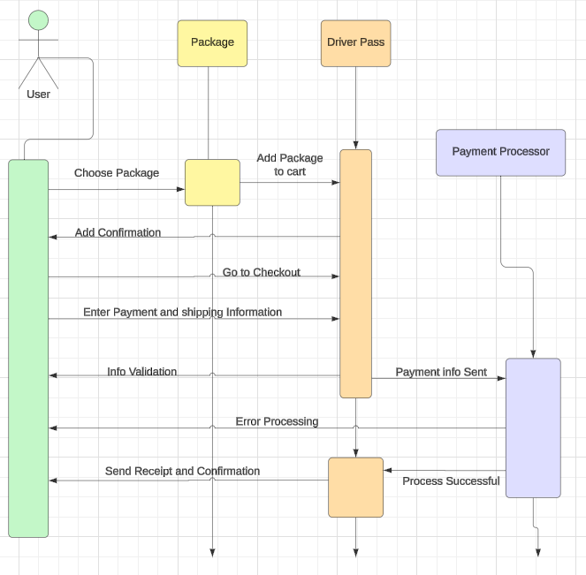

### UML Class Diagram

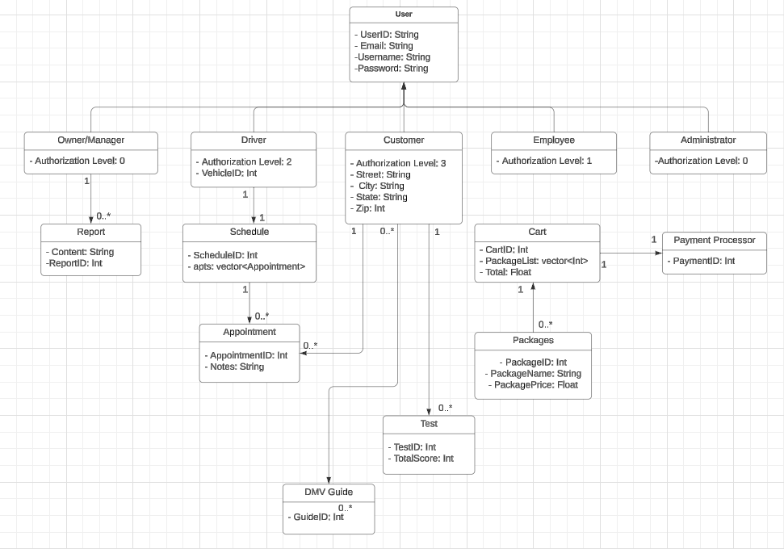

## Technical Requirements

Hardware Requirements for Developers:

* Physical servers to Host with
* Networking cables for the servers and various other equipment
* Monitors, Keyboards and computer mice for interaction with the system
* Reliable power sources
* Internet connection and a reliable provider

Hardware Requirements for Users:

* Either a Laptop device, or a desktop computer with a monitor, keyboard and mouse
* Wireless card or Ethernet cable connection for networking purposes.
* Reliable power sources
* Internet connection and a reliable provider

Software Requirements for Developers:

* Windows server OS
* DriverPass Software access
* Docking software for control of VM traffic
* Reliable Security software

Software Requirements for Users

* Any compatible web browser application
* Any compatible OS
* Reliable Security Software

Tools required for Developers

* Computer device that has a compatible programming software installed
* Internet connection
* Server connection capabilities
* Networking/Administrator toolkit for additional security measures

Required Infrastructure

* Physical Server location or a cloud service provider
* Reliable power supply
* Sufficient Internet service to improve upload speeds
* On location parking for employees
* Training vehicles that students and instructors can access
* Insurance to the level that is required by law in the state of operations
* Payment method processing and protections
* Internal Contract documentation